QUERY JOIN, RIGHT JOIN DAN LEFT JOIN

1. SELECT obat.`nama`, jenis, harga, obat.`id_supplier`,supplier.`nama`, jenis_kelamin, alamat

FROM obat

JOIN supplier ON obat.`id_supplier` = supplier.`id_supplier`

ORDER BY id_supplier ASC

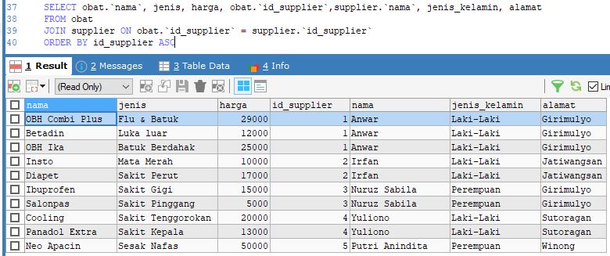

1. SELECT id_obat, obat.`nama`, jenis, harga, obat.`id_supplier`,supplier.`nama`, jenis_kelamin, alamat

FROM obat

RIGHT JOIN supplier ON obat.`id_supplier` = supplier.`id_supplier`

ORDER BY id_supplier ASC

1. SELECT id_obat, obat.`nama`, jenis, harga, obat.`id_supplier`,supplier.`nama`, jenis_kelamin, alamat

FROM obat

LEFT JOIN supplier ON obat.`id_supplier` = supplier.`id_supplier`

ORDER BY id_supplier ASC

1. SELECT id_obat, obat.`nama`, jenis, harga, obat.`id_supplier`,supplier.`nama`, jenis_kelamin, alamat

FROM obat

JOIN supplier ON obat.`id_supplier` = supplier.`id_supplier`

WHERE jenis_kelamin LIKE '%Perempuan%' AND alamat='girimulyo'

ORDER BY id_supplier ASC

1. SELECT obat.`nama`, jenis, obat.`id_supplier`,supplier.`nama`, alamat, tgl_kadaluwarsa

FROM obat

JOIN supplier ON obat.`id_supplier` = supplier.`id_supplier`

WHERE tgl_kadaluwarsa <= '2024-01-31'

ORDER BY id_supplier ASC

