QUERY DATABASE APOTEK

1. **SELECT * FROM obat ORDER BY id_obat DESC**

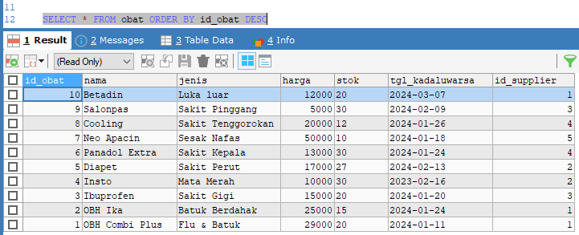

1. **SELECT * FROM obat ORDER BY NAMA ASC**

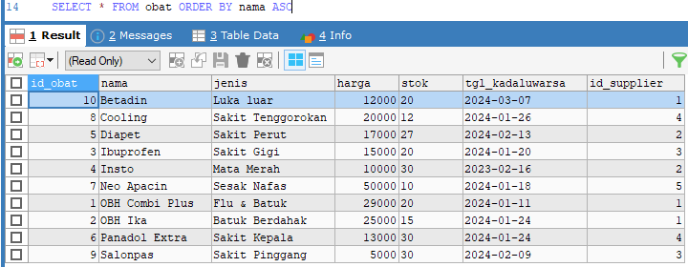

1. **SELECT * FROM pelanggan WHERE alamat LIKE '%wadas%'**



1. **SELECT * FROM pelanggan WHERE alamat LIKE '%kutoarjo%'**

1. **SELECT id_supplier, nama, jenis, SUM(stok) AS jumlah_stok FROM obat GROUP BY id_supplier**

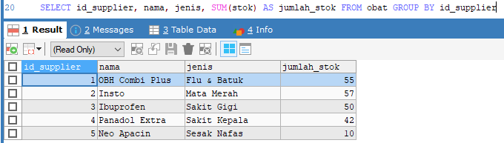

1. **SELECT id_supplier, nama, tgl_kadaluwarsa, SUM(stok) AS jumlah_stok FROM obat GROUP BY id_supplier**

1. **SELECT id_obat, harga_satuan, SUM(jumlah) AS jumlah_obat_keluar FROM faktur_penjualan GROUP BY id_obat**

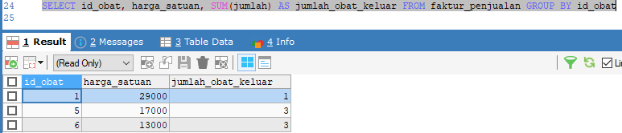

1. **SELECT nama, keluhan, SUM(usia) AS usia FROM pelanggan GROUP BY nama**

1. **SELECT nama, keluhan, SUM(usia) AS usia FROM pelanggan GROUP BY nama ORDER BY nama ASC**

1. **SELECT nama, keluhan, SUM(usia) AS usia FROM pelanggan GROUP BY nama ORDER BY usia DESC**

