STLC or QA Process
A software testing life cycle (STLC) is a set of steps used to test software products. In STLC process, different activities are carried out to improve the quality of the product. Software testing is a critical part of preparing software for use, and a STLC helps make this process more sophisticated, consistent and effective.

Requirement Analysis:
Requirement Analysis is the very first step in STLC. In this step Quality Assurance (QA) team understands the requirement in terms of what will be tested & figure out the testable requirements. If any conflict, missing or not understood any requirement, then QA team follow up with the various stakeholders like Business Analyst, System Architecture, Client, Technical Manager/Lead etc to better understand the detail knowledge of requirement.
Review Requirements

QA Testers start their work on the project in parallel with documentation generation ( Example: Test Case Document, Test Plan Document etc). They review the requirements and other documentation for:
- completeness
- redundancies
- clarity
- consistency
- executability
- verifiability

Test planning:

When the requirements have been established, it is time to start planning test cases, i.e. - describe the actions QA engineers perform to make sure the piece of software functions as planned.
In this stage, a Senior QA manager will determine effort and cost estimates for the project and would prepare and finalize the Test Plan.
Activities
- Preparation of test plan/strategy document for various types of testing
- Test tool selection
- Test effort estimation
- Resource planning and determining roles and responsibilities.
- Training requirement
Deliverables : Test plan /strategy document. Effort estimation document.

Test Case Development and Testing: Making Sure It Works

Once the development has finished, the next phase of the SDLC life cycle is testing. Before the solution can be made live and available to the users, it needs to be tested to make sure it works.

This phase involves creation, verification and rework of test cases & test scripts. Test data , is identified/created and is reviewed and then reworked as well.
Activities
- Create test cases, automation scripts (if applicable)
- Review and baseline test cases and scripts
- Create test data (If Test Environment is available)
Deliverables
- Test cases/scripts
- Test data

Test Environment Setup:
Test environment decides the software and hardware conditions under which a work product is tested. Test environment set-up is one of the critical aspects of testing process and can be done in parallel with Test Case Development Stage.
Test team may not be involved in this activity if the customer/development team provides the test environment in which case the test team is required to do a readiness check (smoke testing) of the given environment. Activities
- Understand the required architecture, environment set-up and prepare hardware and software requirement list for the Test Environment.
- Setup test Environment and test data
- Perform smoke test on the build
Deliverables
- Environment ready with test data set up
- Smoke Test Results.

Test Execution:
During this phase the testers will carry out the testing based on the test plans and the test cases prepared. Bugs will be reported back to the development team for correction and retesting will be performed. Activities
- Execute tests as per plan
- Document test results, and log defects for failed cases
- Map defects to test cases in RTM
- Retest the Defect fixes
- Track the defects to closure
Deliverables
- Completed RTM with execution status
- Test cases updated with results
- Defect reports

Test Cycle Closure
Testing team will meet , discuss and analyze testing artifacts to identify strategies that have to be implemented in future, taking lessons from the current test cycle. The idea is to remove the process bottlenecks for future test cycles and share best practices for any similar projects in future.
Activities
- Evaluate cycle completion criteria based on Time,Test coverage,Cost,Software,Critical Business Objectives , Quality
- Prepare test metrics based on the above parameters.
- Document the learning out of the project
- Prepare Test closure report
- Qualitative and quantitative reporting of quality of the work product to the customer.
- Test result analysis to find out the defect distribution by type and severity.
Deliverables
- Test Closure report
- Test metrics

Test Plan and more:
What is Test Plan
A software project test plan is a document that describes the objectives, scope, approach, and focus of a software testing effort. The process of preparing a test plan is a useful way to think through the efforts needed to validate the acceptability of a software product. The completed document will help people outside the test group understand the 'why' and 'how' of product validation. It should be thorough enough to be useful but not so overly detailed that no one outside the test group will read it. The following are some of the items that might be included in a test plan, depending on the particular project:
- Title
- Identification of software including version/release numbers
- Revision history of document including authors, dates, approvals
- Table of Contents
- Purpose of document, intended audience
- Assumptions and dependencies
- Project risk analysis
- Scope and limitations of testing
- Test automation - justification and overview
- Test tools to be used, including versions, patches, etc.
- Software entrance and exit criteria

Why Create a Test Plan?
A test plan helps you and your peers get on the same page. It serves as a framework and a guide to ensure your testing project is successful and helps you control risk. The very act of writing helps us think through things in ways we might not think about normally. The value of writing your plan alone is tremendous.
These documents serve as a means of communication across the software team. They can also help track changes to the testing project overall. As changes to the test plan are made (items to be tested, resources involved, schedule, etc) the test plan document should be updated to reflect those decisions.
There’s no set way of creating a test plan, but there are common suggestions on what to include.

Test design and Test cases

Test Design is creating a set of inputs for given software that will provide a set of expected outputs. The idea is to ensure that the system is working good enough and it can be released with as few problems as possible for the average user.

A test case is a document, which has a set of test data, preconditions, expected results and Actual results, developed for a particular test scenario in order to verify funcrionality against a specific requirement.

Defect life cycle
Defect life cycle is a cycle which a defect goes through during its lifetime. It starts when defect is found and ends when a defect is closed, after ensuring it's not reproduced. Defect life cycle is related to the bug found during testing.

Defect Life Cycle - Workflow:

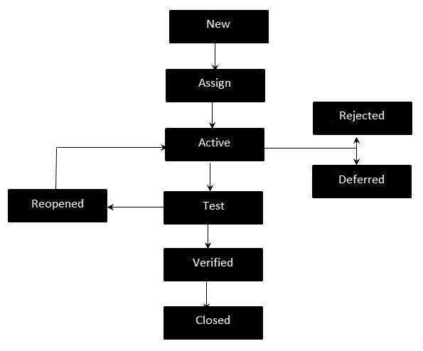

Defect Life Cycle States:
- New - Potential defect that is raised and yet to be validated.
- Assigned - Assigned against a development team to address it but not yet resolved.
- Active - The Defect is being addressed by the developer and investigation is under progress. At this stage there are two possible outcomes; viz - Deferred or Rejected.
- Test/Fixed - The Defect is fixed and ready for testing.
- Verified - The Defect that is retested and the test has been verified by QA.
- Closed - The final state of the defect that can be closed after the QA retesting or can be closed if the defect is duplicate or considered as NOT a defect.
- Reopened - When the defect is NOT fixed, QA reopens/reactivates the defect.
- Deferred - When a defect cannot be addressed in that particular cycle it is deferred to future release.
- Rejected - A defect can be rejected for any of the 3 reasons; viz - duplicate defect, NOT a Defect, Non Reproducible.

