Mỗi vị trí chứa cụm từ replace me tương ứng 01 hoặc NHIỀU hình ảnh, hãy thực hiện yêu cầu và dán 01/các ảnh chụp toàn màn hình kết quả đạt được và mô tả tóm tắt ý nghĩa dưới mỗi hình ảnh. Thay "(Thực hiện theo yêu cầu trên)" bằng lời giải thích cho hình chụp đó (thường là nghĩa tiếng việt dịch được theo yêu cầu tiếng anh), hoặc giải thích ngắn gọn hơn theo ý sinh viên, không giải thích -25% điểm câu đó
- Shell scripting basic (5 Points):
After VM successfully startup , login as user with GUI (Xfce Session) pre-configured. All shell script files created in the steps below must be in the same folder. This folder will be opened with the vscodium application.
  - Created new shell script ~/PlayWithShell.sh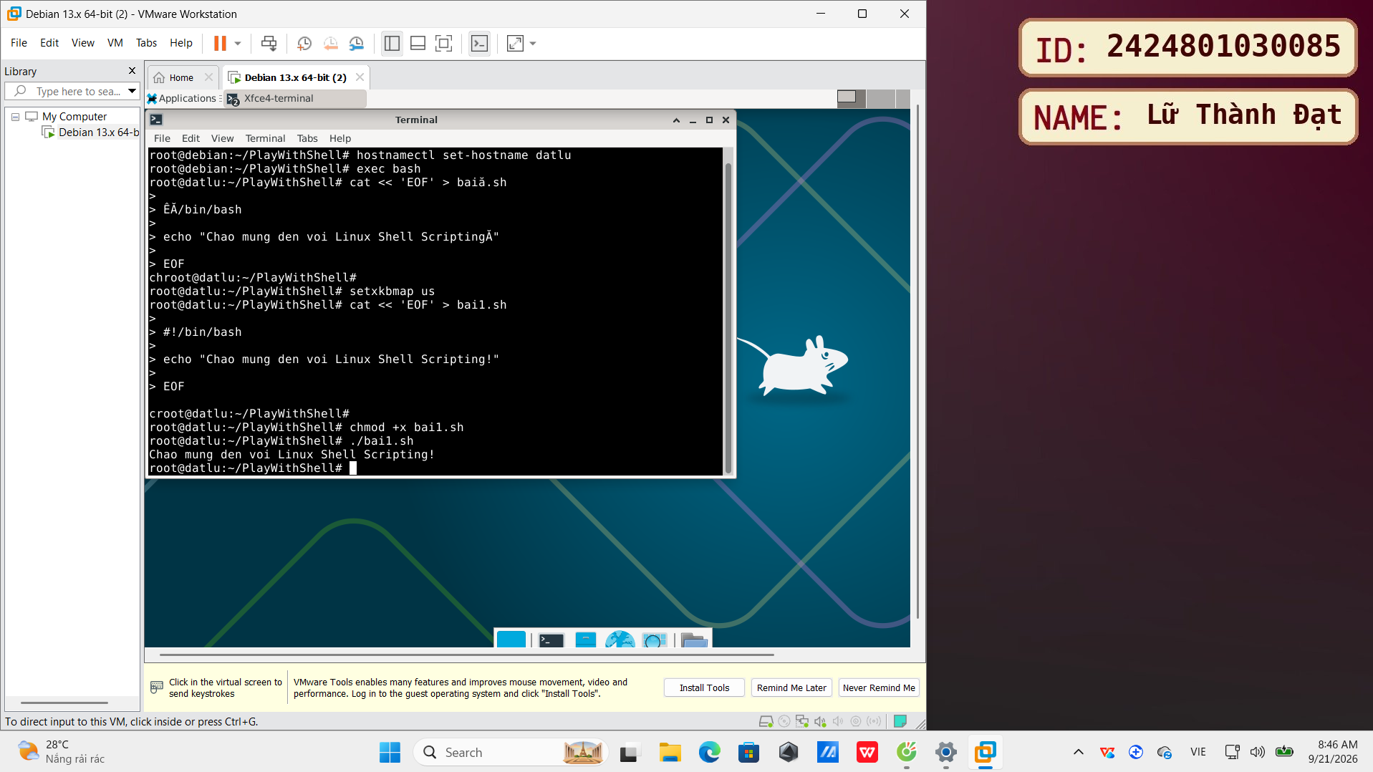

  - Write a simple shell script that prints the line "Chao mung den voi Linux Shell Scripting!" to the screen:
Note: Use the basic echo command to print a string of characters.
- replace me (màn hình sau khi thực hiện theo yêu cầu trên)
- 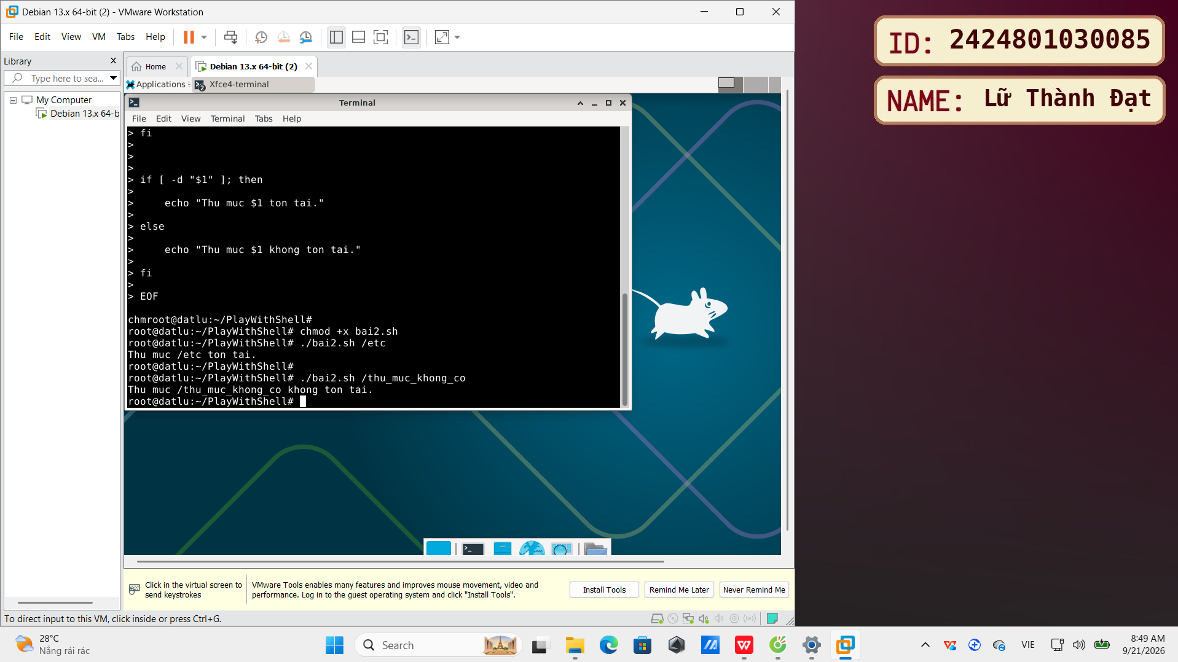
  - Create a shell script that takes a command-line parameter which is the name of a directory. This script will check if that directory exists. If it exists, the script will print "Thu muc [ten thu muc] ton tại.", otherwise print "Thư mục [ten thu muc] khong ton tai."
- replace me (màn hình sau khi thực hiện theo yêu cầu trên)
- 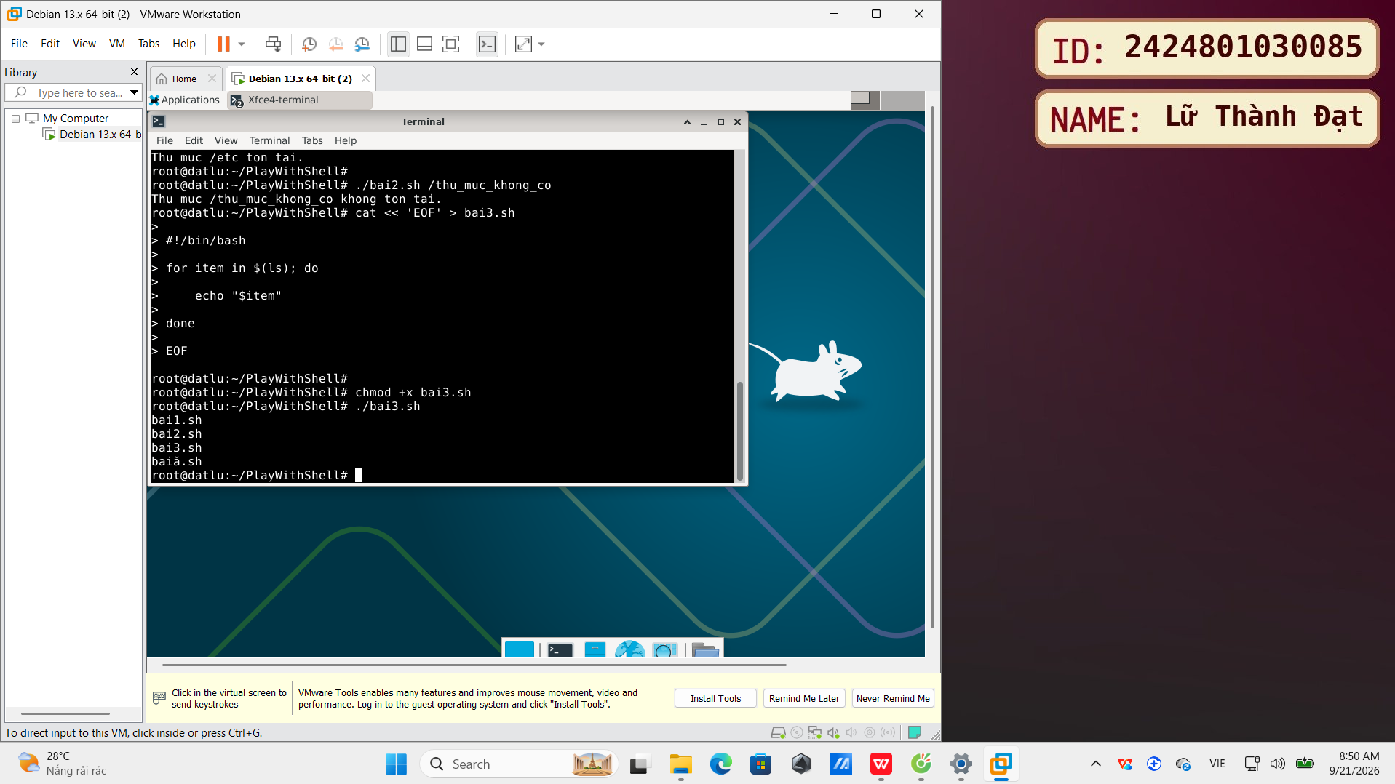
Note:
- Access command-line parameters ($1).
- Use the conditional statement if and the directory checking command (-d or test -d).
  - Write a shell script that lists all files and directories in the current directory, each item on a separate line.
- replace me (màn hình sau khi thực hiện theo yêu cầu trên)
- 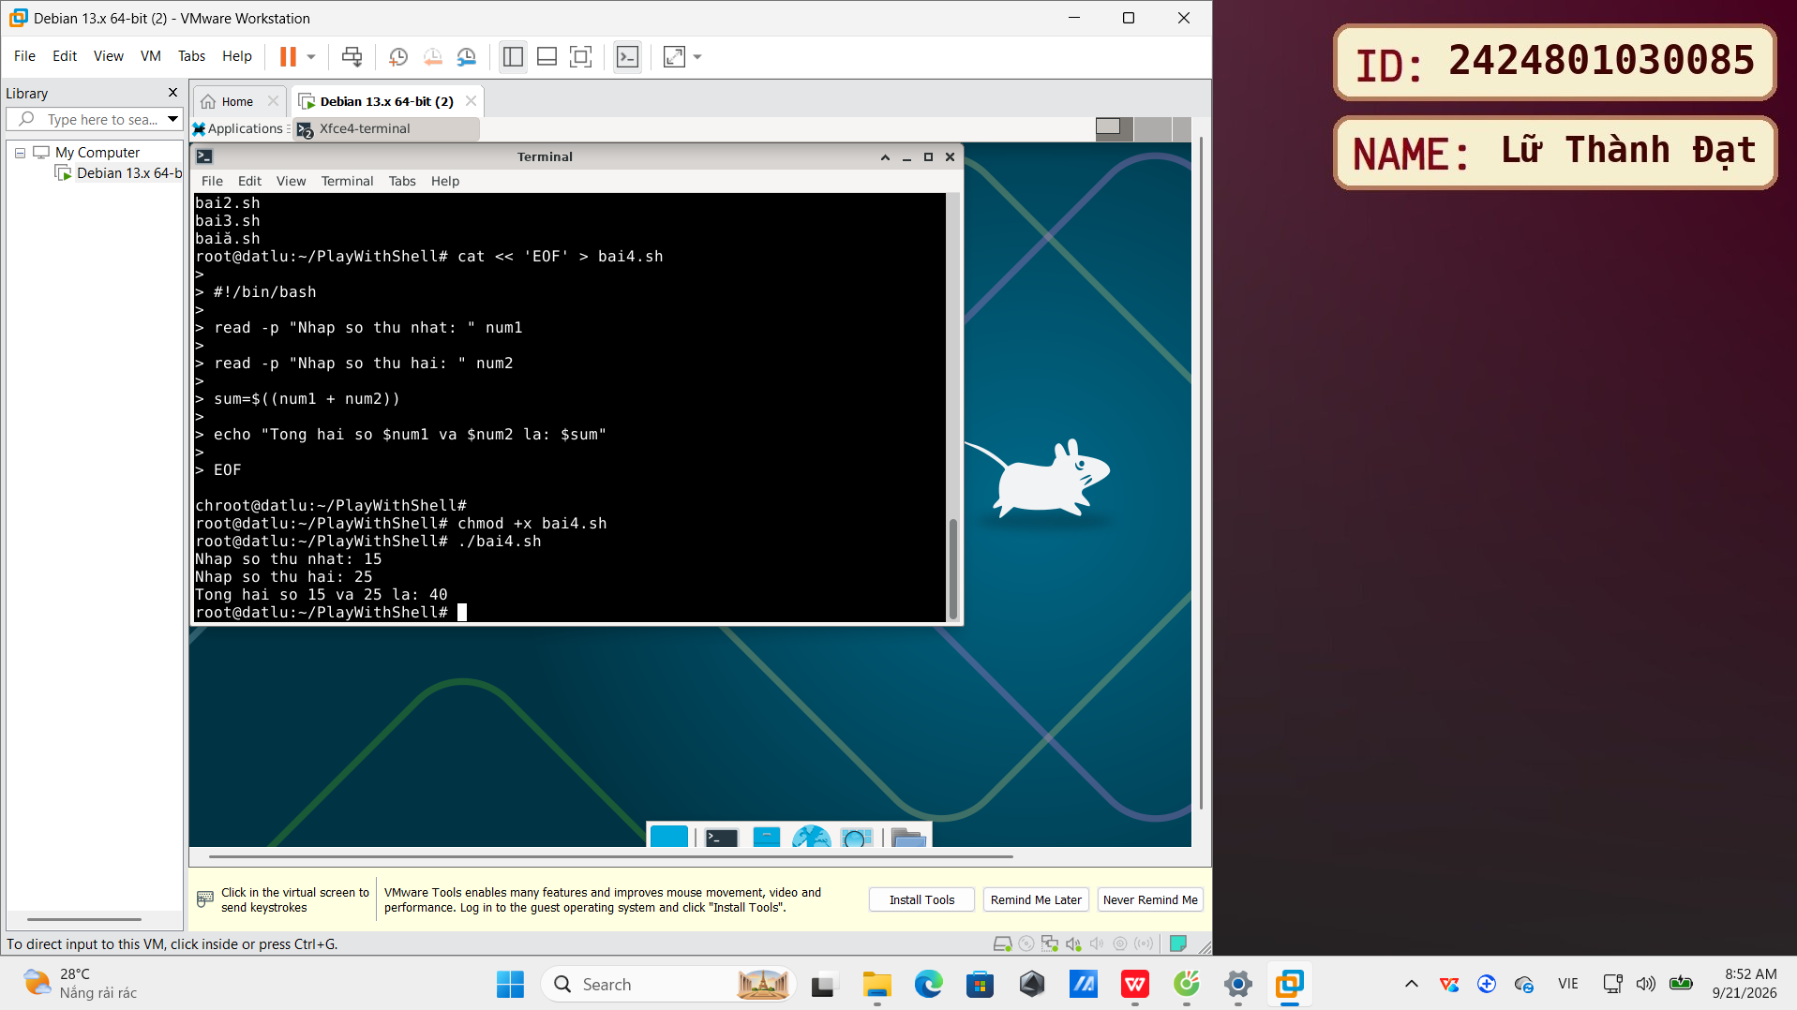
Note:
- Use the ls command.
- Use the for loop to process the output of the ls command. (Or you can use ls -1)
  - Write a shell script that calculates the sum of two integers entered by the user. Then print the sum result.
- replace me (màn hình sau khi thực hiện theo yêu cầu trên)
- 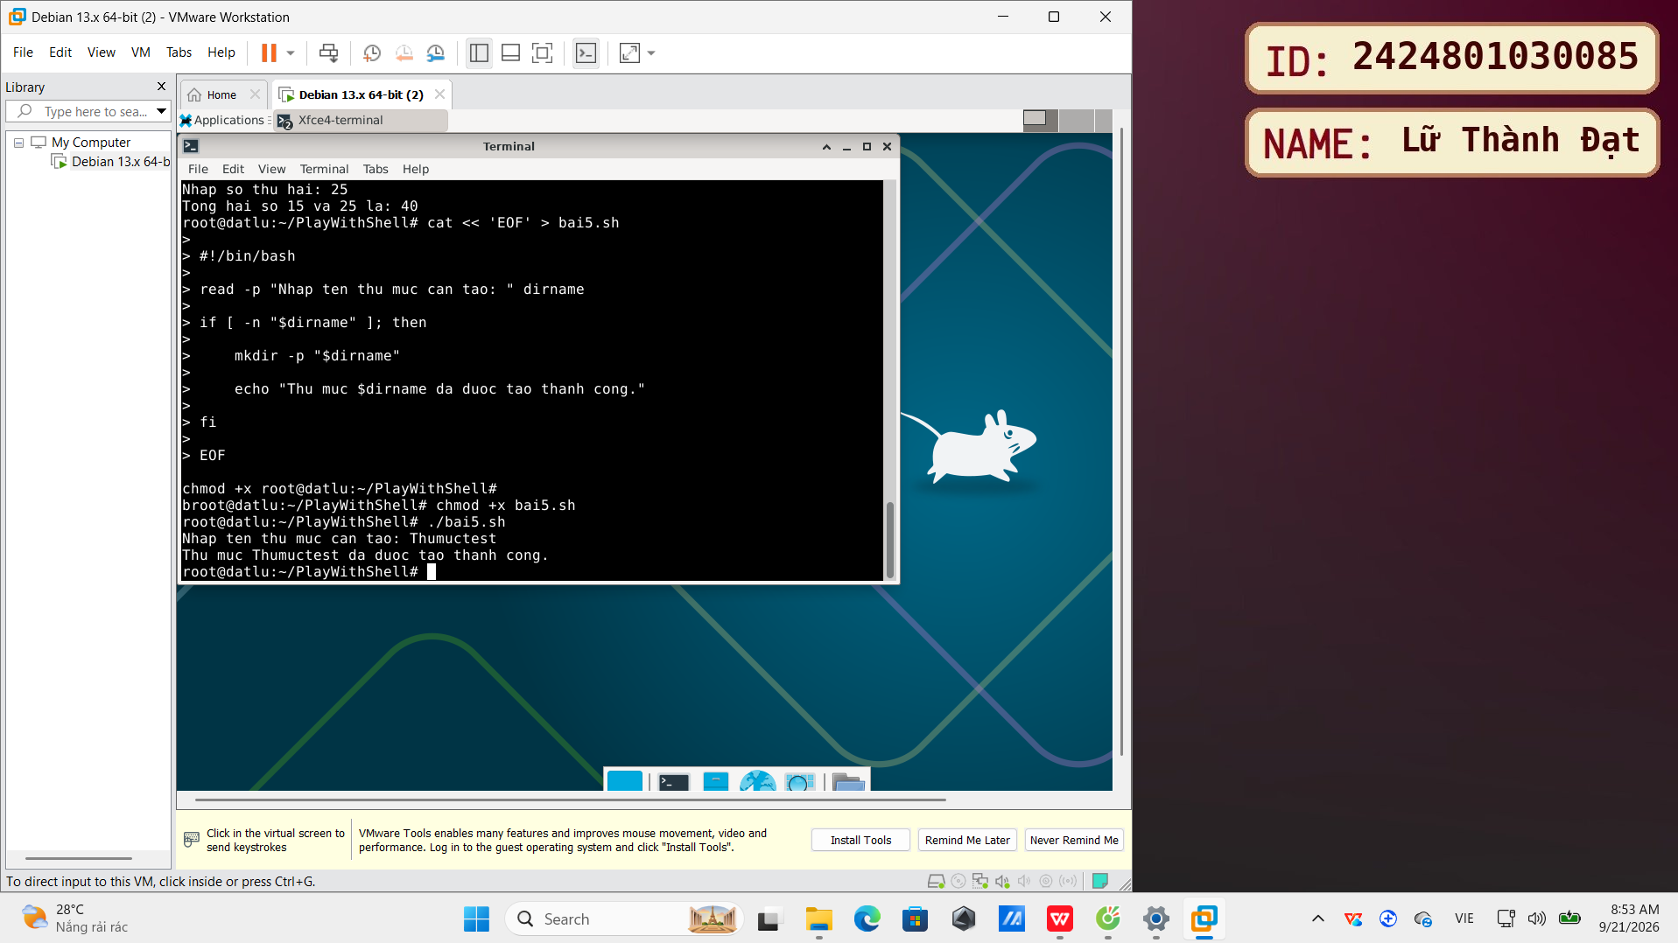
Note:
- Read user input using the read command.
- Perform arithmetic calculations in a shell script.
- Print the result to the screen.
  - Write a shell script that creates a new directory with a name entered by the user. After creating the directory, the script will print the message "Thu muc [Ten thu muc] da duoc tao thanh cong."
- replace me (màn hình sau khi thực hiện theo yêu cầu trên)
- 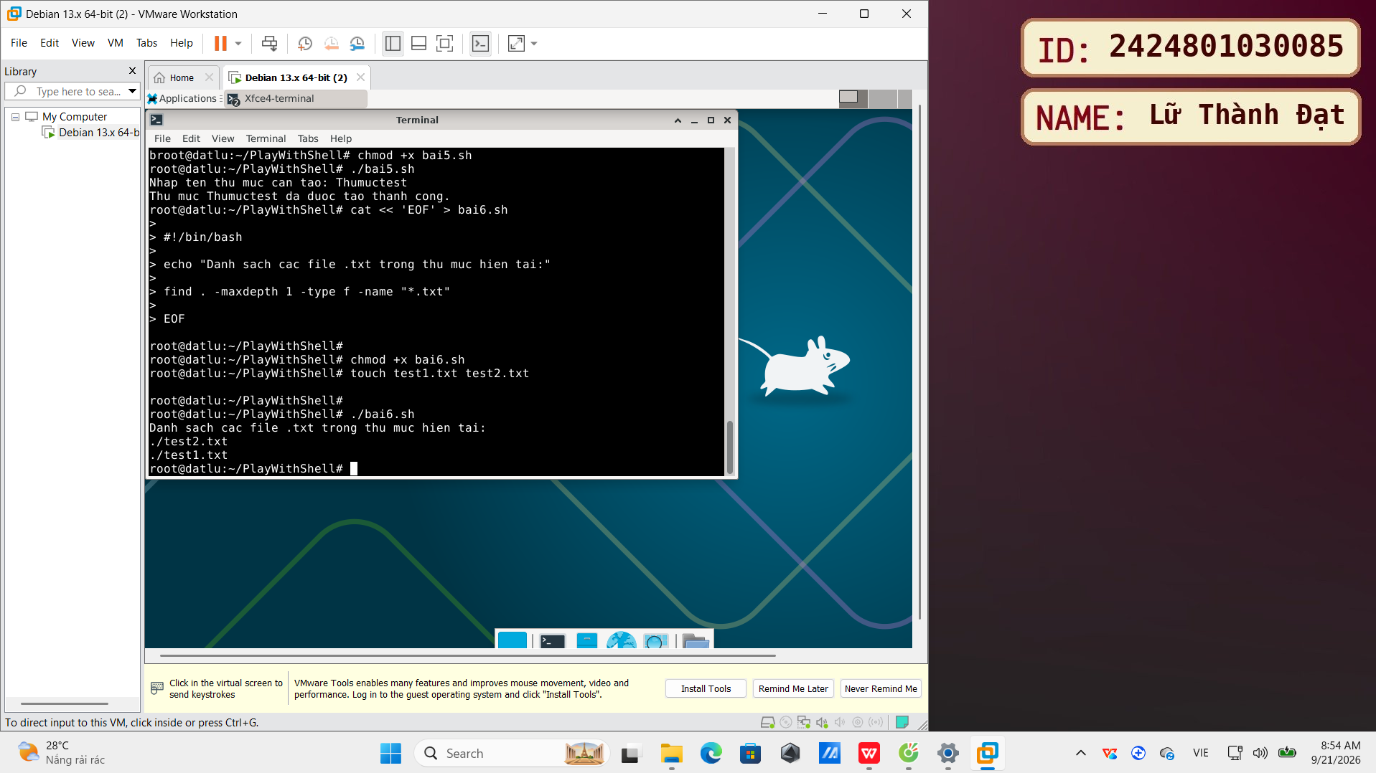
Note:
- Read user input using the read command.
- Use the mkdir command to create a directory.
- Print a success message.
  - Write a shell script that finds all files with the extension ".txt" in the current directory and prints their names.
- replace me (màn hình sau khi thực hiện theo yêu cầu trên)
- 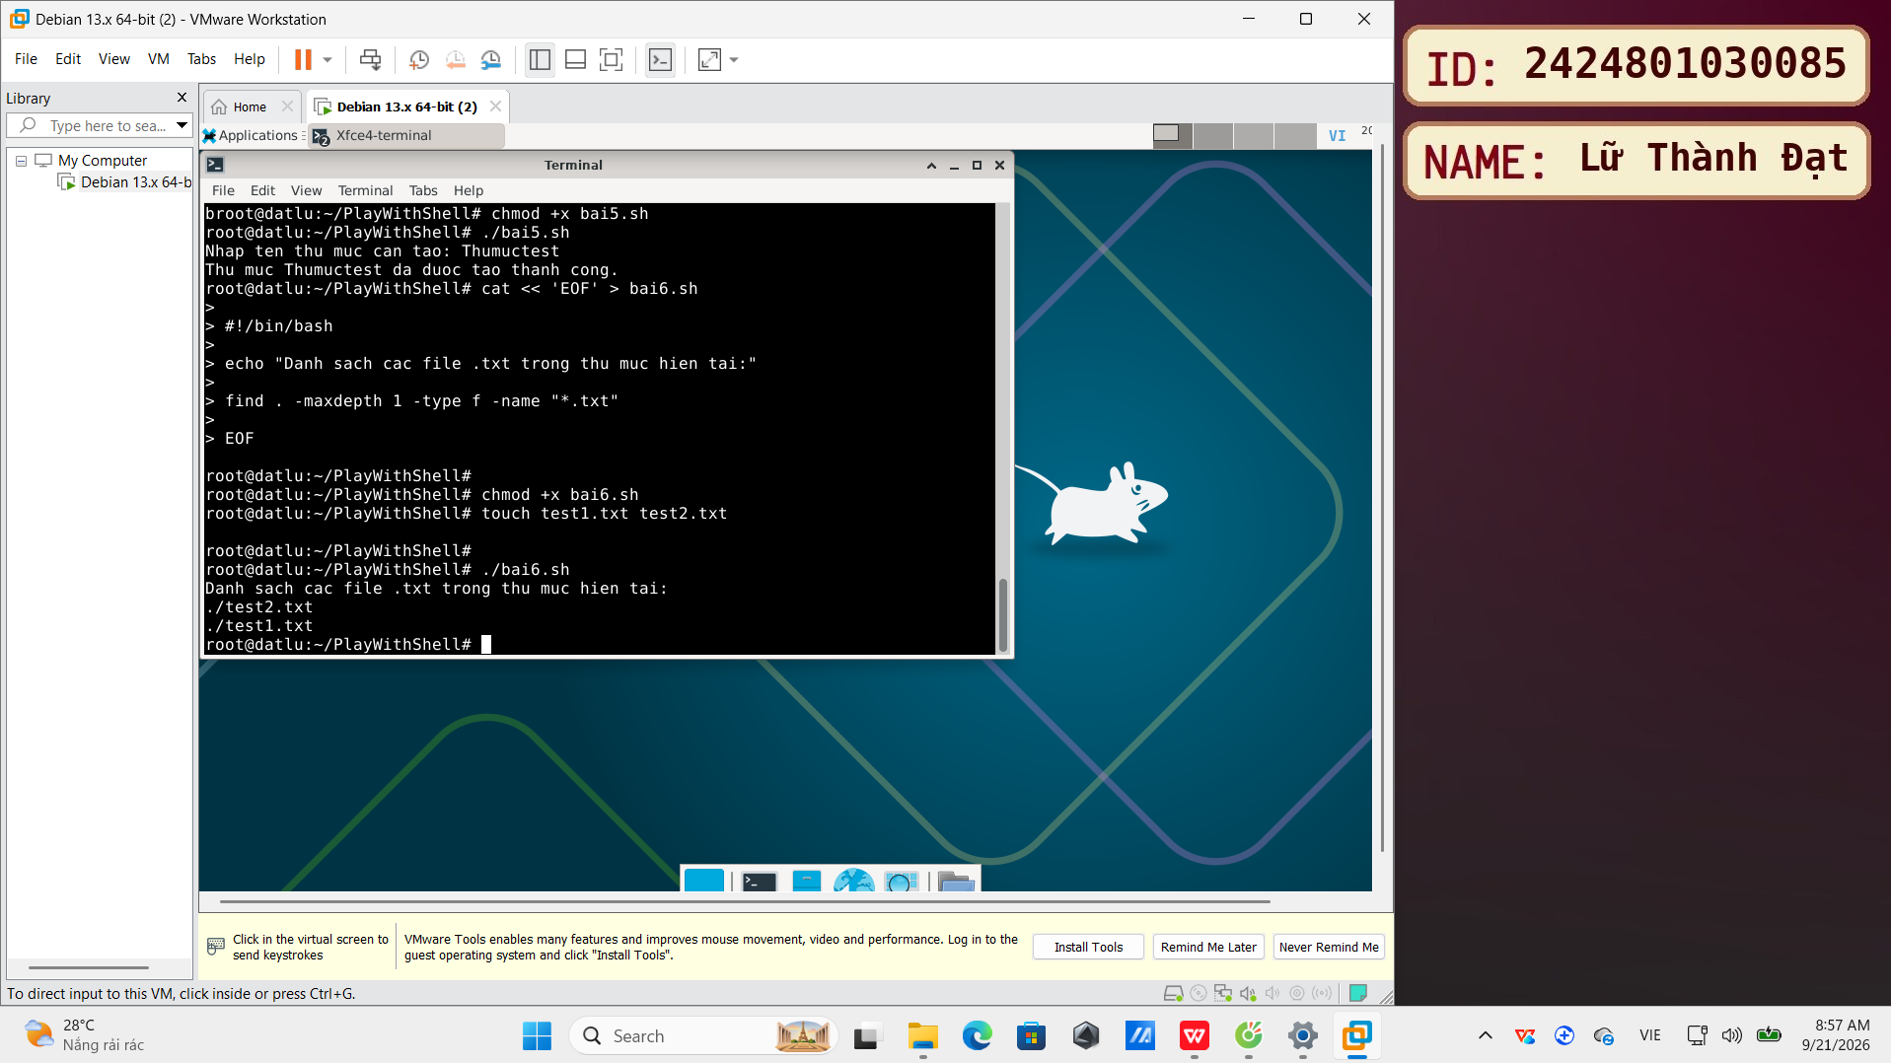
Note:
- Use the find command to search for files based on conditions.
- Use wildcards (* character) to specify the ".txt" extension.
- Shell scripting advanced (5 Point):
Login as root
  - Write a shell script that prints a title table to the screen with the text "BANG THONG KE" centered, bordered by the * character:
Tip: Packages to install: xorg, xinput, xbindkeys, xvkbd
- replace me (màn hình sau khi thực hiện theo yêu cầu trên)
- 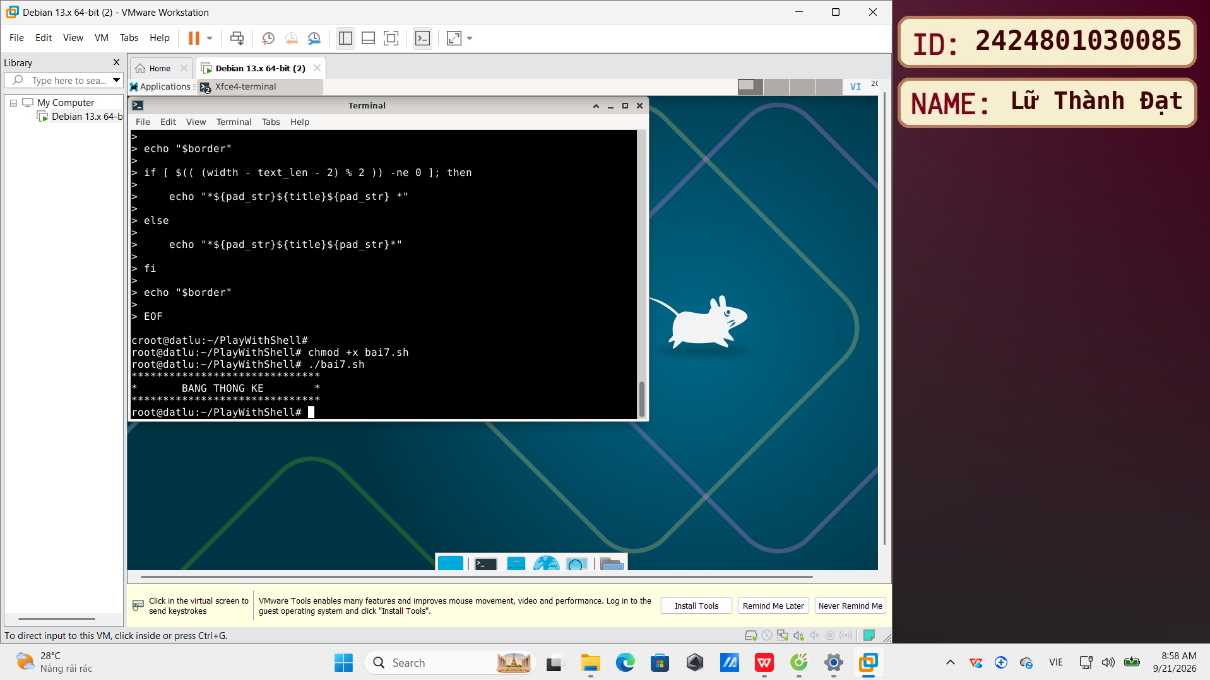
Note:
- Use the echo command to print special characters and newlines.
- Calculate string length and center content.
- Use loops (optional) to create borders.
  - Write a shell script that takes multiple command-line arguments as paths to files or directories. The script will check each argument: if it is a regular file, print the filename and size (in a human-readable format, e.g., KB, MB, GB); if it is a directory, print the directory name and the number of files inside; if it does not exist, print an error message "Path [path] does not exist."
- replace me (màn hình sau khi thực hiện theo yêu cầu trên)
- 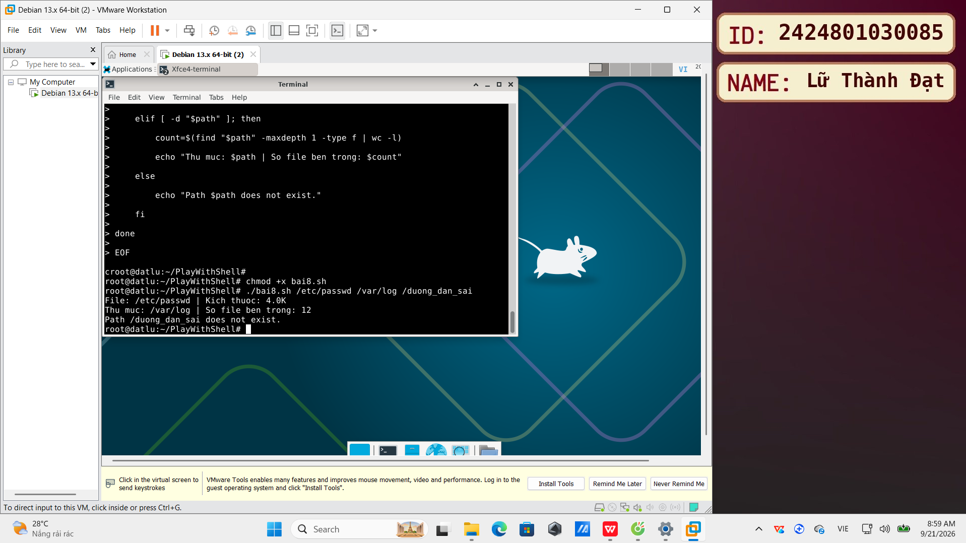
Note:
- Handle multiple command-line arguments ($1, $2, $3, ... or $@).
- Use a for loop to iterate through the arguments.
- Use file test commands (-f), directory test commands (-d), and existence test commands (-e or check the results of -f and -d).
- Use the du -h command or combine ls -l and awk to get human-readable file sizes.
- Use the find command or ls -l combined with wc -l to count the number of files in a directory.
- Handle errors and print error messages.
  - Write a shell script that lists files in the current directory, sorted by size from largest to smallest, and prints only the filename and size (in a human-readable format, e.g., KB, MB, GB).
- replace me (màn hình sau khi thực hiện theo yêu cầu trên)
- 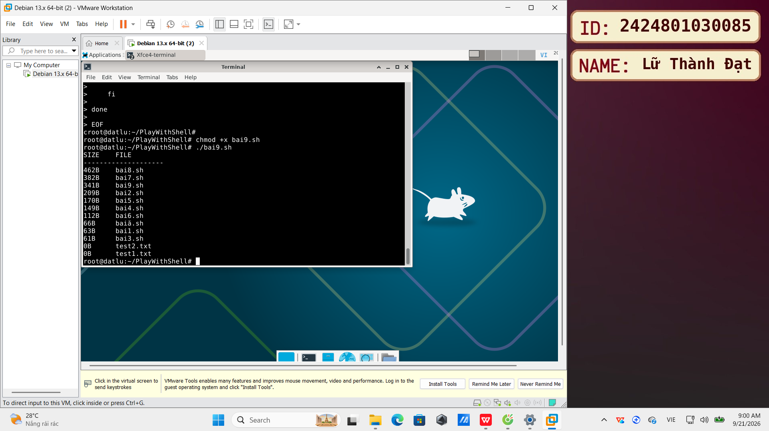
Note:
- Use the ls -l command to get detailed file information.
- Use awk to extract filename and size.
- Use the sort -k 5 -h -r command to sort by size (5th column), human-readable format, and reverse order.
- Combine commands using pipes (|).
  - Write a shell script that performs a simple command-line calculator. The script takes a mathematical expression (e.g., "2 + 3 * 4") as input and calculates it, then prints the result. It should handle basic arithmetic operations (+, -, *, /) and potential spaces in the expression.
- replace me (màn hình sau khi thực hiện theo yêu cầu trên)
- 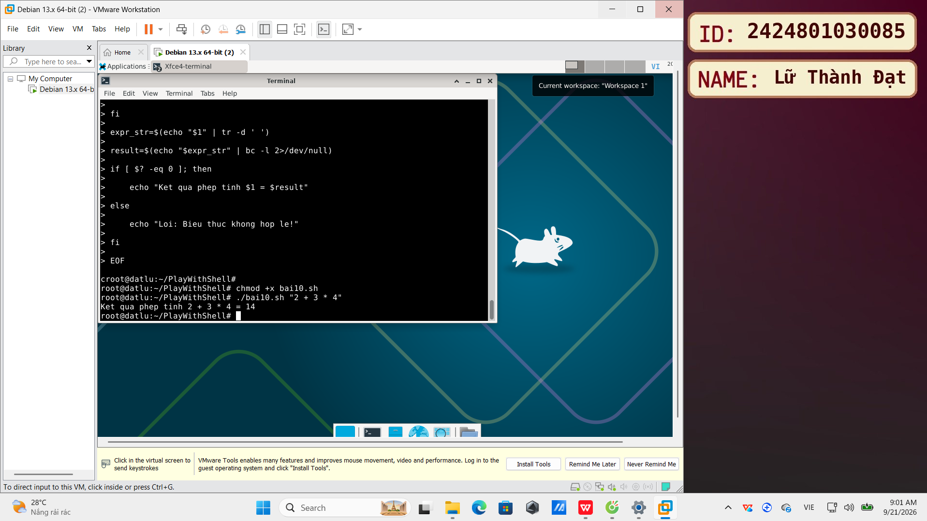
Note:
- Take a command-line argument as an expression string.
- Remove spaces from the string (if necessary).
- Use the expr or bc command to evaluate arithmetic expressions.
- Handle different arithmetic operations.
  - Write a shell script that creates a directory tree structure based on a configuration file. The configuration file (e.g., config.txt) contains a list of subdirectory paths, each path on a new line, relative to a root directory specified by the user (command-line argument).
- replace me (màn hình sau khi thực hiện theo yêu cầu trên)
- 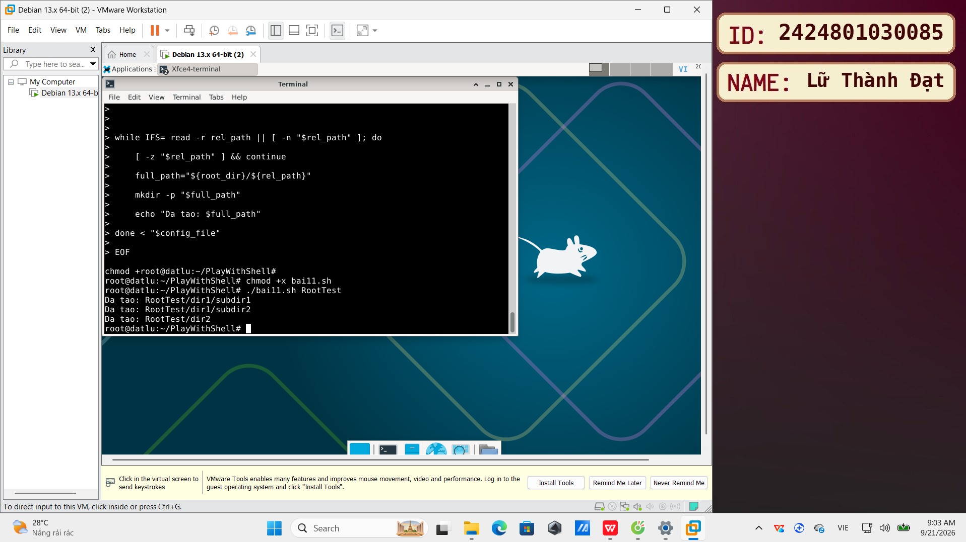
Note:
- Take a command-line argument as the root directory path.
- Read content from a configuration file line by line.
- Use a while or for loop to read each line in the file.
- Combine the root path and relative paths to create absolute paths.
- Use the mkdir -p command to create parent directories if needed.
- Handle errors if the configuration file does not exist or has an incorrect format.
  - Write a shell script that finds and replaces all occurrences of old_string with new_string in all .txt files within the current directory and its subdirectories. The user will provide old_string and new_string via command-line arguments. The script should print a list of modified files.
- replace me (màn hình sau khi thực hiện theo yêu cầu trên)
- 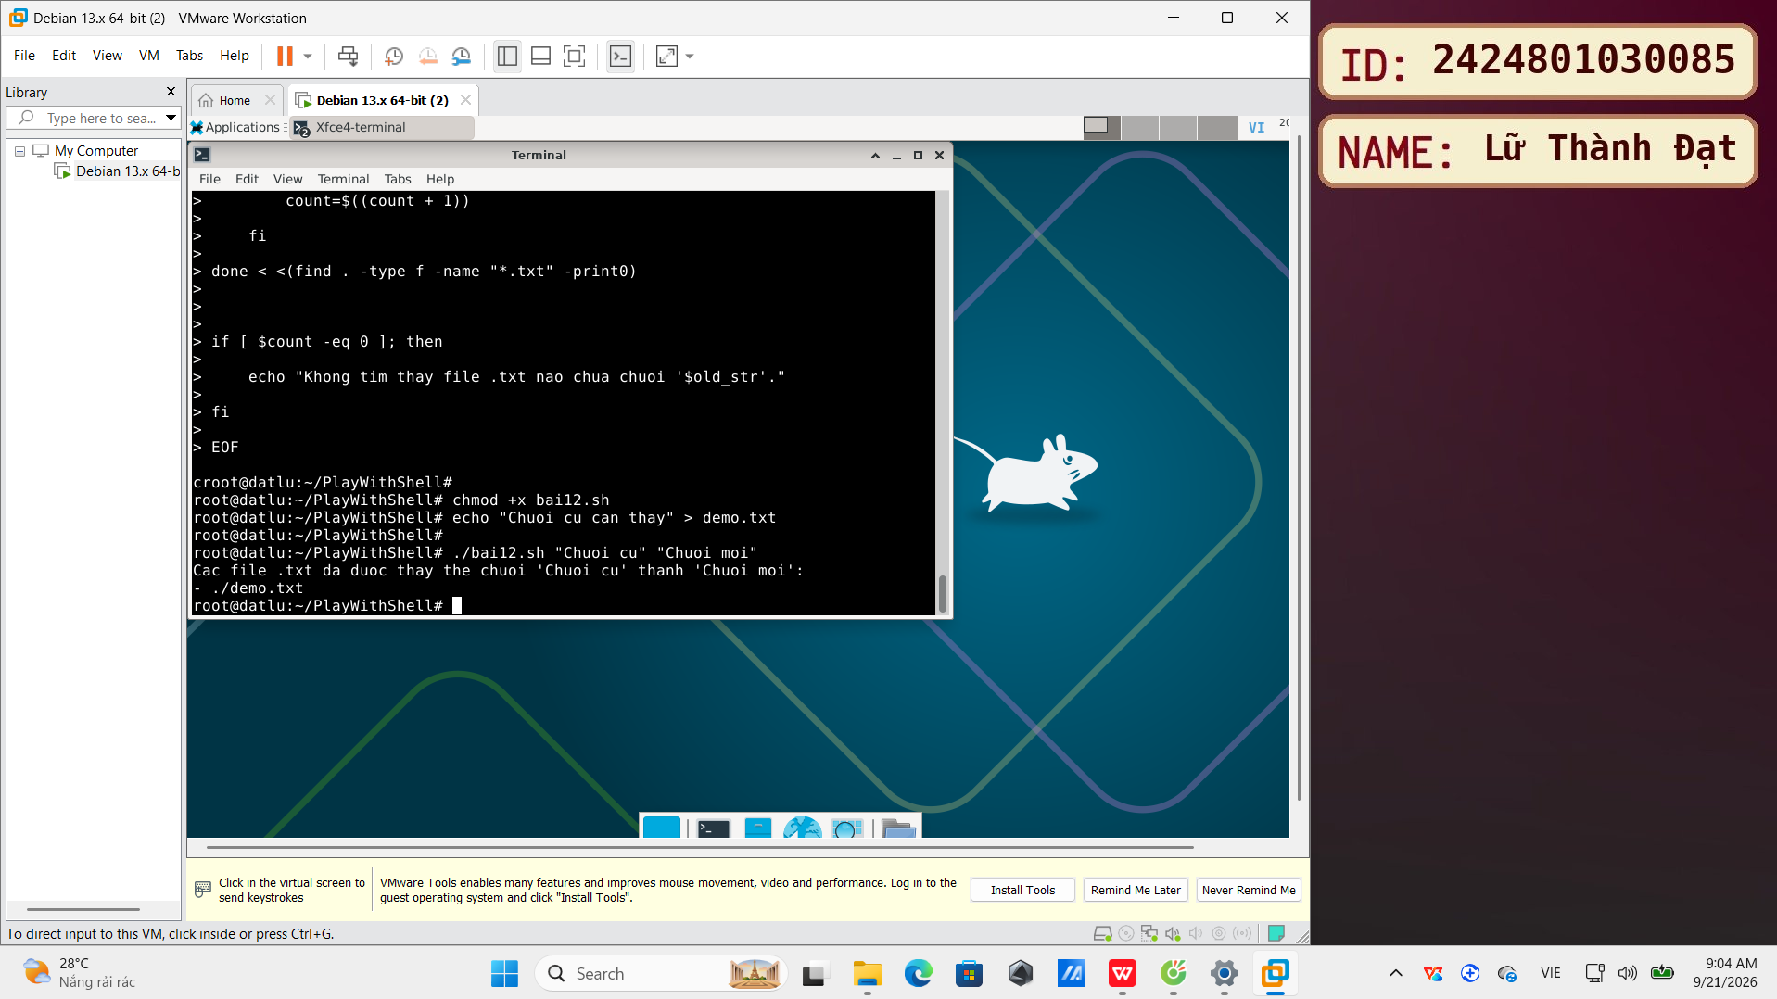
Note:
- Take two command-line arguments: old_string and new_string.
- Use the find command to find all .txt files in the current directory and subdirectories (-type f -name "*.txt").
- Use a while read or for loop to process the results of the find command.
- Use the sed -i 's/old_string/new_string/g' command to replace strings in a file (pay attention to escaping special characters in old_string and new_string if needed, or use sed more safely with variables).
- Print a list of modified files.
- Handle the case where no .txt files are found.

