**GAME DESIGN DOCUMENT**

2.5D Puzzle Platformer

Exit



**Last Updated:**

October 2020

**Prepared By:**

Luke Campbell

**TABLE OF CONTENTS**

Game Overview 3

Genre 3

Platforms 3

Target Audience 3

Storyline & Characters 3

Gameplay 4

Your Game’s Core 4

Design Pillars 4

Features: 4

Overview of Gameplay 4

Mechanics and rules 4

NPCs/Enemies 4

Game Objectives & Rewards 5

Controls and interfaces 5

Control Scheme 5

User Interface and H.U.D. Design 5

Level Design 5

Art Style: 6

Music/Sound: 6

Schedule & Tasks 7

# Game Overview

Exit is a puzzle platformer where you navigate 3d space from a 2d perspective. The player will orient themselves by switching between a side-on camera aligned with the x-axis and one aligned with the z-axis, revealing different information about routes through the level and where certain items and obstacles are positioned. The gameplay will be focused on discovery and problem solving creating the opportunity for eureka moments and the development of new skills to face problems of greater complexity as the game progresses.

## Genre

Puzzle  
Platformer

## Platforms

PC

## Target Audience

Puzzle gamers, small indie players.

## Storyline & Characters

Very little focus on the story is planned. You play the stick figure on the exit sign and need to escape/progress/exit each level to continue towards some ultimate goal. Maybe there’s a fire that fills up the previous level each time to give the feeling you are being chased?

|  |  |  |  |
| --- | --- | --- | --- |
| Character | Description | Characteristics | Misc. Info |
| Exiteer | Playable Character  Just a stick figure destined to try and find the exit. | Can walk, run, interact with objects, jump (?). Can’t perceive 3d space. |  |

# Gameplay

## Your Game’s Core

Exit the room.

## Design Pillars

Aha! - Orientation – Exploration

## Features

The camera will be from a side-on perspective as with 2d platformers but the level will be laid out on a 3d grid. The player will have the ability to realign the camera to be side-on to the z-axis, providing opportunities to design puzzles around navigating the 3d space using these two 2d perspectives.

## Overview of Gameplay

Similar games:

* Paper Mario
* A Link Between Worlds
* Portal 2D
* The Pedestrian

The game is a puzzle platformer based on navigation and lateral thinking. The platforming elements are second to the puzzle elements and serve mostly to implement the gameplay of navigating a level in search of an exit. The game has more in common with Portal 2D than Mario in that it is based around problem solving rather than skill-based movement.

The game will feature only a single player mode, where you can progress through the levels in order or replay levels you have already played.

## Mechanics and rules

The player controls the Exiteer with arrow keys/WASD to walk both ways and jump.  
The R key rotates the camera 90 degrees to align with the z axis/x axis.  
The spacebar will be used to interact with switches or keys highlighted when the PC is close enough in the level.  
The goal in each level is to get to the exit, and overall is to complete all the levels.

## NPCs/Enemies

No NPCs/enemies currently planned.

## Game Objectives & Rewards

Reward is more levels of greater complexity / the feeling of accomplishment from solving the puzzle  
Potential to add unlockable customization for the Exiteer if time allows it.

# Controls and interfaces

## Control Scheme

Game will support keyboard and gamepad.  
WASD/arrow keys for movement on keyboard with spacebar for interaction.  
Directional Pad for movement on gamepad with x/a/button1 for interaction.  
R/Right Bumper = Rotate camera 90 degrees  
Esc or P/start = Pause Menu

## User Interface and H.U.D. Design

The UI will be quite minimal, with a small bar at the top of the screen with control reminders and the rest of the information displayed through non-text means. The Exit which is the goal of each level will be a door with light spilling out of it and this light will also be used to highlight interactable objects in the level, moreso when the Exiteer is close enough to interact. Simple chimes will be used as sound cues for when you interact with an object and when you reach the Exit. 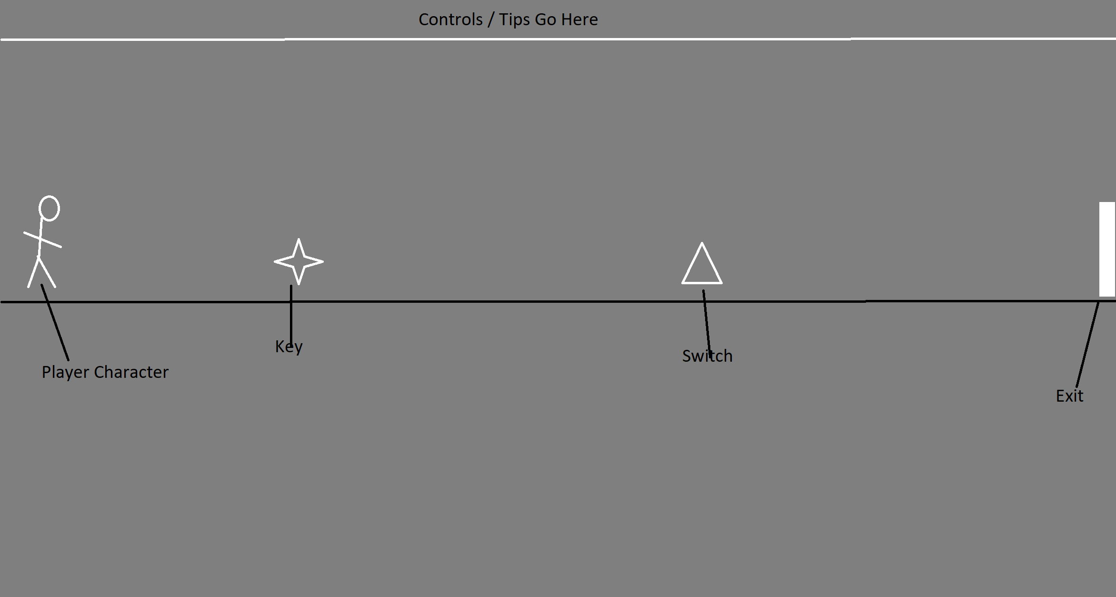

# Level Design

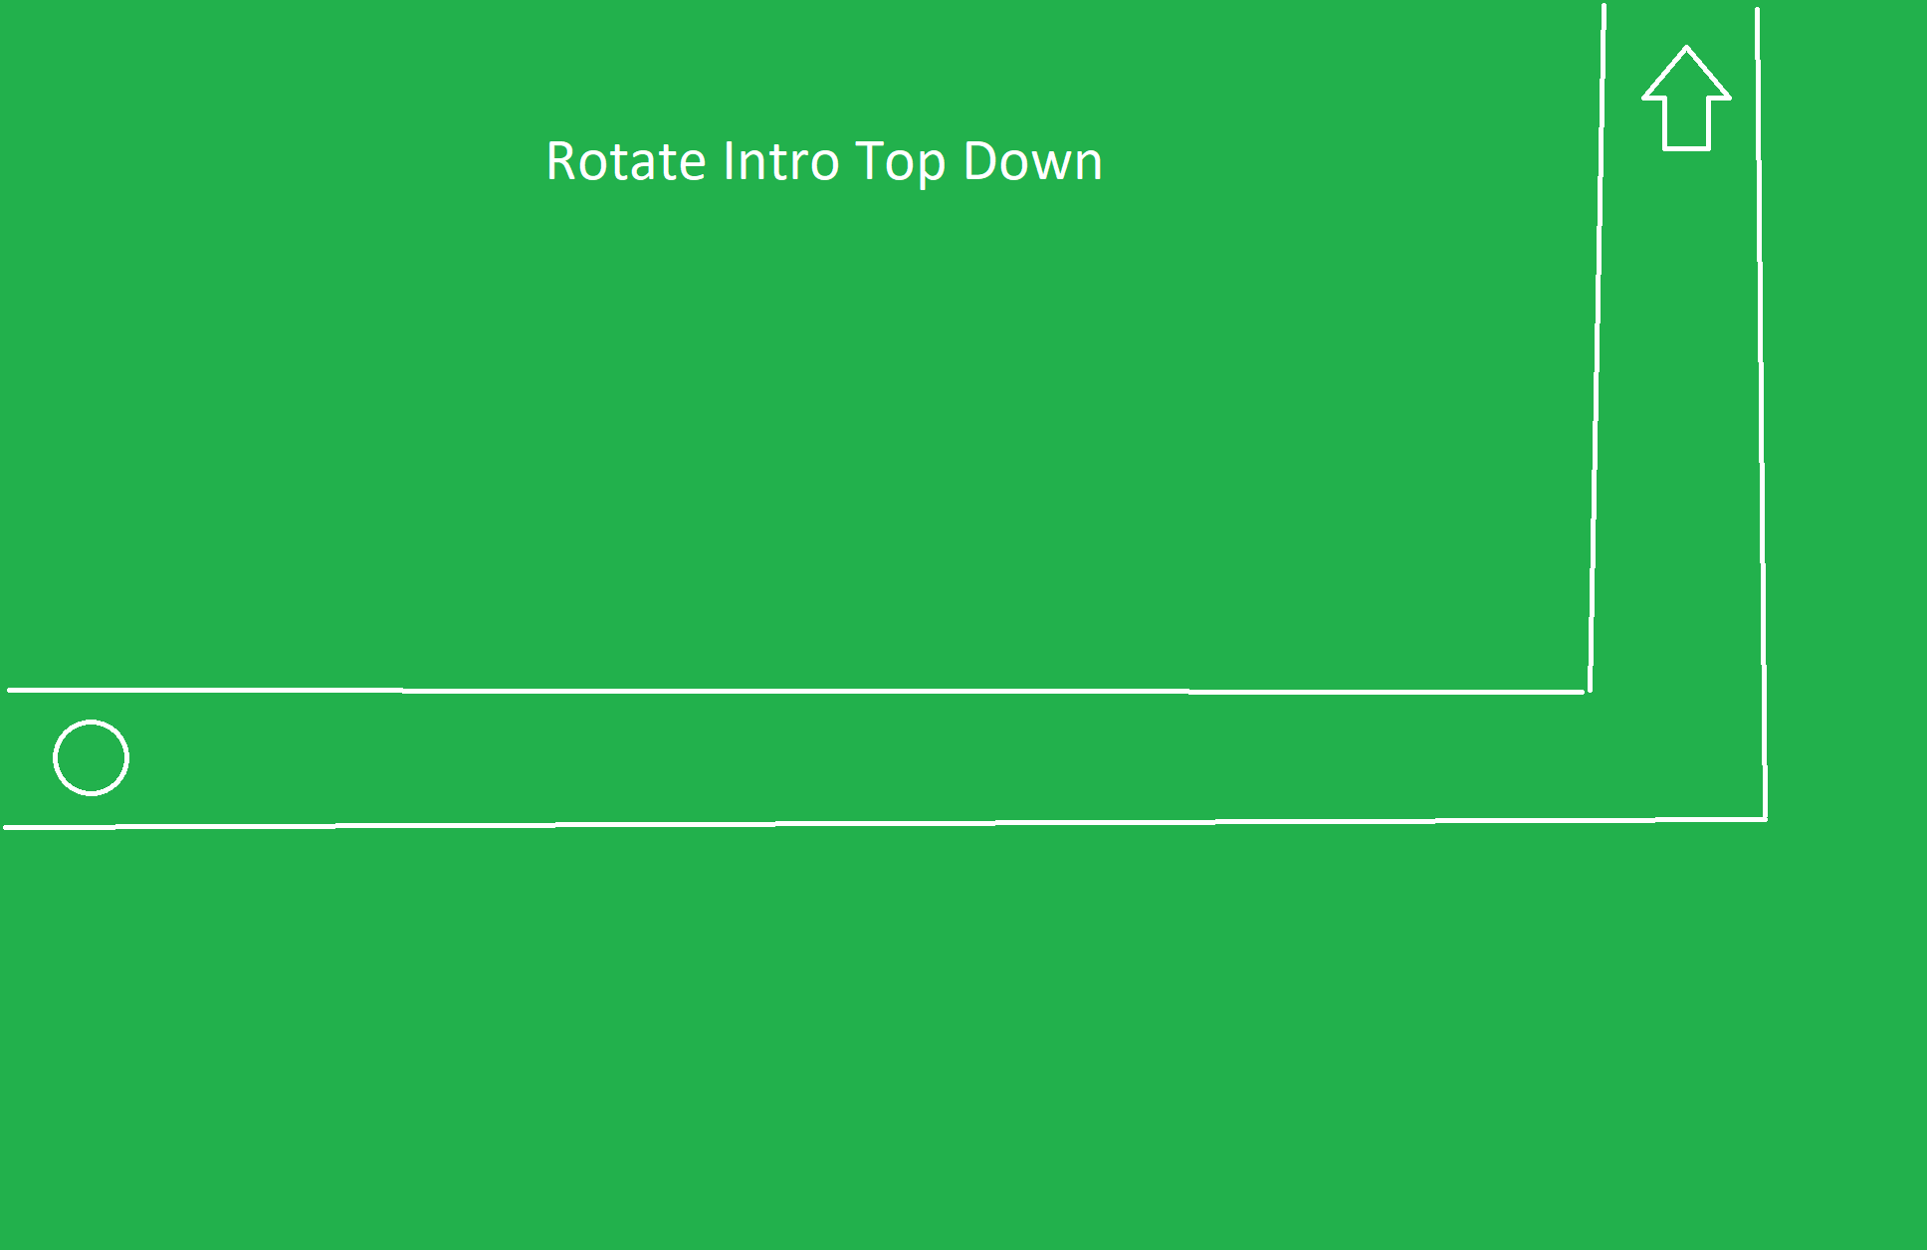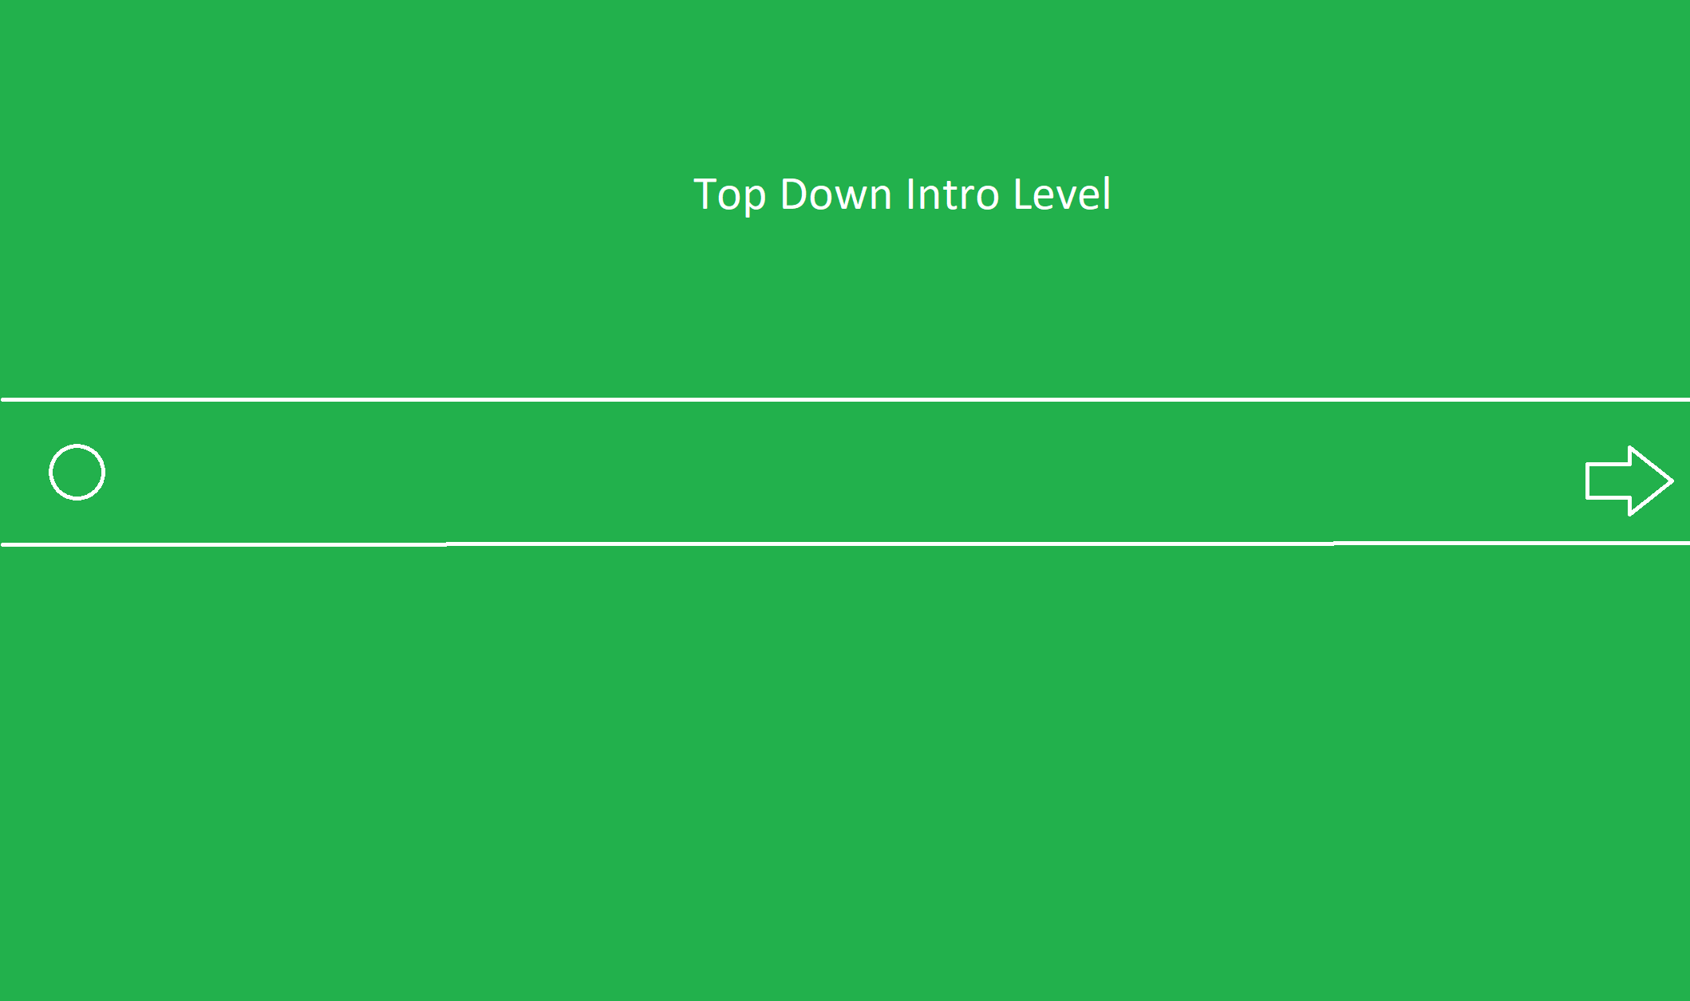

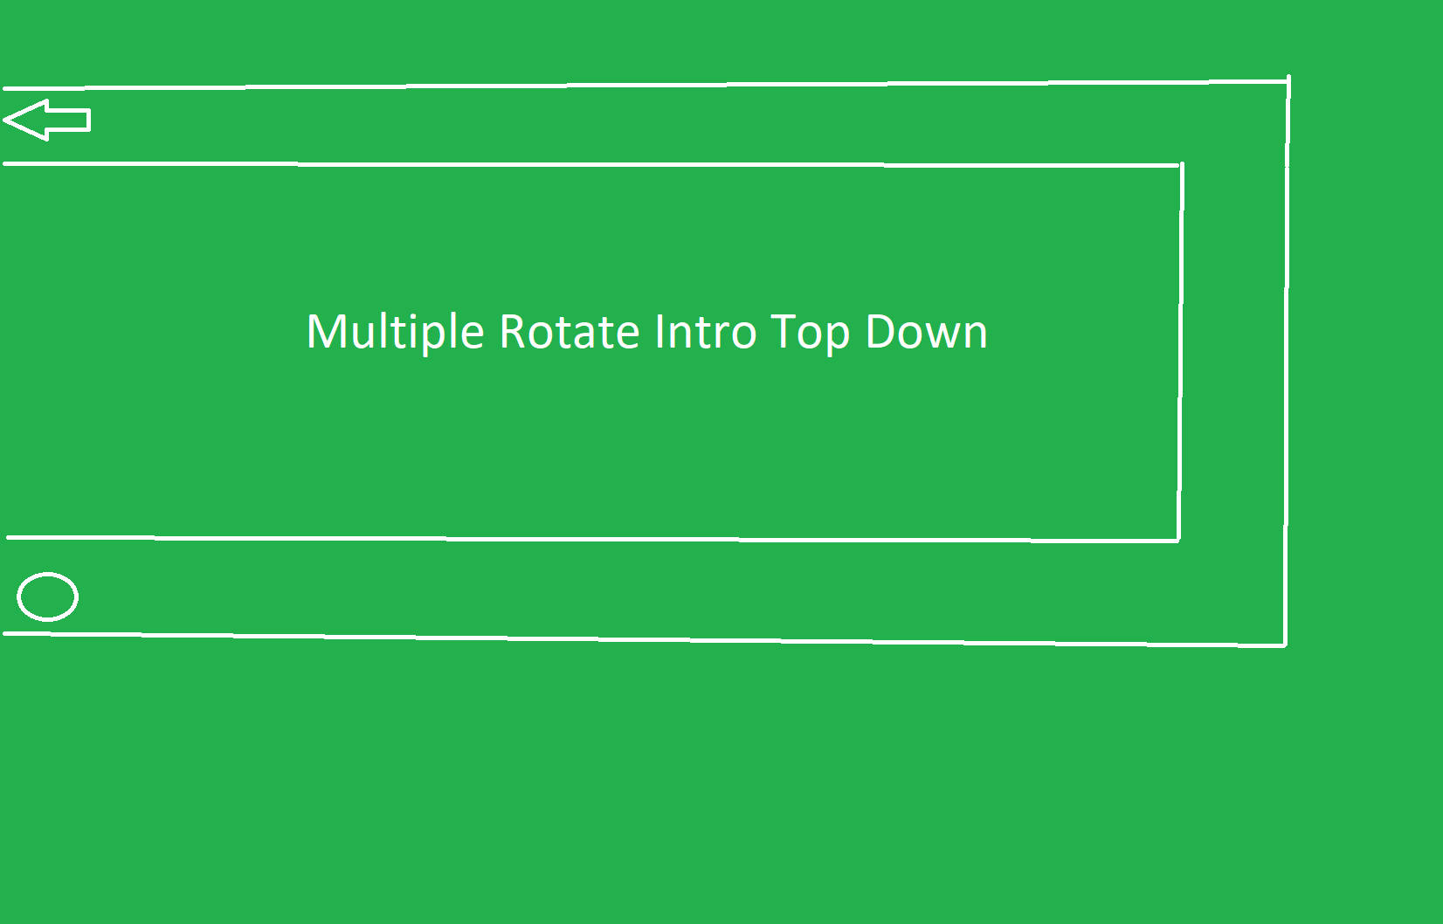

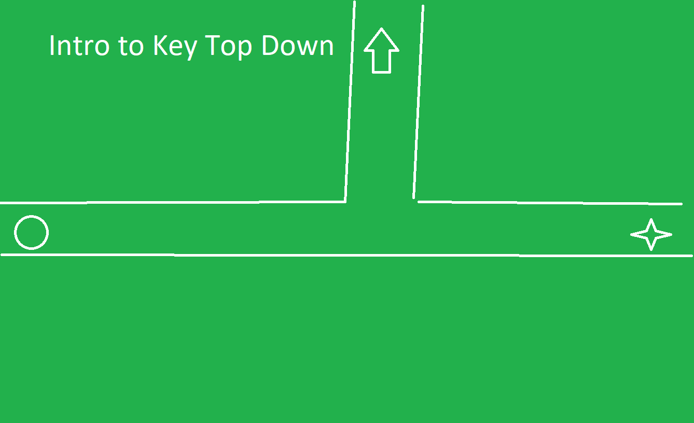

Above are top down diagrams of some introductory levels to teach the player about the goal of each room, the rotate mechanic and its simplest applications, and keys which can be needed to open doors. The top down perspective makes the levels easy to understand where the variable side-on perspective requires some orientation and experimentation. Later levels will incorporate vertical space and will be diagrammed Top Down and Side-On maintain readability.

# Art Style:

<https://store.steampowered.com/app/466630/The_Pedestrian/>

Very similar in concept to this but without the real word perspective, the game will be entirely inside of the Sign-World.

Simple Green/White colour palette and minimalist design principles.

# Music/Sound:

This kind of vibe but with less intense peaks <https://www.youtube.com/watch?v=TPqtl6HQBgE>

# Schedule & Tasks

List the tasks that need to be completed along with the basic timeline to complete them by. The task list can be as detailed as you like to fit your studio’s needs. The table below can be substituted for the excel file. This table is a great start but the tasks should be much more detailed.

|  |  |  |  |  |
| --- | --- | --- | --- | --- |
| **Tasks to Complete & Schedule** | | | | |
| **Tasks** | **Task Lead** | **Start** | **End** | **% Complete** |
| **Development Phase** | | | | |
| Design |  | 1/11/20 | 22/11/20 |  |
| Implementation of Core Mechanics |  | 15/11/20 | 12/20 |  |
| Level Construction |  | 22/11/20 | 1/20 |  |
|  |  |  |  |  |
|  |  |  |  |  |
|  |  |  |  |  |
|  |  |  |  |  |
|  |  |  |  |  |
|  |  |  |  |  |
|  |  |  |  |  |
|  |  |  |  |  |
|  |  |  |  |  |
|  |  |  |  |  |
| **Testing Phase** | | | | |
| Test Plan |  |  |  |  |
| Beta Testing |  |  |  |  |
| Milestone: QA Testing |  |  |  |  |
| **Deploying Phase** |  |  |  |  |
| "Go Live" Plans |  |  |  |  |
| Milestone: Ready for Usage |  |  |  |  |