Ketentuan Konten :

* About Me (sudah termasuk nama, nim, prodi, univ, hobi, cita-cita dan quotes)

Hello I’m Luthfiyya! Lets’s find out about me and my world! (Student, Copy-writing, Programmer)

My name is Luthfiyya Ayu Noor Chandra, a student of Information Technology Education at the Faculty of Computer Science, Universitas Brawijaya (NIM: 235150600111025). I am passionate about learning how technology can revolutionize education, and I am constantly seeking ways to integrate innovative teaching methods into the digital age. In my free time, I enjoy reading and writing stories, as these hobbies fuel my creativity and critical thinking. I believe in the power of words and knowledge, as Albert Einstein once said, \*"Imagination is more important than knowledge. For knowledge is limited, whereas imagination encircles the world."\*

* Foto Diri

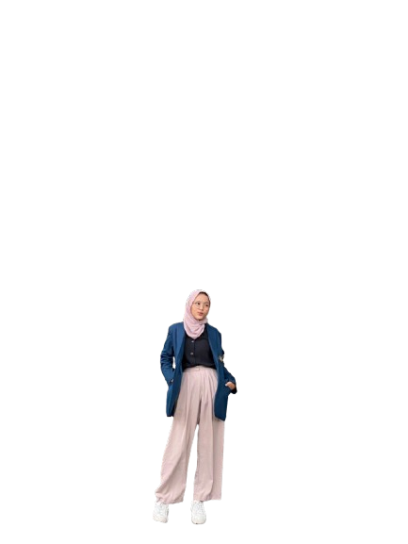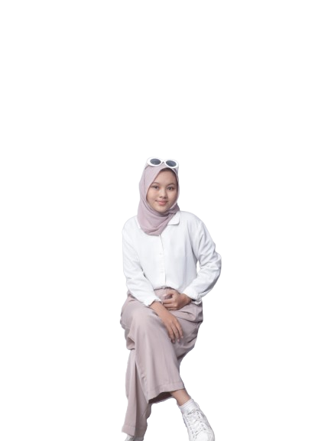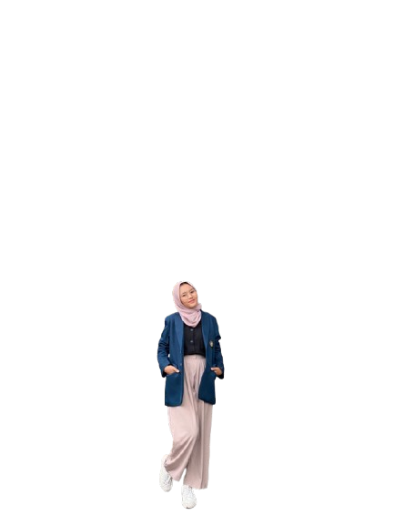

* Sosial Media

let's connect with me to create a project together or just chit chat about experiences.

Instagram:

Github:

Linkedin:

Email:

* Pengalaman Organisasi / Projek / Portofolio

1. Organisasi:
   1. Jurnalistik: Ketua
   2. Reporter: Ketua
   3. LPM Display: Staff Magang Editor
   4. LPM Display: Staff Ahli PSDM
   5. Nol Derjat Film: Staff Ahli PSDM
2. Kepanitiaan:
   1. Launching Majalah: Ketua Pelaksana
   2. BORN: Ketua Divisi Konsumsi Kesehatan
   3. Filkom Greeneration: Staff Acara
   4. Makrab PTI: Staff Acara
   5. C-Class 1 Nol Derajar Film: Staff Acara
   6. C-Class 2 Nol Derajat Film: Staff Humas
   7. C-Class 3 Nol Derajat Film: Ketua Divisi Konsumsi Kesehatan
3. Freelance:
   1. Naskah
   2. Buket
4. Lomba
   1. Finalis MYRES
   2. Peserta Terpilih Film Pendek
   3. News Anchor (AAMIIN)
5. Portofolio
   1. Film BORN: Better Left Unsaid: Director
   2. Film Freshman: Odd: Assistant Director
   3. Film Maarif: Perumahan Indah: Director – ScriptWriter
   4. Project Adios: Director – ScriptWriter

* Skill Sets (hard skill, soft skill)
  + Hard Skill
    - Copy-writing
    - Programming
    - Technical Writing
  + Soft Skill
    - Communication
    - Team-work
    - Time-management