Música puertorriqueña

I. HISTORIA
- By Columbus' arrival, the taíno were firmly established on Puerto Rico.
- Taíno instruments were the same as in Cuba.
- ~1510 — the taíno were forced into hard labor.
- By the early 1600s — taíno were no longer a distinct people. Small bands survived in indieras (— inaccessible hills).

- 19.9.1512 — a botswain Alfonso de Buenaño brought the 1st vihuela to Puerto Rico.
- 11.12.1516 — a passenger Juan Martín brought the 1st guitarra to Puerto Rico.
- 1520s–1530s — disastrous for Puerto Rico; the discovery of gold in Mexico, Peru, Venezuela lured settlers away, halving the Spanish population of Puerto Rico and isolating it from other colonies. For those who remained, life became austere, social events were limited.
- The Church sponsored the musical activities. African and Amerindian slaves organized informal musical activities (e.g., family parties).
- By the 1540s — Puerto Rico became commercially unimportant for Spain. Most of its merchandise (including musical instruments) was secondhand. → The absence of instruments created a preference for singing and crafting its own instruments.
- Until the XIX c. — Puerto Rico was not a virreinato or a capital of economic importance. → The origins of its music is not well-documented.

- It is logical to infer that the church was the cradle of Puerto Rican music.
- The richness of Puerto Rican musical culture derives largely from the adoption of many imported musics and turning them into something new and local, while nurturing Puerto Rico’s own musics. More than any other country, Puerto Rico embraced many Cuban genres and transformed them, giving them a boricua identity.
- Some genres can be regarded as counterparts to Cuban ones:
  - bomba — rumba;
  - música jíbara — punto;
  - danza — danzón.
- In the XIX c., Cuba’s sugar-plantation economy required lots of slaves. Puerto Rico’s main agricultural products were tobacco and coffee, neither of which required many slaves. →
  - Fewer Africans were brought to Puerto Rico; slaves never amounted to more than 12% of the population;
  - slavery was far less widespread and culturally significant than in Cuba and the U.S.;
  - neo-African music and religion are less prominent in Puerto Rico than in Cuba.
- 1873 — abolition of slavery.
- Hacendado — an agricultural landowner.
- Jíbaros — white, mulatto small farmers.
  - Until the 1930s — constituted the majority of the population.
- Since the 1920s — Puerto Rican music has been as much a product of NYC as of Puerto Rico.
- As American agribusiness (e.g., United Fruit Company) acquired most of the arable land, most hacendados were bankrupted, and the jíbaros were dispossessed. Deprived of livelihood, they migrated en masse to cities, especially San Juan, where they congregated in slums like La Perla. Urban population:
  - 1900: ~5%;
  - 1970: ~60%.
- Most Puerto Ricans lived in abject poverty until the 1940s.
- Since the 1940s — lots of jíbaros migrated to the U.S. in search of work.
- → Jíbaros and their lifestyle have nearly disappeared, although their music lives on.
- Música jíbara and bomba did not thrive as much on the mainland.
- The travails of migration are chronicled in plenas, seises, boleros (e.g., Rafael Hernández, Pedro Flores).
- Puerto Rican musicians and audiences came to dominate the NYC Latin music scene.
- By the late 1940s — the Latin dance music scene in NYC outstripped that in Puerto Rico.
- Late 1960s — Newyoricans began to recognize and affirm the uniqueness of their culture en masse.

- 1950s — the immigration of Dominicans along with their music.

- 1970s–1990s — the roquero–cocolo divide in Puerto Rico.
  - Roquero — a white, middle- / upper-class rock fan.
  - Cocolo (“coconut-head”) — a black / mulatto, working-class fan of música latina.

II. INSTRUMENTOS

Percusión

Bomba
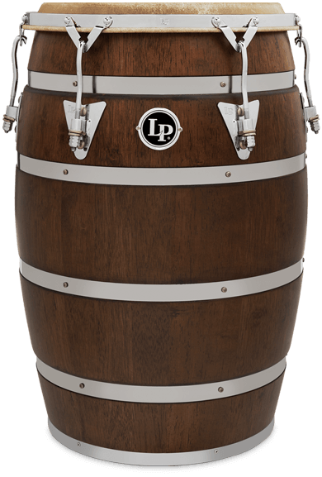
- Barríl de bomba = bomba larga = bomba — an open-ended, straight, barrel-shaped drum.
- A set of 2–3:
- buleador (“bulear” — “to drum”) = segundo = sonador — low;
- seguidora;
- requinto = subidor (“subir” — “to raise up”) = primo — high.

- Originally made from barrels for food and rum.
- Goatskin.
- Length 75 cm.
- Drumhead ø ~40 cm.
- Originally, the drumhead was fixed by 6 pegs.

- Folkloric. → Rarely tuned to a note.
- 1970s — Mr. Aquino, the lone drum builder at Loíza Aldea, discontinued making drums; → the drumheads were fixed by screws (as on commercial drums).

- Played seated, between knees, with hands only.

- Produces more overtones than tumbadora.

Pandereta
- Pandero = pandereta — a jingle-less tambourine.
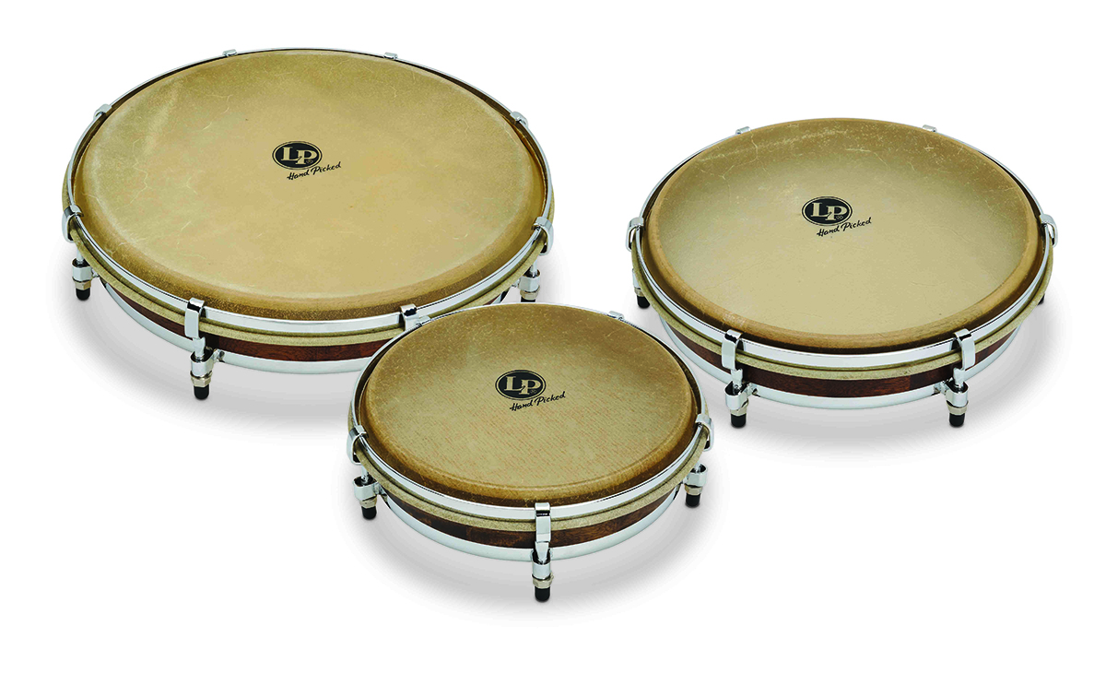
- A set of 2–3:
- seguidor — low;
- punteador = segundo — middle;
- requinto = quinto = primo — high.
- Probably derives from the Spanish pandero, as it is also tuneable and has no jingles.

Sonidos
- Abierto.
- Tip.
- Slap — a louder tip.

Cuás
- Cuás — 2 sticks striking a hollow bamboo log / small bottomless barrel / the skinless drum’s side / the buleador’s side lying horizontally.
- The same as catá cubana.

Güícharo
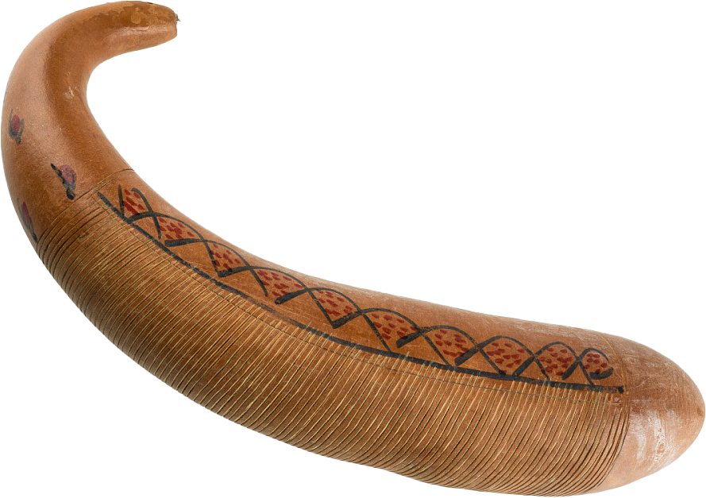
- Thinner grooves than güiro cubano.

Melódicos

Marímbula
- 1800–1880 — arrived with slaves.
- Early 1900s — dissipated. Only a few isolated builders and players remained.
- Since the 1950s — has not been a part of rural tradition.

Cordófonos
- Unknown when cordófonos were made. But it seems that the seis (emerged in the early 1600s) was always performed on these.
- Most are hourglass-shaped, with regional variations.
- Preferred wood:
  - guaraguao, jagüey, maga;
  - for soundboard: yagrumo — a light softwood.
- To avoid difficulty attaching the neck to the sound box, the entire instrument, except the soundboard, is carved from a single block of wood and sanded down to the appropriate dimensions and thickness.

Bordonúa
- Bordonúa (“bordón” — “bass”) — a bass guitar.
- Resembles late XVII-c. Spanish instruments with low-pitched, double-stringed courses including a thick string tuned an octave lower than its companion.
- 6 double courses:
  - G♯, C♯, F♯ — unisono;
  - B, e, a — octavas.
- Primarily plays bass rather than harmony.

Tres
- 3 triple-stringed courses: A, d, f♯.

Cuatro
- Most popular.
- Derived from the guitarra.

- Size — 90 cm:
  - body — 50 cm;
  - brazo (neck) — 20 cm;
  - pala = mano (pegbox) — 20 cm.
- Strings:
  - (originally) 4 doubled;
  - (now) 5 doubled: B₁, E, A, d, g (as the XVI-c. vihuelas, lutes).
- The 1st 2 courses are in unison.
The rest are in octaves.

Requinto
- A variant of tres; similar size.
- 3 strings: e₁, a₁, c♯₂.

Tiple
- Tiple (“treble”).
- Derives from the timple (— a single-coursed vihuela from Andalucía).

- Length 56 cm.
- 5 strings: A, e₁, B₁, G, B.

III. GÉNEROS

- Although bomba and plena are often mentioned together, they are quite distinct as they use different instrumentation, rhythms, lyrical structures and dance steps.
- The story of urban plena and bomba was in part a chronicle of the interaction of native Puerto Rican forms with imported Cuban genres, which Puerto Ricans have adopted as their own.
- Bomba, plena were important in the salsa development.

Bomba
- Bomba — a secular folkloric music and dance.
- Initially, “bomba” meant the drum and later came to denote the genre.

- Bombero — a player.
- Bombazo — a drum-dance community where all are invited to participate.

- Similarities to the rumba:
- contains several styles, each with its own rhythms for each percussion instrument;
- percussion + vocal;
- dance is integral.
- Common in salsa.

- Consists of 1-bar patterns. → Bomba is clave-neutral, but salsa arrangement requires clave-correctness.
- Modern bomba incorporates aspects of la clave cubana (structure, arrangement).

- Common montuno progression: I–V–V–I.

Historia
- Many slaves were bantú.
- Bomba emerged in the lowland plains where sugarcane was cultivated.
- Early 1700s — first written reports of bomba.
- 11.9.1797 — the first written record of African music (bomba) in Puerto Rico. → The tradition was then at least a few generations old, reasonably dating to 1700–1750.
- The people of Loíza Aldea say that their tradition of dancing and drumming the seis de bomba at the cathedral of San Juan dates to the 1600s as part of the original series of seises.
- Early 1800s — emergence.
- The bomba dance was slaves’ and free blacks’ most important social event performed on special dates, at the end of harvesting, private parties (weddings, birthdays, etc.).
- Served as an occasion for meetings and as a signal for rebellions.
- Bomba was allegedly used by slaves to distract their masters from impending revolts or escape breaks, and was performed immediately prior to several insurrections, → bomba was tightly regulated by the government and banned outright in certain municipalities.

- African drummers associated rhythmic patterns with the words they paralleled; the patterns were mnemonic devices for learning. It demised as African languages were forgotten.
- 1690s–1790s — the promise of freedom upon the arrival to Puerto Rico attracted slaves from around the Caribbean, resulting in musical acculturation.

- The Haitian Revolution made the French and their slaves settle on the southern coast of Puerto Rico. → In eastern, southern, western Puerto Rico, the drumming derives from the musique de maison of Haïti and Martinique, resembling the tumba francesa of Cuba.
- French Caribbean influence:
  - words of refrains from Ponce and Mayagüez,
  - some piquetes (— free dance moves) resemble counterparts in the gwoka of Guadeloupe.
- The Afro-Curaçaoan tambú, as brought to Puerto Rico by immigrants, may have been the source of the “holandés” rhythm.

- Bomba has been passed down through oral traditions of families (e.g., Cepedas of Santurce, Ayalas of Loíza).

- 1930s–1940s — Canario and César Concepción recorded a few bombas listing them as plenas and replacing barriles with tumbadoras.
- By the 1950s — bomba was in steep decline.
- 1950s–1980s — “folkloric” period of bomba.
- 1950s —
  - popularity;
  - adaptation to the conjunto cubano by Rafael Cortijo (the most commercially successful bomba interpreter) and Ismael Rivera;
    - barriles → tumbadoras;
  - emergence of ‘bomba de salón’ (ballroom bomba).
- Since the 1960s —
  - many drummers have an economic need to perform in salsa, merengue, guaguancó ensembles and mix bomba with these genres;
  - salseros (e.g. El Gran Combo) included bombas in their albums.
- Since the 1980s — bomba has become part of pan-Caribbean repertoires.
- Since the 1990s — “post-folkloric” period of bomba: bombazos replaced the stage performance. Now even in stage presentations the public expects audience participation.

Instrumentation
- Bombas.
  - A basic ensemble uses 2 bombas.
  - Professional ensembles use 3 bombas (2 buleadores, subidor).
  - Bombazos may use >3 bombas.
  - 2 bombas are usually at the center of an ensemble with rattles, responsorial singers, often other percussion.
- Cuás.
  - Traditionally, the learning of bomba began with the cuás.
- Maraca.
  - Large.
  - Played by the lead singer.

Música
- Elements:
  - instruments;
  - rhythms;
  - songs;
  - improvisations;
  - markings;
  - protocols / conventions.

Ritmos
- 3 rhythm complexes:
- sicá;
- holandés;
- yubá.
- Each bomba type relates to the buleo (— the buleador’s ostinato pattern).
- Rhythms vary with regions.
- Some songs are performed in various rhythms (e.g., in Mayagüez, some yubá songs may be performed in public in a more secular rhythm (e.g., guembé), but the vocal would remain in the original time signature).
- A rhythm may be switched in mid-song.

- Seis = son (in the south) — a rhythmic variation.
  - XXI c.: ≥16 seises survived.
- The seises refer to a:
  - a composition’s distinct metric (e.g., coro’s swing);
  - performance style:
    - whether piquetes are performed;
    - whether sticks are used;
    - when it is performed;
    - tempo.
- Cynyá, leró, yubá, sicá, grasimá, holandés, calindá are bombas brought to Puerto Rico. → “Bomba” is a generic name.

- In Loíza, bomba is fast.

Sicá
- Sicá (“an uprising”).
- The largest.
- 2/4, 4/4.
- The basic rhythm is the most familiar to salseros and is often called “bomba”.
Seises
- Paulé — the slowest.
- Sicá — de Santurce; the most popular.
- Gracimá (probably French “gracieusement”)— mid to mid-fast tempo.
- Danué.
- Calindá.
- Cunyá — de Santurce.
- Balancé — traditionally danced without piquetes; pure paseo with repiques; a slower substyle of güembé.
- Cocobalé — danced with sticks similar to Brazilian maculele.
- Bambulé — the fastest; a substyle of corrido.
- Cuembé = güembé (in the south) — de Ponce; the most popular after the sicá; mid to mid-fast tempo.
- Belén — the “last dance”, also played in honor of the deceased; the slowest of all bomba; southern.
- Seis corrido — in Loíza, the corresponding rhythm of belén; similar to güembé but very fast in the modern version developed by the Ayalas in the 1960s.

Holandés
- Holandés = holandé.
- 2/4, 4/4.
- The fastest and hardest to play.
- Most fully developed in Mayagüez. Frequent but with only one variant in Cataño, Santurce. Less common in the south (Ponce, Guayama, Arroyo). Unheard in Loíza.
- There are disagreements as to the number, names, meaning of variations.
- The dance imitates the slave master.

Yubá
- 6/8, 12/8.
- Performed with an extra seriousness, has the most “character”.
- The best dancers often jockey for position to dance the yubá, the highlight of most group repertoires.
Seises
- Leró (probably French “le rose” — the circle formation of dancers) — slowest; in Ponce, played seating atop of the laying drum.
- Yubá — de Guayama; faster.
  - Yubá corrido (“running yubá”) = leró at 2× tempo.
- Corvé = corbé = rul — fastest; in Loíza.
- Rul = roulé (from a song “roulé sondá”).

Singing
- Antiphonal singing mostly on a pentatonic scale. Sometimes with harmonizing.
- Voz — lead vocal: verses on a theme dictated by the coro.
  - In the south (Ponce, Guayama), usually sung by a woman. Elsewhere, by anyone.
- Coro — refrain by chorus.
  - Introduced by the lead singer.
  - The chorus is often short, percussive, chant-like.
  - The coro alternating with each verse is short, setting a mood rather than telling a story (as in plena).
- Voz starts with the improvised / known refrain (call) introducing the theme. The drums (in a bombazo context) are challenged to identify and play the rhythm of the lyrics’ metrica (— a characteristic swing).
- Drums and coro come in simultaneously.
- Next, voz often starts with a few well-known verses, then improvises lyrically and melodically around the theme and refrain.

- Rarely, a song may begin with a litany. Some variants (e.g. calindá) have short, suggestive, percussive, chant-like refrains. Others (e.g. cuembé) have longer and more flowing, lyrical, melodious refrains.

Lyrics
- Mostly in Spanish. Often with Afro-French Kreyòl and bantú phrases.
- The lyrical “call” focuses on common everyday themes emphasizing the singers’ dignity, self-respect, aspirations.
- Comedic put-downs and romance are occasional themes, but explicit sexual references and double entendres are absent.
- Lyrics cannot be easily interpreted, even by local experts. Many traditional songs (e.g. “Anaízo”, “Deloyé”) are recited without knowing their meanings and stories. To reconstruct the lost meanings of these songs would require multiple fluencies and an understanding of local and regional vernacular dialects, Afro-French kreyòl, Congolese.

- The lyrics are the most difficult part of bomba to learn in depth. A singer must:
  - have a wide song repertoire;
  - have a deep knowledge of the lyrics, their contexts and their meaning;
  - be able to improvise lyrically and melodically;
  - be able to time elocution in the heat of performance.
- Skilled vocalists are always in short supply.

Patrones

Traditional
- >40 patterns.

Bombas
- Buleador — buleo.
- Seguidora — ostinato.
- Subidor — improvises in West African style in conversation with the buleador; mimics, follows, sonically interprets the solo dancer.

- Accent beat 4.
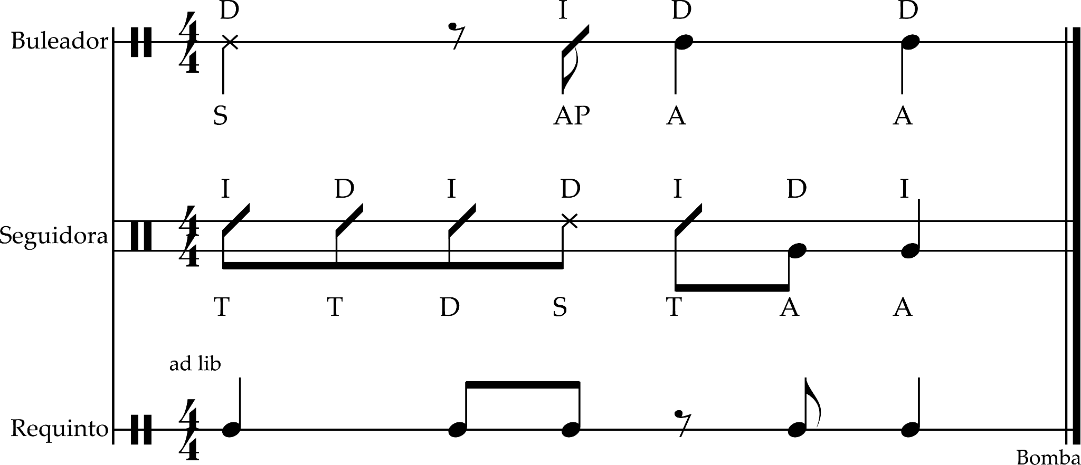

Cuás
- Ways of playing:
- duplicate the buleador’s pattern;
- mark the time subdivisions;
- (bomba sureña) patrones distintos al resto de los tambores.

- Cuá — the principal pattern holding together the bomba's rhythm (like the clave in la música cubana).

Maraca
- Keeps the pulse and tempo corresponding to each rhythm.

Güiro
- Initially, in Loíza, maraca’s sicá part was played by the güiro.

Adaptation for salsa

Tumbadoras
- Seguidora → salidor.
- Requinto → conga.

Claves, cencerro, bloque
- Cuá.

Piano
- 1-bar.
- Accents beat 4 every bar.
- No beat 1.
- Arpegio.
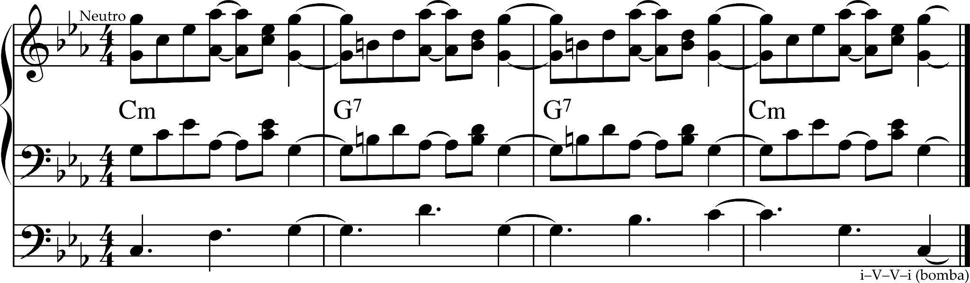

Dance
- Dance is the focus in live bomba.
- Consists of basic steps corresponding to the basic rhythms being played.

- Paseo — an initial ambulatory choreographic figure.
- Piquete — a dance step, move, pattern.
  - May vary a lot, but generally follow established conventions emphasizing grace and elegance rather than raw sexuality.
- Ponche — an abrupt, jerky move that initiates the rendering of other moves (piquetes) and the interaction with the drummer.
- Soberao — the ring of people around the dancer.

- The essence of the dance was reduced to a challenge between the repicador’s (1st drum) and dancer’s improvisations.
- Through the drum-dance dialogue, dancers perform as musicians.
- Dancers may approach the repicador individually / in pairs / in groups, and take turns challenging him to make beats corresponding to their movements.
- Repicador’s tasks:
  - play combinations that motivate dancers;
  - to “mark” the dancer’s movement = to read the dancing body and make sounds corresponding to particular movements.
- The best dancers know how to create exciting music on the drum.

- In Loíza Aldea and Guayama, the bomba is danced by men and women moving separately within a soberao. On one side of soberao are 2 barriles de bomba. The elders stand to the right of the drums / sit behind the drums. The 2nd drum begins a basic pattern, while the 1st is idle. The singer begins the song; the dancer approaches the drummers from the opposite side of the circle to get the 1st drummer's attention and challenge him, and begins the improvised dance consisting of steps, jumps, abrupt body movements, stamping of feet / heels, shoulder movements, whirls. Men prefer jumps with exaggerated foot and leg movements. Women prefer whirl and arm movements. The idea is that drummers should synchronize a beat to each dance movement. The improvisation is due to the lack of a drum language. It is unknown if a drum language was ever established.

Plena
- Plena — popular, urban, informal dance music (like calypso) performed at parties, street protests, processions.
- Puerto Rico’s foremost folk expression. Representative of the working class, particularly white peasantry.
- Versions:
  - informal;
  - dance-band.

Name
- An expression with the same name and similar poetic structure was reported in the República Dominicana around the 1890s, but no musical or choreographic relationship with plena puertorriqueña has been found so far.
- In Panama, plena refers to reggae.

Historia

Origin
- ~1900 — plena dance and music emerged as an offshoot of bomba in marginal urban and rural barrios of Ponce after immigrant workers from the British Caribbean introduced their music to local sugarcane laborers. First heard in the neighborhood Barriada de la Torre populated mostly by immigrants from St. Kitts, Tortola, St. Thomas.
- Plena was performed with pandero, guitarra, concertina.
- 1907 — singing was added.
- Catherine George, her husband, John Clark, and daughter, Carola, have arrived from Barbados with a pandero and songs, which they disseminated with the help of fellow immigrants from St. Kitts and Nevis.
- Their music was adopted by Joselino “Bumbún” Oppenheimer (1884–1929), a descendant of African slaves. During his plantation work, he improvised coplas (= quatrains — a stanza of 4 hexasyllabic lines) of joys and vicissitudes of his community, rehearsing them a capella in a song-and-refrain (mostly A–A / A–B) form: his coworkers sang the refrain (invariably the introductory melodic theme A) while guiding the ox and clearing the land ahead of Bumbún’s plowing. In the evenings, back home in La Joya del Castillo (Ponce's arrabal (= marginal neighborhood)), Bumbún introduced the new compositions to a growing number of fellow performers — pleneros. Bumbún created the first known plena group (pandero, güiro, concertina, vocal).
- ~1906 — popularity the south and southwest.
- 1918–1924 — peak of popularity throughout Puerto Rico.
  - Famous songs: “El temporal”, “Submarino alemán”, “Mamita, llego el obispo”, “Tanta vanidad”, “Juana Peña me llora”.
- Groups with panderos played to dancing couples. Initially, plena was played in ill-reputed parties of arrabales, with at least 1 conjunto de plena for each neighborhood.
- Plena is often compared with the tango that was emerging around the same time in similar marginalized working-class enclaves of Buenos Aires.
- Jíbaros, slave descendants, Anglo-Caribbean immigrants converged in Puerto Rico creating plena, which musically and poetically is similar to guaracha and some Dominican forms based on the copla.

1920s
- Years of U.S. colonialism, social turbulence in the 1910s–1920s, and the Great Depression caused unemployment and misery that compelled peasants to establish settlements in the swamps and mangroves of San Juan. Along with them, the plena disseminated through the main sugarcane centers. In San Juan, plena secured its place among the artisan groups of Puerta de Tierra (one of the oldest working-class barrios).
- ~1927 — musicians puertorriqueños moved en masse to NYC.
- 1927 — Canario y su Conjunto recorded the first plenas in a compromise with major American recording companies that required the subordination of the plena ensemble to a conjunto cubano format, and entailed plena’s first successful international exposure.
  - bongó, claves, trompeta, solo voice;
  - accompaniment: guitarra, acordeón.
- Manuel “Canario” Jiménez popularized the plena in the dance-band format and modernized (instrumentation, structure, etc.) the plena in the 1930s.

Elegant plena
- 1945–1949 — urbanization brought in a musical elegance akin to the urban American one.
- Late 1940s — Orquesta de Cesar Concepción created a big-band plena de salón: suppressed the pandero, acquiesced to soft percussion presented by a visiting Cuban orchestra.
- Introduction of standardized big-band arrangements and simple dance steps to local upper- and middle-class couples in major hotel ballrooms.

Traditional plena revival
- 1950s —
  - popularity;
  - bringing back to its original earthy character, revitalization, and adaptation to the conjunto cubano by Rafael Cortijo and Ismael Rivera.
- The musical conformism of Cesar Concepción was overwhelmed by the poor-neighborhood plena: as the agricultural economy declined and peasants settled in San Juan, conflicts between the rural (slave-related) past and the industrial present fueled barrio plenas with faster and satiric stories.
  - Rafael Cortijo y su Combo (big band + cubano + jíbaro):
    - impovised soneos by Ismael Rivera;
    - piano;
    - saxofón;
    - trompetas;
    - bajo / marímbula;
    - bongó;
    - timbales;
    - güiro.
  - After Cortijo, plena became closely tied to the bomba.
- 1970s — Los Pleneros del Quinto Olivo:
  - a salsa-like format;
  - reintroduced pandero, applying tumbadora techniques to the 3-pandero set;
  - replaced the antiphonal coro–pregón with the leading role of the coro along the entire piece.

Instrumentation
- The definitive characteristic of the genre is the percusión. Aside from the panderetas, whatever instruments are available are used, or none at all.

- Initial: tambourine, guitarra.
- 1920s: + double-keyboard accordion, güícharo (from rural ensembles).

- Panderos:
- seguidor — pulse; constant;
- punteador — plena pattern; constant;
- requinto — improvisation.
- Güícharo = güiro.
- Acordeón.

- Easily adapted to any ensemble.

Música
- 4/4.
- Since Bumbún, the plena has maintained (retained by Canario):
  - a combination of pan-Caribbean danceable rhythms;
  - simple melody and harmony;
  - mixed choruses of men and women;
  - alternating verse–chorus structure (as opposed to the son’s tema–montuno);
  - topical texts in Spanish poetic forms with strong social / historical content and comments on current events.
- Modern plena incorporates aspects of la clave cubana (structure, arrangement).
- The emphasis on beat 4 makes plena similar to some versions of Trinitarian quadrilles, calypso, mento (Jamaica). Related near-improvisatory rhythms are registered in early XX-c. recordings of danzas in Ponce.
- Common montuno progression: I–V–V–I.
- Text: anything.

Patrones

Adaptation for salsa
- The essential melody between the low and high panderetas can be played by the 2 tumbadoras / timbales.
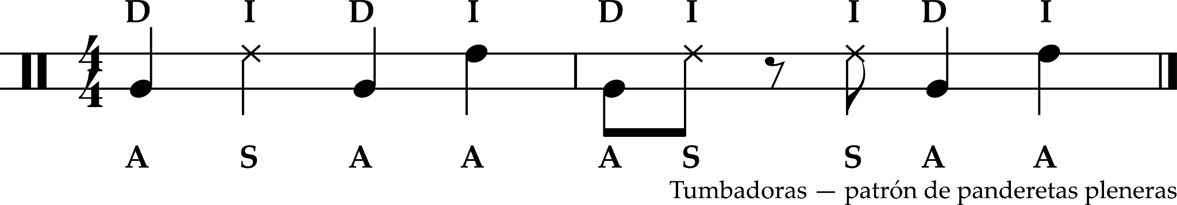
- Bongó, campana support the rhythm. Bongosero either plays campana de mano or güícharo.
- Often, the bajo is not syncopated.

Piano
- The part below is not specific to the plena.
- If in clave: downbeat on the 2-side, anacrusa on the 3-side.
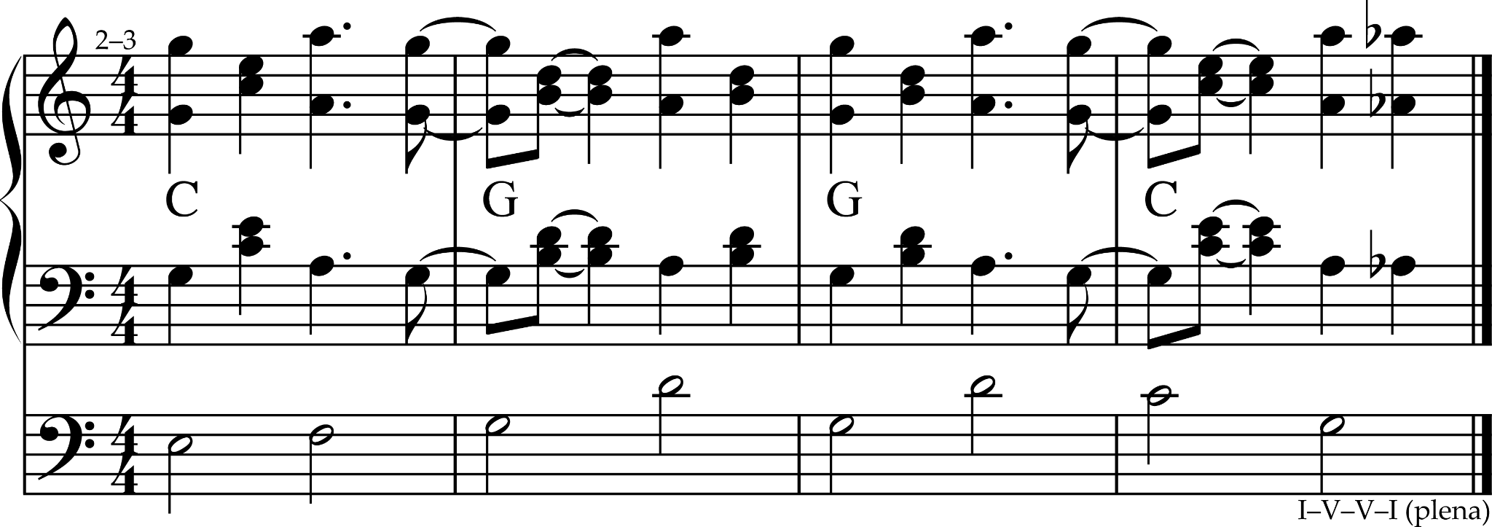
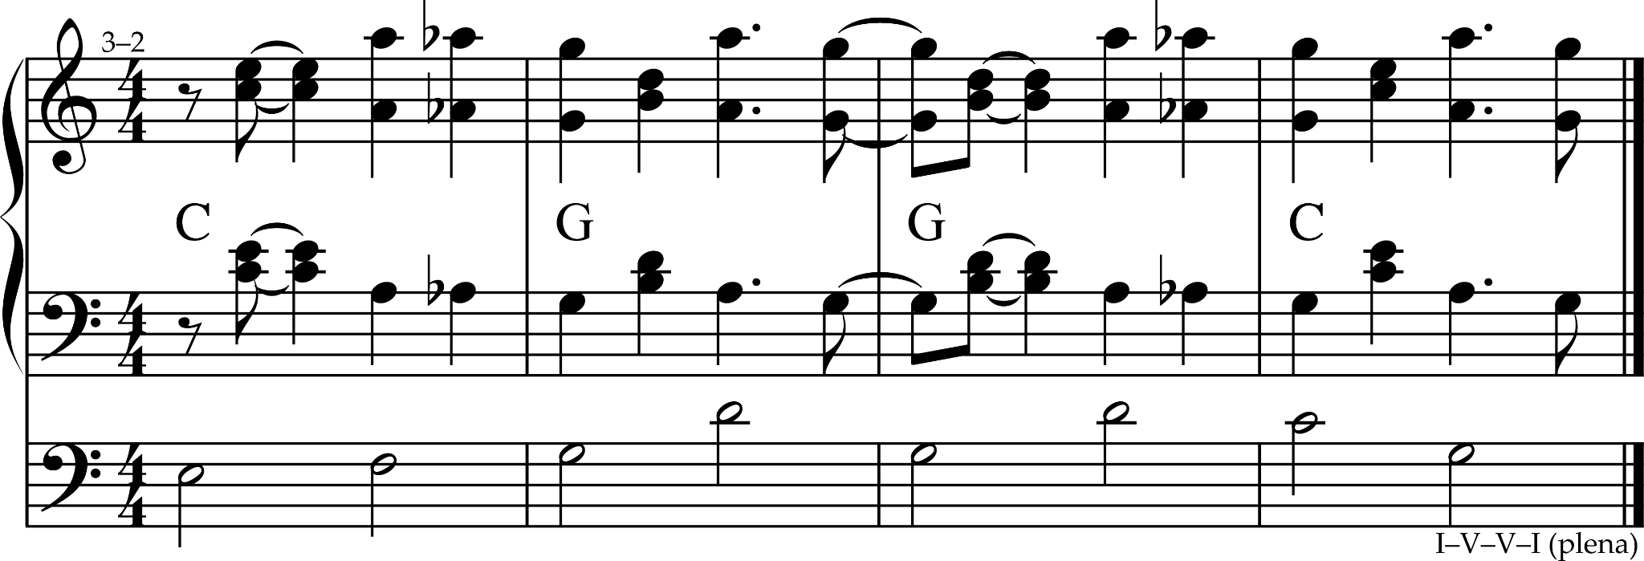

Música jíbara
- Música jíbara (“farmer music”) — the music of the largely white peasantry (like the música campesina cubana).
- A quintessential symbol of Puerto Rico.

- Mostly Spanish-derived.
- A leading exponent of la música de tríos.

- Contains many styles and instrumentations.
- Styles:
  - seis (“six”) — the most important subgenre;
  - aguinaldo;
  - waltz;
  - mazurka;
  - guaracha;
  - merengue.
- Aguinaldo — a kind of jíbaro music performed especially during the Christmas season.
- Seis and aguinaldo are lyrical and lively.
- There are 15–20 substyles of seis and aguinaldo used today, differing by stock melodies and harmonic progressions.
- Each substyle has its own, standardized accompaniment pattern and melody.
- Aguinaldos are particularly associated with the Christmas season,when parrandas perform in the streets from house to house.
- Parranda —
  - a roving group;
  - = trulla = asalto.
- Parrandero — a paranda’s member.
- Asalto — a visit by a parranda (usually unexpected).

- Until the 1930s, the seis often accompanied dancing, with men and women in opposite lines.
- With the decline of dancing, the most important aspect of the seis and the aguinaldo has been the lyrics.
- Early XXI c. — música jíbara is not popular anymore. Many young Puerto Ricans regard it as “hick” music.
- Música jíbara is called “kachi-kachi” in Hawaii (in reference to the güiro).

- Seis and aguinaldo lyrics are generally décimas (like the punto cubano) chronicling the joys and sorrows of the people.
- The verses are sung solo.
- In between the verses, the cuatro improvises.

- Features:
  - improvisation of complicated décimas by the lead singer (often in a competition with another singer — controversia);
  - virtuosic cuatro.

- Bolero, son influenced professional jíbaro ensembles.

Instrumentation
- Instrumentation is the most distinct feature.

- Typical jíbaro ensemble:
  - güiro;
  - tiple / cuatro;
  - guitarra.

- Maracas.
- Other percusión.

- There’s no specific way of adapting la música jíbara to the salsa ensemble and piano.

Subgéneros

Décima
- Décima — a verse form consisting of stanzas of 10 8-syllable lines in the espinela rhyme scheme: abba:accddc.
  - : — pause; otherwise, the rhymes of the last 5 lines mirror those of the first 5.
  - This strophe is called “espinela” because it is associated with the Spanish poet Vicente Martínez Espinel.
- One of the oldest and most popular jíbaro traditions.
- Poetry + music.

- Décima was a minor verse form in XVI- and XVII-c. Spain; it came to be widely cultivated as a song text in diverse forms in Latin America but after the XVI c. essentially fizzled out in Spain itself.
- 1591 — Vicente Espinel introduced the décima espinela, → décima reached its definitive form.
- By late XIX c. — décima and copla became the principal forms for jíbaros. Regardless of the widespread illiteracy, jíbaros could improvise décimas, surprising educated people.

- Written / improvised.
- A poet should be able to improvise. Improvisation takes years to learn.
- Cantaor — a person who memorizes décimas to sing them.
- Trovador — a person who can improvise décimas.
- Décima improvisation is a folk custom from Chile to Colorado.

- The rhyme scheme is so tightly integrated with the elaboration of the lyrical theme that décimas lose their impact in translation.
- Symmetry superimposed to create asymmetry: mirroring abbaa ccddc, but the logic of the text divides it as abba ac cddc, i.e. the rhyme scheme is 5 + 5, the rhetorical scheme is 4 + 2 + 4.
  - abba (1.ª redondilla) — propose and conclude a theme;
  - ac (puente = bisagra) — transitional;
  - cddc (2.ª redondilla) — propose and conclude a theme.

- There can be any number of stanzas in one text on a single theme (1–dozens).
- Décima cuarenticuatro (called by jíbaros) = glosa (in the Hispanic world) — 4-stanza décimas based on a cuarteta (“couplet” — a 4-line poem). The last line of the stanzas are respectively the 1st, 2nd, 3rd, 4th lines of the cuarteta. // Initial quatrain and 4 décimas, ending with each line of the original quatrain.
  - Most popular.
- Pie forzado (“forced foot”) — a décima with an indefinite number of stanzas and always the same obligatory line 10, upon which a singer can improvise a décima.

- In the verse endings of décima,
  - Puerto Rican classical poets prefer consonant rhymes;
  - jíbaros prefer assonantal rhymes.
- Jíbaros are masterful in the inner rhythms of the verses (— the syllabic accents at the beginning and middle of the line). Poetic meter is mostly trochaic, dactylic, mixed. The inner rhythm synchronizes the poetry to the seis music.

Decimilla
- Decimilla (“little décima”) — a décima with 10 6-syllable lines:
  - aguinaldo — religious topics;
  - seis con décima — secular topics.
- abba:accddc.
- Almost as popular as décimas.

Seis
- Seis (“six”) —
  - (originally) a choirboy;
  - (originally) a choir of 6 children carrying the treble lines (alto, soprano) during service music;
  - (now) the most important creole music and dance genre.
- The largest corpus of creole music.
- The seis tradition includes names, rhythms, instruments, dance, possibly singing styles.
- European + African + Amerindian.
- Décima.

Historia
- Obscure origins.
- Probably originated as a liturgical dance celebrating Christmas and Corpus Christi.
- 1520s–1530s — probable beginning.
- XVIII c. — even the most advanced churches did not have enough pews for the entire congregation. → The regular people stood. → When upbeat service music was played, they would naturally dance.
- The bishop banned dancing in the church. → This dance tradition was continued outside, especially in isolated mountainous jíbaro communities.
- In Mexico, there were a few European chapel masters who assimilated rhythms and songs of the Indians and blacks.
- ½ XIX c. — cadenas was the preferred dance among jíbaros.
- By the 2/2 XIX c. — seis had become the preferred dance among jíbaros.
- 1910–1942 — most seises were made in NYC, many were patriotic and protestful, which was forbidden in the Puerto Rico.
- 1950–1970 — the best period of seis.
- Rock, pop, salsa tempered the interest in seis and cuatro.
- Nueva canción renewed the interest in seis.
- Seis lost its connection to dance, which now can only be found in folkloric dance companies.
- Now, trovador competitions are abundant.

Instrumentos

Old
- Güícharo.
- Maracas.
- Bordonúa.
- Vihuela.
- Cuatro antiguo / (sometimes) tres / (sometimes) tiple.

Modern
- Bongó — probably since the 1930s.
- Güiro — improvises on the 4 basic patterns.
- Guitarra — primarily plays a basso continuo, sometimes chordally reinforcing the rhythm and harmony.
- 2 cuatros — probably since the 1930s; the principal instrument associated with seis.
Additional
- Tumbadoras.
- Panderetas — frequent in 1930–1960.
- Timbales.
- Contrabajo — for dance-hall settings, since the 1950s.
- Piano.
- Acordeón — frequent in 1930–1960.
- Trompeta — frequent in 1930–1960.
- Clarinet — frequent in 1930–1960.
- Flauta.

Tipos
- Each seis has its own melody, with which its name is most closely identified. The melody is short (usually 1–2 phrases).
- >150 seises. / 90–117 extant seises.

For dancing
- Fast, lively.
- Some of its names are related to the choreography:
- zapateado (from “zapato” — “shoe”) — fancy footwork;
- amarrao (“tied”);
- valseao (“waltzed”);
- del pañuelo (“with a handkerchief”);
- del sombrero (“with a hat”);
- juey (“crab”).

For singing
- Slower.
- The substyles are named after:
  - places of origin;
- seis orocoveño;
- seis bayamonés;
- seis cagüeño;
  - musicians;
- seis fajardeño;
- seis de Andino;
- seis de Pepe Orné;
- seis Portalatín;
- seis Villarán;
  - formal features;
- seis con décimas — favourite among trovadores;
  - influences;
    - América Latina:
      - seis de milonga, seis gaucho, seis tango — Argentina;
      - seis montuno, seis habanero — Cuba;
      - seis joropo, seis llanero — Venezuela;
    - África (probably since the mid-1500s):
      - seis mapeye (minor mode), seis montebello (major mode) — the melodies’ rhythm resembles the Ghanaian Akan mpintín (which comes from Dagombas of Burkina Faso);
        - originally a dance;
        - Andalusian cadence;
      - enramada — after the dance; Andalusian cadence;
      - seis bombeao — instrumental, people yell “Bomba!” and exchange pleasantries in couplets;
      - seis de bomba;
  - seises creados (“created seises”);
    - antillano;
    - canto Serrano y Villarán (Chuito el de Bayamón);
    - Pampero y Gaucho (Luisito Morales;
    - Tango y Montebello (Arturito Avilés);
    - Yumac (Nerí Orta);
    - Celinés (Germán Rosario);
    - seis cimarrón (Juan Ortiz);
  - seises importados — adapting foreign genres (joropo, llanera, canto veracruzano (introduced by Ramito), milonguero (based on Atahualpa Yupanqui — “Los ejes de mi carreta”, adapted by Luis Miranda), punto cubano, seis moruno (“Moorish seis”), etc.).
Seis con décima
- The most common of seises for singing.
Estructura
- Introducción: the instruments play the traditional theme (melody) 2×.
  - Cuatro 1 plays the theme, cuatro 2 plays a duet with cuatro 1.
- Décima: the singer starts right after.
  - Cuatro 1 improvises, cuatro 2 plays the theme as an ostinato. Proficient cuatristas may alternate the roles.
- Interludio: the instruments play the theme once between stanzas.
- Coda = introducción.
Seis chorreao
- The best known. One of the oldest.
- I–IV–V⁷–V⁷.
- One of the most festive.
- Found in parallel with old music: chaconas, guarachas, gallardas, napolitanas, jácaras.
- ~1880 — popularity.
- The 1st seis to be notated (“Canto jíbaro” in Juan Morel Campos — “Aires del país” (1893)).
- Variants (the same harmony):
  - fajardeño;
  - de Bayamón;
  - marumba;
  - sucu-sucu;
  - de Andino;
  - de Pepe Ornéz (tintillo);
  - zapateo;
  - de Ceiba;
  - de Oriente.
- Almost unchanged since the times of the “El gíbaro” book.
Other
- Seis del Dorado, borinqueño, de Comerío, con décima, de la Serranía, tierra adentro — i–iv–V7.
- Seises aguarachaos — seises similar to guaracha.
  - Syncopated accompaniment. Strong accent on beat 4.
  - I–V7.
  - Ejemplos: mariyandá, tumbao, seis son, seis Villarán, viequense, cante jondo de Vieques.

Accompaniment patterns
Seis mapeyé
Seis fajardeño
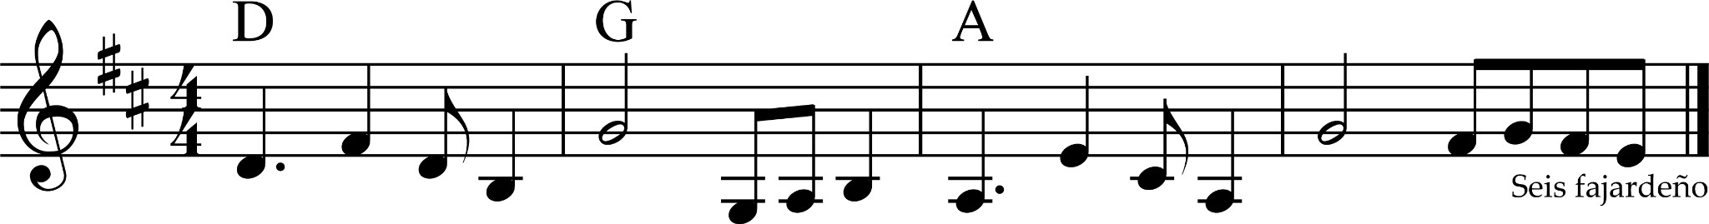

Aguinaldo
- Aguinaldo (= aguilnaldo = aquilando = equiland — “New Year’s gift”).
- Usually linked to the Christmas–New Year season. Used in promesas. But aguinaldos de la pasión are sung during Lent.
- Not always danceable.

- Evolved from Spanish Christmas villancicos, folías.
- Zéjel (= old villancico) — a precursor to glosas in the form of quatrains / distichs / pie forzado.
- Zéjel árabe — a strophic composition comprising (e.g., aa–bbba):
  - a short stanza / estribillo;
  - a variable number of 3-line monorhyme stanzas;
  - a line rhyming with the opening refrain.
- Early XVIII c. — the 1st reports of cánticos, sung rosaries, promesas, which were followed by a celebration. As of early XXI c., this tradition has not altered since then.

- Often confused with villancico.
 | Villancico | Aguinaldo
Time signature | Any | 2/4
Poetic form | Any | Décima, sometimes copla
Choir | May be | Never
Instruments | Any | Traditional
Origin | Urban | Rural
Title | Yes, identified by a title | No, identified by the genre
Danceable | No | No

Instrumentation

Old
- Bombo — a remnant of Spanish military drums; similar to tambora.
  - Still used in western Puerto Rico in some promesas de Reyes.
- Güícharo.
- Maracas.
- Tiple.
- Bordonúa.
- Vihuela.

Modern
- Bongó.
- Güiro.
- Guitarra.
- Cuatro.
- (Optional) button acordeón = sinfonia — since the early XX c.
  - Brought by sailors from Germany.

Text
- 2 ways:
  - coplas responsoriales — antiphonal (verse, refrain) coplas;
    - similar to and derive from zéjels árabes;
  - decimilla espinela (= rima espinela).

Tipos
- Almost 150 styles (as of 2013).
- Classified by namings:
  - geography;
    - de Cayey;
    - de Adjuntas;
    - de Cidra;
    - de Aibonito;
    - de Ciales;
    - de Aguas Buenas;
    - de Bayamon;
    - de Toas Alta;
    - de Naranjito;
    - cagüeño — IV–I–V⁷–I;
    - orocoveño;
    - isabelino;
    - costanero;
    - de Yumac (Camuy in reverse);
    - etc.;
  - generic;
    - jíbaro;
    - lamento;
    - lorenzillo;
    - viejo;
  - event at which it is sung;
    - de Fiestas de Inocentes;
    - baquiné = velorio de angelito;
    - de pastorcillos;
    - romería;
    - de San Martín de Porres;
    - del Nacimento;
    - los Mandamientos = Corozal;
    - de rosarios cantados — by the neighborhood;
  - region in which a promesa de Reyes occurs;
    - de Añasco;
    - de Moca;
    - de San Germán;
    - de Peñuelas;
    - de Cabo Rojo;
    - de Aguada;
    - de Isabela;
    - de Quebradillas = de Membrillo;
    - de Mayagüez;
    - de Humacao;
    - de San Sebastián.

Aguinaldo jíbaro
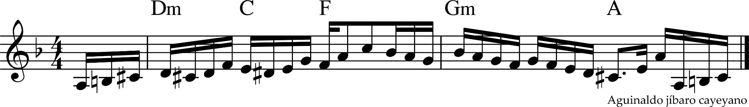
- One of the oldest.
- Infinite variants, which:
  - preserve / change the name (e.g., “aguinaldo de Cayey”, “aguinaldo de Aibonito”);
  - preserve the harmony;
  - may change the rhythm;
  - may change the melody;
  - added lyrics;
  - etc.
- Historically linked to the folía.
- Folía.
  - First appeared as a dance in XV-c. Europe.
  - Usually: triple meter, minor.
  - “Rodrigo Martínez” (1493): the opening section has the same harmony as the aguinaldo jíbaro (i–III–VI–V7), but resolves at the end of the 2nd half while aguinaldo jíbaro remains on V.

- Louis Moreau Gottschalk — “Souvenir de Porto Rico” (“Marche de Gibaros”).
- Los Jardineros (= Sexteto Okeh) — “Estrella del Oriente” (= “Los reyes que llegaron a Belén”).

- Some variants:
  - de pastorcillos;
  - viejo;
  - villaldeño;
  - de Adjuntas;
  - de Cayey;
  - de Aibonito;
  - de Villalba;
  - de Ciales.
- Many variants of the aguinaldo jíbaro have Andalusian cadence.

Aguinaldo orocoveño
- iv–i–V⁷.
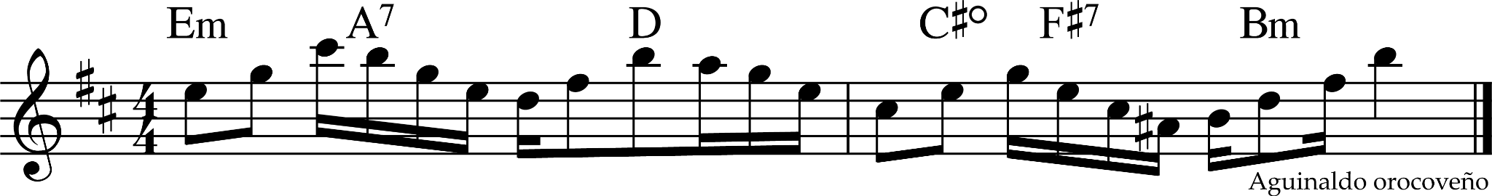

Aguinaldo de Reyes
- Aguinaldo de Reyes = promesa.
- The oldest aguinaldo (at least since the 1650s).
- Copla.
- Antiphonal.

Rosario cantao
- ~1530 — the Spanish fled Puerto Rico; → local versions of Catholicism began to develop.
- Rosario cantao (“sung rosary”) — a set of songs, practices, beliefs developed in Puerto Rico around the rosary, a cycle of prayers marked with a circular string of 59 beads.
- Types:
  - rosario de promesas (“rosary of promises” to the Virgen / a saint in return to a problem solution) — the most common;
  - rosario a la Santa Cruz (“rosary to the Holy Cross”) — performed particularly in May;
  - rosario para los muertos (“rosary for the dead”).
- Similar to the ecclesiastical ones, but sung outside the church.

- Common poetic forms:
  - copla (“couplet”);
  - décima;
  - decimilla.
- Often accompanied by the typical jíbaro ensemble (güiro, guitarra, cuatro / tiple).

Cadenas
- Cadenas — an aguinaldo style with coplas responsoriales / de controversia sung by ≥2 singers.
- XIX c.
- Initially, used by carters as an alert system: if one carter failed to sing a response, the caravan would stop to check on him.
- Were sung at funerals.
- Women sung cadenas while doing laundry at the river. → Many cadenas mention laundry at the river.

In salsa
- In aguinaldos and seises of Asalto Navideño and Asalto Navideño 2, the cuatro is the main instrument and plays the guitar part.

Danza
- Danza = merengue (mid-1800s) (different from merengue dominicano).
- Danza puertorriqueña = contradanza española + influencias cubanas (mainly of habanera) brought by Cuban immigrants.
- Little Caribbean influence. Essentially European-derived.
- One of the initial creole genres.

- The contradanza had been the predominant salon dance in Puerto Rico in the ½ XIX c.
- Mid-XIX c. — emergence.
- By the 1920s — had become archaic.
- Once considered vulgar by high society, it became the consummate expression of the boricua identity.
- Danza:
- romántica;
- festiva.

- Used cinquillo.
- The “obbligato” counterpoint melodies played on the bombardino gave danza a unique character.

Comentarios para el MIDI

COMENTARIOS PARA EL MIDI

Bomba

Buleador, seguidora
- 1–5
- 6–12
- 13–21

Subidor
- 1
- 2 [какая-то из книг].

Cuá
- 1
- 2
- 3

Maraca
- 1
- 2

Güiro
- 1 — vir2 version is better.

Campana de mano
- Percutiendo

Plena

Percusión

Seguidor
- 1 — the constant pattern that never changes but can be ornamented.
- 2–5 — the modern playing style does not use fingertips in between as much.

Punteador
- 1
- 2
- 3 — moderno; skip the 1st hit.
- 4
- 5
- 6

Requinto
- 1

Combinadas
- 1
- 2–7

Güícharo
- 1–2

Piano
- 1 — #76 [101 Montunos]
  - 3–2 — my adaptation.
- 2 — #77 [101 Montunos]

- Seis mapeyé, seis fajardeño, aguinaldo orocoveño, aguinaldo jíbaro cayeyano 1 [Caribbean Currents]
- Aguinaldo jíbaro cayeyano 2 — my edit.

- Bomba — #78 [101 Montunos]

- Guajeo — onbeat–offbeat motif.

To do
- Transcribe aguinaldos and seises: https://youtube.com/playlist?list=PLn6Yt6D2f_-qdt5AYxtzRBuIgPiu8gskR&si=DSUrUEEgCV0oQkQt

Fernando Callejo Ferrer.
Bloomsbury Encyclopedia of Popular Music of the World, volume IX, page 71. Michael de Miranda
Michael de Miranda
Michael de Miranda
Bloomsbury Encyclopedia of Popular Music of the World, volume IX, page 69.
The Garland Encyclopedia of World Music
Bloomsbury Encyclopedia of Popular Music of the World, volume IX
Michael de Miranda
Michael de Miranda
Michael de Miranda
Michael de Miranda
Bloomsbury Encyclopedia of Popular Music of the World, volume IX
Michael de Miranda
Michael de Miranda
Bloomsbury Encyclopedia of Popular Music of the World, volume IX, page 72.
LP
Bloomsbury Encyclopedia of Popular Music of the World, volume IX, page 71.
Michael de Miranda
Peter Manuel, Caribbean Currents, p. 321
Bloomsbury Encyclopedia of Popular Music of the World, volume IX, p. 73
Peter Manuel, Caribbean Currents, p. 321
Peter Manuel, Caribbean Currents, p. 321
Peter Manuel, Caribbean Currents, p. 321
Peter Manuel, Caribbean Currents
Bloomsbury Encyclopedia of Popular Music of the World, volume IX, page 69.
Encyclopedia of Latin American Popular Music, page 302.
Bloomsbury Encyclopedia of Popular Music of the World, volume IX, page 15.
The Garland Encyclopedia of World Music, volume 2, page 937.
Bloomsbury Encyclopedia of Popular Music of the World, volume IX, page 763.
Bloomsbury Encyclopedia of Popular Music of the World, volume IX, p. 764.
Tito Matos
Tito Matos

