Table of Contents
1. What's New 4
2. Overview 4
2.1 Introduction 4
2.2 Features 4
2.3 System Requirements 4
2.4 Installation and Uninstallation 5
3. Quick Start Tutorials 8
3.1 Getting Started 8
4. How to use 8
5. Main 9
5.1 Order In Out View (Main Screen) 9
6. Master System Setup 10
6.1 User Account 10
6.2 Customer 10
6.3 Product 10
6.4 Change Password 10
6.5 Room 10
6.6 Set Aisles 10
6.7 Service Definition 10
6.8 Work Definition 11
7. Warehouse Management 11
7.1 Receiving Order (RO) 11
7.2 Dispatching Order (DO) 16
7.3 Trips Planning 20
7.4 EDI 20
7.5 Pallet Info 21
7.6 Stock Movements 23
7.7 Free Location 25
7.8 Blast Freezer 25
7.9 Find 25
7.10 Trucks In Out 25
7.11 Container In Out 25
7.12 Temp. Humidity 26
7.13 Oursourced Jobs 26
7.14 Un-Lock Orders 26
8. Warehouse Report 26
8.1 Stock On Hand 26
8.2 Stock By Location 26
8.3 Stock Receivied 26
8.4 Stock Dispatched 26
8.5 Stock Movement 26
8.6 Daily Report 26
8.7 Weekly Report 27
8.8 Lost Products 27
8.9 Orders Overtime 27
8.10 Expiry Warning 27
9. Billing Report 27
9.1 Run Billing 27
9.2 Billing Confirmation 30
9.3 View By Service 30
9.4 Other Service 30
9.5 View By Customer 30
9.6 Billing By RO 30
9.7 Billing By DO 30
9.8 Product Tracing 30
9.9 Trace Changes 30
10. Personal 31
10.1 Employees 31
10.2 Traninings 31
10.3 Department 31
10.4 Employee Performance 31
10.5 Monthly Evaluation 31
10.6 Overtimes Entry 31
10.7 Contracts 31
11. Help 31
12. Miscellaneous 32
12.1 Technical Support 32
12.2 Ordering Information 32
12.3 Other information 32
12.4 Contacting Me 32
12.5 End User License 32
12.6 License Agreement 32
12.7 Credits 32

1. What's New
What's New
WMS he on 1.0

2. Overview

2.1 Introduction
Warehous gement System is application useful for enterprise in d ement operation system, monitoring all operations in ent as:
stomer, product, receiving order, dispatching orders, location products in stock, stock on hand, price, cost
With more intelligent ns integrated on systems, it help manager easy handle th ests complex short time.
to do find 1 product about to expire on stock has 100, lets?
How to sumary total Kgs of product A on And where is it on stock?
How many product ha eived or dispatched?...
has resolved all the questions that

2.2 Features
User interface is frie
Supp b, Enter, short keys when move between functions, screen ttons then doestn’t used mouse
Send email auto with datasource from report, grid data
erace tive with zalo, slack
Import, export excel from grid data rt
Export grid data, report to multi extention file as PDF, X XLS, Image, RPT, DOC, DOCS, HTML

2.3 System Requirements
System quirements
➢ Operating Systems: Windows (7,8,10)
➢ Net framework: 4.6.1
➢ SQL server: 2012 or above
➢ Mail server: SMTP

2.4 Installation and Uninstallation
Introduction setup
Copy http://125.212.248.71/WMS_TKM/publish.htm
Step 1: Copy link download paste on browser as internet exp firefox, chrom..
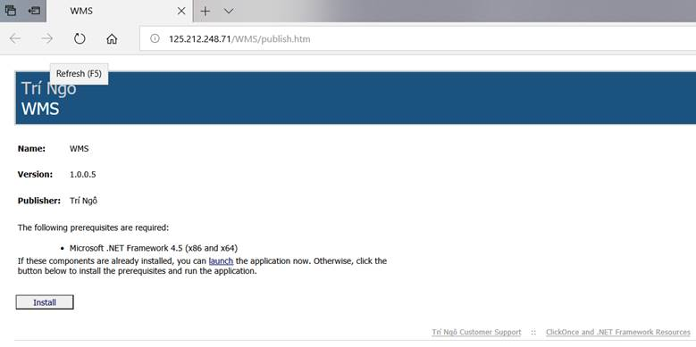
Step 2: Click “Install”
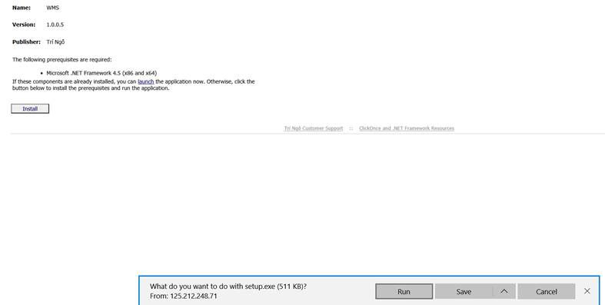
Step 3: Click “Run”
S When windows dialog show as image below click “More info”
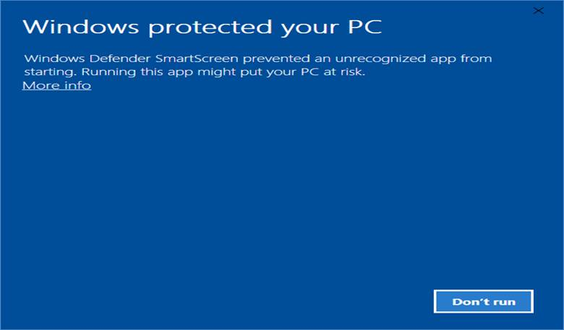
Before click “Run Anyway”
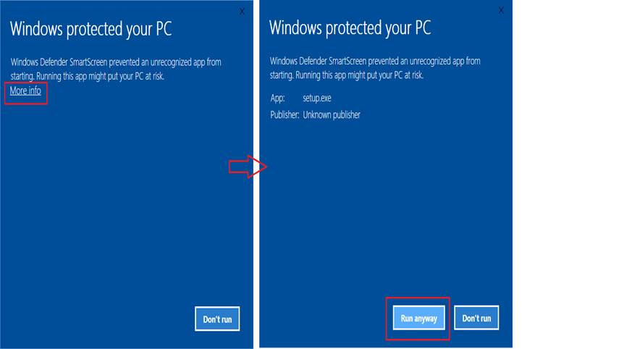
Step 5: Click “Install” on windows dialog as image
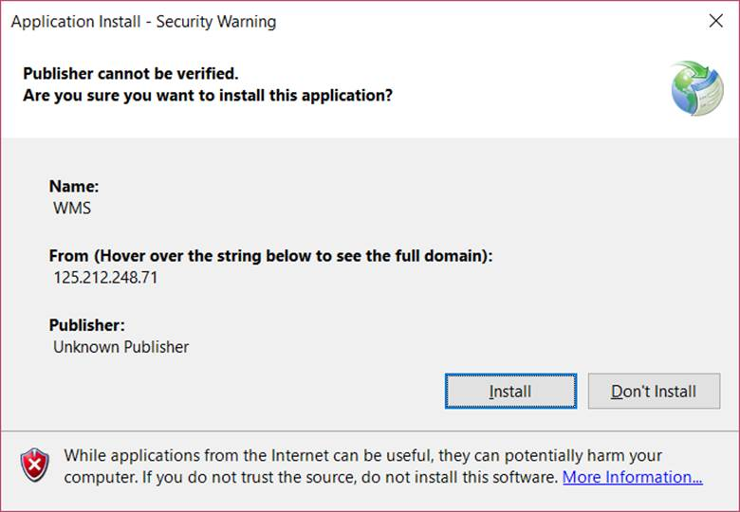

Step 6: Download app and install windows
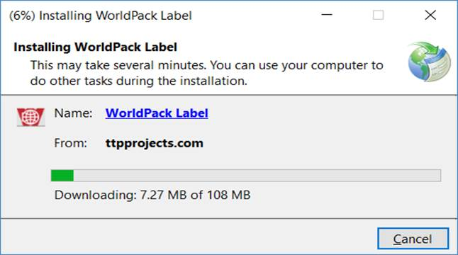
Step 7: Before windows install completed then has 1 dialog showing as “step 5”, we do as “step 5” to run app
Step 8: Login
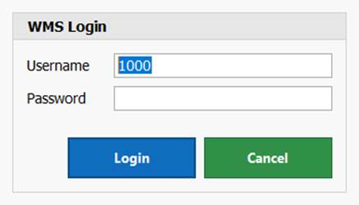
Input user name and passwords to login app (account test)

3. Quick Start Tutorials

3.1 Getting Started
Getting Started
On desktop screen con 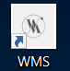-> double click on this icon to open app

4. How to use
How to use

5. Main

5.1 Order In Out View (Main Screen)
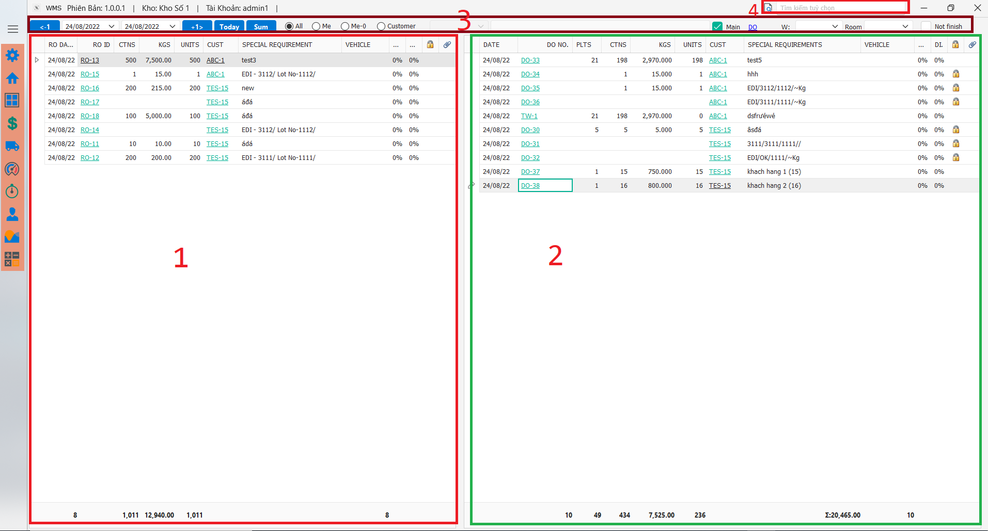
1. This scope display receiving list has created, default filter mode “Me”
2. This scope to display dispatching list has created, default filter mode (3) is “Me”
3. Filter mode
➢ “<-1”, ”+1”: View order list (Receiving, Dispatching) previous 1 day or next 1 day
➢ “Today”: View order list today
➢ “All”: Load all order list on from date -> to date
➢ ”Me”: Load all order list has created by current user login on time from date-> to ate
➢ “Me-0”: Load all order list is not yet confirmed current user login on time from date-> to date
➢ “Customer”: Load all order list by current customer s on time from date-> to date
4. Support to lookup multi value as receiving order, dispatching order, pallets, location, customer, employee, trip, EDI, … with out results is the same with value input

6. Master System Setup

6.1 User Account
User Account

6.2 Customer
Customer

6.3 Product
Product

6.4 Change Password
Change Password

6.5 Room
Room

6.6 Set Aisles
Set Aisles

6.7 Service Definition
Service Definition

6.8 Work Definition
Work Definition

7. Warehouse Management

7.1 Receiving Order (RO)
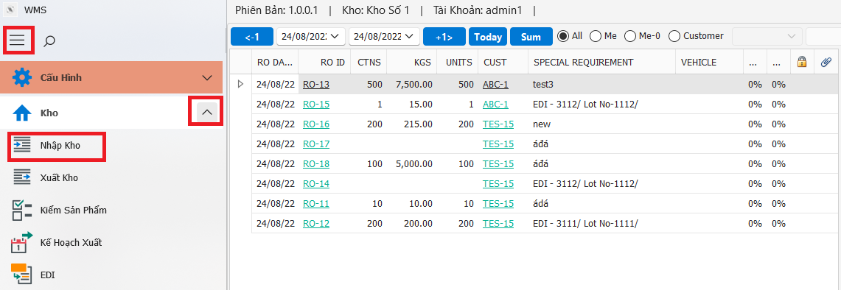
Open RO from Main screen, ”Kho” group, next-> click on “Nhập kho” icon
➢ Create New RO
Step 1:

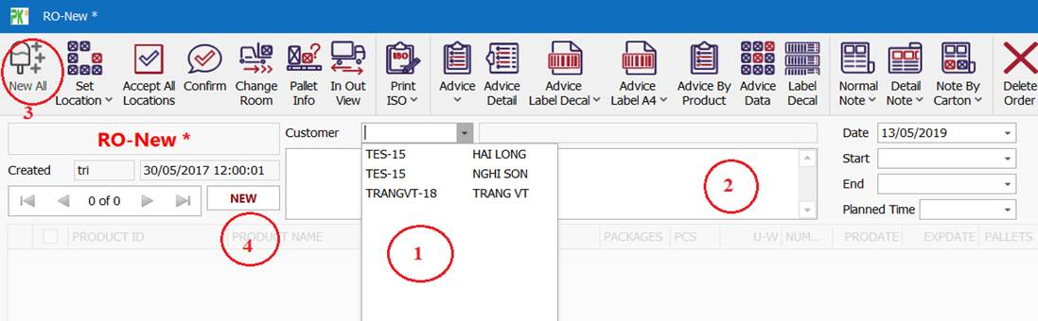
(1) Select ‘’Customer”, (2) input Special Requirement, (3) press Tab key then press Enter key (short key open (3) “New All” this step you can direct click on “New All” icon. To continue add new other the click (4) “New” again (1), (2), (3)
Step 2:
After “New All” icon has clicked then it w splay screen as below:
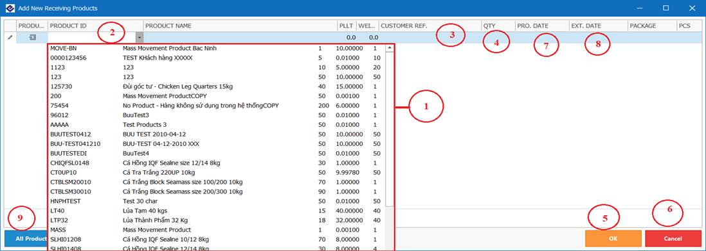
(1) List product of current customer is creating order, (2) input product number want find cell after select it from (1), (3) input remark for product selected,
Next step is press to move next step, (4) input quantity want received, press Enter key to move next step, if this product production date and expiry date then input (7), (8) else 2 this values => done input 1 product.
To next input others products then you do the same above, then to input all products , next you click button (5) “OK to finished.
Cancel input product you click on button (6) “Cancel“
( “All Products” this function to support select multi product once times
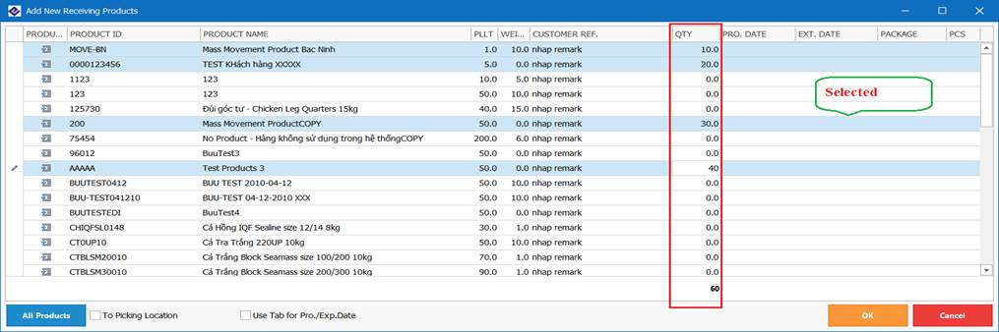
You just only keeping Ctrl key + Click Left Mouse button select on rows need select then input value on column ”QTY”, the end is click “OK” to finished.

Step 3:
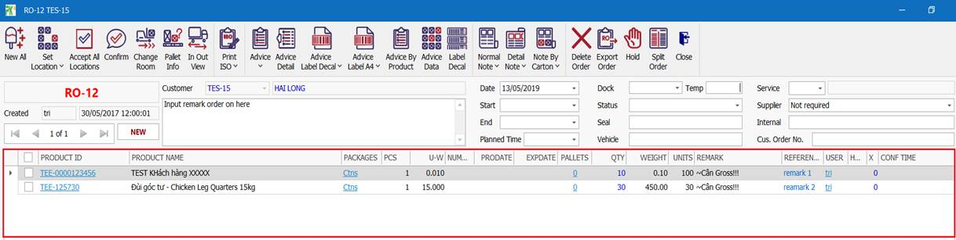
This is result after you has inputted products on above
View or Modify old
To review old RO, you are need to click button as below:
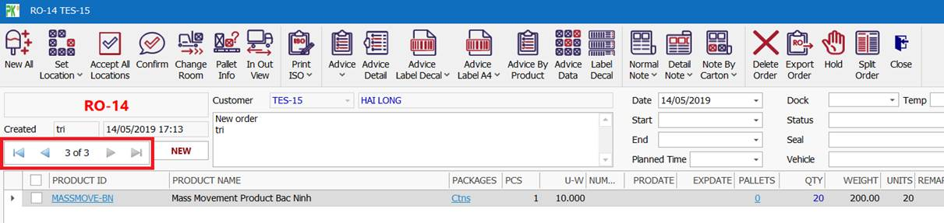
Or on “Screen” on display view (1), you click on “RO ID” column with order selected, immediately systems will open current RO has select

Delete RO
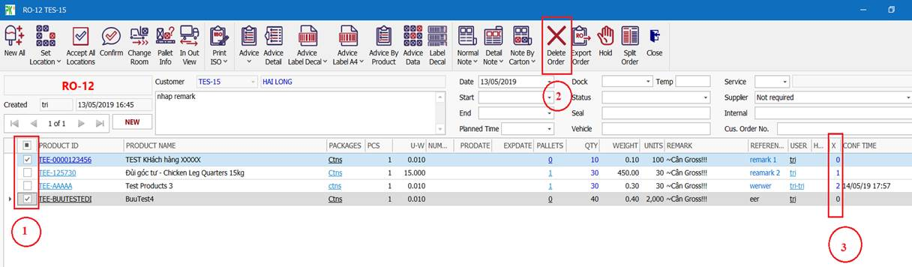
Step 1: Delete all product on RO
“Checked” on rows (or products) need press “Delete” hen will has 1 message box display as below:
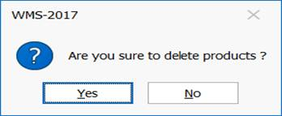
“Yes” to delete products has selected, or “No” do nothing
Note: You are must delete all product as there in current RO before delete RO
Systems just only allow to delete product when it has status is “0” (3), supervisor can delete with status 1, 2
“0”: just created
“1”: has accepted
“2”: has confirmed
Step 2 lick (2) ”Delete order” button to delete current RO

➢ Update quantity products has id
Step 1: Click on user name on “USER” column at row want modify quantity value as image bellow:
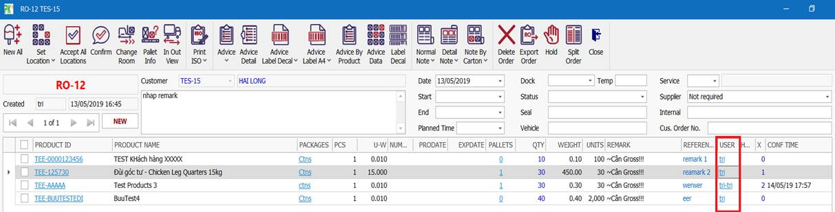
Set 2: When receiving order details (RO Details) from has displayed as below:
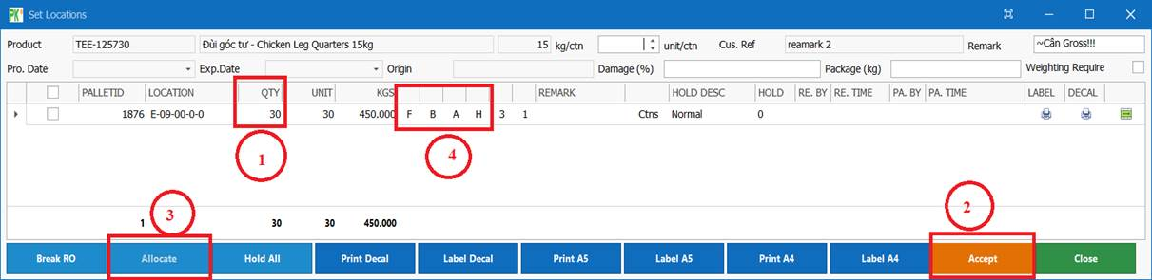
Note: Just only product update, modify value status is “0”, if has status “1” accept) then you can un-accept (change status >0) by away click on (2) “Accept”
button to change status to 0.
Next step: You input new quantity at (1) “QTY” column on row want to change then press key Enter, next click (2) or “Close” button to close form

➢ Update or allocate location pallet
On image at step 2 “Update quantity products has inputted”, you to change location for pallets then click on buttons “F”, ”B”, ”A”, H” to select other location
”F”: All free locations current room
“A”: All locations on current room
“B”: All locations had allocated on current room
“H”: High locations
Normal you will click “F” button to select free location to change current pallet to new location

➢ Change Room
On image at step Update quantity products has id”, you click on buttons (3) ”Allocate” to change
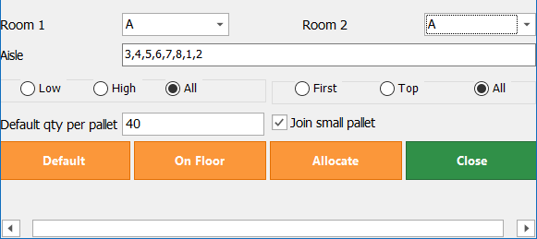
Step 1: Select room want change from ”Room 1” and “Room 2”
If you want change current pallet same room then select “Room 1” and “Room 2” is the same, else is difference
Click “Allocate” button
If you want the pallets is on floor then click ”On Floor” button
“Default” button -allocate for all pallet of current product with quantity “default qty per pallet”
➢ Accept- Confirmed product
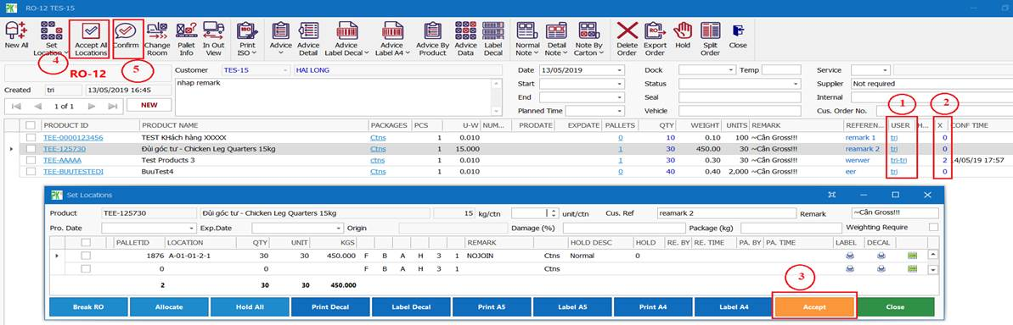
“Accept 1 product”: (1) click “USER”, next click “Accept”, if current product status is “Accepted“ before you click (3) it will “Accept”
“Accept all click on (4) “Accept All Locations” then will has 1 dialog message display as below
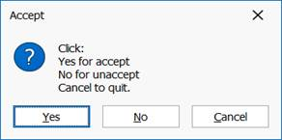
“Yes“ accept
“No”: Un- accept products has status is “” (view status at “X” column (2))
“Cancel”: Cancel this session
“Confirm 1 product”: at (2) “X” column, the products has stat “1”, you double click “1” and 1 dialog will display as below:
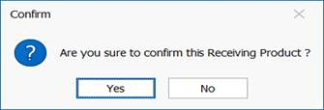
”Yes”: Agree confirmed
”No”: Do nothing
“Confirm all”: At (5) click “Confirm” button then 1 dialog will display as below:
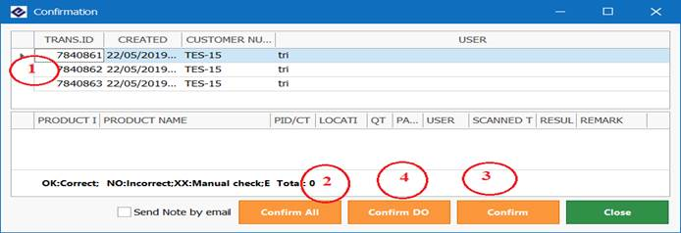
(2) ”Confirm All” process confirm products has in list (1) and close form
(3) “Confirm” just only confirm the products has select (1)
⇨ products has status “2” (confirmed) => complete receiving for this products
⇨ product in RO has status “2” (confirmed) => complet receiving for this order
➢ View Report

7.2 Dispatching Order (DO)
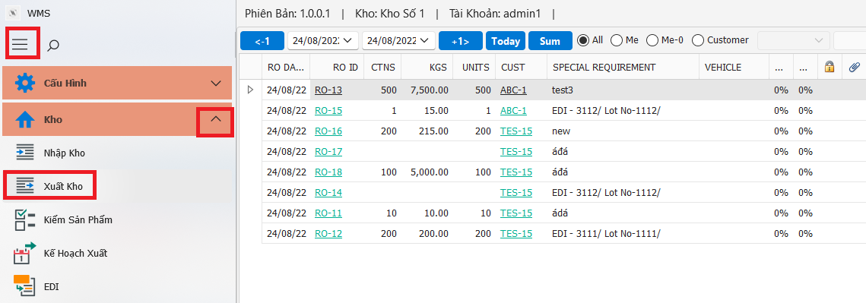
Open DO from Main screen: Select ”Kho” next-> click on “Xuất kho” icon
➢ Create New DO
Step 1:
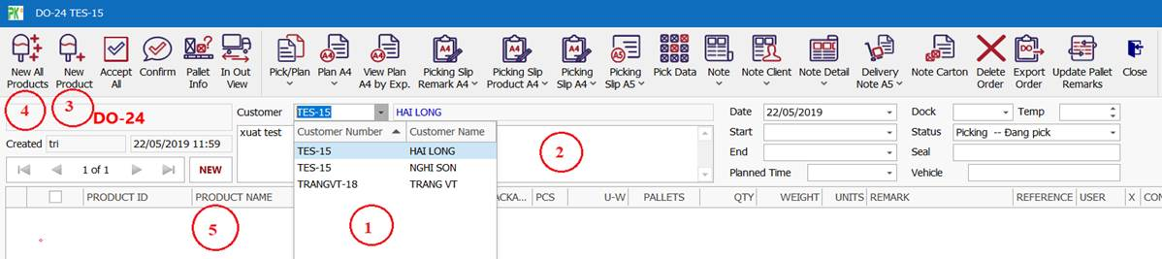
(1) Select “Customer (2) input remark order, (3) press Tab key then press Enter (short keys) to open (3) “product”, at this step you can direct click on “New Product” icon, wit you want to select multi products at once time then click “New All Products”
To continue add new other click (5) “New” again (1), (2), (3)

Step 2:
After “New Product” icon has clicked then it will display screen
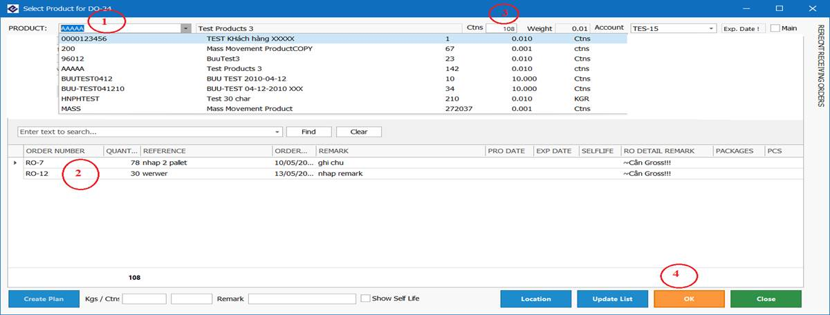
(1) Select “Product” want input, on list products has inputted in RO l 2) previous.
You can choose 1 or all products on RO list, default if you select 1 RO special then systems will get all.
Total quantity product selected will display on (3), you can view quantity product at column “QUANTITY“
You can input all quantity on (3) to quantity want selected (quantity input less more total quantity selected on RO list)
(4) click “OK” button to finished
Summary: product (1)-> in quantity (3)-> OK (4)
(4) “New All Products from screen “Step 1”, this function to support multi select products for once time
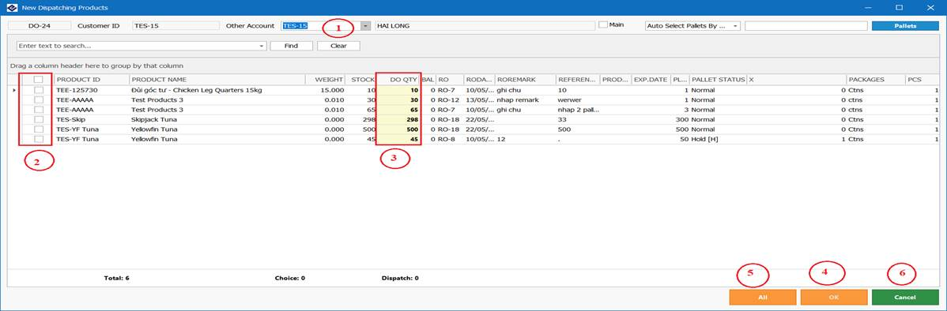
(1) select “Other Account“ to get products (default is current customer), (2) “Checked” on products want s (3) input quantity want get on column “DO QTY’,
default quantity selected = current DO QTY), (4) click “OK” button to finished
If you want get all product then (2) “Checked” on top row, (4) “OK” button to find
Step 3:
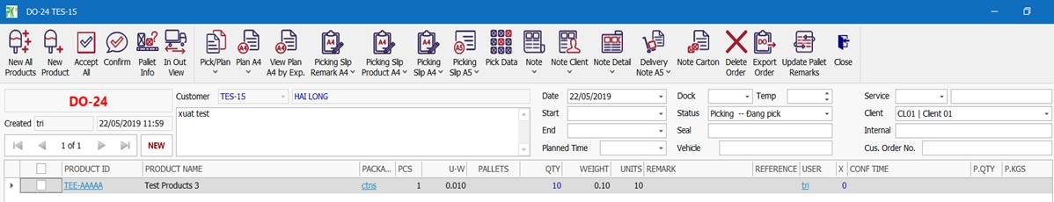
This is result after you has inputted products on above step
➢ View or Modify old
To review old DO, you are need to click on button as below:
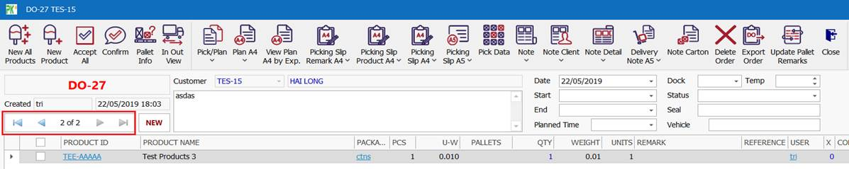
Or on “Main Screen” on display, you click on “DO ID column with order has selected, immediately systems will current DO has selected.

➢ Delete DO
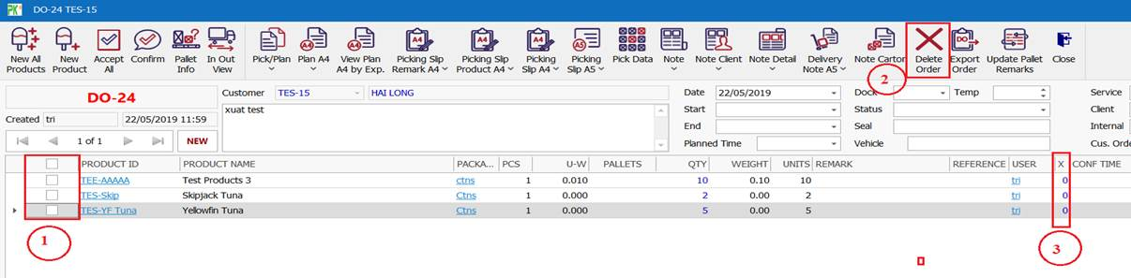
Step 1: Delete all product on DO
“Checked” on rows (or pro need delete, press “Delete” key, when will has 1 message box display as below
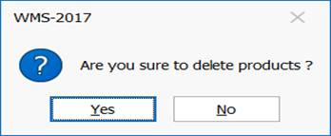
“Yes” to delete the products has selected, or “No” do nothing
Note: You are must delete all products has there in current DO before delete DO
Systems just only to update, delete with status < 2

➢ Update quantity p as inputted
Step 1: Click on user name USER” column at row modify quantity value as image bellow:
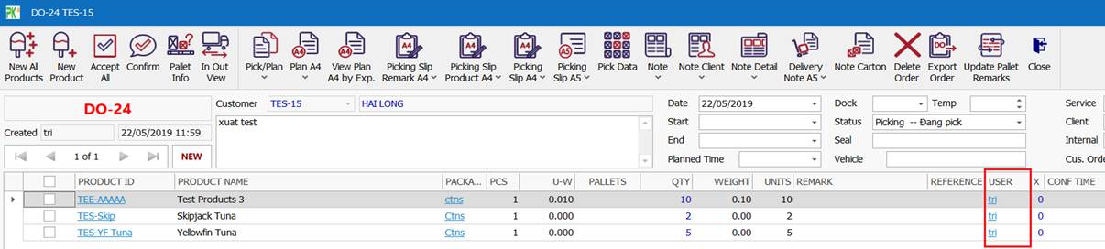
Set 2: When dispatching or details (DO Details) from has displayed as below:
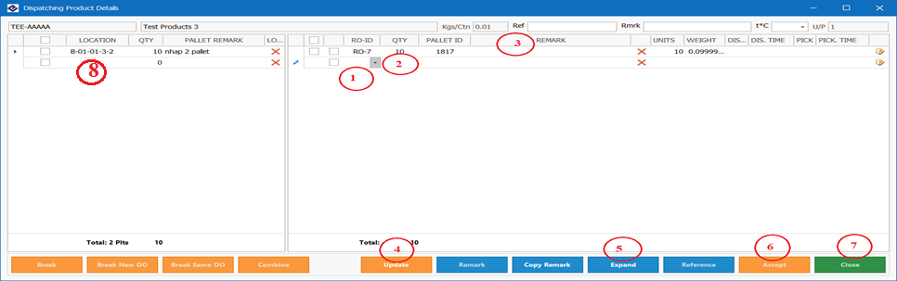
If you want get product from other RO then click (1) “RO-ID” and RO want change (just only apply for case this product from multi RO)
If you want to change quantity product then view quantity at (2) “QTY”, next click (4) “Update” button, next click (6) “” to finished or click (7) “Close” if you aren’t want to accept
You can update “Remark“ (3)
You can view more detail as ”location”, …., with (5) “Expand”
You can change other location to g s product from (8) “Location”
Accept- Confirmed products
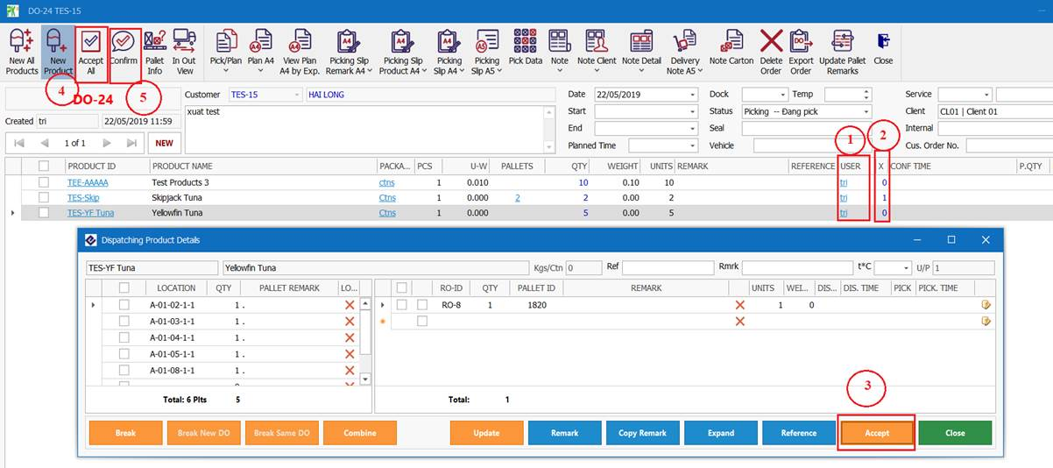
“Accept 1 product”: (1) click on “USER”, next click (3) “Accept”, if current product is “Accepted” before click (3) it will “Un-Accept”
”Accept all”: Click “Accept All Locations” then will has 1 dialog message display as below:
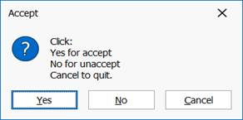
“Yes”: Agree accept
“No”: Un-Accept the products has status is “1” (view status at “X” column (2))
“Cancel”: Cancel this session
“Confirm 1 product”: at (2 ”X” column, the product status is “1”, you are click on “1” and log message will display as below:
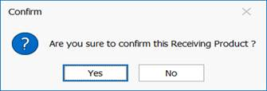
“Yes”: Agree confirmed
“No”: Nothing
“Confirm all”: click “Confirm” then 1 dialog message will display as below:
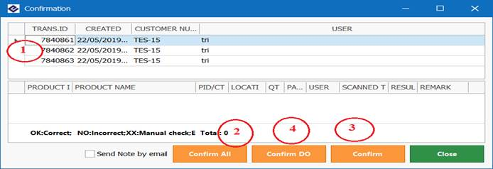
(2) ”Confirm All”: Process confirm all product has in list (1) and close
(3) “Confirm” just only confirm the p as selected on list (1)
⇨ The products has status “2” (confirmed) => completed processing dispatching for this products
All products in DO has status (confirmed) => completed processing dispatching for order

7.3 Trips Planning
Trips Planning

7.4 EDI
EDI

7.5 Pallet Info
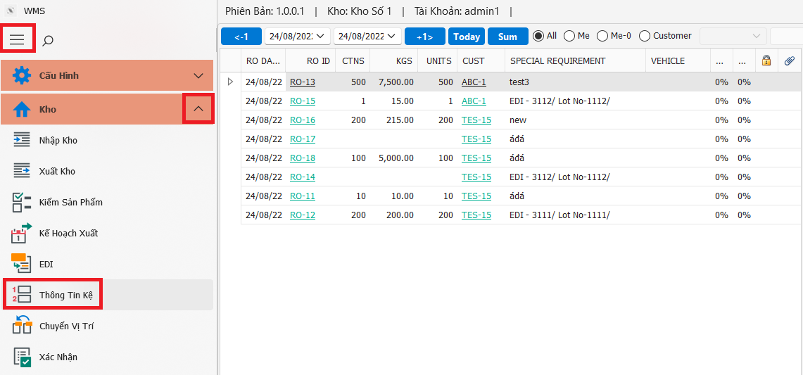
Open from Main screen: Select” Kho” group, next-> click on “Thông tin kệ” icon
Or open from "Pallets" column on RO, DO
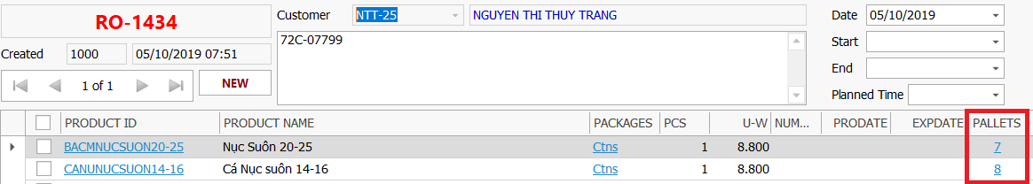
➢ Products by customer
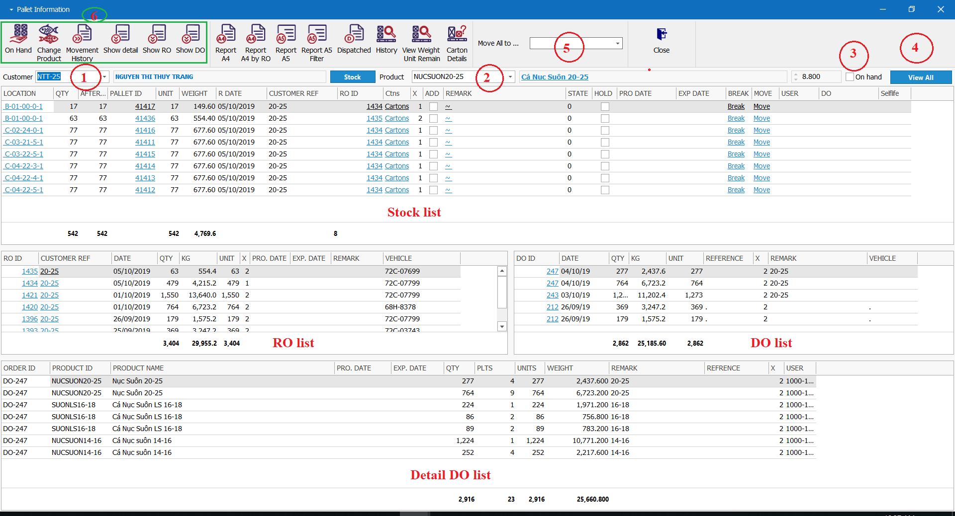
- Select “Customer”, (2) Select Product” need stock, and result list will display on “Stock List”
Stock List” >View all location storage this product, and more info as D, total QTY, total Unit…
“RO List” =>View all RO received for this product
“DO List” =>View as dispatched for this products
“Detail DO List” =>View all pr as dispatched in this DO
(3) Just only use when you want to view on hand
(4) Just only hen you want to view out of stock
(5) Just only use want move all location of this products to other location
(6) functions to support:
“On Hand” => Open tock on hand by customer
“Change product” => Open form change product
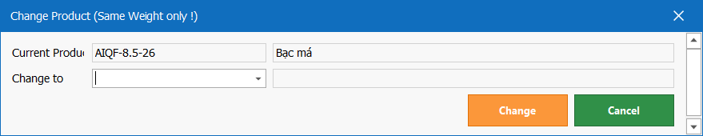
This function only use when customer has required change product in (products change must have weight=weight current product)
“Movement History” => Open form Movement history (this products)
“Show Detail” => Hide or visible “Detail list”
“Show RO” => Hide or visible “RO list”
“Show DO” => Hide or le “DO list“
“Report A4” => View stock report with format A4
“Report A4 By RO“ => View stock report with group by RO
“Report A5” => View stock report with format A5
“Report A5 Filter” => View stock report filter RO date
“Dispatched” => View stock has dispatched

7.6 Stock Movements
Stock Movements
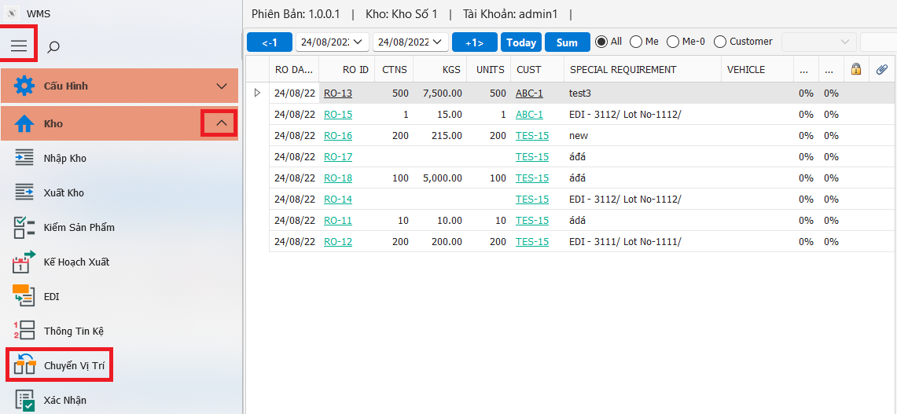
Open from Main screen: Select ”Kho” group, next-> click on “Chuyển vị trí” icon
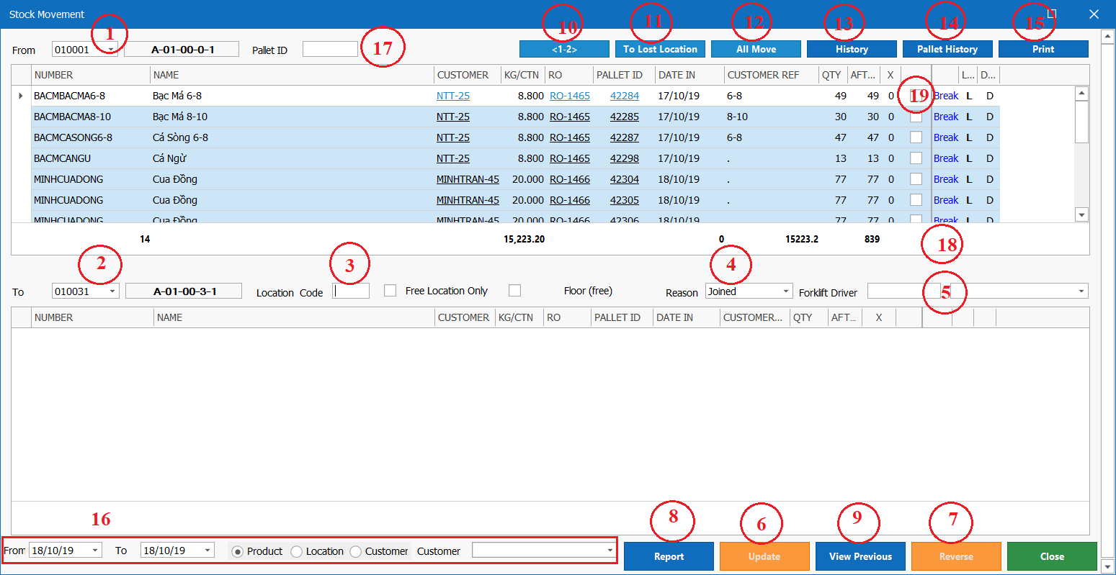
- Move, Joined, Reverted products in location source to location target
Step 1:
Input location source on textbox “From” (1) or input “Pallet ID” (17)
Checked rows want move on column (19) or check all row then click “All Move” (12)
Step 2:
Input location target on textbox “To” (2)
Step 3:
Input location code (3) with location code from 0->9 (0 or 1, or 2…)
When input location code has dialog message as image bellow is location code is incorrect
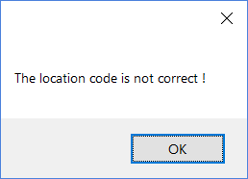
Step 4: Chose type will process as “Move,Joined,Reverted” as “Reason” (4)
If you want move location source to location target then chose “Move”, with joned, reverted the same with move
Step 5:
Choose or input people will process on real location “Forklift Driver” (5)
Step 6:
Click “Update” (6) -> Done

7.7 Free Location
Free Location

7.8 Blast Freezer
Blast Freezer

7.9 Find
Find

7.10 Trucks In Out
Trucks In Out

7.11 Container In Out
Container In Out

7.12 Temp. Humidity
Temp. Humidity

7.13 Oursourced Jobs
Oursourced Jobs

7.14 Un-Lock Orders
Un-Lock

8. Warehouse Report

8.1 Stock On Hand
Stock On Hand

8.2 Stock By Location
Stock By Location

8.3 Stock Receivied
Stock Receivied

8.4 Stock Dispatched
Stock Dispatched

8.5 Stock Movement
Stock Move

8.6 Daily Report
Daily rt

8.7 Weekly Report
Weekly Report

8.8 Lost Products
Lost Products

8.9 Orders Overtime
Orders Overtim

8.10 Expiry Warning
Expiry Warnin

9. Billing Report

9.1 Run Billing
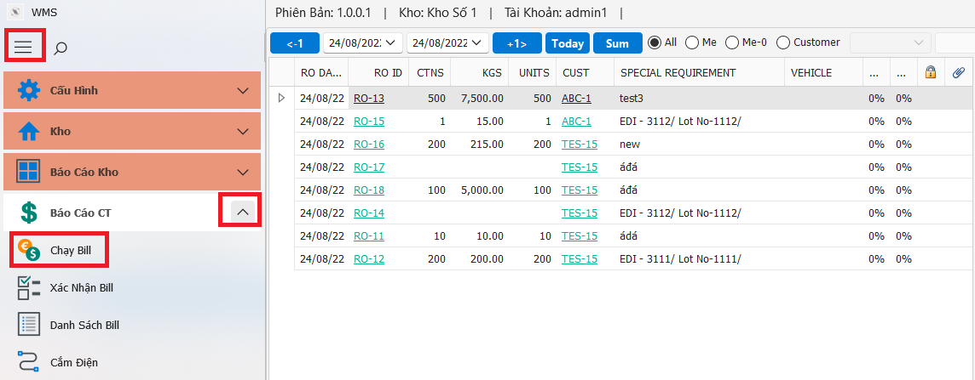
Open from Main screen: Select ”Báo cáo CT” group, next-> click on “Chạy bill” icon
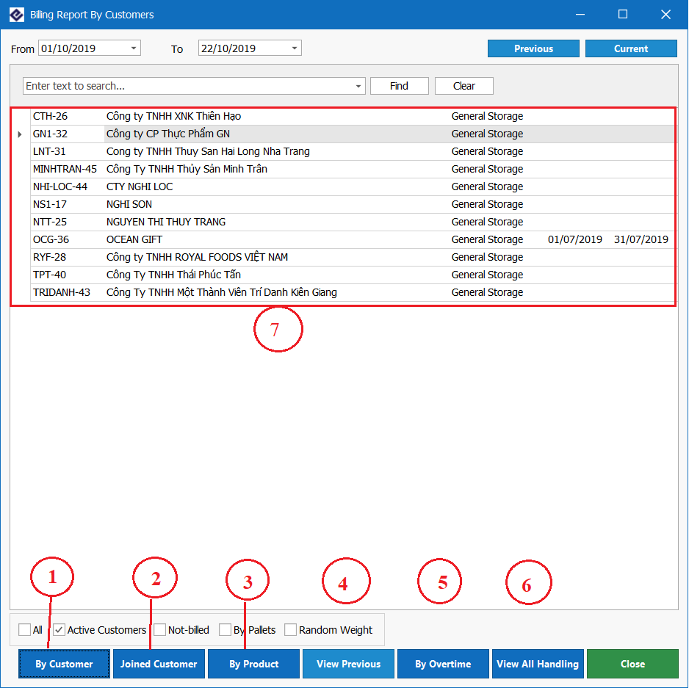
- Run billing
Select 1 or multi customers on grid (7), before click on “By Customer” (1) to run bill
- Other functions
(2): Run billing the same (1) and open contract of this customer selected
(3): View report products of this customer selected
(4): Review run billing previous
(5): View report and export excel RO, DO has process by this customer
(6): View report all handling
- Billing Info

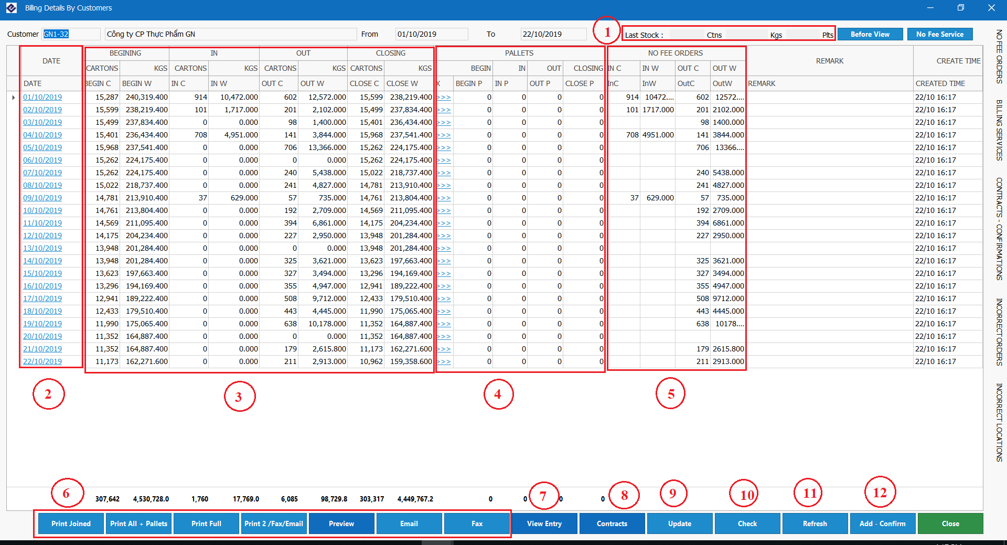
- Functions info
(1): Total info last stock, ctns, kgs
(2): Click on this column to view RO, DO has proceed in this day
(3): View summary In-Out “Cartons”, ”KGs” on current month and stocks in last month
(4): View summary In-Out pallets
(5): View summary In-Out “Cartons”, ”Weigh” on current month
(6): The functions to view report and send email, fax to customer
(7): View, and other services for RO, DO
(8): View contract this customer
(9): Update the data modify on this gird (only use when the data on grid is not consitence with summary data on RO, DO), data modify by user handle input
(10): Validate current data on grid is correct with data on each RO, DO
(11): Reload data on grid
(12): Confirmed data is conrrect and create billing
- Creating billing
Step 1: Review data on gird is correct with data on each RO, DO, (if data is incorrect then update data and click (9))
Step 2: Click “Add- Confirm” (12) to create billing
Done

9.2 Billing Confirmation
Billing Confirm

9.3 View By Service
View By Service

9.4 Other Service
Other Service

9.5 View By Customer
View B tomer

9.6 Billing By RO
Billing By RO

9.7 Billing By DO
Billing By DO

9.8 Product Tracing
Product Tracing

9.9 Trace Changes
Trace Changes

10. Personal

10.1 Employees
Employees

10.2 Traninings
Traninings

10.3 Department
Department

10.4 Employee Performance
Employee Performance

10.5 Monthly Evaluation
Monthly Ev

10.6 Overtimes Entry
Overtimes Entry

10.7 Contracts
Contra

11. Help
Help

12. Miscellaneous

12.1 Technical Support
Technical Support

12.2 Ordering Information
Ordering Information

12.3 Other information
Other information

12.4 Contacting Me
Contacting Me

12.5 End User License
End User e

12.6 License Agreement
License Agreement

12.7 Credits
Credits

