Tickerline documentation
Tickerline is a theme for illogical-impulse ("ii", end-4's Hyprland dotfiles on Quickshell) plus a matching GRUB boot menu. Cyan on deep navy, square corners, monospace numbers, and a look taken from trading terminals and boot screens.
This document is the full reference: the design rules, every color and size, how each part of the desktop should look, how the scripts apply it, and what to watch out for when changing it. The README covers installing and uninstalling. NOTES.md collects the implementation gotchas in short form.

How to read this
- Section 1 is a quick reference. If you're an agent or in a hurry, start there.
- Sections 2 to 6 are the design spec. They describe the intended result, independent of how ii implements it.
- Section 7 is the GRUB theme.
- Section 8 explains how the scripts get the spec onto a running system, and section 9 lists the known limits.
- Colors are written as tokens in backticks (surface-base). The values live in desktop/palette.json and desktop/palette-matte.json; if a table here and the JSON disagree, the JSON wins.
- Sizes are in px on a 1920×1080 screen at scale 1 unless a unit says otherwise. Font sizes are in pt at 96 dpi (10 pt is about 13 px).
- File paths are relative to the repo root.

Contents
- Quick reference
- Design rules
- Color
- Shape, type and motion
- Desktop components
- Wallpaper
- GRUB boot menu
- How it's built
- Known limits

1. Quick reference
Question | Answer
Source of truth for colors | desktop/palette.json (Default), desktop/palette-matte.json (Matte)
Source of truth for shape, motion, fonts | desktop/palette.json (shape, motion, fonts)
Script that applies everything | desktop/apply-palette.py (installed to ~/.local/share/tickerline/)
One-time setup | install.py
Undo | uninstall.py (restores every <file>.pre-tickerline)
Runtime state | ~/.local/state/tickerline/matte and night, each on or off
Tokens at runtime | ~/.local/state/quickshell/user/generated/ticker-tokens.json, read by TickerTokens.qml
Hyprland settings | desktop/hypr/tickerline.lua, installed to ~/.config/hypr/custom/
Replacement QML | desktop/ii/ (bar, right sidebar, Matte toggle, Claude Code AI strategy)
Lock screen layout | desktop/hyprlock.conf
GRUB theme | grub/boot-terminal/, installed by sudo grub/install.sh
Mockups | design/desktop/, design/sidebar/, design/grub/
Contrast checks | design/desktop/contrast.csv (98 pairs, all pass)
Try changes safely | dev/nested.sh (nested Hyprland with its own home folder)
Restart the shell | pkill -x qs, then hyprctl dispatch 'hl.dsp.exec_cmd("qs -c ii")'
Shell log | qs -c ii log
Rules that every change has to keep:
- Radius 0 everywhere. No shadows. No glow on live text.
- Cyan is the only accent. Green only means ready or OK.
- Components refer to tokens, never to a palette. Default and Matte have the same token names.
- Edit the repo, then rerun the script. Installed files under ~/.config get overwritten.

2. Design rules
These hold for the boot menu and the desktop alike.
One accent. Cyan (accent, #22D3EE in Default) marks focus, selection, the active workspace and the primary action. Nothing else is cyan.
Green means ready or OK. Full battery while charging, a finished task, READY on the lock screen. It never decorates and is never a second accent, which is why the Material 3 tertiary role is pale cyan instead of green.
Amber and coral only for real states. warning and error show warnings and errors, nothing else.
Square corners. Every surface has radius 0. Where a corner needs attention it gets a bracket mark instead of rounding. Brackets (2 px thick, 16 px long, cyan) only appear on focal surfaces, places where your input goes: the lock panel, the selected session tile (small 8 px brackets, as in the GRUB highlight) and the workspace strip in the bar (6 px long, 1 px thick). Notifications, the OSD and menus get a 1 px divider border instead. Brackets stay rare so they keep their meaning.
The GRUB highlight is the selection style. A 10 % cyan fill, 1 px edges at 35 % cyan, a 3 px solid bar on the left and brackets on the right corners. Toolkits that can't draw that (fuzzel, GTK, Qt) use a flat fill: selection-bg for text and file selection, 14 % cyan for list rows.
No glow, no shadow on live text. Shadows are off on every layer. Blur is allowed only behind shell layers, and those stay 92 % opaque so text contrast barely changes.
Two palettes, one set of roles. Anything that would need a Matte-only exception is a missing token, not a special case.
App icons sit in squares, never circles: notification popups, the sidebar and the workspace cells.
Uppercase labels use Chakra Petch (section labels, the SESSION and AUTHENTICATE headers, the wordmark). Everything else uses IBM Plex Sans or BlexMono.

3. Color

3.1 Tokens
Token | Default | Matte | Use
surface-sunken | #060D1A | #0A0D13 | Deepest layer: lock screen field, overview backdrop
surface-base | #0A1628 | #11161E | Desktop and window background, bar, terminal
surface-low | #0D1B2F | #151B24 | Sidebars, side panes inside apps
surface-raised | #11223A | #1B222D | Cards, toolbars, session tiles
surface-overlay | #152A45 | #212A36 | Popups, menus, notifications, OSD, launcher
surface-highest | #1A3250 | #28323F | Chips, occupied workspace, slider track
surface-hover | #1A314E | #27313E | Hover on any surface up to raised
surface-pressed | #1E395B | #2D3948 | Pressed state
text-primary | #EAFBFF | #F1F9FB | Titles, body text, selected labels
text-secondary | #B4C4D8 | #BBC3CD | Secondary lines, unselected list items
text-muted | #8FA6C4 | #9AA5B4 | Captions, metadata, hints
text-disabled | #526986 | #5D6877 | Disabled labels only (below 4.5:1 on purpose)
accent | #22D3EE | #89C9D6 | Selection, focus, active workspace, links in the UI
accent-hover | #67E8F9 | #A7DEE6 | Accent under the pointer
accent-active | #0FB5D0 | #74ACB9 | Accent pressed
focus-ring | #22D3EE | #89C9D6 | 2 px keyboard focus outline
on-accent | #04222B | #142025 | Text and icons on a solid accent fill
accent-container | #0E3446 | #22323B | Tinted fill: toggle on, selected chip
on-accent-container | #A5F3FC | #C7EBF0 | Text on accent-container
border-active | #22D3EE | #89C9D6 | Focused window border, launcher border
border-inactive | #52709A | #617085 | Unfocused window border
outline | #6C84A4 | #778393 | Control borders: inputs, secondary buttons
divider | #1C3554 | #293544 | Hairlines and panel borders (decorative)
success | #34D399 | #82C6A6 | Ready or OK only
on-success | #04222B | #122025 | Text on a success fill
warning | #F5B83D | #DFBF86 | Low battery (15 %), updates waiting for a reboot
on-warning | #2A1C00 | #251E10 | Text on a warning fill
error | #FF7A8C | #DD939A | Errors, critical notifications, failed unlock
on-error | #3A0610 | #2E1416 | Text on an error fill
error-container | #4A1622 | #3D2126 | Error banner fill
on-error-container | #FFD9DE | #F3DEE1 | Text on error-container
selection-bg | #155E75 | #3E5A65 | Text and file selection background
selection-fg | #EAFBFF | #F1F9FB | Text on a selection
scrim | #060D1AB3 | #0A0D13B3 | 70 % backdrop behind modal layers (8-digit hex)
A few choices that aren't obvious from the table:
- error is coral, not pure red. Its warmth sits between the cyan and the amber, it stays clear of the accent in hue and lightness, and it keeps 4.5:1 on every surface up to surface-highest.
- border-inactive is brighter than a hairline because an unfocused window border has to reach 3:1 against the wallpaper behind it, including the lighter chart area. divider stays dim because it only decorates.
- text-disabled is below 4.5:1, which WCAG allows for disabled controls. Don't use it for anything you need to read.

3.2 Matte
Matte is the evening palette. Every hue stays where it is, saturation is roughly halved, and the surfaces move from navy toward a neutral slate.
 | Default | Matte
Accent | #22D3EE cyan | #89C9D6 muted teal-grey
Base surface | #0A1628 navy | #11161E slate
Contrast checks | 98 pairs, all pass | 102 pairs, all pass
Closest ANSI pair | blue/magenta, ΔE 34.2 | blue/magenta, ΔE 23.6
How switching works:
Rule | Behavior
Toggle | "Matte" tile in the right sidebar's CONTROLS grid, icon contrast. It replaces ii's Dark Mode toggle, since the theme is dark only
Night Light | Turning Night Light on also turns Matte on, on top of the color temperature change. The tile then reads "On with Night Light"
Live switch | No restart and no flash. Bar, sidebars, kitty, fuzzel, hyprlock, GTK and KDE change together
Unchanged | Shape, motion and fonts. Matte only swaps colors
From a terminal: python3 ~/.local/share/tickerline/apply-palette.py --matte toggle (also on, off).

3.3 Contrast
Text needs 4.5:1 and UI borders 3:1 (WCAG AA). Every pair is in design/desktop/contrast.csv with columns fg,bg,ratio,needs,kind,result. Some anchors from the Default palette:
Foreground | Background | Ratio
text-primary | surface-base | 17.04:1
text-muted | surface-pressed | 4.70:1 (the lowest text pair)
accent | surface-highest | 7.19:1
error | surface-highest | 5.21:1
on-error | error | 6.93:1
selection-fg | selection-bg | 6.83:1
outline | surface-overlay | 3.78:1 (border)
border-inactive | surface-base | 3.58:1 (border)
text-disabled (2.08 to 3.45:1) and divider (1.16 to 1.46:1) are exempt: disabled and decorative.
The ratios assume a 92 % layer over the navy wallpaper. A bright window under a blurred popup lowers them a little. If text gets hard to read somewhere, raise the layer opacity to 0.96 rather than adding glow.

3.4 Material 3 mapping (ii)
ii reads Material 3 color roles. Each one maps to a token or, where no token fits, a literal hex. m3 in the palette file holds the mapping; m3_resolved holds the hex values.
M3 key | Token | Default | Matte | Why
background, surface | surface-base | #0A1628 | #11161E
surface_container_lowest, surface_dim | surface-sunken | #060D1A | #0A0D13 | The deepest navy of the GRUB gradient
surface_container_low | surface-low | #0D1B2F | #151B24
surface_container | surface-raised | #11223A | #1B222D
surface_container_high, surface_variant | surface-overlay | #152A45 | #212A36 | ii draws inputs and chips with surface_variant, so it sits above surface_container
surface_container_highest, surface_bright | surface-highest | #1A3250 | #28323F | Dark only, so "bright" is the top surface step
on_surface, on_background | text-primary | #EAFBFF | #F1F9FB
on_surface_variant | text-muted | #8FA6C4 | #9AA5B4
primary, primary_fixed_dim, surface_tint | accent | #22D3EE | #89C9D6
on_primary, on_primary_fixed, on_tertiary, on_tertiary_fixed | on-accent | #04222B | #142025
primary_container | accent-container | #0E3446 | #22323B
on_primary_container, on_tertiary_container, primary_fixed, tertiary, tertiary_fixed_dim | on-accent-container | #A5F3FC | #C7EBF0 | Tertiary is a pale tint of the same cyan, never green
secondary, secondary_fixed_dim | text-secondary | #B4C4D8 | #BBC3CD | Secondary is the neutral slate text tone, not a second hue
secondary_container, tertiary_container | surface-highest | #1A3250 | #28323F | Neutral chips, so nothing brings in a third color
on_secondary, on_secondary_fixed, inverse_on_surface | surface-base | #0A1628 | #11161E
on_secondary_container | text-primary | #EAFBFF | #F1F9FB
inverse_surface | text-primary | #EAFBFF | #F1F9FB | Tooltips and snackbars flip to near-white with navy text
inverse_primary |  | #0E7490 | #4A6F7D | A darker cyan keeps 4.5:1 on the light inverse surface
on_primary_fixed_variant, on_tertiary_fixed_variant |  | #0E5468 | #36505A | Text on primary_fixed_dim at 4.5:1
on_secondary_fixed_variant |  | #2B4466 | #384455 | Slate ink for text on secondary_fixed
secondary_fixed |  | #D3DEEB | #D8DDE4
tertiary_fixed |  | #CFFAFE | #E0F5F7
outline | outline | #6C84A4 | #778393
outline_variant | divider | #1C3554 | #293544 | Decorative hairline, like the GRUB panel border
error | error | #FF7A8C | #DD939A
on_error | on-error | #3A0610 | #2E1416
error_container | error-container | #4A1622 | #3D2126
on_error_container | on-error-container | #FFD9DE | #F3DEE1
scrim |  | #060D1A | #0A0D13 | Opaque here; the shell applies the 70 % alpha
shadow |  | #000000 | #000000 | Shadows are off; black keeps any leftover invisible
Because the light tooltips come from inverse_surface, they are intended, not a bug.

3.5 Terminal (kitty)
Colors 1 to 15 reach at least 4.5:1 on the background in both palettes. ansi0 is the exception at about 3:1, because it's used for dim UI and as a background color, as in most palettes. The closest pairs (CIE76 ΔE, above 20 reads as clearly different) are blue/magenta at 34.2, green/cyan and blue/cyan at 47.5.
# | Name | Default | Matte
0 | black | #4A658C | #54657D
1 | red | #F0717F | #D5868B
2 | green | #3FC98F | #77BF9B
3 | yellow | #E2B347 | #D3B77C
4 | blue | #5C9DF5 | #779ED4
5 | magenta | #C08CF5 | #B798D9
6 | cyan | #22D3EE | #7ACBDC
7 | white | #B4C4D8 | #B9C3D0
8 | bright black | #7189AA | #7A899D
9 | bright red | #FF9AA5 | #E7A8AE
10 | bright green | #6EE7B7 | #9ADDBF
11 | bright yellow | #FAD27A | #EDD5A1
12 | bright blue | #93C0FF | #A4C0E7
13 | bright magenta | #DDB8FF | #D6BFEB
14 | bright cyan | #8BEFFF | #AFE9F2
15 | bright white | #EAFBFF | #EFFAFC
 | foreground | #C9D6E6 | #CFD5DD
 | background | #0A1628 | #11161E
 | cursor | #22D3EE | #89C9D6
 | cursor text | #0A1628 | #11161E
 | selection background | #155E75 | #3E5A65
 | selection foreground | #EAFBFF | #F1F9FB
 | url | #67E8F9 | #9AE1EB

4. Shape, type and motion

4.1 Shape and depth
Property | Value | Notes
Corner radius | 0 | Windows, bar, popups, buttons, inputs. No exceptions
Window border | 2 px, border-active or border-inactive | Hyprland has one global border width, so only the color changes
Gap between windows | 8 px | Hyprland gaps_in = 4, applied on each side
Gap to screen edge and bar | 16 px | gaps_out = 16
Bar height | 40 px | Flush to the top, full width, 1 px divider along the bottom
Grid | 8 px | Every size is a multiple of 8, except gaps_in, which produces an 8 px gap
Blur | Shell layers only | Bar, sidebars, notifications, OSD, fuzzel, session menu, overview. Size 8, 2 passes, noise 0, contrast 1, brightness 1, vibrancy 0, xray off. Never on windows
Shell layer opacity | 0.92 | On the background color only, never on text
Window opacity | 1.0 | Active and inactive alike. No dimming
Shadows | Off | Hyprland and ii

4.2 Typography
Role | Family | Arch package
UI | IBM Plex Sans | ttf-ibm-plex
Monospace: terminal, numbers, launcher | BlexMono Nerd Font (Nerd-patched IBM Plex Mono, the GRUB face) | ttf-ibmplex-mono-nerd
Display: uppercase labels, clocks | Chakra Petch | Google Fonts (OFL), downloaded by install.py
ii icons | Material Symbols Sharp | ships with ii
Symbol fallback for GTK and Qt | Symbols Nerd Font Mono | ttf-nerd-fonts-symbols-mono
Kitty, fuzzel and hyprlock use the glyphs built into BlexMono Nerd Font. ii draws its icons from Material Symbols, switched from Rounded to Sharp: same glyph names, square ends.
Style | Family | pt | Weight | Used for
caption | Plex Sans | 8 | 400 | Bar window class, timestamps
small | Plex Sans | 9 | 400 | Metadata, tooltips
body | Plex Sans | 10 | 400 | Default UI text
body-strong | Plex Sans | 10 | 600 | Notification title, primary button
title | Plex Sans | 11 | 500 | Window and panel titles
heading | Plex Sans | 13 | 600 | Sidebar section headings
section-label | Chakra Petch | 9 | 600 | UPPERCASE labels
display | Chakra Petch | 18 | 600 | SESSION and other large headers
clock-lock | Chakra Petch | 72 | 500 | Lock screen clock
mono-ui | BlexMono NF | 10 | 400 or 600 | Bar numbers (workspace digits at 9), OSD value
terminal | BlexMono NF | 11 | 400 | kitty
launcher | BlexMono NF | 12 | 400, selected 600 | fuzzel
GTK and Qt use IBM Plex Sans 10 and BlexMono Nerd Font 10.

4.3 Motion
One ease-out curve, nothing longer than 225 ms, no bounce or overshoot.
Curve | cubic-bezier | Hyprland name
term (enter, move) | 0.2, 0.0, 0.0, 1.0 | term
term_exit (leave) | 0.4, 0.0, 1.0, 1.0 | termExit
linear | 0, 0, 1, 1 | termLinear
What | ms | Curve | Style | Hyprland speed (1 = 100 ms)
Window open | 200 | term | popin 96 % | 2.0
Window close | 150 | term_exit | popin 96 % | 1.5
Window move or resize | 200 | term | slide | 2.0
Workspace switch | 225 | term | slide | 2.25
Layers in (popups, OSD, notifications, sidebars) | 175 | term | slide and fade | 1.75
Layers out | 125 | term_exit | fade | 1.25
Fades | 150 | term |  | 1.5
Border color | 150 | linear |  | 1.5
ii's own QML animations follow the same numbers: its "elementMove" family uses 200, 175 and 125 ms with term and term_exit, and spring or overshoot curves are replaced with term.

5. Desktop components
The mockups in design/ show the target. The running theme is close to them, not pixel-identical.
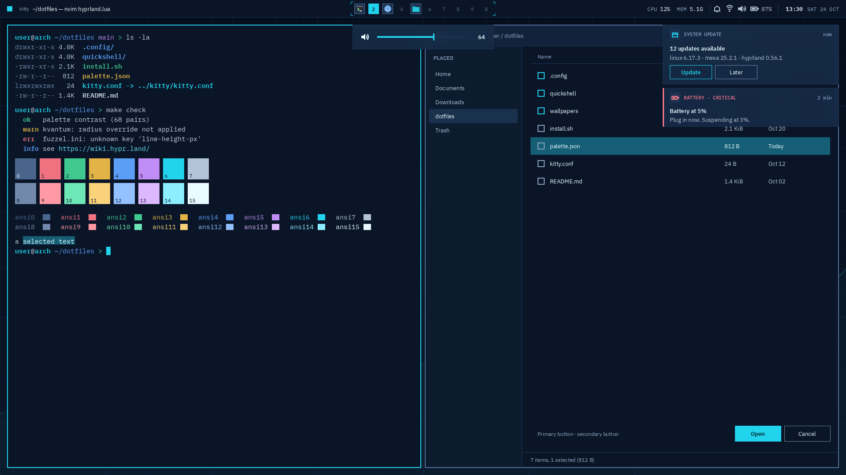

5.1 Top bar
Property | Value
Position | Top, full width, 40 px tall, no outer margin
Background | surface-base at 0.92 with blur, 1 px divider bottom edge with tick marks
Left | 12×12 cyan square (opens the left sidebar), window class (caption, text-muted), window title (body, text-primary)
Center | Workspaces 1 to 10
Right, right to left | Date SAT 24 OCT (mono 9, muted), clock 13:30 (mono 10/600, primary), divider, battery %, battery icon lying flat with the terminal pointing right, volume, network, notifications, divider, CPU 12% MEM 5.1G (label mono 9 muted, value mono 10 primary), tray
Icons | 16 px, text-secondary, 16 px between modules
Dividers | 1×20 px divider between module groups
Workspace cells are 24×24 px squares with an 8 px gap and BlexMono 9 pt numbers. The strip is framed by 6×1 px accent brackets.
State | Fill | Border | Content
Active | accent |  | Number in on-accent, 600
Occupied | surface-highest | 1 px border-inactive | Icon of the biggest window on it, 16 px, full color
Empty |  |  | Number in text-disabled
Urgent |  | 1 px warning | Icon, or the number if empty
If an app has no icon in the icon theme, the cell shows its number in text-secondary.

5.2 Notification popup
Property | Value
Position | Top right, 16 px below the bar and 16 px from the edge, stacked with 8 px gaps
Size | 400 px wide, height from content
Surface | surface-overlay at 0.92 with blur, 1 px divider border
Padding | 16 px
Header | 16 px app icon in a 24 px surface-highest square, APP NAME (BlexMono 8 pt/500, uppercase, text-muted), time on the right
Title | Plex Sans 10 pt/600, text-primary
Body | Plex Sans 10 pt, text-secondary, at most 3 lines
Actions | 96×32 px, 8 px apart. Primary: 1 px accent border, accent text. Secondary: 1 px outline border, text-primary text
Critical | 3 px error bar on the left, header text in error, never dismissed automatically

5.3 Volume and brightness OSD
Property | Value
Position | Centered, 16 px below the bar
Size | 320×56 px
Surface | surface-overlay at 0.92 with blur, 1 px divider
Content | 16 px icon inset 20 px, 4 px track in surface-highest, fill accent, 2×16 px accent thumb, value BlexMono 10/600 right-aligned and inset 20 px
Muted | Icon and value text-muted, fill text-disabled
Timeout | 1200 ms, then the 125 ms layer-out fade

5.4 Launcher (fuzzel)
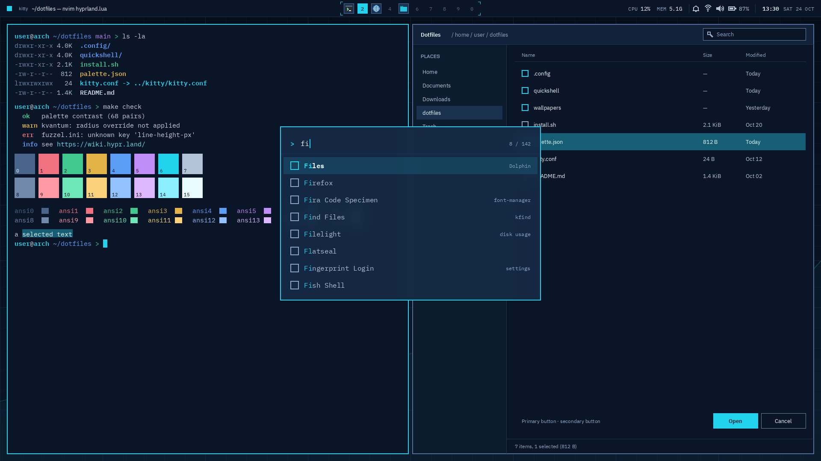
fuzzel can't draw 9-slices, so it gets the flat version of the highlight. Its 2 px cyan border matches the focused window border, since the launcher has keyboard focus. fuzzel writes colors as rrggbbaa without #.
Property | Value | fuzzel key
Size | 56 characters wide (about 610 px), 8 rows | width=56, lines=8
Row height | 40 px | line-height=40px
Padding | 24 horizontal, 16 vertical, 8 inner | horizontal-pad, vertical-pad, inner-pad
Font | BlexMono Nerd Font 12 pt, no DPI scaling | font, dpi-aware=no
Background | surface-overlay at 0.92 | background
Text, match | text-secondary, accent | text, match
Selected row | 14 % accent, text text-primary, match accent | selection, selection-text, selection-match
Prompt | > in accent, input text-primary | prompt, input
Border | 2 px accent, radius 0 | [border] width=2 radius=0
Icons | Papirus-Dark | icon-theme

5.5 Terminal (kitty)
Property | Value | kitty key
Font | BlexMono Nerd Font 11 pt | font_family, font_size
Margin | 0 | window_margin_width 0
Padding | 16 px | window_padding_width 12 (kitty counts in pt)
Opacity | 1.0 | background_opacity
Colors | Section 3.5 | color0 to color15 and friends

5.6 Lock screen (hyprlock)
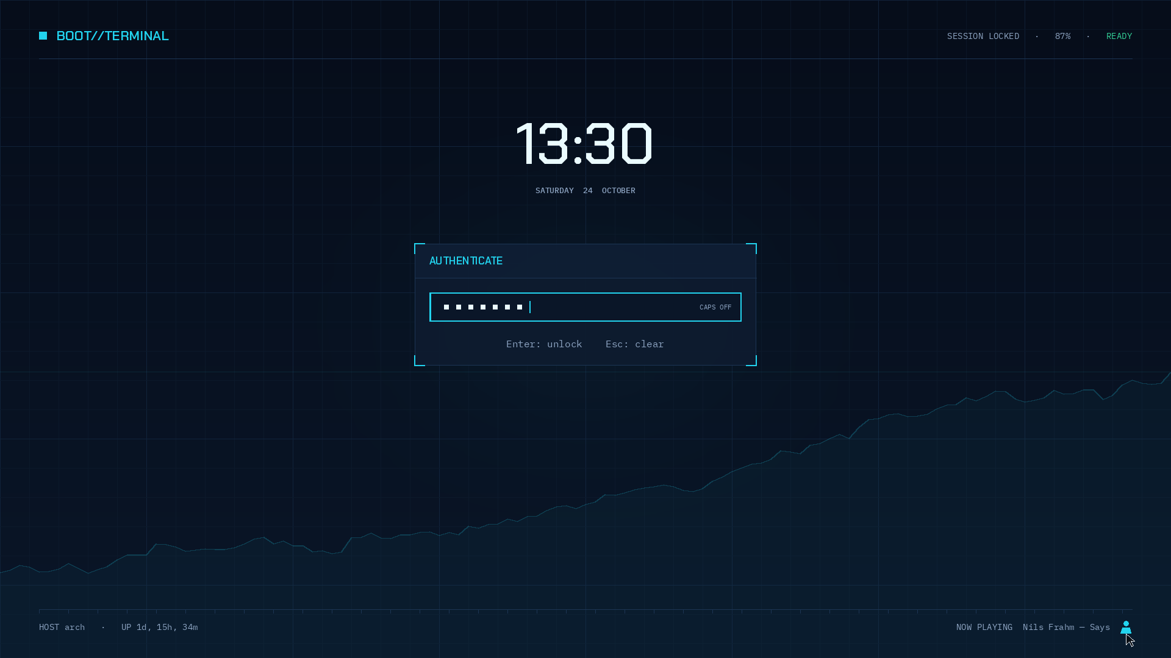
The lock screen reuses the GRUB layout: the same top and bottom bars and the same panel construction. Positions are absolute, so it only lines up at 1920×1080.
Element | Spec
Background | wallpaper.png, no blur
Top bar | 12 px accent square at x 64, then "BOOT//TERMINAL" in Chakra Petch 22 px accent at x 92, y 58. On the right, "SESSION LOCKED · 87% · " in mono 14 px text-muted, then "READY" in success, right-aligned at x 1856. Hairline at y 96
Clock | HH:MM in Chakra Petch 72 pt/500, text-primary, centered at y 236. Date below in BlexMono 10 pt/500, uppercase, text-muted, y 312
Panel | x 680 to 1240, y 400 to 600. surface-low at 0.92, 1 px divider border. A 56 px header in #0E1E34 holds only "AUTHENTICATE" (Chakra Petch 17 px/600, accent); there is no user name. 18×2 px cyan brackets on all four corners, built from eight shape widgets
Input | 512×48 px, 24 px inside the panel and below the header. Inner surface-base, 2 px accent outline, rounding 0. Dots are 8 px squares, 12 px apart, text-primary. Check accent, fail error, caps lock warning
Hint | "Enter: unlock Esc: clear", mono 16 px text-muted, centered 24 px below the input
Bottom bar | Hairline at y 1000 with ticks every 48 px. Left: host and uptime, mono 14 px text-muted. Far right: a 20 px user icon in accent, with now playing just left of it (empty when nothing plays)
User switch | Clicking the user icon asks GDM for a new login screen. The current session stays locked. The cursor stays visible for this
Alignment | Icons and the wordmark square are centered on the letters next to them, not on the text box

5.7 Session menu
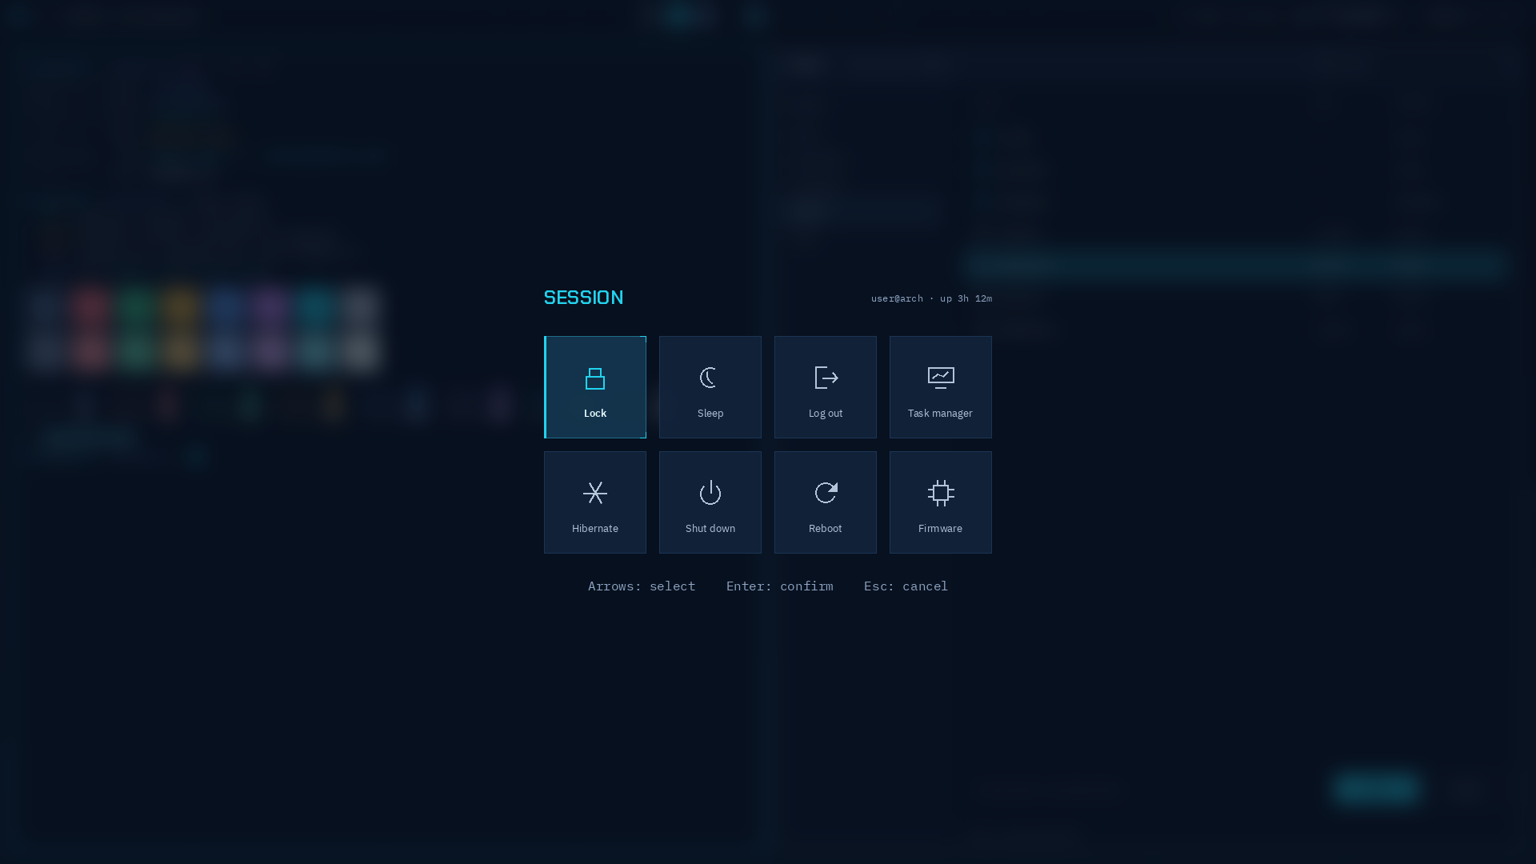
Property | Value
Backdrop | Full-screen blur (size 8, 2 passes) plus scrim
Header | "SESSION" in Chakra Petch 18 pt/600 accent, 48 px above the grid. user@host · uptime in BlexMono 9 pt muted, right-aligned
Grid | 4×2 tiles of 128×128 px with 16 px gaps (560×272), centered
Order | Lock, Sleep, Log out, Task manager, then Hibernate, Shut down, Reboot, Firmware
Tile | surface-raised at 0.92, 1 px divider, 32 px icon in text-secondary at y+36, label Plex Sans 10 pt text-secondary at y+96
Selected | GRUB highlight, icon accent, label text-primary 600
Hint | "Arrows: select Enter: confirm Esc: cancel", mono 16 px text-muted, 40 px below the grid
Destructive actions | No special color. Enter confirms

5.8 Right sidebar
Default | Matte, with Night Light
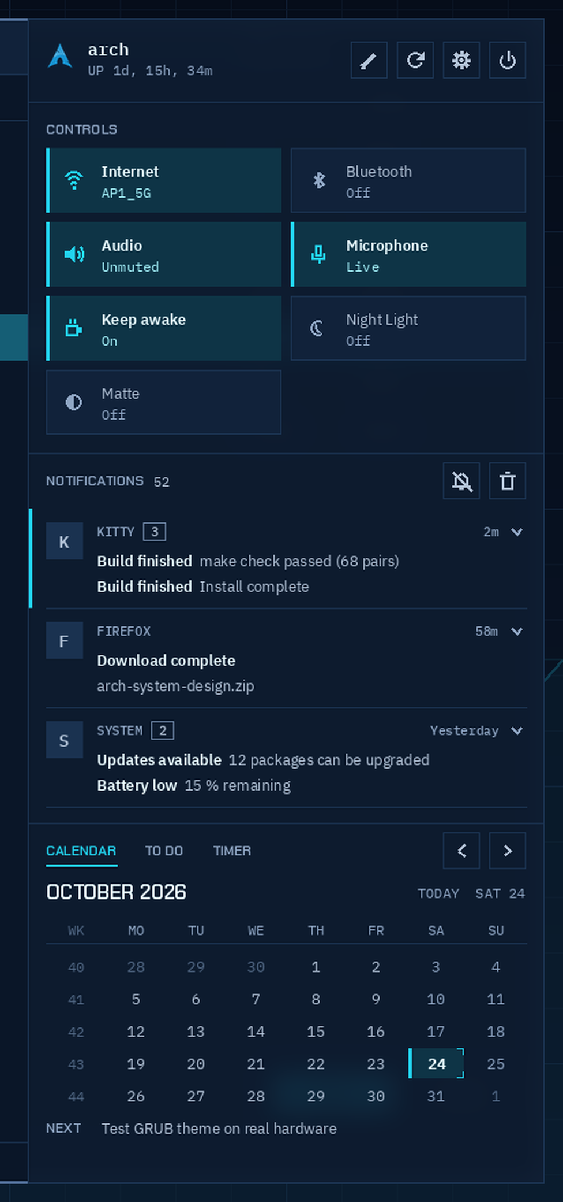 | 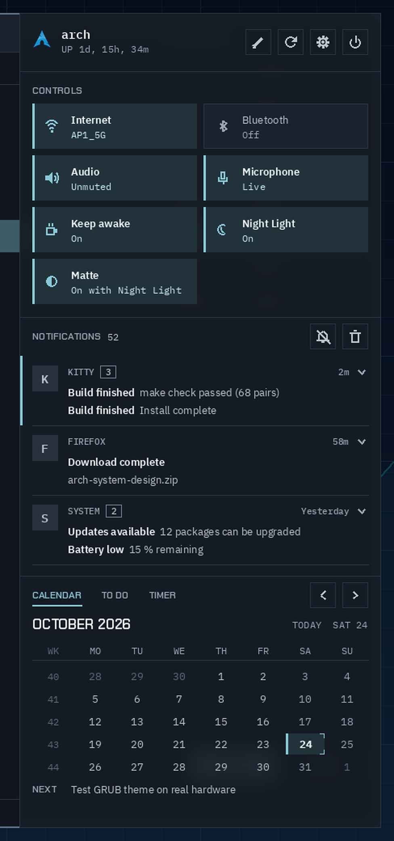
Property | Value
Position | Right edge, 16 px below the bar and 16 px from the right and bottom
Size | 448 px wide, the remaining height (1008 px at 1080)
Surface | surface-low at 0.92 with blur, 1 px divider border
Padding | 16 px. Full-width 1 px divider lines between sections
Section labels | Chakra Petch 9 pt/600, uppercase, text-muted
From top to bottom:
Header (72 px). Arch logo (24 px), host name in BlexMono 11 pt/600, uptime below it (UP 1d, 15h, 34m, BlexMono 9 pt muted). On the right, four 32 px square buttons 8 px apart: edit, reload, settings, power. Each has a 1 px divider border, a 16 px text-secondary icon and surface-hover on hover.
CONTROLS. Two columns of 204×56 px tiles with 8 px gaps: Internet, Bluetooth, Audio, Microphone, Keep awake, Night Light, Matte. Each tile has a 16 px icon inset 16 px, its name in Plex Sans 10 pt and a status line in BlexMono 9 pt (AP1_5G, Unmuted, On with Night Light). Left click toggles, right click opens the detail dialog.
Tile state | Look
Active | accent-container fill, 3 px accent bar on the left, icon accent, name text-primary 600, status on-accent-container
Inactive | surface-raised fill, 1 px divider border, icon and status text-muted, name text-secondary
The detail dialogs (Wi-Fi, Bluetooth, audio, Night Light) are square with a 1 px divider border, 16 px padding and a Chakra Petch uppercase title.
NOTIFICATIONS. The header shows the total count (BlexMono 9 pt, text-secondary) and 32 px mute and clear-all buttons. Notifications are grouped per app, groups separated by 1 px divider lines, and the list scrolls.
Group part | Spec
Badge | 32 px surface-highest square with the app's icon (20 px). Apps without an icon get their first letter (BlexMono 11 pt/600, text-secondary)
Header | APP NAME (BlexMono 8 pt/500, caps, text-muted), count box (1 px outline), time, expand arrow
Lines | One per notification: bold summary (Plex Sans 10 pt/600, text-primary), then the body in text-secondary, cut off with …
Unread | 3 px accent bar along the panel's left edge, spanning the group
Tabs: CALENDAR, TO DO, TIMER. Labels in Chakra Petch 9 pt/600 caps. The active tab is accent with a 2 px underline, the others text-muted. All three tabs share one fixed height: a 6-week calendar (tab row, month line, weekday header, 6 rows of 28 px, NEXT line). A 5-week month leaves an empty row under NEXT.
Tab | Spec
Calendar | Month title in Chakra Petch 13 pt/600 caps. "TODAY SAT 24" on the right (BlexMono 9 pt muted) returns to the current month. 32 px prev and next buttons. ISO week column (WK, text-disabled), then Monday to Sunday in 28 px rows of BlexMono 10 pt: weekdays text-secondary, weekends text-muted, other months text-disabled. Today gets the GRUB highlight with a 700-weight number. The NEXT line shows the first open to-do item
To Do | 36 px rows with 1 px dividers. 16 px square checkbox: open is a 2 px outline border, done is an accent fill with an on-accent check. Done items are struck through, text-muted and sorted to the bottom. × on hover deletes. Below: a square input with the placeholder NEW TASK and a 36 px + button with an accent border
Timer | POMODORO / STOPWATCH switch (active: accent-container, 1 px accent border). CYCLE 1 / 4 on the right. Time in Chakra Petch 48 pt/500, centered. FOCUS / BREAK / LONG BREAK in Chakra Petch 9 pt caps, current one accent. 2 px progress line. Full-width 40 px buttons: START and PAUSE filled accent, RESET and LAP outlined
To Do and Timer sit on top of ii's own Todo and TimerService, so tasks and running timers carry over from plain ii.
To Do | Timer
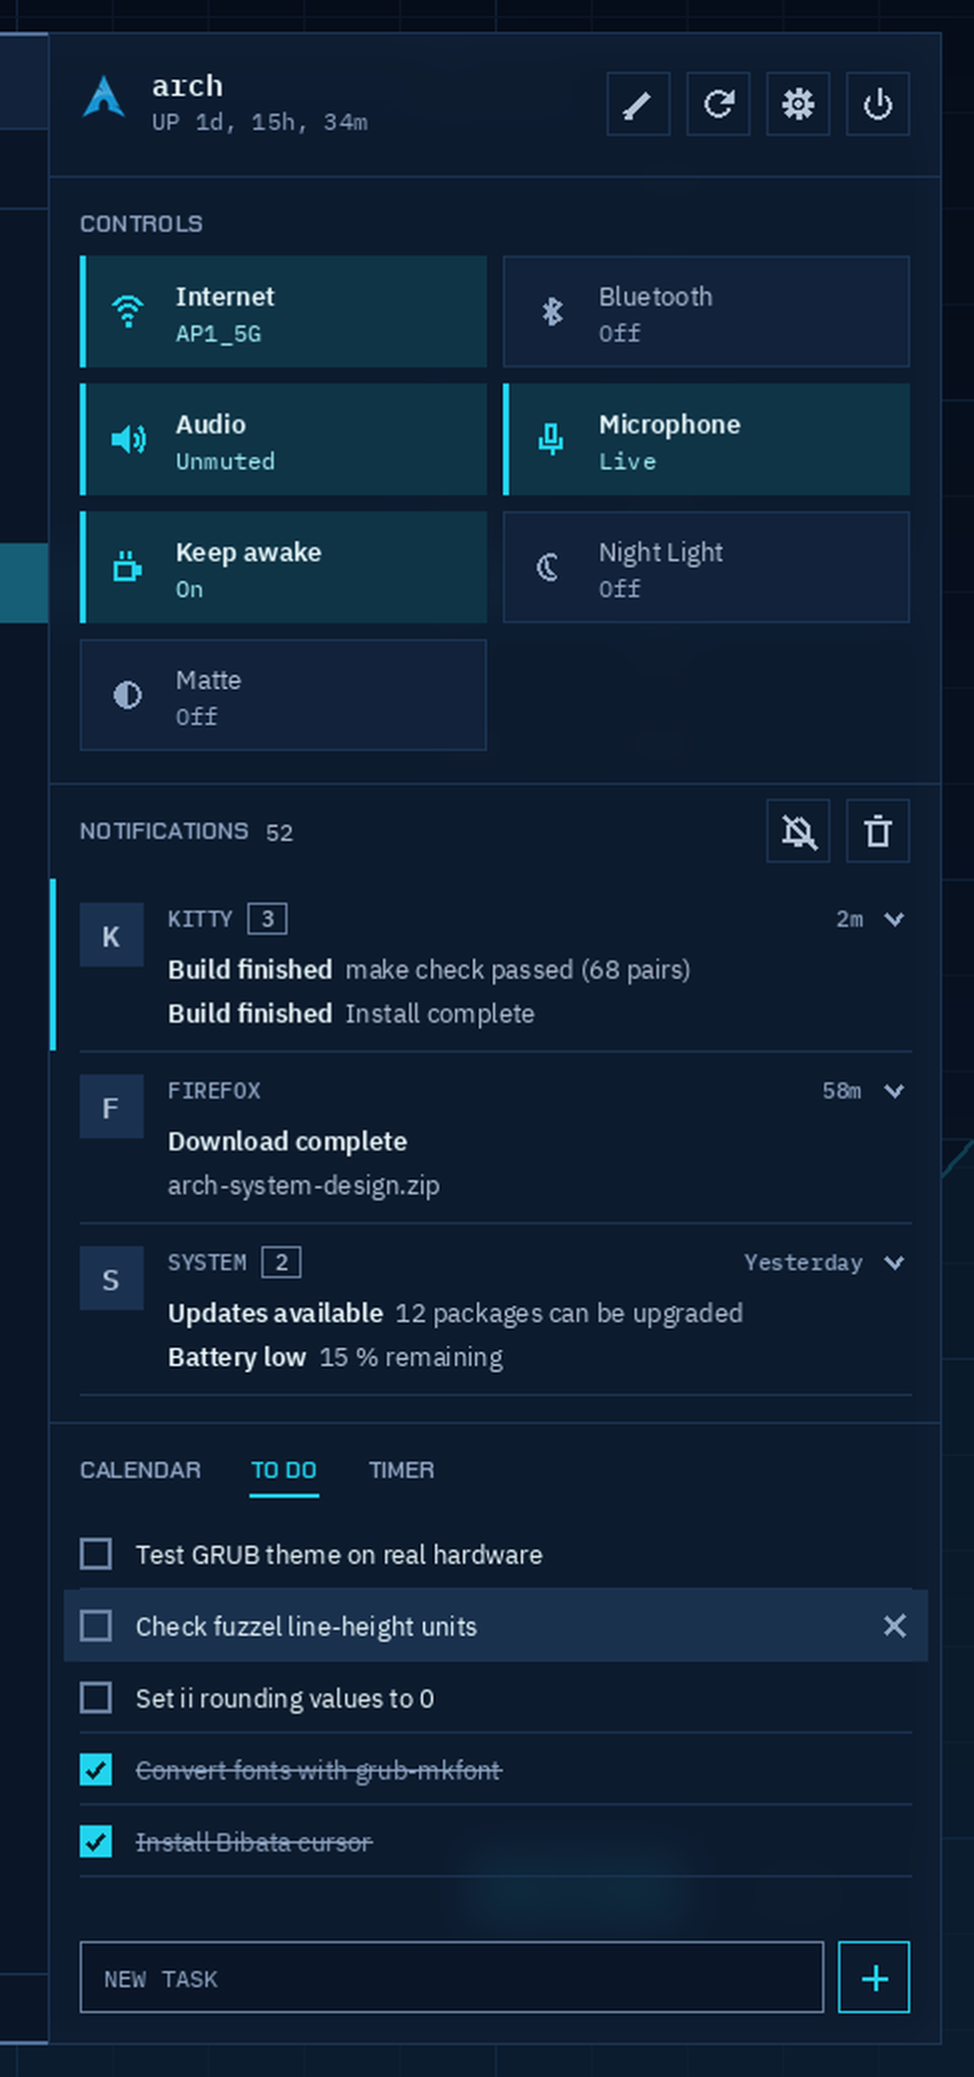 | 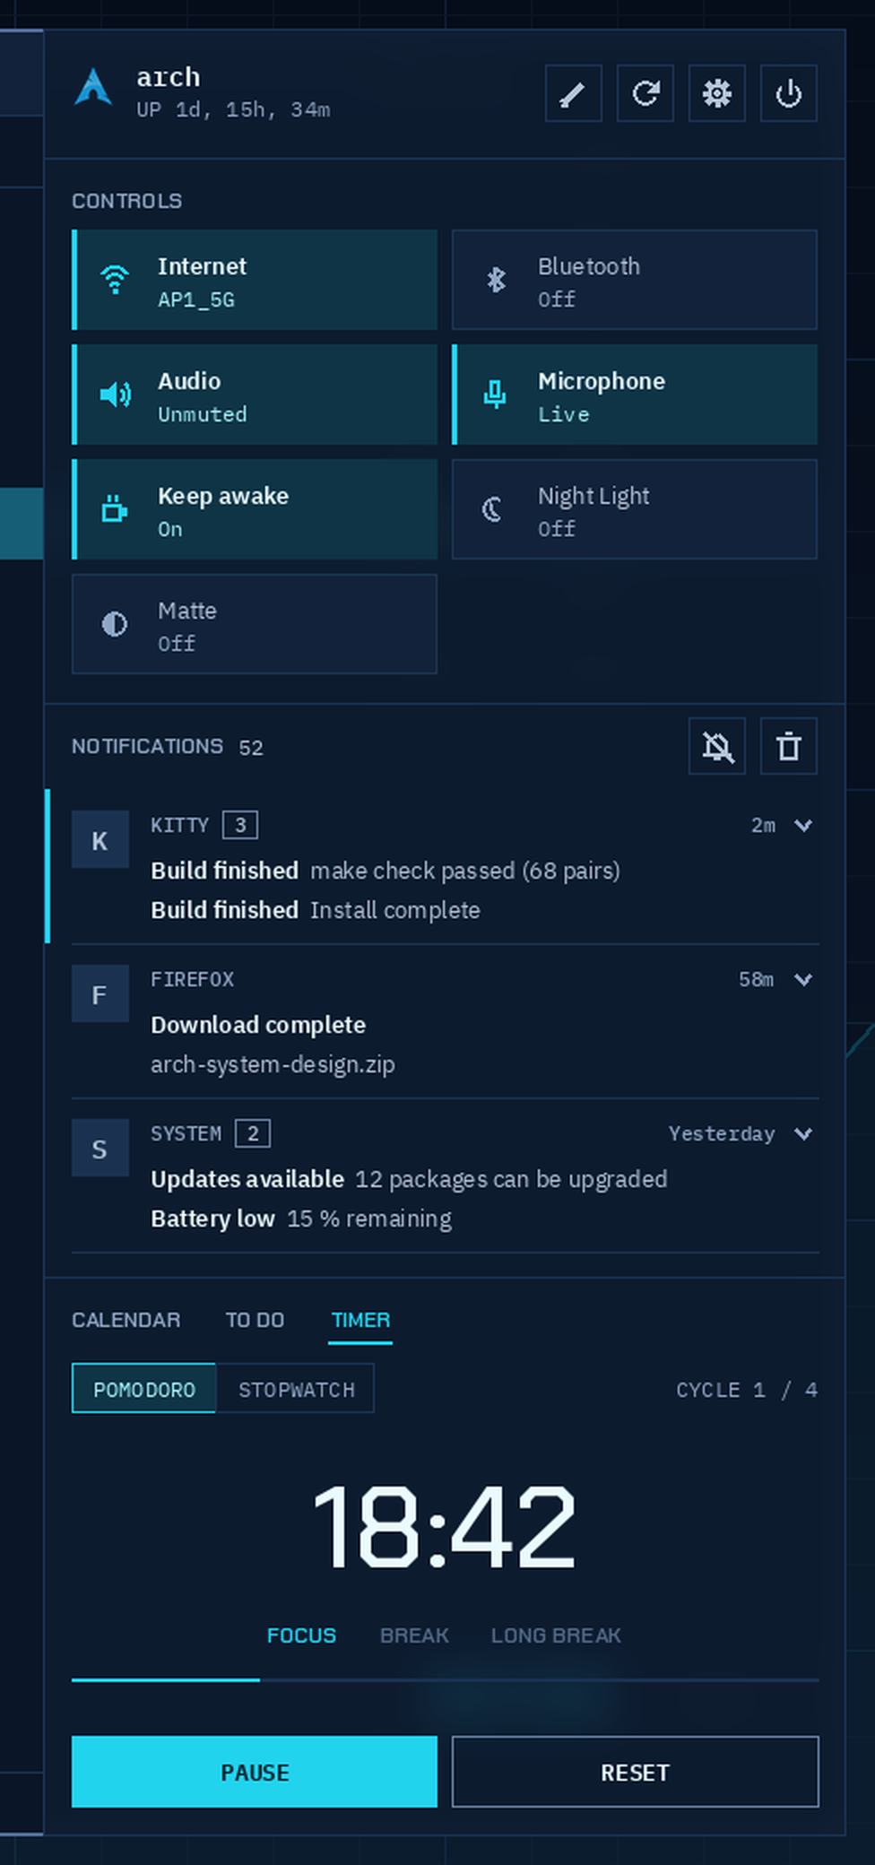

5.9 Left sidebar: AI tab
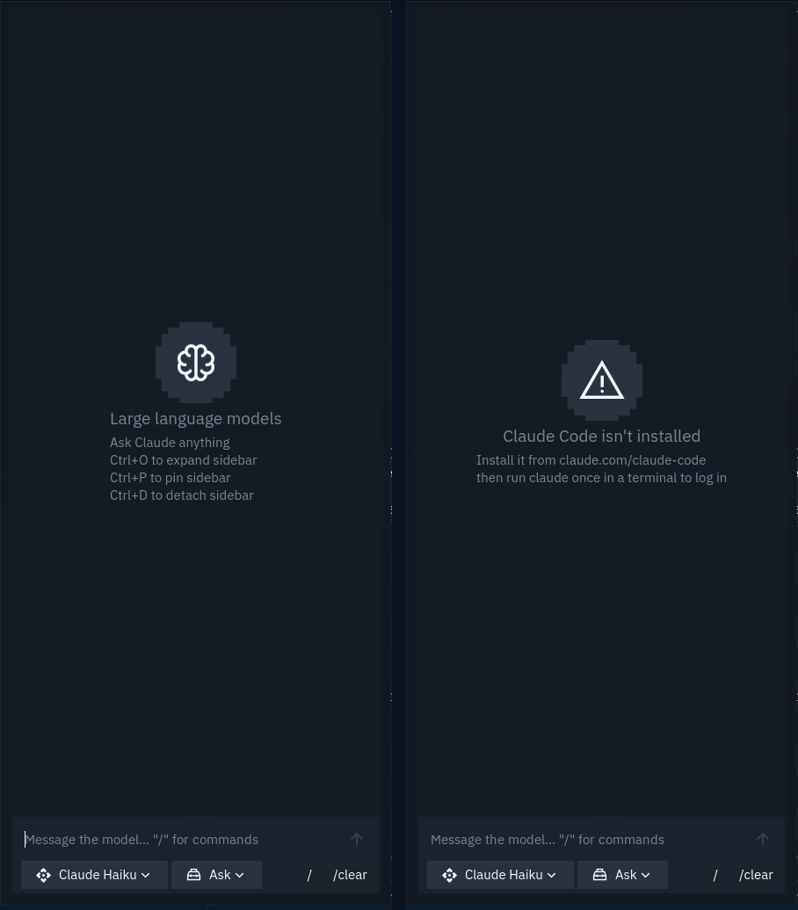
The AI tab runs the local Claude Code CLI instead of a web API. It uses the Claude login, so there's no API key to set.
Part | Behavior
Model picker | Claude Haiku, Sonnet, Opus
Mode picker | ask, edits, plan, full, mapped to Claude Code's --permission-mode values default, acceptEdits, plan, bypassPermissions
Sessions | One chat is one Claude session; later turns --resume it. /clear or loading a saved chat starts a new one
Permissions | Tool calls that Claude Code's settings don't allow show Approve and Reject buttons. Approve allows it for the rest of the session: the exact command for shell calls, the whole tool otherwise
Missing CLI | If claude isn't on the PATH, the tab says so
Removed | The Anime tab, the tab bar (when only the AI tab is left) and the key and temperature status row
The protocol details are in NOTES.md.

5.10 Shortcuts
Keys | Action
Super + H | ii's cheat sheet. Added because Super + / needs Shift on some layouts (German, for one)
Super + Shift + Alt + right click | Sends the selected text to the AI tab with a summary prompt, always on Haiku and in the text's language. Apps that don't publish their selection fall back to the clipboard

5.11 GTK, Qt and KDE apps
App | Approach
GTK 3 | ~/.config/gtk-3.0/gtk.css with @define-color values from the tokens and * { border-radius: 0; }
GTK 4 / libadwaita | The same @define-color names in ~/.config/gtk-4.0/gtk.css (accent_bg_color, window_bg_color, headerbar_bg_color, card_bg_color, popover_bg_color, dialog_bg_color, sidebar_bg_color, destructive_bg_color, success_color, warning_color, error_color)
KDE and Qt (Dolphin and others) | A KDE color scheme per palette, Tickerline and TickerlineMatte. Window and view surface-base, buttons and headers surface-raised, selection selection-bg, tooltips surface-overlay. Links accent-hover, negative error, neutral warning, positive success
Fonts | IBM Plex Sans 10 and BlexMono Nerd Font 10, through gsettings, kdeglobals and fontconfig

5.12 Cursor and icons
What | Choice | Why
Cursor | Bibata-Original-Classic, 24 px, installed to ~/.local/share/icons from the Bibata GitHub release | "Original" has sharp tips, "Classic" is dark with a light outline. The AUR package would clash with ii's Bibata package
Icons | Papirus-Dark, optionally with cyan folders (papirus-folders -C cyan --theme Papirus-Dark) | Flat, squarish, and the cyan folders pick up the accent

6. Wallpaper
desktop/wallpaper.png is 1920×1080, 8-bit RGB. It is the GRUB background without the panel, the top and bottom bars and all text: the same gradient, the 48 px grid with major lines every 240 px, the soft cyan bloom, the price chart and the last-price line. Booting from GRUB into the desktop looks like the panel and text bars fading out of the same scene.

7. GRUB boot menu
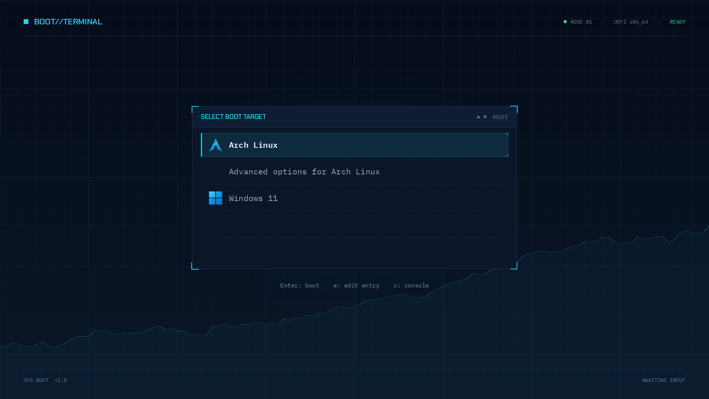
A static menu for a dual-boot PC (Arch Linux and Windows), drawn for exactly 1920×1080. No countdown, no animation. design/grub/mockup_main.png is the target and mockup_advanced.png shows the Advanced options submenu at its 5-row maximum.

7.1 What GRUB draws and what is baked in
Layer | Drawn by | Contents
background.png | Baked | Gradient, grid, price chart, top bar ("BOOT//TERMINAL", "NODE 01 · UEFI x86_64 · READY"), bottom bar, the whole panel frame with its SELECT BOOT TARGET header, corner brackets, dotted guides between rows
boot_menu | GRUB | Entry labels, icons, selection highlight
label | GRUB | Enter: boot e: edit entry c: console
The panel frame is in the background, so menu_pixmap_style stays unset.

7.2 Layout
The design numbers and the values that make GRUB actually draw them differ, because of how GRUB places the 9-slice highlight. Both are listed. The theme file uses the right-hand column.
Property | Design | theme.txt | Why they differ
Menu left / top | 544 / 360 | 544 / 360
Menu width | 832 | 834 | GRUB takes 2 px off when it computes the highlight width
Menu height | 352 (5 rows) | 352
Row height | 64 | item_height = 48 | The top and bottom slices (8 px each) are drawn outside item_height
Gap between rows | 8 | item_spacing = 24 | Keeps the 72 px row pitch
Padding |  | item_padding = 0 | Padding shifts the whole list right and down
Highlight edge to icon | 20 | left slices 20 px wide | GRUB puts the icon right after the left slice
Icon | 40×40 | 40×40
Icon to label | 16 | item_icon_space = 16
Scrollbar | off | off
Row n (counting from 0) starts at y = 360 + n × 72, so the rows fall between the dotted guides at y 427, 499, 571 and 643. The baked panel spans x 520 to 1400 and y 288 to 728, with the header from y 288 to 344. The hint line sits at y 760, 24 px tall, full width, centered.

7.3 Selection highlight
Nine slices, select_*.png, 8-bit RGBA. The corners and right edge are 8×8 px. The three left slices (select_nw, select_w, select_sw) are 20 px wide; the extra 12 px repeat each slice's inner column, so the left bar and border look the same while the icon gets its 20 px inset.
- Center: #22D3EE at 10 % alpha
- Top, bottom and right borders: 1 px #22D3EE at 35 %
- Left: a 3 px solid #22D3EE bar, full height
- Right corners: 8 px L-brackets in solid #22D3EE
- The outer edge covers x 544 to 1376 and the full 64 px row

7.4 Fonts and colors
Use | Font in theme.txt | Color
Entry | IBM Plex Mono Regular 22 | #8FA6C4
Selected entry | IBM Plex Mono SemiBold Regular 22 | #EAFBFF
Hint line | IBM Plex Mono Regular 16 | #7D95B5
Fallback background (desktop-color) |  | #0A1628
Contrast: entries 7.2:1 on the panel, the selected entry 13.8:1 on the highlight, the hint 5.1:1 on the background. Chakra Petch and the 14 px status text only appear inside background.png.
grub-mkfont only knows Regular and Bold, so a SemiBold file converted plainly gets the name IBM Plex Mono Regular 22, the same as the Regular file. grub/build-fonts.sh therefore passes -n "IBM Plex Mono SemiBold", which produces the name IBM Plex Mono SemiBold Regular 22. If a name in theme.txt doesn't match a loaded font, GRUB silently uses its default font. strings file.pf2 | grep -m1 Plex shows the name inside a file.

7.5 Icons
Icons map by entry class: icons/arch.png for --class arch, icons/windows.png for --class windows (os-prober sets that). Entries with other classes get no icon; copy or rename a file to match. "Advanced options" has no icon, and its label still lines up with the others.

7.6 Install and preview
sudo grub/install.sh finds the GRUB folder (/boot/grub, /efi/grub or /boot/efi/grub), copies the theme to themes/boot-terminal/, builds the fonts, sets these keys in /etc/default/grub and runs grub-mkconfig:
GRUB_THEME="<grub dir>/themes/boot-terminal/theme.txt"
GRUB_GFXMODE=1920x1080,auto
GRUB_GFXPAYLOAD_LINUX=keep
GRUB_TIMEOUT_STYLE=menu
The old file is kept once as /etc/default/grub.pre-tickerline. GRUB_TIMEOUT isn't touched; set it to -1 if you want the menu to wait without a countdown, as in the design.
grub/preview.sh packs the theme and grub/preview.cfg into a standalone GRUB EFI binary, boots it in QEMU with OVMF at 1920×1080, presses the given keys and saves grub/shot.png. It runs headless in about 20 seconds.
grub/preview.sh # main menu
grub/preview.sh "down" # second entry selected
grub/preview.sh "down ret" # Advanced options submenu
Two things preview.cfg needs that a real grub.cfg already has: one loadfont line per font (a *.pf2 glob needs insmod regexp, and without fonts GRUB falls back to 8 px Unifont), and export theme, or submenus open in text mode on a black screen.

7.7 Rules for the artwork
- One accent hue. Cyan means selected or frame. Green appears once, on READY. No red.
- Square edges, with brackets at corners.
- No shadow, glow or transparency on live text. Any glow is baked into the background.
- PNGs must be 8-bit RGB or RGBA. GRUB can't read indexed or palette PNGs; with ImageMagick, write with a PNG32: prefix.

8. How it's built

8.1 Install
install.py checks the requirements (ii present, Hyprland on the Lua config, kitty, fuzzel, hyprlock, the fonts, Papirus) and prints the pacman command for anything missing. Then it:
- copies desktop/ and uninstall.py to ~/.local/share/tickerline/ and the wallpaper to ~/.local/share/backgrounds/tickerline.png
- downloads Chakra Petch and the Bibata cursor if they aren't there yet
- writes ~/.config/hypr/custom/tickerline.lua and loads it from custom/general.lua
- sets kitty, fuzzel and fontconfig values, GTK fonts and icons (gsettings) and KDE fonts (kwriteconfig)
- edits ii's config.json: matugen off, fonts, transparency 0.92, flat bar, numbered workspaces, hyprlock, wallpaper, the Dark Mode toggle shown, the Anime tab off, no extra AI models
- runs apply-palette.py and restarts Quickshell
Before changing a file for the first time, it saves the original as <file>.pre-tickerline. Running it again is safe. The installed copy doesn't depend on the clone, so the clone can be moved or deleted afterwards.
Without git, the source archive (without design/ and dev/) is enough:
curl -L https://github.com/luto2/Tickerline/archive/refs/heads/main.tar.gz | tar xz
Tagged releases have the same archive under archive/refs/tags/<tag>.tar.gz.

8.2 apply-palette.py
apply-palette.py reapply everything with the saved state
apply-palette.py --matte toggle Matte on or off (also: on, off)
apply-palette.py --night on|off called by ii's Night Light; on forces Matte
The Matte palette is active when either matte or night in ~/.local/state/tickerline/ is on. Each run writes:
Target | Contents
~/.local/state/quickshell/user/generated/colors.json | M3 colors for ii, reloaded live
generated/material_colors.scss | For ii's terminal scripts
generated/ticker-tokens.json | All tokens plus _variant, _matte, _night; read live by the bar, sidebar and Matte toggle
generated/terminal/kitty-theme.conf | kitty colors
~/.config/hypr/hyprland/colors.lua | Border and background colors
~/.config/hypr/hyprlock.conf, hyprlock/colors.conf | Lock screen layout, every token as $name
~/.config/fuzzel/fuzzel_theme.ini | Launcher colors
~/.config/gtk-3.0/gtk.css, gtk-4.0/gtk.css | From ii's matugen templates, plus libadwaita pins
~/.local/share/color-schemes/Tickerline[Matte].colors | KDE and Qt scheme
ii's QML | Radius 0 with spacing put back, Sharp icons, no shadows, square notification icons, dialog styling, the replacement bar and sidebar, the Matte toggle, the Night Light hook, the Claude Code AI tab
Then it reloads Hyprland, kitty (SIGUSR1), the Plasma color scheme and KDE's icon cache.
ii uses its rounding values as padding in many places, so zeroing them would also remove padding. The script puts fixed spacing back wherever a rounding value is used as a margin or padding (SPACE in the script: 4, 8, 12, 16 or 24 px).
In the replacement QML, a quoted "{{token}}" becomes (TickerTokens.t["token"] ?? "transparent"). TickerTokens watches ticker-tokens.json, which is why switching palettes needs no restart.
ii updates overwrite the patched files. After every dots-hyprland update, run python3 ~/.local/share/tickerline/apply-palette.py.

8.3 Uninstall
uninstall.py moves every .pre-tickerline file back, deletes the files the theme added, and removes its line from custom/general.lua. Fonts, the cursor and font settings stay. Afterwards restart the shell and pick a wallpaper in ii so matugen recolors everything. If ii was updated after the install, the backups of ii's files are older than the update; run ii's update again.
GRUB: sudo cp /etc/default/grub.pre-tickerline /etc/default/grub && sudo grub-mkconfig -o /boot/grub/grub.cfg. If the theme ever breaks, GRUB shows its plain text menu and still boots.

8.4 Working on the theme
dev/nested.sh starts a second Hyprland as a window inside the running session, with its home folder at local/dev-home (ignored by git). It copies dots-hyprland's config on the first run, links your fonts and icons, runs install.py with stubbed reload commands and a private D-Bus session, then starts Hyprland. Every start reinstalls the repo's current state; --reset starts over.
The nested session can't test the lock screen, idle or GRUB, and keybinds the outer Hyprland already uses won't reach it. Use grub/preview.sh for the boot menu.
Things that waste time if you don't know them (more in NOTES.md):
- Quickshell only loads new or renamed QML files after a full restart. After a failed reload it can keep running a stale copy, and its errors then point at code that no longer exists.
- In ii components, avoid a property called active on a MouseArea component, anything named data, an id called bottom, and inline component names that clash with ii widgets (prefix them with Ticker).
- A plain file path as an IconImage source needs a file:// prefix.
- kitty padding is in pt, fuzzel scales fonts by DPI unless dpi-aware=no, and hyprlock reads # as a comment (write ##RRGGBB in label text).

9. Known limits
- GTK4 and libadwaita keep small rounded corners on some buttons and dialogs. A stylesheet can't reach all of them, and libadwaita isn't patched.
- The lock screen and the boot menu use pixel positions for 1920×1080. On other resolutions they don't line up. The desktop itself works at any resolution.
- The boot panel fits 5 rows. More entries scroll inside it, without a scrollbar.
- The lock screen's user switch only works with GDM.
- ii updates undo the QML patches until apply-palette.py runs again.

