ARTICLE
A Leakage-Controlled Evaluation of Class-Imbalance Strategies for Credit-Card Fraud Detection
Henry Veilhelm Lutterodt¹, Edward Danso Ansong¹, Simon Bonsu Osei¹, Benjamin Yankson², Prince Boakye-Sekyerehene¹
¹ Department of Computer Science, University of Ghana, Accra, Ghana
² Department of Cybersecurity, University at Albany, Albany, NY 12222, USA
*Corresponding author: Henry Veilhelm Lutterodt. Email: veilhelmz@gmail.com
ABSTRACT Credit-card fraud benchmarks are extremely imbalanced, so accuracy and results from contaminated test sets can give a misleading picture of detection quality. We audited the supplied notebook and manuscript, then rebuilt the evaluation as a reproducible comparison of class weighting and SMOTE-ENN for logistic regression, random forest and XGBoost on the European Credit Card Fraud Detection dataset. The 284,807 records were divided chronologically on complete Time groups into training (199,364), validation (42,722) and test (42,721) partitions. Scaling and SMOTE-ENN were fitted using training records only. Each decision threshold was selected by F1 on validation data, and the test partition was evaluated once at that fixed threshold. It contains 52 frauds. The highest test F1 was 0.788 (95% stratified-bootstrap interval 0.698–0.868) for class-weighted XGBoost; its precision was 0.830 and recall 0.750. SMOTE-ENN and class weighting produced similar random-forest results: the paired F1 difference was 0.011, with a 95% interval from −0.043 to 0.062, and exact McNemar p=1.00. We report CPU batch-averaged inference time, serialized estimator size, uncertainty intervals and validation-set permutation importance. These measurements do not establish peak memory use or edge-device suitability. The dataset contains no cardholder identifier, so it cannot support per-card GRU sequences. The revised contribution is a leakage-controlled, uncertainty-aware benchmark; previous MobileNetV3, GRU, stacking and near-perfect-performance claims are withdrawn. Independent datasets and device-specific measurements remain necessary.
KEYWORDS credit-card fraud detection; class imbalance; data leakage; chronological evaluation; SMOTE-ENN; uncertainty; permutation importance

1 Introduction
Credit-card fraud detection is a rare-event classification problem. The widely used European benchmark contains 284,807 transactions, including 492 labelled as fraud, and its anonymized tabular variables are often used to compare detection methods [1,2]. Under this prevalence, a classifier can attain very high accuracy while missing many fraud cases. Precision, recall, F1 and precision–recall summaries therefore need to be reported alongside accuracy [7].
The evaluation protocol matters as much as the classifier. If synthetic samples or data-dependent preprocessing are created before the holdout is formed, information from records later treated as test observations can influence training. This is a documented source of optimistic performance in machine-learning research, including credit-card fraud studies [3,4]. In the supplied project materials, the original notebook contains stale saved outputs, and the current evaluation cells use test labels when setting the decision threshold. The summarized paper also reports a MobileNetV3–GRU–MLP stack and near-perfect metrics that the supplied executable notebook does not implement. Those numbers cannot be treated as reproducible held-out estimates.
This revision replaces those claims with a controlled comparison of three conventional classifiers under two imbalance treatments: class weighting and SMOTE-ENN. We split by transaction Time, fit scaling and resampling on training records only, choose thresholds on a separate validation partition, and reserve the final partition for one evaluation. The dataset has no stable card or account identifier; its Time field is elapsed time from the first recorded transaction. It therefore does not support grouping transactions into card-level sequences. We make no claim that a GRU or a one-dimensional MobileNetV3 was evaluated.
The contribution is a transparent benchmark with confidence intervals, a paired comparison of random-forest imbalance variants, CPU and storage measurements, and validation-set permutation importance. We do not claim a new architecture, a state-of-the-art ranking, or edge readiness. Since only one benchmark was available in the supplied project and it is a historical dataset, the results are scoped to this dataset and require external validation.

2 Related work

2.1 Evaluation under class imbalance
Credit-card fraud detection involves severe imbalance and changing transaction distributions, making performance sensitive to sampling, feature timing and evaluation design [2]. SMOTE generates minority-class observations by interpolation [5]; SMOTE-ENN combines that oversampling step with edited-nearest-neighbour cleaning [6]. Both methods must be applied after the holdout split and only to the training partition if the test is to remain independent. Class weighting provides a cost-sensitive comparator without synthesizing observations.
Precision–recall curves are informative when positives are rare because precision reflects the fraction of alerts that are true frauds, while recall measures how many frauds are found [7]. Average precision (AP) summarizes ranking performance over thresholds; it does not select an operational threshold. Threshold-dependent precision, recall and F1 should be reported separately, and the threshold must be fixed without using test labels.

2.2 Temporal and lightweight-model claims
Sequence classifiers have been studied for credit-card fraud when transactions can be organized into meaningful histories [8]. That assumption requires a customer, account or card identifier, which is absent from the benchmark used here. Sorting anonymous transactions by Time creates a chronological holdout but does not create within-card sequences. MobileNetV3 was designed through hardware-aware search for mobile vision workloads [14]; its origin does not demonstrate superiority on an arbitrary ordering of anonymized PCA columns. Lightweight anomaly-detection and knowledge-distillation research is relevant to deployment questions in other settings [15], but its results do not validate this dataset or the unimplemented architecture in the earlier draft.

3 Materials and methods

3.1 Dataset and predictors
We used the public European Credit Card Fraud Detection CSV distributed through Kaggle [1]. It contains 284,807 transactions from September 2013 and 492 positive labels (0.1728%). The 30 predictors are elapsed Time, anonymized PCA variables V1–V28 and Amount; Class is the binary target. We retained these 30 numeric predictors. The file contains no cardholder identifier or transaction-chain key. Time was used both to define chronological partitions and as a numeric predictor; we did not infer unobserved sequences or cyclic daily patterns.

3.2 Leakage-controlled split and preprocessing
Rows were stably sorted by Time. All records sharing the same Time value were kept together, and cumulative row counts were used to choose boundaries closest to 70%, 85% and 100% of the dataset. The resulting training, validation and test partitions contain 199,364, 42,722 and 42,721 records, respectively. The first and last Time values are 0–132,928 for training, 132,929–151,328 for validation and 151,329–172,792 for testing. This is a forward-in-time holdout, not a card-level grouping split.
Table 1. Chronological partition composition
Partition | Transactions | Frauds | Legitimate | Fraud rate
Training | 199,364 | 384 | 198,980 | 0.193%
Validation | 42,722 | 56 | 42,666 | 0.131%
Test | 42,721 | 52 | 42,669 | 0.122%
A StandardScaler was fitted to the training predictors and then applied unchanged to validation and test data. For SMOTE-ENN variants, SMOTE used five neighbours and EditedNearestNeighbours used three neighbours. The combined resampler was fitted only on the scaled training partition. It produced 397,960 training rows: 198,980 fraud and 198,980 legitimate transactions. Validation and test data retained their original observations and prevalence. No resampling was done before the chronological split.
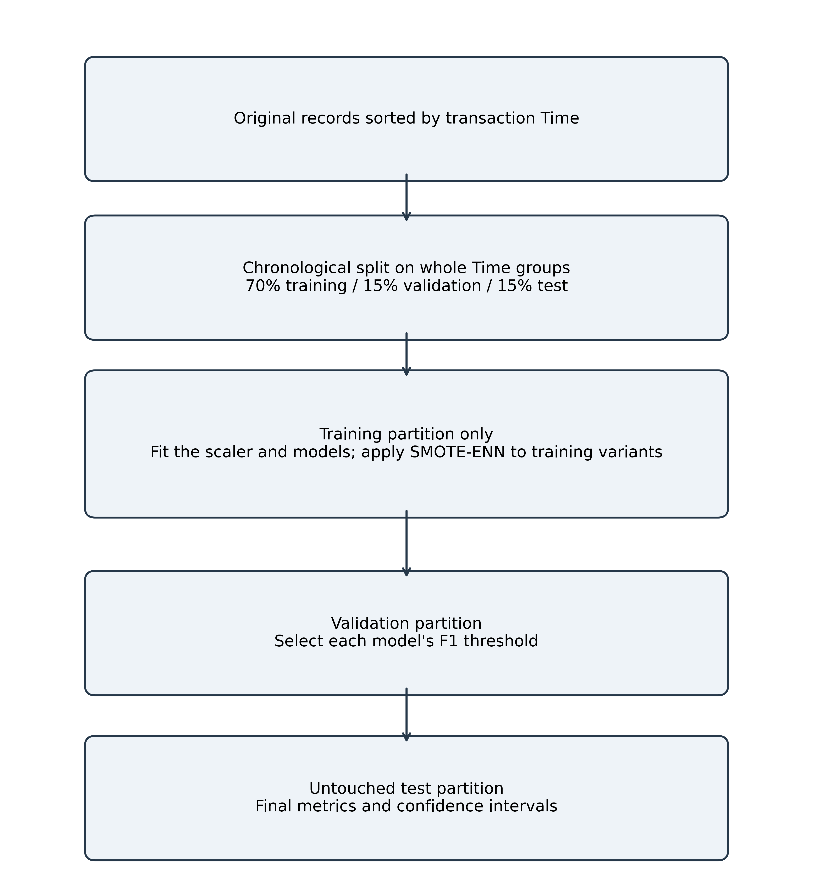
Figure 1. Leakage controls in the evaluation workflow: split first, fit preprocessing and resampling on training only, select thresholds on validation, and evaluate on untouched test records.

3.3 Classifiers and imbalance variants
We compared logistic regression, random forest and XGBoost using fixed settings and random seed 42. The class-weighted logistic model used balanced class weights, the L-BFGS solver and a maximum of 1,000 iterations. The random forest used 200 trees, minimum leaf size two, unlimited depth and balanced-subsample weights for the weighted variant. XGBoost used 300 trees, depth four, learning rate 0.05, row and column subsampling of 0.8, L2 regularization of 1, maximum delta step of 1 and histogram tree construction on CPU. Its scale_pos_weight was set from the training class ratio. The SMOTE-ENN variants used the corresponding estimator without the logistic or forest class weight; XGBoost used the post-resampling class ratio. We did not search hyperparameters or compare neural architectures. The implementation uses scikit-learn and imbalanced-learn [11,12].

3.4 Threshold selection and performance measures
For each fitted model, positive-class probabilities were computed on validation and test records. The decision threshold maximizing validation F1 was fixed before test classification. We report precision, recall, F1, average precision, ROC AUC and confusion counts. Precision, recall and F1 are defined as follows:
P = TP / (TP + FP); R = TP / (TP + FN); F1 = 2PR / (P + R).
P denotes precision and R denotes recall.
Two-sided 95% Wilson intervals are reported for precision and recall [16]. F1 intervals are percentile intervals from 2,000 bootstrap replicates that resample fraud and legitimate test observations separately, preserving the test class counts. For the exploratory paired comparison of the two random-forest variants, we resampled the same test indices for each model to form a confidence interval for the F1 difference and used an exact McNemar test on paired fraud-case detections [17]. These intervals condition on the fitted models and do not capture variation from retraining, hyperparameter selection or a new source population.

3.5 Runtime and explainability
Training duration was timed separately for each classifier fit; the shared SMOTE-ENN fit_resample operation was timed separately. CPU inference was measured after one warm-up call on batches of up to 5,000 test records; the median of seven batch-average timings is reported in microseconds per record. It excludes data loading, scaling, alert delivery and single-record service overhead. Serialized estimator size is the byte count of the fitted estimator object; it excludes the scaler, Python runtime, dependencies and process memory. Peak resident memory was not measured.
For global explanation, we selected the model with the highest validation AP across the six fitted variants, the class-weighted random forest (0.876). We measured the decrease in validation AP when each feature was permuted, using five repeats [13]. This analysis uses validation data only and describes predictive reliance, not causal effects; correlated PCA features can share or redistribute importance. Error bars show the standard deviation across the five permutations, not a confidence interval.

4 Results

4.1 Held-out performance
The untouched test partition contained 42,721 transactions and 52 frauds (0.122%). Table 2 reports point estimates and intervals. Class-weighted XGBoost had the highest F1 (0.788; 95% CI 0.698–0.868), with precision 0.830 (0.699–0.911), recall 0.750 (0.618–0.848), AP 0.764 and ROC AUC 0.983. It detected 39 of 52 frauds and produced eight false-positive alerts. The class-weighted random forest detected 39 frauds with ten false positives; its F1 was 0.772 (0.680–0.854).
SMOTE-ENN changed results modestly and not uniformly. For the random forest, F1 increased from 0.772 to 0.784 while recall changed from 0.750 to 0.731; the resampled model detected 38 frauds with seven false positives. Logistic regression had the same confusion counts under both variants at the validation-selected thresholds. High accuracy across all variants is driven mainly by the large legitimate class and should not be interpreted as near-perfect fraud detection.
Table 2. Performance on the untouched chronological test partition
Model variant | Precision  (95% CI) | Recall  (95% CI) | F1  (95% CI) | AP | ROC AUC
LR, weighted | 0.943 (0.814–0.984) | 0.635 (0.499–0.752) | 0.759 (0.651–0.848) | 0.707 | 0.977
LR, SMOTE-ENN | 0.943 (0.814–0.984) | 0.635 (0.499–0.752) | 0.759 (0.651–0.848) | 0.718 | 0.976
RF, weighted | 0.796 (0.664–0.885) | 0.750 (0.618–0.848) | 0.772 (0.680–0.854) | 0.767 | 0.927
RF, SMOTE-ENN | 0.844 (0.712–0.923) | 0.731 (0.597–0.832) | 0.784 (0.688–0.863) | 0.780 | 0.964
XGB, weighted | 0.830 (0.699–0.911) | 0.750 (0.618–0.848) | 0.788 (0.698–0.868) | 0.764 | 0.983
XGB, SMOTE-ENN | 0.844 (0.712–0.923) | 0.731 (0.597–0.832) | 0.784 (0.687–0.863) | 0.755 | 0.974
Precision and recall intervals use the Wilson method; F1 intervals use a 2,000-replicate class-stratified percentile bootstrap. AP = average precision; LR = logistic regression; RF = random forest; XGB = XGBoost. Thresholds were selected on validation data; exact values and confusion counts are included in the machine-readable results file.

4.2 Paired random-forest comparison
The class-weighted and SMOTE-ENN random forests were compared on identical test records. The SMOTE-ENN model minus class-weighted model F1 difference was 0.011, with a paired class-stratified 95% bootstrap interval of −0.043 to 0.062. One fraud case was detected only by the weighted model and none only by the resampled model; the exact McNemar p-value was 1.00. The interval includes zero, so this test does not show a detectable difference in paired fraud detections. The comparison was exploratory and limited to the random-forest pair; it is not evidence that the methods are equivalent across models or datasets.

4.3 Validation precision–recall behaviour
Figure 2 compares validation precision–recall curves for the two random-forest variants. The dashed horizontal line marks the validation fraud prevalence (0.00131). This figure describes threshold-free ranking on validation data; it is separate from the test estimates in Table 2. The SMOTE-ENN random forest had slightly lower validation AP than its class-weighted counterpart (0.866 versus 0.876), which is why the class-weighted forest was selected for the feature-importance analysis.
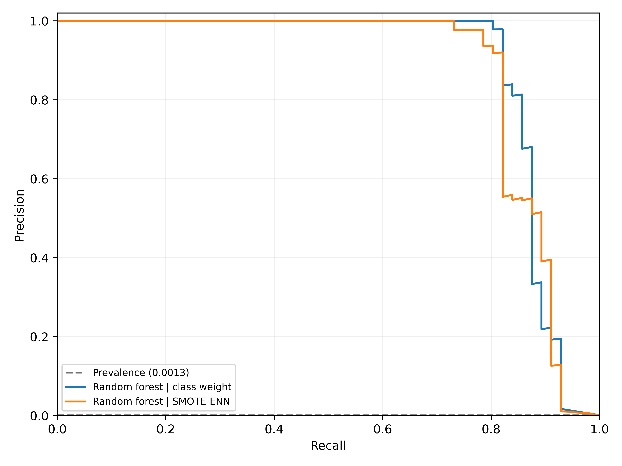
Figure 2. Validation precision–recall curves for the two random-forest variants. The dashed baseline is the validation fraud prevalence. The selected operating thresholds are not implied by the full curves.

4.4 Runtime and serialized model size
Table 3 reports local CPU timing on an Intel Core i7-1165G7 processor with four physical cores and eight logical processors. The shared SMOTE-ENN preprocessing operation took approximately 1,298 seconds (21.6 minutes) and expanded the training data to 397,960 rows. Among classifier fits, the weighted random forest took 58.0 seconds and the resampled forest 164.1 seconds; these fit times exclude the shared resampling step. XGBoost fit in 4.5 seconds when weighted and 8.2 seconds after resampling. Batch-averaged CPU inference ranged from 0.046 to 11.287 microseconds per record in this environment. Serialized estimator size increased from 5.58 MB for the weighted forest to 29.68 MB for the resampled forest. These measurements do not quantify peak RAM or performance on a mobile, payment-terminal or other target device.
Table 3. Local computation and serialized estimator size
Model variant | Fit time (s) | Inference (µs / transaction) | Estimator pickle (MB)
LR, weighted | 0.938 | 0.047 | 0.001
LR, SMOTE-ENN | 1.444 | 0.046 | 0.001
RF, weighted | 58.014 | 9.436 | 5.584
RF, SMOTE-ENN | 164.106 | 11.287 | 29.681
XGB, weighted | 4.456 | 1.322 | 0.458
XGB, SMOTE-ENN | 8.180 | 1.152 | 0.474
Inference is the median of seven batch-average measurements after warm-up, using batches of up to 5,000 test records. Model-fit times exclude scaler fitting and SMOTE-ENN preprocessing; “estimator pickle” excludes preprocessing, framework/runtime and peak resident memory.

4.5 Validation-set permutation importance
The class-weighted random forest was selected for explanation because it had the highest validation AP across the six variants. On the validation partition, permuting V4 produced the largest mean AP decrease (0.0354), followed by V14 (0.0302); V12 (0.0085) and V7 (0.0061) were next. Figure 3 shows the twelve largest mean decreases. The bars summarize model reliance on the validation distribution and should not be interpreted as causal or stable rankings outside this dataset.
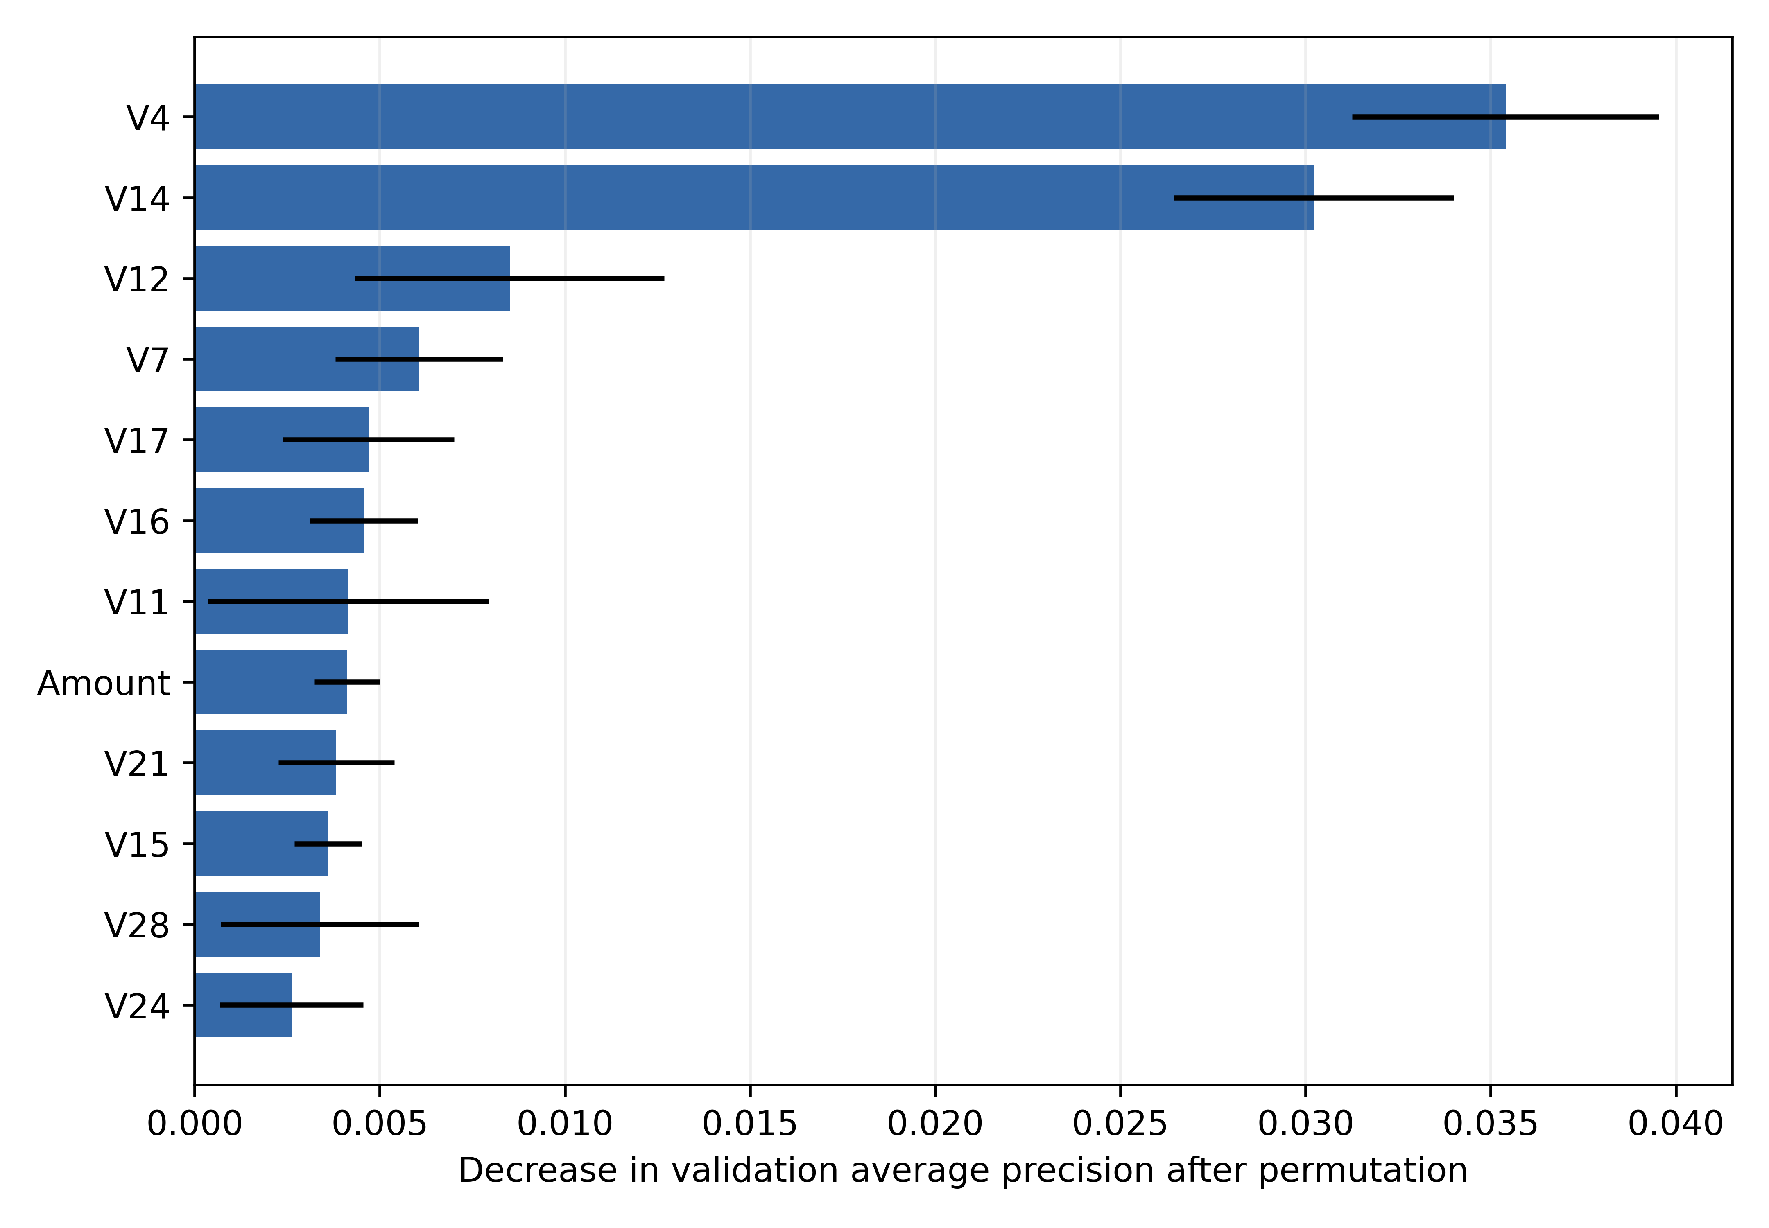
Figure 3. Mean decrease in validation average precision after feature permutation for the class-weighted random forest selected by validation AP. Error bars are one standard deviation across five permutations.

5 Discussion
The recalculated metrics are materially below the earlier near-perfect F1 claim. The source audit identified test-threshold selection in the supplied evaluation cells and mismatch between notebook source and saved outputs, while the claimed MobileNetV3, GRU and MLP stack was absent from the executable code. We therefore withdraw the earlier 0.992 F1 claim and the comparison with a “perfect” Transformer result. Cross-paper leaderboard comparisons were also removed because splits, feature access, threshold choice and leakage control were not comparable.
In this forward-in-time partition, class-weighted XGBoost achieved the largest point estimate of F1, but its interval overlaps the other models’ intervals. In the paired random-forest analysis, the confidence interval for SMOTE-ENN minus class weighting includes zero and McNemar’s exact test found no discordant evidence in favour of resampling. The small number of test frauds (52) leaves material uncertainty. We do not infer equivalence or universal superiority from this one evaluation.
Resampling was computationally consequential on the measured machine: generating the training-only SMOTE-ENN data took about 21.6 minutes, and the resampled random forest was larger and slower to fit than its weighted counterpart. Its measured batch-average prediction time remained low on the workstation CPU, but that result does not address single-record service latency, memory ceilings, energy use or target-device behaviour. The original edge-deployment claim is therefore withdrawn.
The validation permutation analysis identifies V4 and V14 as the most relied-upon predictors for the selected random forest. Because V1–V28 are anonymized principal components, this ranking cannot be translated into named transaction behaviours. Permutation importance can also split importance among correlated predictors. The figure is included as a transparent global explanation, not as a causal account or a substitute for transaction-level review.

6 Limitations
This study evaluates one historical public dataset. We did not run a second independent dataset, so robustness across institutions, countries, products, fraud strategies or modern payment systems is unknown. The time-ordered holdout can reveal some distribution shift but does not establish performance under current concept drift. Only 52 frauds occur in the test partition, yielding wide intervals. The dataset lacks cardholder identifiers; no card-level sequence model, GRU, transaction graph or customer-grouped split can be evaluated from these fields alone.
The classifier settings were fixed rather than extensively tuned. Confidence intervals quantify test-sample uncertainty conditional on one fitted model and do not quantify training-seed variability or model-selection uncertainty. The paired significance analysis covers only the random-forest variants. Permutation importance is a global validation-set explanation and can be affected by correlated inputs. Peak memory and on-device latency were not measured. Finally, the original project artefacts contain inconsistent notebook outputs and unsupported model claims; this manuscript reports only the new reproducible evaluation script and results included with the revision.

7 Conclusion
We replaced an unsupported deep-learning and edge-efficiency narrative with a leakage-controlled benchmark of class weighting and SMOTE-ENN for three conventional classifiers. The revised pipeline splits by time before fitting scaling or resampling, selects thresholds on validation data, and evaluates the test partition at the fixed thresholds. Class-weighted XGBoost attained F1 0.788 (95% CI 0.698–0.868) on 52 test fraud cases. The paired random-forest comparison did not show a detectable advantage for either imbalance treatment. The results provide a reproducible estimate for this historical dataset, not evidence for an unevaluated MobileNetV3–GRU ensemble or edge deployment. Evaluation on independent, contemporary data and device-specific resource measurements are required before broader claims can be made.

Backmatter
Acknowledgment and AI disclosure: During preparation of this revised draft, OpenAI Codex (GPT-6, OpenAI) assisted with software development, analysis workflow, figure generation and manuscript structure/language editing. Authors must independently verify and approve the methods, data-derived results, interpretations, text and citations before submission. The source project acknowledges Kingsley Amoafo and the authors’ professors; the authors should confirm the final acknowledgment wording.
Funding statement: The source manuscript states that no specific funding was received. Authors should confirm whether this remains accurate for the revised analysis.
Author contributions: AUTHOR CONFIRMATION REQUIRED: all authors should agree on an updated contribution statement that reflects the revised analysis and manuscript before submission.
Data availability: The anonymized European Credit Card Fraud Detection dataset is publicly available through Kaggle at https://www.kaggle.com/datasets/mlg-ulb/creditcardfraud. The raw CSV is not redistributed in this repository. Evaluation code, pinned software requirements and derived result files are provided in the repository branch reviewer-revisions-2026.
Ethics approval and consent to participate: Not applicable; this secondary analysis uses a publicly available, de-identified dataset and involved no participant intervention or interaction.
Competing interests: AUTHOR CONFIRMATION REQUIRED: each author should disclose any financial or non-financial interests and confirm the final declaration.

References
- Machine Learning Group, Université Libre de Bruxelles. Credit Card Fraud Detection [dataset]. Kaggle; 2016 [cited 2026 Oct 29]. Available from: https://www.kaggle.com/datasets/mlg-ulb/creditcardfraud
- Dal Pozzolo A, Caelen O, Le Borgne YA, Waterschoot S, Bontempi G. Learned lessons in credit card fraud detection from a practitioner perspective. Expert Syst Appl. 2014;41(10):4915–4928. doi:10.1016/j.eswa.2014.02.026.
- Kapoor S, Narayanan A. Leakage and the reproducibility crisis in machine-learning-based science. Patterns. 2023;4(9):100804. doi:10.1016/j.patter.2023.100804.
- Hayat A, Magnier B. Data leakage and deceptive performance: a critical examination of credit card fraud detection methodologies. Mathematics. 2025;13(16):2563. doi:10.3390/math13162563.
- Chawla NV, Bowyer KW, Hall LO, Kegelmeyer WP. SMOTE: synthetic minority over-sampling technique. J Artif Intell Res. 2002;16:321–357. doi:10.1613/jair.953.
- Batista GEAPA, Prati RC, Monard MC. A study of the behavior of several methods for balancing machine learning training data. SIGKDD Explor Newsl. 2004;6(1):20–29. doi:10.1145/1007730.1007735.
- Davis J, Goadrich M. The relationship between Precision-Recall and ROC curves. In: Proceedings of the 23rd International Conference on Machine Learning; 2006. p. 233–240. doi:10.1145/1143844.1143874.
- Jurgovsky J, Granitzer M, Ziegler K, Calabretto S, Portier PE, He Guelton L, et al. Sequence classification for credit-card fraud detection. Expert Syst Appl. 2018;100:234–245. doi:10.1016/j.eswa.2018.01.037.
- Breiman L. Random forests. Mach Learn. 2001;45:5–32. doi:10.1023/A:1010933404324.
- Chen T, Guestrin C. XGBoost: a scalable tree boosting system. In: Proceedings of the 22nd ACM SIGKDD International Conference on Knowledge Discovery and Data Mining; 2016. p. 785–794. doi:10.1145/2939672.2939785.
- Pedregosa F, Varoquaux G, Gramfort A, Michel V, Thirion B, Grisel O, et al. Scikit-learn: machine learning in Python. J Mach Learn Res. 2011;12:2825–2830.
- Lemaître G, Nogueira F, Aridas CK. Imbalanced-learn: a Python toolbox to tackle the curse of imbalanced datasets in machine learning. J Mach Learn Res. 2017;18(17):1–5.
- Fisher A, Rudin C, Dominici F. All models are wrong, but many are useful: learning a variable’s importance by studying an entire class of prediction models simultaneously. J Mach Learn Res. 2019;20(177):1–81.
- Howard A, Sandler M, Chu G, Chen LC, Chen B, Tan M, et al. Searching for MobileNetV3. In: Proceedings of the IEEE/CVF International Conference on Computer Vision; 2019. p. 1314–1324. doi:10.1109/ICCV.2019.00140.
- Yousefimehr B, Ghatee M, Razavi-Far R. Multi-teacher knowledge distillation framework for lightweight anomaly detection. Neural Netw. 2026;195:108267. doi:10.1016/j.neunet.2025.108267.
- Brown LD, Cai TT, DasGupta A. Interval estimation for a binomial proportion. Stat Sci. 2001;16(2):101–133. doi:10.1214/ss/1009213286.
- McNemar Q. Note on the sampling error of the difference between correlated proportions or percentages. Psychometrika. 1947;12:153–157. doi:10.1007/BF02295996.

