A Bayesian Optimized Deep Learning Approach for Accurate State of Charge Estimation of Lithium Ion Batteries Used for Electric Vehicle Application
Battery technologies are using inside electric vehicles and its accurate State of Charge (SOC) prediction play an important role in smooth functioning of vehicles as driver heavily dependent on battery to move vehicle forward. In the past many Machine and deep learning algorithms were introduced which were using Grid Search technique to find optimal parameters which can help in enhancing algorithms prediction accuracy and reducing error rate. Grid Search technique may give improper optimization parameters which may degrade algorithm performance.
To overcome from above issue author of this paper employing Bayesian Optimization. Bayesian Optimization is a method that optimizes decision-making on setting parameters by applying an objective function to understand past settings, ultimately finding the best hyper-parameter settings efficiently compared to grid and random searches.
Author has optimized multiple neurons such as 30, 50, 70 and 100 on 4 different battery dataset and among them 70 neurons giving less RMSE and Max error. RMSE (root mean square error) and MAX ERROR refers to difference between predicted and true values so the lower the RMSE the better is the algorithm.
In propose work author has experimented with Bayesian Optimized 70 neurons with 3 different algorithms such as LSTM, GRU and BI-LSTM. Among all 3 algorithms BILSTM with 70 neurons gave less RMSE error.
In propose work to implement above algorithms author has used Panasonic battery with different temperature such as 0 degree, 10 degree, 25 and N10 degree. Training on all 4 datasets is difficult task so we have used Panasonic 10 degree dataset. Author used ‘Voltage, Current, Temperature, Capacity, Voltage-Average and Current-Average’ columns from dataset.
Extension Concept
In propose work author has used traditional deep learning algorithms so as extension we have experimented with CNN2D (convolution neural network 2 Dimension) algorithm which is best known for optimizing and selecting relevant features by using 2 dimension CNN and MaxPooling2D layer. CNN2D is giving less RMSE and MAX ERROR compare to propose 3 algorithms.
In below screen showing dataset details
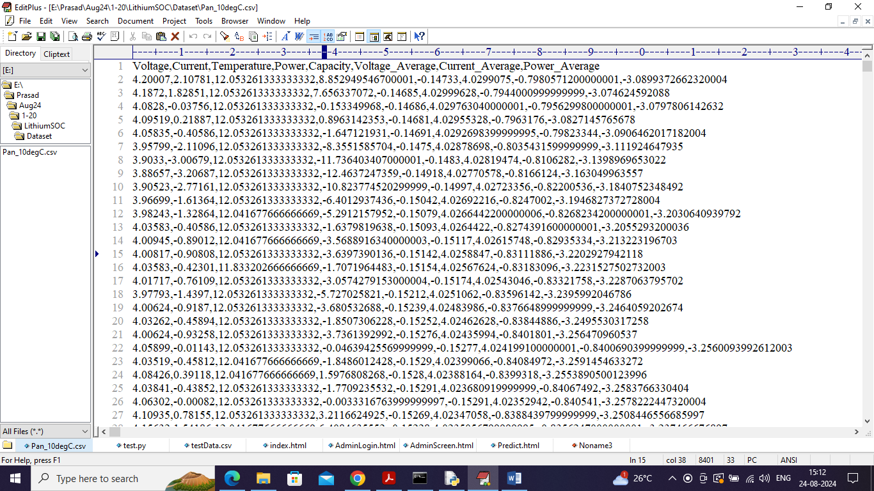
In above dataset screen first row contains dataset column names and remaining rows contains dataset values and by using above dataset values we are training and testing all algorithm performance.
SCREEN SHOTS
We have coded this project using JUPYTER notebook and below are the code and output screens with blue colour comments
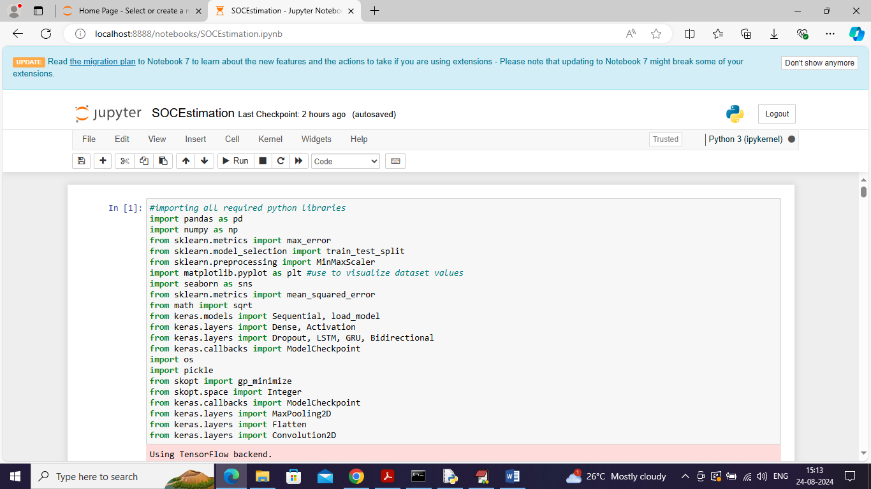
In above screen importing required packages and classes
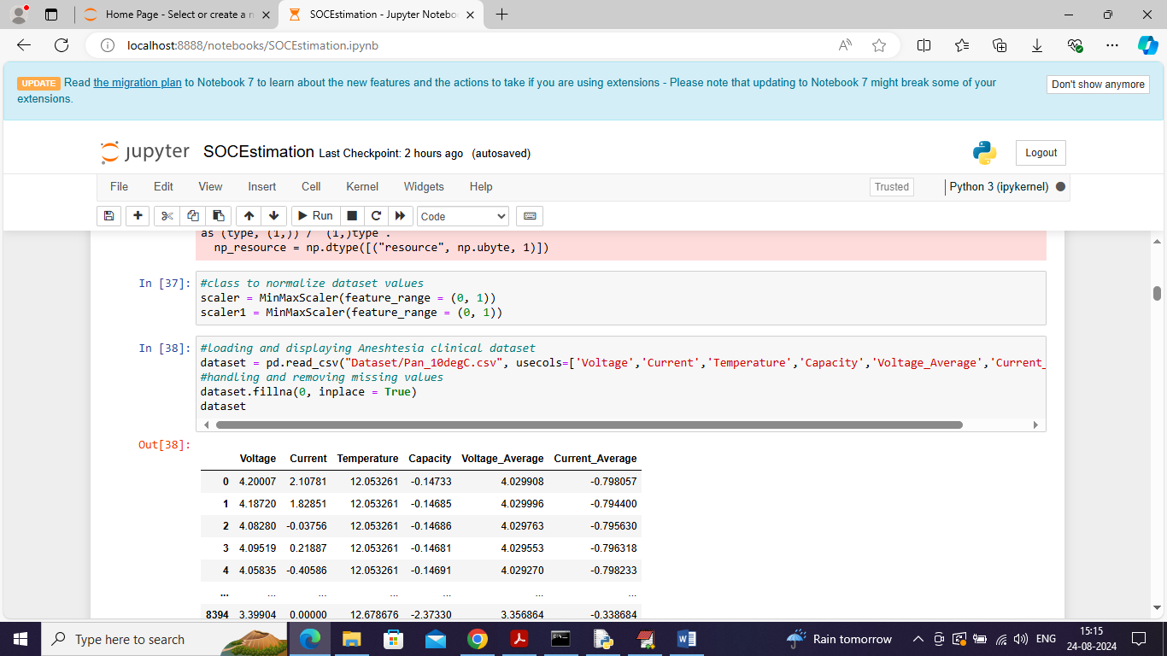
In above screen loading and displaying dataset values
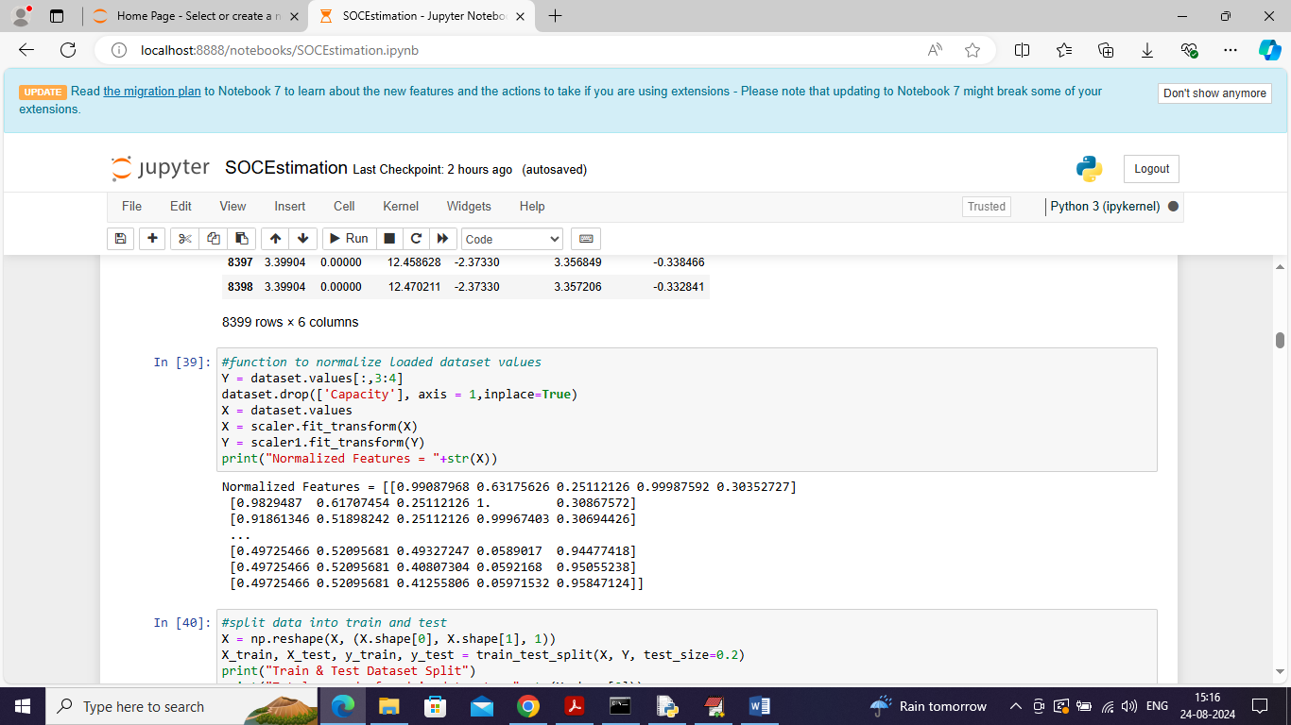
In above screen applying pre-processing techniques such as normalization on dataset values
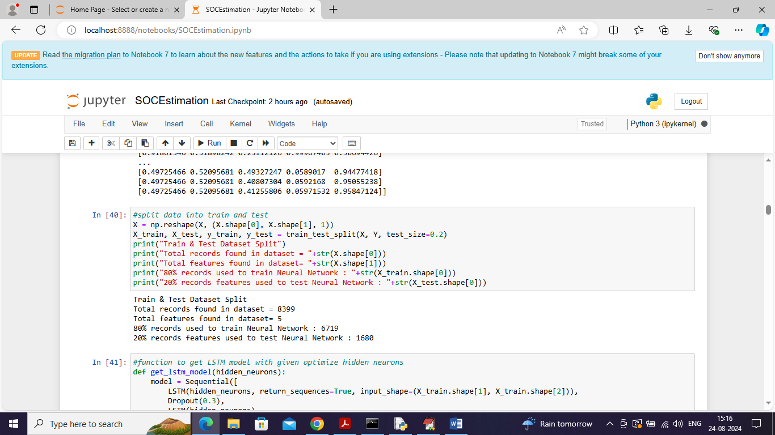
In above screen splitting dataset into train and test values where 80% dataset using for training and 20% for testing
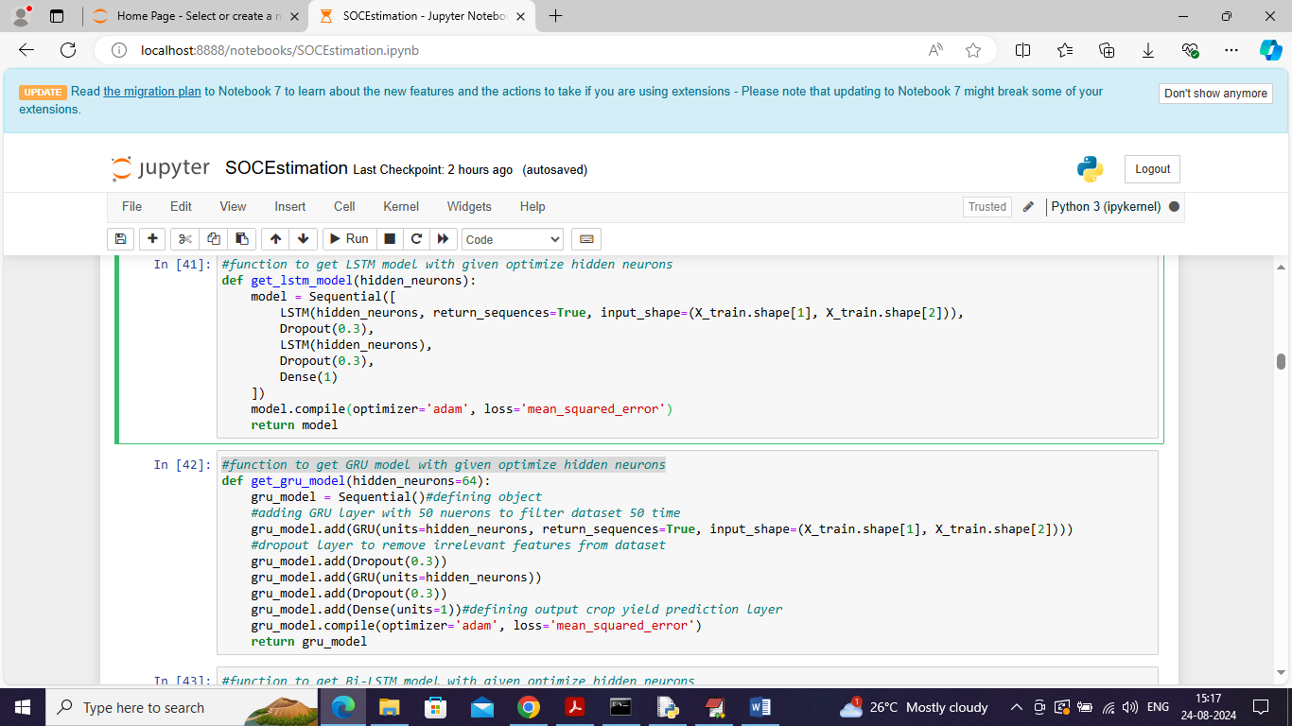
In above screen defining architecture for LSTM and GRU algorithms
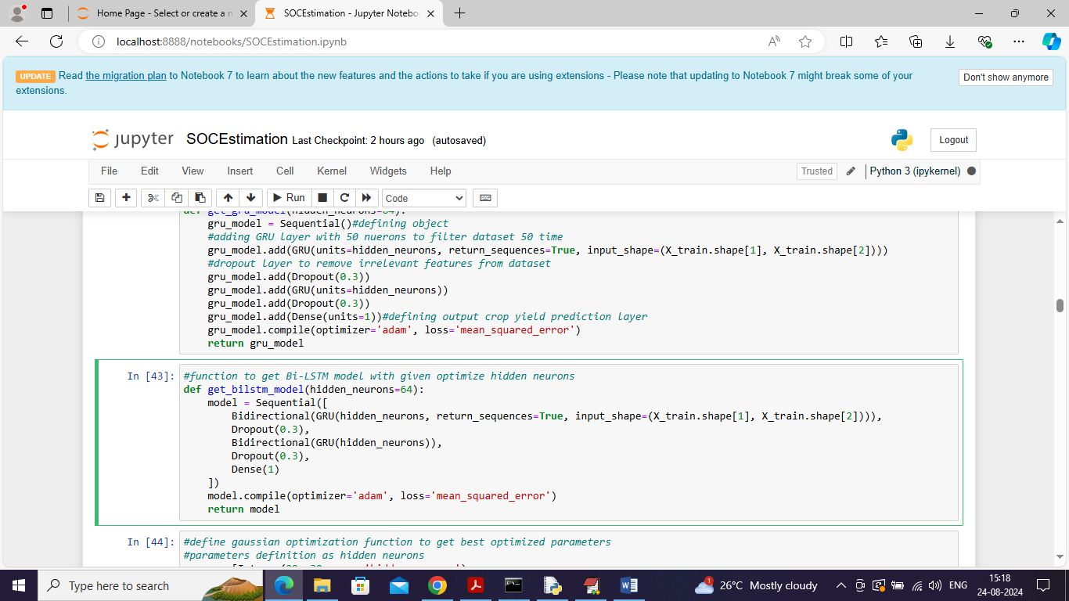
In above screen defining BILSTM algorithm
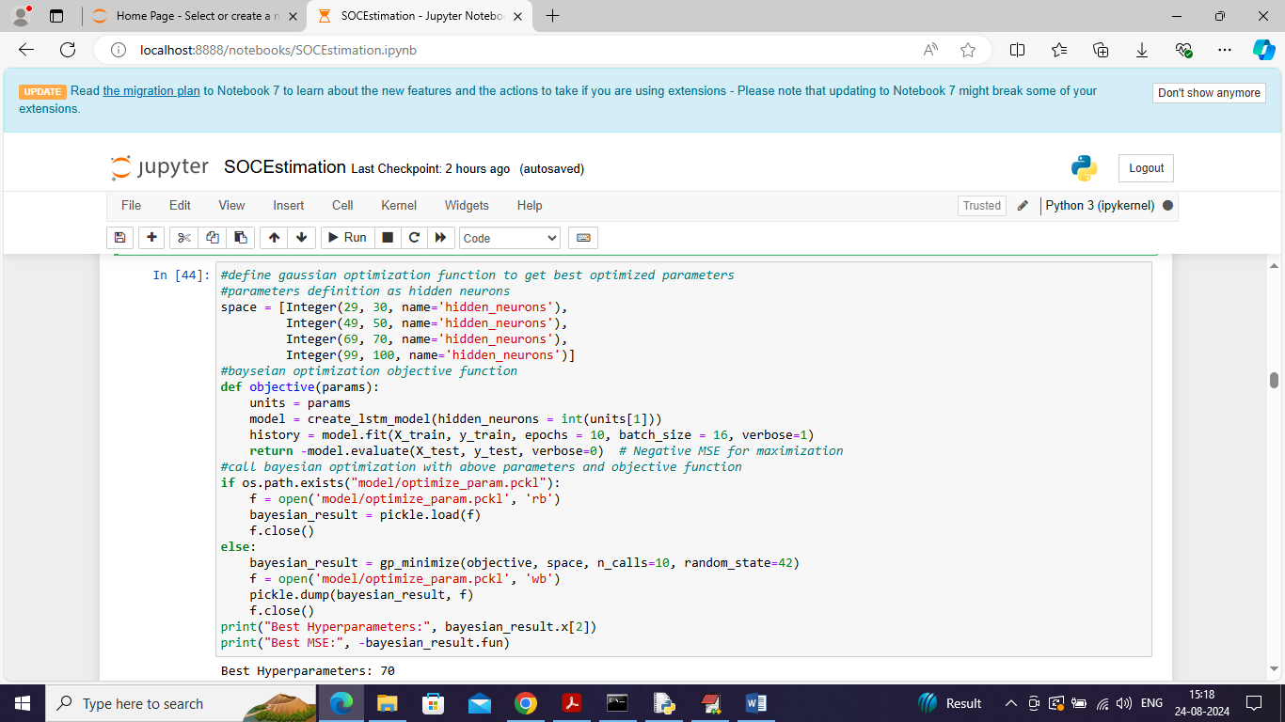
In above screen defining function to select optimize parameters using Bayesian Optimization algorithm
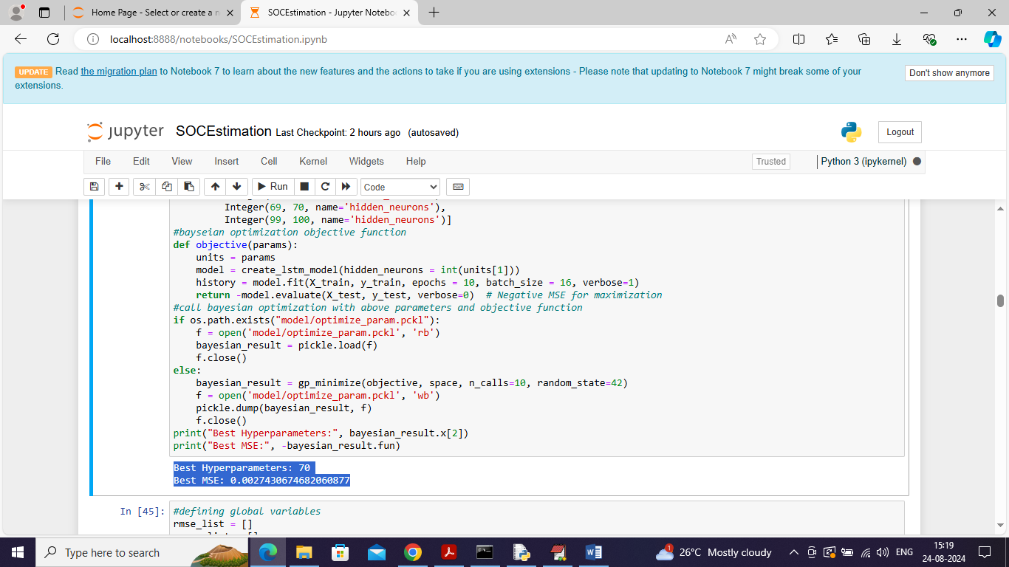
In above screen in blue colour text displaying best selected number of parameters as 70 and then displaying best RMSE error
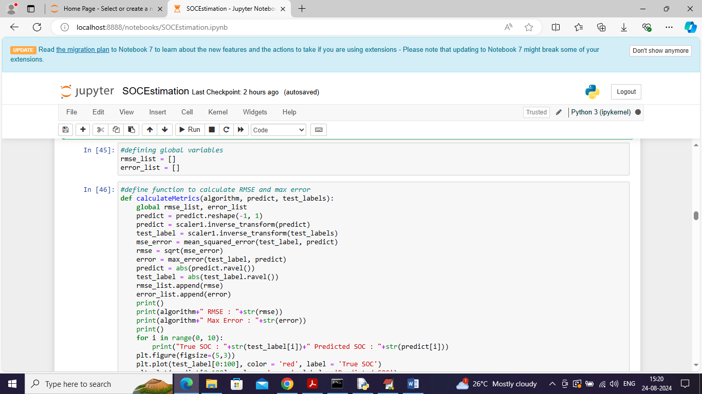
In above screen displaying function to calculate RMSE and MAX error using true and predicted values
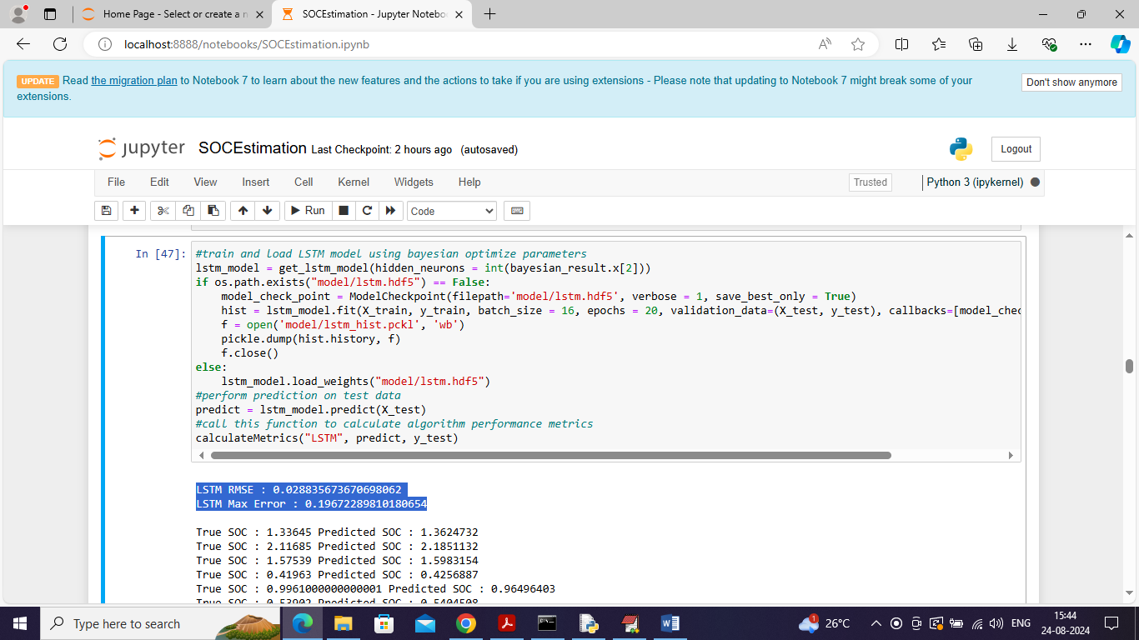
In above screen training LSTM with Bayesian optimized number of neurons and then can see RMSE and Max error in blue colour text and in next line can see True battery SOC and predicted SOC values. In below screen can see predicted and true SOC values graph
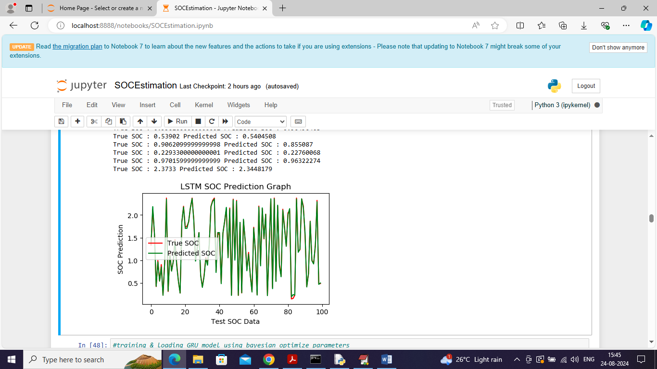
In above graph x-axis represents TEST data and y-axis represents SOC values and then red line represents TRUE TEST SOC values and green line represents Predicted SOC values and can see both lines are fully overlapping so LSTM with optimized Bayesian parameters giving accurate prediction
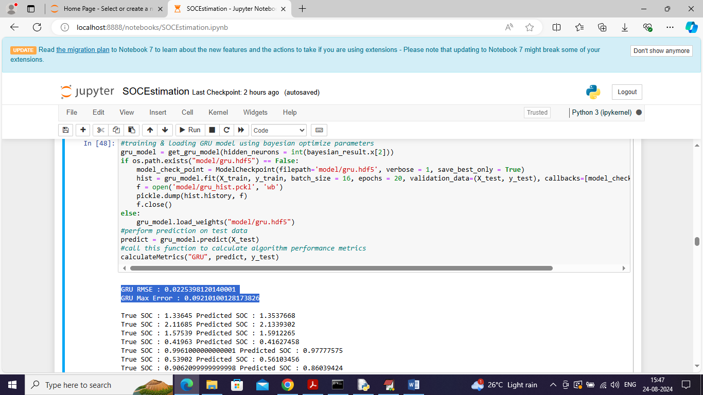
In above screen can see GRU RMSE and MAX Error values and below is the comparison graph
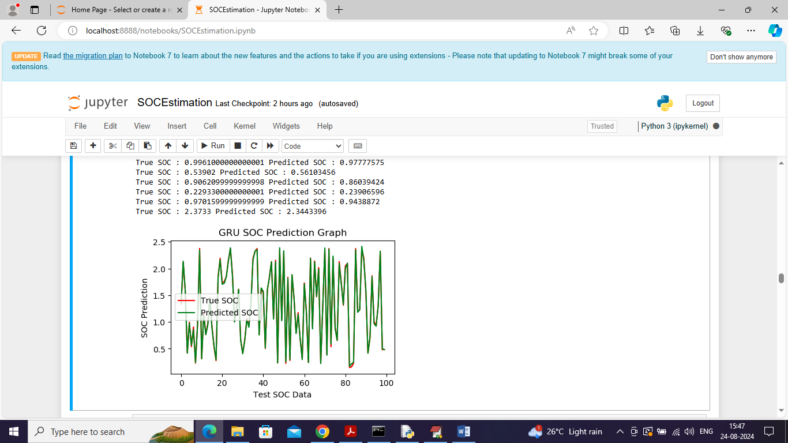
In above graph GRU also giving accurate prediction
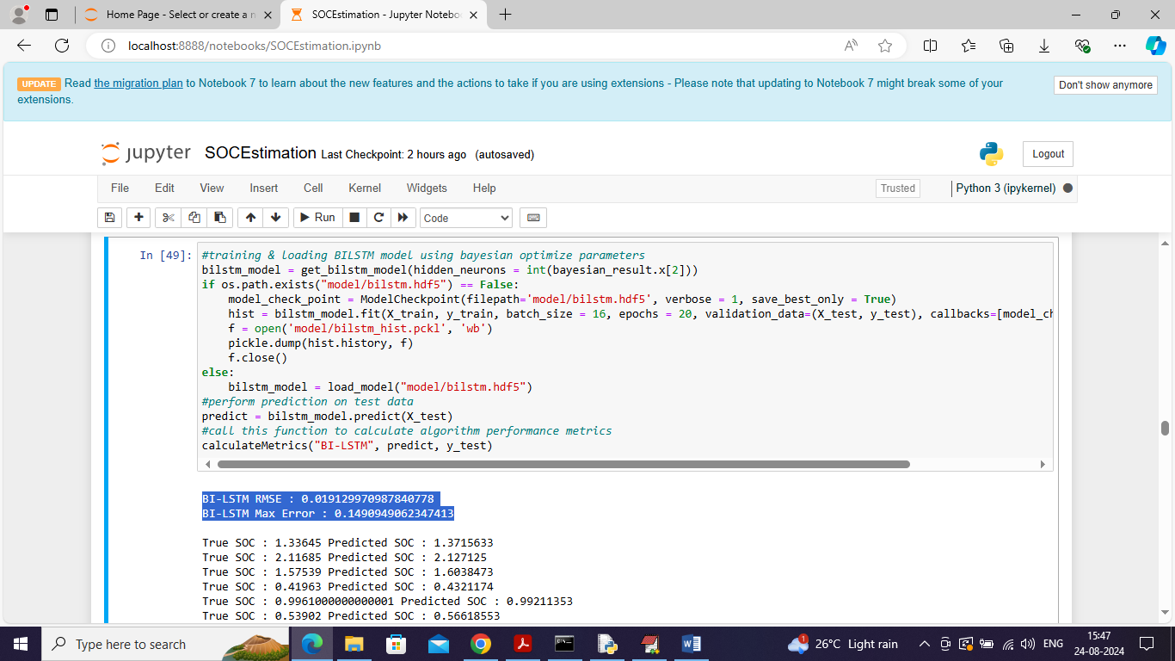
In above screen training BILSTM algorithm and can see RMSE and other values
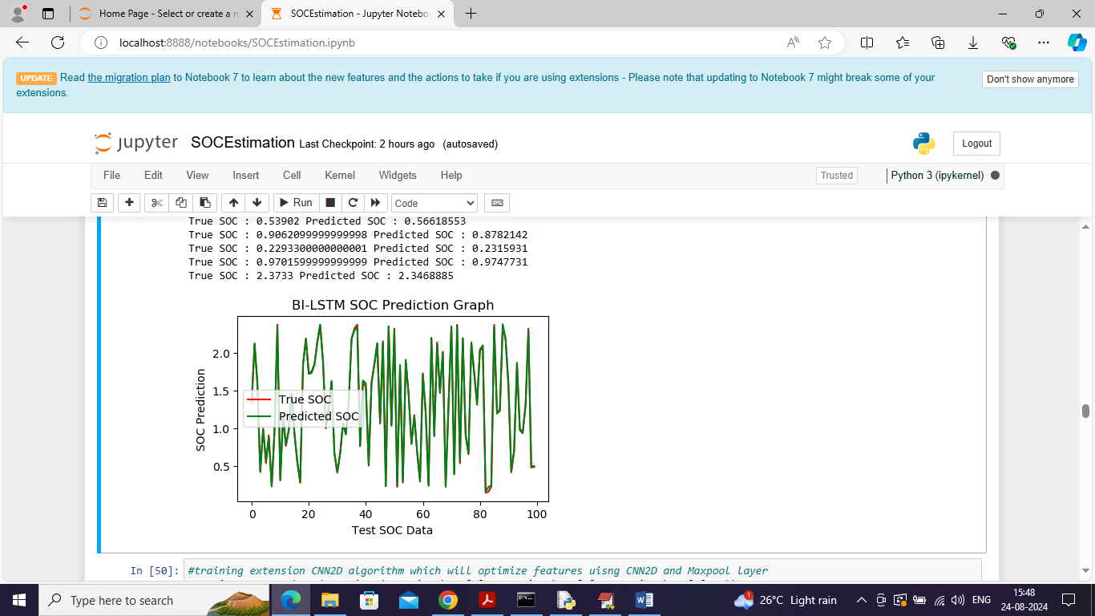
In above graph can see BILSTM prediction also accurate
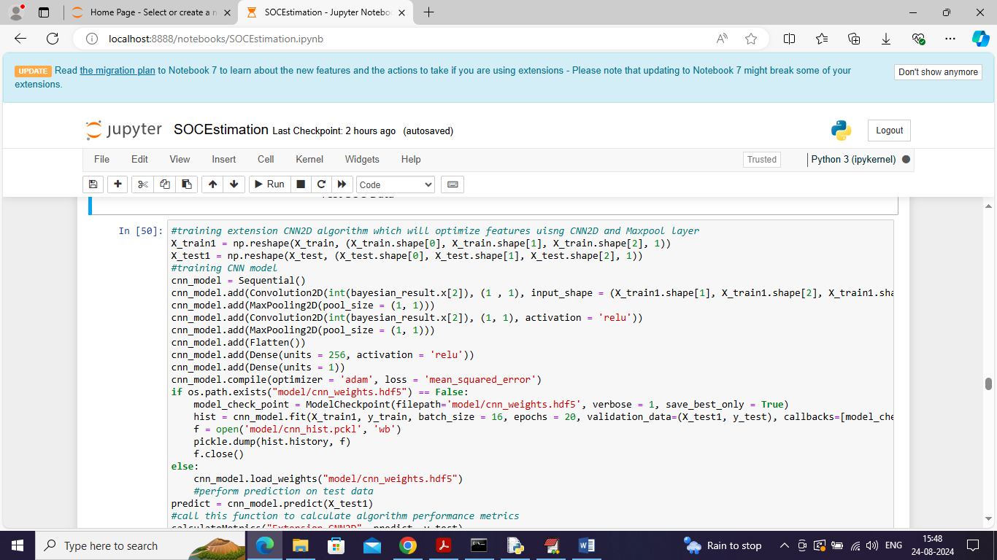
In above screen training CNN2D extension algorithm and below is the performance output
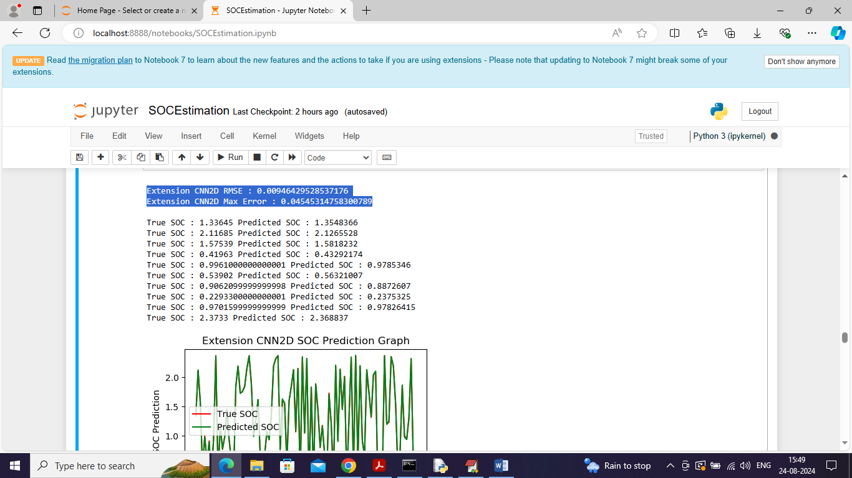
In above screen CNN2D extension algorithm prediction also accurate as both TEST and predicted SOC values are fully overlapping without any gap
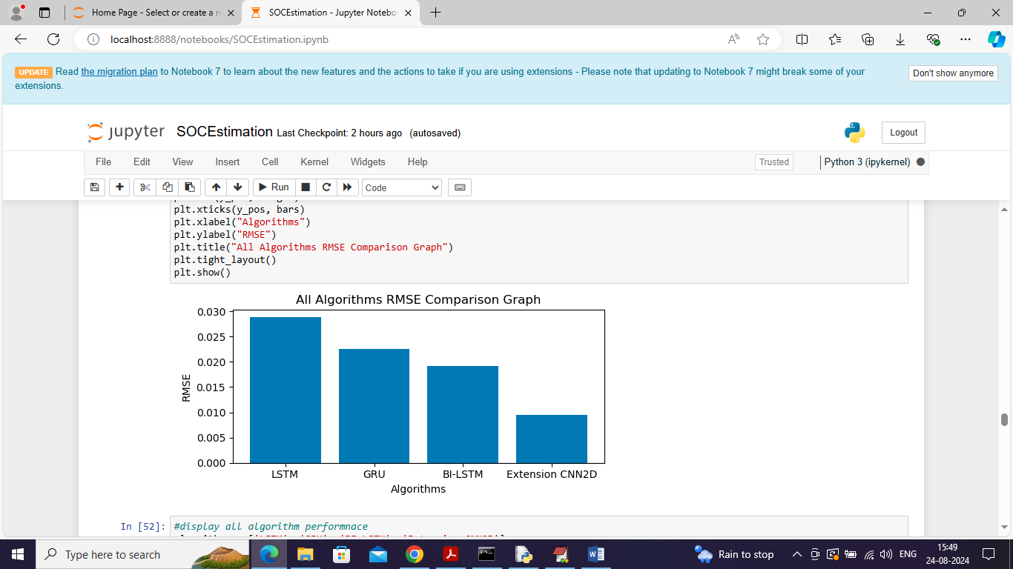
In above graph displaying RMSE comparison graph where x-axis represents algorithm names and y-axis represents RMSE and in all algorithms BILSTM and extension CNN2D gave less RMSE error rate
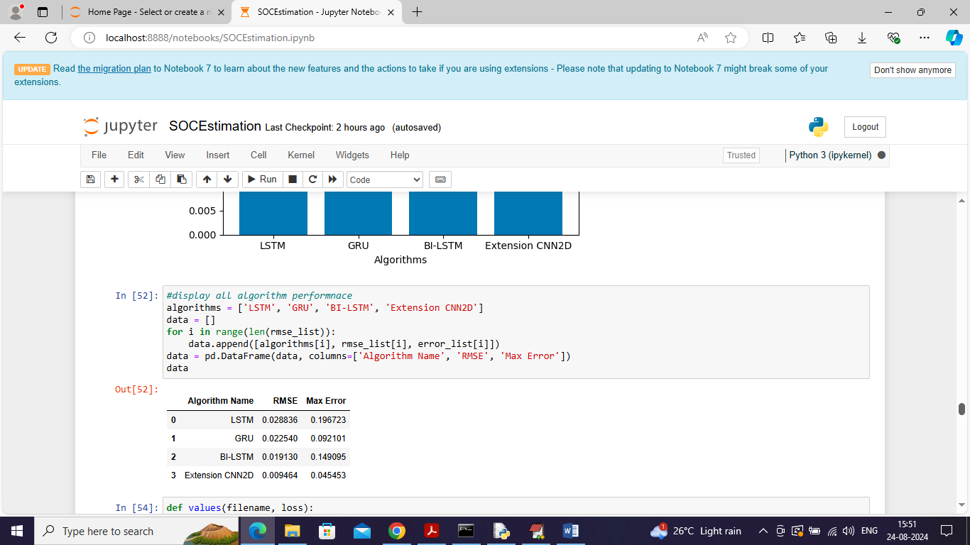
In above screen displaying all algorithm performance in tabular format and can see RMSE and MAX error for each algorithm
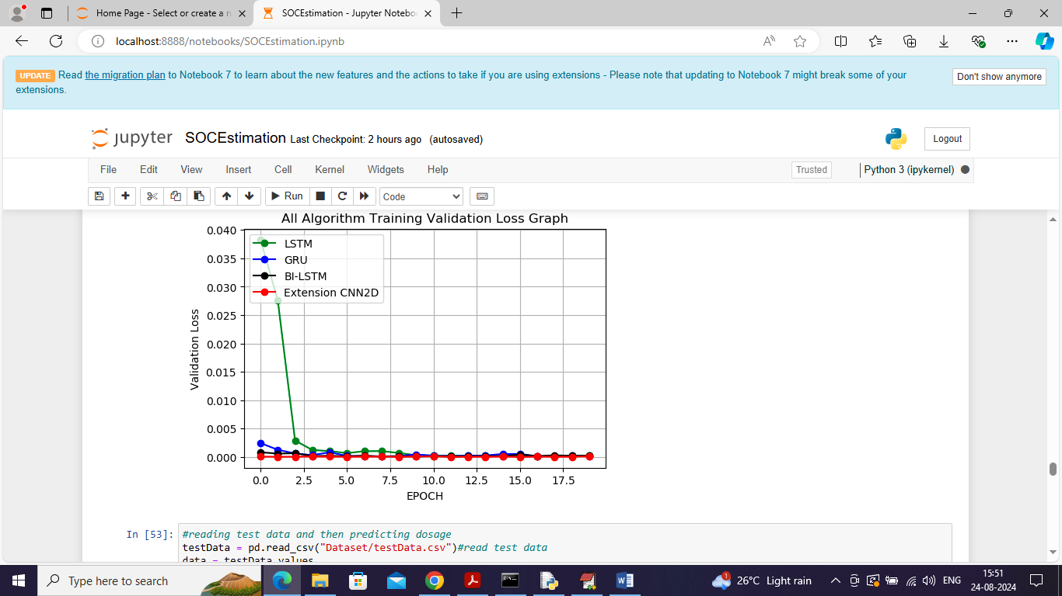
In above graph displaying Validation loss for each algorithm where x-axis represents training epochs and y-axis represents LOSS values and in above graph can see BILSTM and extension CNN2D got less loss values
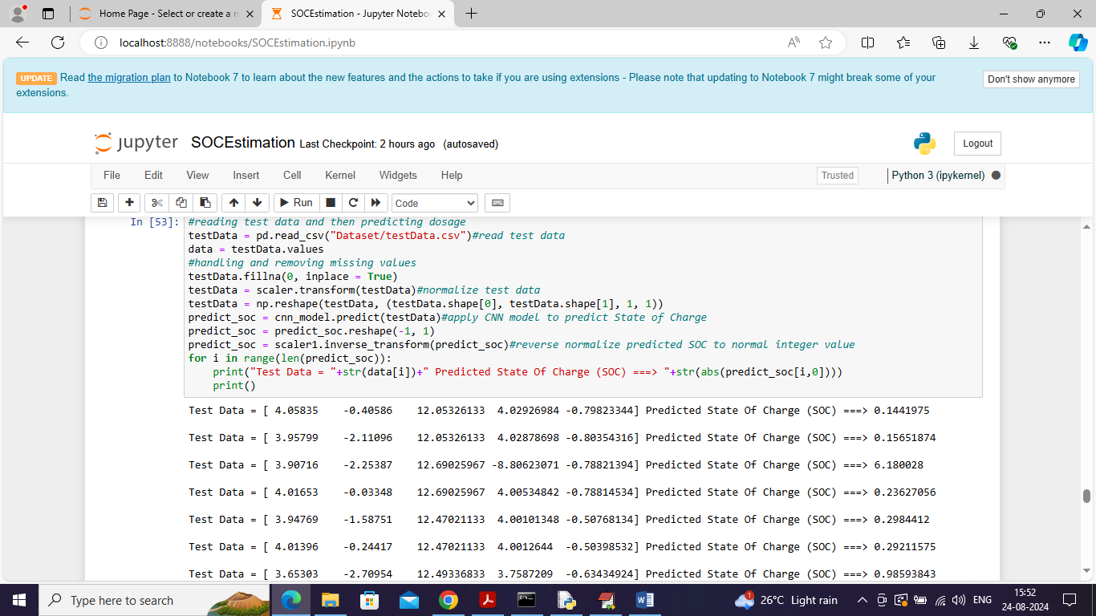
In above screen performing prediction on test data and in square bracket can see test values and after = symbol can see predicted battery SOC or state of charge values
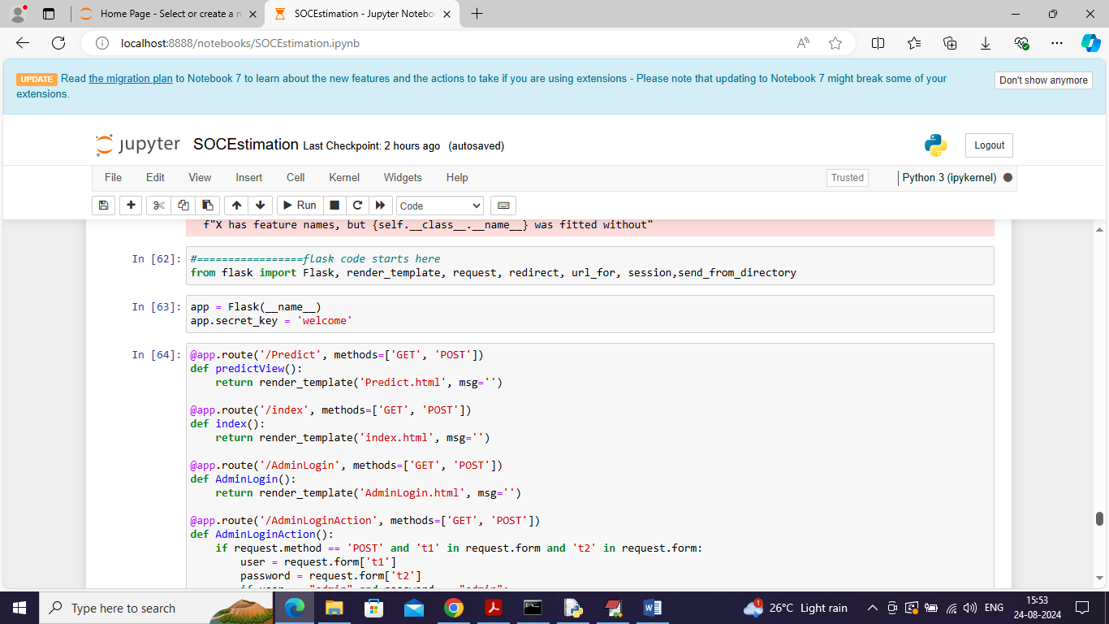
In above screen run all flask code block and then open browser and enter URL as http://127.0.0.1:5000/index and press enter key to get below page
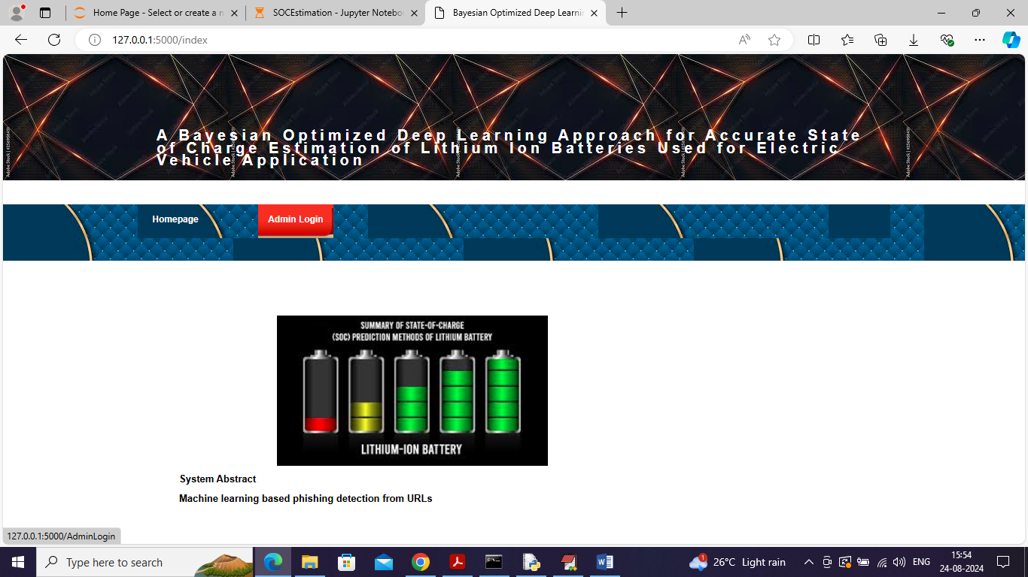
In above screen click on ‘Admin Login’ link to get below page

In above screen login as admin by entering username and password as ‘admin and admin’ and after login will get below page
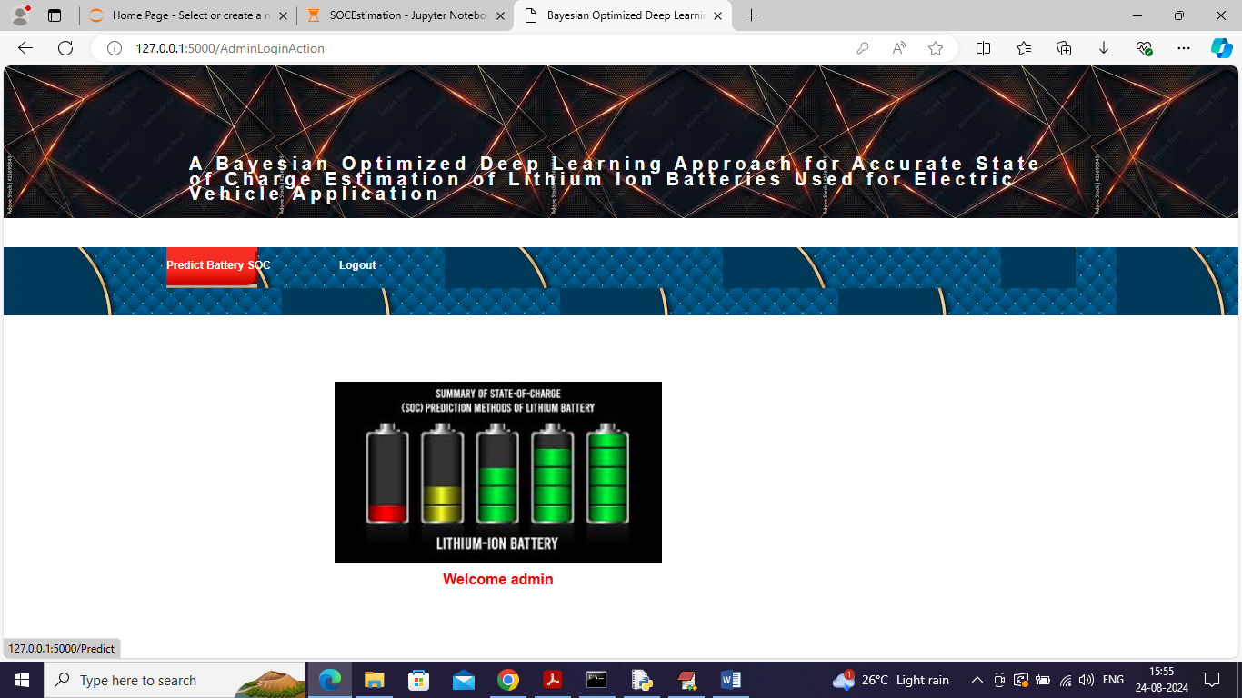
In above screen click on ‘Predict Battery SOC’ link to get below page
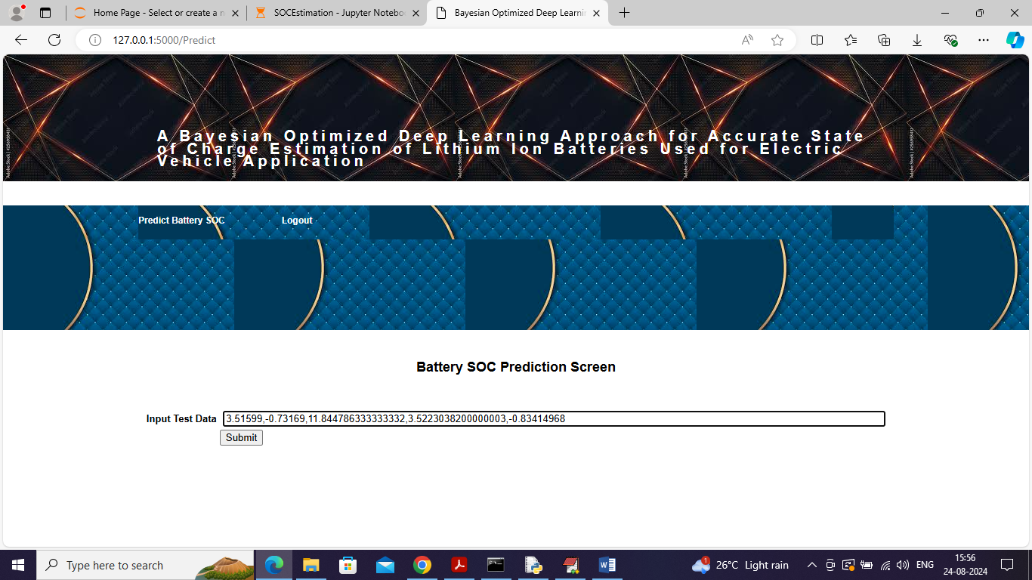
In above screen paste input data by copying values from ‘Dataset/testData.csv’ file and then press button to get below page
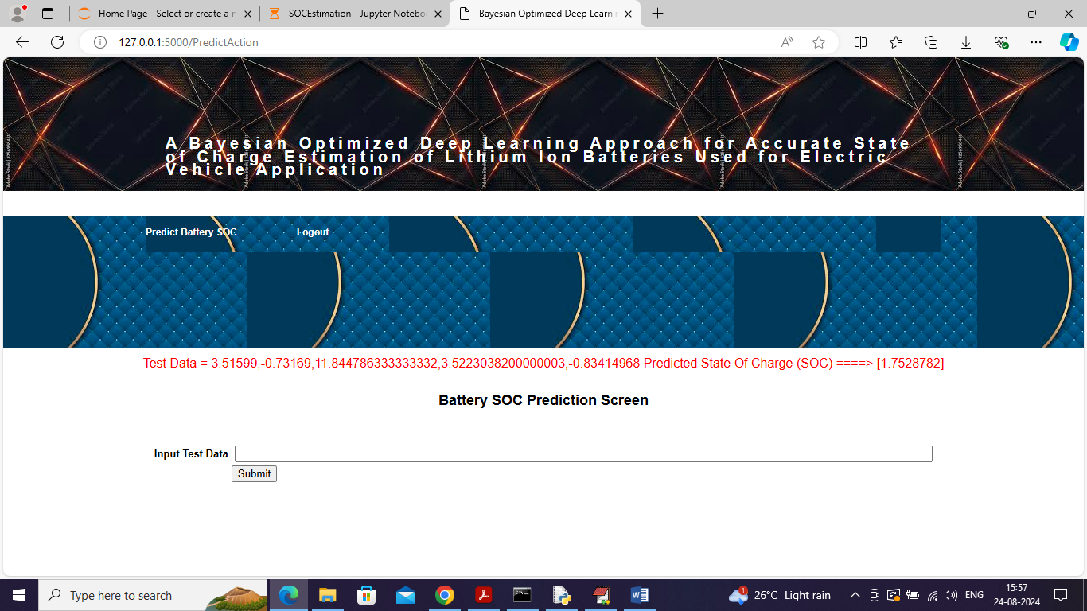
In above screen in red line can see ‘TEST Data’ values in square bracket and after = symbol can see predicted SOC value and similarly you can test with other values

