University of Rhode Island

Department of Computer Science and Statistics

CSC402, Programming Language Implementation, Fall 2022
Instructor: | Lutz Hamel
Office Location: | Tyler Hall 251
Email: | lutzhamel@uri.edu
Class Days/Time: | MWF 11-11:50am
Classroom: | Engineering Building Room 040
Prerequisites: | CSC301
Webpage: | https://lutzhamel.github.io/CSC402 or BrightSpace

Course Description

- Have you ever wondered how the syntax highlighter in Eclipse works?
- Have you ever wondered how your favorite programming language is implemented?
- How about Python and JavaScript?
- What is the difference between interpreting a programming language and translating/compiling it?
- What is the difference between an interpreter and a virtual machine?

If any of these questions interest you, then CSC402 is for you. We will spend the semester looking at programming language implementations: from syntax highlighters to code analyzers, from interpreters and virtual machines to compilers.

As part of the course we will construct interpreters and translators for domain specific languages such as calculator languages and command line languages for steering your favorite game character. The course will also include one large semester project of a language implementation project of your choosing. This could be a graphics language, a new programming language (think Ruby), a domain specific language such as PHP or a new command line shell interpreter for Unix/DOS.

Course Goals
The goal of the course is to give you a solid foundation with respect to programming language implementation that includes:
- grammar construction
- parsing techniques
- intermediate representations
- abstract syntax tree construction
- tree pattern matching techniques
We will study a number of different programming language implementation techniques including,
- compilers
- interpreters, and
- virtual machines.
These tools will enable you to add domain specific and general programming language implementations to your tool chest to solve difficult engineering problems.

Upon successful completion of this course, each student will be able to:
- Understand the difference between compilers and interpreters.
- Use grammar specification tools effectively.
- Design and implement domain specific and general purpose programming languages.

Required Texts/Readings

Textbook
none – free online textbook draft available:

Exams, Assignments, and Grading Policy

Course Grade Composition:
Assignments 40%
Midterm 20%
Final 20%
Attendance 20%

Class attendance is mandatory. You will be given one unexcused absence per semester otherwise an unexcused absence will count against your attendance grade.

Grading Key
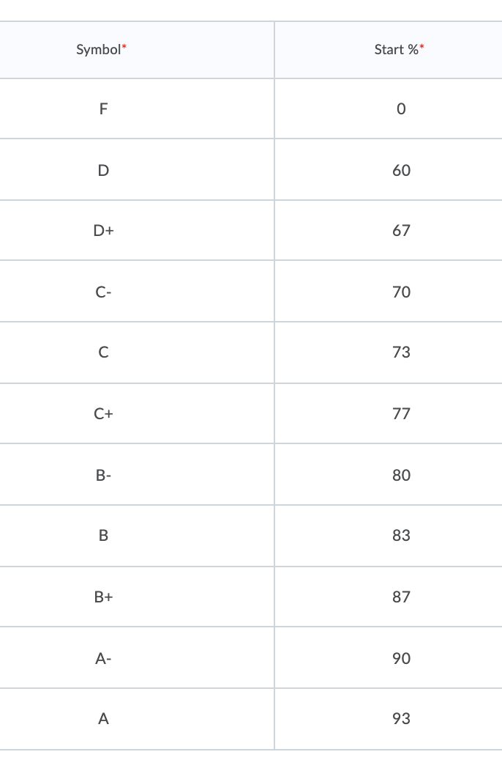

Homework consists of exercises to familiarize you with common tools and concepts in programming language implementation. Programming assignments are typically projects that can be completed within a couple of days. The midterm and the final comprise major projects and you should budget your time accordingly. Assignments are given on a weekly basis.

Classroom Protocol
- Check the website (often)! I will try to keep the website as up-to-date as possible.
- Promptness, participation, and adequate preparation for each class are expected. If you are absent, it is your responsibility to find out what you missed (e.g. handouts, announcements, assignments, new material, etc.)
- Late assignments/project will not be accepted without a valid excuse, such as illness etc. If you find that you are unable to submit an assignment/project please get in touch with me as soon as possible before the deadline expires.
- All work is to be the result of your own individual efforts unless explicitly stated otherwise. Plagiarism, unauthorized cooperation or any form of cheating will be handled according to the University Man- ual section 8.27.10 through 8.27.21 (see www.uri.edu/facsen/8.20-8.27.html). The penalty for cheating or plagiarism can range from a zero score on the assignment to a failing grade for the course.
- Software piracy will be dealt with exactly like stealing of university or departmental property. Any abuse of computer or software equipment will subject to disciplinary action.
- Any student with a documented disability is welcome to contact me as early in the semester as possible so that we may arrange reasonable accommodations. As part of this process, please be in touch with Disability Services for Students Office at 302 Memorial Union, Phone 401-874-2098.

Anti-Bias Statement: We respect the rights and dignity of each individual and group. We reject prejudice and intolerance, and we work to understand differences. We believe that equity and inclusion are critical components for campus community members to thrive. If you are a target or a witness of a bias incident, you are encouraged to submit a report to the URI Bias Response Team at www.uri.edu/brt. There you will also find people and resources to help.

Disability Services for Students Statement: Your access in this course is important. Please send me your Disability Services for Students (DSS) accommodation letter early in the semester so that we have adequate time to discuss and arrange your approved academic accommodations. If you have not yet established services through DSS, please contact them to engage in a confidential conversation about the process for requesting reasonable accommodations in the classroom. DSS can be reached by calling: 401-874-2098, visiting: web.uri.edu/disability, or emailing: dss@etal.uri.edu. We are available to meet with students enrolled in Kingston as well as Providence courses.
Academic Enhancement Center: Located in Roosevelt Hall, the AEC offers free face-to- face and web-based services to undergraduate students seeking academic support. Peer tutoring is available for STEM- related courses by appointment online and in-person. The Writing Center offers peer tutoring focused on supporting undergraduate writers at any stage of a writing assignment. The UCS160 course and academic skills consultations offer students strategies and activities aimed at improving their studying and test-taking skills. Complete details about each of these programs, up-to-date schedules, contact information and self-service study resources are all available on the AEC website, uri.edu/aec.

Disability Accommodations and Opportunities

Any student with a documented disability should contact me early in the semester so that we can make reasonable accommodations to support your success in this course. You should also contact Disability Services for Students, Office of Student Life, 330 Memorial Union, 874-2098

Tentative Course Schedule
- Programming Languages and their Processors
- Parsing and Lexing
- Syntax-Directed Processing
- Interpretation with Intermediate Representations
- Tree Based Intermediate Representations
- A Basic Compiler
- Symbol Tables and Scope
- Functions
- Type Systems
- Structured Data Types
- Parser Generators

