- Environment
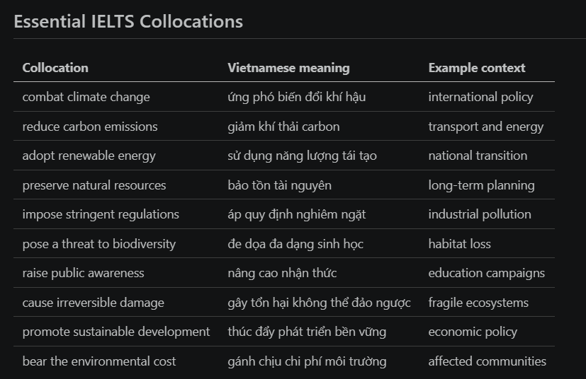

- Nhiều
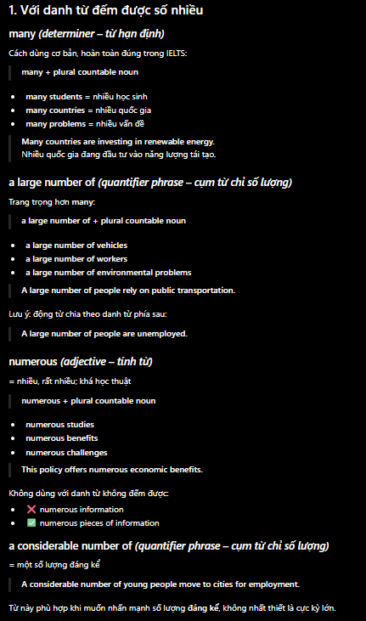
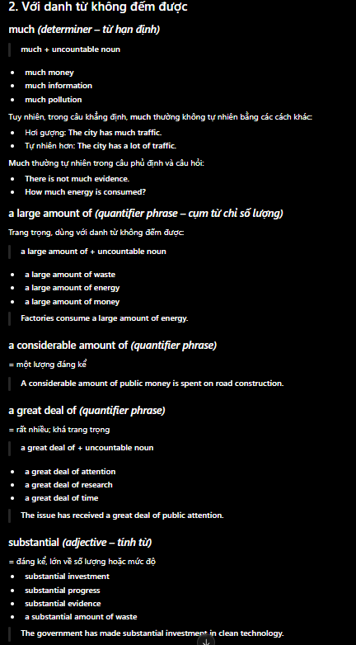
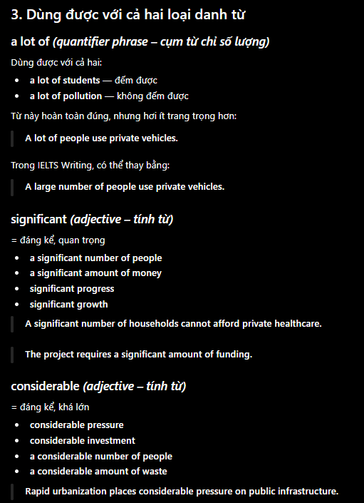
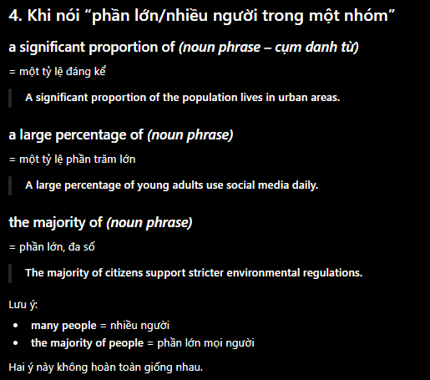
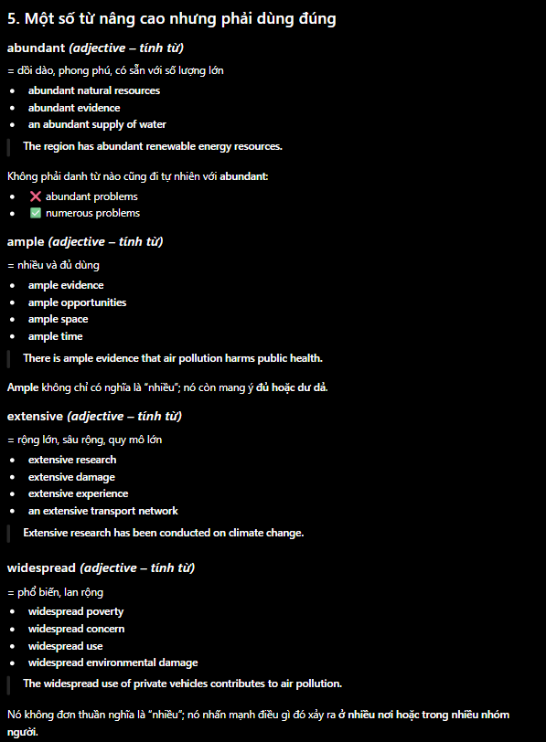

- Climate change is impacting on weathy nations and impoverished nations
- Burning fossil fuels raises greenhouse gases in the atmosphere
- Air pollution leads to be poisonous for people’s health and lowers people’s life quality
- The government should impose gas standards more stringent on factories
- Solar energy can reduce dependency on imported fuels
- Building wind farm can affect some local creatures
- Protecting biodiversity should be an important priority in economic planning
- Electrical motorbikes help cities mitigate noisy and gas emission
- Households should repair devices intead of disposing products which can still continue to be used
- Developing long-term economy depends on using renewable resources

- When people’s income increases, their energy demand often also raises, exclude electrical saving technology is used widely
- Many enterprises continue to cause pollution because waste handling cost is higher than current penalty
- Deforestation not only emits carbon but also degrades the integrity of the ecosystem
- Investing in energy effect often spends less cost than building additional electrical factories
- Local government can provide financial promotions to encourage household owners to install solar panels
- If public transportation is more reliable, citizens will less depend on private cars
- Carbon taxes can cause low-income households to put a high pressure if government do not refund a part of revenue
- Companies which cause serious environmental pollution must bear environmantal recovery cost instead of transfering burden to people paying taxes
- A city can reuse treated sewage to water plants in parks in dry season
- Environmental education should help students evaluate consequences of daily consumption habits

- Although tranfering to renewable energy demands high investment, long-term benefits about health and energy security can overcome initial cost
- While some people suppose that personal choice creates negligible impact, millions of consumption decisions can form strategy of enterprises
- A reason of deforestation which is still prevalent is short-term profit from exploiting soil which is often prioritized more than long-term values of forests
- When wetlands are filled and levelled, coastal communities not only lose spawn places of animals but also are flooded more easily
- The government should only provide subsidy in green technology if enterprises can prove that these grants will create measurable gas emission decrease
- Instead of extending road traffic, developing railway network is generally a more sustainable solution for interprovincial transportation demands
- We should not require developing countries to give up growth if weathy countries do not share the clean technology and support finance appropriately
- If a industry shares a sewage treatment system, cost of each enterprise can reduce while environmental standards are improved
- To avoid merely symbolic policies, regulatory authority needs to disclose data transparently, inspect indepently and fine incorrect reporting behaviors
- Eventually, a feasible climate strategy must balance among environmental urgency, affordability and developing demand

Urban air pollution cannot be resolved only by requiring citizens drive less. Many residents use cars because bus network is slow, crowded and not reliable. If authority invests in fast bus routes with a reasonable ticket, commuters will have a more practical choice. For instance, a dedicated lane can help buses avoid traffic congestion in peak hours. Therefore, improving public infrustrature should be implemented before limiting private transportation.

- Numerous plants use obsoleted devices. These devices consume a large amount of electricity. The government should provide loans to upgrade devices
- Plastic packages are immensely convenient. However, it exists in a long time in environment. There are some nations impose a high tax on disposable plastic packages
- Wind energy do not create gas emission in its operating process. Wind electricity generation changes depending on weather. Electricity system needs a store ability

