- Appetizer - món khai vị
- Dessert (/dɪˈzɜːt/) - tráng miệng

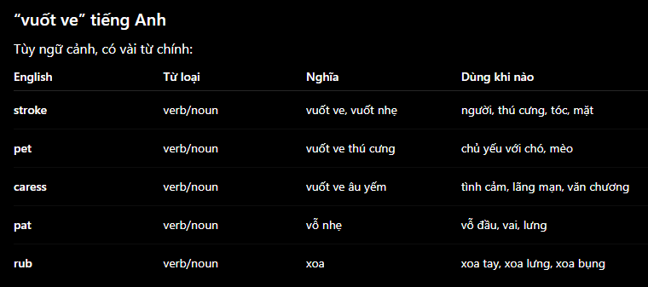

- Be apt to # have a predisposition to
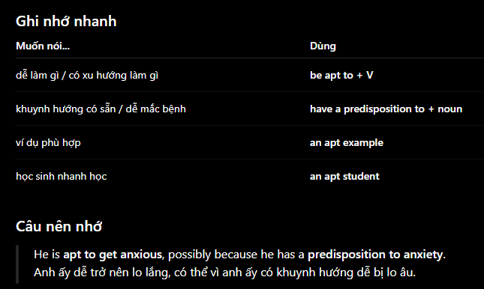

- Try + not + to + V
-> I try not to spend too much money

- Uncountable nouns
- waste = garbage
- Luggage = baggage
- homework
- work
- news
- progress
- behaviour
- accommodation
- software
- hardware
- funding
- infrastructure
- harm
- education

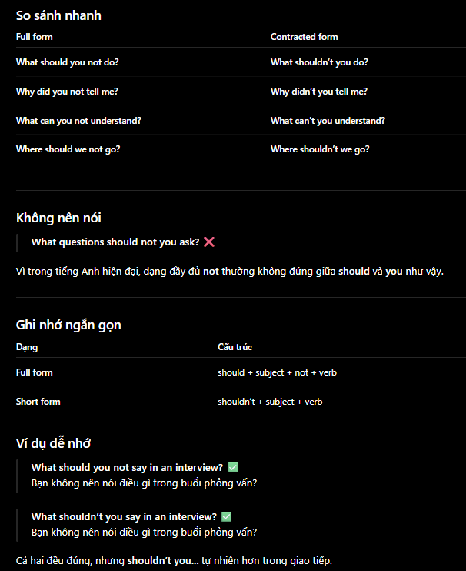

- What brings you here?
- Do you know many people here?
- Is this your first time here?
- Do you come here often?

- Are you from around here?
- Do you live here or are you just visiting?

- What kind of work do you do?
- What do you do for a living?
- Are you working or studying?

- Do you have any plans for this weekend?
- What are you doing this weekend?
- Are you doing anything fun?

- What’s your hobby? -> No friendly
-> What do you do for fun?
- What do you like to do in your free time?

- That’s a cool T-shirt. Where did you get it?
- That’s a nice laptop. What brand is it?
- Cool tattoo. Is there a story behind it?
- I like your hair color. Is it natural?

- Sorry for asking, but …
- I hope you don’t mind me asking, but …
- I don’t mean to be rude, but …
- May I ask …

- Threaten one’s life = life-threatening
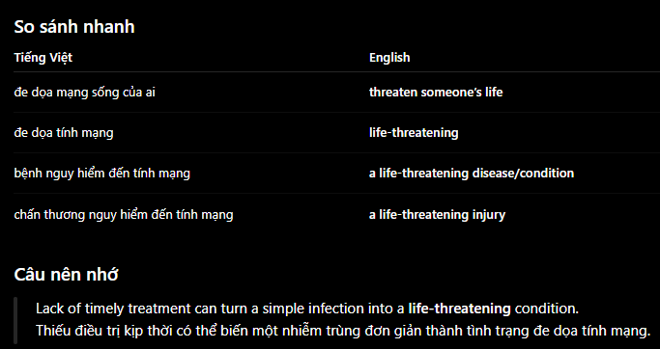

- Broth - nước lèo
- Vinegar (/ˈvɪnɪɡə(r)/) - giấm
- Chew (/tʃuː/) - nhai
- Invasive surgery - phẫu thuật xâm lấn

- Amateur # professional
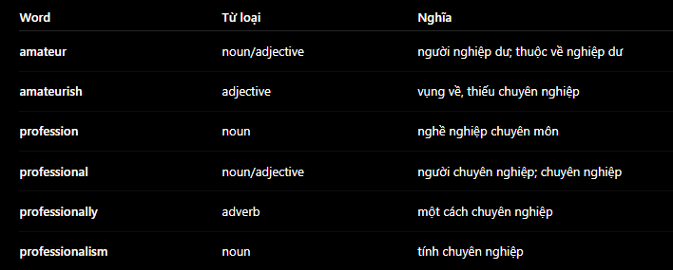

- S + be + to + V
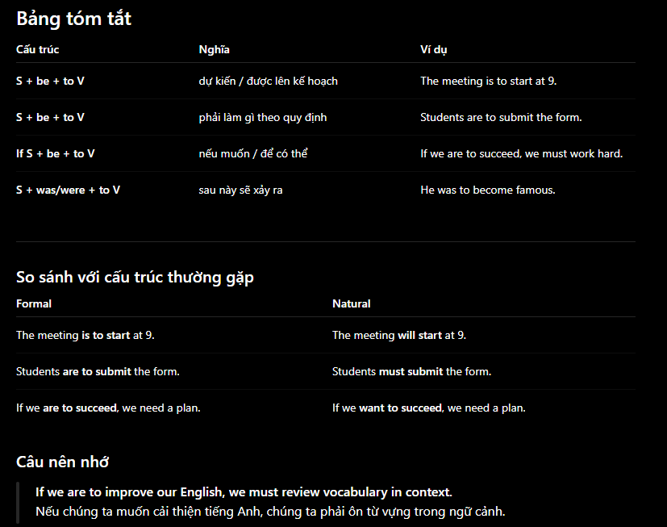

- Why + not + V?
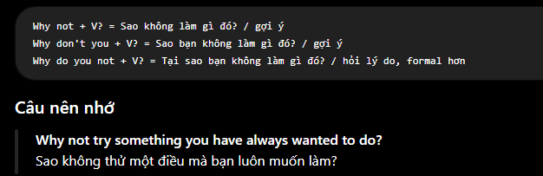

- Watering can
- Be + still
- S + has/have + not + V3 + object + YET
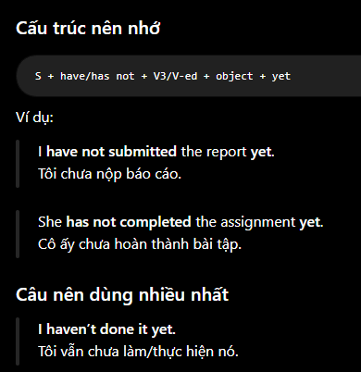
- Remote control

- Intense # intensive
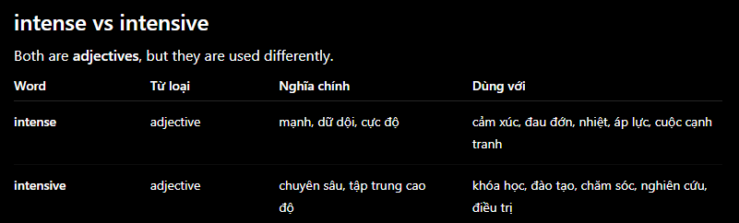

- Sau này nói dễ hiểu thì nói là -> Straightforward thay vì easy to understand

- N + with + Noun phrase
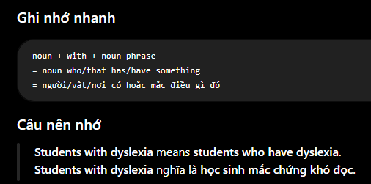

- Still
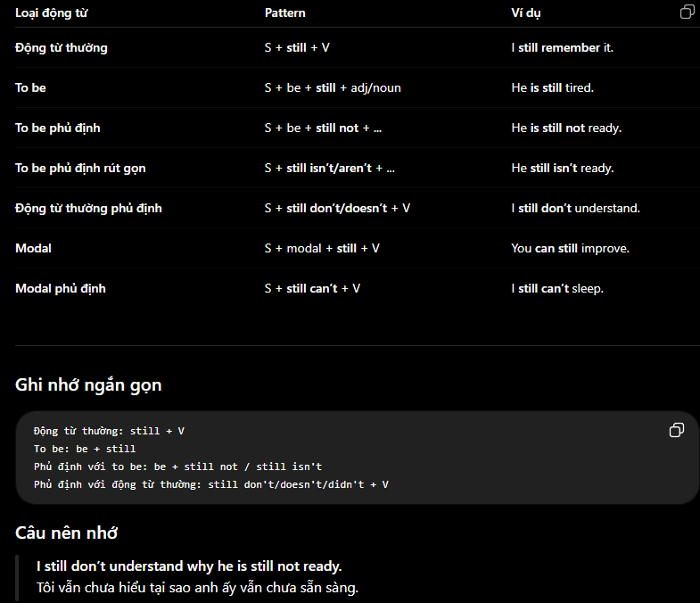

- Adjective
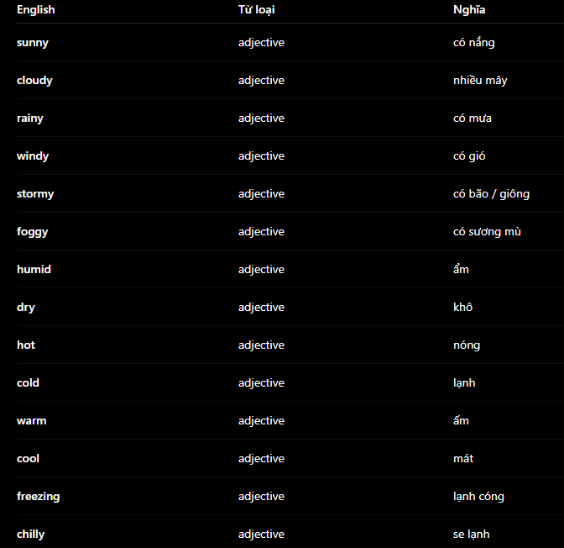
- Destroy = Damage = Devastate = Demolish

- All # whole
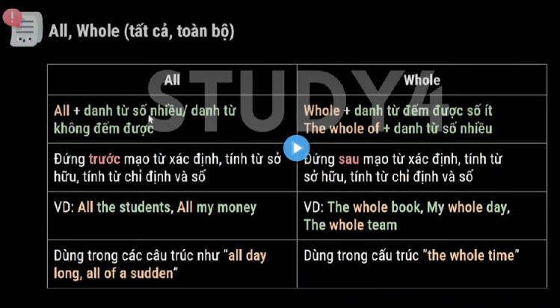

- No
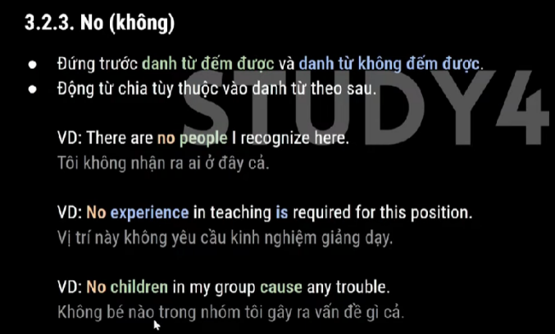

- Either # Neither
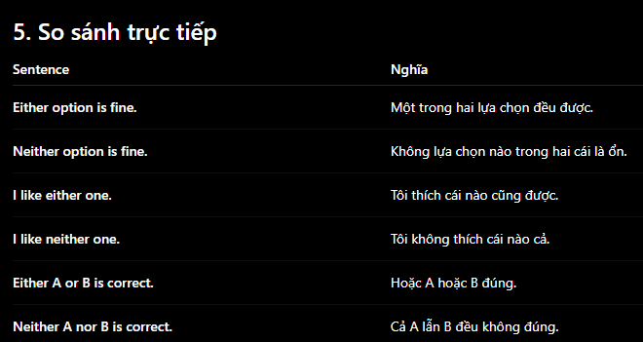
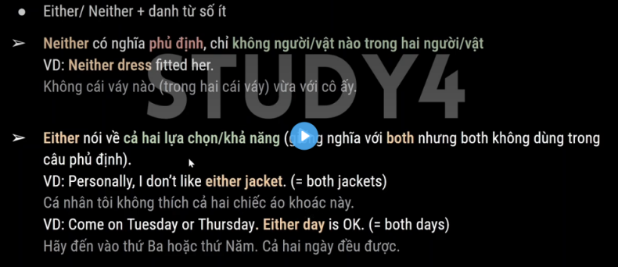

- Of
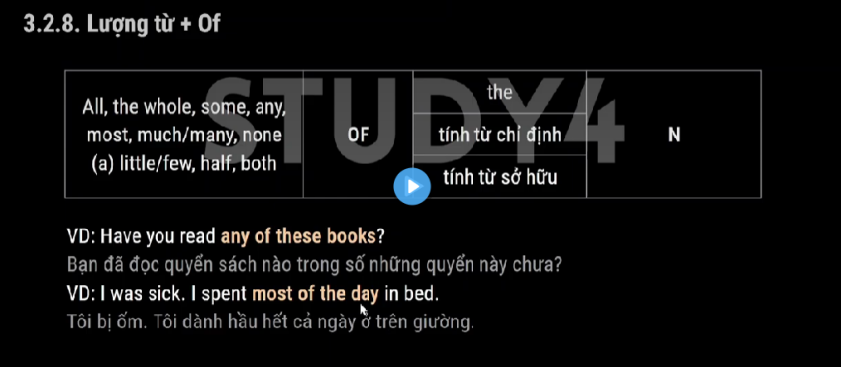

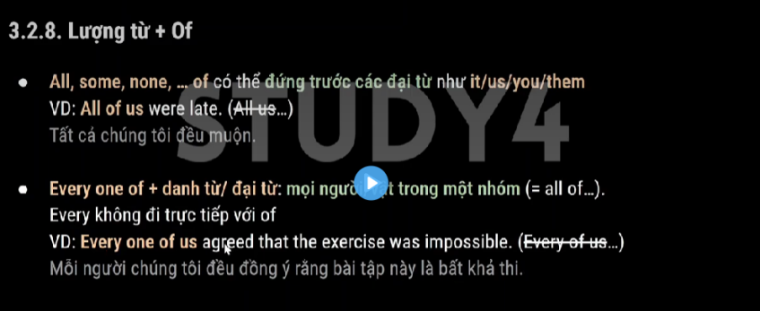

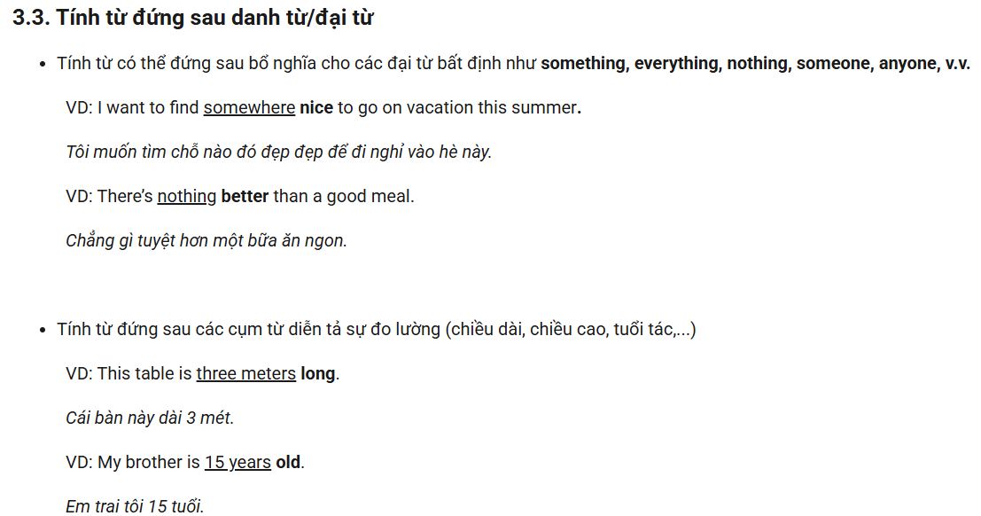

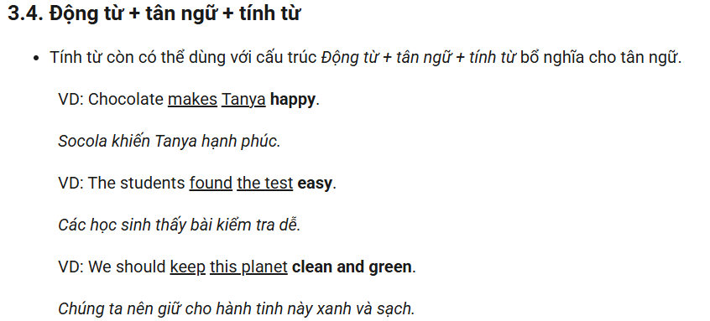

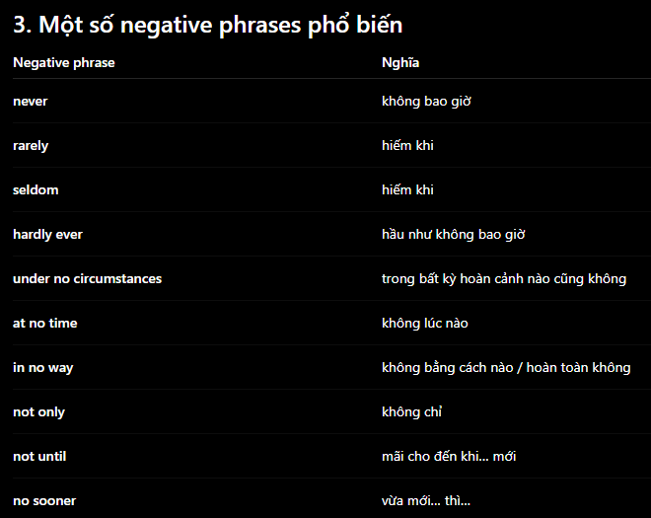
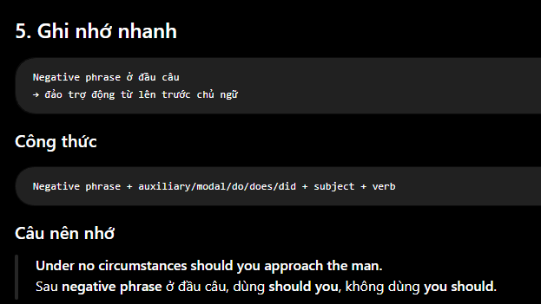

-> The clause after the negative phrase may be seen as a question

- Whenever I write a sentence with many clauses, remember checking whether the tenses of those clauses is similar

- So … that # Such … that
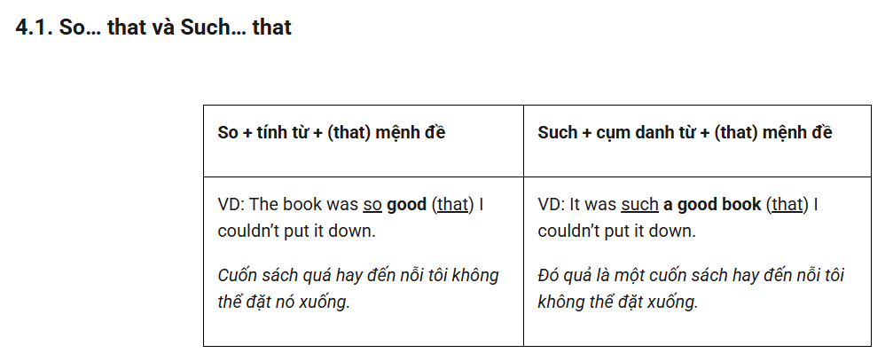

- The handle - tay cầm
- Suffix with “wards” and “wise”
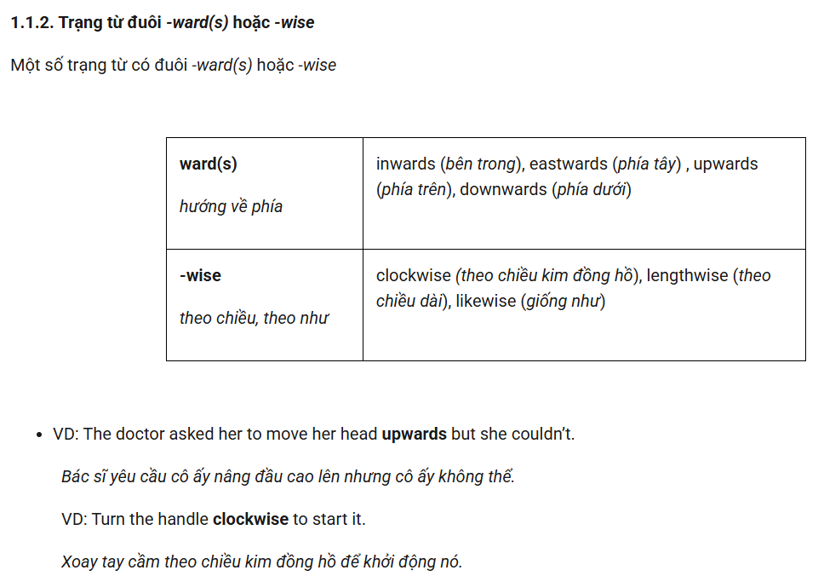
- Counter-terrorism - chống khủng bố

- Counter measure - biện pháp đối phó

- Suy luận
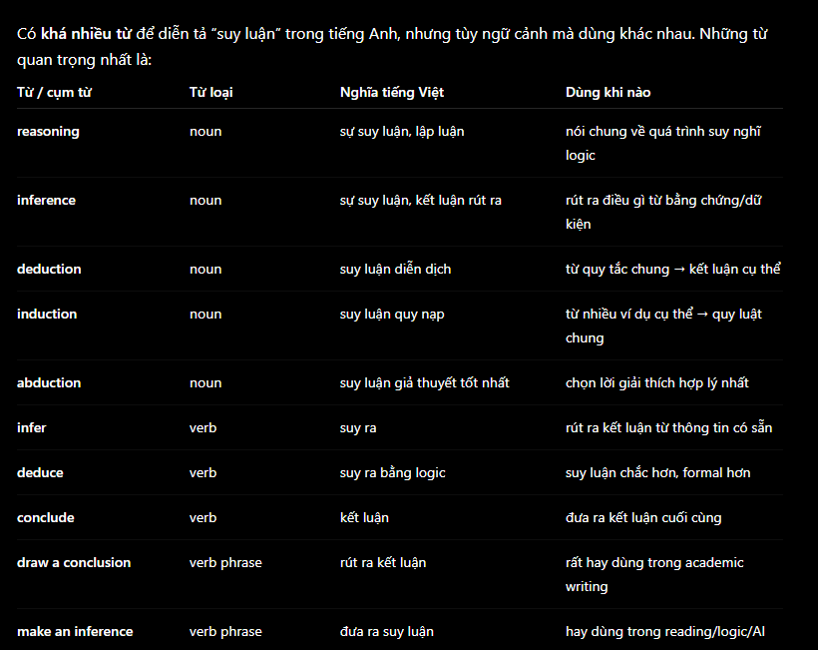

- Phỏng đoán
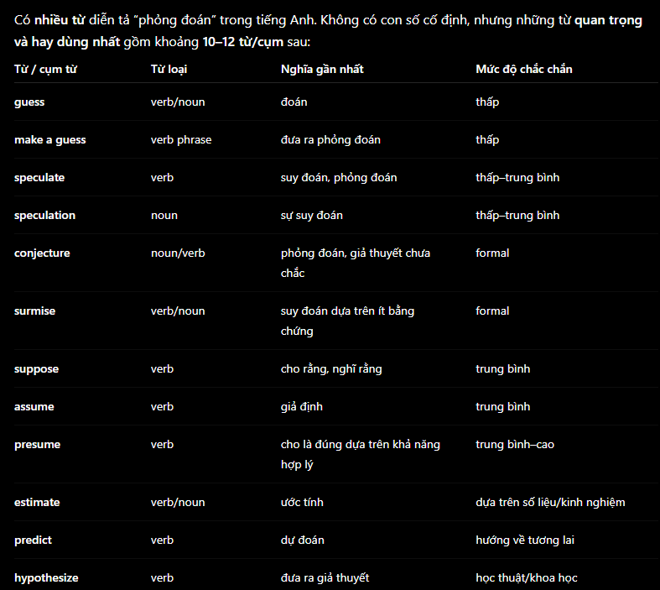

- Nhìn thoáng
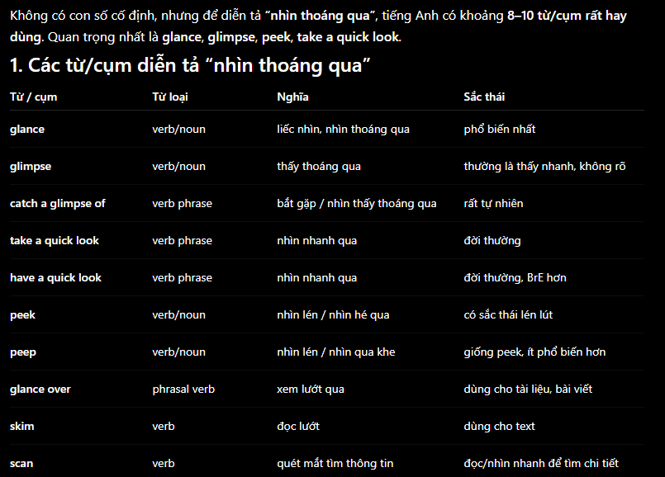
- Nhìn chằm chằm
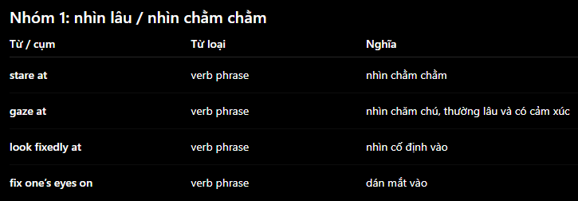

- From
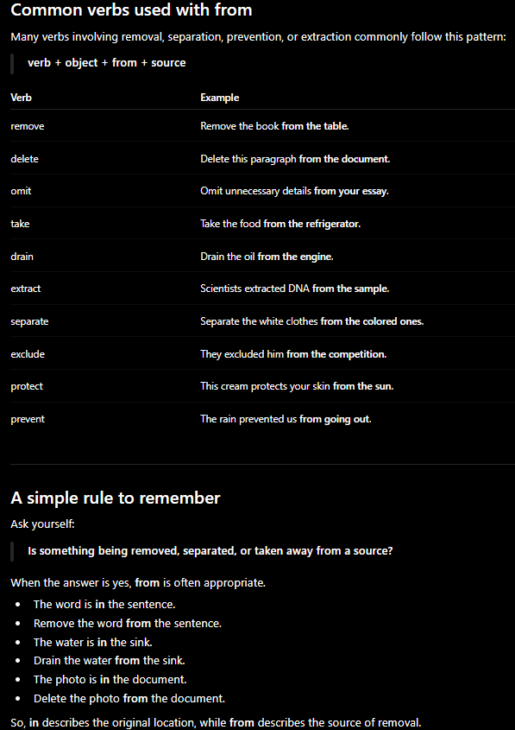

- At first glance - thoạt nhìn

- Into # out of

- Over # under above # below
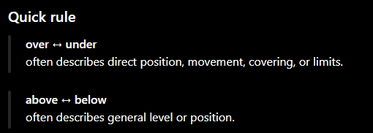

- Over # through # across
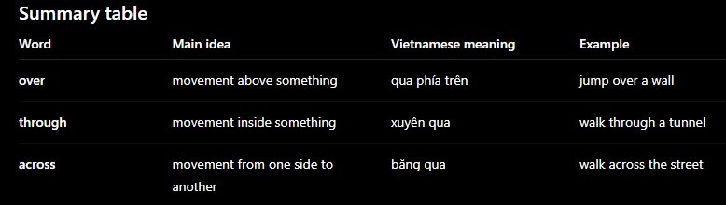

- Distinct (adj) = Different

- Cứ tự nhiên
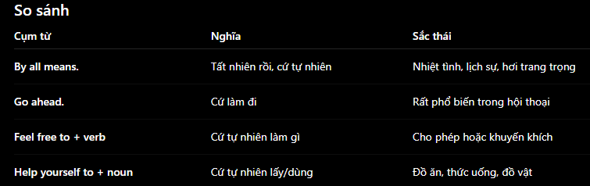

- Happen to + V
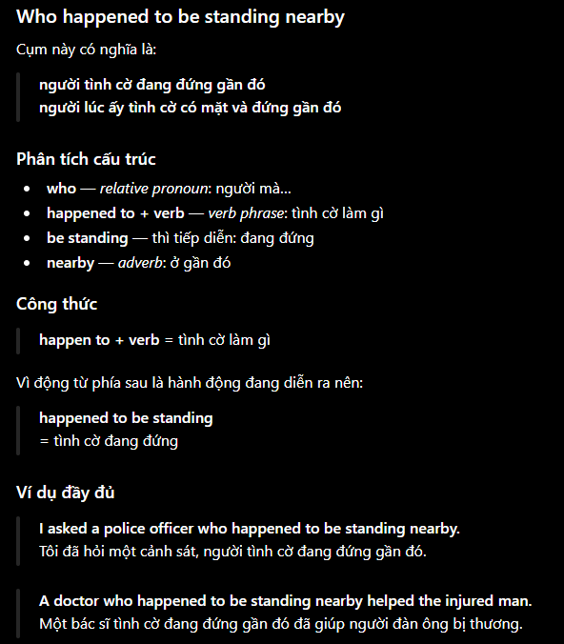

- At the end of each session - cuối mỗi buổi

- Neighborhood - khu vực, khu vực

- Learn from each other = learn from one another

- didn’t sleep well the night before = slept badly the night before

- Set an alarm for 6 a.m Set an alarm for tomorrow morning

- Clear my head Clear my mind
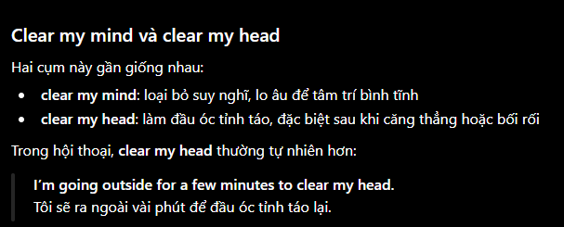
- Compost bin - thùng ủ phân hữu cơ

- V3 + N
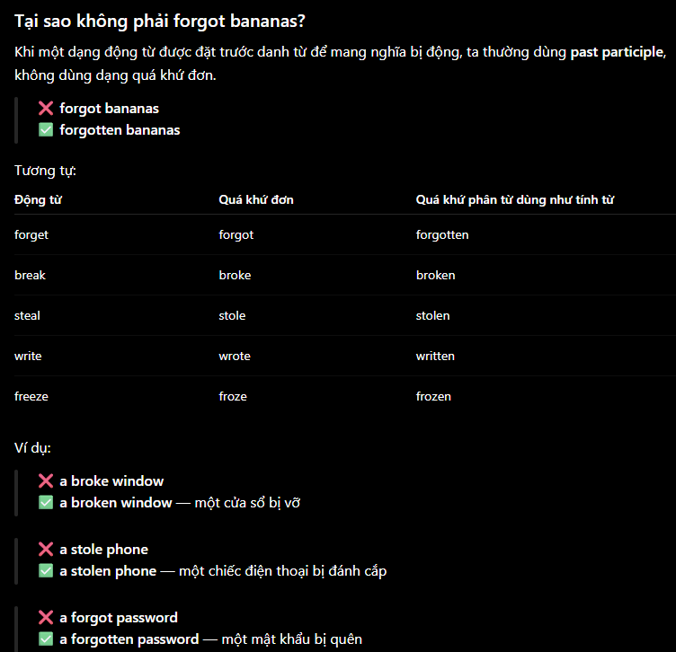

- Be sick of = be tired of = be fed up with = have had enough of

- Continuous # Constant

- Envious of = jealous of

- Thiếu 1 số lượng gì đó
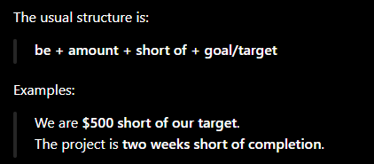

- Raise
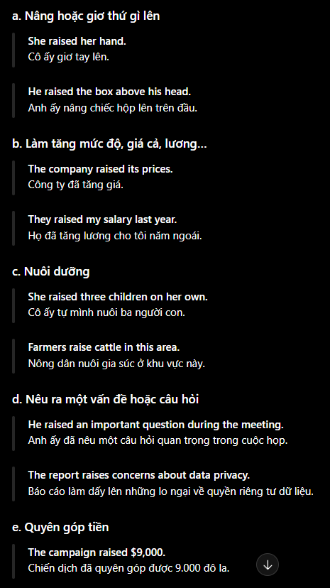

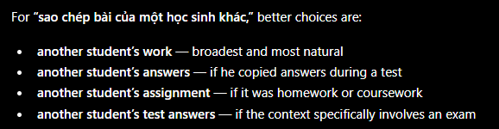

- Older people (người lớn tuổi) = elderly people (người CAO tuổi) = the elderly

- Lecture hall - giảng đường

- Raise funds = fundraise
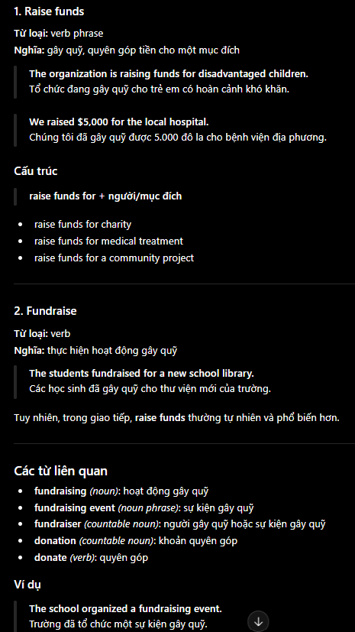

- Relating to # associated with
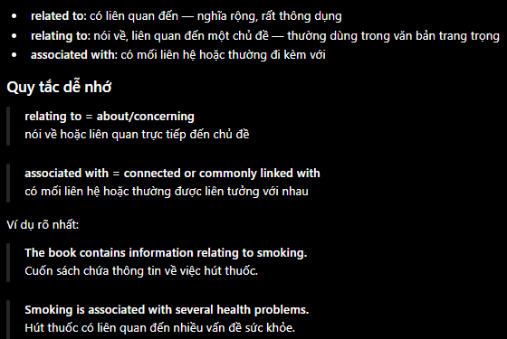

- Increasingly
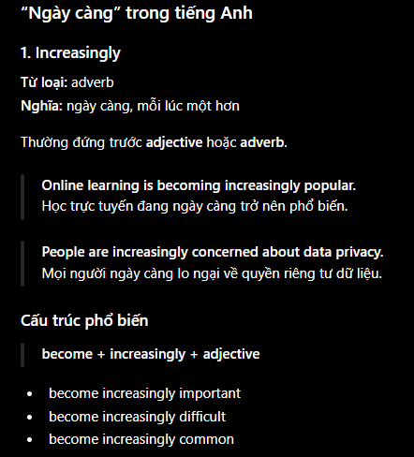
-> Besides, we can also use structure “more and more” (comparative structure in Study4). However, “increasingly” is more formal than “more and more”

- Major
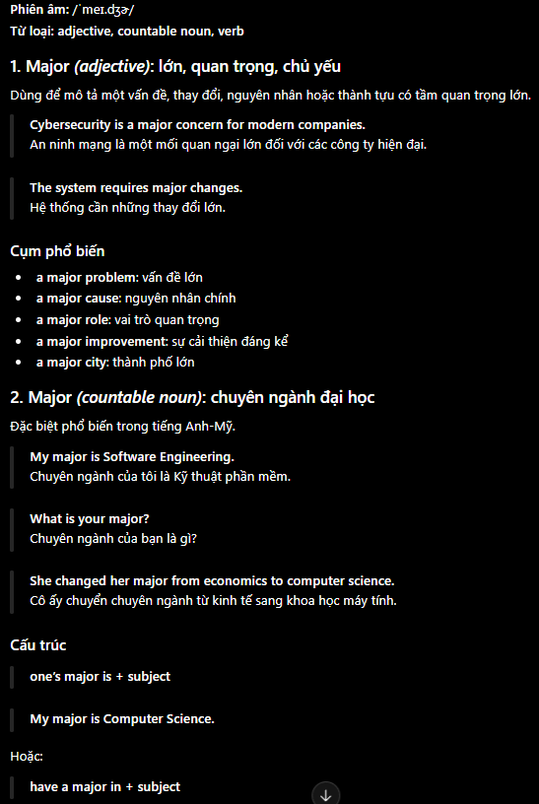
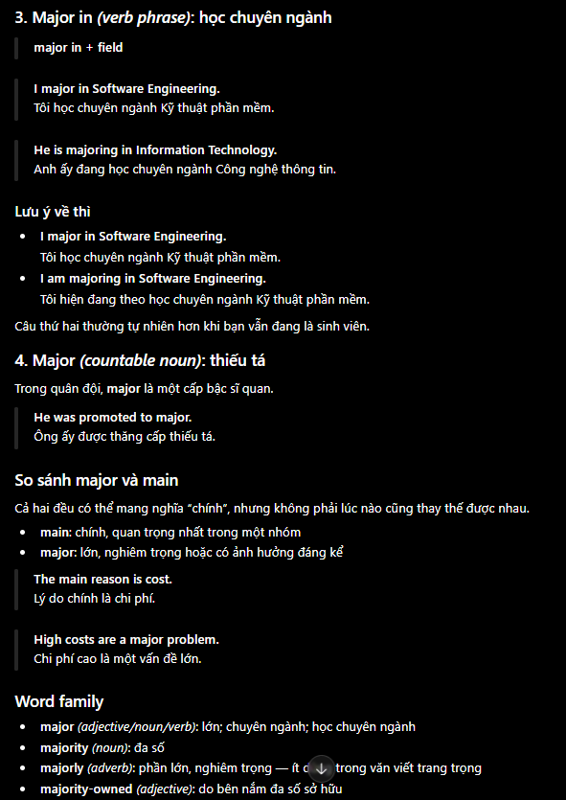

- Make + progress

- Sợ không dám làm gì thì đi với “to”
- Hội đồng đánh giá
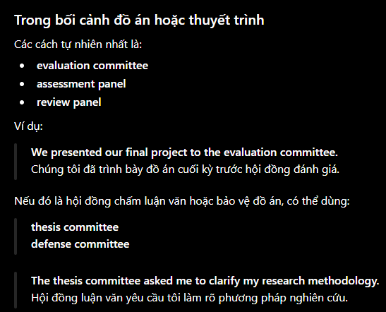

- Operate independently of

- Became/grow + adj - dần dần 1 việc gì đó

- Delighted # delightful

- Heavy vehicle - xe tải trọng lớn

- A solution to a problem

- đến mức nào


- Do my best work

- Will - be going to
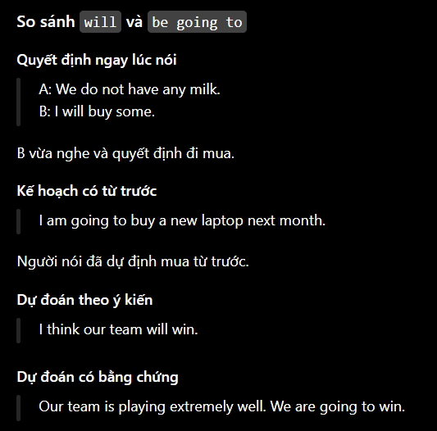

- Defending champion - đương kim vô địch

- Would rather + Vo ( + than Vo) - thích cái này hơn cái khác
-> I’d rather get a taxi than take a bus
-> I would rather not go out tonight

- It’s (high) time + Mệnh đề quá khứ đơn - đã đến lúc làm gì
-> It’s high time we started work

- Imagine if + mệnh đề quá khứ đơn = Imagine + V-ing - hãy tưởng tượng nếu
-> Imagine if we had a car = Imagine having a car

- Suppose + mệnh đề quá khứ đơn - giả sử.. thì sao?
-> Suppose we asked Mary to baby-sit? Do you think she’d do it?
- Suggest + (that) + S + (should) + Vo
-> I suggest that we should wait a while before we make any firm decisions

- Tốn công vô ích làm gì
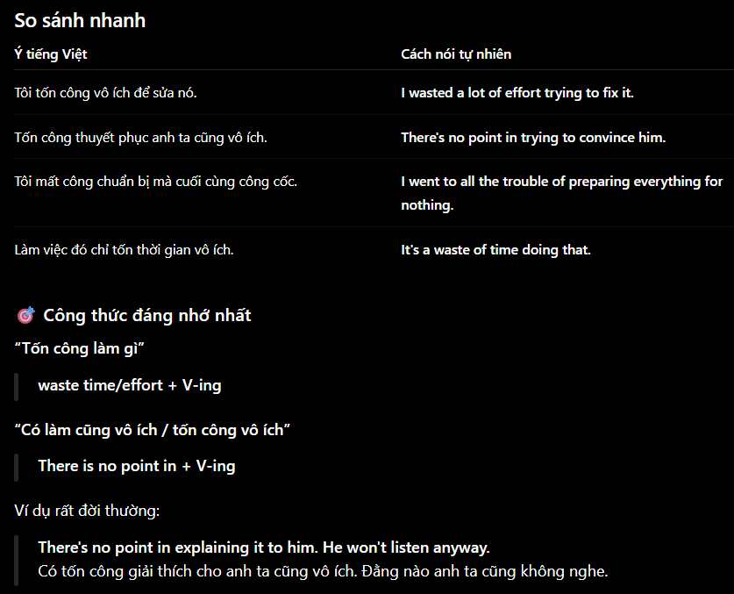

- Have trouble/difficulty/problems (in) + Ving - gặp khó khăn khi làm gì
-> I had no trouble in finding a place to stay

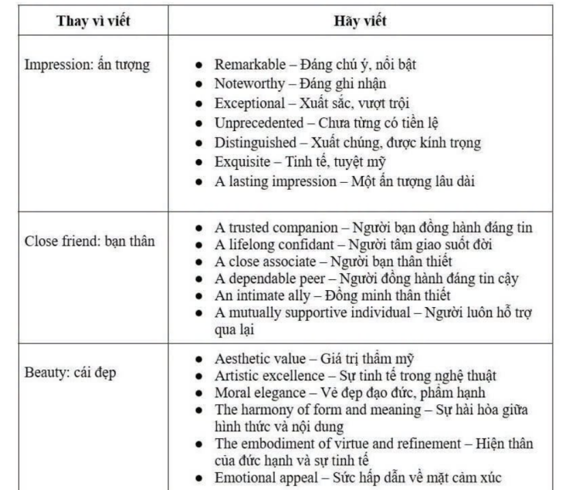
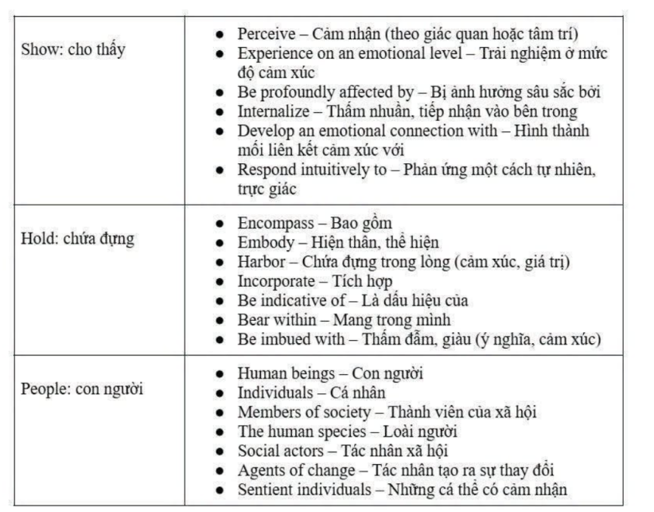

- The harmony of form and meaning

- Emotional support = a source of emotional support = someone to lean on = emotional anchor
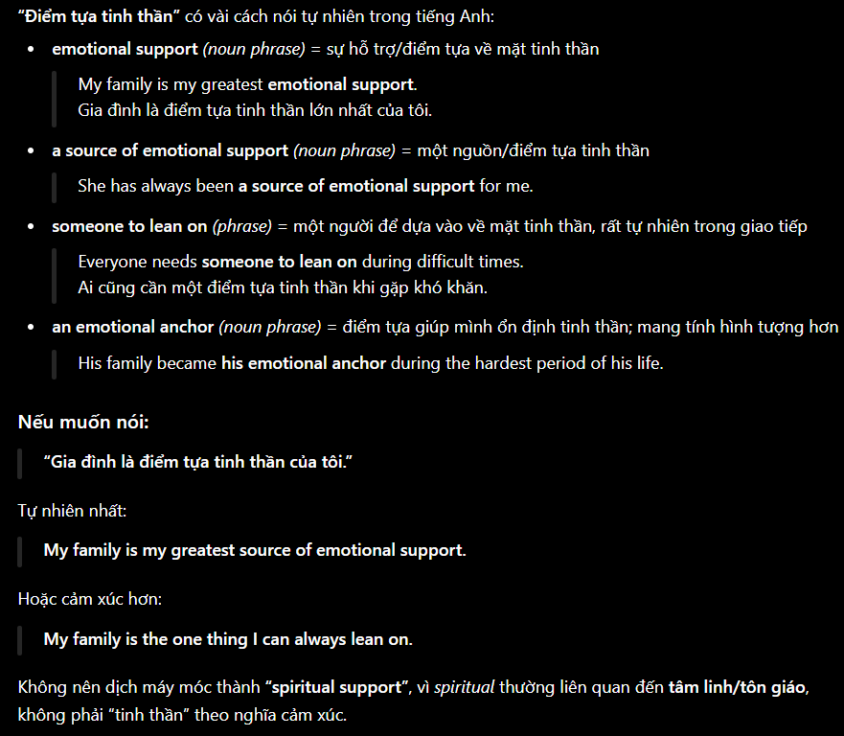

- In such a way that
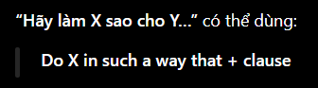
-> Do your work in such a way that you never have a guilty conscience

- Late
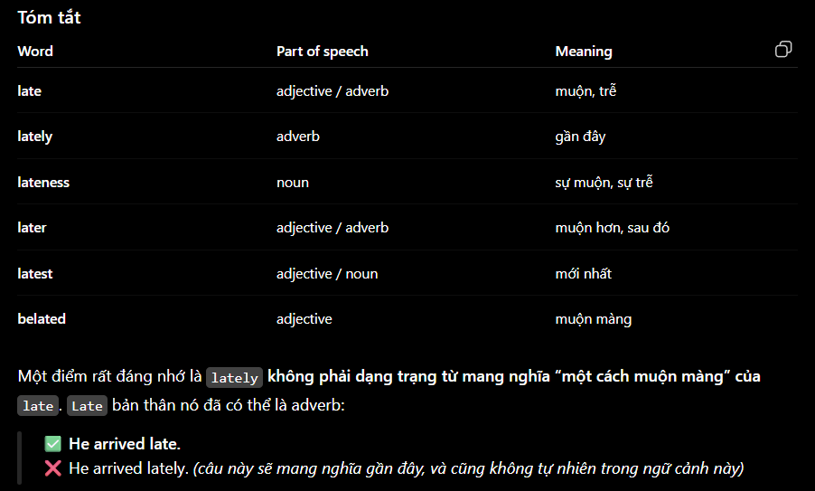

- Venture capitalist - nhà đầu tư mạo hiểm

- Blame oneself for something = Beat oneself up about something = reproach oneself for something
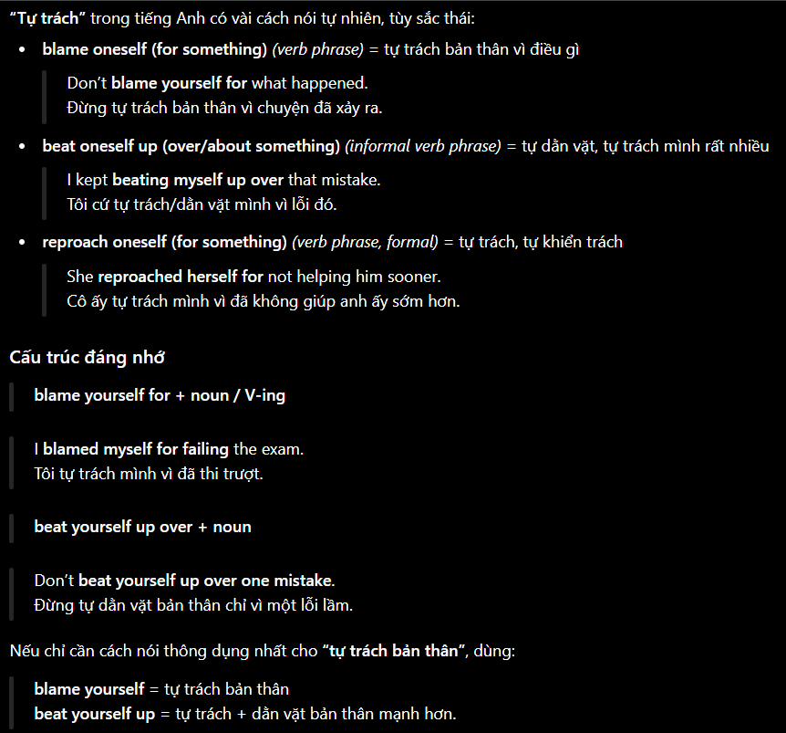
- Up to = a maximum of = at most
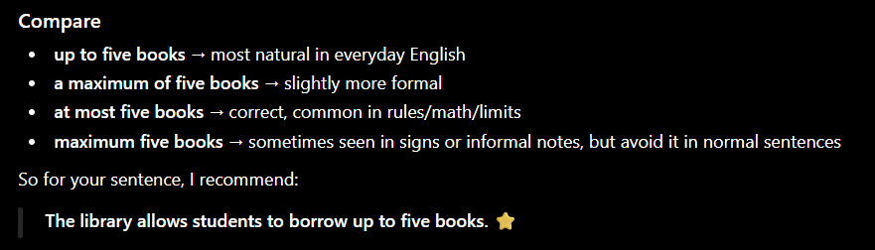

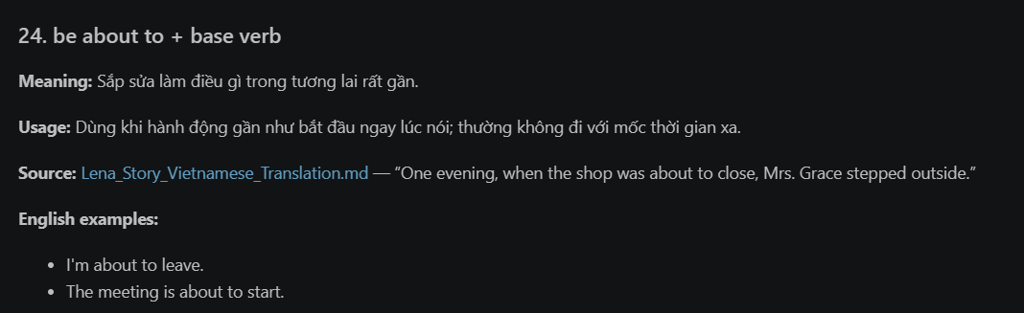

- Nới lỏng hạn chế - ease restrictions

- Lose - loss - lost
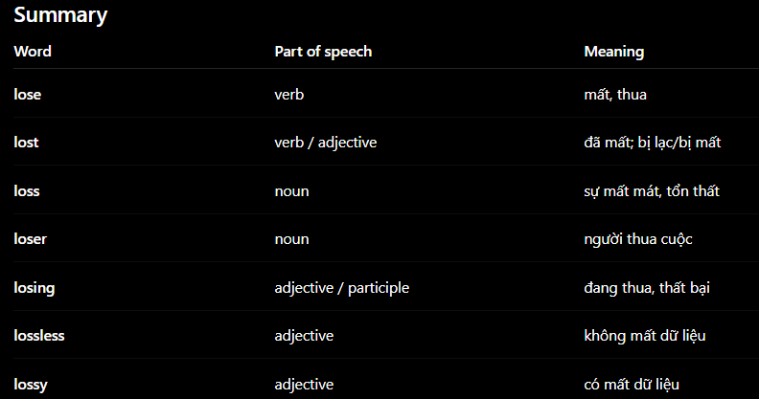

- Package = Packaging
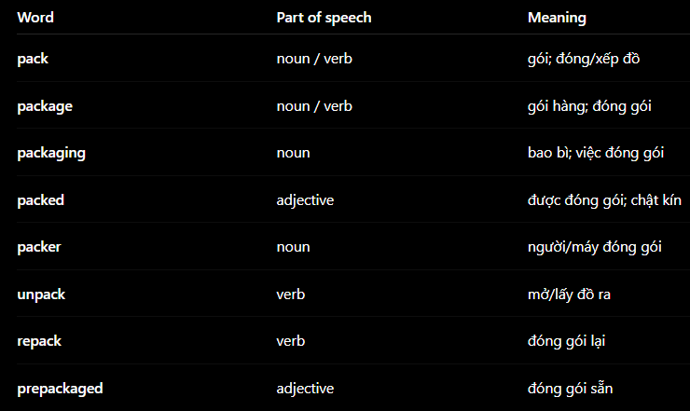

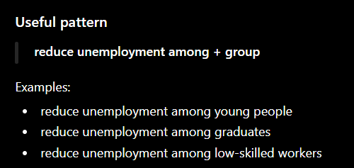

- Youth
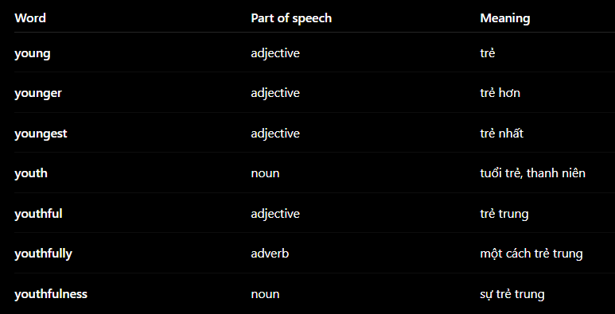

- Class size - sỉ số lớp

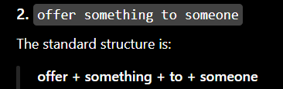

- PhD student - nghiên cứu sinh

- Intern
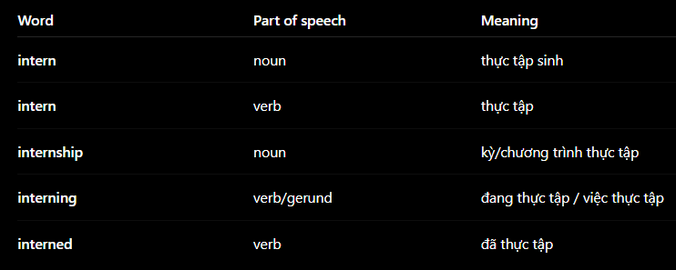

- Compete
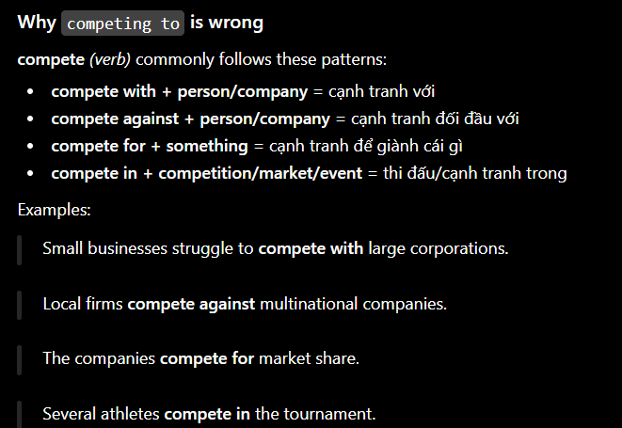

- Apply vs adopt
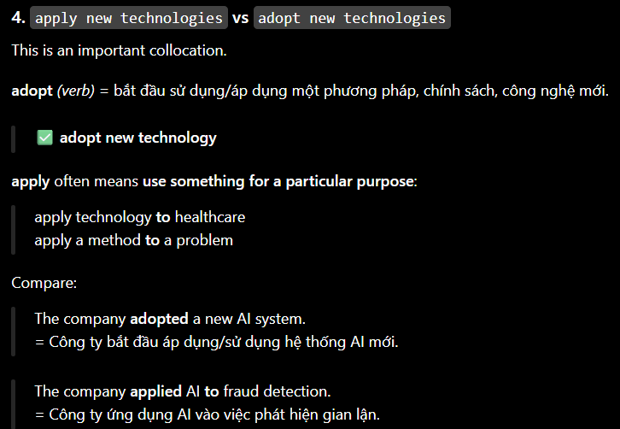

- Chỉ … thôi
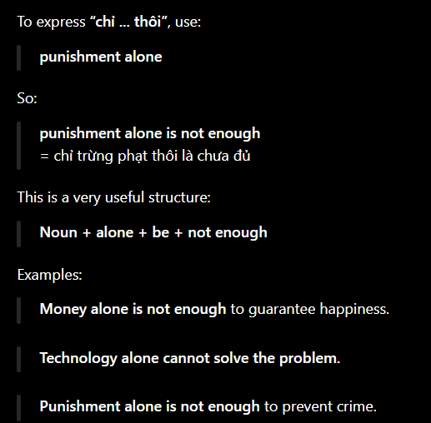

- If
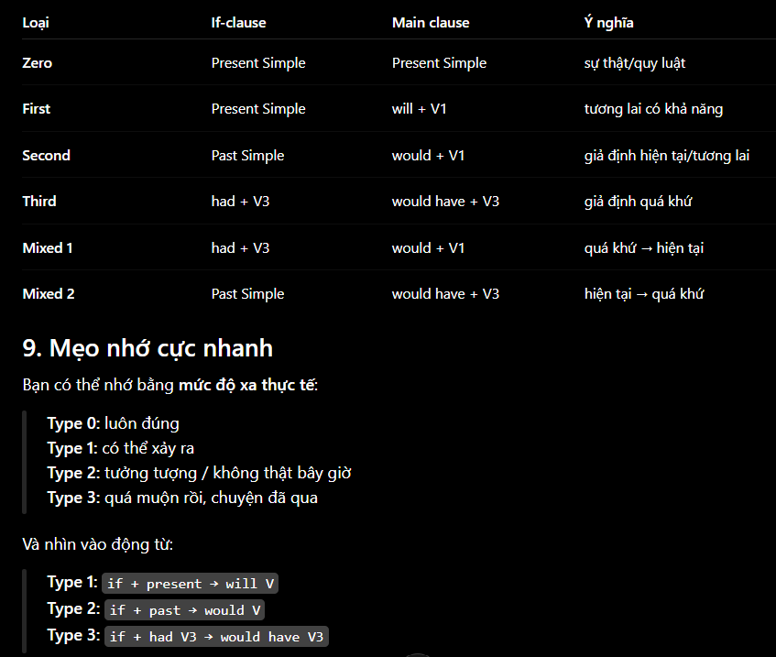

- Nghe lời khuyên

- Usual - Casual
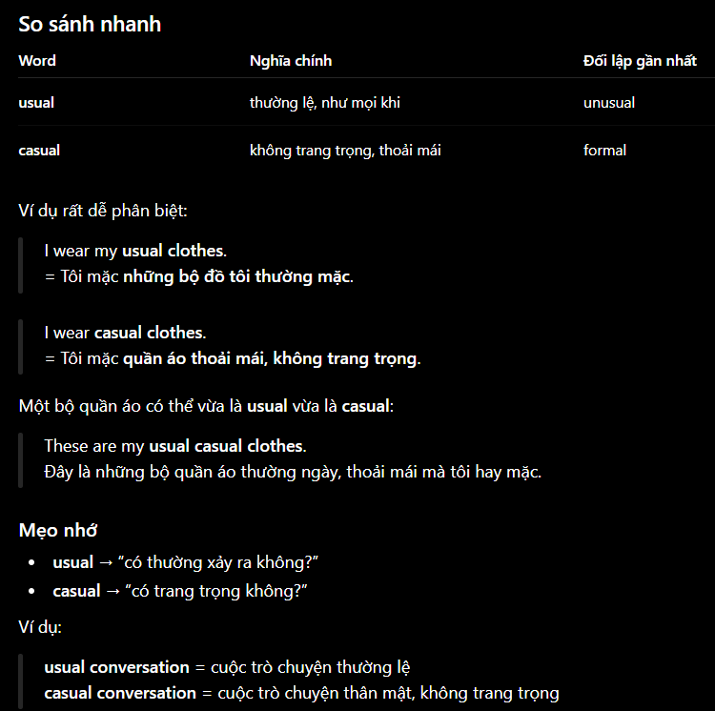

- Hard-working , diligent , industrious

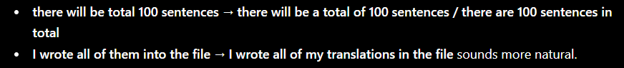
-> There will be a total of 100 sentences / There will be 100 sentences in total
-> I wrote all of my translations in the file

- The results are slow to come

Model V + Adv + be

- Break down

- Only = Just
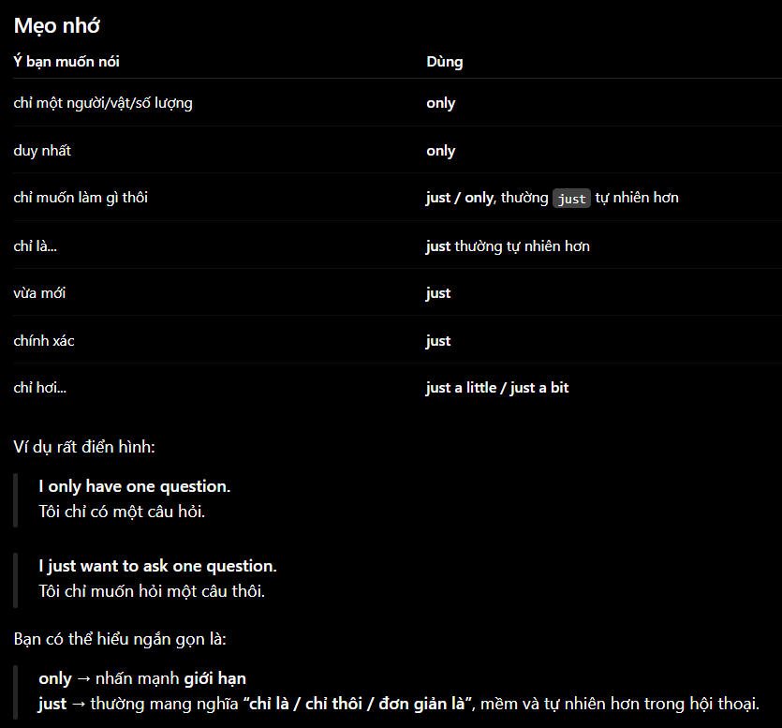

xxxxxxxxxxxxxxxxxxxxxx

- Enter
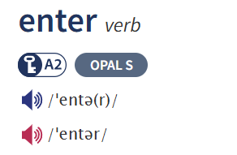

- defeated soldiers

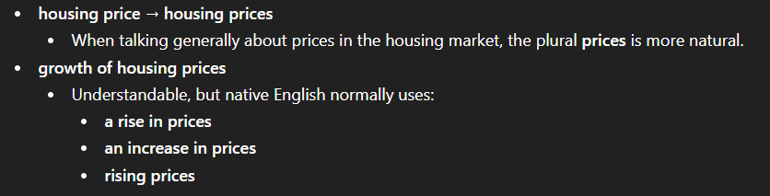

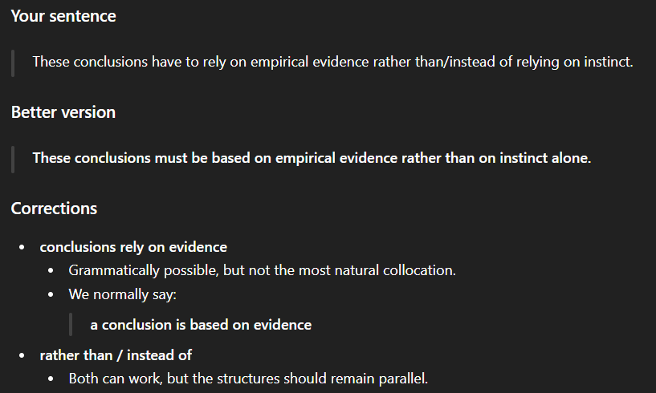

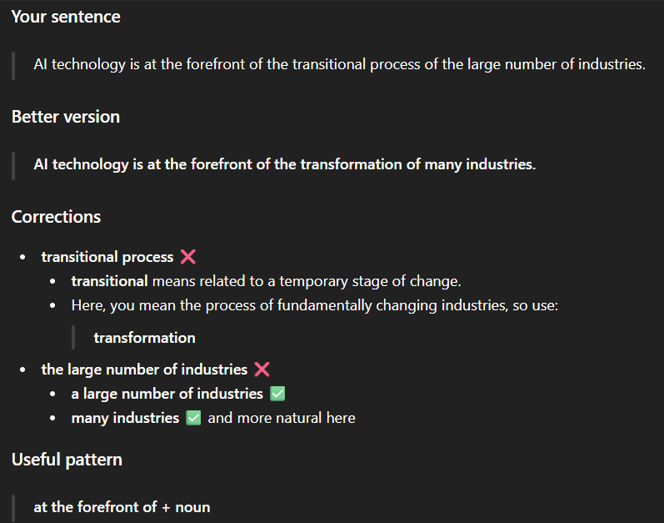

- Experience failure = Experience a setback = encounter a setback
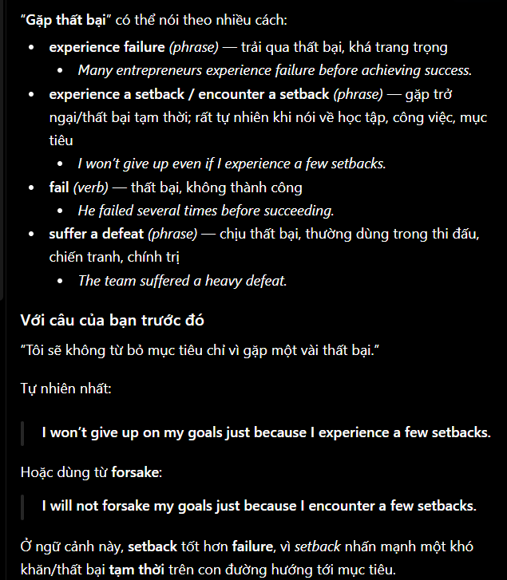



- Let me know in advance

- Guide me on how to ..

Xxx

- An exercise + on + java..

- I am torn between A and B - đang vân vân giữa A và B

- Media organization = Media outlet = News organization
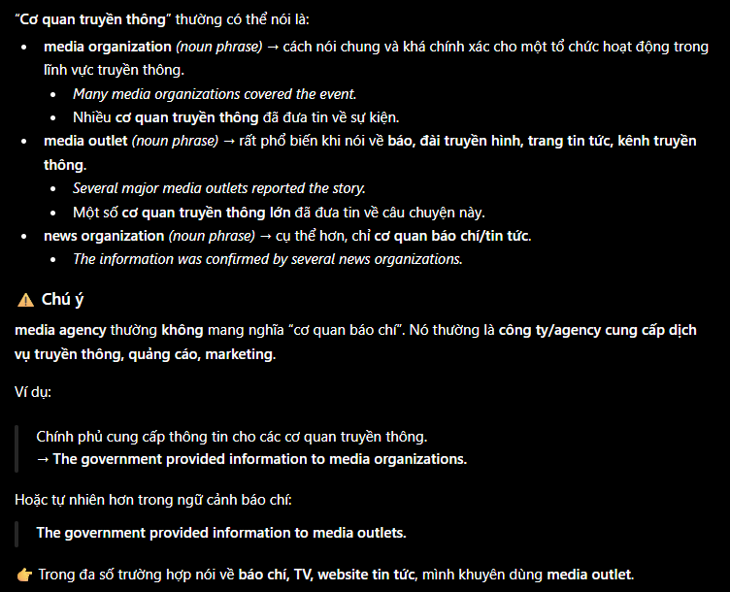

- Real-world project

- Nó không nhất thiết phải.. - it is not necessarily the classic Singleton design pattern

- Only for ceremony - chỉ cho mục đích hình thức, cho vui..

- Carnivore
- Herbivore
- Omnivore
- Omni
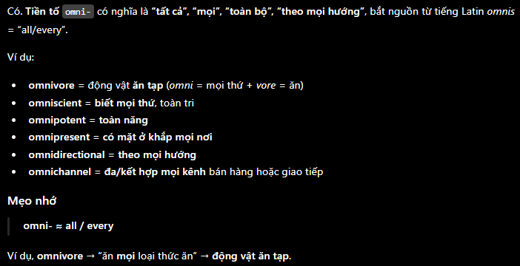

- Nocturnal animal
- Diurnal animal
- Poisonous animal
- Extinct animal
- Native / Indigenous species
- Migratory animal
- Social / herd animal
- Solitary animal

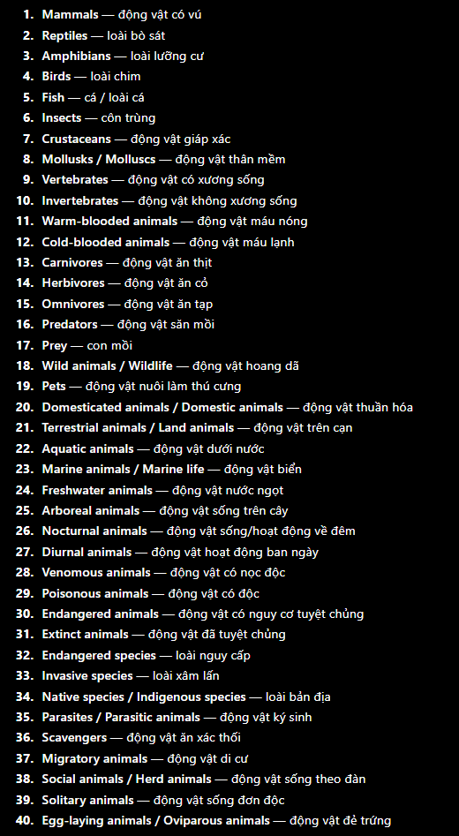

- DA2 - 3 (SE122)
- PTYC - 2 + 1 (SE357)
- Testing - 3 + 1 (SE113)
- DevOps - 3 + 1 (NT548)

Core Java ✅
↓
OOP ✅
↓
Collections + Generics ✅
↓
Exceptions ✅
↓
Java I/O ✅
↓
Threads / Concurrency basics ✅
↓
Maven / Gradle ✅
↓
SQL + PostgreSQL ✅
↓
JDBC ✅
↓
DataSource + Connection Pool concept
↓
🔥 Spring Core
↓
🔥 Spring Boot
↓
🔥 REST API
↓
🔥 Validation + Global Exception Handling
↓
🔥 Spring Data JPA + Hibernate
↓
Flyway or Liquibase (Tools)
Spring Transactions deeper
↓
🔥 Spring Security
↓
🔥 Testing
↓
Dockerize Spring Boot + PostgreSQL
↓
Deployment

- Hiển
- System design
- Design pattern..
- Ask ChatGPT to provide roadmap

- Collect an English video, listen to it once
- After that, ask NotebookLM to extract all sentences from this video
- Carefully read the transcript
- Then, ask an AI model to analyze grammars in this transcript. And give many examples of these grammars so I can practice and remember them better
- Listen the video again, about 3-4 times to be familiar with vocab and grammars

https://ttsmaker.com/?utm_source=chatgpt.com&fbclid=IwY2xjawTcfq1wZG9mBWV4dG4DYWVtAjEwAGJyaWQRMVBkMVE3U09vSXBOc0c5U2JzcnRjBmFwcF9pZBAyMjIwMzkxNzg4MjAwODkyAAEeViy194utUHv9HkcpHD8ReMUBhVkBXZf32-NeXvBTNM3FpDi__-mytG4Om9s_aem_MDG1qQkXLADiS6FsLVU5pw

https://audio-joiner.com/vi/#google_vignette

- Software/Tool helps to test whether a software has any bugs?

- Actuator

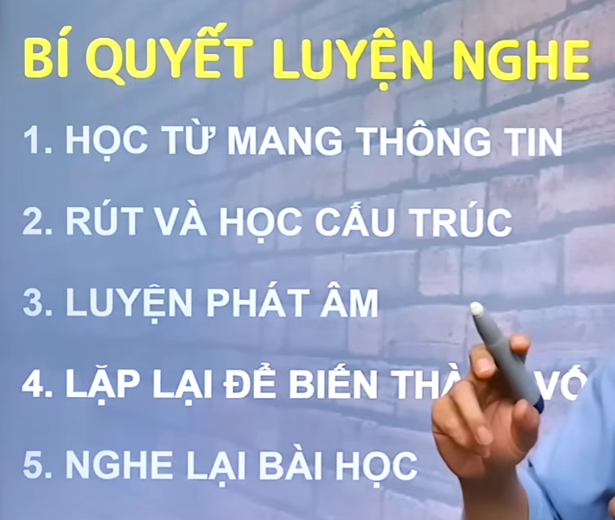

- Interleave

Practice LISTENING with TED while I can also improve my Speaking and Writing skills
- Carefully read the script in the first time. In this time, extract all new vocabulary words I don’t know and l will explore what they mean
- Listen to the speaker’s monologue 3 times. Besides, read the script simultaneously so I can practice the above new words..
- Writing: translate from Vietnamese to English
- Dictate: Listen and write

ok, now provide me with a prompt asking an AI model to:
- create a .md file containing all essential, crucial and main Spring Boot concepts (ask the AI model to reference all topics I learned before such as Spring core, Connection pool if necessary..)
- Create another .md file containing a simple exercise on this topic so that I can review and practice my knowledge (format is similar to the DataSource_Connection_Pool_Exercise.md file..)

ok, I have already finished learning Validation and Global Exception Handling. Now provide me with a prompt asking an AI model to: 1. create a .md file containing all essential, crucial and main Spring Data JPA + Hibernate concepts (ask the AI model to reference all topics I learned before such as Spring core, Connection pool if necessary..) 2. Create another .md file containing a simple exercise on this topic so that I can review and practice my knowledge (format is similar to the DataSource_Connection_Pool_Exercise.md file. And reuse the project "book-catalog-api" in the directory "Validation" (this is the project I reuse for Validation and Global Exception Handling from REST API )

- Git and Github

