* **Text field:** **Content of text field.**
* **Text field in a shape:**
* **HTML field in a shape:**
* 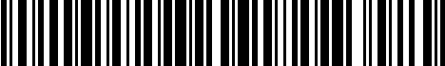**Barcode field in a shape:**
* 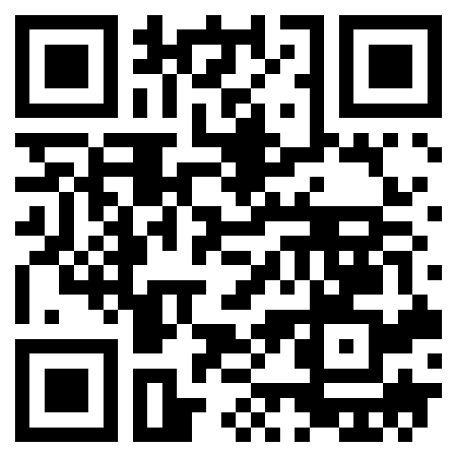**Qrcode field in a shape:**
* **Repeat a paragraph:**

This **paragraph** will repeat 1st time for for testing first time.

This **paragraph** will repeat 2nd time for for testing second time.

This **paragraph** will repeat 3rd time for for testing third time.

* **Repeat a/multiple row(s) of table:**

|  |  |  |
| --- | --- | --- |
| **Order** | **Name** | **DOB** |
| 1 | Brian | 20/05/1987 |
| 2 | Wade | 02/10/1992 |
| 3 | Carlos | 20/03/1986 |
| 4 | Dave | 30/09/2014 |
| 5 | Gilbert | 20/05/2017 |

* **A bookmark insides a bookmark:**
* **Insert equations from other document:**

**This equations are from another document!**

$${\left(1+x\right)}^{n}=1+\frac{nx}{1!}+\frac{n\left(n-1\right)x^{2}}{2!}+…$$

$$f\left(x\right)=a_{0}+\sum_{n=1}^{∞}{\left(a_{n}\cos{\frac{nπx}{L}}+b_{n}\sin{\frac{nπx}{L}}\right)}$$

$$\sin{α}±\sin{β}=2\sin{\frac{1}{2}\left(α±β\right)}\cos{\frac{1}{2}\left(α∓β\right)}$$