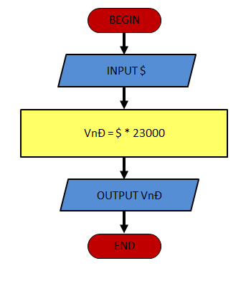

BEGIN

Input $ (dollar)

VnĐ = $ \* 23000

Output VnĐ

END