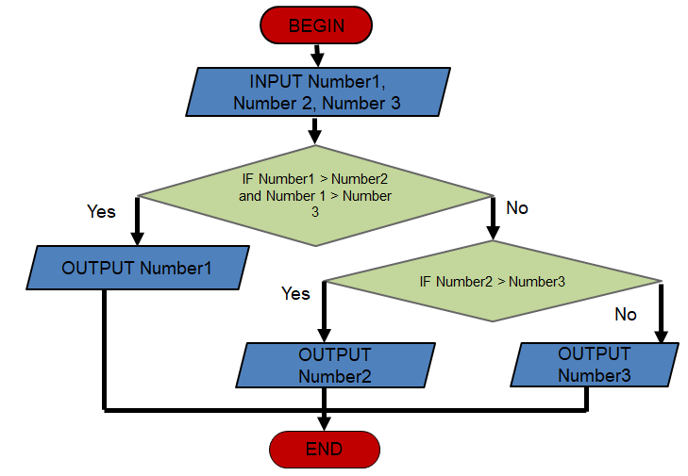

BEGIN

Input number 1 ; number2 ; number 3

IF number1 >number2 and number 1 > number3

Else display number1

IF number2 > number3

Else display number2

END