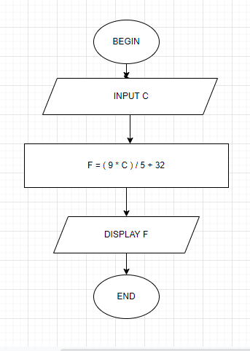

Begin

Input C

F = ( 9 \* C ) / 5 + 32

Display F

End