Our application is a software about expo management system. We will help you how to use it.

You must have an account to log in the system. 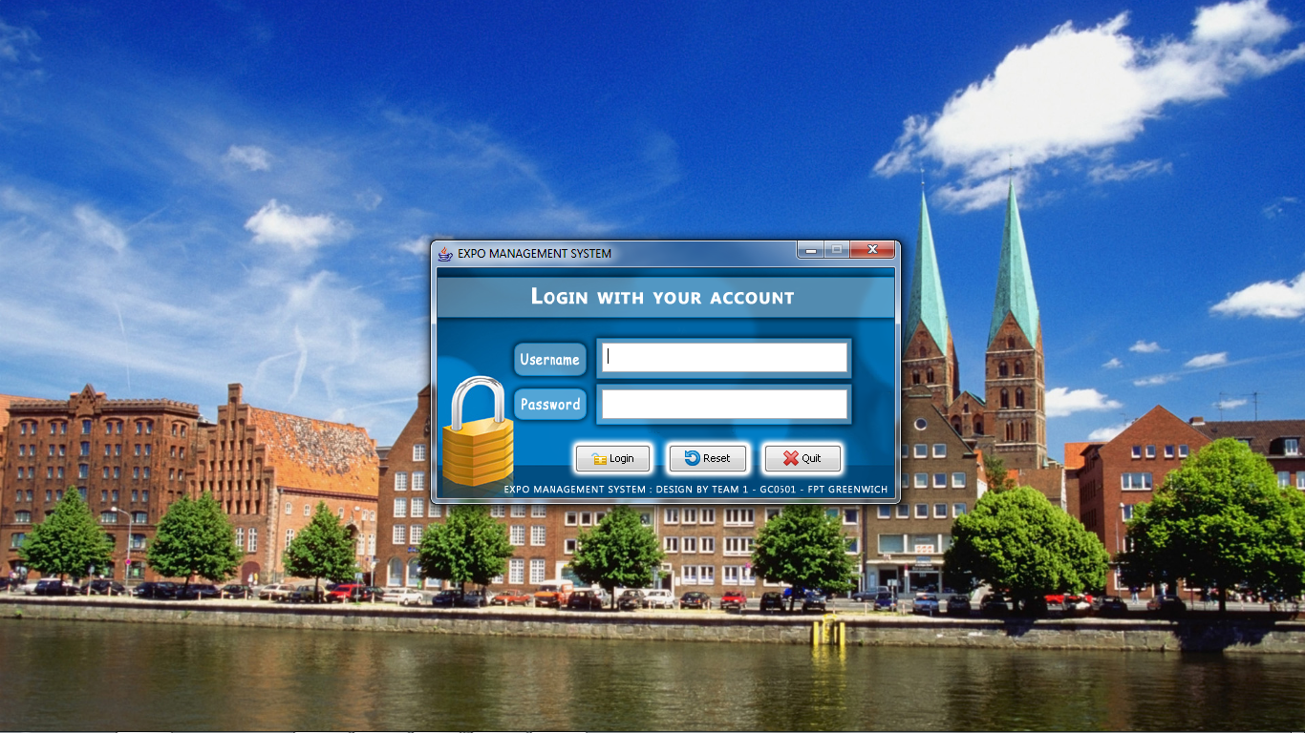

There are two types of account: manager and exhibitor.

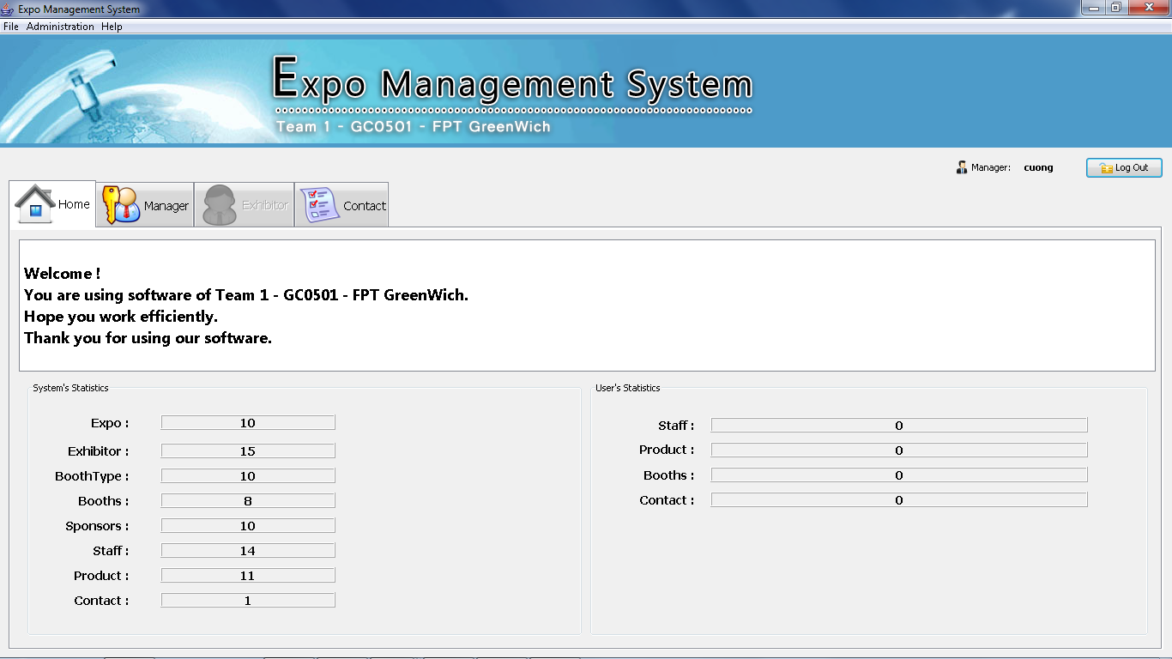

If you log in by manager account, you can have right to add, edit or delete Expo, Booth Type, Booth, Sponsor, Account and Exhibitor.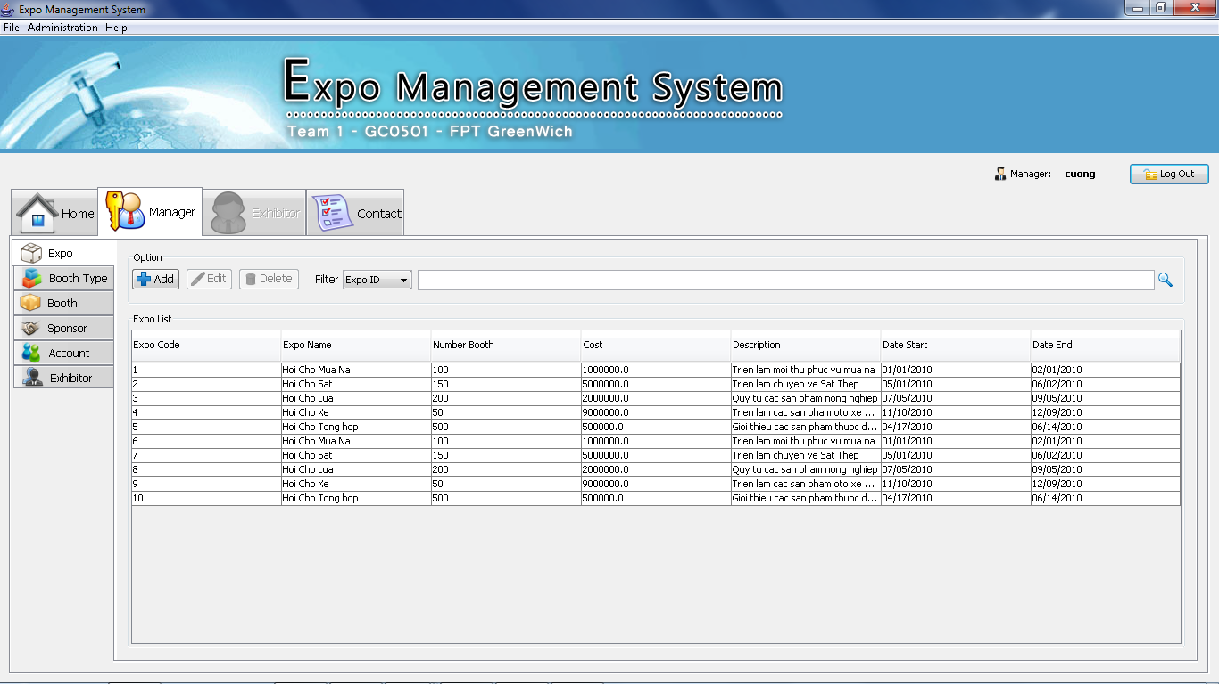

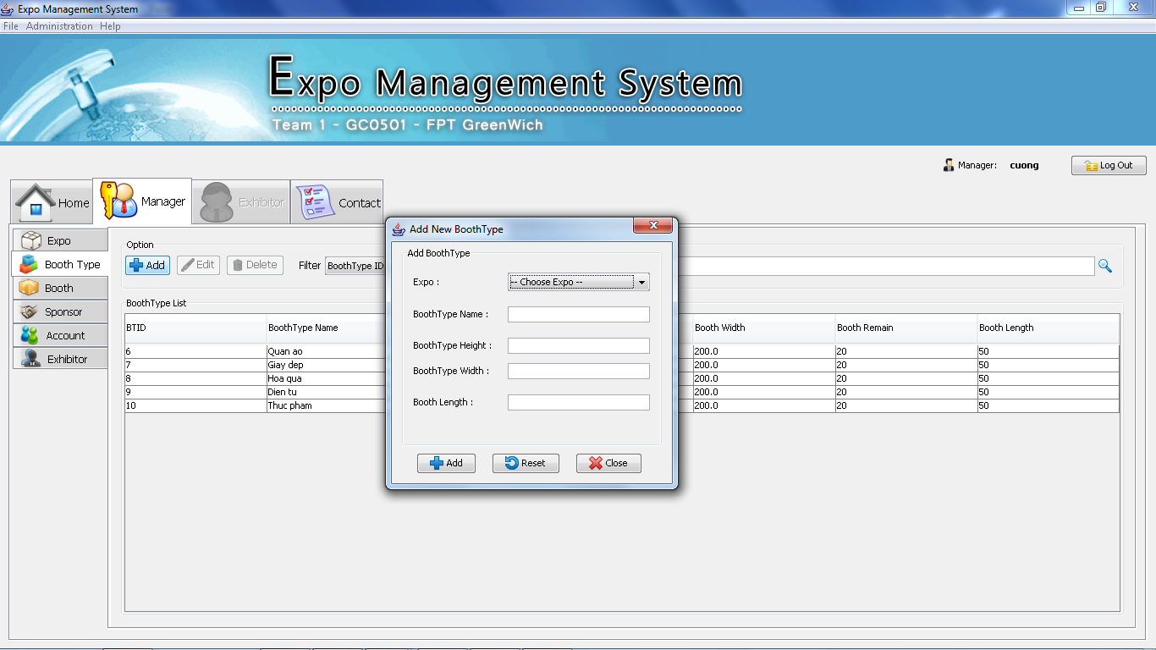

.

If you log in by exhibitor account, you can have right to manage Booth, Staff, Product.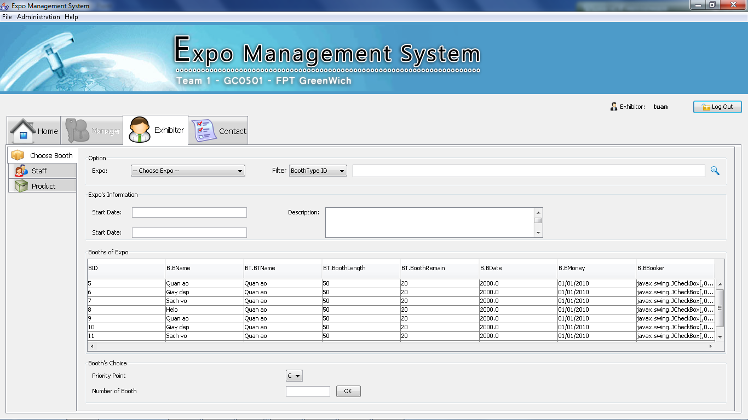

This is the contact screen when you add contact on Choose Booth table.

