1. Problem Definition

With the increasing growth in the number of industries and the competitive run for the trophy of perfection and profit, these industries round the globe are in the lookout for a roof to exhibit their products in the most convenient ,profitable and successful means.
Expos or large trade fair and exhibitions with the aim of promoting their products and companies. The organizers face a huge amount of effort in conduction such large scale expos. All the details are recorded in the respective registers by however to manage huge information in this type of paper based system is really difficult task. The computer based system is required so that the information can be maintained more effectively and easily.
Our group present to you the new program “Exhibition Management Program” which will help us to manage information in the efficient and easy way.
- Main user: Manager, Exhibitor
- Main functions:
- Maintain Exhibitor Information:
  - Exhibitor's membership status
  - Total number of years exhibiting in expo
  - Total number of booths - along with booth numbers
  - Number of booths by year
  - Staff working at the booth
  - Sponsors
  - Prints badges and confirmations
  - Exhibitor priority points (for booth preferences and awards)
  - Exhibit space size - along with the amount
  - Source of exhibitor leads
  - Capture important dates including: last change, paid, contract sent, and contract return date
- Booth Management
- Expo Management System automatically updates exhibitor accounts when fees or services are changed for a booth.
- Have the option of printing reports of booth assignments and analyzing your booth data with statistical reports.
- Create charts and graphs for the Executive Director/Board.

2. Customer Requirements Specification(CRS)
2.1 - Functional Requirments

Our application has following functions for each type of user:

- For Manager :
  - View, search, add, delete and update the information of expo, booth and exhibitor
  - View report in system.

- For Exhibitor :
  - Add, update or delete the information of his/her own.
  - Make contacts
  - View, search, add, delete and update products.
  - Add the information of sponsors, staff.

2.2 - Deployment environment

A. Hardware

- A minimum computer system that will help you access all the tools in the courses is a Pentium 166 or better
- 128 Megabytes of RAM or better
B. Software

- Visual Studio .Net / ASP / visual studio 6.0

- IIS server

- .Net Framework

- Java Virtual Machine/ J2EE server

- Notepad/Java editor

- j2sdk1.4.1_02 (or later).

- EJB Dev Kit

- Java enabled web server

- JSP / Servlets Dev. Kit

3. Architecture and Design of the Project

Tier 1
Presentation Tier
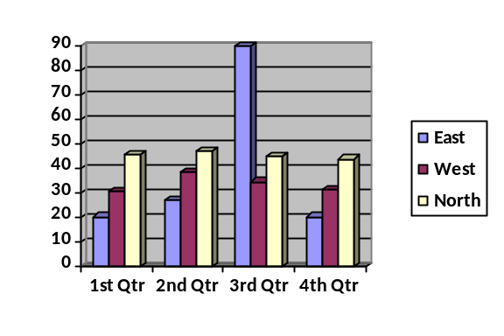
User Interface - GUI Components

Tier 2
Database Tier

Database Access

4. Data Flow Diagram
4.1 - Context Diagram

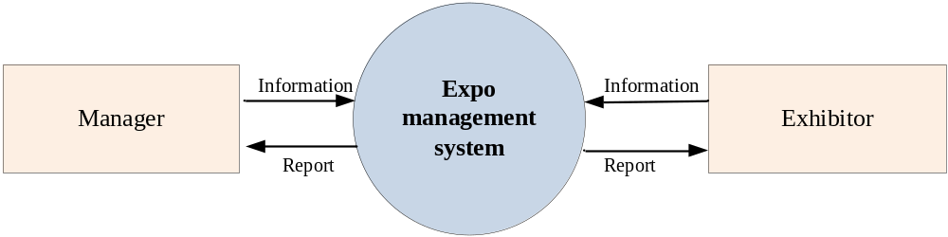

4.2 - Application Process
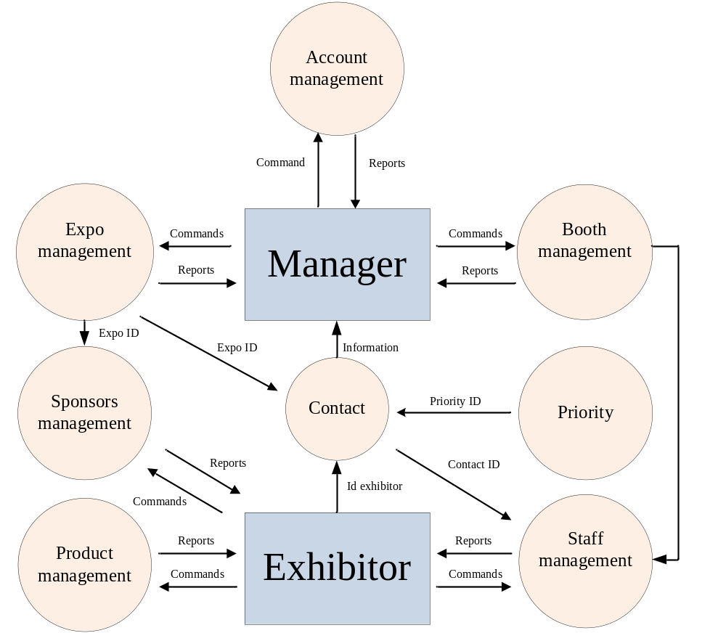

4.1 - Manager Process
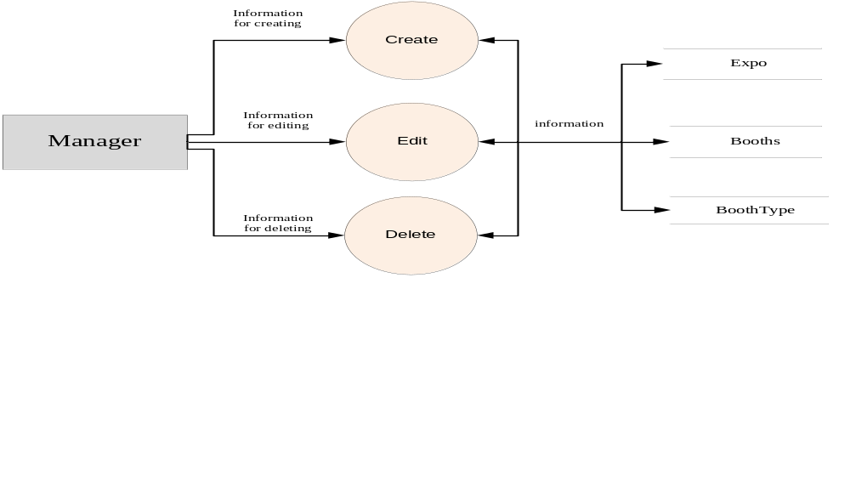

4.2 - Exhibitor Process
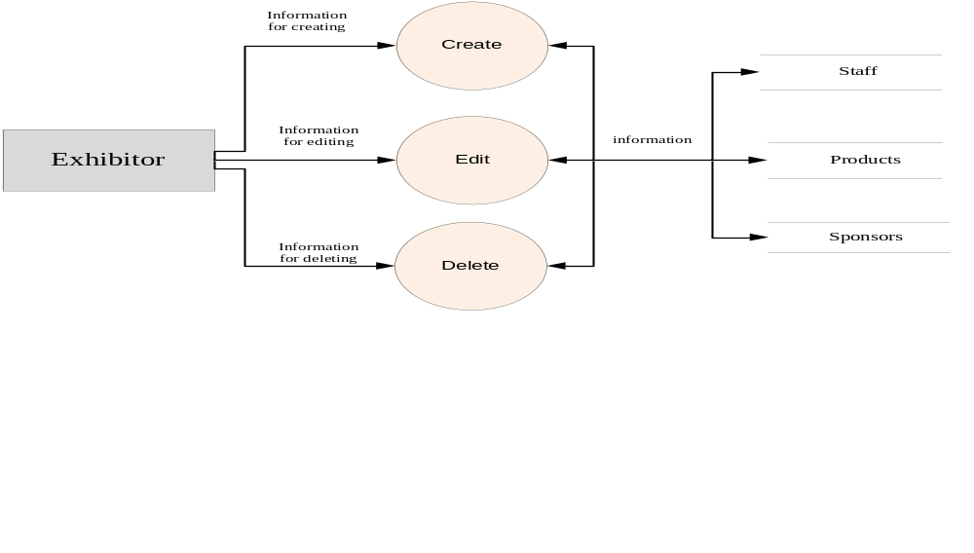

4.4 - Contact Process
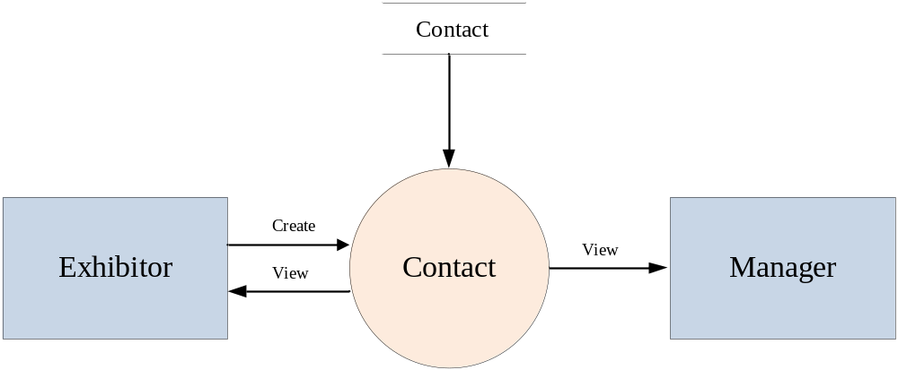

4.4 - Expo Management Process
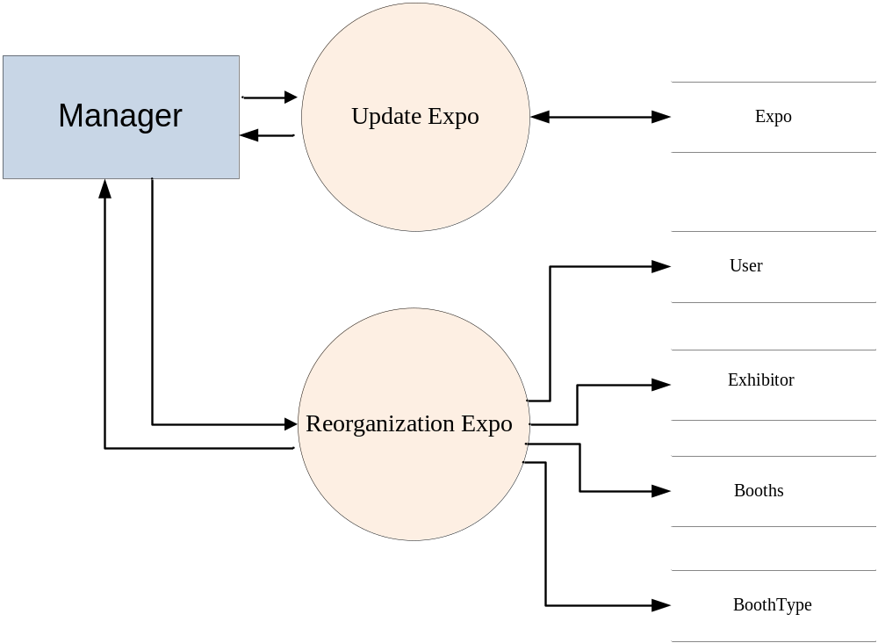

4.5 - Account Management Process

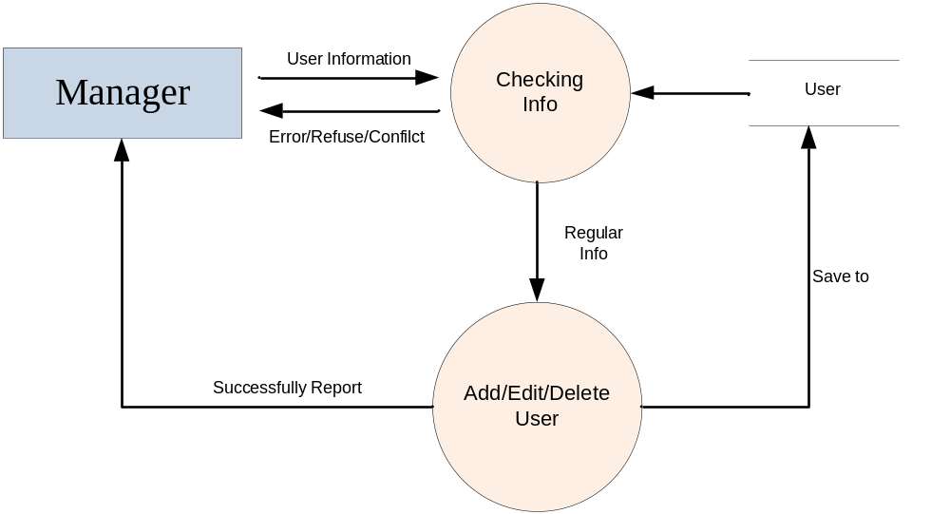

4.6 - Search Process

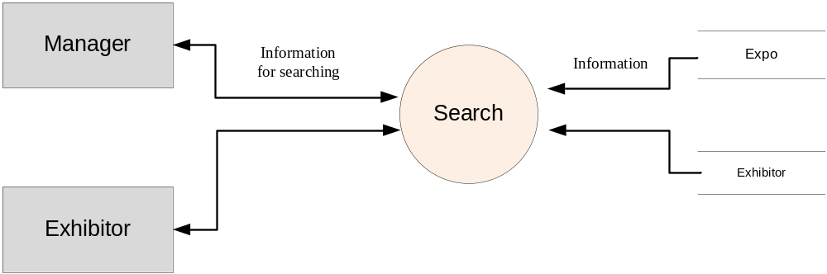

5. Database Design

5.1 - (ER) Diagram

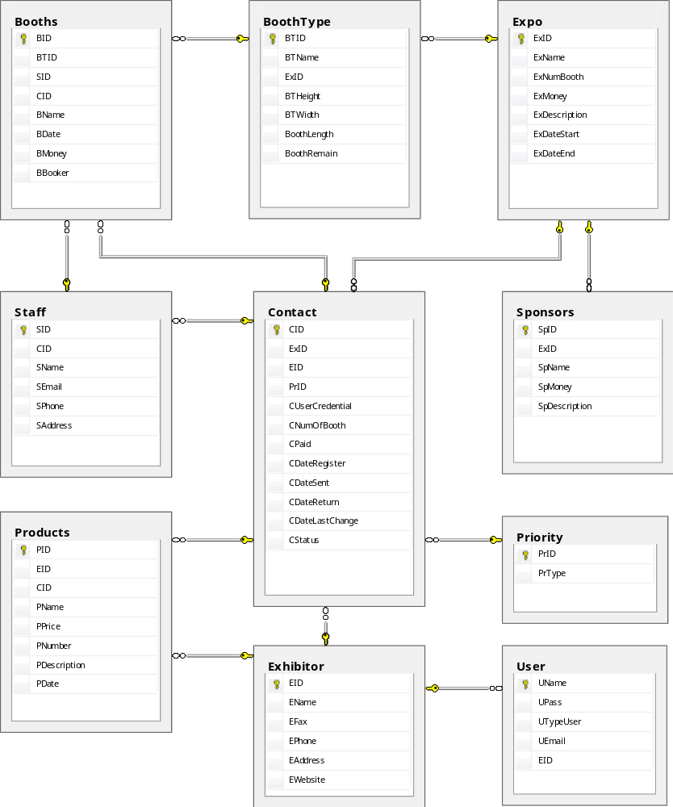

6. Flowcharts Diagram
6.1 - Manager Account Module
A - Insert Manager Account
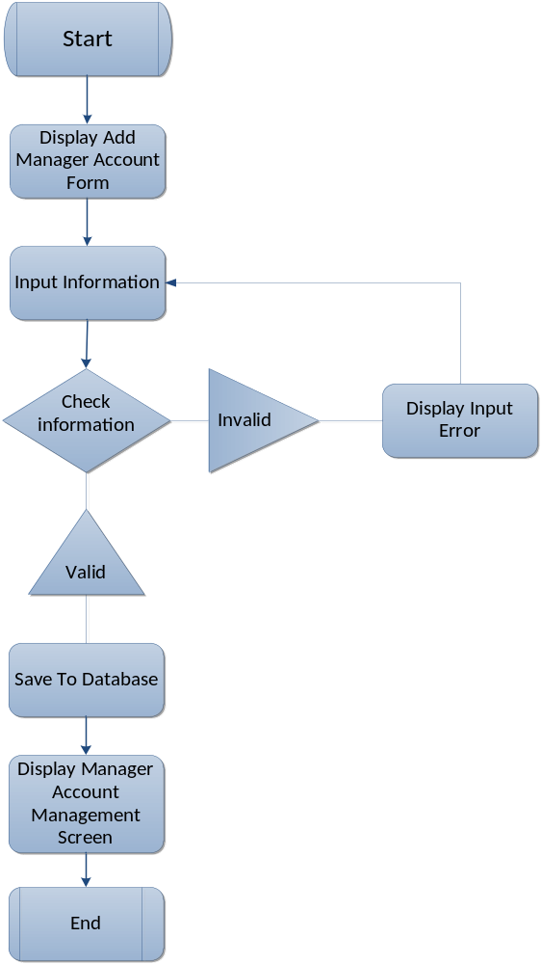

B - Delete Manager Account

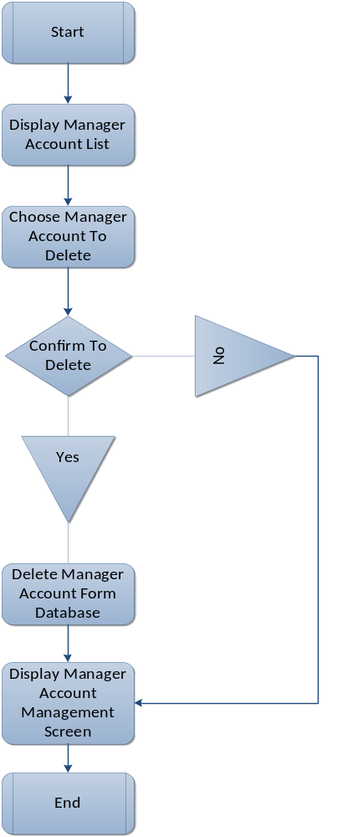

C - Edit Manager Account
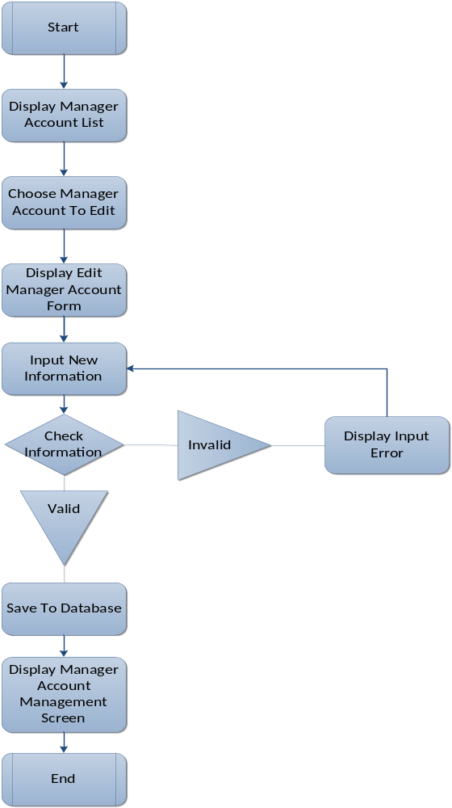

6.2 - Exhibitor Module
A - Insert Exhibitor
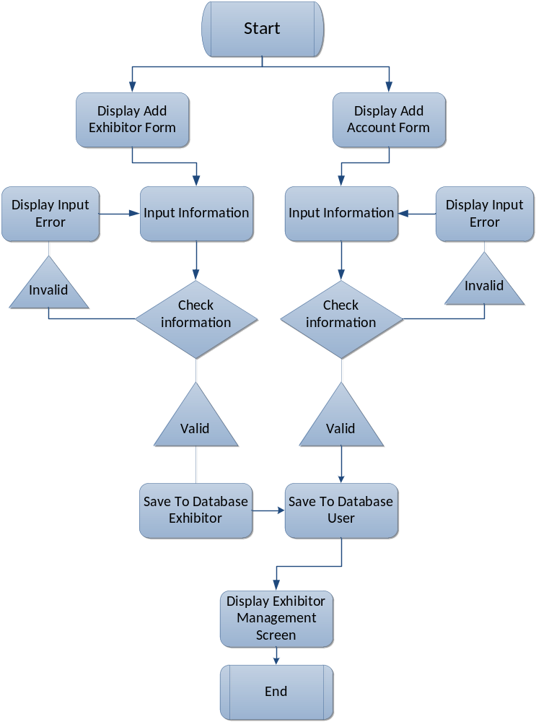

B - Delete Exhibitor

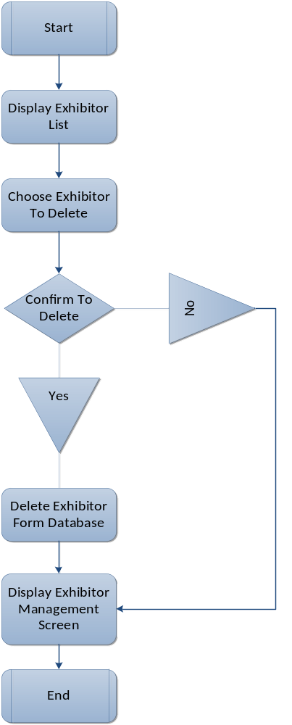

C - Edit Exhibitor
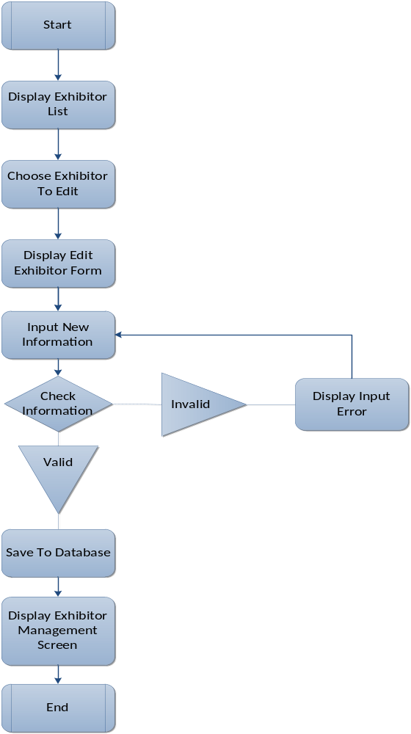

6.3 - Expo Module
A - Create Expo
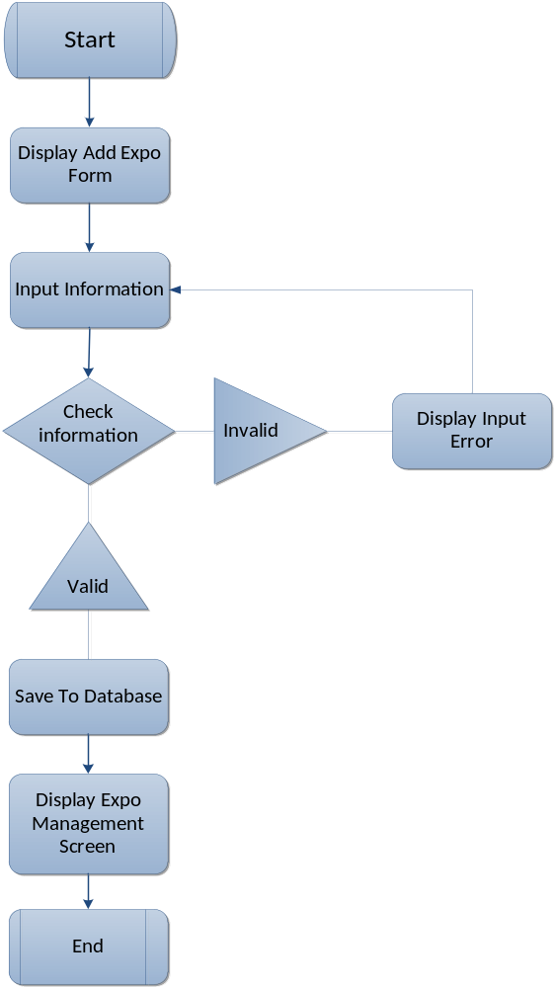

B - Delete Expo

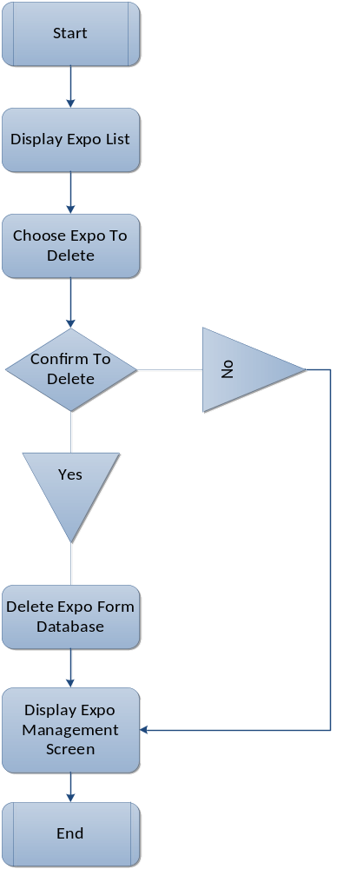

C - Edit Expo
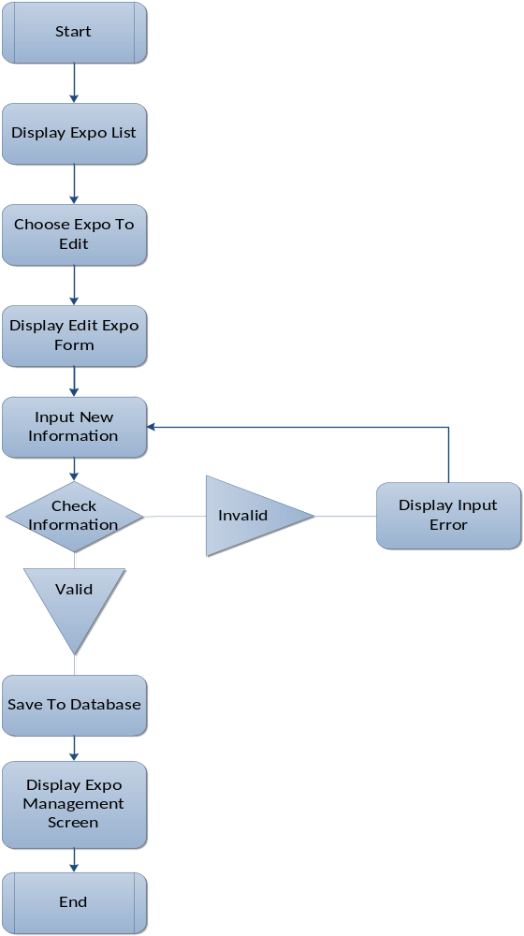

6.4 - Booth Type Module
A - Insert Booth Type
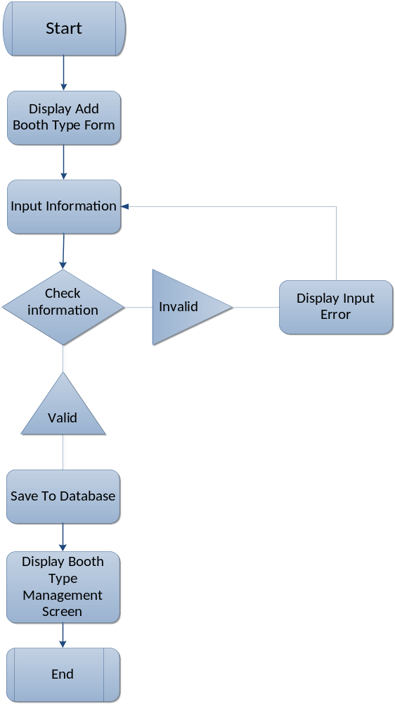

B - Delete Booth Type

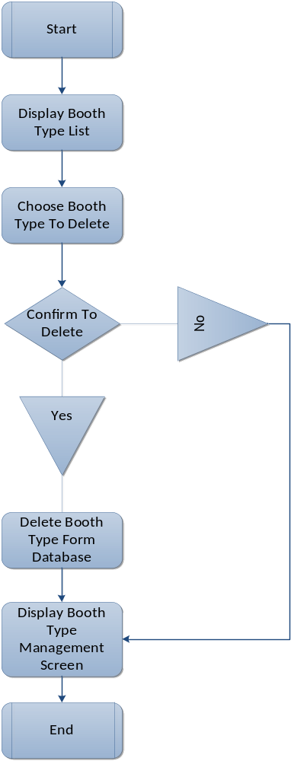

C - Edit Booth Type
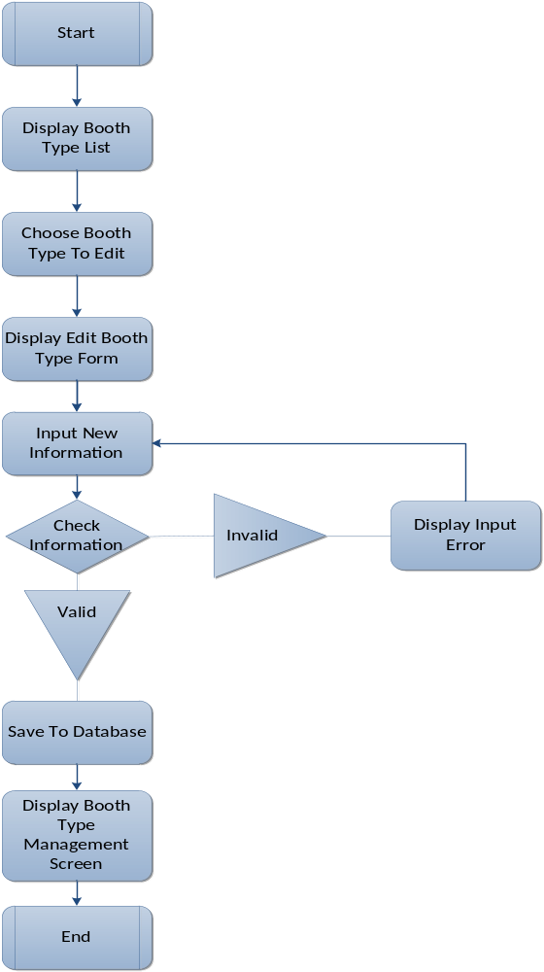

6.5 - Booth Module
A - Insert Booth
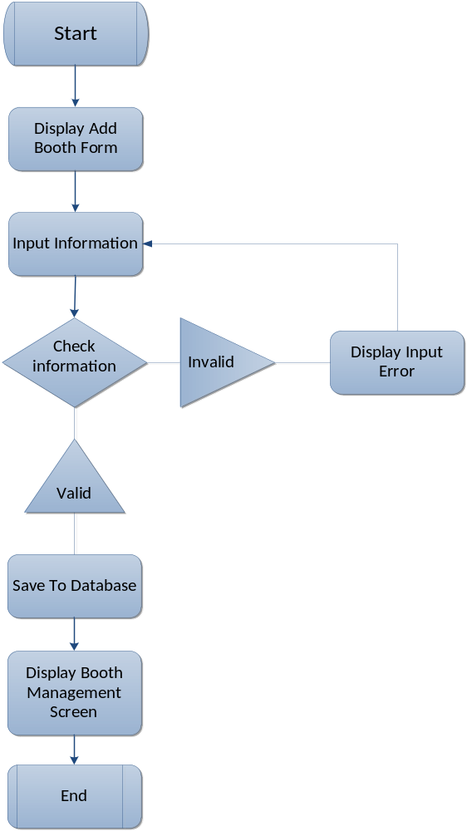

B - Delete Booth

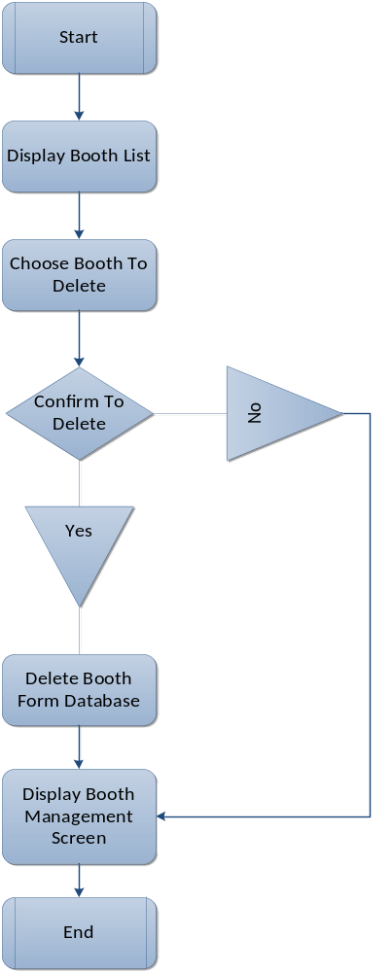

C - Edit Booth
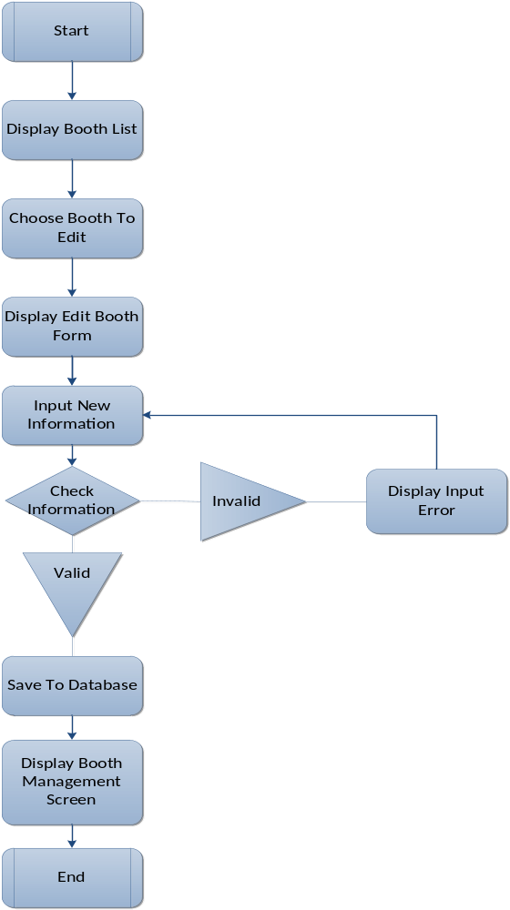

6.6 - Product Module
A - Insert Product
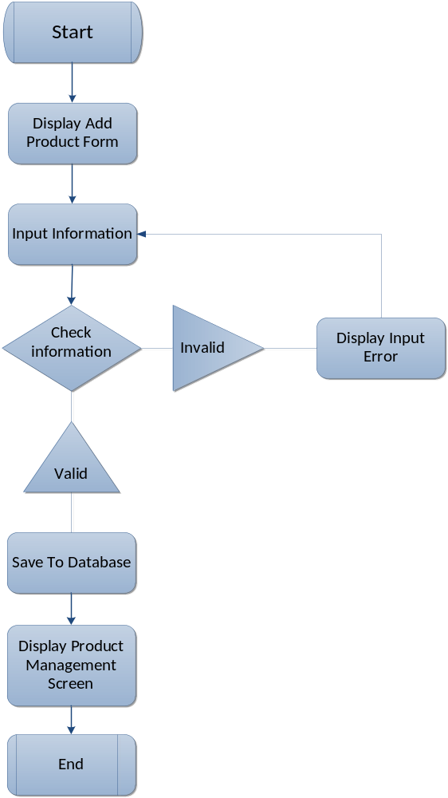

B - Delete Product

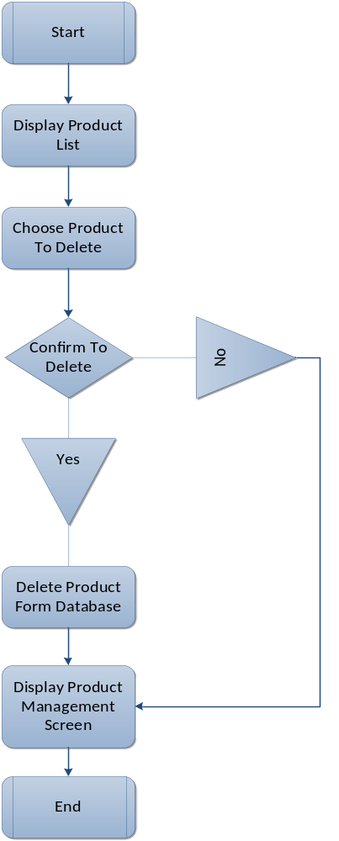

C - Edit Product
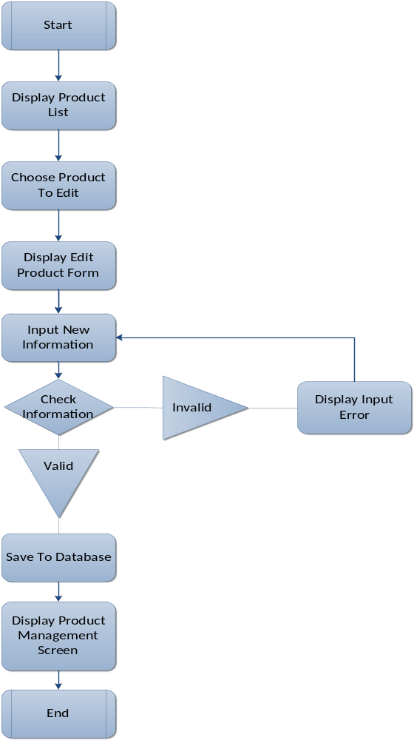

6.7 - Staff Module
A - Insert Staff
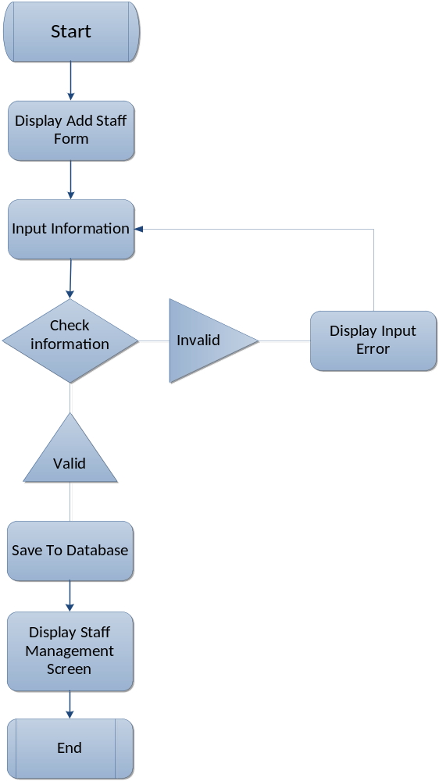

B - Delete Staff

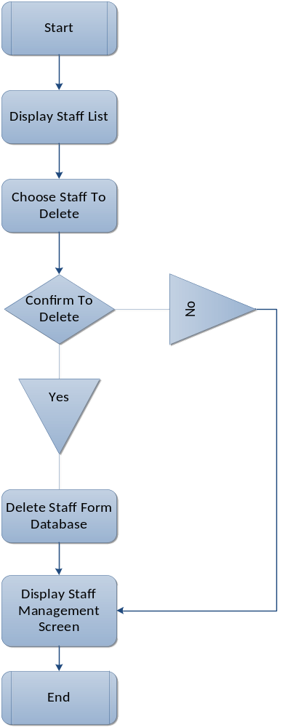

C - Edit Staff
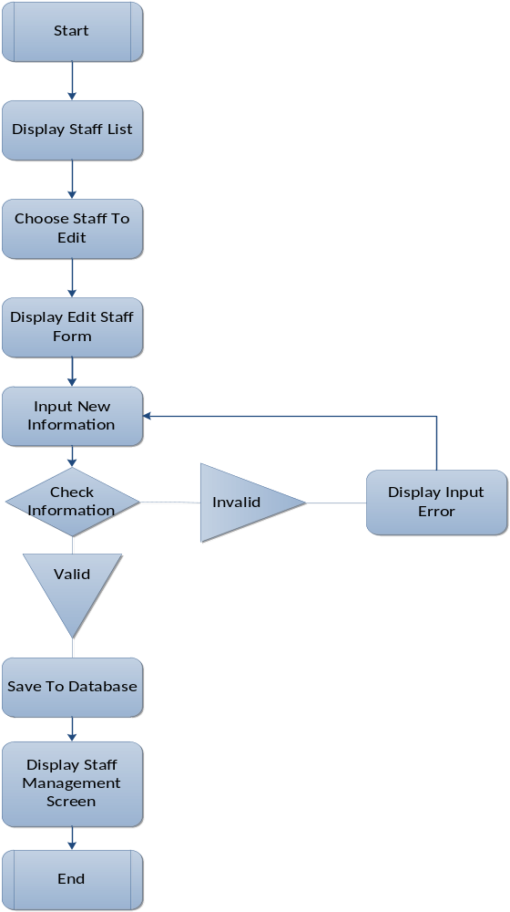

6.8 - Sponsor Module
A - Insert Sponsor
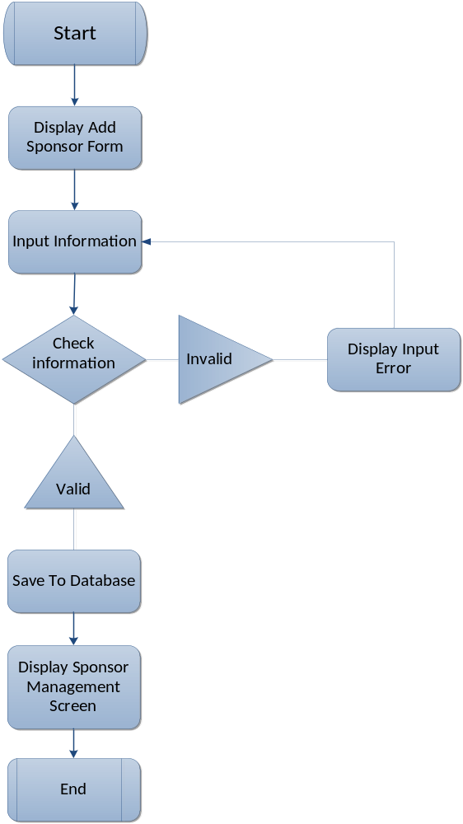

B - Delete Sponsor

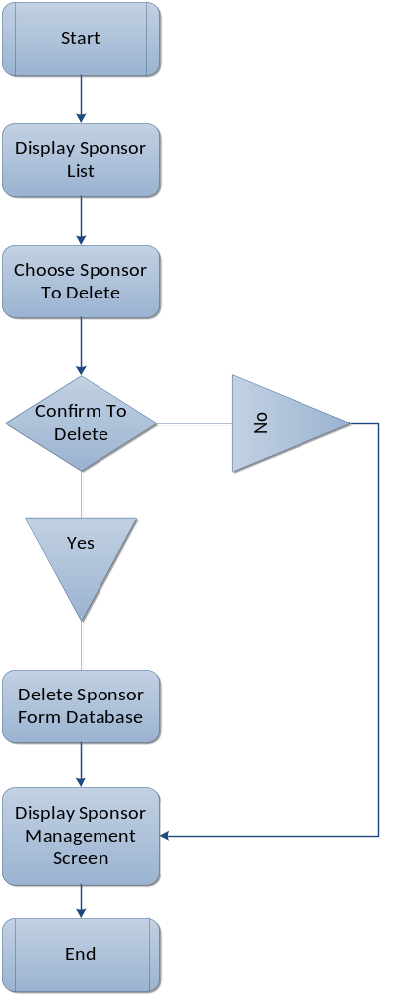

C - Edit Sponsor
