Expo Management System

Installation Guide

- JDK Installation Guide
- SQL Server 2005 Installation Guide

JDK Installation Guide

Download file “jdk-6u5-windows-i586-p.exe” (71.3 MB)
ftp://ftp.wsisiz.edu.pl/pub/pc/pozyteczne%20oprogramowanie/java/stare/jdk-6u5-windows-i586-p.exe
Click Double file “jdk-6u5-windows-i586-p”

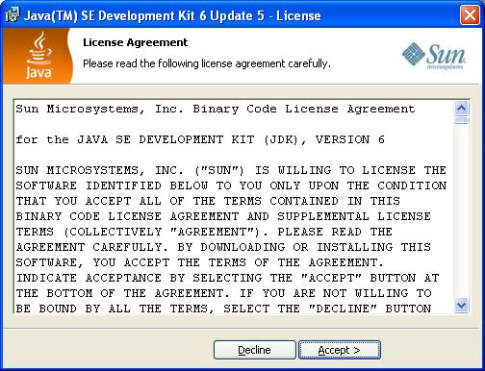
Click “Accept”
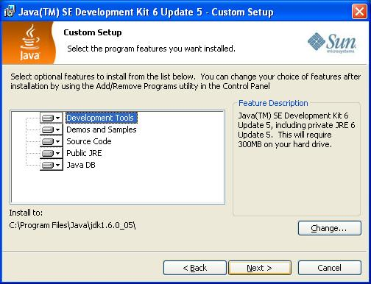
Click “Next”

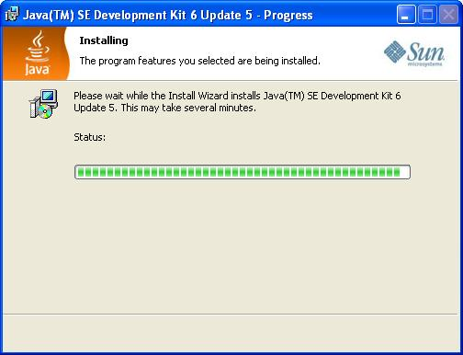
Wait…….
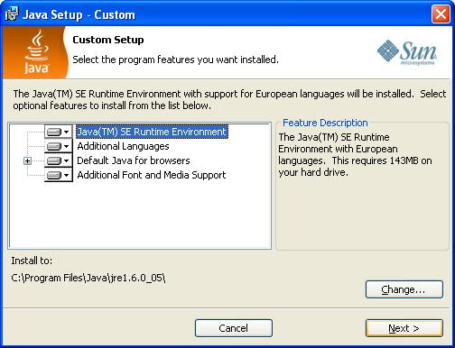
Click “Next”

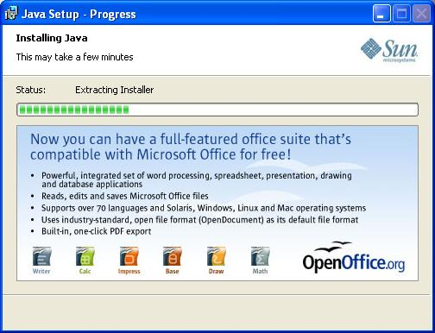
Wait……
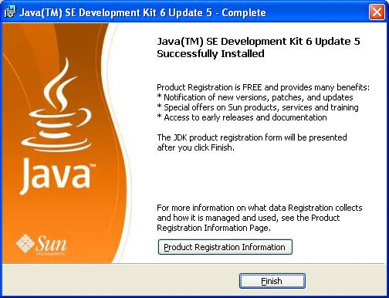
Click “Finish” to finish install JDK….

Install Environment Variable :
Right Click in “My Computer” on Desktop
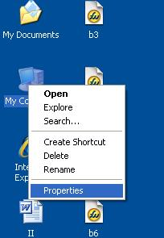
Choose Properties
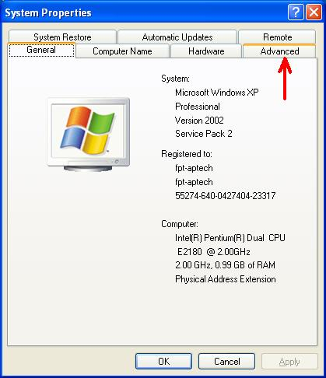
Choose “Advanced” tab
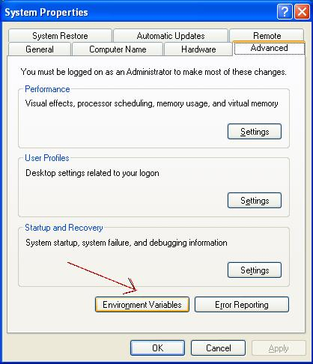
.
Click “Environment Variables”
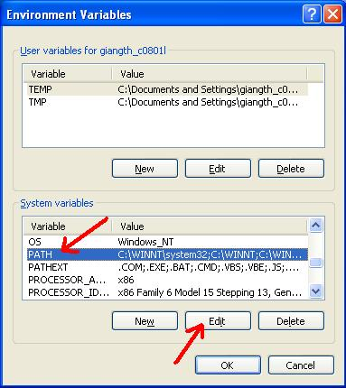
In “System Variables” choose PATH ,then click “Edit”

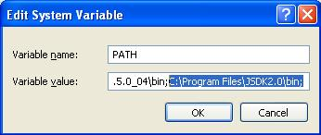
Copy the path of “Bin” Folder in “JDK” Folder was installed previously…then paste in “Variable value”…
Then Click OK.

SQL Server 2005 Installation Guide

Inserting the Installation CD

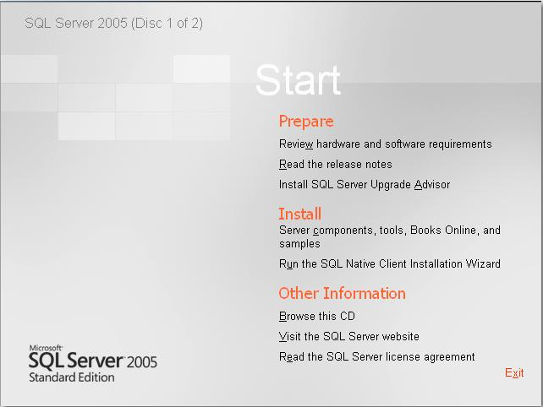

Click to install the “Server Component, Tool, Books Online and samples”.
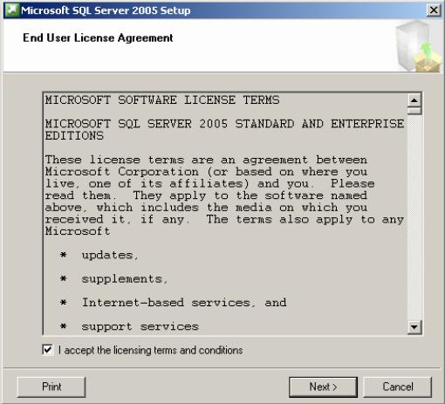

Accept the “End User License Agreement”. Click Next.
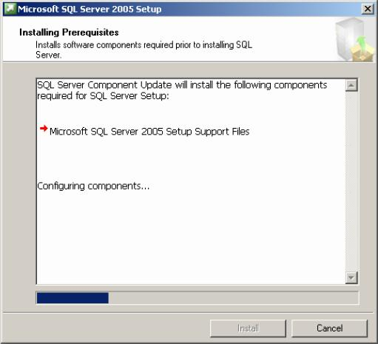

The Installing prerequisites window will appear.
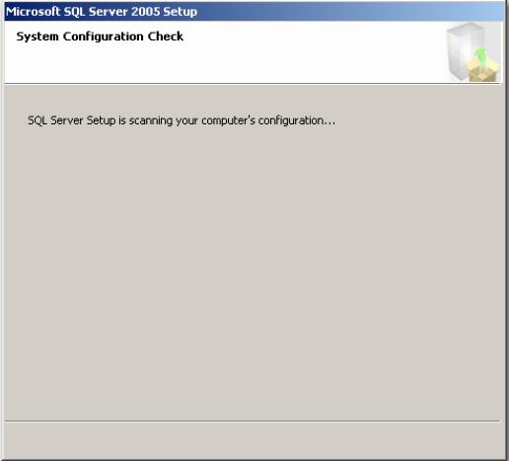

Once the Installation of the prerequisites are completed click Next.
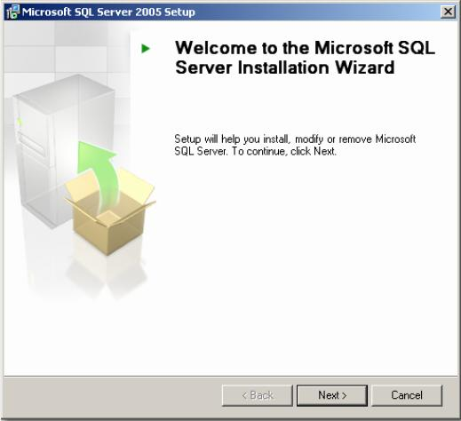

The SQL Server Installation Wizard will now appear. Click Next.
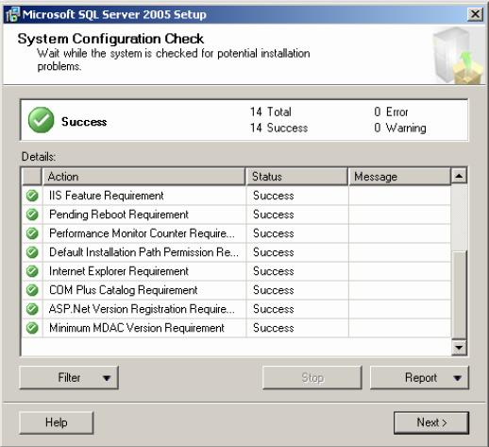

The System Configuration Check window will appear. The status of each should indicate a status of “Success”. If everything checks out, click Next.
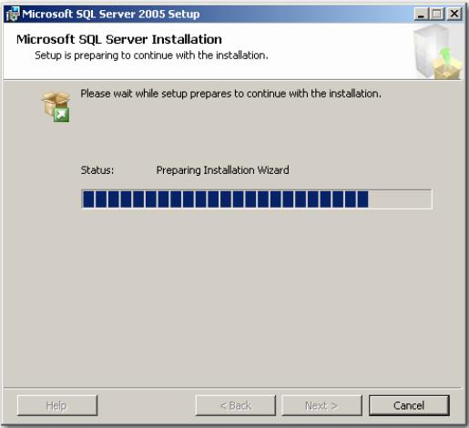

The SQL Server installation will begin to prepare the installation.
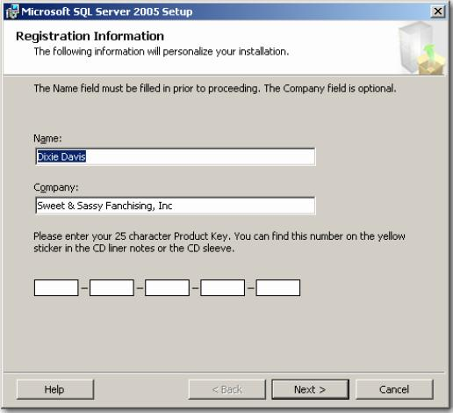

The Registration Information window will appear. Please locate the registration number and input below. Click Next when finished.
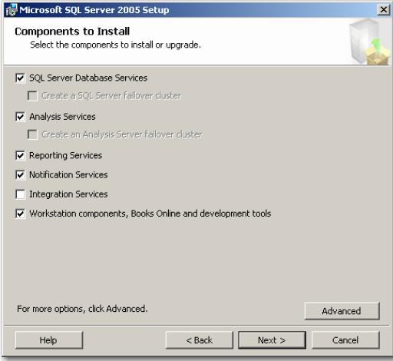

Check the followings boxes when the Components to install window appears.Click Next when finished.
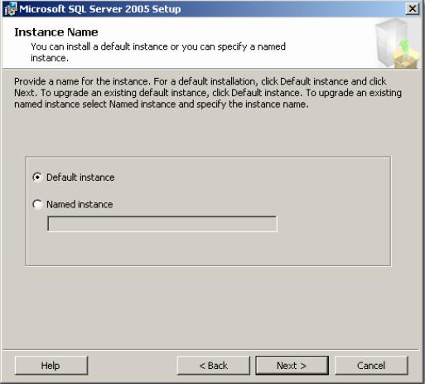

When the “Instance Name” window appears, be sure that “Default Instance” is selected and click Next.
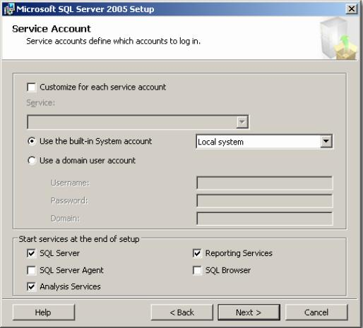

On the “Service Account” window, please select the option for “Use the built-in System account”. Be sure that “Local System” is selected. Click Next when finished.
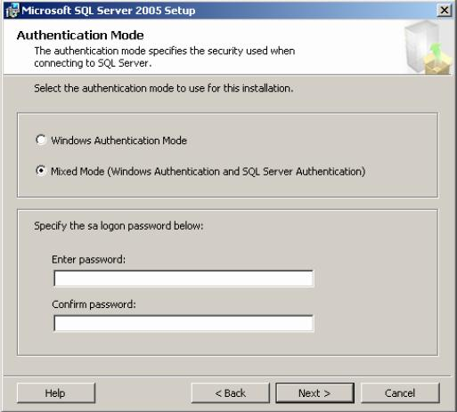

Select the “Mixed Mode” option on the “Authentication Mode” window.At this point you may specify an sa logon password. Leave it blank. Click Next when finished.
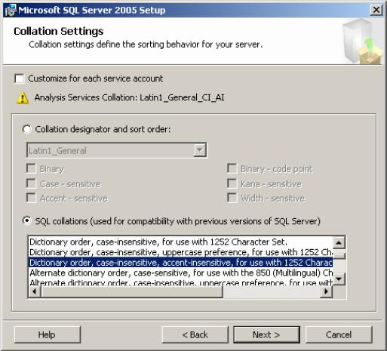

For the “Collation Settings” window, please select the option for “Dictionary order, case-insensitive, accent-insensitive, for use with 1225 Character Set”. Click Next when finished.
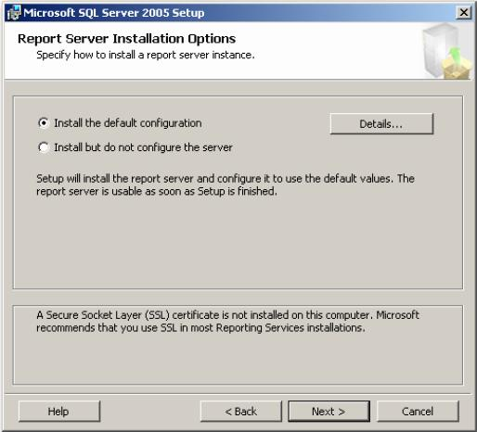

For the Report Server Installation Options, leave all defaults and click Next.
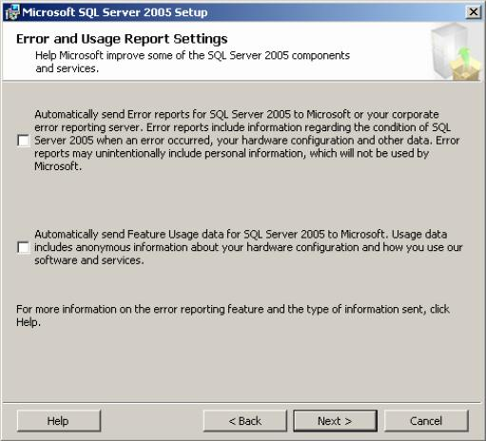

The Error and Usage Report Settings windows will appear, if you wish to send info to Microsoft, select each item, otherwise, please click Next to continue.
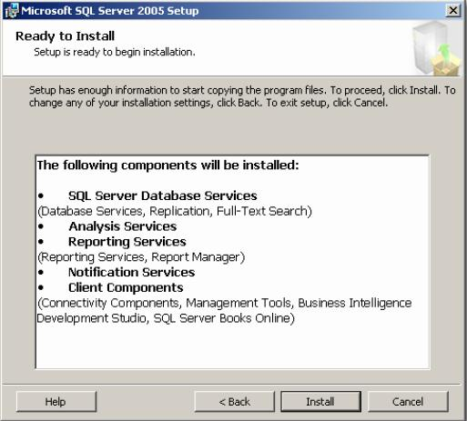

The Ready to Install window will appear. Review the components getting installed and click the Next button to continue.
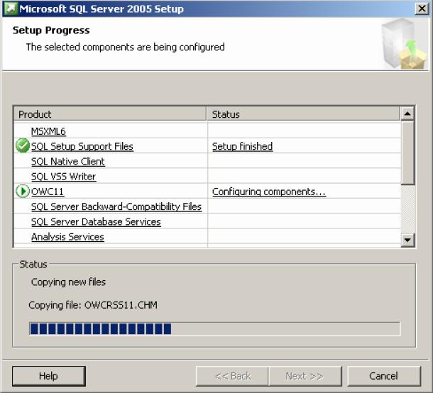

The “Setup Progress” window will appear. This will take several minutes to finish.
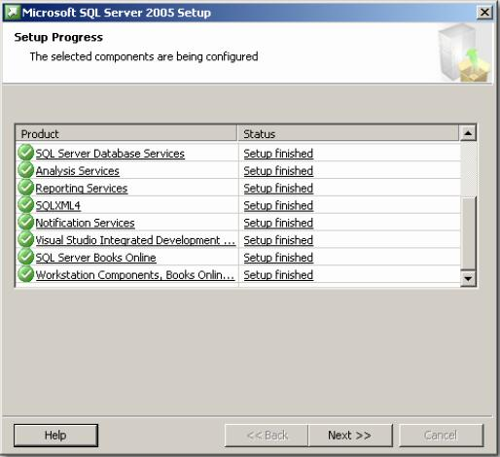

When the setup finishes, each status should indicate that the “Setup Finished”. Click Next to continue.
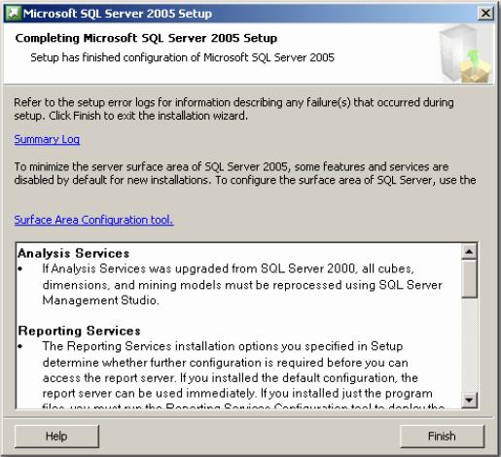

When completed, the “Completing Microsoft SQL Server 2005 Setup” window will appear. Review the services installed and click Finish.

Configuring MS SQL Server 2005:
To enable using EzCM, you must config MS SQL Server 2005.At first, you configure “port”
-Select Start menu - Microsoft SQL Server\Microsoft SQL Server 2005\Configuration Tools\SQL Server Configuration Manager
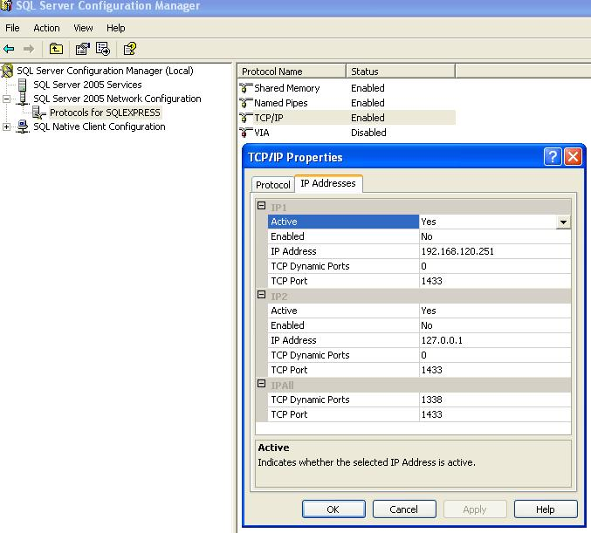
Enter TCP Port : “1433”.
-Change Authencation Mode:
Start MS SQL Server 2005 Start Program \Microsoft SQL Server\Microsoft SQL Server 2005\SQL Server Management Studio
Right –click on Server Data Engine and choose Properties

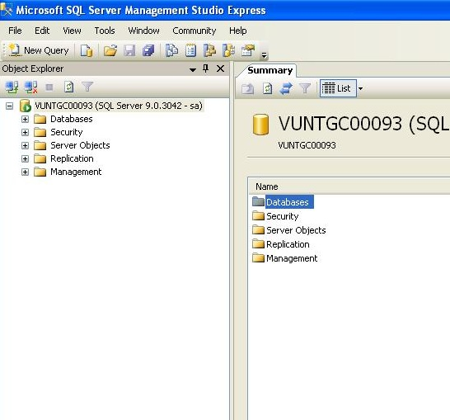
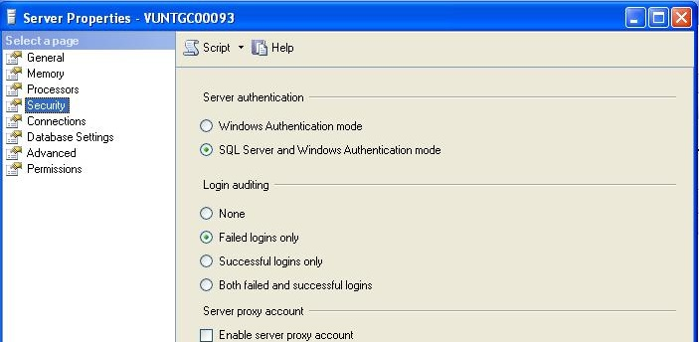

Check whether “SQL Server and Windows Authentication mode”
-Drop down Security tree. Right click on Login node choose New Login if you want to create a new login

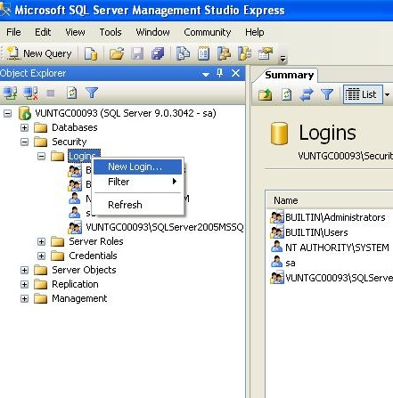
Attach database
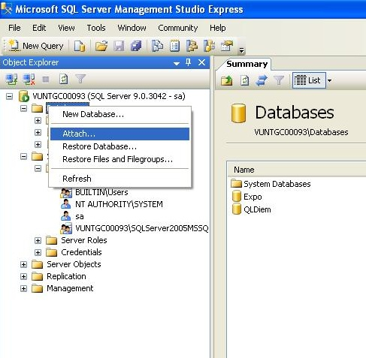

Select Database file path and click “Add”
And then, drop down Security-Logins .Right click on User node choose New User, input some information to create a new user if you want.
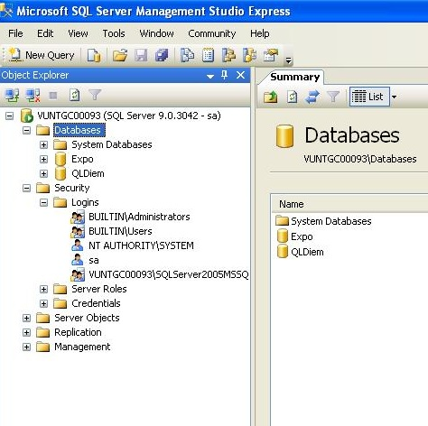

Configure connection
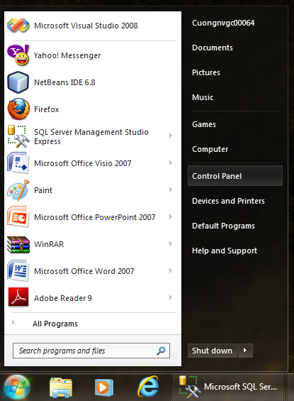

1.Click Start → Control Panel

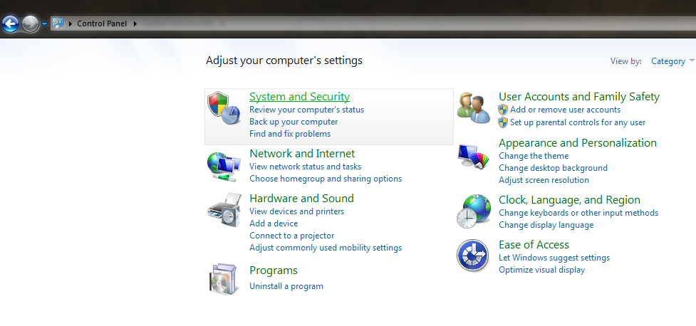
2. Click “System and Security”
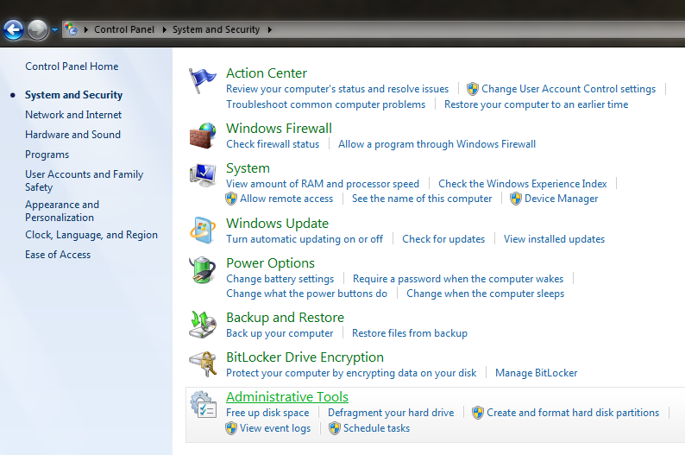
3.Click Administratice Tools
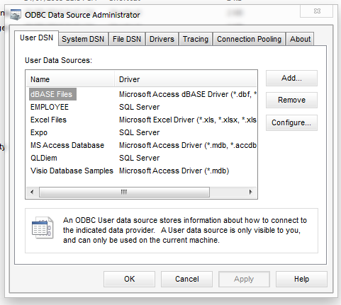
4. Click “Add” in tap “User DSN” → “OK”

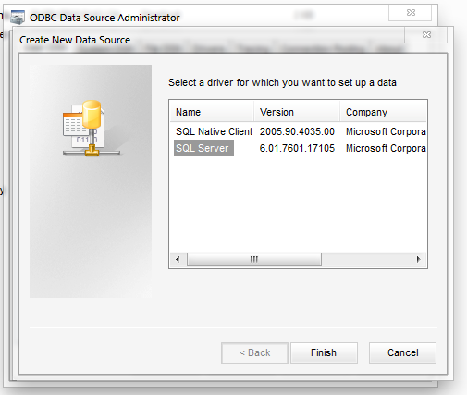
5. Choose “SQL Server” → Finish

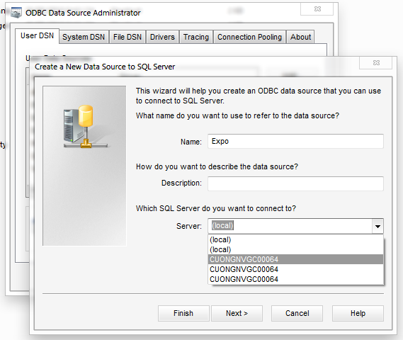

6. - In label “ Name” enter: Expo
- In label “Server” choose name local SQL Server → “Next”
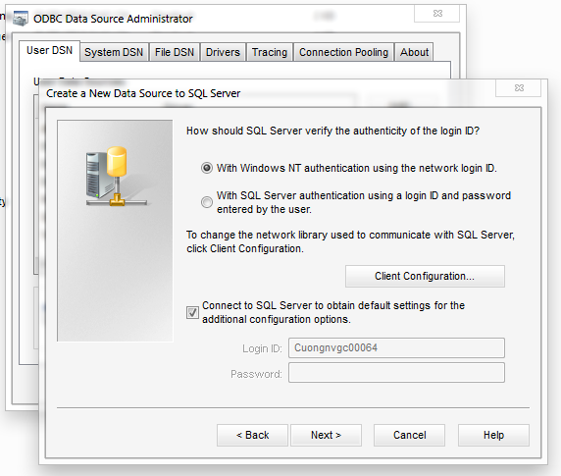
7. Next

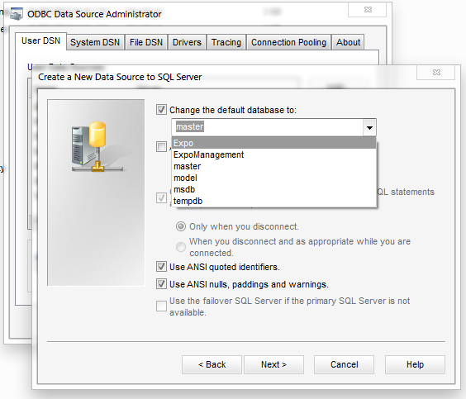
8. Choose “Expo” in label “Change the default database to:” → Next
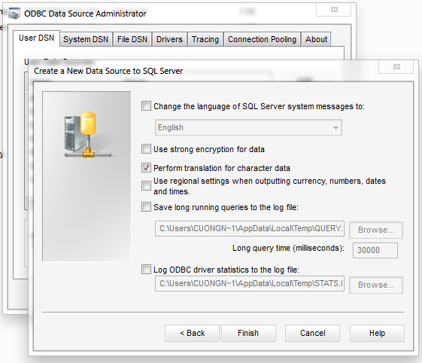
9.Finish
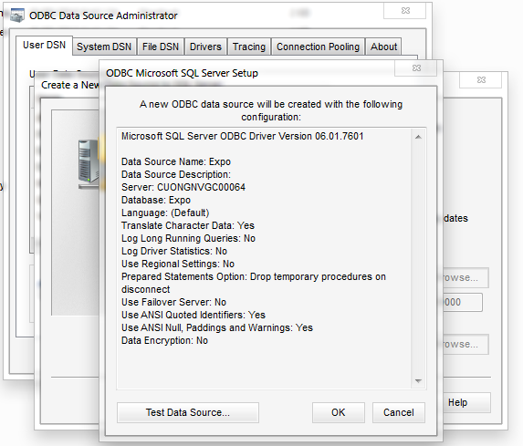
10. Click “Ok”

