1. Our application is a software about expo management system. We will help you how to use it.

You must have an account to log in the system. 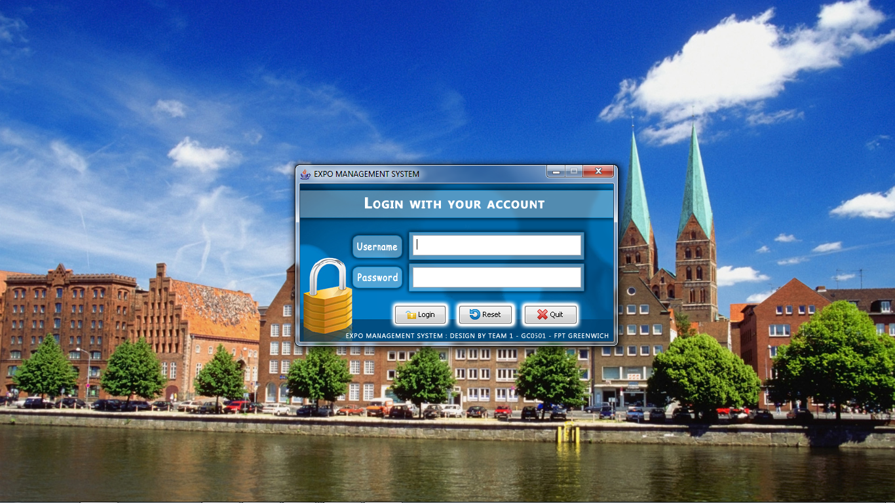

There are two types of account: manager and exhibitor.

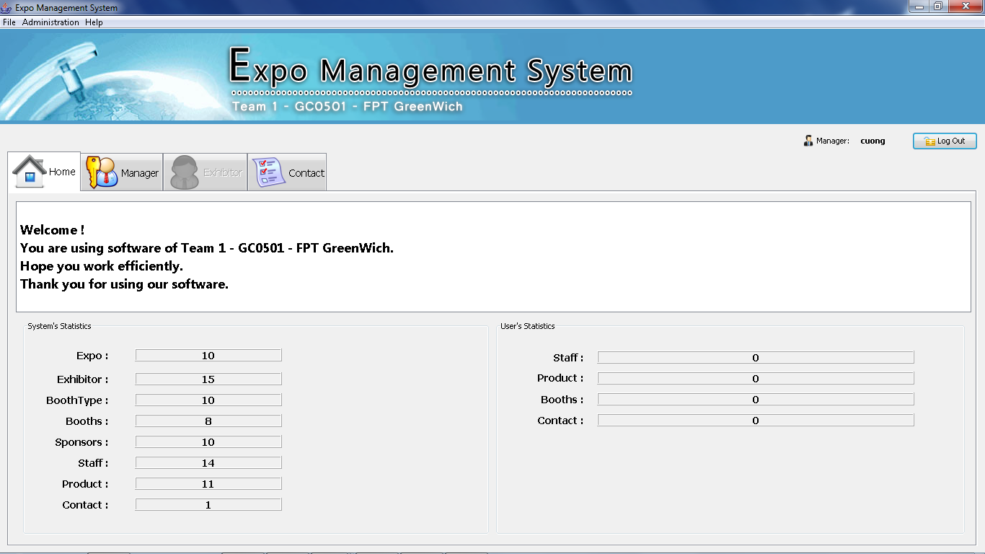

If you log in by manager account, you can have right to add, edit or delete Expo, Booth Type, Booth, Sponsor, Account and Exhibitor.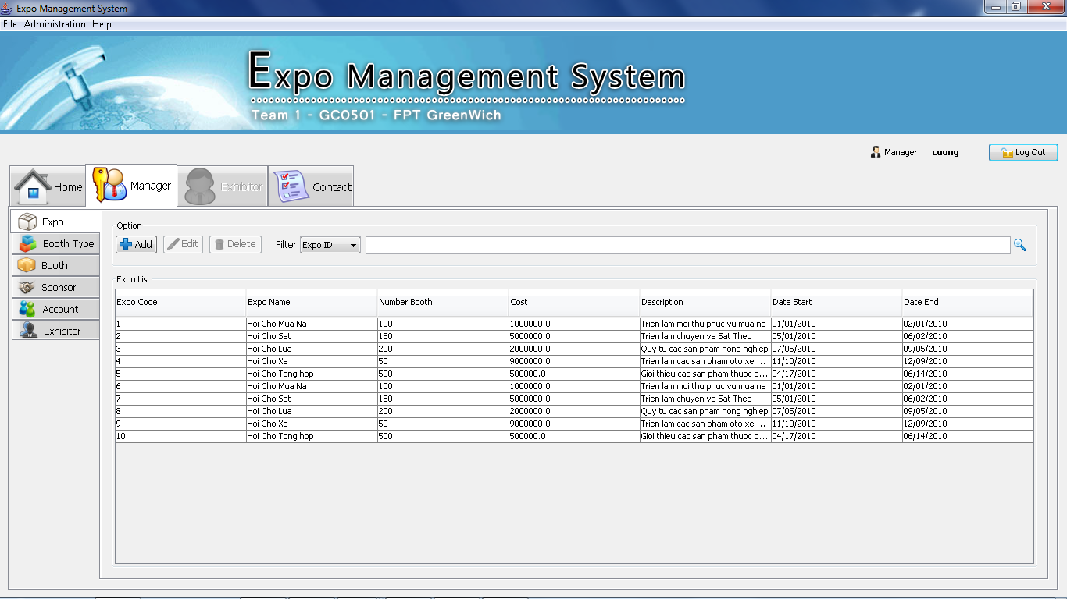

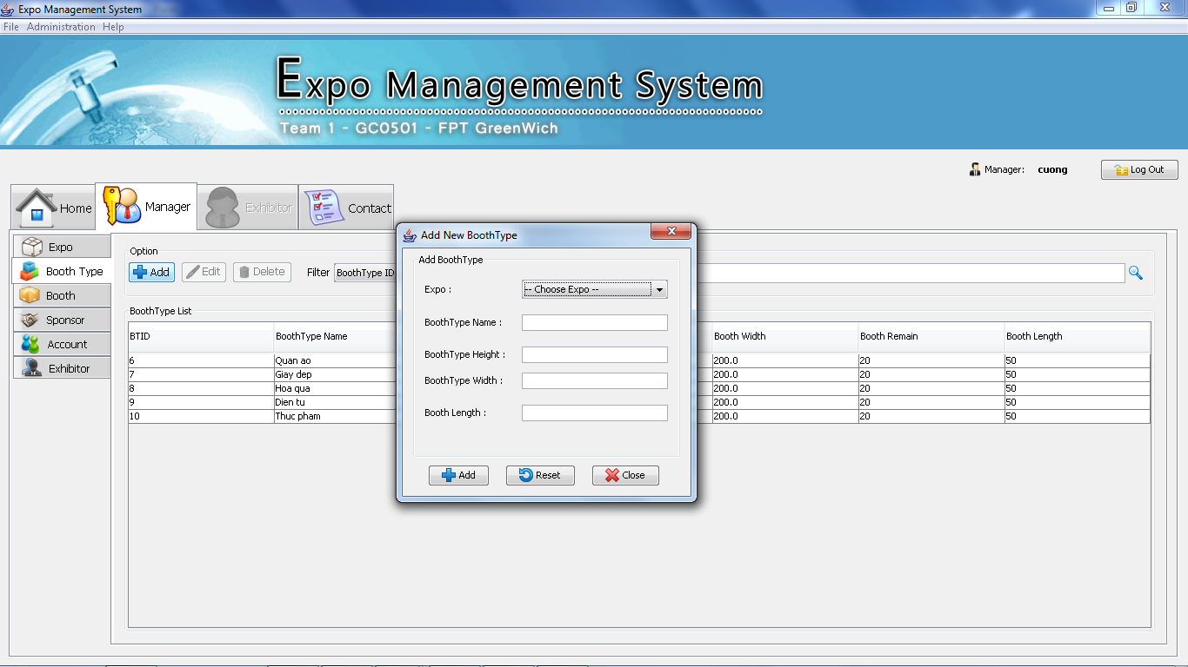

.

If you log in by exhibitor account, you can have right to manage Booth, Staff, Product.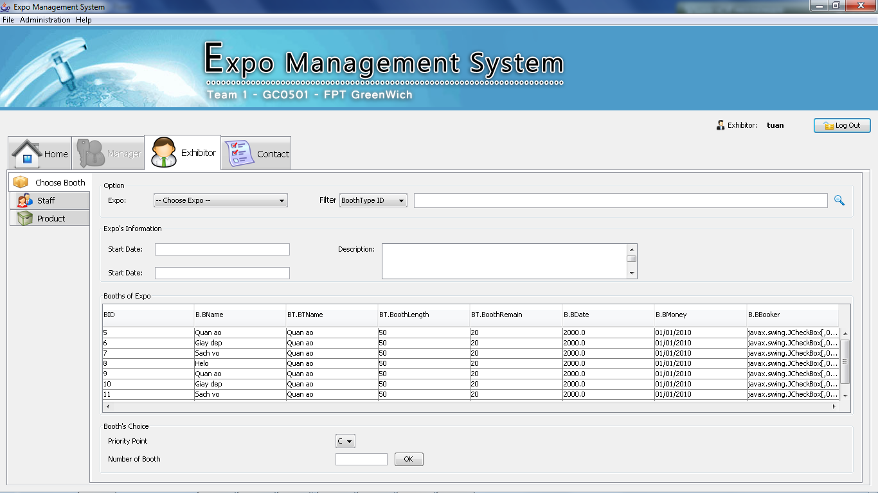

This is the contact screen when you add contact on Choose Booth table.

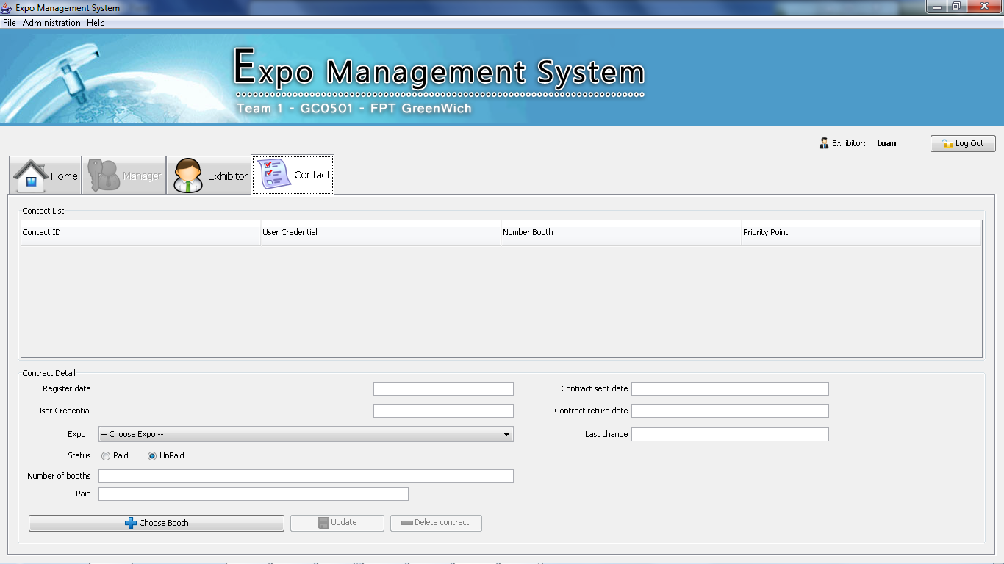

1. Admin account :

Admin pw: 123456

DuyDT pw: 123456

Vu pw: 123456

Hoa pw: 123456

1. Exhibitor account :

Exhibitor pw: 123456

Exhibitor2 pw: 123456

Exhibitor3 pw: 123456

Exhibitor4 pw: 123456