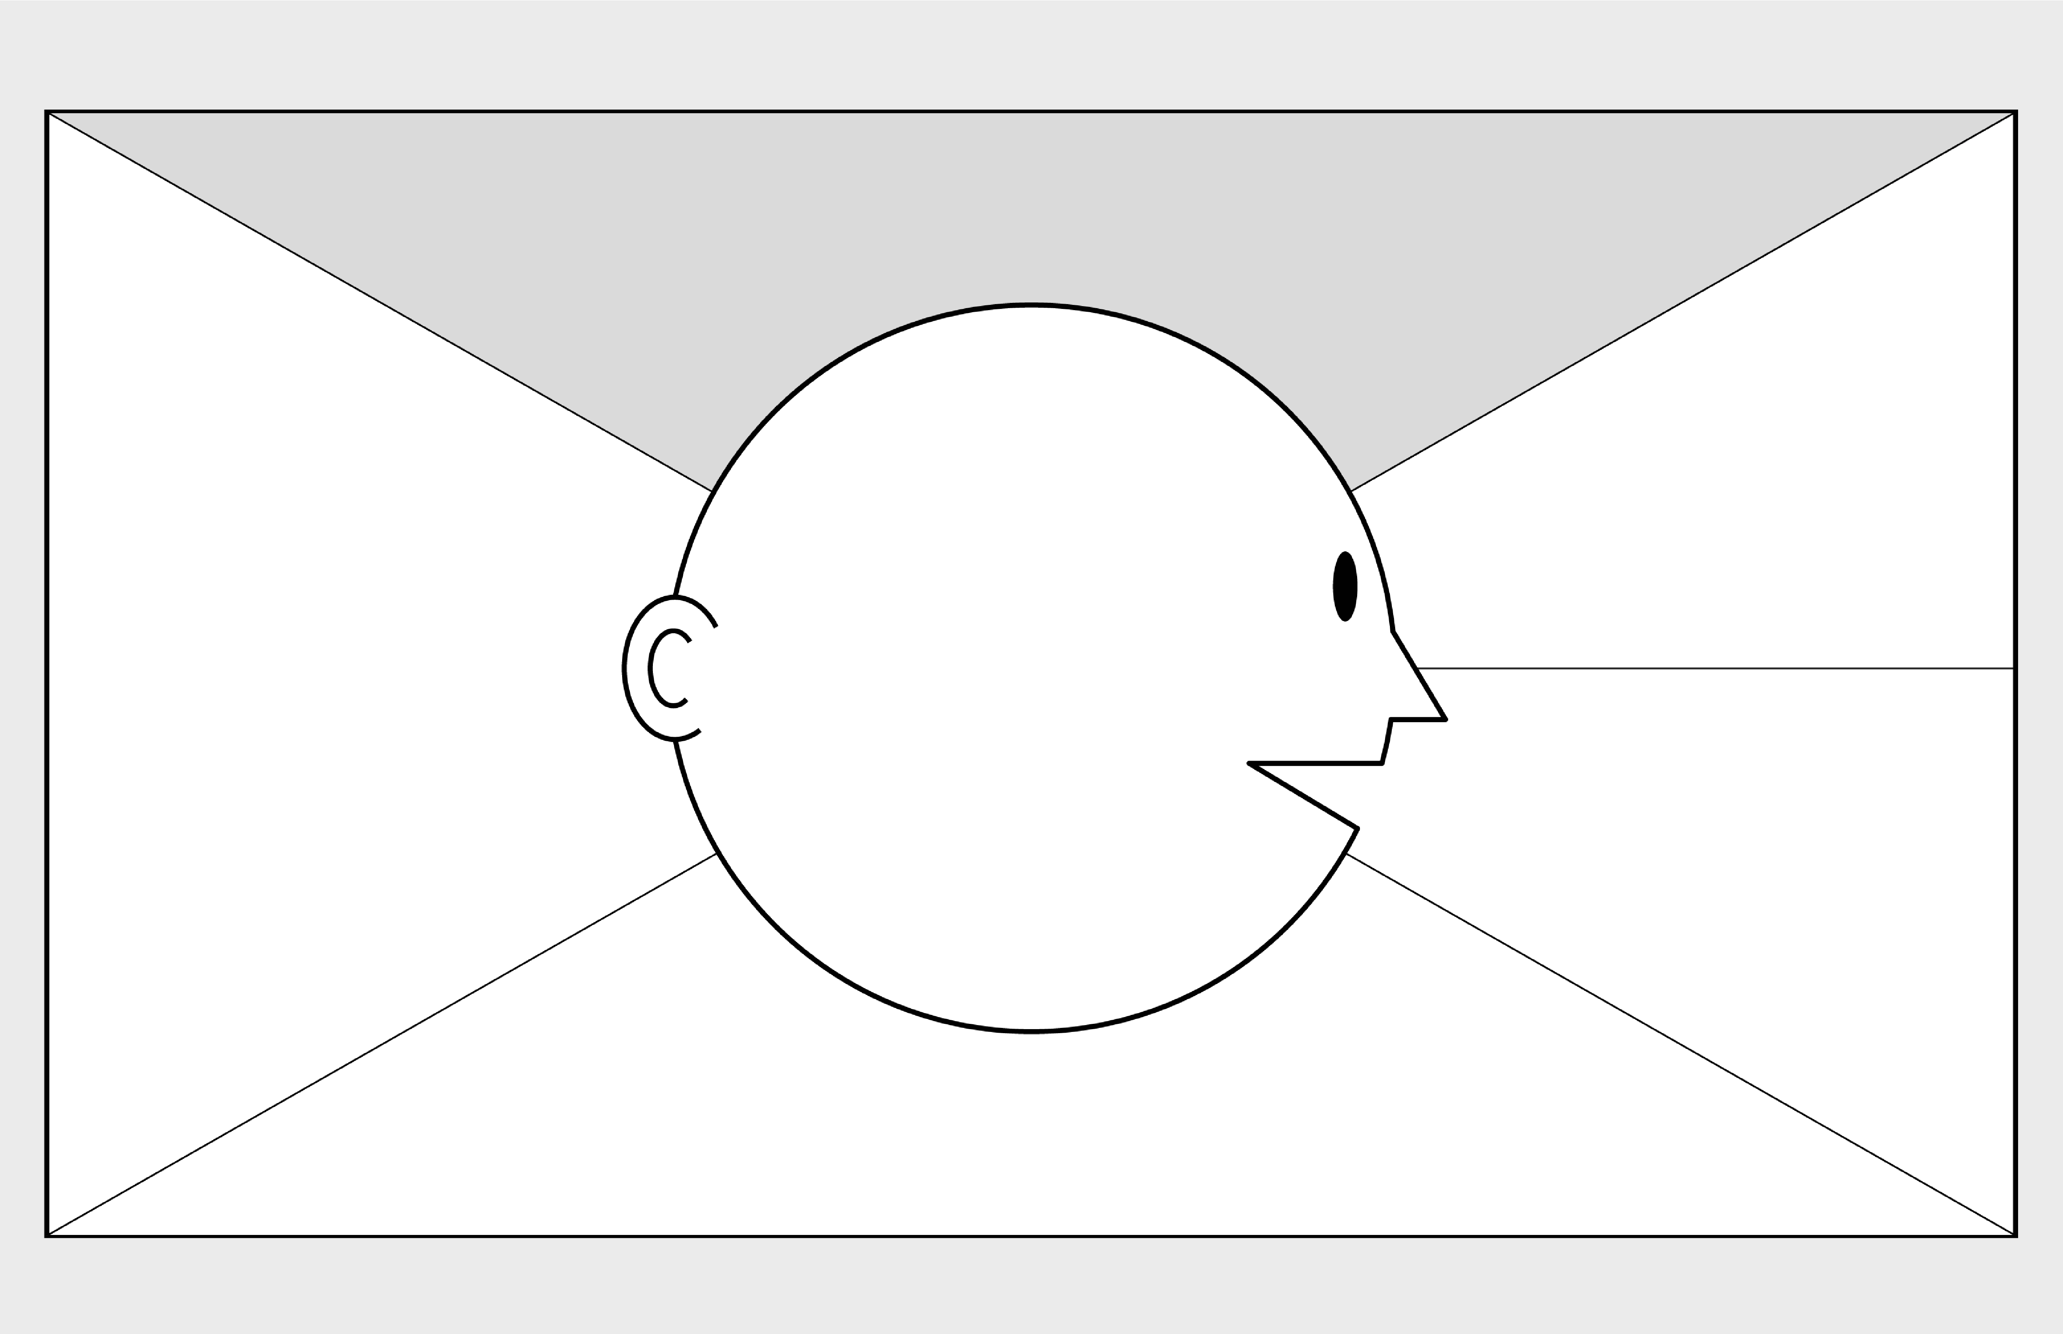

**Empathy Map Canvas**

*Designed for:*

*Designed by:*

*Date:*

*Version:*

**WHO**

**are we empathizing with?**

**What do they need to DO?**

What do they need to do differently?

What job(s) do they want or need to get done?

What decision(s) do they need to make?

How will we know they were successful?

Who is the person we want to understand?

Relationship Managers (RMs)

What is the situation they are in?

A new information system to be developed will change how they work

What is their role in the situation?

They are employees working for a travel company

**GOAL**

**What do they**

**SEE**

**?**

**What do they**

**SAY**

**?**

**What do they**

**DO**

**?**

**What do they**

**HEAR**

**?**

**What do they**

**THINK**

**and**

**FEEL**

**?**

What do they see in the marketplace?

What do they see in their immediate environment?

What do they see others saying and doing?

What are they watching and reading?

What have we heard them say?

What can we imagine them saying?

What do they do today?

What behavior have we observed?

What can we imagine them doing?

What are they hearing others say?

What are they hearing from friends?

What are they hearing from colleagues?

What are they hearing second

-

hand?

© 2017 Dave Gray, xplane.com

Last updated on 16 July 2017. Download a copy of this canvas at http://gamestorming.com/empathy

-

map/

**1**

**2**

**3**

**4**

**5**

**6**

**7**

**PAINS**

**GAINS**

What are their fears,

frustrations, and anxieties?

What are their wants,

needs, hopes and dreams?

What other thoughts and feelings might motivate their behavior?

1.0

04/05/2020

Jennifer Luu

RMs