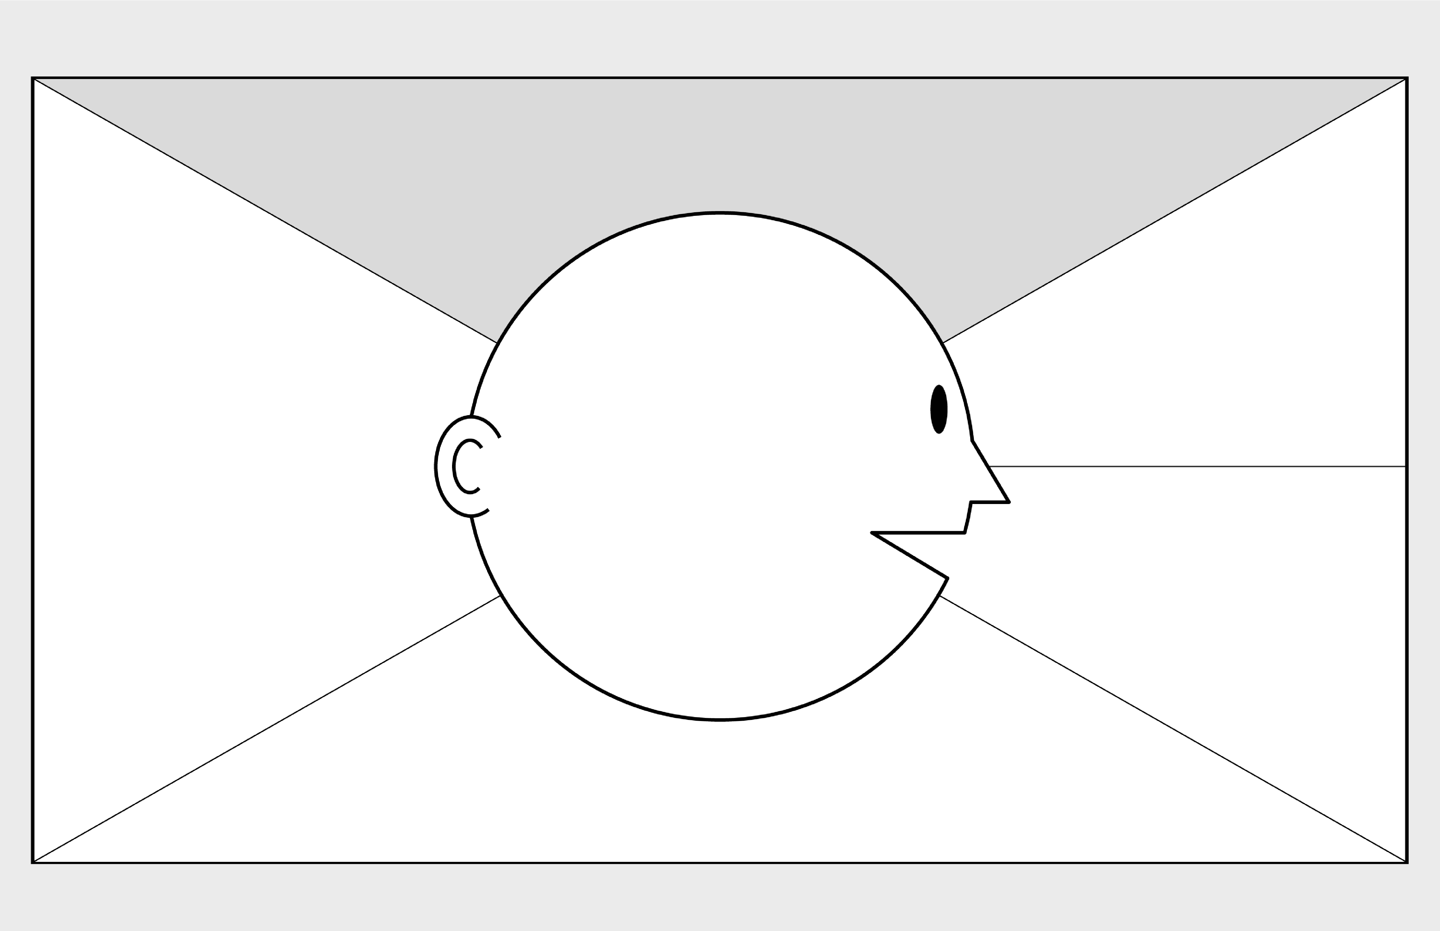

**Empathy Map Canvas**

*Designed for: Travel Company*

*Designed by: Harrison Kellick (13196997)*

*Date: 11/05/20*

*Version: 1.0*

**WHO**

**are we empathizing with?**

**What do they need to DO?**

The travel company needs to change and develop a new information system to improve their operation. They want to improve call routing and dynamic call flow control. Similarly, the creation of a customer profile tool would be beneficial. The travel company needs to decide how to best utilize their Relationship Managers to create the best experience for their customers. Success can be measured through customer   
 satisfaction ratings, customer holding time   
 and a measurement of efficiency in   
 serving customers.

We are empathizing with a major travel company, who want to develop an information system which improves their in-house call management center operation. Their role within the situation is overlooking and funding the development for the better of the whole business.

**GOAL**

**What do they**

**SEE**

**?**

**What do they**

**SAY**

**?**

**What do they**

**DO**

**?**

**What do they**

**HEAR**

**?**

**What do they**

**THINK**

**and**

**FEEL**

**?**

The travel company’s marketplace is mainly over phone and online, however there would be many competing businesses within the same scope. Within their immediate environment would be their employees (relationship managers) who would prove a good indication of employee satisfaction. They would be constantly talking to customers over the phone throughout work, which would also an indication of satisfaction. They would be watching comments from employees and customers and monitoring other competing businesses. Within the scope of the current Covid-19 pandemic, there is most likely fewer employees, and none within the workplace, and travel is currently completely redundant.

The travel company have expressed interest in developing a new system to better improve their business, with many specifics that focus on heightening customer experience and improving relationship managers work. We can imagine them asking to track the progress of development and using iteration cycles to further improve and maximize the changes. Similarly, they may express any problems they come across.

While the system is in development, we can assume the business will continue to operate as it did prior to introducing a new system. Observed behaviors include interest from employees and the business in implementing the new system. We can imagine them being eager to use the new system and learn it, and how it will affect the business. It will provide them with a profiler tool which will improve their customer experience, as well as allowing Relationship Managers to maximize their skills within the company. However, as the current Covid-19 pandemic progresses, there is little for the company to do as travel is not allowed currently.

We can assume the company is hearing other business develop similar systems, so they are eager to get the cutting edge on competitors. Friends and family would be curious about the work experience and how the company is going. Colleagues including Relationship Managers will be eager to talk about the new incoming system, and how it will better improve their work. Second-hand, the development employees may be talking about how the process is going. Similarly, customers may express opinion about the changes that will occur, and how it will affect them.

-

© 2017 Dave Gray, xplane.com

Last updated on 16 July 2017. Download a copy of this canvas at http://gamestorming.com/empathy

-

map/

**1**

**2**

**3**

**4**

**5**

**6**

**7**

**PAINS**

**GAINS**

The company would be nervous that the new development system will work as planned. There is a worry that customers and employees wouldn’t take to the new implemented system. Also, we can assume competition would be on the rise and the use of money to develop the system may be crucial. Currently there is now work for the company as travel is banned.

* An improved information system which will increase customer experience and employee satisfaction
* Reduction of costs
* Automating aspects of the business to save time, such as Interactive Voice Response and Customer Profile.

What other thoughts and feelings might motivate their behavior?

Competing businesses, customer feedback, finances, employee   
feedback, board of directions, technician suggestions