2/5/2023

LƯU QUỐC BẢO

22125008 – 22CTT1

DATA VISUALIZATION

CS162 – Introduction to Computer Science II - Lab work Project Report

1. **Features**

Details on the features of functional used in this project can be found in “Features.pdf” in the same folder as this report.

1. **Program structure**
2. **Tutorial**
3. General

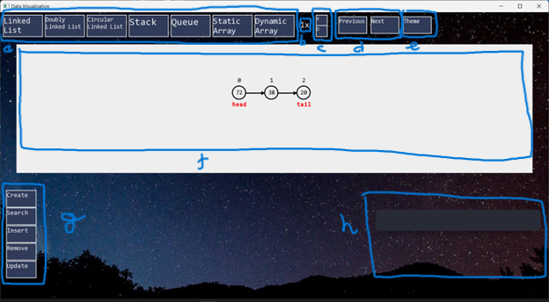

1. Switch the data button. There are all data types in this app provided. Press on it will change to those types.
2. Speed display. It shows us what speed of the graph now.
3. Change speed button. The top one for increasing speed and the down is for decreasing speed.
4. Change steps button. You can use this button to run step-by-step any function or to go back to any step you want. The graph and the code will show at the step you want. If pressed but no change, it means you have moved to the last step or the first step.
5. Change theme button. When pressed, the app will change theme from night to light or vice versa. However, the graph and graph box will not change due to give the unified look to the graph representation.
6. Graph box. All the parameters and changing of graph are displayed in this rectangle box.
7. Functional button. This is all the function used for the type of data being displayed. Some functions when you press will show more minimal function, some function you press will show the box for input or will immediately execute the corresponding function. Some examples of these functions.

1. The highlight corresponding source codes or pseudocode of the function just executed. This box will show the code, and a small rectangle to highlight which line are executed.
2. Get data from file.

This app provides the user with the ability to input data from file in “Create” function in all data types. In bin folder, there is a file name “customInput.txt”, the data is only got from file with exact that name and correct format. Users can only input a list value of data. They don’t need to input the number of values and always have “;” after each value, including the last value.

1. Input data from keyboard.

* Users can click on the text to move the cursor to this position of text.
* This box only takes numbers. The value in box is automatically random when then function button contain it pressed. The blank box means that the value in it is 0.
* Some functions which contain input boxes have “Go” button. When “Go” is pressed, the corresponding function gets data from input box and executes. If nothing happened, it is possible that the input data exceeds the limit.
* To the left of each input box there is a short text indicating what the type of value of the box is. Some examples of it:
* “n =” or “c =”: this input box stores the value of size of graph. The maximum value for graph size in this program is 15.
* “i =”: this input box stores the value of index of graph. The maximum value for this box is the graph size being displayed.
* “v =”: this input box stores the value of node. The maximum value for this box is 99.

1. **How to compile**

* Get the folder of program from git link and download and extract this folder to setup:

https://drive.google.com/file/d/1mmmEFDe851fau7_jYbBf_B76_-Hu16TA/view?usp=sharing

* In this folder will have 2 achieved files are “SFML.zip” and “mingw64.zip”. Extract the file “mingw64.zip” and put it to any folder you want, in this tutorial we assume it is in disk C:\. This is important, the “SFML.zip” must be extracted and put in same folder with “Data Visualization” – app folder.
* Follow these steps below to setup Environment:
  + Find “Edit the system environment variables”

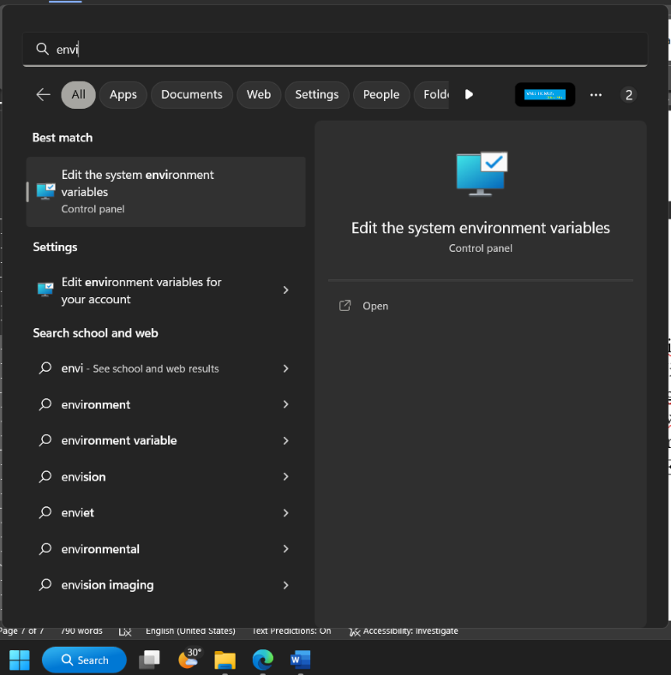

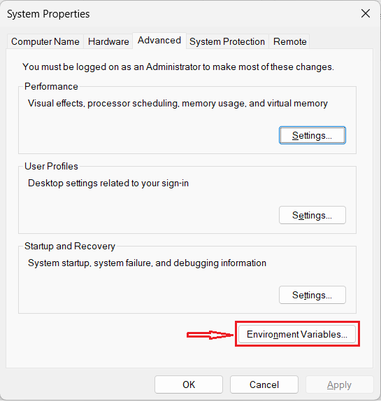

* + Choose “Path” line below and click “Edit…”

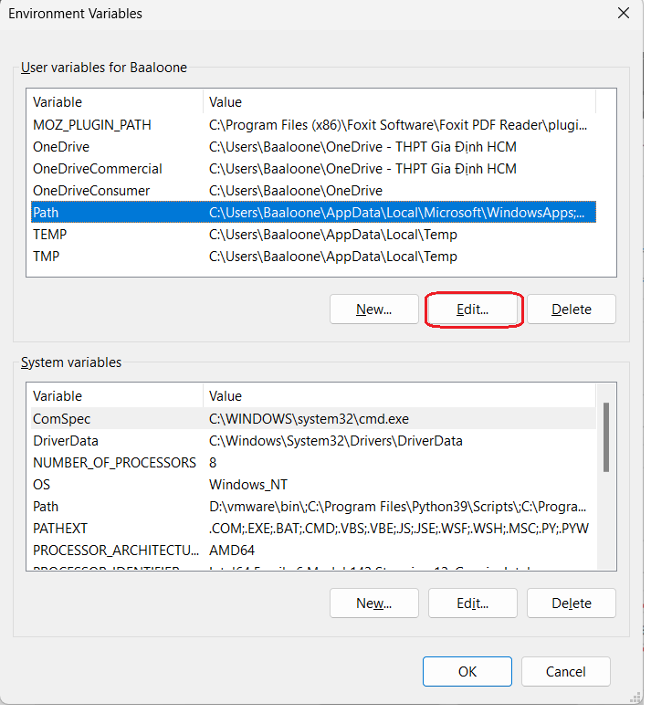

* + Choose “New”, paste the address of bin folder of mingw, default is “C:\mingw64\bin” and click “Ok”

* + Run file “setup.bat” in “Data Visualization” folder. Then it will run a little bit and “Data Visualization.exe” appeared in this “bin” folder. Click and play.

1. **Commit list: 41 commits.**

* commit b0c2c606673af8c44698e6079a5a17b171b3d4c1 (HEAD -> master)

Author: luuquocbao56132 <luuquocbao56132@gmail.com>

Date: Tue May 2 18:58:37 2023 +0700

Change the first initiate data

At last time, the program will create all object of data types and they slow down the program. Then, I change in World.cpp that create buttons of each data types. The data is initialized only when user presses corresponding button.

* commit bff80d3975bb441716a8cc660f0fba90cc03523b

Merge: 230eec6 ceb8f52

Author: luuquocbao56132 <luuquocbao56132@gmail.com>

Date: Tue May 2 17:06:18 2023 +0700

Merge branch 'master' of https://github.com/luuquocbao56132/Data-Visualization

* commit 230eec690e5685fb961227a396b64921fde7e456

Author: luuquocbao56132 <luuquocbao56132@gmail.com>

Date: Tue May 2 17:06:08 2023 +0700

Update setup file and features list

* commit ceb8f52f6835455f70e9194d74ebea8c7a7027b4

Author: Lưu Quốc Bảo <50264549+luuquocbao56132@users.noreply.github.com>

Date: Tue May 2 16:23:06 2023 +0700

Create README.md

* commit 51dd3c7433707ced1ae060f0c07e7a6272b8e918

Author: luuquocbao56132 <luuquocbao56132@gmail.com>

Date: Tue May 2 12:53:36 2023 +0700

Updated Dynamic Array

* commit e68920192c9e424f8e70cfb22b3a971387af9074

Merge: b7a6857 451459e

Author: luuquocbao56132 <luuquocbao56132@gmail.com>

Date: Tue May 2 04:32:12 2023 +0700

Merge branch 'master' of https://github.com/luuquocbao56132/Data-Visualization

* commit b7a685700afccc4213b71fd1f77c9a78872db627

Author: luuquocbao56132 <luuquocbao56132@gmail.com>

Date: Tue May 2 04:01:07 2023 +0700

Allocate (create empty) for Dynamic Array and Text

* commit 451459ea5723920dd67687e208a154a8713e8e1a

Author: luuquocbao56132 <luuquocbao56132@gmail.com>

Date: Tue May 2 04:01:07 2023 +0700

Allocate (create empty) for Dynamic Array and Text

* commit 949e2469e50aa0824bd17329a7b36354bc28f7b9

Author: luuquocbao56132 <luuquocbao56132@gmail.com>

Date: Tue May 2 03:40:57 2023 +0700

Change Theme color

Change all button and background color through a button. The graph is not changed due to it seems good view

* commit 172c81e9a38b1fae52c28c2f1d9d92c0c66ada49

Author: luuquocbao56132 <luuquocbao56132@gmail.com>

Date: Mon May 1 22:53:02 2023 +0700

Update image

* commit 5c01b3cff4291201aed34258a5ccd4fd385dde09

Author: luuquocbao56132 <luuquocbao56132@gmail.com>

Date: Mon May 1 04:00:11 2023 +0700

Complete Circular Linked List

* commit 0b9b77e97380dfab09340023e4c73e2b66841f5a

Author: luuquocbao56132 <luuquocbao56132@gmail.com>

Date: Mon May 1 03:08:53 2023 +0700

Complete Dynamic Array

* commit 3a3b00784ef2f9674a7761471f86466164a61c3d

Author: luuquocbao56132 <luuquocbao56132@gmail.com>

Date: Sun Apr 30 17:13:24 2023 +0700

Complete Static Array

* commit 2204510ce768dc517a8ff15ddc0ed9f98ea9230f

Author: luuquocbao56132 <luuquocbao56132@gmail.com>

Date: Sun Apr 30 02:43:20 2023 +0700

Complete Doubly Linked List

* commit bbf4e42c6c7bcd3ca2c6c44d50217e3c61f46979

Author: luuquocbao56132 <luuquocbao56132@gmail.com>

Date: Sun Apr 30 00:58:24 2023 +0700

Complete Stack and Queue

* commit 3ca53330e79f7b7911c17455c943bf62eb580bbc

Author: luuquocbao56132 <luuquocbao56132@gmail.com>

Date: Sat Apr 29 19:51:53 2023 +0700

Complete LL (updated: show code)

* commit a9587da10013e8434b6f9c1f4a9b2a2845608eb7

Author: luuquocbao56132 <luuquocbao56132@gmail.com>

Date: Sat Apr 29 18:26:46 2023 +0700

Complete Insert and Search LL (update: show code)

* commit c6ce80c562bfa37c6f4a90b493d88fef1d5685e3

Author: luuquocbao56132 <luuquocbao56132@gmail.com>

Date: Fri Apr 28 12:11:53 2023 +0700

Convert from using std::vector to LinkedList

* commit fce46b13fb3caa91f6a3047980450e01597b3fb1

Author: luuquocbao56132 <luuquocbao56132@gmail.com>

Date: Fri Apr 28 10:47:36 2023 +0700

Complete Stack and Queue

* commit 585ea5b1f91286a8cc844ce7729c9475725246ef

Author: luuquocbao56132 <luuquocbao56132@gmail.com>

Date: Fri Apr 28 10:46:49 2023 +0700

Step-to-step for graph

* commit f4732b529523d8b0a5cfe1c5221de97f21eb1fbc

Author: luuquocbao56132 <luuquocbao56132@gmail.com>

Date: Tue Apr 25 19:03:30 2023 +0700

Complete update function

* commit 93f0d010763d42fbece94eeeef513321c3535959

Author: luuquocbao56132 <luuquocbao56132@gmail.com>

Date: Tue Apr 25 16:37:21 2023 +0700

Complete remove function

* commit a02d86f1c92cb5005297260f1061d895a367f91d

Author: luuquocbao56132 <luuquocbao56132@gmail.com>

Date: Tue Apr 25 13:52:51 2023 +0700

Complete insert function

* commit d363790cb274d273748ebd7bf902d0412f690359

Author: luuquocbao56132 <luuquocbao56132@gmail.com>

Date: Tue Apr 25 12:33:04 2023 +0700

80% insert function

* commit 894d2000008b6a9a2623612b28bd8f1f72db26fc

Author: luuquocbao56132 <luuquocbao56132@gmail.com>

Date: Mon Apr 24 16:21:19 2023 +0700

Completed Searching LL with animation

* commit eadb1279b0478f3032de302d04658471f53d0bc8

Author: luuquocbao56132 <luuquocbao56132@gmail.com>

Date: Mon Apr 24 02:44:01 2023 +0700

Add reset graph function

* commit 960a18eed1ca6c6ff742e90453aa534bb79dc6e6

Author: luuquocbao56132 <luuquocbao56132@gmail.com>

Date: Sun Apr 23 19:10:09 2023 +0700

Animation for create graph and node

* commit 3a05e7b1d01c7c42b29eaecef7c8d63c14ac2d2f

Author: luuquocbao56132 <luuquocbao56132@gmail.com>

Date: Sat Apr 22 12:05:08 2023 +0700

Add change speed graph

* commit 6024a5f2a2e357735aeb85daffa88084d77d18c4

Author: luuquocbao56132 <luuquocbao56132@gmail.com>

Date: Fri Apr 21 18:53:38 2023 +0700

First Search without animation

* commit 5e81d7cff169152d4b4163017fc27a822d7e5bff

Author: luuquocbao56132 <luuquocbao56132@gmail.com>

Date: Thu Apr 20 11:42:10 2023 +0700

Chage the Graph size to pointer

* commit be6eda56fa75321cf3e5360cc68d190099304a5b

Author: luuquocbao56132 <luuquocbao56132@gmail.com>

Date: Thu Apr 20 02:28:39 2023 +0700

Input file

* commit 86ba0ac9a333b050d52277d36b1448d2bdb4fe7b

Author: luuquocbao56132 <luuquocbao56132@gmail.com>

Date: Thu Apr 20 01:16:20 2023 +0700

Complete input box from user

* commit ccef6b548a7c509951ba6cc193e8404fd6ff6a58

Author: luuquocbao56132 <luuquocbao56132@gmail.com>

Date: Wed Apr 19 17:19:58 2023 +0700

Input box with non-cursor

* commit 902ce00ef38a982ed47d6f9561ff726420dfabdf

Author: luuquocbao56132 <luuquocbao56132@gmail.com>

Date: Mon Apr 17 02:18:13 2023 +0700

Change size node animation

* commit aead0d0bf5348daa45d564c6e1afad1934fccf94

Author: luuquocbao56132 <luuquocbao56132@gmail.com>

Date: Sun Apr 16 14:40:41 2023 +0700

Setting arrow of 1 note can follow the next node

* commit e310f7f1ff6bf984207f94e6f531dc75e363d941

Author: luuquocbao56132 <luuquocbao56132@gmail.com>

Date: Fri Apr 14 14:07:30 2023 +0700

Class for arrow

* commit e1ff7e6c1e3e9c5904f867ab797221ca823136a9

Author: luuquocbao56132 <luuquocbao56132@gmail.com>

Date: Thu Apr 13 01:04:45 2023 +0700

Complete menu with function and data type button

* commit ca80d8fc3f80a22450f7a4138c1ce8e34fc01d8d

Author: luuquocbao56132 <luuquocbao56132@gmail.com>

Date: Tue Apr 11 09:43:39 2023 +0700

Complete data type menu

* commit 22b31e27af5f1dad19718b2d33f4bab676545169

Author: luuquocbao56132 <luuquocbao56132@gmail.com>

Date: Sun Apr 9 01:23:49 2023 +0700

Init first Button class and flow of Event in app

* commit 400addf5e31f0d8d259477b6c087f3276707deb8

Author: luuquocbao56132 <luuquocbao56132@gmail.com>

Date: Sun Mar 26 18:44:15 2023 +0700

First setup environment

* commit 8e7b5875b379c3c4d6f5b2ef83d0cfd703d8776c

Author: luuquocbao56132 <luuquocbao56132@gmail.com>

Date: Tue Mar 7 00:16:43 2023 +0700

Add .gitattributes and .gitignore.

1. **Link of git:** **https://github.com/luuquocbao56132/Data-Visualization.git**
2. **Video demo:**