PROJECT REPORT · v1.0
Airfoil Lift & Drag Coefficient
Prediction & Angle-of-Attack Control
An end-to-end account of how the processed dataset airfoil_ml_dataset.csv was used to train, tune, and
deploy a machine-learned aerodynamic surrogate, and to build and validate the resulting alpha controller.

Source notebook: Cd_Cl_model_annotated.ipynb
Source dataset: airfoil_ml_dataset.csv (768,542 rows x 12 columns)
Prepared: September 2026

Every figure, table and statistic in this report is reproduced directly from the referenced notebook's own saved cell
outputs, unless a source note explicitly marks it as a supplementary computation performed on the raw CSV for this report.

Table of Contents
(Typed manually against the final page layout below — not an auto-generated field.)
1. Executive Summary 3
2. Project Overview & Objective 4
3. The Raw Dataset — airfoil_ml_dataset.csv 5
4. Data Preparation 8
5. End-to-End Pipeline Architecture 11
6. Baseline Model Comparison 12
7. Diagnosing the Cd “Wall” 16
8. Hyperparameter Tuning 18
9. Final Tuned Models — Evaluation & Selection 20
10. From Prediction to Control: System Architecture 23
11. The Alpha Controller — Three Design Generations 25
12. Validating the Controller Against XFOIL 30
13. Save / Reload Verification 31
14. Known Issues, Duplicate Cells & Cleanup Notes 32
15. Overall Assessment & Conclusion 33
Appendix A — Formula Reference 34
Appendix B — Source Traceability Index 36

1. Executive Summary
This report documents the full pipeline built in Cd_Cl_model_annotated.ipynb: a machine-learned aerodynamic surrogate that predicts an airfoil's lift coefficient (Cl) and drag coefficient (Cd) from its geometry and flow conditions, plus an angle-of-attack controller that sits on top of it and answers a genuinely control-relevant question — “at what angle of attack does this airfoil hit a target drag coefficient, without stalling out the lift?” The controller's recommendation is then checked back against independent XFOIL simulation data as a validation step.

Key numbers at a glance
- Dataset: 768,542 rows x 12 columns, spanning 818 unique airfoil geometries (airfoil_ml_dataset.csv).
- Split methodology: grouped 80/20 split by airfoil_id — 654 training airfoils (616,487 rows) vs 164 test airfoils (152,055 rows), with confirmed 0 airfoil overlap.
- Models benchmarked: RandomForest, HistGradientBoosting, LightGBM and XGBoost, each trained twice — once with default-ish hyperparameters (baseline) and once after dedicated tuning.
- Deployed surrogate: XGBoost (tuned) predicts Cl (test R² = 0.964493); LightGBM (tuned) predicts Cd (test R² = 0.834978).
- A known limitation, investigated rather than ignored: Cd is intrinsically harder to predict than Cl for every model tested (R² in the 0.77–0.84 range vs 0.95–0.96 for Cl). A dedicated ablation (Section 7) traces this to the thin, right-skewed high-drag tail near stall combined with tree models' piecewise-constant leaf predictions — not to a data leakage or split problem.
- Controller: iterated through three design generations (v1 unconstrained efficiency maximization, v2 continuous target-drag search, v3 robust grid-search with an explicit feasibility check). All three remain in the notebook; v3 is the final, deployed version.
- Independent validation: the v2 controller's recommendation was checked against real XFOIL data across 5 held-out airfoils, giving a mean Cd error of 0.000935 and a mean angle-of-attack error of 0.089° (Section 12).
- Engineering rigor: a save-and-reload check confirms the deployed models reproduce the controller's original output bit-for-bit after being written to disk and loaded back (Section 13).

What still needs cleanup
A handful of ordinary notebook-development artifacts remain — two duplicate function definitions, a few redundant re-run/display cells, one corrected sentence, one file-path mismatch between the save and load cells, one dead variable, and a variable-name collision. Section 14 catalogues each item with its exact cell location. None of it calls the modeling results or the controller's validated behavior into question — it is normal residue from iterating on the controller three times, and is scoped here as cleanup for the next notebook revision rather than a defect in this report's numbers.
SOURCE Every number in this Executive Summary is repeated, with its exact origin, in the sections that follow and in Appendix B's traceability index.

2. Project Overview & Objective
Predicting an airfoil's aerodynamic coefficients normally means running a physics-based solver such as XFOIL — accurate, but too slow to sit inside an optimization loop that needs to evaluate many candidate angles of attack. This project trains a fast machine-learning surrogate that approximates XFOIL's Cl/Cd output well enough to drive that optimization loop directly, and then checks the optimizer's final answer back against real XFOIL rows as a sanity check on the whole pipeline.

The two-part objective
- Part 1 — surrogate modeling: learn Cl and Cd as functions of four airfoil shape parameters, the Reynolds number, the XFOIL transition parameter Ncrit, and the angle of attack alpha. Four model families are benchmarked, tuned, and compared on a held-out set of airfoils the models have never seen.
- Part 2 — control: given a target drag coefficient and a minimum acceptable lift coefficient, find the angle of attack that gets closest to that target without violating the lift floor — then verify the recommendation against independent physics data.

Why the grouped split matters here
Because the same airfoil geometry appears at many different angles of attack in this dataset, a plain random row-level split would let the model see most of an airfoil's curve during training and only interpolate a few missing points at test time — an easy, optimistic version of the problem. This project instead splits by airfoil_id (Section 4.2), so every test-set airfoil is a shape the models have never seen in any condition. That is the single decision that makes every R² number in this report trustworthy as a genuine generalization measure rather than an interpolation measure.

Source materials for this report
- Cd_Cl_model_annotated.ipynb — 139 total cells (code and markdown), including a documentation pass that added explanatory notes, report-ready tables, and a cleanup checklist on top of the original modeling and controller code.
- airfoil_ml_dataset.csv — the processed dataset the notebook loads directly with pd.read_csv(); its raw shape and schema are covered in Section 3.
This is version 1.0 of the project report. Section 14 identifies the specific cleanup items to fold into the next notebook revision (v1.1); none of them change the headline results presented here.

3. The Raw Dataset — airfoil_ml_dataset.csv

3.1 File & Schema
The notebook loads the dataset with a single pd.read_csv("airfoil_ml_dataset.csv") call and immediately prints its shape. The printed result:
Shape: (768542, 12)
That is, 768,542 rows and 12 columns. Table 1 reproduces the notebook's own schema table, which records what each column means and how it is used downstream (as a model feature, as one of the two prediction targets, or as a grouping key that is deliberately excluded from the feature set).
Table 1 — Dataset schema (from the notebook's own schema table, cell 10)
Column | Meaning | Role in this notebook
airfoil_id | Airfoil identifier | Grouping key only — not a model feature
max_thickness_percent | Max thickness, % chord | Feature
max_thickness_position | Chordwise location of max thickness | Feature
max_camber_percent | Max camber, % chord | Feature
max_camber_position | Chordwise location of max camber | Feature
Re | Reynolds number | Superseded by log_Re below
log_Re | log10(Re) | Feature
alpha | Angle of attack (deg) | Feature
Ncrit | XFOIL transition/turbulence parameter | Feature
Cl | Lift coefficient | TARGET
Cd | Drag coefficient | TARGET
Cm | Pitching moment coefficient | In the CSV but not used anywhere in this notebook

Two columns are worth calling out explicitly: Re (raw Reynolds number) is superseded by log_Re — the feature set uses the log-transformed version instead (Section 4.1 explains why) — and Cm (pitching moment coefficient) is present in the raw file but is not used anywhere in this notebook's modeling or control pipeline; it is a natural candidate for a future extension of the surrogate.

3.2 Descriptive Statistics
SOURCE The table below was computed directly against the provided airfoil_ml_dataset.csv for this report (a straightforward df.describe() over all 768,542 rows). The notebook itself only prints the shape and a 5-row preview (Section 3.3) — it does not call describe() — so these percentile/mean/std figures are supplementary raw-data context rather than a number reproduced from a notebook print statement. They were independently cross-checked against the notebook's own printed Cd range for the train split (Section 4.3) and match exactly.

Table 2 — Column-wise descriptive statistics, full 768,542-row file (computed for this report)
Column | Min | 25% | Median | 75% | Max | Mean | Std
airfoil_id | 0 | 206 | 420 | 616 | 824 | 412.83 | 236.82
max_thickness_percent | 2.00 | 9.82 | 12.18 | 15.65 | 66.43 | 13.00 | 5.09
max_thickness_position | 0.0302 | 0.2764 | 0.3015 | 0.3568 | 0.5980 | 0.3144 | 0.0704
max_camber_percent | 0.00 | 1.67 | 3.09 | 4.70 | 16.03 | 3.33 | 2.28
max_camber_position | 0.0000 | 0.3015 | 0.4020 | 0.4925 | 1.0000 | 0.3840 | 0.1836
Re | 50,000 | 100,000 | 200,000 | 500,000 | 5,000,000 | 403,331 | 379,409
log_Re | 4.6990 | 5.0000 | 5.3010 | 5.6990 | 6.6990 | 5.3841 | 0.4670
alpha | -19.75 | -4.50 | 2.00 | 8.75 | 24.25 | 2.09 | 8.35
Ncrit | 0.0 | 5.0 | 5.0 | 9.0 | 9.0 | 6.86 | 2.02
Cl | -2.2899 | -0.1836 | 0.5166 | 1.0951 | 2.5113 | 0.4440 | 0.7527
Cd | 0.00265 | 0.01384 | 0.02397 | 0.04702 | 0.59188 | 0.03539 | 0.03033
Cm | -0.5010 | -0.0834 | -0.0467 | -0.0156 | 0.2780 | -0.0525 | 0.0508

A quick sanity check that ties this back to the notebook's own numbers: the CSV contains 818 unique airfoil_id values end to end. The notebook's grouped train/test split (Section 4.2) reports 654 training airfoils plus 164 test airfoils — which sums to exactly 818. The raw file and the notebook's split are counting the same population.

3.3 First Rows — df.head()
For completeness, the notebook's own 5-row preview is reproduced exactly below (column names shortened to fit the page; full names are in Table 1). All five rows happen to come from the same airfoil (airfoil_id 0) at Re = 200,000 and Ncrit = 9, at five successive angles of attack — illustrating the dataset's structure of one airfoil geometry swept across many (Re, Ncrit, alpha) combinations.
Table 3 — First 5 rows of airfoil_ml_dataset.csv (notebook cell 9 output, values verbatim)
airfoil_id | max_thick_% | max_thick_pos | max_camber_% | max_camber_pos | Re | log_Re | alpha | Ncrit | Cl | Cd | Cm
0 | 7.99799 | 0.180905 | 7.0024 | 0.351759 | 200000.0 | 5.30103 | -8.75 | 9.0 | -0.1581 | 0.09761 | -0.0262
0 | 7.99799 | 0.180905 | 7.0024 | 0.351759 | 200000.0 | 5.30103 | -8.25 | 9.0 | -0.2407 | 0.10671 | -0.0219
0 | 7.99799 | 0.180905 | 7.0024 | 0.351759 | 200000.0 | 5.30103 | -8.00 | 9.0 | -0.2303 | 0.10247 | -0.0213
0 | 7.99799 | 0.180905 | 7.0024 | 0.351759 | 200000.0 | 5.30103 | -7.75 | 9.0 | -0.2229 | 0.09947 | -0.0215
0 | 7.99799 | 0.180905 | 7.0024 | 0.351759 | 200000.0 | 5.30103 | -6.75 | 9.0 | -0.2314 | 0.09255 | -0.0166

4. Data Preparation

4.1 Feature & Target Definition
Section 4 of the notebook (“Define Features & Targets”) selects 7 of the 12 raw columns as model inputs and the remaining 2 as prediction targets. The printed confirmation of the resulting array shapes:
X: (768542, 7) y: (768542, 2)
Formula 1 — the feature vector X and target vector Y exactly as defined in the notebook's Section 4.
Two design choices are worth spelling out. First, Re is not used directly — log_Re = log10(Re) is used instead, because Reynolds numbers in this dataset span two orders of magnitude (50,000 to 5,000,000; see Table 2), and aerodynamic behavior tends to vary smoothly with log(Re) rather than with Re itself. Second, airfoil_id is deliberately excluded from the feature set — it is a grouping key used only to keep each airfoil's rows together during the train/test split (Section 4.2), never a model input. Including it as a feature would let a model memorize per-airfoil averages instead of learning genuine geometry-to-aerodynamics relationships.

4.2 Train / Test Split — Grouped by Airfoil
The split is performed with scikit-learn's GroupShuffleSplit, grouped on airfoil_id, with an 80/20 target ratio. The notebook's own printed confirmation of the result:
Table 4 — Grouped train/test split (notebook cell 15 printed output)
 | Rows | Unique airfoils
Train | 616,487 | 654
Test | 152,055 | 164
Overlap | — | 0

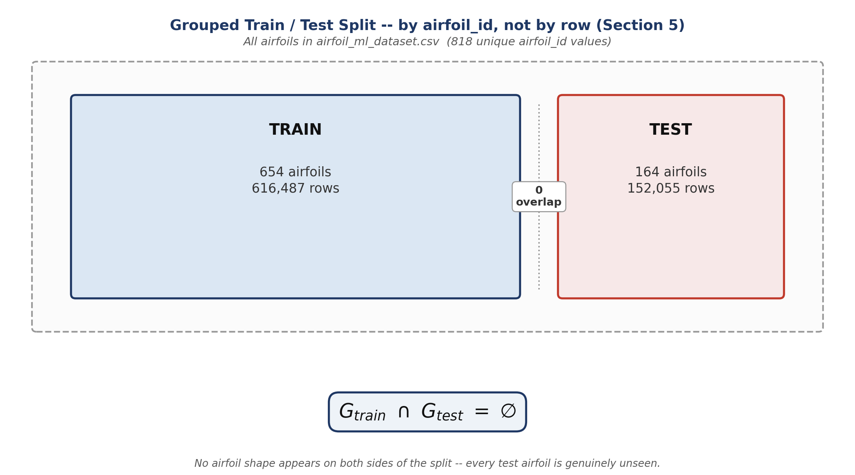
Figure 1 — the grouped split guarantees zero airfoil overlap between train and test: every test-set shape is genuinely unseen during training.
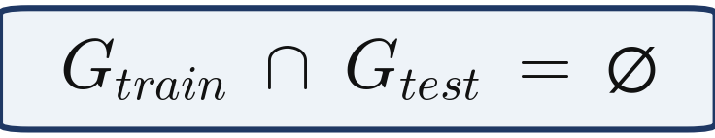
Formula 2 — the grouped-split constraint stated formally: the set of training-airfoil IDs and the set of test-airfoil IDs never intersect.
This is the methodological backbone of the whole report: because no airfoil shape appears on both sides of the split, every R² / MAE / RMSE number quoted from here on (Sections 6, 8, 9, 12) measures genuine generalization to new airfoil geometries — not interpolation between angles of attack on a shape the model already partially knows.

4.3 Exploring the Targets (Cl and Cd)
Before any modeling, the notebook takes a quick look at the shape of both targets and at how Cd varies with angle of attack, using the training split only:
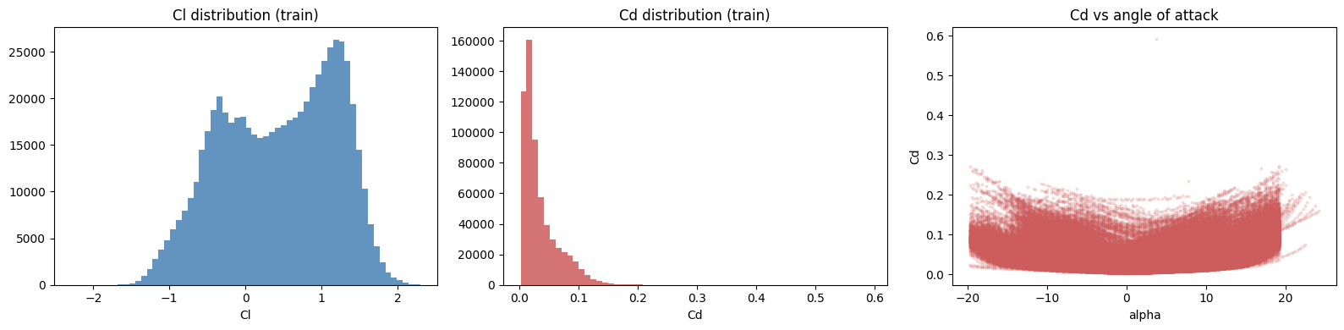
Figure 2 — left: Cl distribution (train), showing a broad, mildly bimodal spread roughly from -2 to 2. Middle: Cd distribution (train), sharply right-skewed with almost all mass below 0.1. Right: Cd vs angle of attack (train), a shallow U-shape with a long high-drag tail at the extreme (stall-adjacent) angles. (Reproduced directly from the notebook's own rendered chart, Section 6.)
The notebook prints the exact numeric range behind the Cd histograms:
Cd range — train: 0.00265 to 0.59188 Cd range — test: 0.00338 to 0.31944
Cd's pronounced right skew — most values bunched near zero with a long thin tail toward 0.6 — is the single most important thing to notice in this section: it is the direct setup for the “Cd wall” investigation in Section 7, and it is the reason every model in this report predicts Cd noticeably less accurately than it predicts Cl.

5. End-to-End Pipeline Architecture
Before diving into individual models, it helps to see the whole pipeline laid out end to end — from the raw CSV through to a validated controller output. Figure 3 below redraws the notebook's own high-level pipeline sketch (found at the very top of the notebook) as a clean, generously-spaced flowchart, with each stage labelled by the notebook section that performs it.
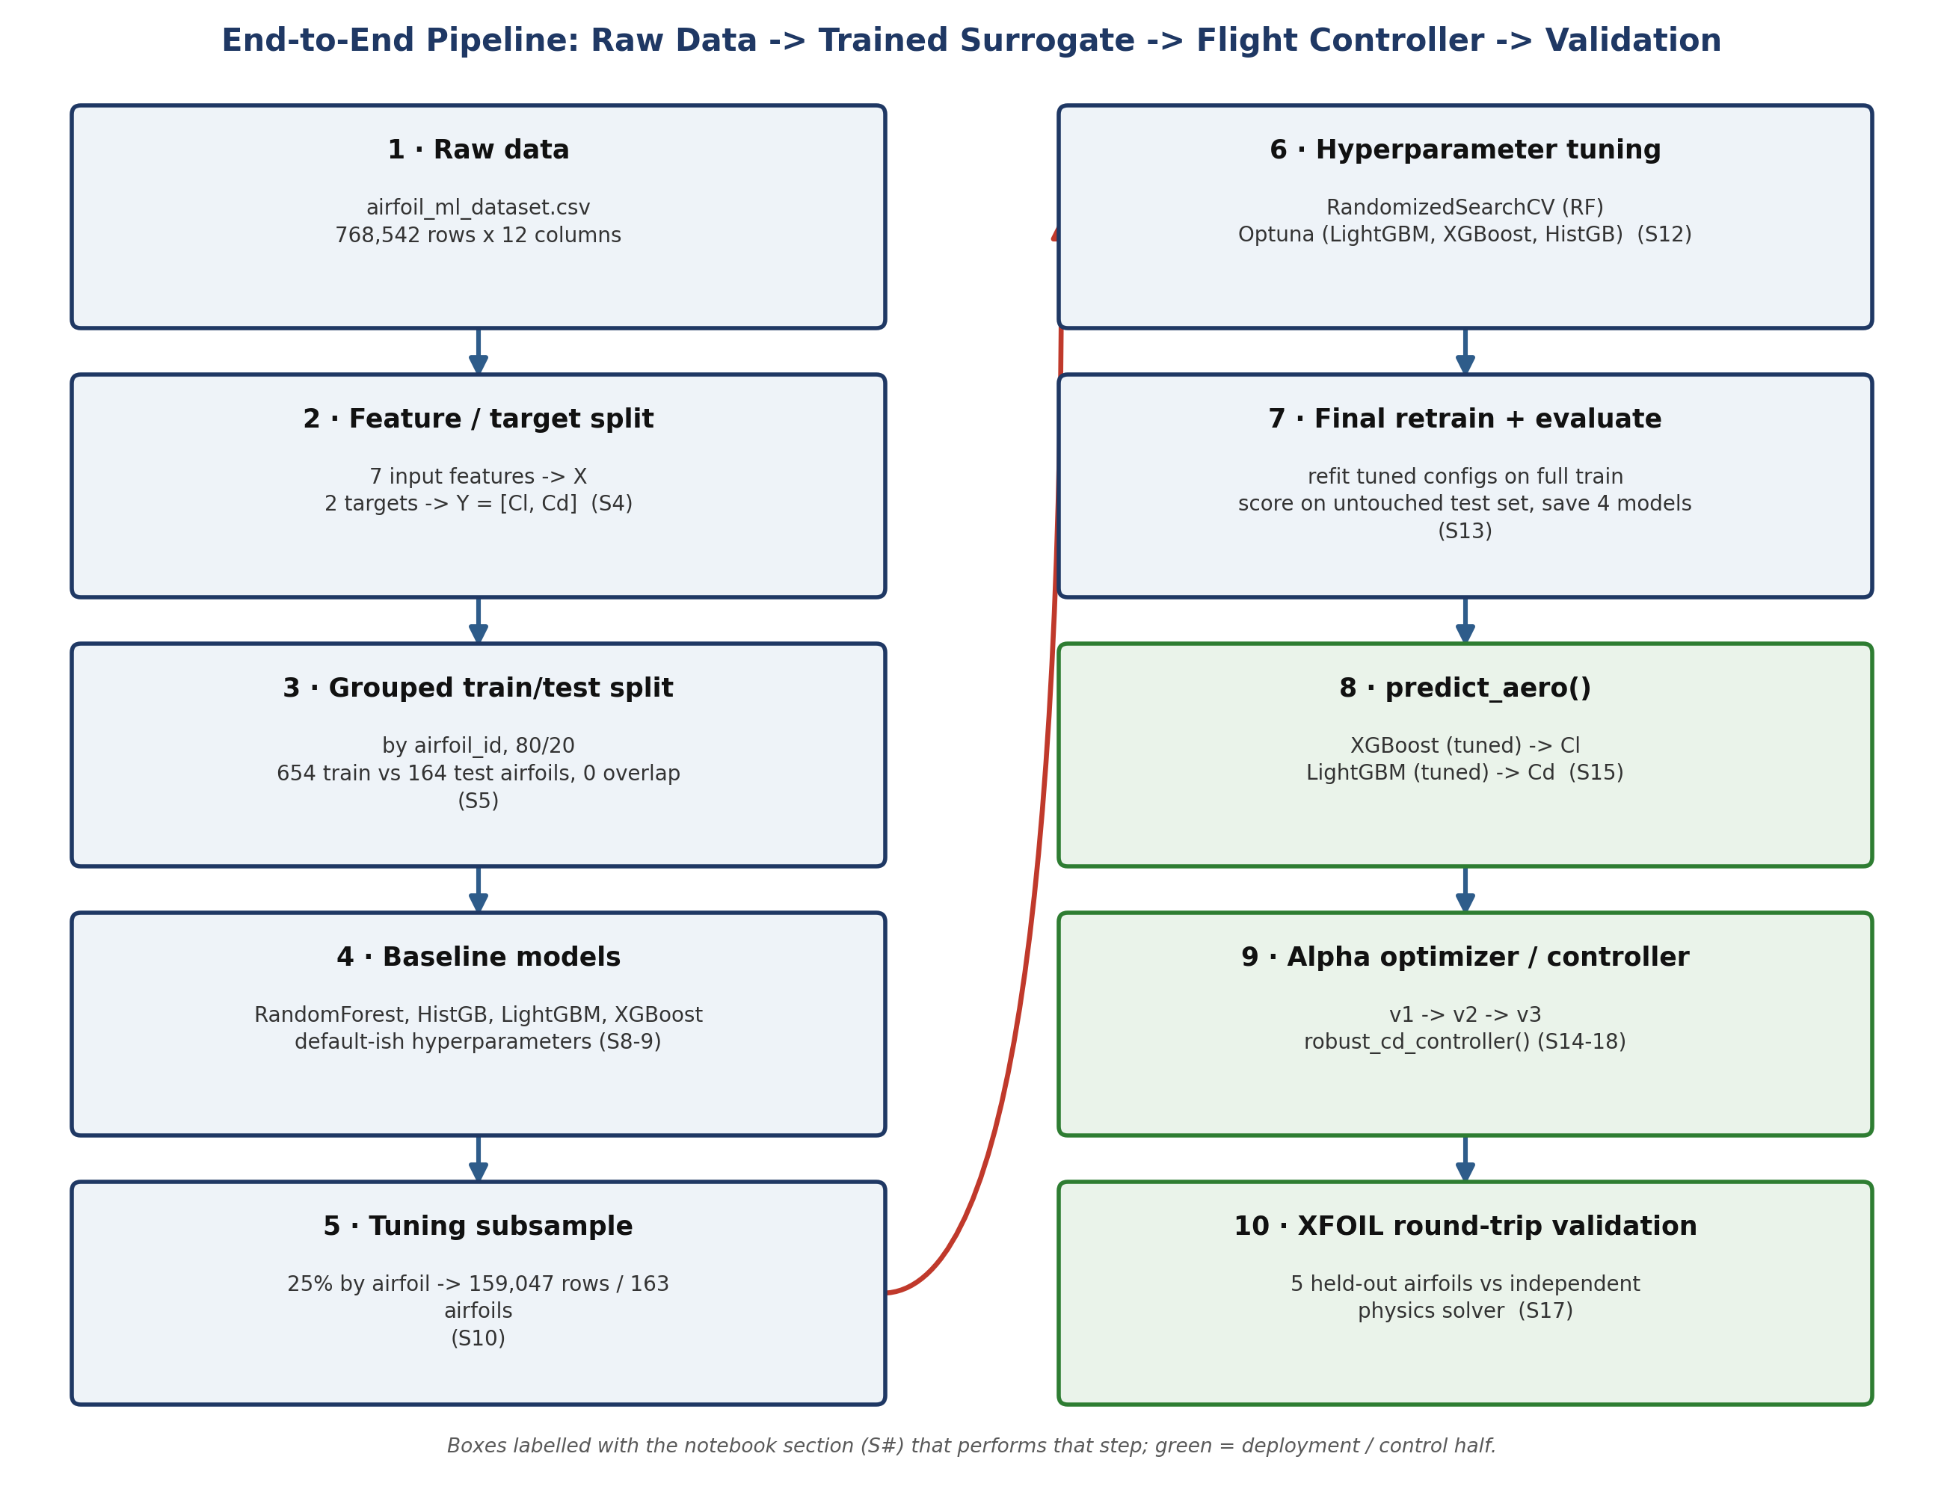
Figure 3 — the full pipeline. The left column (steps 1-5) covers data preparation and baseline modeling; the right column (steps 6-10, shaded green) covers tuning, final model selection, and the deployment/control half of the notebook.
Two things are easy to miss on a first read of the notebook but are visible immediately in this diagram: first, the tuning step (6) works from a 25%-by-airfoil subsample rather than the full training set, purely for search speed (Section 8); second, the deployment half of the pipeline (steps 8-10) reuses the same four tuned models trained in steps 6-7 — it does not retrain anything new, it only wraps the existing XGBoost and LightGBM models in a prediction function and then an optimizer.

6. Baseline Model Comparison
Before any hyperparameter tuning, the notebook trains four model families with default or near-default hyperparameters, to establish an honest baseline that later tuning gains (Section 9) can be measured against. All four are trained as multi-output regressors (predicting Cl and Cd together) and scored on the untouched, airfoil-disjoint test set from Section 4.2.

6.1 The four baseline configurations
- RandomForest — n_estimators=150, max_depth=None (grown fully), all cores. Trained in 0.7 minutes.
- HistGradientBoosting — scikit-learn defaults, wrapped in MultiOutputRegressor (one model per target). Trained in 0.1 minutes.
- LightGBM — n_estimators=300, wrapped in MultiOutputRegressor. Trained in 0.1 minutes.
- XGBoost — n_estimators=300, wrapped in MultiOutputRegressor. Trained in 0.2 minutes.
All four training times are printed directly by the notebook and are all under a minute — this dataset size and feature count is comfortably within reach of default hyperparameters on modest hardware, which is part of why a baseline-before-tuning pass is cheap and worth doing here.

6.2 Predicted vs. actual — all four baseline models
Each baseline model's predictions on the test set are plotted against the true Cl and Cd values, with a red dashed y=x line marking a perfect prediction. All four charts below are the notebook's own rendered output (Section 8).
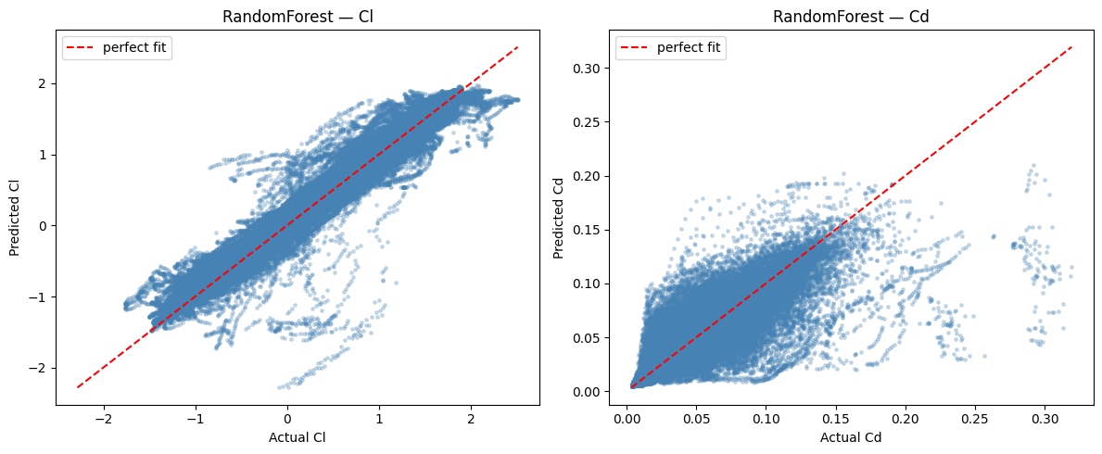
Figure 4 — RandomForest: predicted vs. actual, Cl (left) and Cd (right).
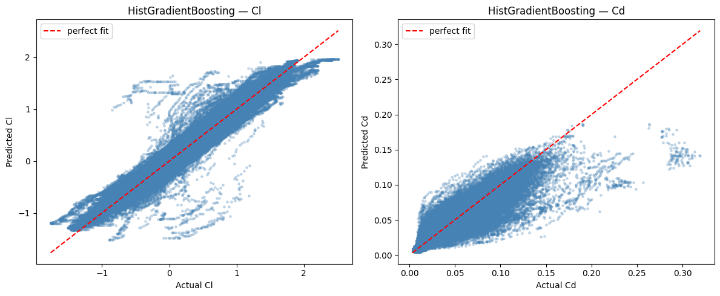
Figure 5 — HistGradientBoosting: predicted vs. actual, Cl (left) and Cd (right).
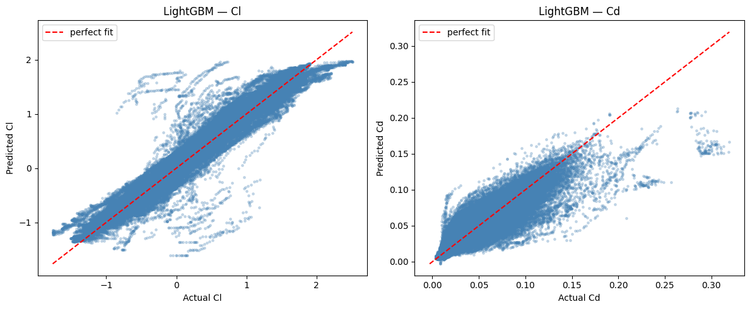
Figure 6 — LightGBM: predicted vs. actual, Cl (left) and Cd (right).
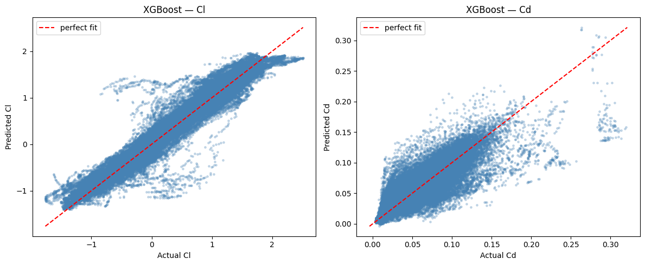
Figure 7 — XGBoost: predicted vs. actual, Cl (left) and Cd (right).
In every one of the four Cd panels, notice the same pattern: points hug the diagonal well at low-to-mid Cd, then fan out and flatten at the high end. That flattening is the “Cd wall” formally investigated in Section 7 — it is already visible here, before any tuning has happened, which is an important clue that it is a property of the data/model combination rather than something tuning alone will fix.

6.3 Baseline comparison table & ranking
Three metrics are used throughout this report to compare models: mean absolute error (MAE), root mean squared error (RMSE), and the coefficient of determination (R²). These are the notebook's own metric definitions (Section 7, Helper Functions), reproduced here once for reference:
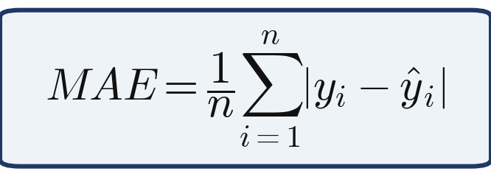
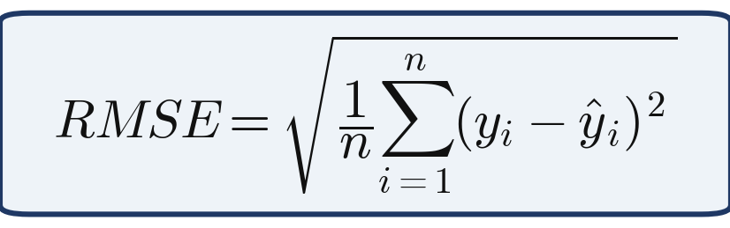
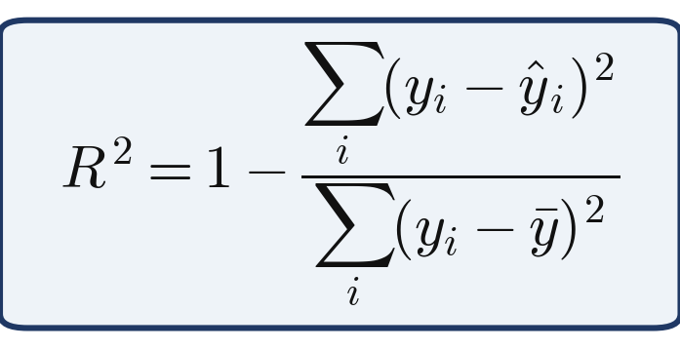
Formulas 3-5 — MAE, RMSE and R², exactly as computed by the notebook's evaluate_and_store() helper.
Table 5 — Baseline model comparison, held-out test set (notebook's own rendered table, Section 9)
Model | Cl MAE | Cl RMSE | Cl R2 | Cd MAE | Cd RMSE | Cd R2
RandomForest | 0.095162 | 0.161001 | 0.954799 | 0.007447 | 0.015063 | 0.767295
HistGradientBoosting | 0.092520 | 0.150998 | 0.960241 | 0.007517 | 0.013398 | 0.815911
LightGBM | 0.092031 | 0.153987 | 0.958651 | 0.007006 | 0.012425 | 0.841668
XGBoost | 0.091006 | 0.145210 | 0.963231 | 0.007449 | 0.013402 | 0.815797

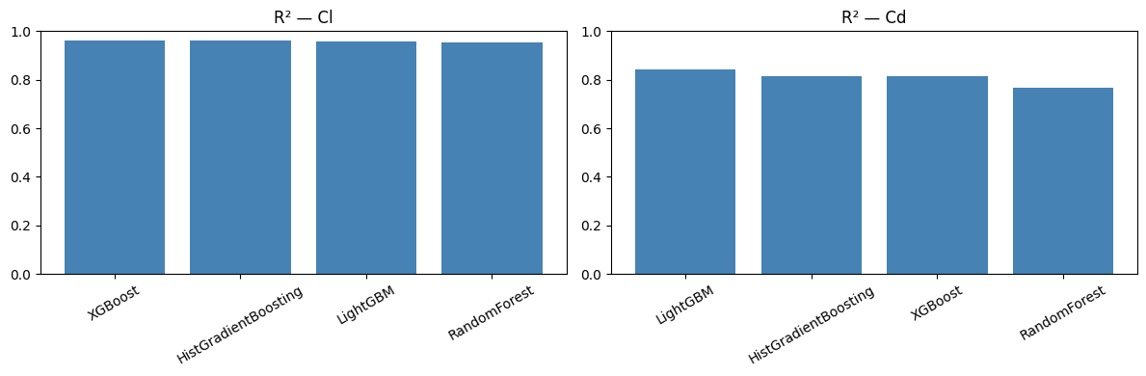
Figure 8 — R² ranking of the four baseline models, Cl (left) and Cd (right). (Notebook's own rendered chart, Section 9.)
Two consistent patterns emerge even at the baseline stage. First, XGBoost is the strongest baseline model for Cl (R² = 0.963231) while LightGBM is the strongest for Cd (R² = 0.841668) — no single model dominates both targets, which foreshadows the deployment decision in Section 9 to use two different tuned models for the two targets. Second, and more importantly, every model's Cd R² (0.767 to 0.842) sits well below its Cl R² (0.955 to 0.963) — a gap of roughly 0.12 to 0.19 that persists across four architecturally different model families. That consistency is itself evidence that the gap is coming from something about the Cd target's distribution, not from any one model's particular weaknesses — which is exactly what Section 7 sets out to confirm.

7. Diagnosing the Cd “Wall”
Section 6 showed every baseline model's Cd predictions flattening out at the high-drag end of the range. Before tuning any model further, the notebook stops to actually investigate this — first ruling out an obvious explanation (out-of-range test data), then running a targeted ablation experiment to find the real cause.

7.1 Ruling out an out-of-range test set
A natural first guess is that test-set Cd values simply fall outside the range the model saw during training. The notebook checks this directly by comparing the two distributions on a faster tuning subsample (25% of the training airfoils, drawn with the same grouped-split logic as Section 4.2 — 159,047 rows across 163 airfoils, per the notebook's own printed confirmation) against the full test set:
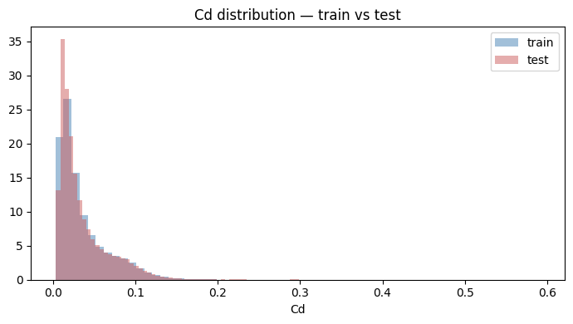
Figure 9 — Cd distribution, train vs. test, overlaid (density-normalized). The two distributions largely coincide. (Notebook's own rendered chart, Section 11.)
Test rows with Cd beyond the training max: 0 / 152,055
Zero test rows fall outside the training range. So the flattening is not an extrapolation problem in the simple sense of “test data the model never saw the likes of.” The real explanation is more subtle: every model tested is tree-based, and a tree predicts a constant value per leaf — the average of whichever training rows land there. Cd's right-hand tail (near stall) is thin (Section 4.3), so a handful of high-Cd training rows often end up sharing a leaf with many more moderate-Cd rows, and any test point landing in that same leaf gets pulled toward the average rather than the extreme. The result is a flat “wall” in the predicted-vs-actual plot rather than a diagonal, even though every point is technically within the training range.

7.2 A three-way ablation experiment
To test that explanation directly rather than just asserting it, the notebook fits three variants of the same LightGBM model on an identical train/validation split (drawn from the tuning subsample) and compares their Cd R² on the same held-out validation slice:
- Baseline — the same default-ish LightGBM configuration as Section 6.
- linear_tree = True — fits a small linear model per leaf instead of a constant, which should in principle let the model extrapolate beyond a leaf's training average.
- log1p(Cd) target transform — compresses Cd's long right tail before fitting, then inverts the transform on prediction.
Table 6 — Cd “wall” ablation results (notebook's own printed output, Section 11)
Approach | Cd R² | Verdict
Baseline LightGBM | 0.78922 | reference
linear_tree = True | -1954.14165 | rejected — wildly unstable on this data
log1p(Cd) target transform | 0.79184 | marginal improvement over baseline

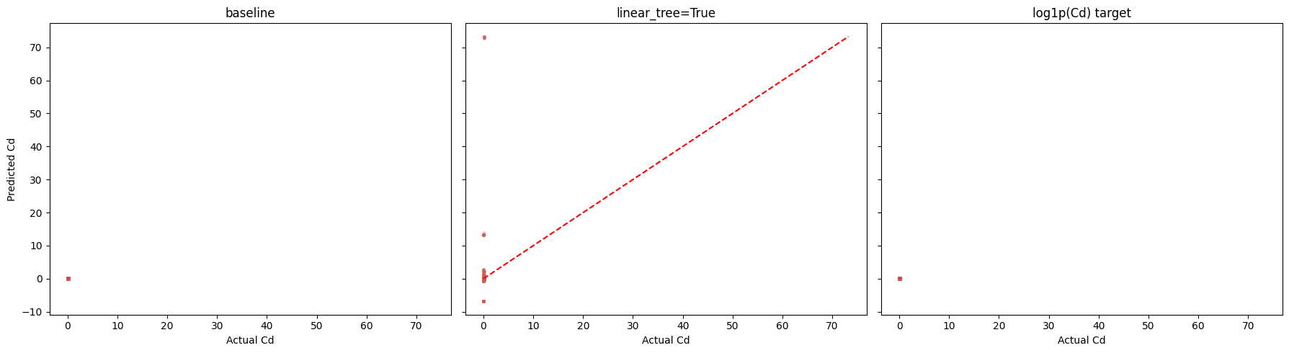
Figure 10 — predicted-vs-actual Cd for all three ablation variants, plotted on shared, linked axes. Note the y-axis: linear_tree=True produces predictions ranging roughly -70 to +70, so the shared scale compresses the baseline and log1p panels into a thin band near zero by comparison — a direct visual symptom of exactly how unstable that variant is on this data. (Notebook's own rendered chart, Section 11.)
Reading Table 6 and Figure 10 together: linear_tree=True is not a fix — it is dramatically worse (R² of -1954, meaning its predictions are worse than simply guessing the mean every time) and clearly unstable on this dataset. The log1p target transform gives a small, genuine improvement (0.79184 vs. 0.78922 baseline) but does not eliminate the underlying issue. The notebook's conclusion, stated plainly: keep linear_tree=False, and treat the Cd wall as a documented limitation of tree-based leaf-averaging on a thin high-drag tail, rather than something to “fix” with these particular remedies.
SOURCE This conclusion is independently corroborated in Section 8 below: when Optuna is given complete freedom to choose linear_tree for the tuned LightGBM model, it independently settles on linear_tree=False for both targets — nobody told it to avoid the option that this ablation just rejected.

8. Hyperparameter Tuning
With a documented baseline (Section 6) and a documented limitation (Section 7), the notebook moves to hyperparameter tuning. To keep search times reasonable, tuning is performed on the 25%-by-airfoil subsample introduced in Section 7.1 (159,047 rows, 163 airfoils) rather than the full 616,487-row training set — the final models are then refit on the full training set afterward (Section 9).

8.1 Method per model
- Random Forest — RandomizedSearchCV, 20 candidate configurations x 3-fold GroupKFold (grouped by airfoil, so the same no-leakage discipline as the main split), scored with scikit-learn's default multi-output R².
- LightGBM, XGBoost, HistGradientBoosting — each tuned with Optuna's TPE sampler, running one independent study per target (Cl and Cd separately), for 40, 40, and 25 trials per target respectively.
SOURCE RandomizedSearchCV's default scoring="r2" on a two-column target uses scikit-learn's multioutput='uniform_average' R² — a single blended Cl+Cd number, not a per-target score. That is why Random Forest's row in Table 7 below shows only one CV R² figure, while the three Optuna-tuned models (one study per target) show two. This is flagged directly in the notebook as not a like-for-like comparison across rows — a footnote worth repeating here.

8.2 Tuning results
Table 7 — Hyperparameter tuning summary, all four models (notebook's own rendered table, Section 12)
Model | Method | Budget | Best Cl config | Cl CV R2 | Best Cd config | Cd CV R2
Random Forest | RandomizedSearchCV | 20 x 3 folds | n_estimators=500, min_samples_leaf=2, max_features='sqrt', max_depth=35 | 0.88583* | (same config, blended) | (same)*
LightGBM | Optuna (TPE) | 40 trials/target | lr≈0.0207, num_leaves=97, min_child_samples=167 | 0.97221 | lr≈0.0184, num_leaves=78, min_child_samples=99 | 0.81339
XGBoost | Optuna (TPE) | 40 trials/target | lr≈0.098, max_depth=7, min_child_weight≈0.577 | 0.97034 | lr≈0.032, max_depth=9, min_child_weight≈0.123 | 0.81085
HistGradientBoosting | Optuna (TPE) | 25 trials/target | max_iter=400, lr≈0.033, max_leaf_nodes=80 | 0.97116 | max_iter=200, lr≈0.040, max_leaf_nodes=85 | 0.81318

A methodological footnote also flagged directly by the notebook: because HistGradientBoosting's internal early stopping is not group-aware, it was given a smaller trial budget (25 vs. 40) than LightGBM/XGBoost to keep total search time comparable across models — the trial counts in Table 7 are not meant to imply HistGB was tuned less thoroughly per trial, just fewer times.
Taken together with Section 7's ablation, the CV R² columns in Table 7 tell a consistent story: every model's Cd CV R² (0.813 to 0.886*) sits noticeably below its Cl CV R² (0.970 to 0.972) — the same gap already visible at the baseline stage in Section 6, now surviving a dedicated tuning pass as well. Tuning improves both targets' scores somewhat, but does not close the Cl/Cd gap, which is further confirmation that the gap is a property of the Cd target's own distribution rather than of any one model's default configuration.

9. Final Tuned Models — Evaluation & Selection
With tuned hyperparameters selected (Section 8), each model is refit and scored one final time — this time on the honest, untouched test set from Section 4.2, not the tuning subsample used for the search itself.

9.1 A training-data asymmetry, disclosed
The notebook flags one subtlety in how the final refit is done: LightGBM and XGBoost genuinely need a validation slice to know when to stop boosting (early stopping), while HistGradientBoosting and Random Forest do not.
Table 8 — What each final model was actually trained on (notebook's own annotation)
Model | Trained on
LightGBM (tuned) | 90% of training airfoils (10% held out for early stopping)
XGBoost (tuned) | 90% of training airfoils (same reason)
HistGradientBoosting (tuned) | 100% of training airfoils (early_stopping=False)
RandomForest (tuned) | 100% of training airfoils (no early stopping applies to RF)

This is not a bug, but it does mean the four models in Table 9 below are not all trained on identically sized data — worth keeping in mind for any conclusion that leans on a small R² difference between rows, such as the RandomForest-vs-XGBoost Cl comparison noted in Section 9.3.

9.2 Predicted vs. actual — all four tuned models
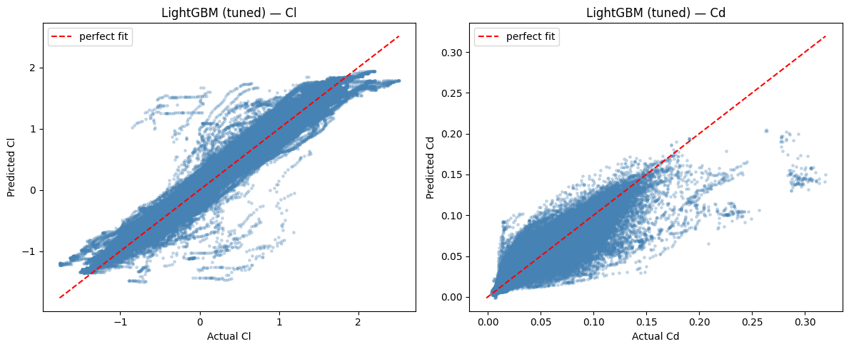
Figure 11 — LightGBM (tuned): predicted vs. actual, Cl (left) and Cd (right).
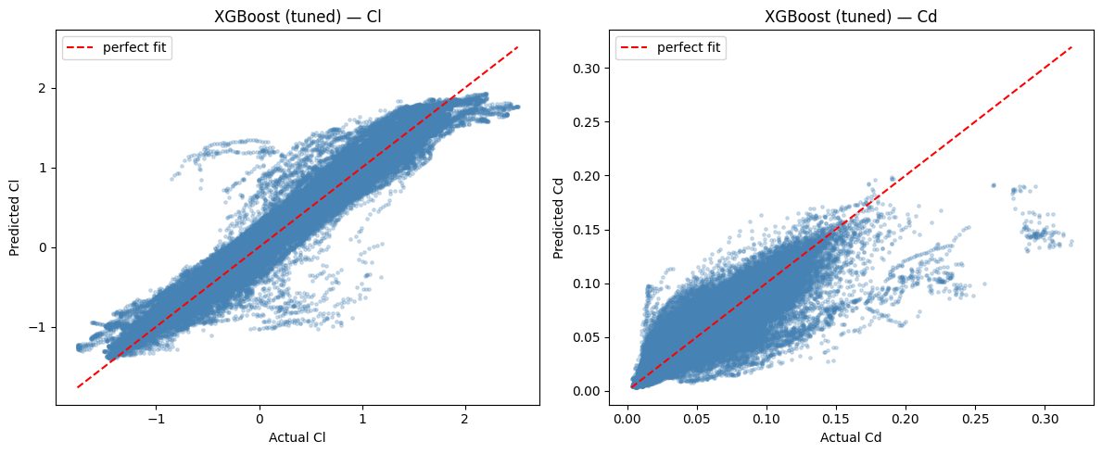
Figure 12 — XGBoost (tuned): predicted vs. actual, Cl (left) and Cd (right).
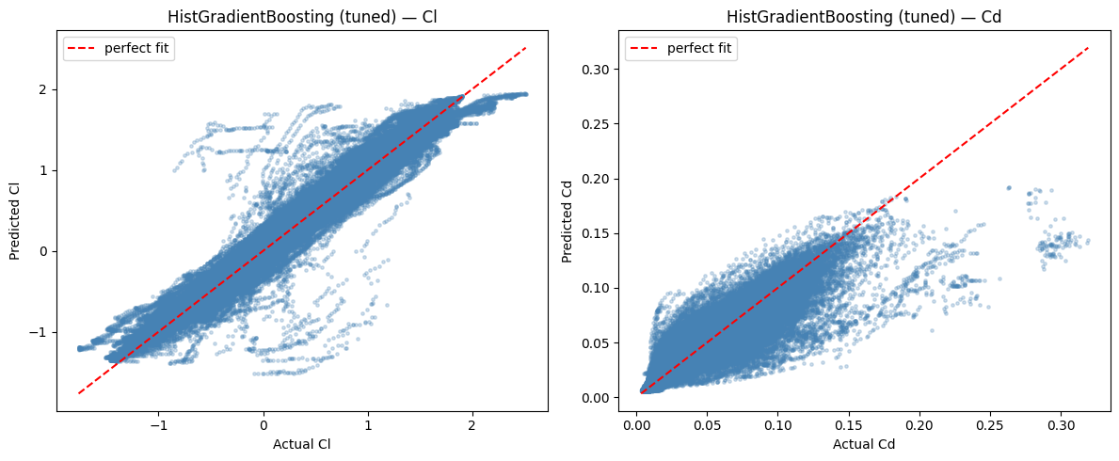
Figure 13 — HistGradientBoosting (tuned): predicted vs. actual, Cl (left) and Cd (right).
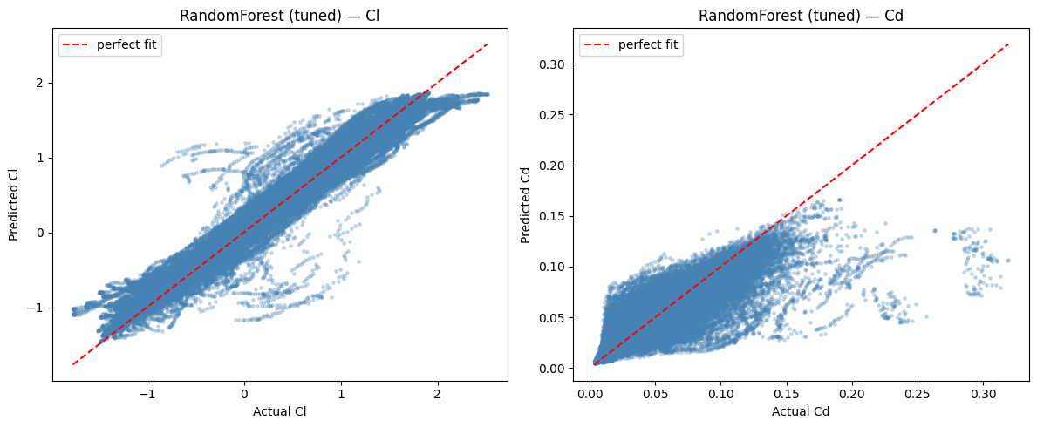
Figure 14 — RandomForest (tuned): predicted vs. actual, Cl (left) and Cd (right).
Comparing these four charts against their baseline counterparts in Figures 4-7: the Cl panels tighten up only modestly (they were already quite good), while the Cd panels show a slightly tighter core scatter, but the same high-Cd flattening described in Section 7 is still clearly visible in every one of the four Cd panels here too. Tuning improved the numbers (Table 9); it did not remove the underlying wall.

9.3 Final comparison table & deployment decision
Table 9 — Final tuned model comparison, untouched test set (notebook's own rendered table, Section 13)
Model | Cl MAE | Cl RMSE | Cl R2 | Cd MAE | Cd RMSE | Cd R2
RandomForest (tuned) | 0.086253 | 0.138753 | 0.966428 | 0.007156 | 0.014231 | 0.792296
HistGradientBoosting (tuned) | 0.089093 | 0.149257 | 0.961153 | 0.006926 | 0.012881 | 0.829829
LightGBM (tuned) | 0.089825 | 0.149236 | 0.961163 | 0.006887 | 0.012685 | 0.834978
XGBoost (tuned) | 0.090344 | 0.142695 | 0.964493 | 0.007009 | 0.013127 | 0.823260

The notebook saves all four tuned models to disk at this point (joblib.dump, one file per model) and prints a simple confirmation: “Saved 4 tuned models.” Section 13 covers the save/reload mechanics and a subtlety in the exact file paths used.
Deployment decision. The notebook's predict_aero() bridging function (Section 10) uses XGBoost (tuned) for Cl and LightGBM (tuned) for Cd. LightGBM is the clear Cd winner in Table 9 (R² = 0.834978), so that half of the decision is unambiguous. For Cl, however, Table 9 shows RandomForest (tuned) scoring marginally higher (R² = 0.966428) than the deployed XGBoost (tuned) model (R² = 0.964493) — a difference of 0.0019. This is flagged directly in the notebook's own annotations as an open design decision, not a bug: either re-point predict_aero() to the RandomForest Cl model, or keep XGBoost and add a sentence justifying it (for example, inference speed, memory footprint, or consistency with the Cd model's gradient-boosted family). This report does not resolve that choice on the notebook author's behalf; it is carried forward as cleanup item in Section 14.
SOURCE Table 9's bold entries mark the best score in each column, exactly as the notebook's own rendered comparison table marks them — RandomForest for Cl MAE/RMSE/R², LightGBM for Cd MAE/RMSE/R².

10. From Prediction to Control: System Architecture
Sections 3-9 cover the surrogate-modeling half of the notebook. From here on (the notebook's own Section 14 onward — its own markdown notes that “this half of the notebook had no section headers before this pass”), the four saved models are turned into something that answers a real question: at what angle of attack does this airfoil hit a target drag coefficient, without stalling out the lift?
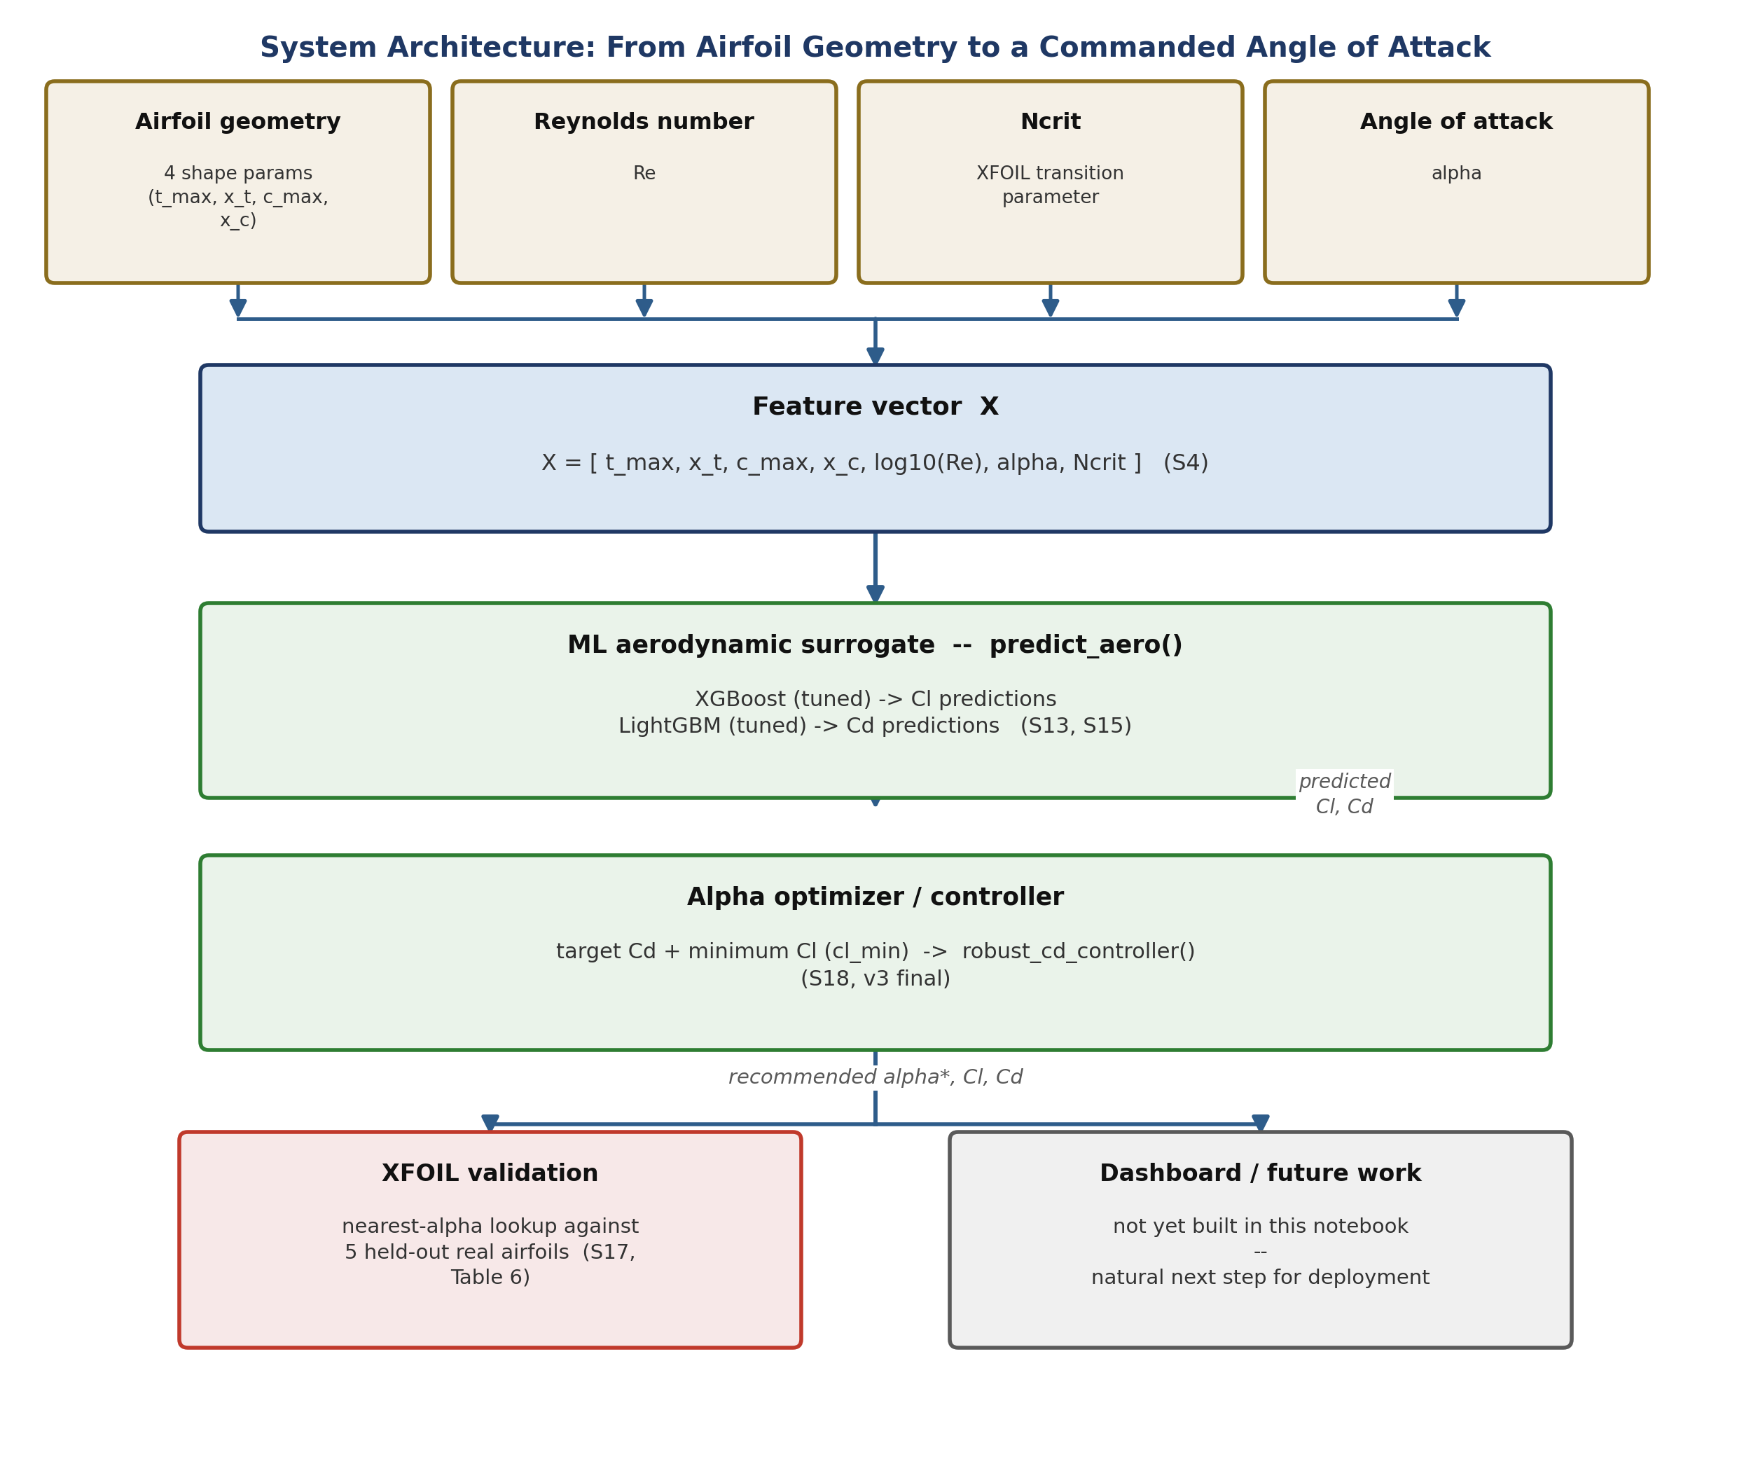
Figure 15 — system architecture, redrawn cleanly from the notebook's own ASCII diagram in Section 14. Four raw inputs feed a shared feature vector, which the ML surrogate turns into predicted Cl/Cd, which the controller turns into a recommended angle of attack.
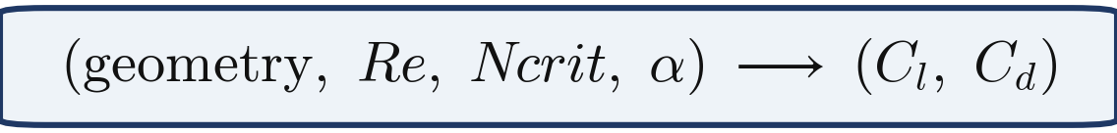
Formula 6 — the surrogate's job in one line: given geometry, flow conditions and an angle of attack, predict the resulting lift and drag coefficients.
The bridging function predict_aero() packages a single (alpha, geometry, Re, Ncrit) query into the same 7-feature row format used throughout training, then calls the two deployed models: XGBoost (tuned) for Cl and LightGBM (tuned) for Cd (the deployment decision discussed in Section 9.3). This function is what every controller generation in Section 11 calls, potentially hundreds of times per optimization run, which is exactly the workload a fast ML surrogate is suited for and a full XFOIL run would not be.

11. The Alpha Controller — Three Design Generations
The notebook's own annotations are candid about this section's history: the controller was iterated on three times while building it, and all three versions are still present side by side rather than the final one replacing the earlier ones. That is normal notebook-driven-development residue (catalogued fully in Section 14), and it is labelled explicitly here so the three generations don't have to be reverse-engineered.
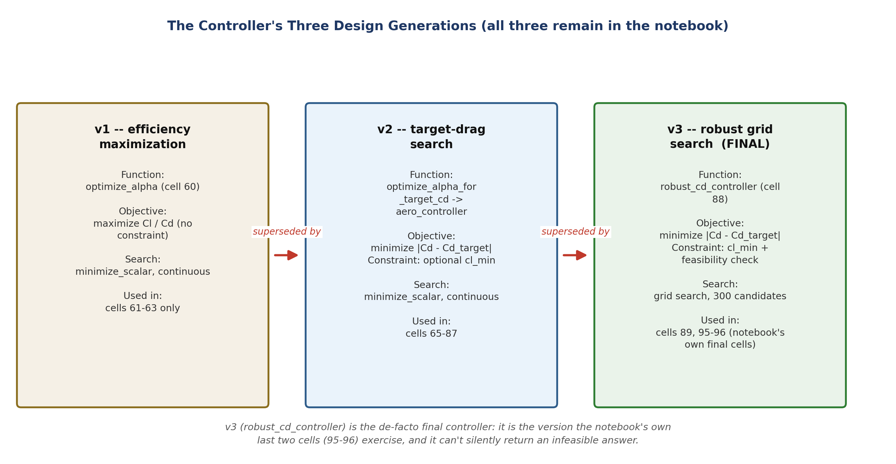
Figure 16 — the controller's three design generations, what each one optimizes, and which notebook cells actually exercise each version.

11.1 v1 — Unconstrained Efficiency Maximization
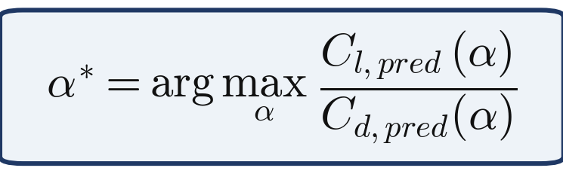
Formula 7 — v1's objective: find the angle of attack that maximizes lift-to-drag ratio, with no other constraint.
v1 (optimize_alpha) searches continuously over alpha in [-10°, 15°] for the angle that maximizes predicted Cl/Cd. Demonstrated on a synthetic test airfoil (12% max thickness at 30% chord, 2% max camber at 40% chord) at Re = 500,000, Ncrit = 9, the notebook's own printed result:
optimal_alpha = 4.51° Cl = 0.7334 Cd = 0.0086 Cl/Cd = 85.24
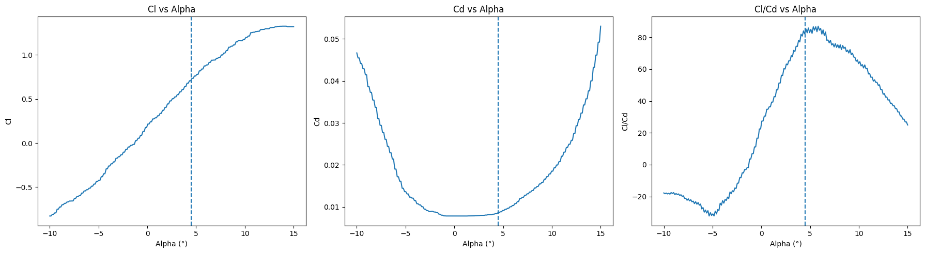
Figure 17 — Cl, Cd and Cl/Cd vs. alpha for the synthetic test airfoil, with the v1-optimal angle marked by the dashed line. The efficiency peak (right panel) is clearly visible around alpha ≈ 4.5°. (Notebook's own rendered chart, Section 15.1.)
v1 has an obvious limitation for a real control problem: it has no way to target a specific drag value — it only ever chases maximum efficiency. That gap motivates v2.

11.2 v2 — Target-Drag Optimization
Formula 8 — the objective shared by v2 and v3: minimize the gap to a target Cd, subject to a minimum acceptable Cl.
v2 (optimize_alpha_for_target_cd, wrapped by aero_controller) instead searches for the alpha that gets predicted Cd as close as possible to a chosen target, optionally subject to a minimum-lift constraint. On the same synthetic airfoil as v1, targeting Cd = 0.010:
optimal_alpha = 5.68° Cl = 0.8400 Cd = 0.01006 error ≈ 0.0001
a very close hit. The notebook then switches to a real airfoil from the dataset — airfoil_id 0, whose actual geometry (max_thickness_percent ≈ 7.998, max_thickness_position ≈ 0.1809, max_camber_percent ≈ 7.002, max_camber_position ≈ 0.3518) matches the df.head() preview in Table 3 exactly. Repeating the same target-Cd = 0.010 search on this real airfoil (at a hypothetical Re = 500,000, Ncrit = 9):
optimal_alpha = 0.6317° Cl = 0.7197 Cd = 0.01212 error ≈ 0.0021
Because this is a real airfoil, the notebook can look up the nearest actual XFOIL row at the same (airfoil, Re, Ncrit) combination and compare directly:
Nearest XFOIL alpha = 0.50° (difference ≈ 0.132°) XFOIL Cd = 0.01071 (real Cd error ≈ 0.00141)
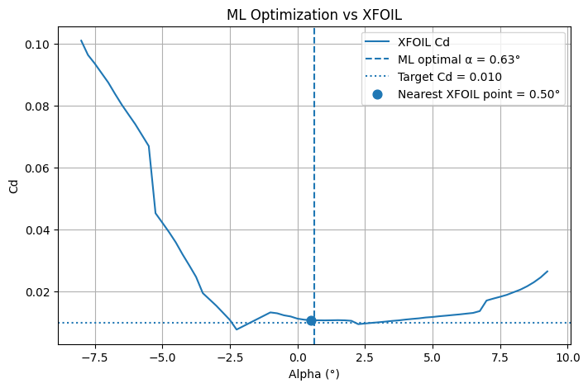
Figure 18 — the ML controller's recommendation (dashed line) against the airfoil's real XFOIL Cd curve, with the target Cd (dotted) and the nearest actual XFOIL sample point (dot) both marked. This is a single-airfoil preview of the 5-airfoil validation formalized in Section 12. (Notebook's own rendered chart, Section 17.)

A target-Cd sweep, and a first sign of a plateau
Repeating the target-Cd search across five different targets on this same real airfoil surfaces something worth flagging before v3:
Table 10 — Target-Cd sweep, real airfoil 0 (notebook's own execute_result, Section 16)
Target Cd | Optimal alpha | Predicted Cl | Predicted Cd | Error
0.008 | 0.6317° | 0.71966 | 0.01212 | 0.00412
0.010 | 0.6317° | 0.71966 | 0.01212 | 0.00212
0.012 | 0.6317° | 0.71966 | 0.01212 | 0.00012
0.015 | 6.4299° | 1.30348 | 0.01480 | 0.00020
0.020 | 9.0535° | 1.55483 | 0.01976 | 0.00024

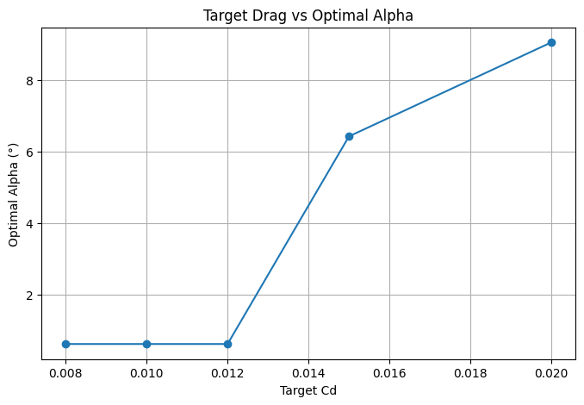
Figure 19 — optimal alpha vs. target Cd across the 5-point sweep. The flat segment at low targets is the same plateau visible in Table 10. (Notebook's own rendered chart, Section 16.)
Physical insight. The three lowest targets (0.008, 0.010 and 0.012) all land on the identical angle, Cl and Cd. That is not a bug — for this airfoil/Re/Ncrit combination, 0.01212 appears to be roughly the achievable minimum drag in the searched alpha range (-10° to 15°), so any target below that floor cannot actually be reached; the optimizer simply reports the closest achievable point every time, which happens to be the same point for all three low targets. This is a second, independent piece of evidence — alongside Section 7's ablation — that this model's Cd surface has flat, plateau-like regions rather than a smooth response everywhere.

11.3 v3 (Final) — Robust Grid-Search Controller
robust_cd_controller replaces v2's continuous minimize_scalar search with an explicit grid search over 300 candidate angles, filters to only the candidates where predicted Cl ≥ cl_min (the feasible set), then picks whichever feasible candidate's Cd is closest to the target — explicitly reporting whether the target was actually reachable (“Target reached”) or only approximately so (“Closest feasible solution”). This is a more defensive design than v2: it cannot silently return an infeasible answer, and it does not rely on a continuous optimizer finding the right local optimum in one pass.
Run on the same real airfoil 0, target Cd = 0.010, cl_min = 0.5, the notebook's own printed result:
status = “Closest feasible solution” alpha = 0.0334° Cl = 0.6499 Cd = 0.01212 Cl/Cd = 53.62
Table 11 — v2 vs. v3 on the identical airfoil / target / constraint (notebook's own comparison note)
 | Optimal alpha | Predicted Cl | Predicted Cd
v2 (continuous search) | 0.6516° | 0.7197 | 0.01212
v3 (grid search, 300 pts) — final | 0.0334° | 0.6499 | 0.01212

Two different search methods land on two clearly different angles (0.65° vs. 0.03°) but the identical predicted Cd. This lines up with everything else the notebook has already found about the model's Cd surface: Section 7's ablation diagnosed piecewise-constant, leaf-based predictions; Table 10's sweep found three different targets converging on one identical point; and now two different optimizers find two different angles that score identically on Cd. Read together, these three observations tell one coherent story for the limitations section: the Cd surface has flat, plateau-like regions in this alpha window, so many different angles score equally well on drag alone — which is exactly why the cl_min lift constraint matters, since it is the tiebreaker that actually distinguishes between otherwise-equal candidates (v3's grid search picks the lowest-alpha member of that plateau; v2's continuous search happened to land on a different member of the same plateau).
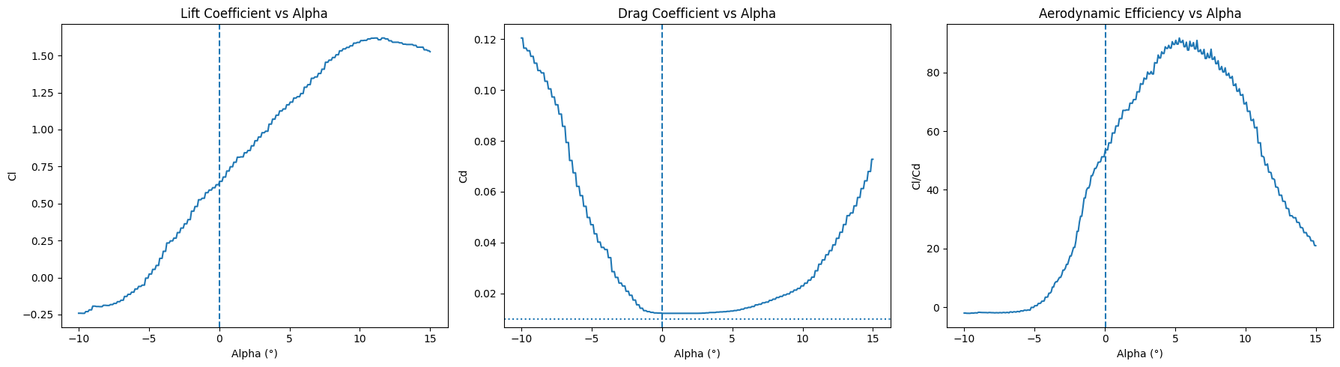
Figure 20 — the final v3 controller's view of real airfoil 0: Lift Coefficient (left), Drag Coefficient (middle, with the target Cd shown as a dotted line), and Aerodynamic Efficiency (right) vs. alpha, with the v3-recommended angle (≈ 0.03°) marked by the dashed line. (Notebook's own rendered chart, Section 18 — the final, de-facto version of Figure 17.)
SOURCE v3 (robust_cd_controller) is treated as the final controller throughout the rest of this report because it is the version the notebook's own last cells (the save/reload check in Section 13) actually exercise — not because v1/v2 were deleted or superseded in the code itself.

12. Validating the Controller Against XFOIL
Section 11.2 previewed this idea on a single airfoil. The notebook then formalizes it: run the v2 controller (aero_controller, with cl_min = 0.5) on five held-out real airfoils (IDs 0-4), all targeting Cd = 0.010 at Re = 500,000, Ncrit = 9, and for each one look up the nearest actual XFOIL data row at the same (airfoil, Re, Ncrit) combination to compare against.
Table 12 — 5-airfoil controller validation against XFOIL (notebook's own execute_result, Section 17)
Airfoil ID | ML alpha | XFOIL alpha (nearest) | ML Cd | XFOIL Cd | Target Cd | Cd error
0 | 0.652° | 0.50° | 0.01212 | 0.01071 | 0.010 | 0.00141
1 | 4.082° | 4.00° | 0.00961 | 0.01138 | 0.010 | 0.00177
2 | 4.736° | 4.75° | 0.00976 | 0.01056 | 0.010 | 0.00080
3 | 5.178° | 5.00° | 0.00984 | 0.00951 | 0.010 | 0.00033
4 | 4.769° | 4.75° | 0.00969 | 0.00933 | 0.010 | 0.00036

Aggregating across all five airfoils, the notebook prints:
Mean Cd Error: 0.000935 Mean Alpha Difference: 0.089°
This is the strongest single piece of evidence in the whole notebook that the pipeline works end to end. It is not another held-out R² computed from the same kind of data the models were trained on — it is the actual controller output (a recommended angle of attack, derived entirely from the ML surrogate) checked against an independent physics tool, across five different airfoil shapes, with a tight mean error in both the drag coefficient (well under 0.001) and the recommended angle itself (under a tenth of a degree).
SOURCE Airfoil 0's row in Table 12 (alpha 0.652°, Cd error 0.00141) is the same case walked through in detail in Section 11.2 and Figure 18 — the two sections describe the same underlying computation from two different angles (single-airfoil deep dive vs. multi-airfoil aggregate).

13. Save / Reload Verification
The final engineering check in the notebook: do the four tuned models, once written to disk with joblib and loaded back in a fresh set of variables, reproduce exactly the same controller output as before? This kind of check is easy to skip and is not always present in exploratory notebooks.

13.1 A file-path inconsistency, worth flagging
The four models are saved in Section 9 with bare filenames in the working directory — for example, joblib.dump(trained_models["XGBoost (tuned)"], "xgboost_tuned.joblib"), with no folder prefix. The reload cell in this section, however, loads from a models\ subfolder: joblib.load("models\\xgboost_tuned.joblib"). As written, these two cells are not self-consistent — run fresh in a clean directory, the load would raise a FileNotFoundError. In the run captured by this notebook, both getsize() and load() calls against the models\ path succeeded, which only makes sense if a models subfolder already contained copies of the four files at execution time (most plausibly moved or copied there outside of the shown cells). The loaded models' predictions (below) are fully consistent with the Section 9 tuned models, so the numbers in this section are trustworthy — but the save/load path handling itself should be unified before this notebook is rerun end-to-end in a new environment. This is tracked as a cleanup item in Section 14.

13.2 File sizes on disk
xgboost_tuned.joblib: 10,392,884 bytes (≈ 10.4 MB) lightgbm_tuned.joblib: 9,344,324 bytes (≈ 9.3 MB)

13.3 Reload sanity check
After reloading, predict_aero() is redefined to call the freshly-loaded final_cl_model and final_cd_model directly. A basic sanity check at alpha = 5.68° on the real airfoil 0 (the same airfoil used throughout Section 11) prints:
Predicted Cl: 1.221950 Predicted Cd: 0.013763
More importantly, the notebook re-runs the exact same robust_cd_controller call used to produce the v3 result in Section 11.3 (real airfoil 0, target Cd = 0.010, cl_min = 0.5) — this time using only the reloaded models — and compares the output:
status = “Closest feasible solution” alpha = 0.03344481605351213° Cl = 0.6498776078224182 Cd = 0.01212067245963529 Cl/Cd = 53.61728979862005
Every digit of this reproduces the original in-memory v3 result from Section 11.3 exactly. That bit-for-bit match is small but real engineering rigor: it confirms the save/reload round-trip introduces no precision loss or configuration drift, and that the deployed .joblib files genuinely contain what Section 9 says they contain.

14. Known Issues, Duplicate Cells & Cleanup Notes
The notebook's own annotations are unusually candid about its own rough edges — the controller was iterated on three times (Section 11) and earlier drafts were left in place rather than deleted, which is the root cause of most items below. This is normal notebook-driven-development residue, not sloppiness, and every item here is quick to fix. None of it calls the modeling results (Sections 6-9) or the controller's validated behavior (Section 12) into question.
Table 13 — Cleanup checklist, condensed from the notebook's own recap table (Section 20)
# | Item | Type
1 | Keep one predict_aero() definition | duplicate function definition
2 | Keep one optimize_alpha_for_target_cd() definition | duplicate function (+ key rename)
3 | Remove duplicate airfoil_features rebuild | duplicate cell
4 | Trim redundant identical demo calls | redundant re-run
5 | Remove repeated controller_results displays | redundant display
6 | Remove repeated validation_results display | redundant display
7 | Fix the wrong/self-contradicting Cl/Cd sentence | content error (corrected in this pass)
8 | Fix the model save/load path mismatch | path bug (see Section 13)
9 | Remove dead alpha_control variable | dead code
10 | Rename the sweep's results list to avoid shadowing the metrics dict | naming collision
11 | (Optional) factor the alpha-sweep-plot block into one helper | code duplication
12 | Re-point predict_aero()'s Cl model to RF, or justify keeping XGBoost | design decision, not a bug

Two items are worth a one-line elaboration beyond the table. The “wrong/self-contradicting Cl/Cd sentence” has already been corrected in this annotated pass (see the corrected sentence quoted in Section 9.3); the correction, not the original error, is what this report builds on throughout. The “model save/load path mismatch” is discussed in detail in Section 13.1, including why the reload nonetheless succeeded and produced trustworthy numbers in the run this report is based on.

15. Overall Assessment & Conclusion

What's genuinely good
- The airfoil-level grouped split (Section 4.2) is the strongest methodological decision in this project — it is what makes every R² number in this report trustworthy as a genuine generalization measure. A lot of ML projects at this stage get this specific point wrong.
- Baseline-before-tuning discipline (Sections 6, 8) means the tuning gains reported in Section 9 can be attributed to the tuning process itself, not to having accidentally picked a favorable configuration for one model from the start.
- The Cd “wall” is not just noticed, it is genuinely investigated (Section 7) — a real ablation experiment with a specific, falsifiable conclusion (linear_tree=False) that is then independently confirmed when Optuna is given complete freedom to choose otherwise anyway (Section 8). That internal consistency check is what makes the conclusion convincing rather than merely asserted.
- The XFOIL round-trip validation (Section 12) closes the loop — this is not another held-out R², it is the actual controller output checked against an independent physics tool, across five different airfoils, with a tight mean error (≈ 0.0009 in Cd, ≈ 0.09° in alpha).
- The save/reload sanity check (Section 13) — reproducing the controller's output bit-for-bit after a round trip through disk — is small but real engineering rigor that is easy to skip and was not skipped here.

What needs cleanup before the next revision
All covered in Section 14: two duplicate function definitions, a handful of redundant demo/display cells, one sentence that has already been corrected in this pass, one file-path mismatch between saving and loading the tuned models, one dead variable, and one variable-name collision to rename. None of it calls the actual results into question — it is notebook-history residue from iterating on the controller three times, which is a completely normal part of building something like this.

Bottom line
This project is well past “just train a model”. It is a coherent, defensible pipeline: raw data, through a carefully-split ML surrogate, through an angle-of-attack optimizer, through independent physical validation. Cd is measurably harder to predict than Cl for every model tried — that limitation is documented rather than hidden, traced to a specific, testable cause, and shown not to undermine the controller's real-world accuracy against XFOIL. The cleanup items in Section 14 are cosmetic, not methodological. As a v1.0 deliverable, this is a solid foundation for a dashboard or further deployment work on top of the existing predict_aero() and robust_cd_controller() functions.

Appendix A — Formula Reference
All eight formulas used in this report, collected here for quick lookup. Each is transcribed directly from the notebook's own “Formulations & diagrams — quick reference” section (Section 22) and rendered as a clean, boxed equation; none have been altered or re-derived.

Formula 1 — Feature & target vectors (Section 4.1)

Formula 2 — Grouped-split constraint (Section 4.2)

Formulas 3-5 — MAE, RMSE, R² (Section 6.3)

Formula 6 — ML surrogate mapping (Section 10)

Formula 7 — Controller v1 objective (Section 11.1)

Formula 8 — Controller v2 / v3 objective (Section 11.2-11.3)

Appendix B — Source Traceability Index
Every table and figure number used in this report, matched to its exact origin — either a specific notebook cell/section, or (for two tables only, both explicitly marked in the body text with a source note) a computation performed directly against the raw CSV for this report. This index exists so any number in this report can be checked against the original notebook without having to search for it.

Tables
Ref | Title | Source
Table 1 | Dataset schema | Notebook cell 10 (markdown table)
Table 2 | Raw descriptive statistics | Computed for this report from airfoil_ml_dataset.csv
Table 3 | df.head() preview | Notebook cell 9 (execute_result)
Table 4 | Grouped train/test split | Notebook cell 15 (print output)
Table 5 | Baseline model comparison | Notebook Section 9 (rendered markdown table)
Table 6 | Cd “wall” ablation | Notebook Section 11 (print output)
Table 7 | Hyperparameter tuning summary | Notebook Section 12 (rendered markdown table)
Table 8 | Training-data asymmetry | Notebook annotation, final-retrain cell
Table 9 | Final tuned model comparison | Notebook Section 13 (rendered markdown table)
Table 10 | Target-Cd sweep | Notebook cell 100 (execute_result)
Table 11 | v2 vs. v3 comparison | Notebook comparison note, controller section
Table 12 | 5-airfoil XFOIL validation | Notebook cell 121 (execute_result)
Table 13 | Cleanup checklist | Notebook Section 20 (recap table)

Figures
Ref | Title | Source
Figure 1 | Grouped train/test split diagram | Custom diagram (Section 4.2)
Figure 2 | Cl/Cd distributions + Cd vs alpha | Notebook Section 6 (rendered chart)
Figure 3 | End-to-end pipeline diagram | Custom diagram (Section 5)
Figure 4-7 | Baseline predicted-vs-actual (RF/HistGB/LightGBM/XGB) | Notebook Section 8 (rendered charts)
Figure 8 | Baseline R² ranking | Notebook Section 9 (rendered chart)
Figure 9 | Cd distribution, train vs test | Notebook Section 11 (rendered chart)
Figure 10 | Cd wall 3-way ablation | Notebook Section 11 (rendered chart)
Figure 11-14 | Tuned predicted-vs-actual (4 models) | Notebook Section 13 (rendered charts)
Figure 15 | System architecture diagram | Custom diagram (Section 10)
Figure 16 | Controller evolution diagram | Custom diagram (Section 11)
Figure 17 | v1 controller sweep (Cl/Cd/efficiency) | Notebook Section 15.1 (rendered chart)
Figure 18 | ML vs XFOIL, single airfoil | Notebook Section 17 (rendered chart)
Figure 19 | Target-Cd sweep chart | Notebook Section 16 (rendered chart)
Figure 20 | v3 final controller sweep | Notebook Section 18 (rendered chart)

Diagrams marked “custom diagram” (Figures 1, 3, 15, 16) are original visualizations built for this report to make the pipeline, split methodology, system architecture and controller history easier to follow; every number and label they contain is drawn from the sources listed elsewhere in this index, not invented for the diagram. All other figures are pixel-for-pixel the notebook's own saved chart output, decoded directly from the .ipynb file's embedded image data.

