AEROFOILLAB
Machine-Learning Aerodynamic Surrogate, Data Pipelines and Lattice-Boltzmann CFD Validation
An experimental research report on airfoil Cl/Cd prediction, angle-of-attack control and XFOIL validation
Prepared by Lavish
October 2026
Compiled from: data_processing_REPORT, batch_process_airfoils, airfoil_navier_stokes_batch and Cd_Cl_model_annotated notebooks, and the AeroFoilLab Full Pipeline Report (September 2026).

Abstract
This report documents AeroFoilLab, a project that turns 825 XFOIL-style airfoil records into a machine-learning surrogate for lift and drag and uses it to choose an angle of attack. Two independent processing pipelines both produce 768,542 aerodynamic records for 818 airfoils (seven records contain geometry only) over eight Reynolds numbers from 50,000 to 5,000,000 and angles of attack from −19.75° to 24.25°. A grouped train/test split by airfoil (654 training, 164 test airfoils, zero overlap) measures generalisation to unseen shapes. Four tree-based model families were compared and tuned; the deployed surrogate uses XGBoost for Cl (test R² 0.9645, MAE 0.0903) and LightGBM for Cd (test R² 0.8350, MAE 0.00689). Cd is the harder target: a flat “wall” of predictions in the sparse high-drag region was diagnosed with an ablation and could not be fixed by linear leaves or a log transform.
A constrained optimiser built on the surrogate finds the angle that brings predicted drag closest to a target while keeping lift above a floor. Across five airfoils, its recommendations lie on average 0.089° from the nearest XFOIL angle with a mean Cd error of 0.000935. A from-scratch D2Q9 Lattice-Boltzmann Navier–Stokes solver was also built; at a chord Reynolds number of about 216 it currently serves as a wiring check against XFOIL rather than a numerical validation. The report closes with limitations, a notebook housekeeping checklist and a prioritised plan for the next iteration.
Keywords: airfoil aerodynamics, XFOIL, surrogate modelling, gradient boosting, grouped cross-validation, Lattice-Boltzmann method, Navier–Stokes, angle-of-attack control.

Contents
1. Introduction and Objectives 7
1.1 Motivation 7
1.2 Objectives 7
1.3 Sources used in this report 7
1.4 Structure of the report 8
2. Project Architecture 9
3. The Raw Dataset 11
3.1 Record format 11
3.2 Structural audit 11
3.3 Coverage of flow conditions 12
4. Data Processing Methodology 13
4.1 Pipeline 1: geometry features (Dataset A) 13
4.2 Pipeline 1: aerodynamic extraction (Dataset B) 14
4.3 Pipeline 1: the merged modelling table (Dataset C) 14
4.4 Pipeline 2: the production batch processor 14
4.5 Comparing the two geometry methods 15
5. Exploratory Data Analysis 17
5.1 Integrity checks 17
5.2 Geometry of the airfoil library 17
5.3 Descriptive statistics 17
5.4 Distributions 18
5.5 Case study: one polar 20
5.6 Aerodynamic efficiency 20
5.7 Feature correlations 21
6. Navier–Stokes CFD Layer (Lattice-Boltzmann) 23
6.1 Purpose and workflow 23
6.2 Numerical method 23
6.3 From airfoil geometry to a solid mask 24
6.4 Simulation parameters 24
6.5 Comparison with the bundled XFOIL polar 24
6.6 Results of the single-airfoil check 25
6.7 Status of the batch run and limits of the comparison 26
7. Machine-Learning Surrogate 27
7.1 Problem formulation 27
7.2 Train/test split grouped by airfoil 27
7.3 Evaluation metrics 28
7.4 Target distributions 28
7.5 Baseline models 30
7.6 Diagnosing the Cd “wall” 32
7.7 Hyperparameter tuning 35
7.8 Final models on the untouched test set 36
8. Angle-of-Attack Controller and XFOIL Validation 39
8.1 From predictor to controller 39
8.2 Formulation 39
8.3 Version 1: efficiency maximisation 40
8.4 Version 2: target-drag control 42
8.5 Version 3 and the drag plateau 43
8.6 Multi-airfoil test and XFOIL round-trip validation 45
8.7 Save and reload check 45
9. Cross-Pipeline Consistency 46
10. Discussion and Limitations 47
10.1 What the results support 47
10.2 Limitations 47
11. Future Work 48
12. Conclusion 49
Appendix A. Notebook Housekeeping Checklist 50
Appendix B. Software Environment 50
Appendix C. Figure Sources 51

List of Figures
Figure 1. End-to-end architecture of AeroFoilLab 9
Figure 2. Geometry of the 20-32C airfoil 11
Figure 3. Distribution of maximum thickness 17
Figure 4. Distribution of log10(Reynolds number) over all samples 18
Figure 5. Distribution of angle of attack 19
Figure 6. Distribution of lift coefficient Cl 19
Figure 7. Distribution of drag coefficient Cd 19
Figure 8. Cl versus angle of attack for airfoil 0 at Re = 200,000 20
Figure 9. Cd versus angle of attack for airfoil 0 at Re = 200,000 20
Figure 10. Distribution of the lift-to-drag ratio Cl/Cd over all samples 21
Figure 11. Pearson correlation matrix of all numeric columns of Dataset C plus Cl/Cd 21
Figure 12. Final-frame vorticity around the 20-32C airfoil at AoA = 5° and Re ≈ 216 25
Figure 13. XFOIL Cl and Cd versus alpha for the 20-32C airfoil at the closest bundled Reynolds n... 25
Figure 14. Training-set Cl distribution, Cd distribution and Cd versus alpha 29
Figure 15. Cd density for the training and test sets 30
Figure 16. Random Forest 31
Figure 17. HistGradientBoosting 31
Figure 18. LightGBM 31
Figure 19. XGBoost 32
Figure 20. R² of the four baseline models for Cl 32
Figure 21. Cd wall ablation: predicted versus actual Cd for baseline, linear_tree=True and log1p... 34
Figure 22. LightGBM 36
Figure 23. XGBoost 37
Figure 24. HistGradientBoosting 37
Figure 25. Random Forest 37
Figure 26. Test R² before and after tuning for Cl and Cd 38
Figure 27. Evolution of the angle-of-attack controller 39
Figure 28. Version 1: predicted Cl, Cd and Cl/Cd versus alpha for the synthetic airfoil at Re = ... 41
Figure 29. XFOIL Cd for airfoil 0 42
Figure 30. Target Cd versus optimal alpha for airfoil 0 43
Figure 31. Version 3: predicted Cl, Cd and Cl/Cd versus alpha for airfoil 0 at Re = 500,000, Ncr... 44

List of Tables
Table 1. Source files used to compile this report. 8
Table 2. Pipeline stages, their inputs and outputs, and their status as documented by the note... 10
Table 3. Fields of each raw JSON airfoil file. 11
Table 4. Structural audit of the 825 raw files. 11
Table 5. Datasets produced by the reference pipeline 13
Table 6. Descriptive statistics of Dataset A 13
Table 7. Outputs of the production batch processor 15
Table 8. Design differences between the two geometry-extraction methods. 15
Table 9. The two methods on airfoil 0 15
Table 10. Integrity and sanity checks on Dataset C. 17
Table 11. Dataset C: geometry descriptors 18
Table 12. Dataset C: flow conditions and aerodynamic targets. 18
Table 13. Selected Pearson correlations with the aerodynamic targets 21
Table 14. D2Q9 lattice constants used by the solver 23
Table 15. Lattice-Boltzmann parameters used for every airfoil in the batch. 24
Table 16. Summary returned by the single-airfoil sanity check 25
Table 17. Schema of `airfoil_ml_dataset.csv` 6
Table 18. Grouped train/test split. 27
Table 19. Baseline model configurations and training time. 30
Table 20. Baseline model comparison on the held-out test set 32
Table 21. Cd “wall” ablation on the diagnostic validation slice. 33
Table 22. Tuning methods, budgets and search spaces. 35
Table 23. Best configurations and cross-validated R² on the 25 % search subsample. 35
Table 24. Final tuned model comparison on the held-out test set 36
Table 25. Training data used by each final tuned model. 36
Table 26. Controller generations. 39
Table 27. Target-Cd sweep for airfoil 0 42
Table 28. Version 2 versus version 3 for airfoil 0 43
Table 29. Controller output for airfoils 0 to 4 45
Table 30. Round-trip validation of the controller against XFOIL 45
Table 31. Agreement between Pipeline 1 and Pipeline 2. 46
Table 32. Limitations, the evidence for each, and how to address them. 47
Table 33. Proposed next steps, ordered roughly by value. 48
Table 34. Cleanup items. 50
Table 35. Library versions. 50

1. Introduction and Objectives

1.1 Motivation
Predicting how an airfoil behaves, meaning how much lift it produces and how much drag it pays for that lift, normally requires either a panel/boundary-layer code such as XFOIL or a full computational fluid dynamics (CFD) simulation. Both are cheap for one shape but become slow when thousands of shapes, Reynolds numbers and angles of attack have to be explored, or when the answer is needed inside a control loop. AeroFoilLab asks a practical question: can a machine-learning surrogate trained on a large library of XFOIL polars answer “which angle of attack gives a chosen drag?” fast enough and accurately enough to be useful, and how does it compare with independent physics?
The project grew in stages. It started as a data-processing notebook, was rebuilt as a production batch processor, gained a from-scratch Lattice-Boltzmann (LBM) Navier–Stokes solver, and finally produced a tuned ML surrogate with an angle-of-attack controller that is validated against XFOIL. This report documents the whole chain as an experimental research project, using the notebooks’ own outputs, tables, formulations and plots.

1.2 Objectives
- Convert 825 raw XFOIL-style JSON airfoil records into clean, reproducible, machine-learning-ready tables.
- Build the data twice, independently, and cross-check that both implementations agree.
- Build a two-dimensional Navier–Stokes (D2Q9 Lattice-Boltzmann) solver that runs on the same airfoil geometries and can be compared with the bundled XFOIL polars.
- Train, compare and tune tree-based regressors that map (airfoil shape, Reynolds number, Ncrit, angle of attack) to (Cl, Cd), with an evaluation that measures generalisation to unseen airfoils.
- Use the surrogate inside an optimiser that finds the angle of attack achieving a target drag coefficient subject to a minimum lift, and validate that controller against XFOIL data.

1.3 Sources used in this report
Everything in this report is taken from four Jupyter notebooks and one earlier Word report supplied with the project. Figures marked “notebook” are the plots saved in those notebooks’ outputs; three diagrams and one bar chart were drawn for this report from numbers the notebooks print (they are labelled as such). Table 1 lists the sources.
Table 1. Source files used to compile this report.
Source file | Role in the project | Cells | Embedded plots
data_processing_REPORT.ipynb | Reference data pipeline: structural audit, geometry features, aerodynamic extraction, ML table, exploratory data analysis | 84 | 8
batch_process_airfoils.ipynb | Production batch processor: 1,000-point geometry, master polar table, pressure (Cp) files | 16 | 1
airfoil_navier_stokes_batch.ipynb | D2Q9 Lattice-Boltzmann solver, vorticity images, XFOIL reference comparison | 24 | 3
Cd_Cl_model_annotated.ipynb | ML surrogate: baselines, Cd “wall” diagnosis, tuning, alpha controller, XFOIL round-trip validation | 139 | 16
AeroFoilLab_Full_Pipeline_Report.docx | Earlier (September 2026) pipeline report, used as a cross-reference | n/a | n/a

1.4 Structure of the report
Section 2 describes the architecture. Sections 3 to 5 cover the raw data, the two processing pipelines and the exploratory analysis. Section 6 describes the Lattice-Boltzmann CFD layer. Section 7 presents the machine-learning surrogate and Section 8 the angle-of-attack controller and its validation. Section 9 cross-checks the pipelines against each other, Section 10 discusses limitations, and Sections 11 and 12 give future work and conclusions. Appendices collect the notebook housekeeping items and the software environment.

2. Project Architecture
The project is organised as three data-and-simulation stages feeding one modelling stage. All stages read the same raw json/ folder and write to their own output folders, so re-running one notebook cannot corrupt another’s results. Figure 1 shows the data flow and Table 2 lists the inputs, outputs and status of each stage.
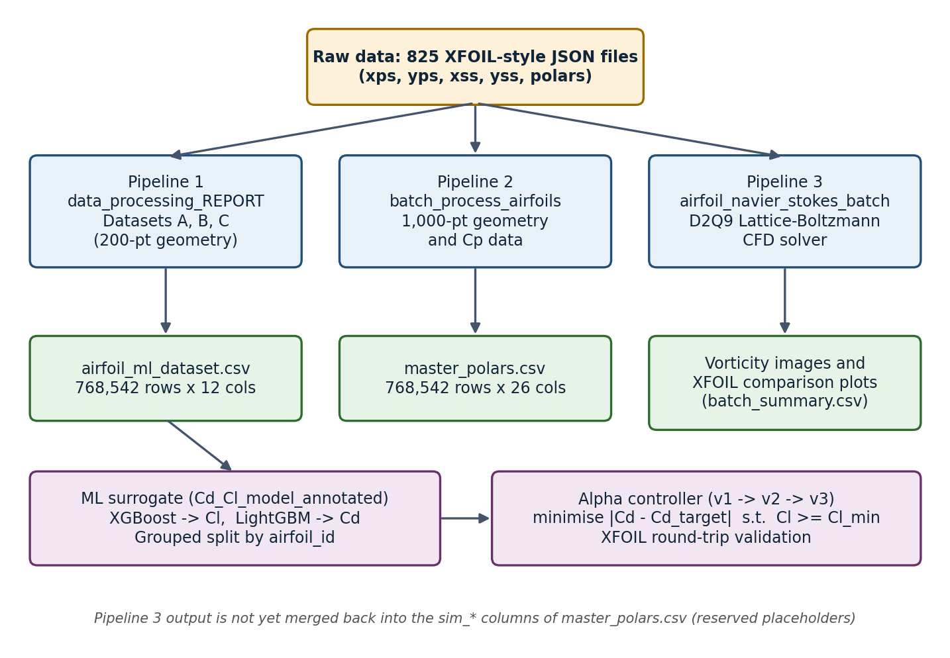
Figure 1. End-to-end architecture of AeroFoilLab (diagram drawn for this report from the notebooks’ file and variable names).
Table 2. Pipeline stages, their inputs and outputs, and their status as documented by the notebooks’ saved outputs.
Stage | Notebook | Reads | Writes | Status
Reference dataset | data_processing_REPORT | json/ (825 files) | processed/: airfoil_metadata.csv, airfoil_aerodynamic_data.csv, airfoil_ml_dataset.csv | Complete
Production batch processor | batch_process_airfoils | json/ (825 files) | processed_new/: airfoil_geometry.csv, geometry_coords.npz, master_polars.csv, cp_data/, failed_files.log | Complete (825/825 parsed)
CFD (Lattice-Boltzmann) | airfoil_navier_stokes_batch | json/ (825 files) | Per-airfoil folder with shape, vorticity and XFOIL-reference PNGs; batch_summary.csv | Single-airfoil check done; saved batch run interrupted
ML surrogate | Cd_Cl_model_annotated | airfoil_ml_dataset.csv | Four tuned .joblib models | Complete
Alpha controller + validation | Cd_Cl_model_annotated | Saved models, dataset | Recommended alpha, Cl, Cd; XFOIL comparison | Complete (5-airfoil validation)

3. The Raw Dataset

3.1 Record format
Each of the 825 files in json/ describes one airfoil in an XFOIL/airfoiltools-style schema. Geometry is given as two coordinate arrays running from leading edge to trailing edge on a chord normalised to 1.0, and aerodynamics as a list of pre-computed XFOIL runs (“polars”). Table 3 lists the fields. File names follow the pattern <id>-il - <NAME>.json, for example 2032c-il - 20-32C AIRFOIL.json or ag24-il - AG24 Bubble Dancer DLG by Mark Drela.json.
Table 3. Fields of each raw JSON airfoil file.
Field | Meaning
name | Human-readable airfoil name (also used for output folders and file names)
xps, yps | Pressure-side (lower surface) x and y coordinates, leading edge to trailing edge
xss, yss | Suction-side (upper surface) x and y coordinates, leading edge to trailing edge
polars[] | List of XFOIL runs; each entry is one flow condition
Re, Ncrit | Reynolds number and the XFOIL transition-sensitivity parameter of the run
alpha (+ alpha_min/max/step) | Angle of attack in degrees (and the sweep definition when present)
Cl, Cd, Cdp, Cm | Lift, total drag, pressure-drag and pitching-moment coefficients
Cp_ps, Cp_ss | Chordwise pressure-coefficient distributions on the two surfaces (present only for a subset of runs)

The geometry of the first airfoil in the library, the 20-32C section, is shown in Figure 2. The plot comes from the CFD notebook and also illustrates how the pressure and suction sides are joined into a closed polygon.
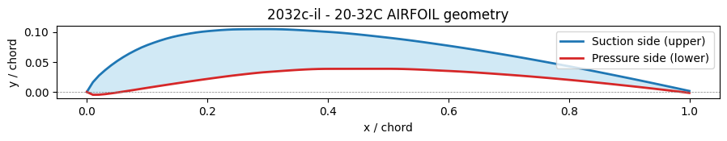
Figure 2. Geometry of the 20-32C airfoil (airfoil 0): suction side (blue), pressure side (red) and the closed polygon used for the CFD mask (notebook plot).

3.2 Structural audit
Before any parsing, the notebook audits every file for the five expected keys and counts polar records. A try/except around each parse means a malformed file is recorded rather than stopping the run. The audit found no problems (Table 4).
Table 4. Structural audit of the 825 raw files.
Check | Result | Comment
JSON files found | 825 | Sorted order used for stable ids
Files with a polars key | 825 | 7 of these yield no usable rows (see below)
Files with all four geometry arrays | 825 | No geometry gaps
Points per surface | 100 | pressure_points = suction_points = 100 for every airfoil
Chord length | 1.0 | All airfoils already normalised
Total polar records | 768,542 | Upper bound for the aerodynamic table
Airfoils contributing at least one row | 818 | 825 − 818 = 7 airfoils have geometry only
Parse failures | 0 | failed_files empty in both pipelines

The seven geometry-only airfoils are the same in both pipelines. According to the earlier report they are airfoil ids 87, 202, 214, 509, 512, 665 and 796 (ids follow the sorted file order).

3.3 Coverage of flow conditions
The 768,542 polar records span eight Reynolds numbers: 50,000, 100,000, 200,000, 231,000, 500,000, 1,000,000, 2,000,000 and 5,000,000. Angle of attack runs from −19.75° to 24.25°. Ncrit takes values between 0 and 9, with quartiles at 5, 5 and 9. The distribution of samples across these variables is analysed in Section 5; one point worth noting here is that the two highest Reynolds numbers are very sparsely populated compared with the five lower ones.

4. Data Processing Methodology
Two independent pipelines process the same 825 files. They are described in turn and compared in Section 9. The reference pipeline produces three progressively refined datasets (Table 5).
Table 5. Datasets produced by the reference pipeline (Pipeline 1).
Dataset | Grain | Content | Saved as
A: metadata | 1 row per airfoil | Shape descriptors: maximum thickness %, maximum camber % and their chordwise positions (825 × 12) | processed/airfoil_metadata.csv
B: aerodynamics | 1 row per (airfoil, Re, alpha, Ncrit) | Every simulated condition with Cl, Cd, Cdp, Cm, Cl/Cd, |alpha|, log10(Re) (768,542 × 12) | processed/airfoil_aerodynamic_data.csv
C: ML dataset | 1 row per (airfoil, Re, alpha, Ncrit) | Dataset B joined to Dataset A: geometry + flow conditions as inputs, coefficients as targets (768,542 × 12) | processed/airfoil_ml_dataset.csv

4.1 Pipeline 1: geometry features (Dataset A)
The function extract_geometry_features turns the raw coordinate arrays into the classical shape descriptors in five steps. (1) Both surfaces are sorted by x. (2) The overlapping x-range of the two surfaces is found and both are linearly interpolated onto 200 common chordwise stations. (3) At each station the upper and lower surface are decided from the data itself, rather than trusting the pressure/suction labels (Eq. (1)). (4) Thickness and camber are computed (Eq. (2)). (5) The maxima are reported as percentages of chord together with the chordwise position (as a fraction between 0 and 1) where they occur (Eq. (3)).
(1)
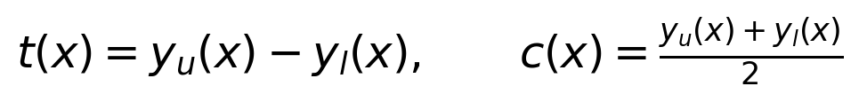 (2)
(3)
where c_ref is the chord length of the overlapping x-range (1.0 for every airfoil in this dataset).
All 825 airfoils were processed with no failures. Table 6 summarises the resulting shape library. Typical sections are about 12 % thick with about 3.4 % camber, but the library also contains extreme shapes: the thickest entry reaches 66.4 % of chord and the most cambered 16.0 %. Symmetric sections give a camber of exactly 0, in which case the recorded camber position is also 0 (the first station), and a camber position of 1.0 means the peak absolute camber sits at the trailing edge.
Table 6. Descriptive statistics of Dataset A (825 airfoils).
Descriptor | Mean | Std | Min | Median | 75 % | Max
Max thickness (% chord) | 12.383 | 5.039 | 1.995 | 11.951 | 15.001 | 66.426
Thickness position (fraction) | 0.3139 | 0.0717 | 0.0302 | 0.3015 | 0.3568 | 0.5980
Max camber (% chord) | 3.404 | 2.287 | 0.000 | 3.227 | 4.796 | 16.034
Camber position (fraction) | 0.3865 | 0.1783 | 0.0000 | 0.4020 | 0.4874 | 1.0000
25 % quartiles: thickness 8.999 %, thickness position 0.2764, camber 1.736 %, camber position 0.3015.

4.2 Pipeline 1: aerodynamic extraction (Dataset B)
A second pass over the sorted files pulls every polar entry into its own row. A file → airfoil_id lookup built from Dataset A guarantees that every row carries the same id Dataset A assigned, which later makes the merge possible. For each entry the notebook reads Re, alpha, Ncrit, Cl, Cd, Cdp and Cm, skips rows lacking Re or alpha, and computes Cl/Cd guarded against a zero or missing Cd. The result is 768,542 rows with zero failed files.
Cleaning then checks missing values per column (none), confirms numeric dtypes, coerces the aerodynamic columns with pd.to_numeric(errors="coerce"), and drops rows missing any of Re, alpha, Cl or Cd (none dropped: 768,542 before and after). Two engineered features are added: abs_alpha = |alpha| and log_Re = log10(Re). The logarithm matters because the Reynolds numbers span nearly two orders of magnitude (5 × 10⁴ to 5 × 10⁶), which is far better behaved both for plotting and as a model input. Cl/Cd is recomputed after cleaning for consistency.

4.3 Pipeline 1: the merged modelling table (Dataset C)
Datasets A and B are reloaded from disk (so this section runs on its own) and joined on airfoil_id with an inner join, giving 768,542 rows by 23 columns. The table is then trimmed to the 12 columns a supervised model needs: the identifier, four geometry descriptors, four flow-condition inputs (Re, log_Re, alpha, Ncrit) and three targets (Cl, Cd, Cm). Any infinities are converted to missing values and rows missing a required value are dropped; none are, leaving 768,542 usable records for 818 airfoils.

4.4 Pipeline 2: the production batch processor
The second pipeline reprocesses the same files with three extra goals: room to parallelise, geometry detailed enough to plot or feed a shape-based model, and the full surface-pressure data. Its configuration is INPUT_DIR=./json, OUTPUT_DIR=./processed_new, INCLUDE_CP=True, RESAMPLE_POINTS=1000 and WORKERS=1.
- Geometry: each surface is resampled to 1,000 points. The resampled x, yps and yss arrays are kept for every airfoil in one compressed file, together with scalar descriptors.
- Polars: every polar entry becomes a row of one long master_polars.csv, carrying the geometry descriptors, flow condition, outputs and a unique polar_id.
- Pressure data: wherever a polar carries Cp_ps and Cp_ss, both arrays are stored in a per-airfoil .npz file linked back to the table through polar_id.
- Placeholders: eight blank columns (AoA_sim, U0_sim, TAU_sim, Re_sim, Cl_sim, Cd_sim, Cm_sim, sim_status) are reserved for simulation results. All 768,542 rows currently carry sim_status = "pending".

The run processed 825 of 825 files with no failures and wrote the outputs listed in Table 7.
Table 7. Outputs of the production batch processor (as printed by the notebook).
Output | Shape / count | Contents
airfoil_geometry.csv | 825 rows × 9 cols | Id, name, source file, point count, chord, max thickness/camber % and positions
geometry_coords.npz | 2,475 arrays | Resampled x, yps, yss (1,000 points each) for all 825 airfoils
master_polars.csv | 768,542 rows × 26 cols | Geometry + flow inputs + Cl/Cd/Cdp/Cm + alpha_min/max/step + 8 simulation placeholders
cp_data/ | 818 .npz files | Full Cp_ps / Cp_ss distributions per polar, one file per airfoil that has them
failed_files.log | empty | No file failed to parse

Engineering note: sequential branch
The code comment says that WORKERS above 1 uses multiple processes, but the branch is written as if WORKERS <= 4: (sequential loop) else: (process pool). With the shipped value of 1 the run was therefore single-process, and a process pool is only used when WORKERS is greater than 4. The earlier report quoted a default of 4, which behaves the same way. Lowering the threshold to WORKERS <= 1 would make the comment true.

4.5 Comparing the two geometry methods
Both pipelines compute the same four descriptors but with different design choices (Table 8). For ordinary cambered sections the results are nearly identical; Table 9 shows airfoil 0. The differences matter when the two pipelines feed one model, in particular the units of the position columns (a fraction in Pipeline 1, a percentage in Pipeline 2) and the sign convention for camber.
Table 8. Design differences between the two geometry-extraction methods.
Aspect | Pipeline 1 (reference) | Pipeline 2 (production)
Resampling | 200 stations over the overlap of the two x-ranges | 1,000 stations from the minimum leading edge to maximum trailing edge
Upper/lower surface | Point-by-point max / min of the two interpolated curves | Suction side assumed to be the upper surface: t = (yss − yps) / chord
Camber sign | Absolute value reported | Signed value at the point of largest |camber|
Position units | Fraction of chord (0 to 1) | Percentage of chord (0 to 100)
Stored output | Scalar descriptors only | Scalars plus resampled x, yps, yss arrays
Extras | None | Cp files, simulation placeholder columns, WORKERS option

Table 9. The two methods on airfoil 0 (20-32C), as printed by each notebook.
Quantity | Pipeline 1 | Pipeline 2
Max thickness (% chord) | 7.99799 | 7.998877
Thickness position | 0.180905 (fraction) | 18.218218 (% chord)
Max camber (% chord) | 7.0024 | 7.003057
Camber position | 0.351759 (fraction) | 35.335335 (% chord)
Thickness differs by about 0.0009 percentage points; position columns differ in both resolution and unit.

5. Exploratory Data Analysis
Dataset C is reloaded fresh from disk and put through the standard checks before modelling: shape, types, missing values, duplicates, descriptive statistics, distributions, a physical sanity check, a single-airfoil case study and feature correlations.

5.1 Integrity checks
Table 10. Integrity and sanity checks on Dataset C.
Check | Result | Interpretation
Shape | 768,542 × 12 | Matches Pipelines 1 and 2 row count
Unique airfoils | 818 | 7 geometry-only airfoils excluded
Missing values (any column) | 0 | No imputation needed
Exact duplicate rows | 0 | No repeated records
Duplicate (airfoil, Re, alpha, Ncrit) | 0 | No physical run recorded twice
Minimum / maximum Cd | 0.00265 / 0.59188 | Physically plausible range
Negative Cd values | 0 | No parsing artefacts or non-physical drag
Alpha range | −19.75° to 24.25° | Wide sweep including deep stall

5.2 Geometry of the airfoil library
The geometry histograms from the production-pipeline notebook (Figure 3) show that thickness is concentrated near 10 % of chord with a tail of thicker shapes, including isolated outliers near 48 % and 66 %. Camber is concentrated between 0 and about 6 % with a few reflexed (negative-camber) sections, which are visible because Pipeline 2 reports signed camber.
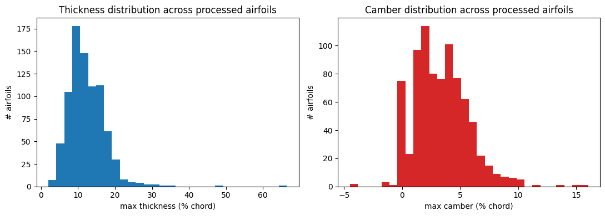
Figure 3. Distribution of maximum thickness (left) and maximum camber (right) across the 825 processed airfoils (notebook, Pipeline 2).

5.3 Descriptive statistics
Table 11 and Table 12 give the statistics of the 768,542 rows. These are row-weighted: airfoils with more polar records count more, which is why the mean thickness (13.00 %) differs slightly from the airfoil-level mean in Table 6 (12.38 %).
Table 11. Dataset C: geometry descriptors (row-weighted).
Descriptor | Mean | Std | Min | Median | 75 % | Max
Max thickness (% chord) | 13.000 | 5.091 | 1.995 | 12.178 | 15.646 | 66.426
Thickness position | 0.3144 | 0.0704 | 0.0302 | 0.3015 | 0.3568 | 0.5980
Max camber (% chord) | 3.326 | 2.276 | 0.000 | 3.087 | 4.697 | 16.034
Camber position | 0.3840 | 0.1836 | 0.0000 | 0.4020 | 0.4925 | 1.0000
25 % quartiles: thickness 9.817 %, thickness position 0.2764, camber 1.667 %, camber position 0.3015.
Table 12. Dataset C: flow conditions and aerodynamic targets.
Variable | Mean | Std | Min | 25 % | Median | 75 % | Max
Re | 403,331 | 379,409 | 50,000 | 100,000 | 200,000 | 500,000 | 5,000,000
log10(Re) | 5.384 | 0.467 | 4.699 | 5.000 | 5.301 | 5.699 | 6.699
alpha (°) | 2.088 | 8.345 | −19.75 | −4.50 | 2.00 | 8.75 | 24.25
Ncrit | 6.861 | 2.019 | 0 | 5 | 5 | 9 | 9
Cl | 0.4440 | 0.7527 | −2.2899 | −0.1836 | 0.5166 | 1.0951 | 2.5113
Cd | 0.03539 | 0.03033 | 0.00265 | 0.01384 | 0.02397 | 0.04702 | 0.59188
Cm | −0.0525 | 0.0508 | −0.5010 | −0.0834 | −0.0467 | −0.0156 | 0.2780

5.4 Distributions
The Reynolds-number histogram (Figure 4) confirms the five well-populated levels between 5 × 10⁴ and 10⁶ with about 130,000 to 175,000 samples each, and shows how few samples exist at 2 × 10⁶ and 5 × 10⁶ (the barely visible bars near log10 = 6.3 and 6.7). The 200,000 and 231,000 levels fall in the same histogram bin.
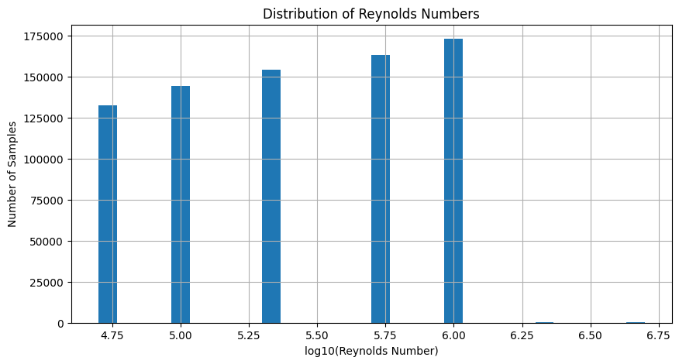
Figure 4. Distribution of log10(Reynolds number) over all samples (notebook).
Angle of attack (Figure 5) is densely sampled between about −8° and +10°, tapering towards −20° and +20°, with very little data beyond 20°. The model therefore sees most of its evidence in the attached-flow and early-stall region.
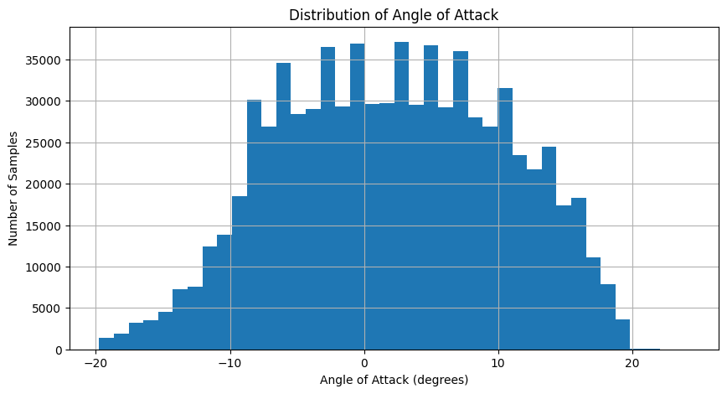
Figure 5. Distribution of angle of attack (notebook).
Lift coefficient (Figure 6) is bimodal, with one mode near Cl ≈ −0.3 and a larger one near Cl ≈ 1.1 to 1.2, reflecting the mix of symmetric and cambered sections and the sweep through zero-lift conditions.
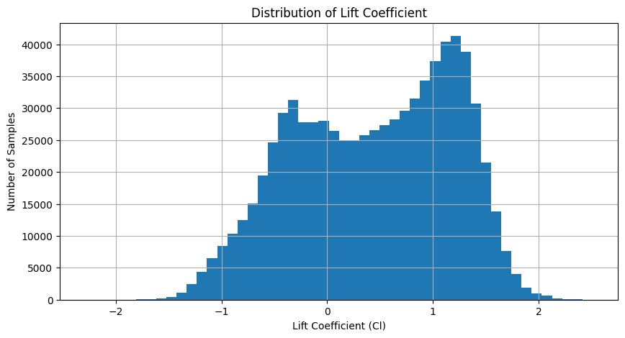
Figure 6. Distribution of lift coefficient Cl (notebook).
Drag coefficient (Figure 7) is strongly right-skewed. Most samples lie below about 0.05, and a long thin tail extends to 0.59 near and beyond stall. This tail is the origin of the difficulty the models later have with Cd (Section 7.5).
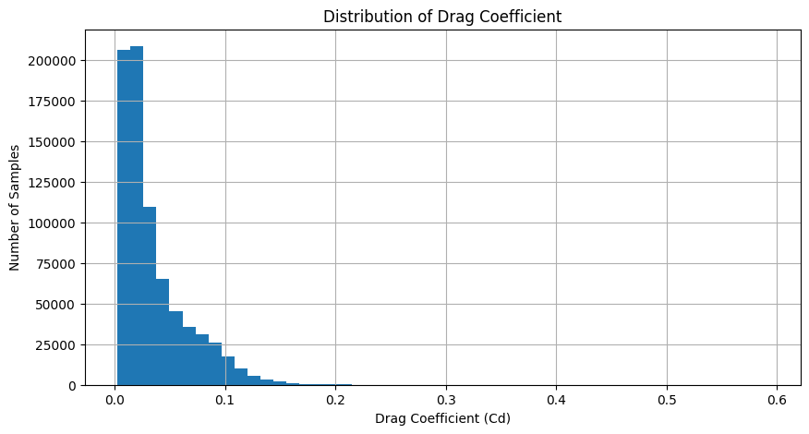
Figure 7. Distribution of drag coefficient Cd (notebook).

5.5 Case study: one polar
To check that the data behaves like real aerodynamics, the first airfoil (id 0) is plotted at its first Reynolds number (200,000), sorted by angle of attack. Lift (Figure 8) rises approximately linearly from about −0.2 near −8° to a maximum of about 1.5 near 10°, then falls slightly past stall. Drag (Figure 9) forms the familiar low-drag bucket of roughly 0.012 to 0.02 between about −1° and 8°, rising steeply on both sides. Small kinks near −7° and between 7° and 11° are visible in both curves; they are consistent with transition jumps or marginally converged XFOIL points rather than processing errors.
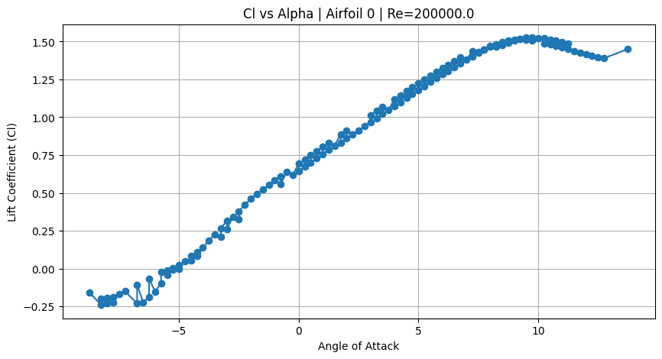
Figure 8. Cl versus angle of attack for airfoil 0 at Re = 200,000 (notebook).
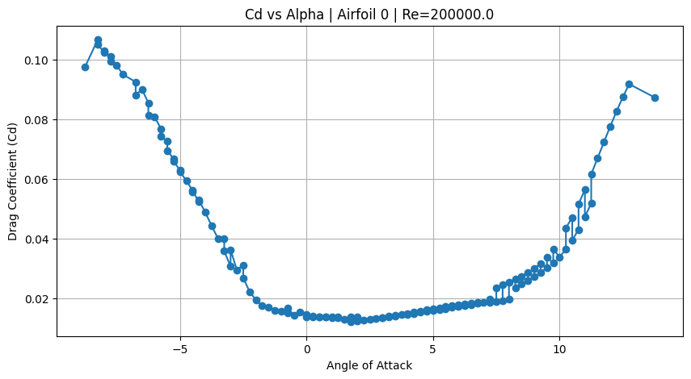
Figure 9. Cd versus angle of attack for airfoil 0 at Re = 200,000 (notebook).

5.6 Aerodynamic efficiency
The lift-to-drag ratio is recomputed on the reloaded data, with infinities from near-zero drag set to missing. Figure 10 shows a broad distribution centred around 15 to 20 and extending from about −110 to 240, with a sharp peak near zero (conditions close to zero lift).
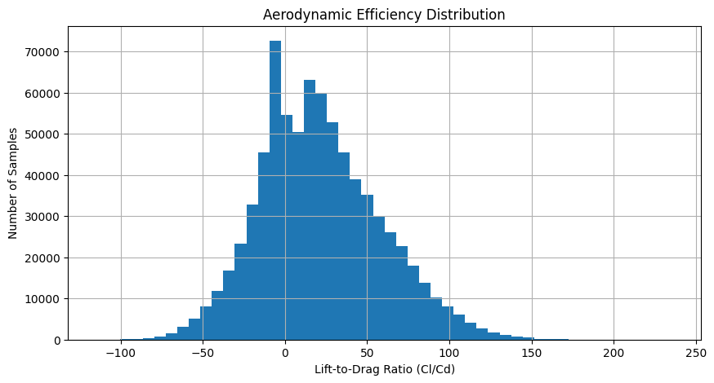
Figure 10. Distribution of the lift-to-drag ratio Cl/Cd over all samples (notebook).

5.7 Feature correlations
A Pearson correlation matrix over all numeric columns (Figure 11, Table 13) gives a cheap first look at what drives the targets. Angle of attack dominates lift (0.93). Max camber is the strongest geometric driver of pitching moment (−0.67) and a moderate one of lift (0.30). Reynolds number mainly acts on drag (log10(Re) vs Cd: −0.35). The linear correlation of Cd with alpha is only 0.12 because drag is U-shaped in alpha, a non-linear dependence Pearson correlation cannot capture. Re and log_Re correlate at 0.91, so they carry nearly the same information, and Ncrit has almost no linear relationship with any target.
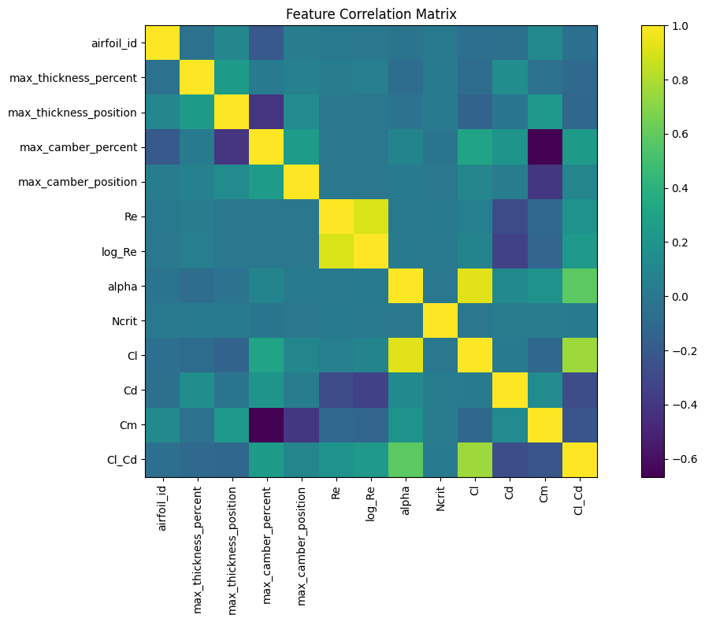
Figure 11. Pearson correlation matrix of all numeric columns of Dataset C plus Cl/Cd (notebook).
Table 13. Selected Pearson correlations with the aerodynamic targets (from the notebook’s printed matrix).
Feature | Cl | Cd | Cm | Cl/Cd
Max thickness % | −0.08 | 0.15 | −0.04 | −0.10
Thickness position | −0.14 | −0.02 | 0.22 | −0.11
Max camber % | 0.30 | 0.19 | −0.67 | 0.24
Camber position | 0.10 | 0.04 | −0.39 | 0.09
Re | 0.05 | −0.28 | −0.10 | 0.19
log10(Re) | 0.08 | −0.35 | −0.12 | 0.23
alpha | 0.93 | 0.12 | 0.18 | 0.58
Ncrit | −0.01 | 0.03 | 0.04 | 0.03

6. Navier–Stokes CFD Layer (Lattice-Boltzmann)

6.1 Purpose and workflow
Rather than automating the third-party XFOIL binary, the project built its own two-dimensional incompressible flow solver and uses it as a second, independent source of aerodynamic information on the same geometries. The notebook is a “batch edition”: for every JSON file it (1) loads the geometry and plots its shape, (2) rasterises the airfoil into a solid mask, (3) runs a D2Q9 Lattice-Boltzmann simulation, (4) saves a vorticity image (or an .mp4 animation if enabled), (5) plots the bundled XFOIL polar next to the simulated angle of attack, and (6) rolls the results into batch_summary.csv. A failure on one file is caught and logged to batch_failures.csv so it cannot stop the batch.

6.2 Numerical method
The solver uses the D2Q9 lattice, with nine discrete velocity directions per cell (Table 14). Each cell stores nine populations f_i. Every time step has four stages: streaming (each population moves one cell along its direction, implemented with np.roll), bounce-back inside the solid cells (populations are swapped to the opposite direction, enforcing no-slip, and the velocity inside the solid is set to zero), computation of the macroscopic density and velocity, and BGK collision towards the equilibrium distribution.
Table 14. D2Q9 lattice constants used by the solver (cxs, cys, weights, opposite).
Direction i | c_x | c_y | Weight w_i | Opposite direction
0 | 0 | 0 | 4/9 | 0
1 | 0 | 1 | 1/9 | 5
2 | 1 | 1 | 1/36 | 6
3 | 1 | 0 | 1/9 | 7
4 | 1 | −1 | 1/36 | 8
5 | 0 | −1 | 1/9 | 1
6 | −1 | −1 | 1/36 | 2
7 | −1 | 0 | 1/9 | 3
8 | −1 | 1 | 1/36 | 4

(4)
equilibrium distribution (function equilibrium)
(5)
BGK single-relaxation-time collision with relaxation time τ
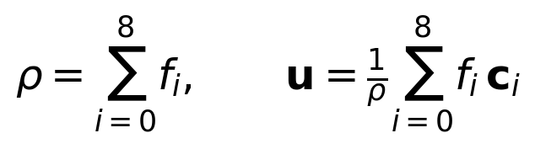 (6)
macroscopic density and velocity
The kinematic viscosity follows from the relaxation time and, with the freestream speed U0 and the chord in grid cells C, defines the chord-based Reynolds number (Eq. (7)). Vorticity is computed from the velocity gradients with np.gradient and set to missing inside the solid (Eq. (8)).
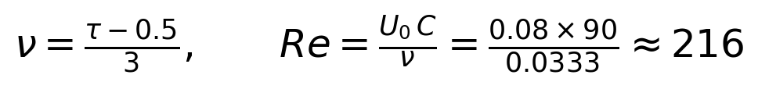 (7)
kinematic viscosity and chord Reynolds number for the batch settings
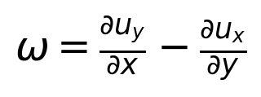 (8)

6.3 From airfoil geometry to a solid mask
The closed airfoil polygon is built by walking the suction side from trailing edge to leading edge (reversed) and then the pressure side from leading edge to trailing edge (dropping its first point to avoid a duplicate). The polygon is rotated by −AoA about the quarter-chord pivot (0.25 c), scaled to CHORD_PX grid cells, placed with its pivot at (X0, Y0) in the grid, and every grid cell is tested with a point-in-polygon test (matplotlib.path.Path.contains_points) to produce a Boolean solid/fluid mask. For the 20-32C airfoil this gives 376 solid cells.

6.4 Simulation parameters
All airfoils in the batch currently run at one identical flow condition (Table 15). The initial state is a uniform flow of speed U0 plus a small random perturbation (0.01·U0 Gaussian noise, fixed seed 0) intended to break symmetry and seed vortex shedding; the fixed seed makes the perturbation identical for every airfoil.
Table 15. Lattice-Boltzmann parameters used for every airfoil in the batch.
Parameter | Value | Note
Angle of attack (AoA) | 5.0° | Airfoil pitched up relative to horizontal flow
Inlet speed (U0) | 0.08 | Lattice units; kept well below about 0.15 for stability
Relaxation time (TAU) | 0.6 | ν = (0.6 − 0.5) / 3 = 0.03333
Grid (NX × NY) | 360 × 120 | Domain height is 1.33 chords
Chord (CHORD_PX) | 90 cells | Pivot at (X0, Y0) = (70, 60)
Steps / sampling | 1,600 / every 8 | 200 vorticity snapshots stored
Chord Reynolds number | ≈ 216 | Re = 0.08 × 90 / 0.03333
Output options | Static PNG | SAVE_ANIMATION=False, SAVE_DEBUG_PLOTS=False; figures saved at 150 dpi

6.5 Comparison with the bundled XFOIL polar
When the JSON carries polars, the notebook selects the XFOIL run whose Reynolds number is closest to the simulated one, using Ncrit = 9 when available (otherwise the smallest Ncrit present), because the files bundle several runs per Reynolds number at different Ncrit values and mixing them would connect points from different runs out of order. Cl and Cd are plotted against alpha with the simulated angle marked, and the XFOIL values at the simulated angle are linearly interpolated (Eq. (9)) and stored in the summary table.
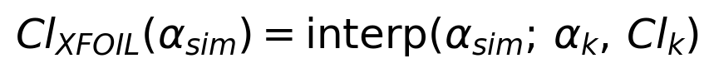 (9)
same interpolation is applied to Cd

6.6 Results of the single-airfoil check
The notebook’s sanity cell runs the full pipeline on the first file (20-32C) and shows the plots inline. The vorticity field after 1,600 steps (Figure 12) shows a thin layer of negative vorticity (blue) on the suction side and positive vorticity (red) on the pressure side, merging into a wake that bends downward behind the trailing edge, which is qualitatively what a lifting airfoil should produce. At Re ≈ 216 the flow is strongly viscous: the shear layers are smooth and diffuse, and no sustained vortex shedding is visible.
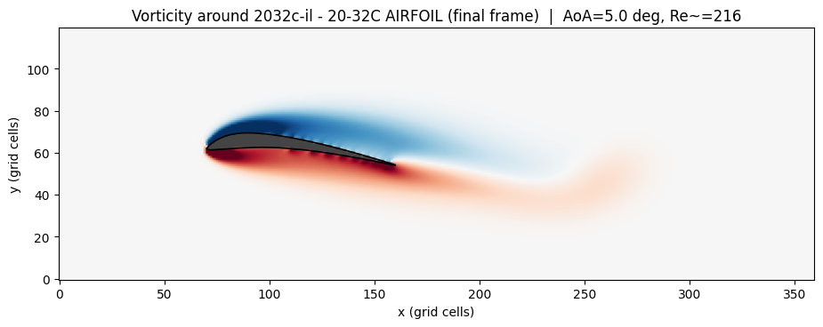
Figure 12. Final-frame vorticity around the 20-32C airfoil at AoA = 5° and Re ≈ 216 (notebook). Grey is the solid body.
The XFOIL reference plot (Figure 13) shows the closest bundled run, Re = 50,000 with Ncrit = 9. The simulated angle of 5° (dashed red) lies just before the lift peak of about 1.2 near 6°, where stall begins and drag rises sharply. The numbers behind the comparison are in Table 16.
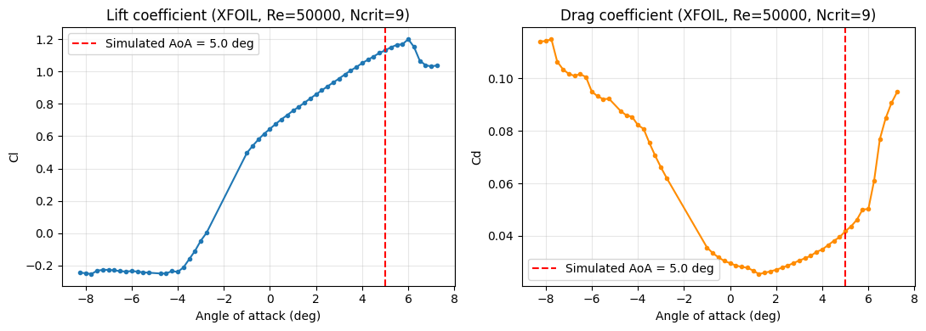
Figure 13. XFOIL Cl and Cd versus alpha for the 20-32C airfoil at the closest bundled Reynolds number (50,000, Ncrit = 9); the dashed line marks the simulated angle (notebook).
Table 16. Summary returned by the single-airfoil sanity check (20-32C airfoil).
Quantity | Value
AoA / LBM Reynolds number | 5.0° / 216.0
Peak absolute vorticity, final frame | 0.03460
Solid cells | 376
Closest XFOIL Re / Ncrit used | 50,000 / 9
XFOIL Cl at 5° (interpolated) | 1.1311
XFOIL Cd at 5° (interpolated) | 0.04178
Run time / estimate for 825 airfoils | 15.7 s / about 215.7 min

6.7 Status of the batch run and limits of the comparison
- Batch run: in the saved notebook, the batch cell shows only “[1/825] Processing …” followed by a KeyboardInterrupt, and the summary list is empty. The saved run therefore produced no batch_summary.csv. The folders of per-airfoil images described in the earlier report are outside the notebooks supplied here.
- Typo in the batch loop: the saved source of that cell has a stray c after traceback.print_exc(), which would be a syntax error if the cell were re-run.
- Reynolds-number gap: 216 is about 230 times smaller than the lowest Reynolds number in the XFOIL data (50,000). The comparison plot therefore checks the wiring (geometry, axes, interpolation) rather than validating numerical Cl or Cd.
- No force output yet: as supplied, run_lbm_simulation returns vorticity, velocity and density fields but does not integrate surface forces, so no simulated Cl or Cd exists to write into the Cl_sim, Cd_sim placeholder columns.
- Boundaries: streaming uses np.roll, which makes the domain periodic in both directions, and the inlet speed enters only through the initial condition. Together with a domain height of only 1.33 chords, this means the result is a periodic-domain flow rather than a free-stream external flow.

From Eq. (7), reaching Re = 50,000 at U0 = 0.08 requires C = Re·ν/U0 grid cells. With τ = 0.6 this is about 20,800 cells per chord, which is impractical; lowering τ to 0.52 (ν = 0.00667) gives about 4,200 cells and τ = 0.505 (ν = 0.00167) about 1,040 cells. These back-of-envelope figures from Eq. (7) show why closing the gap needs a much finer grid and a more stable collision model, not just a parameter change.

7. Machine-Learning Surrogate

7.1 Problem formulation
The surrogate learns the mapping from airfoil geometry and flow condition to Cl and Cd. Seven input features are used and two targets are predicted (Table 17, Eq. (10)). log_Re replaces raw Re so that tree splits and gradient steps are not dominated by a handful of large values. airfoil_id is deliberately excluded from the features: it is used only to group rows, because a tree model given the id could memorise which airfoil a row belongs to instead of learning geometry-to-aerodynamics relationships. The pitching moment Cm is in the file but is not modelled in this notebook.
Table 17. Schema of airfoil_ml_dataset.csv (768,542 rows × 12 columns) and the role of each column.
Column | Meaning | Role
airfoil_id | Airfoil identifier | Grouping key only, not a feature
max_thickness_percent | Maximum thickness, % chord | Feature
max_thickness_position | Chordwise location of maximum thickness | Feature
max_camber_percent | Maximum camber, % chord | Feature
max_camber_position | Chordwise location of maximum camber | Feature
Re | Reynolds number | Superseded by log_Re
log_Re | log10(Re) | Feature
alpha | Angle of attack (°) | Feature
Ncrit | XFOIL transition parameter | Feature
Cl | Lift coefficient | Target
Cd | Drag coefficient | Target
Cm | Pitching-moment coefficient | Present, unused

(10)

7.2 Train/test split grouped by airfoil
The most important methodological choice is the split. A plain random split of rows would put different angles of attack of the same airfoil on both sides, so the test score would partly measure memorisation of shapes. Instead the notebook uses GroupShuffleSplit (80/20, random_state=42) on airfoil_id, so that the two airfoil sets are disjoint (Eq. (11), Table 18). The zero overlap is verified explicitly in the code.
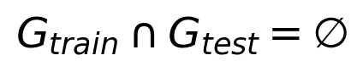 (11)
G denotes the set of airfoil groups on each side of the split
Table 18. Grouped train/test split.
 | Rows | Unique airfoils
Train | 616,487 | 654
Test | 152,055 | 164
Overlap | n/a | 0

7.3 Evaluation metrics
Three regression metrics are used everywhere (Eq. (12) to Eq. (14)). Lower MAE and RMSE are better; R² of 1.0 is a perfect fit.
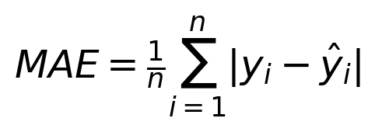 (12)
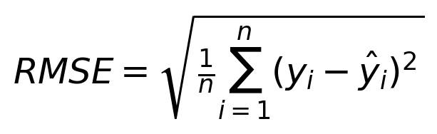 (13)
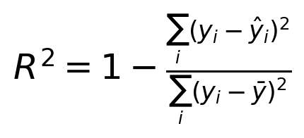 (14)
Helper code stores results in dictionaries, scores every model through one function, and wraps independently fitted per-target models in a small PerTargetRegressor class so that models with different algorithms per target can be scored and plotted exactly like a native multi-output model.

7.4 Target distributions
The notebook’s first target plots (Figure 14) show the training distribution of Cl (bimodal, as in Section 5), of Cd (strongly right-skewed) and a scatter of Cd against angle of attack. The scatter forms a dense bowl of roughly 0.01 to 0.27 across −20° to +20° with a single isolated point near 0.59 around 4°, which is the training maximum.

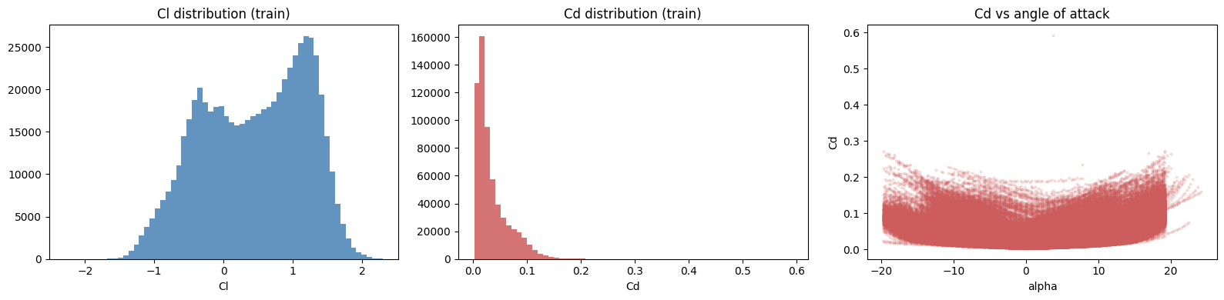
Figure 14. Training-set Cl distribution, Cd distribution and Cd versus alpha (notebook).

Training Cd spans 0.00265 to 0.59188 while test Cd spans 0.00338 to 0.31944, and none of the 152,055 test rows exceeds the training maximum. The two distributions overlap closely (Figure 15), so the split does not create a distribution shift in drag.
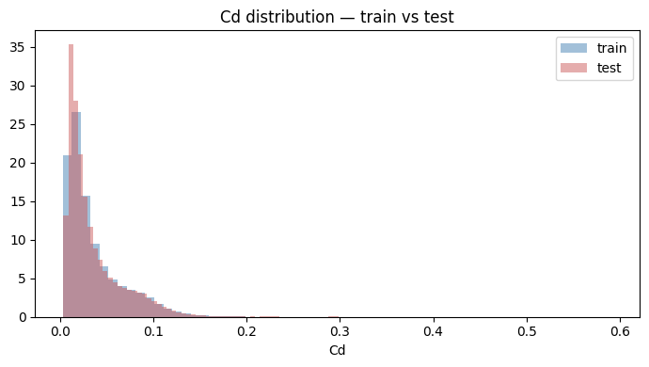
Figure 15. Cd density for the training and test sets (notebook).

7.5 Baseline models
Four tree-based families were first trained with near-default settings so that the later tuning gains can be attributed to tuning (Table 19). Random Forest is natively multi-output; the other three are wrapped in MultiOutputRegressor.
Table 19. Baseline model configurations and training time.
Model | Configuration | Wrapper | Train time
Random Forest | n_estimators=150, max_depth=None, n_jobs=-1, random_state=42 | native | 0.7 min
HistGradientBoosting | library defaults, random_state=42 | MultiOutput (2 jobs) | 0.1 min
LightGBM | n_estimators=300, random_state=42 | MultiOutput (2 jobs) | 0.1 min
XGBoost | n_estimators=300, random_state=42 | MultiOutput (2 jobs) | 0.2 min

The predicted-versus-actual plots follow. For Random Forest (Figure 16) the Cl panel hugs the diagonal with some streaks of badly predicted rows, while the Cd panel is a wide cloud that sits below the diagonal at high drag and flattens at a predicted value of about 0.2. The same qualitative pattern appears in the other three models (Figure 17 to Figure 19): Cl is good, and Cd is the weaker target with predictions saturating at the high-drag end.
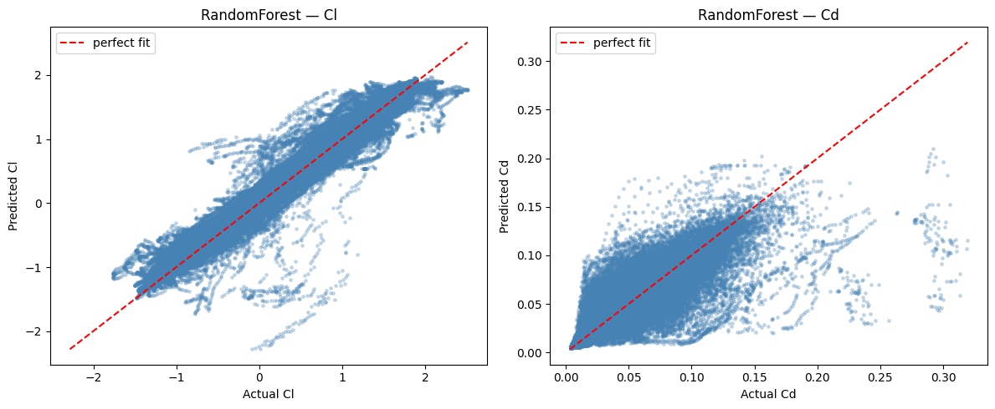
Figure 16. Random Forest (baseline): predicted versus actual Cl (left) and Cd (right) on the test set (notebook).
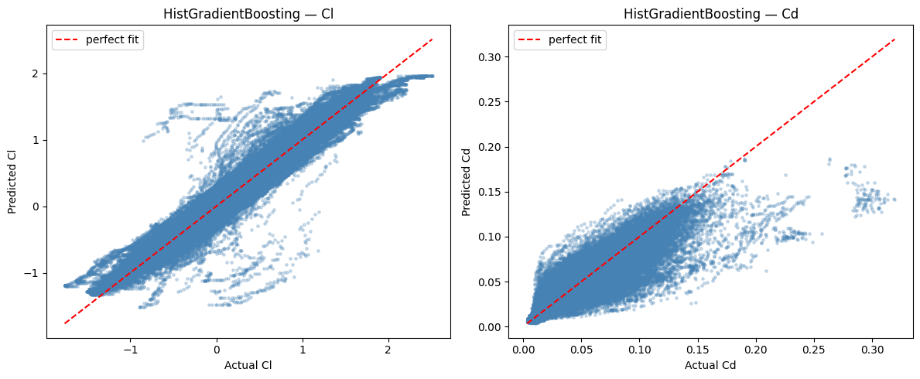
Figure 17. HistGradientBoosting (baseline): predicted versus actual (notebook).
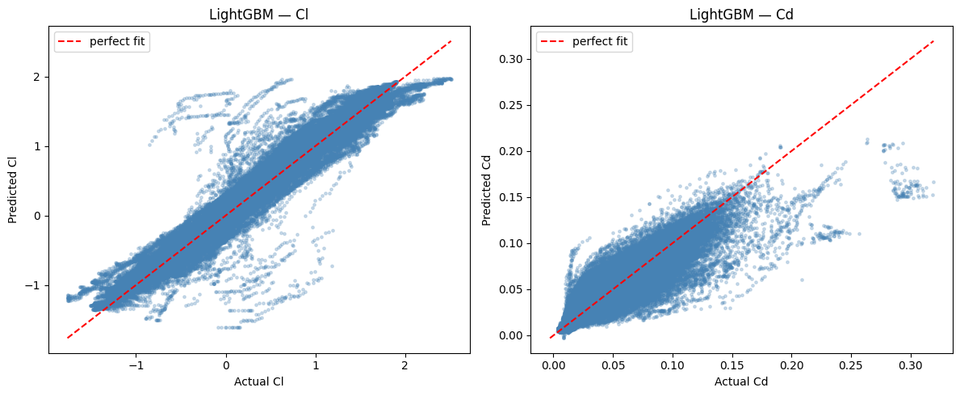
Figure 18. LightGBM (baseline): predicted versus actual (notebook).
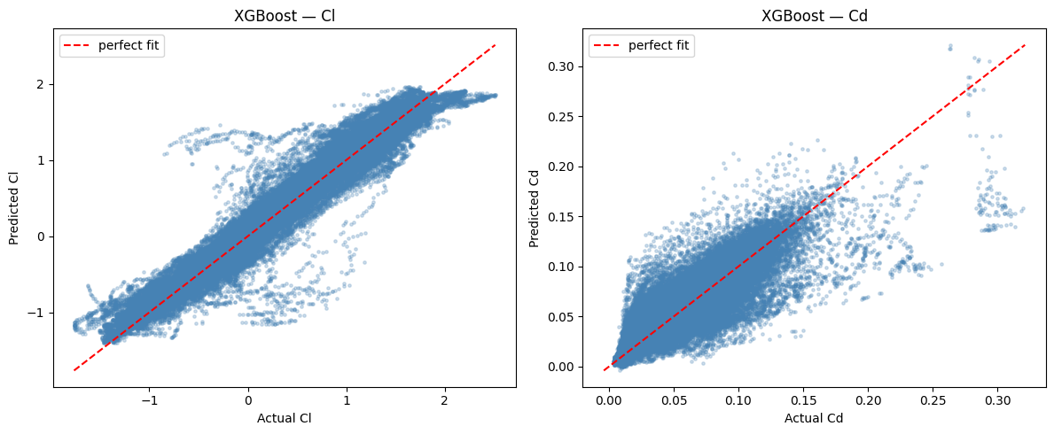
Figure 19. XGBoost (baseline): predicted versus actual (notebook).
Table 20 and Figure 20 compare the baselines. XGBoost is best for Cl (R² 0.9632) and LightGBM is best for Cd (R² 0.8417). Every model’s Cd R² (0.77 to 0.84) is clearly below its Cl R² (0.95 to 0.96).
Table 20. Baseline model comparison on the held-out test set (best value per column in bold).
Model | Cl MAE | Cl RMSE | Cl R² | Cd MAE | Cd RMSE | Cd R²
RandomForest | 0.095162 | 0.161001 | 0.954799 | 0.007447 | 0.015063 | 0.767295
HistGradientBoosting | 0.092520 | 0.150998 | 0.960241 | 0.007517 | 0.013398 | 0.815911
LightGBM | 0.092031 | 0.153987 | 0.958651 | 0.007006 | 0.012425 | 0.841668
XGBoost | 0.091006 | 0.145210 | 0.963231 | 0.007449 | 0.013402 | 0.815797

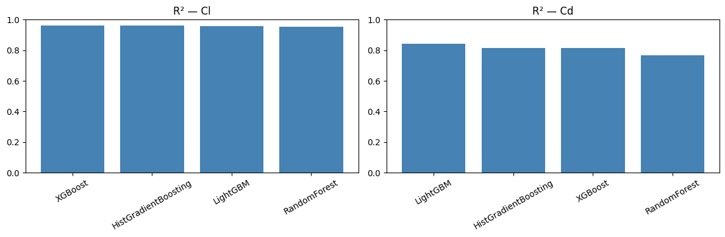
Figure 20. R² of the four baseline models for Cl (left) and Cd (right), notebook plot; note the y-axis starts at zero.

7.6 Diagnosing the Cd “wall”
All four model families predict a constant value per leaf, so they cannot extrapolate and lose resolution in sparse regions. Cd’s high-drag tail near stall is thin, so a few extreme rows share leaves with many moderate ones and every test point in such a leaf is pulled towards the average, producing a flat wall of predictions instead of a diagonal. The test set does not contain any Cd beyond the training maximum, so the wall is not caused by literal extrapolation; it is the piecewise-constant nature of the trees in a sparse region.
Two fixes were tested on a validation slice of the tuning subsample (a 20 % grouped hold-out; Table 21): linear_tree=True in LightGBM, which fits a small linear model in each leaf, and a log transform of the target (Eq. (15)). The result, shown in Figure 21, is that linear_tree is wildly unstable here (R² of −1954) while the log transform gives only a marginal gain (0.7918 versus 0.7892).
(15)
log1p transformation of the target and its inverse
Table 21. Cd “wall” ablation on the diagnostic validation slice.
Approach | Cd R² | Verdict
Baseline LightGBM | 0.78922 | Reference
linear_tree=True | −1954.14165 | Rejected: wildly unstable
log1p(Cd) target transform | 0.79184 | Marginal improvement

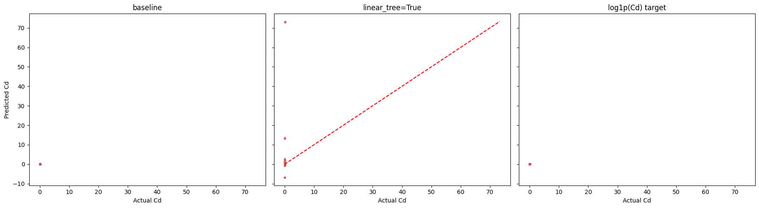
Figure 21. Cd wall ablation: predicted versus actual Cd for baseline, linear_tree=True and log1p target (notebook). The three panels share their axes, so the very large linear_tree predictions (up to about 73) stretch the scale and compress the baseline and log1p panels into a point near the origin; the R² values in the preceding table carry the comparison.

The later Optuna search for LightGBM was free to select linear_tree=True and independently chose False for both targets, which supports the ablation’s conclusion under a full search rather than a one-shot test.

7.7 Hyperparameter tuning
Tuning on all 616,487 training rows would be slow, so a 25 % subsample drawn by airfoil is used (159,047 rows, 163 airfoils). All searches use three-fold GroupKFold so that no airfoil leaks between a fold’s train and validation halves. Random Forest uses RandomizedSearchCV; the three boosters use Optuna, with one study per target. Table 22 lists the search spaces and budgets, and Table 23 the best configurations found.
Table 22. Tuning methods, budgets and search spaces.
Model | Method | Budget | Search space
Random Forest | RandomizedSearchCV, 3-fold GroupKFold, score R² | 20 × 3 = 60 fits | n_estimators {150, 250, 350, 500}; max_depth {None, 15, 25, 35}; min_samples_leaf {1, 2, 4, 8}; max_features {sqrt, 0.5, 0.8, 1.0}
LightGBM | Optuna (TPE), early stopping 50, ceiling 2,000 trees | 40 trials per target | learning_rate 0.01–0.2 (log); num_leaves 15–255; min_child_samples 5–200; subsample, colsample_bytree 0.5–1; reg_alpha, reg_lambda 1e-8–10 (log); linear_tree {False, True}
XGBoost | Optuna (TPE), early stopping 50, ceiling 2,000 trees | 40 trials per target | learning_rate 0.01–0.2 (log); max_depth 3–12; min_child_weight 0.01–20 (log); subsample, colsample_bytree 0.5–1; reg_alpha, reg_lambda 1e-8–10 (log)
HistGradientBoosting | Optuna (TPE), built-in early stopping disabled | 25 trials per target | max_iter 100–800 (step 50); learning_rate 0.01–0.3 (log); max_leaf_nodes 15–255; min_samples_leaf 5–100; l2_regularization 1e-8–10 (log)

HistGradientBoosting gets a smaller budget because its internal early stopping carves out a validation split that is not group-aware and could leak airfoils; it is therefore disabled and max_iter is tuned explicitly, which makes every trial a full fit.
Table 23. Best configurations and cross-validated R² on the 25 % search subsample.
Model | Target | Best parameters (rounded) | CV R²
Random Forest | Cl + Cd (blended) | n_estimators=500, min_samples_leaf=2, max_features=sqrt, max_depth=35 | 0.88583*
LightGBM | Cl | lr 0.0207, leaves 97, min_child 167, subsample 0.841, colsample 0.950, linear_tree=False | 0.97221
LightGBM | Cd | lr 0.0184, leaves 78, min_child 99, subsample 0.918, colsample 0.963, linear_tree=False | 0.81339
XGBoost | Cl | lr 0.098, depth 7, min_child_weight 0.577, subsample 0.522, colsample 0.976 | 0.97034
XGBoost | Cd | lr 0.032, depth 9, min_child_weight 0.123, subsample 0.704, colsample 0.886 | 0.81085
HistGB | Cl | max_iter=400, lr 0.0334, leaves 80, min_samples_leaf 45 | 0.97116
HistGB | Cd | max_iter=200, lr 0.0396, leaves 85, min_samples_leaf 79 | 0.81318
* Random Forest was scored with scikit-learn’s default uniform-average R² over both columns, so this value is not comparable with the per-target numbers in the other rows.

7.8 Final models on the untouched test set
The tuned configurations are refit on the training airfoils and scored once on the untouched test set (Table 24). LightGBM and XGBoost keep 10 % of the training airfoils as a validation slice for early stopping and stop at 444 (Cl) and 688 (Cd) trees for LightGBM and 209 and 422 for XGBoost. Random Forest and HistGradientBoosting need no validation slice and train on 100 % of the training airfoils (Table 25), so the head-to-head is not perfectly like-for-like when differences are small.
Table 24. Final tuned model comparison on the held-out test set (best value per column in bold).
Model | Cl MAE | Cl RMSE | Cl R² | Cd MAE | Cd RMSE | Cd R²
RandomForest (tuned) | 0.086253 | 0.138753 | 0.966428 | 0.007156 | 0.014231 | 0.792296
HistGB (tuned) | 0.089093 | 0.149257 | 0.961153 | 0.006926 | 0.012881 | 0.829829
LightGBM (tuned) | 0.089825 | 0.149236 | 0.961163 | 0.006887 | 0.012685 | 0.834978
XGBoost (tuned) | 0.090344 | 0.142695 | 0.964493 | 0.007009 | 0.013127 | 0.823260

Table 25. Training data used by each final tuned model.
Model | Rows of the training set used | Reason
LightGBM (tuned) | 90 % of training airfoils | 10 % held out for early stopping
XGBoost (tuned) | 90 % of training airfoils | 10 % held out for early stopping
HistGB (tuned) | 100 % | Early stopping disabled; max_iter fixed by tuning
RandomForest (tuned) | 100 % | No early stopping applies

The tuned predicted-versus-actual plots are in Figure 22 to Figure 25, and Figure 26 puts baseline and tuned R² side by side. Tuning helps Random Forest most (Cl R² from 0.9548 to 0.9664, Cd from 0.7673 to 0.7923). For LightGBM the Cd R² actually falls slightly (0.8417 to 0.8350) even though the tuned model has the lowest Cd MAE and RMSE, a reminder that parameters tuned on a 25 % subsample do not always transfer to the full data.
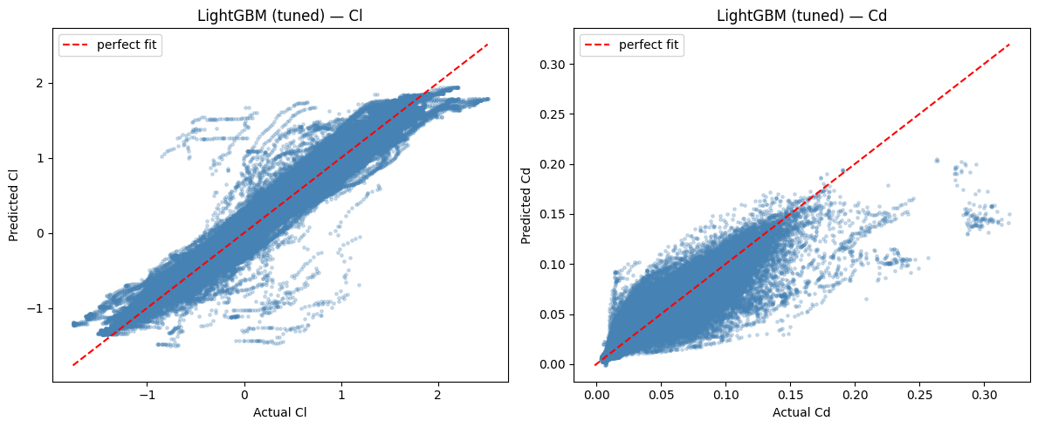
Figure 22. LightGBM (tuned): predicted versus actual on the test set (notebook).
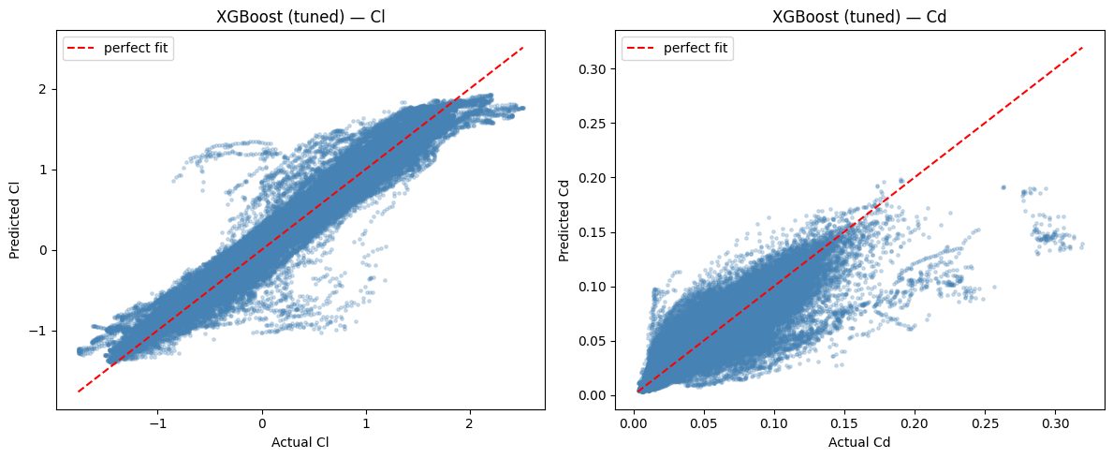
Figure 23. XGBoost (tuned): predicted versus actual on the test set (notebook).
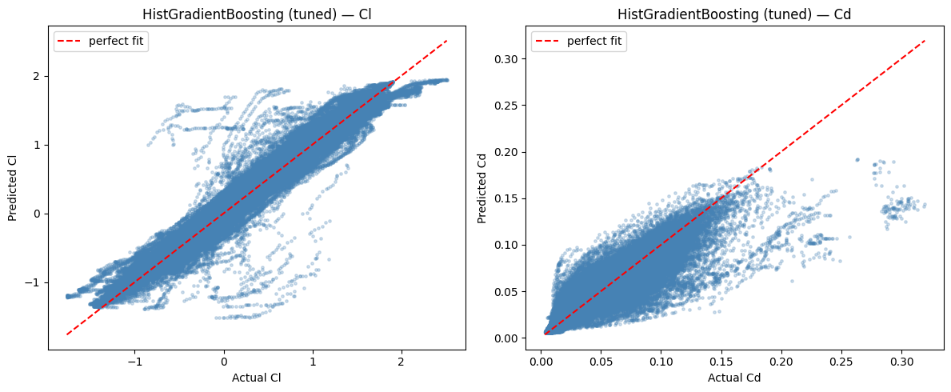
Figure 24. HistGradientBoosting (tuned): predicted versus actual on the test set (notebook).
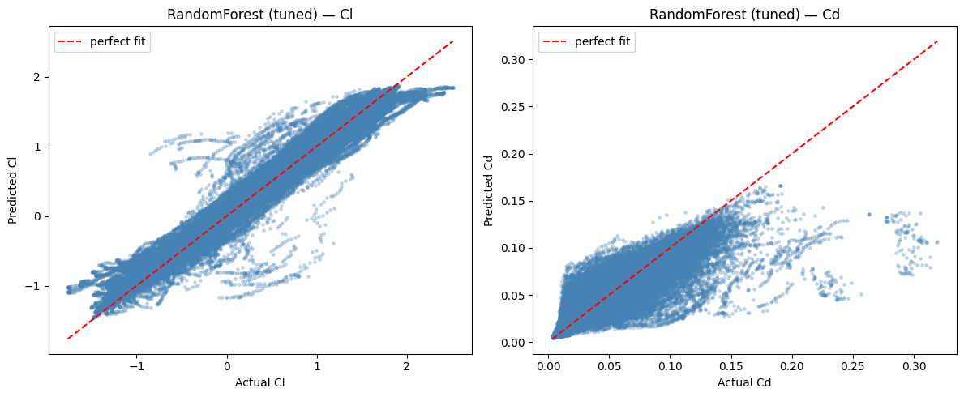
Figure 25. Random Forest (tuned): predicted versus actual on the test set (notebook).
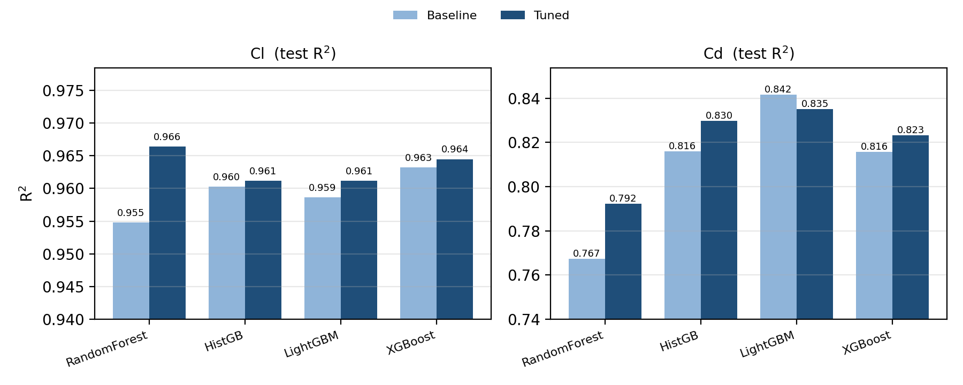
Figure 26. Test R² before and after tuning for Cl and Cd (drawn for this report from the notebook’s baseline and final tables; y-axes are truncated to show differences).
Design decision: which model predicts Cl?
Random Forest (tuned) has the best Cl R² (0.9664) but the deployed predict_aero() uses XGBoost (tuned) for Cl (R² 0.9645) and LightGBM (tuned) for Cd (R² 0.8350). The difference is small and the training data differ (Table 25), but the choice should be stated explicitly. Deployed models are saved with joblib; the reloaded XGBoost and LightGBM files are about 10.4 MB and 9.3 MB.

8. Angle-of-Attack Controller and XFOIL Validation

8.1 From predictor to controller
The surrogate is wrapped in one function, predict_aero(alpha, airfoil_features, re_value, ncrit_value), which builds a single-row feature table, converts Re to log10(Re) and returns a (Cl, Cd) pair. Every controller version talks to the models only through this function, so a better surrogate could be dropped in without touching the optimisation logic (Eq. (16)).
(16)
The controller went through three generations that all remain in the notebook (Figure 27, Table 26). Version 3 is the de-facto final one because the notebook’s own last cells exercise it.
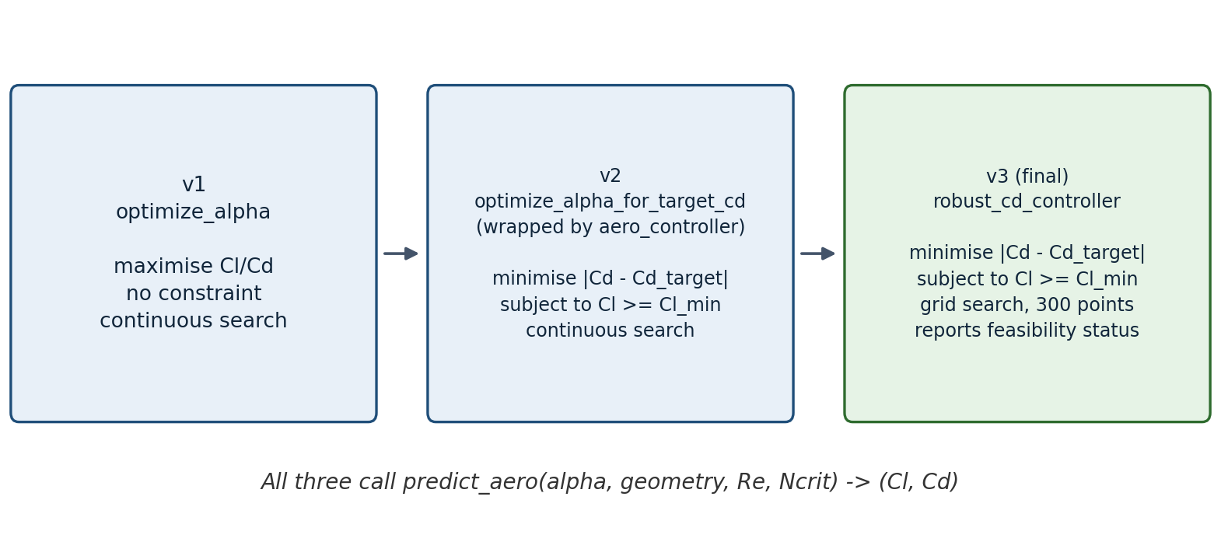
Figure 27. Evolution of the angle-of-attack controller (diagram drawn for this report from the notebook’s function names).
Table 26. Controller generations.
Version | Function | Constraint | Search method | Exercised by
v1 | optimize_alpha | None (maximise Cl/Cd) | Continuous (minimize_scalar) | Early demos
v2 | optimize_alpha_for_target_cd / aero_controller | Optional cl_min | Continuous | Multi-airfoil test
v3 (final) | robust_cd_controller | cl_min + feasibility check | Grid search, 300 candidates | Final checks

8.2 Formulation
Version 1 maximises aerodynamic efficiency; since minimize_scalar only minimises, the code minimises −Cl/Cd. Versions 2 and 3 implement the project’s actual idea: find the angle whose predicted drag is closest to a chosen target while keeping predicted lift above a floor (Eq. (17), Eq. (18)). Version 2 enforces the constraint with a large penalty (1000 plus the lift shortfall); version 3 evaluates 300 angles between −10° and 15°, discards non-finite or non-positive predictions, keeps only candidates with Cl ≥ Cl_min, and returns the one closest to the target together with a status of “Target reached” or “Closest feasible solution”.
(17)
(18)

8.3 Version 1: efficiency maximisation
A first plumbing check uses a hand-typed synthetic airfoil (12 % thick at 0.30, 2 % camber at 0.40) at Re = 500,000 and Ncrit = 9. The optimiser returns α = 4.51° with Cl = 0.733, Cd = 0.00860 and Cl/Cd = 85.2. The sweep in Figure 28 shows a flat drag bucket of about 0.008 between roughly −2° and 4°, and an efficiency peak near 5° that the dashed line marks.

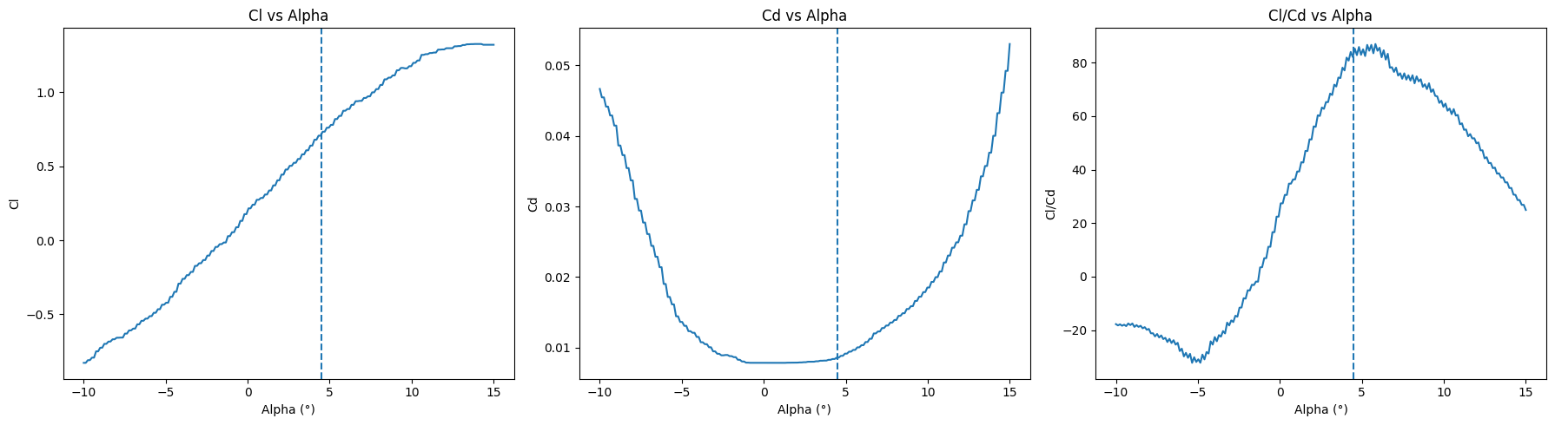
Figure 28. Version 1: predicted Cl, Cd and Cl/Cd versus alpha for the synthetic airfoil at Re = 500,000, Ncrit = 9 (notebook); the dashed line is the optimal alpha of 4.51°.

8.4 Version 2: target-drag control
On the same synthetic airfoil, a target Cd of 0.010 gives α = 5.68°, Cl = 0.840 and Cd = 0.010057 (error 5.7 × 10⁻⁵). On the real airfoil 0 (20-32C, Re = 500,000, Ncrit = 9) the same target gives α = 0.632° with predicted Cd 0.01212, an error of 0.0021 against the target. Checking against the XFOIL data (Figure 29) the nearest XFOIL point is at 0.50°, where Cd = 0.01071, so the real Cd error of the prediction is 0.00141 and the angle differs by 0.132°.
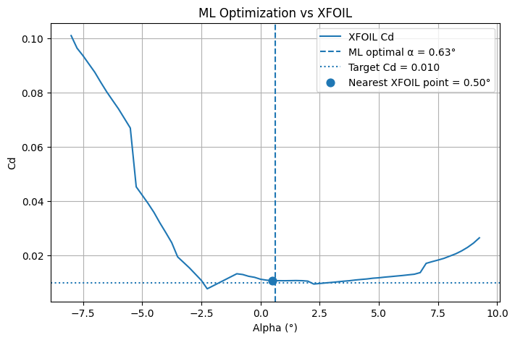
Figure 29. XFOIL Cd for airfoil 0 (Re = 500,000, Ncrit = 9) with the ML-optimal alpha (dashed), the target Cd = 0.010 (dotted) and the nearest XFOIL point (notebook).
A sweep over five targets for airfoil 0 (Table 27, Figure 30) shows that the three lowest targets all land on the same point (α = 0.632°, Cd = 0.01212). That value appears to be the lowest drag the model can deliver for this airfoil in the searched range, so smaller targets are unreachable and the optimiser just reports the closest achievable point. Larger targets move the solution to higher angles (6.43° for 0.015 and 9.05° for 0.020).
Table 27. Target-Cd sweep for airfoil 0 (v2, Re = 500,000, Ncrit = 9).
Target Cd | Optimal alpha | Predicted Cl | Predicted Cd | Error
0.008 | 0.6317° | 0.7197 | 0.01212 | 0.00412
0.010 | 0.6317° | 0.7197 | 0.01212 | 0.00212
0.012 | 0.6317° | 0.7197 | 0.01212 | 0.00012
0.015 | 6.4299° | 1.3035 | 0.01480 | 0.00020
0.020 | 9.0535° | 1.5548 | 0.01976 | 0.00024

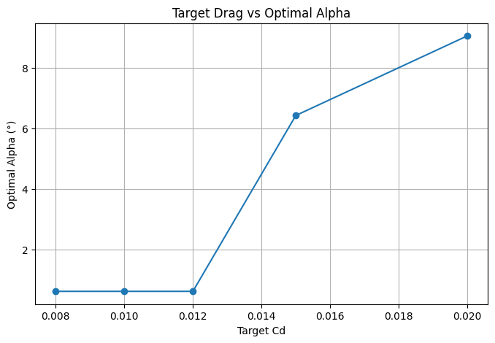
Figure 30. Target Cd versus optimal alpha for airfoil 0 (notebook).

8.5 Version 3 and the drag plateau
The final controller on airfoil 0 with target 0.010 and Cl ≥ 0.5 returns “Closest feasible solution”: α = 0.0334°, Cl = 0.650, Cd = 0.01212, Cl/Cd = 53.6. Version 2 with identical inputs gave α = 0.652°, Cl = 0.720 and the same Cd (Table 28). Two different search methods thus find two different angles with identical predicted drag. Together with the three identical targets above and the piecewise-constant behaviour found in Section 7.6, this indicates that the model’s Cd curve has flat plateau-like regions where many angles score equally on drag alone, which is exactly why the lift floor acts as the tiebreaker.
Table 28. Version 2 versus version 3 for airfoil 0 (target Cd 0.010, Cl ≥ 0.5).
Controller | Optimal alpha | Predicted Cl | Predicted Cd
v2 (continuous) | 0.6516° | 0.7197 | 0.01212
v3 (grid, 300 points) | 0.0334° | 0.6499 | 0.01212

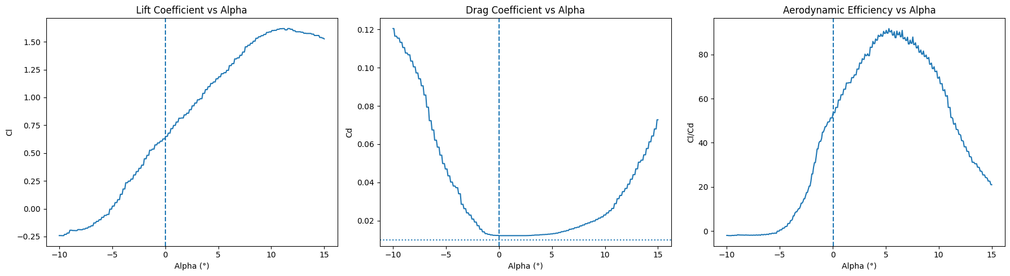
Figure 31. Version 3: predicted Cl, Cd and Cl/Cd versus alpha for airfoil 0 at Re = 500,000, Ncrit = 9 (notebook). The dashed line is the optimal alpha; the dotted line in the Cd panel is the target 0.010, which the curve never reaches.

An important detail: the XFOIL curve in Figure 29 appears to dip to about 0.0095 near 2.3°, below the 0.010 target, so the target was reachable in the XFOIL data while the surrogate puts its floor at 0.0121. This is a reading from the plot, not a printed value, but it suggests the surrogate overestimates the minimum drag of this airfoil.

8.6 Multi-airfoil test and XFOIL round-trip validation
Version 2 was run on airfoils 0 to 4 at target Cd 0.010, Cl ≥ 0.5, Re = 500,000 and Ncrit = 9 (Table 29). Each recommendation is then compared with the nearest real XFOIL row (same airfoil, Re and Ncrit) in Table 30. This checks the actual controller output against an independent tool instead of reporting only a held-out R².
Table 29. Controller output for airfoils 0 to 4 (v2).
Airfoil id | Optimal alpha | Predicted Cl | Predicted Cd | Cd error vs target
0 | 0.6516° | 0.7197 | 0.01212 | 0.00212
1 | 4.0820° | 1.0049 | 0.00961 | 0.00039
2 | 4.7355° | 0.5318 | 0.00976 | 0.00024
3 | 5.1778° | 0.6802 | 0.00984 | 0.00016
4 | 4.7693° | 0.6983 | 0.00969 | 0.00031

Table 30. Round-trip validation of the controller against XFOIL (relative error derived in this report).
Airfoil | ML alpha | XFOIL alpha (nearest) | ML Cd | XFOIL Cd | Target Cd | |ML − XFOIL| Cd | Relative error
0 | 0.652° | 0.50° | 0.01212 | 0.01071 | 0.010 | 0.00141 | 13.2 %
1 | 4.082° | 4.00° | 0.00961 | 0.01138 | 0.010 | 0.00177 | 15.6 %
2 | 4.736° | 4.75° | 0.00976 | 0.01056 | 0.010 | 0.00080 | 7.6 %
3 | 5.178° | 5.00° | 0.00984 | 0.00951 | 0.010 | 0.00033 | 3.5 %
4 | 4.769° | 4.75° | 0.00969 | 0.00933 | 0.010 | 0.00036 | 3.8 %
Aggregate (notebook): mean Cd error 0.000935; mean |alpha difference| 0.089°. Computed here from the table: XFOIL Cd differs from the 0.010 target by 0.00071, 0.00138, 0.00056, 0.00049 and 0.00067 (mean 0.00076).
The surrogate and XFOIL agree closely on angle (mean 0.089° apart) and fairly well on drag (mean absolute error 0.000935, between 3.5 % and 15.6 % of the XFOIL value). The error is largest for airfoils 0 and 1. Five airfoils chosen by convenience (ids 0 to 4) are a small sample, so a histogram over the whole test set would be the honest generalisation claim.

8.7 Save and reload check
The deployed models are loaded back from disk and predict_aero() is redefined to use the reloaded objects, so it works in a fresh kernel without retraining. A plumbing check at α = 5.68° returns Cl = 1.2219 and Cd = 0.01376. Re-running the final controller with the reloaded models reproduces the in-memory result exactly (α = 0.03344°, Cl 0.64988, Cd 0.01212, Cl/Cd 53.617), which is good evidence that the save-and-reload path is correct. The notebook saves to the working folder but loads from models\, so a fresh top-to-bottom run needs that path made consistent (Appendix A).

9. Cross-Pipeline Consistency
Because the data were built twice independently, the two pipelines can be used to check each other (Table 31). The headline result is strong agreement on everything that is countable, and a handful of design differences on everything that is derived.
Table 31. Agreement between Pipeline 1 and Pipeline 2.
Check | Pipeline 1 | Pipeline 2 | Verdict
Files parsed / failed | 825 / 0 | 825 / 0 | Agree
Aerodynamic (polar) rows | 768,542 | 768,542 | Agree
Airfoils with polar data | 818 | 818 Cp files | Agree
Geometry-only airfoils | 7 | 7 (no Cp file) | Agree
Airfoil id assignment | Sorted file order | Sorted file order | Agree
Max thickness, airfoil 0 (%) | 7.99799 | 7.998877 | Close (0.0009)
Upper-surface rule | max / min of curves | Suction side assumed | Differs
Resampling points | 200 | 1,000 | Differs
Position units | Fraction (0 to 1) | Percent (0 to 100) | Differs
Camber sign | Absolute | Signed | Differs

The two surface rules agree for ordinary cambered sections, but the library also contains shapes where the two surfaces can cross (the cambered-plate and Coanda profiles), where Pipeline 2’s assumption could diverge more. One canonical geometry method, with documented units, should be chosen before both feed the same model. A second unfinished link is the join between the CFD stage and the master table: master_polars.csv reserves eight simulation columns that are all still blank.

10. Discussion and Limitations

10.1 What the results support
- Generalisation to unseen airfoils is measured, not assumed. The grouped split keeps all airfoils of the test set out of training, so R² values of 0.964 (Cl) and 0.835 (Cd) are honest estimates for new shapes within this library.
- Cl is predicted well, Cd is not yet. Cl is near 0.96 for all four model families, Cd between 0.77 and 0.84, and tuning moves these numbers only slightly. The limiting factor is the structure of the problem (thin high-drag tail, piecewise-constant trees) more than the hyperparameters.
- The controller works end to end. Predicted angles lie within about 0.09° of XFOIL on average and predicted Cd within 0.00094 of XFOIL on average for five airfoils.
- The pipeline is reproducible. Two independent implementations agree on every count, and the saved models reproduce controller results bit-for-bit after reload.

10.2 Limitations
Table 32. Limitations, the evidence for each, and how to address them.
Limitation | Evidence in the notebooks | Suggested remedy
Weak Cd accuracy near stall | Cd R² 0.77–0.84; flat “wall” at high Cd; linear_tree unstable; log transform only +0.003 | Predict log Cd with a smoother model; add physics-informed features; evaluate on the stall region separately
Geometry reduced to 4 numbers | Only thickness, camber and their positions are inputs; 1,000-point coordinates exist but are unused | Use resampled coordinates or shape parameters (for example CST) as inputs
Single train/test split | One GroupShuffleSplit with random_state=42 | Repeat grouped cross-validation and report spread
Uneven coverage | Very few samples at Re = 2 × 10⁶ and 5 × 10⁶ and beyond α = 20° | Weight or add data, and report error per Re and alpha band
Plateaus in predicted Cd | Three targets give one answer; v2 and v3 give different angles with the same Cd | Add monotonic or smoothness constraints; refine the grid solution continuously
Small controller validation | 5 airfoils, one Re, one Ncrit, one target | Validate on all 164 test airfoils, many targets and conditions
CFD not yet comparable | Re ≈ 216 versus ≥ 50,000; no force integration; periodic boundaries | Increase resolution and Re, add inflow/outflow boundaries and force integration, then fill Cl_sim / Cd_sim
Unequal tuning protocol | Tuning on a 25 % subsample; models train on 90 % versus 100 % of training airfoils | Use one protocol for all models, or disclose it next to every comparison
Extreme library shapes | Thickness up to 66 %, camber up to 16 % | Flag or filter non-airfoil shapes before training
Two geometry definitions | Different surface rule, units and camber sign | Adopt one canonical extractor

11. Future Work
Table 33. Proposed next steps, ordered roughly by value.
# | Step | Why
1 | Raise the LBM Reynolds number towards the XFOIL range, add force integration for Cl and Cd, and write results into master_polars.csv | Turns the CFD layer from a wiring check into a genuine second source of truth
2 | Settle one canonical geometry method and unit convention | Prevents silent errors when both datasets feed one model
3 | Train shape-based models on the 1,000-point coordinates | Removes the 4-scalar bottleneck
4 | Repeated grouped cross-validation, per-Re and per-alpha error analysis | Quantifies uncertainty and reveals weak regions
5 | Add Cm as a third target | Cm is already in the dataset
6 | Model Cp distributions using the stored cp_data files | Gives a richer surrogate than three coefficients
7 | Add the analysis plots proposed in the notebook: residual versus alpha, feature importance, full-test-set Cd error histogram, per-airfoil error boxplot, drag polars, Optuna history, annotated plateau plot | Interpretation and error-localisation figures
8 | Controller validation on all test airfoils; study the plateau behaviour | Turns a 5-airfoil check into a general claim
9 | Service layer and dashboard (FastAPI, database, React front end, carried over from the earlier report) | Makes the surrogate usable interactively

12. Conclusion
AeroFoilLab now covers the full path from raw XFOIL records to a validated control idea. Two independent pipelines turn 825 JSON files into the same 768,542-row table for 818 airfoils; a tuned XGBoost / LightGBM surrogate predicts lift with R² 0.964 and drag with R² 0.835 on airfoils it has never seen; and a constrained optimiser built on it recommends angles of attack that lie within about 0.09° of XFOIL data on average, with predicted drag within 0.00094 on average.
The experiment also exposed clear limits. Drag near stall is hard for piecewise-constant tree models, the controller’s drag predictions show plateaus, the geometry representation is coarse, and the home-built Lattice-Boltzmann solver cannot yet be compared numerically with XFOIL because it runs at Re ≈ 216 and does not output forces. None of these are structural; they define a concrete route to a stronger second iteration.

Appendix A. Notebook Housekeeping Checklist
The annotated modelling notebook and this review identified residue from iterating on the controller three times. None of it changes the results; all of it is worth fixing before the notebooks are shared.
Table 34. Cleanup items.
# | Item | Type | Source
1 | Keep one predict_aero(): the in-memory version reads xgb_tuned / lgb_tuned, the reloaded version reads the disk models (keep this one) | Duplicate function | Notebook
2 | Keep one optimize_alpha_for_target_cd(); the versions differ by cl_min and the output key (error versus Cd_error) | Duplicate + rename | Notebook
3 | Remove the repeated airfoil_features rebuild for airfoil 0 | Duplicate cell | Notebook
4 | Trim three identical demo calls that print the same numbers | Redundant re-run | Notebook
5 | Remove repeated displays of controller_results and validation_results | Redundant display | Notebook
6 | Fix the save/load path mismatch: save to the working folder, load from models\ | Path bug | Notebook
7 | Remove the dead variable alpha_control | Dead code | Notebook
8 | Rename the sweep list results that shadows the metrics dictionary of the same name | Name collision | Notebook
9 | Factor the repeated alpha-sweep plot into one helper | Optional | Notebook
10 | Decide and state whether Cl uses Random Forest or XGBoost | Design decision | Notebook
11 | Make the WORKERS comment and the <= 4 threshold consistent | Logic/comment mismatch | This review
12 | Remove the stray c after traceback.print_exc() in the batch loop | Syntax error | This review
13 | Document the unit and sign differences between Pipeline 1 and 2 geometry columns | Documentation | This review

Appendix B. Software Environment
Versions printed by the notebooks’ install cells (Windows virtual environment in the project folder).
Table 35. Library versions.
Library | Version | Used for
pandas / numpy | 2.3.3 / 2.2.6 | Data handling
matplotlib | 3.10.9 | Plots, polygon mask test
scikit-learn | 1.7.2 | Random Forest, HistGB, grouped splits, metrics
LightGBM | 4.7.0 | Cd surrogate
XGBoost | 3.2.0 | Cl surrogate
Optuna | 5.0.0 | Hyperparameter search
scipy | 1.15.3 | minimize_scalar
joblib | 1.6.0 | Model persistence

Appendix C. Figure Sources
Figures that are plots from the notebooks are reproduced unchanged from their saved outputs. Three figures were drawn for this report: the architecture diagram, the controller-evolution diagram and the baseline-versus-tuned R² chart (the last from numbers in the notebook’s tables). All equations were typeset for this report from the formulas written in the notebooks’ markdown cells.

