<https://www.youtube.com/watch?v=Nabbpl7y4Lo&ab_channel=computer>

https://www.youtube.com/watch?v=Nabbpl7y4Lo&ab_channel=computer

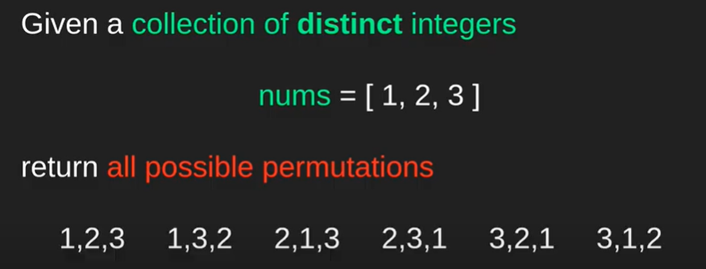

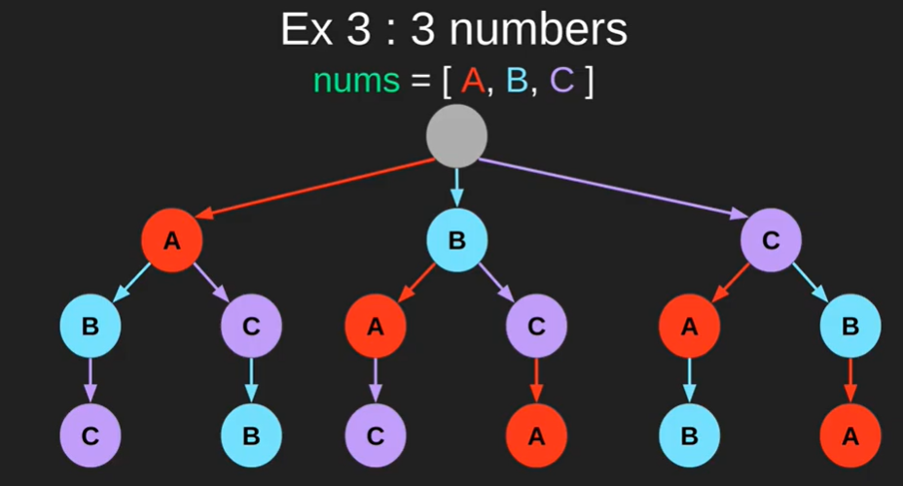



Build a state space tree. It will give all possible solutions.

So it will be solved by backtracking. Why?

When we build a state-space tree and have all possible solutions. It means we are in the domain of BackTracking.

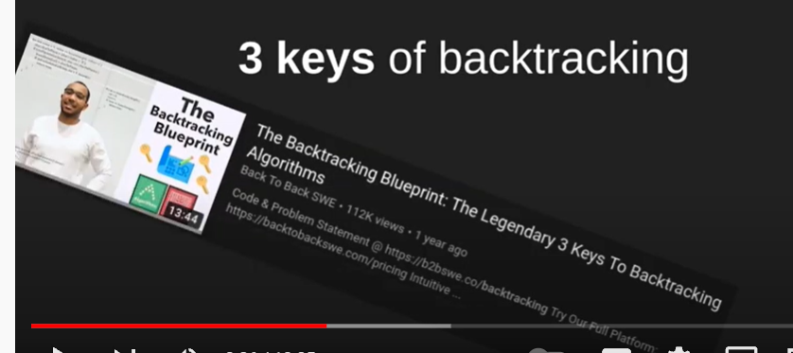

Because there are 3 things/ 3 keys of backtracking:

1. Choice: decision we need to take
2. Constraint: Limits to take a decision
3. Goal: we take decisions to reach a goal.

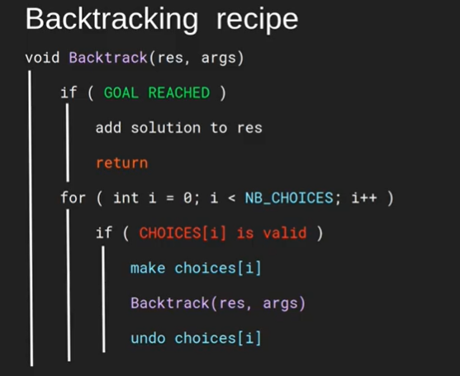

Back track recipe:

1. If goal reached, add solution to result. (Base Case).
2. For loop for all the different choices we can make.
3. If choice is valid, take it and keep going. Make choice.
4. And recursively call backtrack.
5. If goal is reached, we cant make the choice anymore, we undo the choice.

#======🡺

Applying this to our problem:

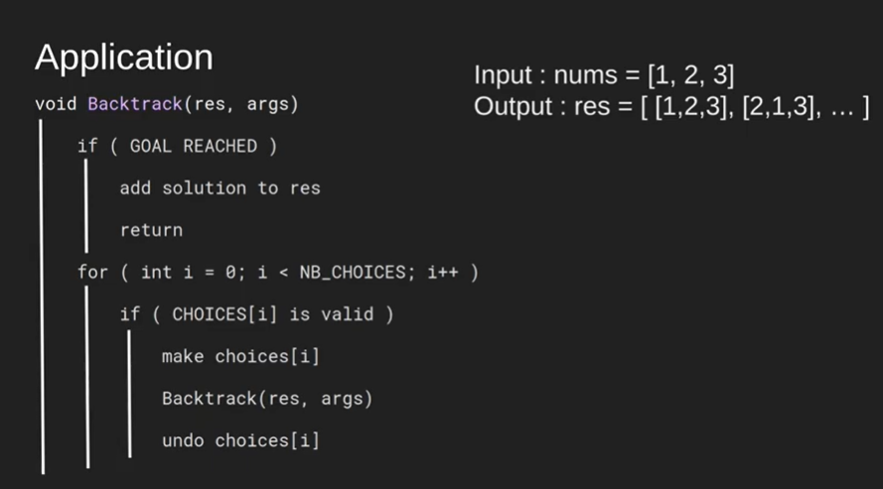

Build a permutation. That is the goal.

When permutation is of same size as the input numbers, then the permutation will be finished. So add a particular permutation to the result.

Also have to keep track of the permutation we are building, put it in the current list.

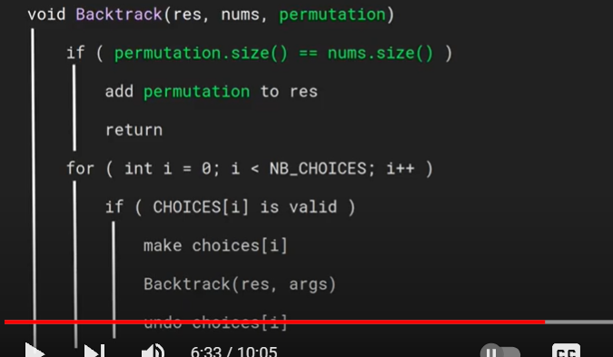

To build this permutation, we need to go through the choices we can make. To make a choice, we have to use a number. So we have to loop through the nums array.

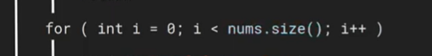

Now look for the constraint. What is the constraint?

Here the number we are choosing is not already used in the current permutation building.

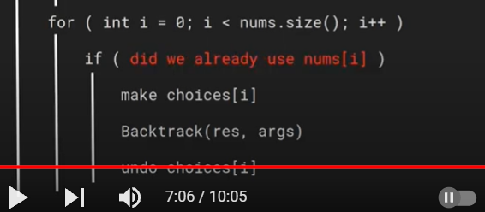

To achieve this choice part, or constraint part, we can either use a hashmap or array of Booleans.

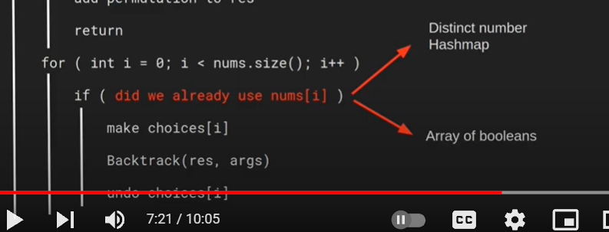

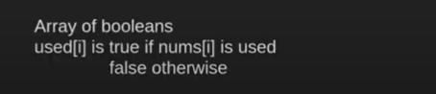

It is easier to use array of Booleans,

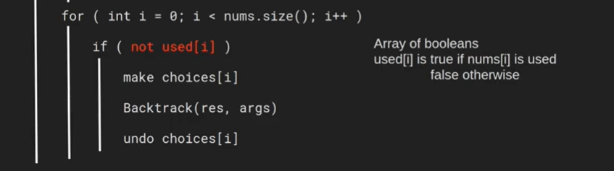

This new array, used has to be added to the argument list.

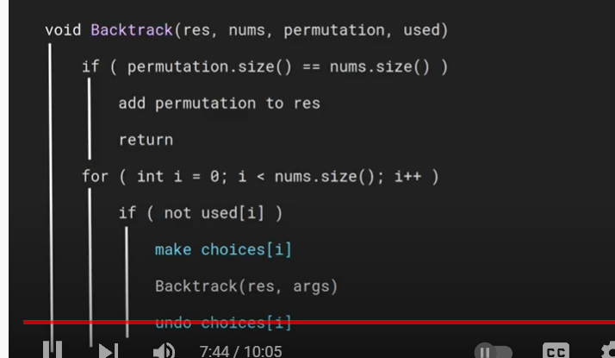

What are the choices that we have to make.??

Choices is to add this particular number. i.e number is used, so we can put Boolean array to true.. as the number is used in this particular iteration.

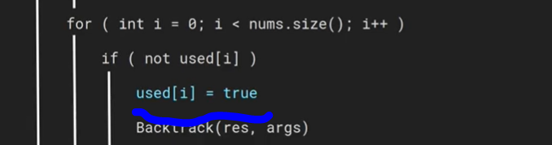

After doing backtrack put it to false. Because we have to backtrack from the current branch of the tree and move into another branch.

So while in the same branch.. this number have to be pushed into the permutation also.



