WonderAgent
User Guide
AI Identity Governance & Runtime Assurance
Covers every module: Foundation, AI Agent Identity, Integration Hub, Access Governance, Runtime Assurance, Risk Engine, Certification & Compliance, Platform Administration, and Operations.
2026-09-16

Table of Contents

Introduction
WonderAgent is an AI Identity Governance & Runtime Assurance platform. It governs AI agents as first-class enterprise identities: their ownership, approved purpose, effective technical access, and observed runtime behavior — and turns any gap between those three into a risk finding an administrator can act on.

How the modules relate
Module | Answers
Foundation | Who can sign in, and what can they do?
AI Agent Identity | What agents exist, who owns them, what are they approved to do (SHOULD)?
Integration Hub | Where does agent and access data come from?
Access Governance | What can each agent technically do (CAN)?
Runtime Assurance | What did each agent actually do (DID)?
Risk Engine | Where do SHOULD, CAN and DID disagree, and how risky is that?
Certification & Compliance | Who reviews and signs off on an agent's access, on a schedule?
Platform Administration | Vendor-only: manage customer tenants (not part of the customer app)
Operations | Audit trail, reports, search, notifications

Signing in and onboarding
- Go to /sign-up to create an account (email + password, 8-character minimum), or /sign-in if you already have one. Your organization may also offer Sign in with SSO if your email domain has a SAML/OIDC connection configured (see Foundation).
- After your first sign-in you land on the onboarding screen: select an existing organization, or create a new one by giving it a name. You become that organization's TENANT_SUPER_ADMIN automatically.
- You land on the Overview dashboard, with left-hand navigation grouped by module.
SCREENSHOT PLACEHOLDER — Sign-in page (real screenshot below) & Onboarding screen (desktop + mobile). Run scripts/capture-screenshots.mjs to fill this in.

Sign-in — actual screenshot
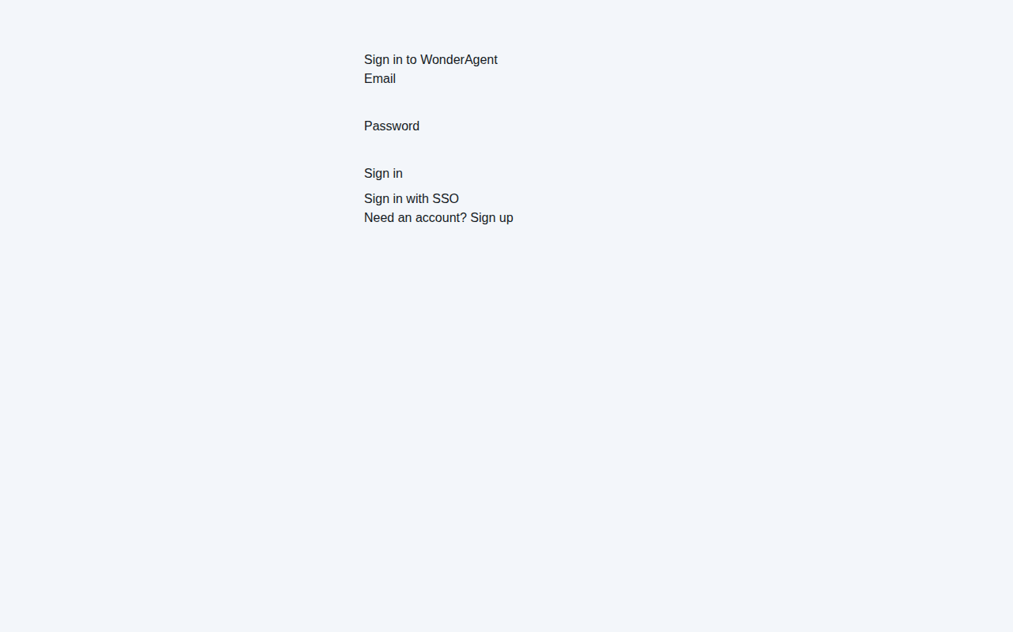
Desktop — /sign-in
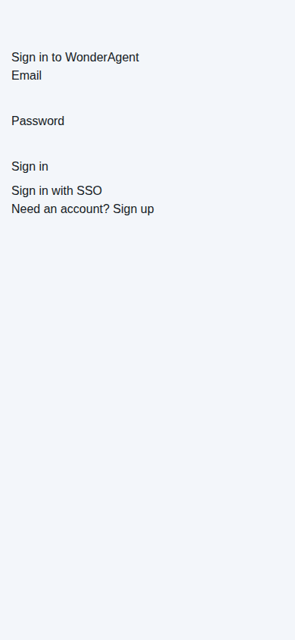
Mobile — /sign-in

Sign-up — actual screenshot
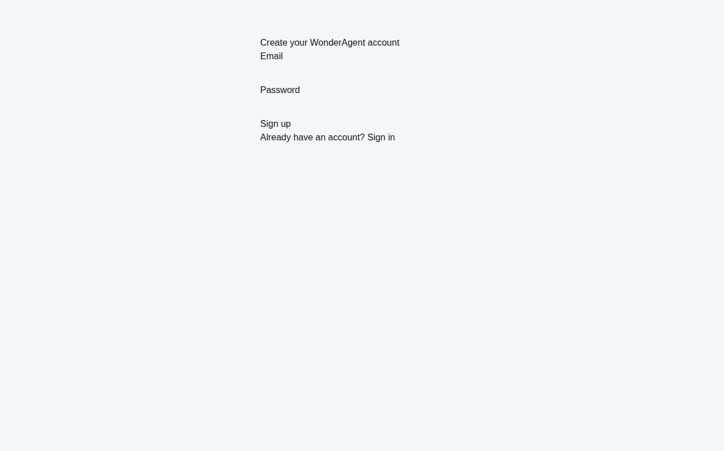
Desktop — /sign-up
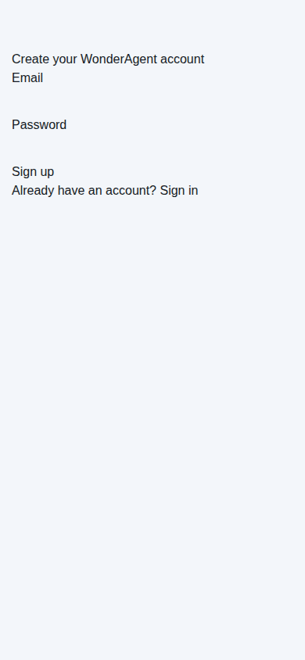
Mobile — /sign-up
Note: these two pages are intentionally minimal, unstyled forms in the current build — that's accurate to the real product today, not a rendering issue with this guide.

Every screen after sign-in requires reaching your live Supabase project, so this guide could not capture real screenshots of them in the sandbox this guide was written in — see the Appendix for exactly how to generate the rest yourself in a couple of minutes.

Foundation
Foundation owns your organization (tenant), users, roles/permissions, and sign-in security. All of its settings live under Settings in the left nav.

Users & Roles — /settings/roles
Requires: role.manage
Every member is listed with their current roles. To grant a role, pick it from the dropdown next to a user and submit; to remove one, use the remove button next to that role badge. A user can hold more than one role — their effective permissions are the union of all of them.
SCREENSHOT PLACEHOLDER — Users & Roles page (desktop + mobile). Run scripts/capture-screenshots.mjs to fill this in.

Built-in roles
Role | Typical use
TENANT_SUPER_ADMIN | Full access to everything. Automatically granted to whoever creates the organization.
IAM_ADMIN | Runs day-to-day identity/access/integration operations and remediation.
IAM_ARCHITECT | Configures integrations, policies and technical mappings.
SECURITY_ADMIN | Owns policies, risk findings and reporting.
CERTIFICATION_MANAGER | Runs certification campaigns.
BUSINESS_OWNER / TECHNICAL_OWNER / APPLICATION_OWNER | Agent owners: read agents, update them, see findings/reports.
AUDITOR | Read-only everywhere, plus report export.
REQUESTER | Can view agents and integrations and submit requests — the most restricted named role.
READ_ONLY | Read-only everywhere.
See the Appendix for the full permission-by-role matrix.

Single Sign-On — /settings/sso
Requires: sso.manage
- Add a connection and fill in Email domain (e.g. example.com), Protocol (SAML 2.0 or OIDC), Entity ID / Issuer, and for SAML, SSO URL and Certificate from your identity provider.
- Set the Default role for new SSO users — the role auto-granted the first time someone from this domain signs in via SSO. Defaults to READ_ONLY.
- Submit, then use Enable/Disable in the connections table to control whether the domain is currently routed to SSO.
SCREENSHOT PLACEHOLDER — Single Sign-On settings page (desktop + mobile). Run scripts/capture-screenshots.mjs to fill this in.
Configuring a connection here does not by itself complete the SAML/OIDC handshake — your Supabase project must also have a matching SSO provider registered (an Enterprise/Pro-tier, project-level step done outside WonderAgent).

Multi-Factor Authentication — /settings/security
This is a personal setting, not an admin one — every user manages their own factors.
- Click Enroll a new authenticator app.
- Scan the QR code with an authenticator app (Google Authenticator, 1Password, etc.).
- Enter the 6-digit code it shows to confirm enrollment.
- Remove a factor at any time from the same page.
SCREENSHOT PLACEHOLDER — MFA enrollment page (desktop + mobile). Run scripts/capture-screenshots.mjs to fill this in.

Organization settings
- Create an organization from /onboarding — this also makes you its TENANT_SUPER_ADMIN.
- Switch between organizations you belong to using the workspace switcher in the top bar.
- Sessions have both an idle and an absolute expiry enforced automatically; you'll be redirected to sign in again with an explanatory message when either is hit.

AI Agent Identity
This module is the canonical registry of every AI agent, its ownership, its lifecycle state, and its contract — the approved purpose that SHOULD is measured against everywhere else in WonderAgent.

Registering an agent — /agents/new
Requires: agent.create
Fill in Agent name and Agent type (required — e.g. chatbot, automation, copilot, pipeline), plus optional Purpose, Framework, Model provider/name, Runtime, Environment (production/staging/development), Criticality (low/medium/high/critical), and Data classification. Submitting registers the agent and opens its detail page.
If the name/attributes look like an existing agent, WonderAgent may instead route you to the duplicate review queue rather than completing registration.
SCREENSHOT PLACEHOLDER — Agents list page (/agents) (desktop + mobile). Run scripts/capture-screenshots.mjs to fill this in.
SCREENSHOT PLACEHOLDER — Register an AI Agent form (/agents/new) (desktop + mobile). Run scripts/capture-screenshots.mjs to fill this in.

Agent detail — /agents/{id}
- Lifecycle: transition an agent through DISCOVERED → REGISTERED → ASSESSED → APPROVED → PROVISIONED → ACTIVE → CERTIFICATION_DUE → RESTRICTED → SUSPENDED → RETIRED, each with a required reason. A CRITICAL risk finding can auto-transition an agent to RESTRICTED.
- Owners: assign at least one owner (business, technical, IAM, application, data, or escalation owner) — an unowned agent is flagged as a governance gap.
- Agent Contract (SHOULD): publish a new contract version specifying approved purpose, approved/prohibited applications, approved/prohibited data, approved/prohibited actions, autonomy level (0–4), allowed tools, and required monitoring/compliance controls. This is the SHOULD that Runtime Assurance and Risk compare everything else against.
- Relationships: record how this agent relates to others (delegates_to, depends_on, shares_credential_with, orchestrates).
- Linked identities: attach the technical identities behind this agent (service account, OAuth client, API key, MCP server, workload identity, human delegate).
SCREENSHOT PLACEHOLDER — Agent detail page (/agents/{id}) (desktop + mobile). Run scripts/capture-screenshots.mjs to fill this in.
From here, the Agent sections sub-nav takes you to this same agent's Access (CAN), Runtime (DID) and Risk & Findings pages — each owned by a different module, covered in its own section below.

Discovery inbox — /agents/discovery
Agents and accounts surfaced by a connected integration land here before they're formally registered. Tabs: All / New / Needs Review / Potential Duplicates / Recently Changed / Ignored. Review a candidate and either register it or ignore it.
SCREENSHOT PLACEHOLDER — Discovery inbox page (desktop + mobile). Run scripts/capture-screenshots.mjs to fill this in.

Duplicate review — /agents/duplicates
Requires: agent.create
When a new registration or discovery candidate closely matches an existing agent, it's queued here with a match score and the field(s) it matched on. Either merge the duplicate into the existing agent or confirm it's genuinely a distinct agent.
SCREENSHOT PLACEHOLDER — Duplicate registration review page (desktop + mobile). Run scripts/capture-screenshots.mjs to fill this in.

Integration Hub
Integrations are how identity, access and activity data gets into WonderAgent from your other systems. All read-only unless a connector explicitly declares write capability — WonderAgent never silently provisions or deprovisions access.

Connector types
Type | Category | Imports
Saviynt | IAM/IGA | Identities, accounts, applications, entitlements, access, policies
Generic REST | Custom API | Identities, accounts, applications, entitlements, access
MCP Server | MCP runtime | Runtime activity only
Webhook | Custom API | Runtime activity only, pushed to WonderAgent rather than pulled

Adding a connection — /integrations/new
Requires: integration.create
- Choose a Type from the catalog above, give it a Name, and optionally a Base URL.
- Submit — you land on the new integration's detail page.
SCREENSHOT PLACEHOLDER — Integrations list page (/integrations) (desktop + mobile). Run scripts/capture-screenshots.mjs to fill this in.
SCREENSHOT PLACEHOLDER — Add an integration form (/integrations/new) (desktop + mobile). Run scripts/capture-screenshots.mjs to fill this in.

Configuring a connection — /integrations/{id}
Requires: integration.update / integration.execute
- Credential: choose an Auth type (oauth2, api_key, basic, bearer, mtls) and enter the Secret / token. Stored encrypted; never exposed to the browser or logs.
- Test connection: verifies the saved credential can reach the configured base URL.
- Sync jobs: click Run sync now to pull data on demand (also check /integrations/jobs for status across the tenant — queued/running/succeeded/failed/partial).
- Field mappings: map a source system's field (dot path, e.g. user.email) to WonderAgent's target field, per object type — needed when your source system's schema doesn't match WonderAgent's out of the box.
SCREENSHOT PLACEHOLDER — Integration detail page (/integrations/{id}) (desktop + mobile). Run scripts/capture-screenshots.mjs to fill this in.
SCREENSHOT PLACEHOLDER — Job Status page (/integrations/jobs) (desktop + mobile). Run scripts/capture-screenshots.mjs to fill this in.

MCP and webhook ingestion (no polling required)
- MCP Server: runtime events are pushed to POST /api/v1/integrations/mcp/{integrationId}/events.
- Webhook: configure your source system to POST to /api/v1/integrations/webhooks/{integrationId}, signed with an HMAC-SHA256 signature using the integration's stored shared secret. Requests with a missing or invalid signature are rejected.
Records imported by any connector are always written with the tenant of the integration that pulled them — never inferred from the source system's own data, so cross-tenant leakage is not possible even with a misconfigured source.

Access Governance
This module computes each agent's CAN — what it can technically do, derived from imported or manually-entered access — and evaluates deterministic policies against it. No LLM is ever used for authorization or policy decisions.

Applications — /access
Requires: access.read (adding one requires access.manage)
Lists every application WonderAgent knows about. Add one with an Application name, optional Category, and an External-facing checkbox (email, messaging, public API) — this flag feeds Risk's "external communication capability" factor, so mark it accurately.
SCREENSHOT PLACEHOLDER — Applications page (/access) (desktop + mobile). Run scripts/capture-screenshots.mjs to fill this in.

Effective Access (CAN) — /access/agents/{agentId}
- Access Graph: a visual path from the agent through its accounts to applications/entitlements, exactly as effective access is derived.
- Effective Access table: every currently-granted entitlement, with grant type, data classification, and evidence for how it was derived. Grants normally arrive via an integration sync; you can also add one manually or Revoke one directly.
- Run evaluation now: runs this agent's access against every active policy and records the results.
SCREENSHOT PLACEHOLDER — Agent Access (CAN) page (/access/agents/{agentId}) (desktop + mobile). Run scripts/capture-screenshots.mjs to fill this in.

Access Requests — /access/requests
Tracks pending, approved, rejected and fulfilled requests for new or modified access (access.request to submit, access.approve to decide). A certification reviewer's "modify" decision (see Certification & Compliance) also creates a request here.
SCREENSHOT PLACEHOLDER — Access Requests page (/access/requests) (desktop + mobile). Run scripts/capture-screenshots.mjs to fill this in.

Policies — /policies
Requires: policy.read (creating requires policy.create)
- Create a policy: Name, Category (identity/access/runtime/agent/lifecycle), and Action (flag/restrict/block).
- On a policy's detail page, add rules (rbac/abac/resource/time — structured field/operator/value conditions, never free-text logic) and, when a documented exception is needed, an exception with reason, business justification, approver, compensating control and expiry.
- Policies have versions — every edit is snapshotted so a past evaluation can be reproduced against the exact rule set that produced it.
SCREENSHOT PLACEHOLDER — Policies page (/policies) (desktop + mobile). Run scripts/capture-screenshots.mjs to fill this in.

Runtime Assurance
This module records what an agent actually did (DID) and compares it against SHOULD (its contract) and CAN (its effective access) — the comparison at the heart of WonderAgent's model.

Activity — /runtime
Requires: runtime.read
Lists every agent with a link into its own runtime page.
SCREENSHOT PLACEHOLDER — Runtime Assurance list page (/runtime) (desktop + mobile). Run scripts/capture-screenshots.mjs to fill this in.

An agent's Runtime (DID) page — /runtime/agents/{agentId}

SHOULD vs CAN vs DID outcome types
Outcome | Meaning
healthy | Everything lines up
excessive_access | CAN includes something SHOULD doesn't approve
insufficient_access | SHOULD approves something CAN doesn't grant
unused_capability | CAN includes something never exercised in DID
unexpected_capability | DID touched something not covered by CAN
behavioral_violation | DID touched something not covered by SHOULD
unscored_unknown | A DID event with no resolvable application/resource — never guessed as compliant or a violation

- DID — Observed Activity: aggregated activity over the last 90 days (application, resource, action, data classification, event count).
- Submit test runtime event: for demonstration/testing only. In production, events arrive automatically via MCP or webhook ingestion, or the runtime.ingest-gated REST endpoint.
SCREENSHOT PLACEHOLDER — Agent Runtime (DID) page (/runtime/agents/{agentId}) (desktop + mobile). Run scripts/capture-screenshots.mjs to fill this in.
Every comparison is a pure, reproducible calculation over already-stored evidence: running it twice with no new data always produces the same result.

Risk Engine
Turns SHOULD/CAN/DID deviations and other deterministic signals into scored, evidenced findings — severity is always a weighted calculation, never an LLM judgment.

Risk — /risk
Requires: risk.read
Every agent with open findings, worst severity first.
SCREENSHOT PLACEHOLDER — Risk list page (/risk) (desktop + mobile). Run scripts/capture-screenshots.mjs to fill this in.

An agent's Risk & Findings page — /risk/agents/{agentId}
- Run risk evaluation now (risk.manage) recomputes findings from current evidence: excessive access, unauthorized resource access, prohibited actions/data, ownership gaps, lifecycle violations, behavioral deviations, and more.
- Each finding shows severity, category, status, a risk score, an explanation, contributing reasons, and a concrete recommendation.
- Assign a finding to a user; Update status through acknowledged/investigating/mitigated/exception; Resolve as verified fixed, accepted risk, or false positive (verified fixed only succeeds if the underlying evidence no longer triggers the rule).
- Request remediation creates a remediation request, which can flow to a connected IAM system; WonderAgent never auto-revokes access itself.
- A CRITICAL finding can automatically move the agent's lifecycle state to RESTRICTED.
SCREENSHOT PLACEHOLDER — Agent Risk & Findings page (/risk/agents/{agentId}) (desktop + mobile). Run scripts/capture-screenshots.mjs to fill this in.

Rogue Agents — /risk/rogue
A focused view of findings that suggest an agent may be behaving outside its intended purpose entirely: behavioral deviation, identity anomaly, ownership violation, lifecycle violation. Each agent's rogue-agent detail page includes an AI-generated summary of the evidence for human review only — the underlying detection itself is deterministic.
SCREENSHOT PLACEHOLDER — Rogue Agents page (/risk/rogue) (desktop + mobile). Run scripts/capture-screenshots.mjs to fill this in.

Certification & Compliance
Periodic, evidenced human review of agent access, plus control mappings and posture tracking.

Certification Campaigns — /compliance/campaigns
Requires: compliance.read (launching requires compliance.manage)
- Launch a new campaign: give it a Campaign name, a Scope type, a Cadence (one-time/periodic/event-driven), and a Reviewer (defaults to you). The 'agent' scope type has a dedicated Criticality filter field in this UI; application/entitlement/privileged_access/high_risk_agent are supported by the platform but configured via the API today.
- Each item is pre-filled with the agent's risk severity and usage at review time, and a computed recommendation: remove if never used and medium+ risk, review if high/critical risk, otherwise keep.
- On the campaign detail page, a reviewer records a decision per item: approve, revoke (initiates remediation), modify (requests a specific change), delegate, or request more information.
- Overdue items are automatically escalated to the agent's business owner once a day.
SCREENSHOT PLACEHOLDER — Certification Campaigns list page (/compliance/campaigns) (desktop + mobile). Run scripts/capture-screenshots.mjs to fill this in.
SCREENSHOT PLACEHOLDER — Campaign detail page (/compliance/campaigns/{id}) (desktop + mobile). Run scripts/capture-screenshots.mjs to fill this in.

Controls — control mappings
Map a control (from a framework you define) to a policy; WonderAgent then continuously reflects that control's status (compliant/non-compliant) based on whether the mapped policy currently has an open violation, unless a human attestation overrides it.

Governance Posture & Attestation
A computed, 12-dimension posture score per agent, distinct from its risk score — it answers "is this agent governed" rather than "how risky is it." A Governance Attestation records a human sign-off (approver, decision, checklist, evidence, validity window) against a specific policy requirement.

Exporting evidence
From a campaign or an individual agent, export a tamper-evident evidence pack in JSON, CSV, or PDF — all three share the same SHA-256 content hash, so any later tampering with a saved copy is detectable.

Platform Administration
This is a wholly separate console for WonderAgent's own vendor staff — not part of the customer application, and not reachable by any customer role, including TENANT_SUPER_ADMIN.
Access is controlled by a dedicated platform_admins table, unrelated to tenant roles; a non-platform-admin hitting any /platform-admin/* URL gets a plain "not found," never a permission-denied page.

Tenants — /platform-admin/tenants
- Create tenant: name, slug, and environment (production/staging/development) — for provisioning a customer before their first user signs up.
- Per tenant: create a subscription (plan), and suspend, activate, or decommission it.
- View a tenant's usage from its own detail page.
SCREENSHOT PLACEHOLDER — Tenants page (/platform-admin/tenants) (desktop + mobile). Run scripts/capture-screenshots.mjs to fill this in.

Feature Flags — /platform-admin/features
- Set a flag's platform-wide default (on/off) — every change is versioned, with rollback available.
- Add per-tenant overrides for gradual or customer-specific rollout.
SCREENSHOT PLACEHOLDER — Feature Flags page (/platform-admin/features) (desktop + mobile). Run scripts/capture-screenshots.mjs to fill this in.

Global Configuration — /platform-admin/branding
Product name, support URL, docs URL, and default theme, applied platform-wide. Versioned with rollback.
SCREENSHOT PLACEHOLDER — Global Configuration page (/platform-admin/branding) (desktop + mobile). Run scripts/capture-screenshots.mjs to fill this in.

Announcements & Maintenance Windows — /platform-admin/announcements
Publish a notice scoped globally or to a specific tenant, of type notice/warning/maintenance, with a title, body, and optional end time. Shown as a banner in the customer app.
SCREENSHOT PLACEHOLDER — Announcements page (/platform-admin/announcements) (desktop + mobile). Run scripts/capture-screenshots.mjs to fill this in.

Platform Health — /platform-admin/health
Operational status across tenants (read-only dashboard).
SCREENSHOT PLACEHOLDER — Platform Health page (/platform-admin/health) (desktop + mobile). Run scripts/capture-screenshots.mjs to fill this in.

Platform Admins — /platform-admin/admins
Grant another user platform-admin access by their user ID. Every grant is itself audited (who granted it, and when).
SCREENSHOT PLACEHOLDER — Platform Admins page (/platform-admin/admins) (desktop + mobile). Run scripts/capture-screenshots.mjs to fill this in.

Operations

Audit Trail — /audit
Requires: audit.read
Every security-sensitive action in your tenant (who, what, target, outcome, timestamp) is recorded immutably. Filter by object type, action, actor, and a date range; export the filtered results as CSV.
SCREENSHOT PLACEHOLDER — Audit Trail page (/audit) (desktop + mobile). Run scripts/capture-screenshots.mjs to fill this in.

Reports — /reports
Requires: report.read (export requires report.export)
Eight built-in reports, generated live: AI Agent Inventory, Ownership, Access Certification, Rogue Agent, Access Violation, Risk, Audit Evidence, and Policy Compliance.
SCREENSHOT PLACEHOLDER — Reports index page (/reports) (desktop + mobile). Run scripts/capture-screenshots.mjs to fill this in.

Search — /search
A single search box across agents, findings, policies and more. Results respect your role — e.g. a user without risk.read sees a result but not its risk detail.
SCREENSHOT PLACEHOLDER — Search page (/search) (desktop + mobile). Run scripts/capture-screenshots.mjs to fill this in.

Notification Preferences — /settings/notifications
Seven notification types (certification due, overdue certification, critical finding, and others) are currently mandatory (always on, in-app + email) rather than individually togglable.
SCREENSHOT PLACEHOLDER — Notification Preferences page (/settings/notifications) (desktop + mobile). Run scripts/capture-screenshots.mjs to fill this in.

AI Provider — /settings/ai
Requires: ai.manage
Configure OpenAI or Gemini for AI-assisted features (e.g. the rogue-agent summary). Choose bring your own key (stored encrypted) or fall back to the platform's own default key if your vendor has configured one. AI is used only for human-readable summaries and explanations — never for authorization, risk scoring, or policy decisions.
SCREENSHOT PLACEHOLDER — AI Provider page (/settings/ai) (desktop + mobile). Run scripts/capture-screenshots.mjs to fill this in.

Appendix

How to fill in the remaining screenshots
This guide was written in a sandbox that could reach only the two static pages above — every other screen needs your live Supabase project to render, which that sandbox's network policy blocked. To fill in the placeholders:
- Run the app somewhere with real access to your Supabase project: npm run build && npm run start -- -p 3100.
- Run node scripts/capture-screenshots.mjs from the repo root, with WONDERAGENT_EMAIL and WONDERAGENT_PASSWORD set to a real, already-onboarded WonderAgent account (add WONDERAGENT_PLATFORM_EMAIL/WONDERAGENT_PLATFORM_PASSWORD too if you want the Platform Administration screens).
- The script writes desktop + mobile PNGs into ./screenshots, named to match every placeholder in this document (e.g. agents-list-desktop.png).
- Paste each image over its matching placeholder box in this document.

Role × permission reference
✓ = full access to that category, ● = read-only, blank = none.
Role | Agents | Policies | Integr. | Findings | Reports | Access | Runtime | Compl.
TENANT_SUPER_ADMIN | ✓ | ✓ | ✓ | ✓ | ✓ | ✓ | ✓ | ✓
IAM_ADMIN | ✓ (no delete) | ● | ✓ | ✓ | ✓ | — | — | —
IAM_ARCHITECT | read/update | ✓ (no delete) | create/update | — | ● | — | — | —
SECURITY_ADMIN | ● | ✓ (no delete) | — | ✓ | ✓ | — | — | —
CERTIFICATION_MANAGER | read/certify | — | — | ● | ✓ | — | — | —
BUSINESS/TECHNICAL/APPLICATION_OWNER | read/update | — | — | ● | ● | — | — | —
AUDITOR | ● | ● | ● | ● | ✓ (export) | ● | ● | ●
REQUESTER | ● | — | ● | — | — | — | — | —
READ_ONLY | ● | ● | ● | ● | ● | ● | ● | ●

Access/Runtime/Compliance permissions were added after the original role catalog; each module's own migration grants them per-role — TENANT_SUPER_ADMIN and READ_ONLY/AUDITOR always get full/read access respectively to every new module.

Environment configuration (for whoever deploys WonderAgent)
Variable | Required | Purpose
NEXT_PUBLIC_SUPABASE_URL | Yes | Supabase project URL (safe for the browser)
NEXT_PUBLIC_SUPABASE_PUBLISHABLE_KEY | Yes | Supabase public key (safe for the browser)
SUPABASE_SERVICE_ROLE_KEY | Yes | Server-only — never exposed to the browser, logs, or source control
SECRET_ENCRYPTION_KEY | Yes | Encrypts stored integration credentials
PLATFORM_OPENAI_API_KEY / PLATFORM_GEMINI_API_KEY | Optional | Platform-wide default AI key for tenants without their own (BYOK still takes priority)
RESEND_API_KEY / RESEND_FROM_EMAIL | Optional | Enables the email channel for mandatory notifications; without it, notifications stay in-app only
CRON_SECRET | Yes, if deploying the scheduled job | Authenticates Vercel Cron's daily call to the certification-escalation job

Glossary
- Tenant — your organization. Every record you create belongs to exactly one tenant; WonderAgent enforces this at the database level, not just in the UI.
- SHOULD — what an agent is approved to do, from its published contract.
- CAN — what an agent can technically do, from its effective access.
- DID — what an agent actually did, from observed runtime activity.
- Effective access — the full set of entitlements an agent currently holds, resolved through its accounts.
- Finding — a scored, evidenced risk detected by the Risk Engine.
- Certification campaign — a scheduled review of a set of agents' access, ending in a human decision per item.
- Rogue agent — an agent showing signs of behaving outside its intended purpose (behavioral deviation, identity anomaly, ownership or lifecycle violation).

