**package** multiArray;

**public** **class** MultiArray {

**public** **static** **void** main(String[] args) {

**int**[][] ar = { { 10, 20 }, { 30, 40 }, { 50, 60 } };

System.***out***.println("배열명 ar =" + ar);

System.***out***.println();

System.***out***.println("행 ar[0] = " + ar[0]);

System.***out***.println("행 ar[1] = " + ar[1]);

System.***out***.println("행 ar[2] = " + ar[2]);

**for** (**int** i = 0; i < ar.length; i++) {

**for** (**int** j = 0; j < ar[i].length; j++) {

System.***out***.println("ar[" + i + "][" + j + "] =" + ar[i][j]);

}

System.***out***.println();

} // for i

}

}

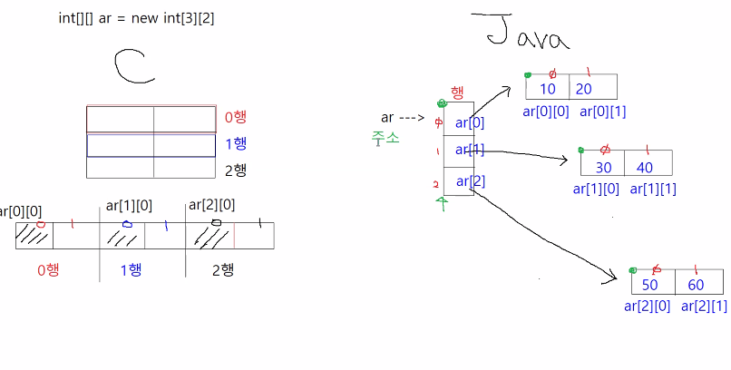

[결과]

배열명 ar =[[I@123a439b

행 ar[0] = [I@7de26db8

행 ar[1] = [I@1175e2db

행 ar[2] = [I@36aa7bc2

ar[0][0] =10

ar[0][1] =20

ar[1][0] =30

ar[1][1] =40

ar[2][0] =50

ar[2][1] =60