**package** constructor;

**class** ConstructorTest {

String name = **null**;

**int** age = 0;

// 생성자 Overload

**public** ConstructorTest() {

System.***out***.println("default 생성자");

System.***out***.println("this = " + **this**);

}

**public** ConstructorTest(String name) { //똑같은 클래스와 외부로부터 데이터를 받은

**this**();

**this**.name = name;

method

class

System.***out***.println("this = " + **this**);

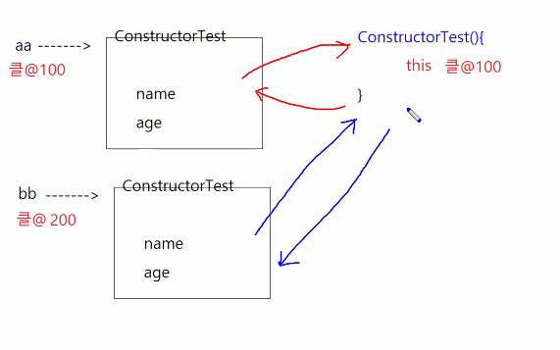

}

**public** ConstructorTest(**int** age) {

**this**("코난"); // Overload된 다른 생성자 호출

**this**.age = age;

System.***out***.println("this = " + **this**);

}

}

//------------

**public** **class** ConstructorMain {

**public** **static** **void** main(String[] args) {

ConstructorTest aa = **new** ConstructorTest();//생성자

System.***out***.println("aa = " + aa);

System.***out***.println("이름 = " + aa.name + "\t 나이 = " + aa.age);

System.***out***.println();

ConstructorTest bb = **new** ConstructorTest("홍길동");

System.***out***.println("bb = " + bb);

System.***out***.println("이름 = " + bb.name + "\t 나이 = " + bb.age);

System.***out***.println();

ConstructorTest cc = **new** ConstructorTest(25);

System.***out***.println("cc = " + cc);

System.***out***.println("이름 = " + cc.name + "\t 나이 = " + cc.age);

System.***out***.println();

}

}

[결과]

default 생성자

this = constructor.ConstructorTest@7de26db8

aa = constructor.ConstructorTest@7de26db8

이름 = null 나이 = 0

default 생성자

this = constructor.ConstructorTest@1175e2db

this = constructor.ConstructorTest@1175e2db

bb = constructor.ConstructorTest@1175e2db

이름 = 홍길동 나이 = 0

default 생성자

this = constructor.ConstructorTest@36aa7bc2

this = constructor.ConstructorTest@36aa7bc2

this = constructor.ConstructorTest@36aa7bc2

cc = constructor.ConstructorTest@36aa7bc2

이름 = 코난 나이 = 25