package array;

public class BubbleSort {

public static void main(String[] args) {
int[] ar = {43, 30, 25, 78, 55};

System.out.print("정렬 전 : ");
for(int x : ar) {
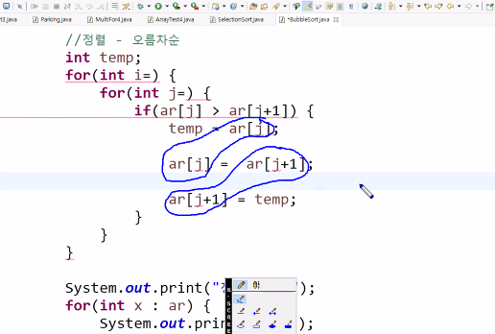
System.out.print(x+" ");
}
System.out.println();

//정렬 - 오름차순
int temp;
for(int i=0; i<ar.length-1; i++) {
for(int j=0; j<ar.length-1-i; j++) {
if(ar[j] > ar[j+1]) {
temp = ar[j];
ar[j] = ar[j+1];
ar[j+1] = temp;
}
}
}
System.out.print("정렬 후 : ");
for(int x : ar) {
System.out.print(x+" ");
}
System.out.println();
}
}

[결과]
정렬 전 : 43 30 25 78 55
정렬 후 : 25 30 43 55 78

