SJF vs Priority Scheduling
Comparison Simulator

1. Project Overview
This project implements a CPU Scheduling Simulator that allows users to input a set of processes and see how two different scheduling algorithms manage their execution. The simulator compares Preemptive Shortest Job First (SJF) with Preemptive Priority Scheduling, providing Gantt charts, metrics tables, a comparison summary, and a conclusion.

Core Comparison Focus:
- SJF always selects the process with the shortest remaining burst time.
- Priority Scheduling always selects the process with the highest priority.
- The key conflict arises when a short job has low priority, or a long job has high priority.
- Both algorithms are preemptive — a running process can be interrupted when a better candidate arrives.

2. Algorithm Explanations

2.1 Preemptive SJF (Shortest Remaining Time First — SRTF)
At every time unit, the CPU selects the ready process with the smallest remaining burst time. If a new process arrives with a shorter remaining time than the currently running process, the CPU preempts the current process and switches to the new one.

Key rules:
- Tie-handling: Stimulates FCFS algorithm
- Starvation risk: Long processes may never execute if short ones keep arriving.
- Advantage: Minimizes average waiting time theoretically.

2.2 Preemptive Priority Scheduling
At every unit, the CPU selects the ready process with the highest priority. If a higher-priority process arrives, it preempts the currently running process.

Key rules:
- Priority rule: lower number = higher priority
- Tie-handling: Checks the lowest burst time
- Starvation risk: Low-priority processes may starve if high-priority ones keep arriving.
- Advantage: Ensures urgent/important processes are served first.

3. Metrics Definitions
Metric | Full Name | Formula | Description
CT | Completion Time | Recorded when process finishes | The time at which a process completes execution
TAT | Turnaround Time | CT − Arrival Time | Total time from arrival to completion
WT | Waiting Time | TAT − Burst Time | Time spent waiting in the ready queue
RT | Response Time | First CPU Access − Arrival Time | Time from arrival until the process first gets the CPU
Avg WT | Average Waiting Time | Sum of WT / Number of Processes | Mean waiting time across all processes
Avg TAT | Average Turnaround Time | Sum of TAT / Number of Processes | Mean turnaround time across all processes
Avg RT | Average Response Time | Sum of RT / Number of Processes | Mean response time across all processes

4. System Design & Interface
The application is built using Python with the Tkinter. All sections are accessible from a single window.

UI Section | Description
Input Panel | Where the user enters the number of processes and their data
Process Table | Displays entered process data (PID, Arrival, Burst)
Priority Input Area | Field for entering priority values per process
Gantt Chart — SJF | Visual timeline showing SJF execution order
Gantt Chart — Priority | Visual timeline showing Priority Scheduling execution order
Results Table — SJF | CT, TAT, WT, RT for each process under SJF
Results Table — Priority | CT, TAT, WT, RT for each process under Priority
Comparison Summary | Side-by-side averages of both algorithms
Conclusion Area | Text interpretation of which algorithm performed better and why

5. Input Validation
All inputs are validated before simulation begins. The following rules are enforced:

Validation Rule | Error Message Shown
Burst Time = 0 or negative | Burst time must be greater than zero.
Arrival Time < 0 | Arrival time cannot be negative.
Non-numeric input in any field | Arrival, Burst and Priority  must be integers.
Duplicate Process ID | Please use a unique ID
Empty field | All fields (ID, Arrival, Burst, Priority) are required.
Invalid or missing priority value | Priority cannot be negative.

6. Test Scenarios

Scenario A — Basic Mixed Workload
A normal workload with different arrival times and burst times to verify basic correctness of both algorithms.

Input Data
PID | Arrival Time | Burst Time | Priority
P1 | 0 | 8 | 3
P2 | 1 | 4 | 1
P3 | 2 | 9 | 4
P4 | 3 | 5 | 2
P5 | 4 | 2 | 5

SJF Results
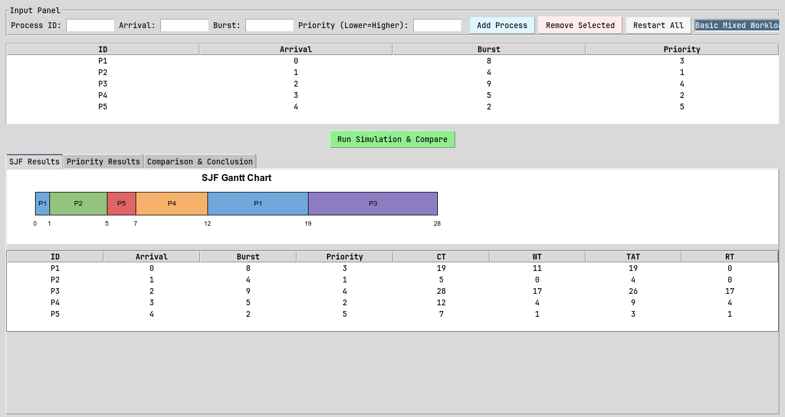

PID | Arrival | Burst | CT | WT | TAT | RT
P1 | 0 | 8 | 19 | 11 | 19 | 0
P2 | 1 | 4 | 5 | 0 | 4 | 0
P3 | 2 | 9 | 28 | 17 | 26 | 17
P4 | 3 | 5 | 12 | 4 | 9 | 4
P5 | 4 | 2 | 7 | 1 | 3 | 1

Avg WT: 6.6 | Avg TAT: 12.2 | Avg RT: 4.4

Priority Scheduling Results
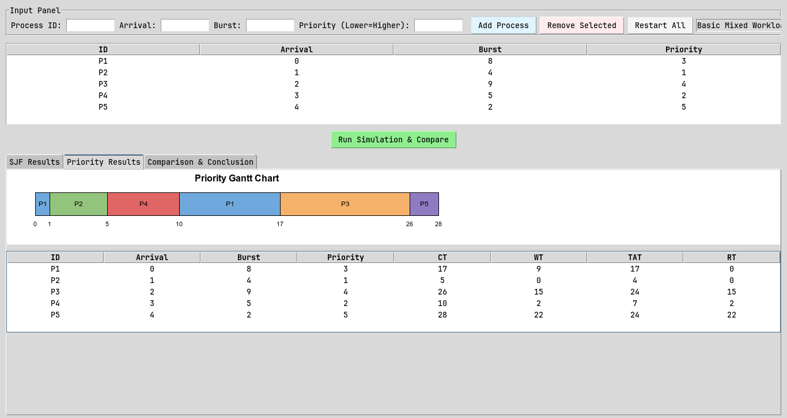

PID | Arrival | Burst | CT | WT | TAT | RT
P1 | 0 | 8 | 17 | 9 | 17 | 0
P2 | 1 | 4 | 5 | 0 | 4 | 0
P3 | 2 | 9 | 26 | 15 | 24 | 15
P4 | 3 | 5 | 10 | 2 | 7 | 2
P5 | 4 | 2 | 28 | 22 | 24 | 22

Avg WT: 9.6 | Avg TAT: 15.2 | Avg RT: 7.8

Analysis
- Waiting Time: SJF achieved a lower average waiting time (6.6 vs 9.6).
- Turnaround: SJF achieved a lower average turnaround time (12.2 vs 15.2).
- Response Time: SJF gave processes CPU access sooner (4.4 vs 7.8).

- Fairness: SJF was fairer - its worst-case wait was 17 vs 22.
- Starvation Risk: A large gap between max and average WT suggests possible starvation for at least one process.

- Recommendation: For this workload, SJF is the better choice overall.
SJF minimizes wait for short-burst jobs but may starve long ones.
Priority favors urgent tasks but may delay low-priority work.

Scenario B — Conflict Between Burst Time and Priority
A workload designed to reveal a meaningful difference: a short-burst process has low priority, while a long-burst process has high priority.

Input Data
PID | Arrival Time | Burst Time | Priority
P1 | 0 | 2 | 5
P2 | 0 | 10 | 1
P3 | 1 | 3 | 4
P4 | 2 | 1 | 3

SJF Results
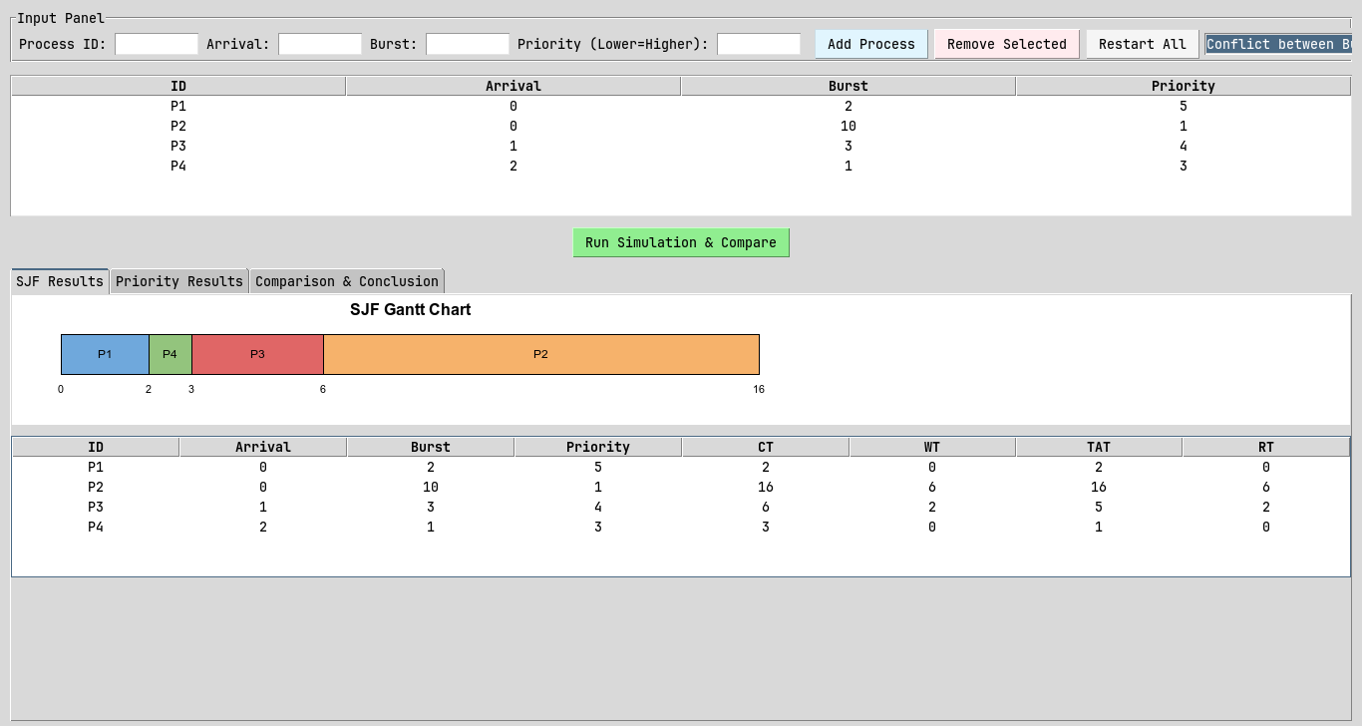

PID | Arrival | Burst | CT | TAT | WT | RT
P1 | 0 | 2 | 2 | 2 | 0 | 0
P2 | 0 | 10 | 16 | 16 | 6 | 6
P3 | 1 | 3 | 6 | 5 | 2 | 2
P4 | 2 | 1 | 3 | 1 | 0 | 0

Avg WT: 2.0 | Avg TAT: 6.0 | Avg RT: 2.0

Priority Scheduling Results
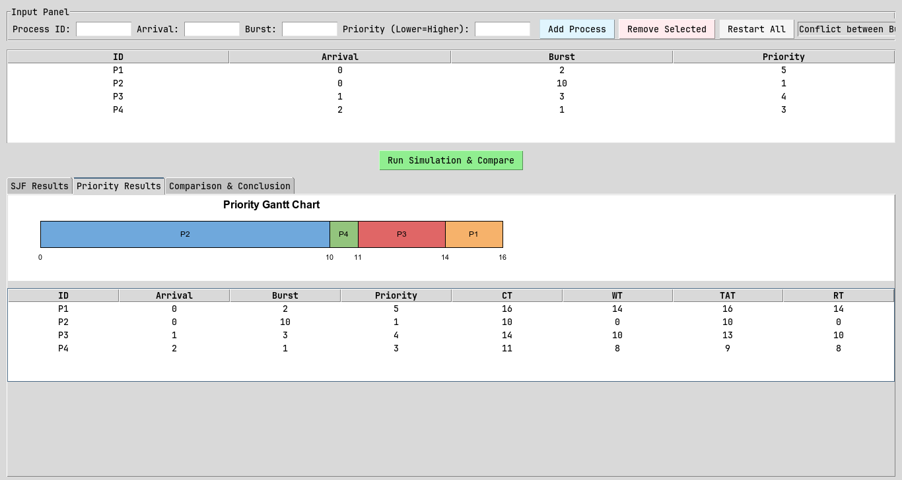

PID | Arrival | Burst | CT | TAT | WT | RT
P1 | 0 | 2 | 16 | 16 | 14 | 14
P2 | 0 | 10 | 10 | 10 | 0 | 0
P3 | 1 | 3 | 14 | 13 | 10 | 10
P4 | 2 | 1 | 11 | 9 | 8 | 8

Avg WT: 8.0 | Avg TAT: 12.0 | Avg RT: 8.0

Analysis
- Waiting Time: SJF achieved a lower average waiting time (2.0 vs 8.0).
- Turnaround: SJF achieved a lower average turnaround time (6.0 vs 12.0).
- Response Time: SJF gave processes CPU access sooner (2.0 vs 8.0).

- Fairness: SJF was fairer - its worst-case wait was 6 vs 14.
- Starvation Risk: A large gap between max and average WT suggests possible starvation for at least one process.

- Recommendation: For this workload, SJF is the better choice overall.
SJF minimises wait for short-burst jobs but may starve long ones.
Priority favours urgent tasks but may delay low-priority work.

Scenario C — Starvation / Fairness Case
A workload where one process may wait much longer under one of the algorithms, demonstrating unfair delay or starvation.

Input Data
PID | Arrival Time | Burst Time | Priority
P1 | 0 | 4 | 3
P2 | 1 | 2 | 3
P3 | 2 | 1 | 3
P4 | 0 | 15 | 5
P5 | 3 | 1 | 3

SJF Results
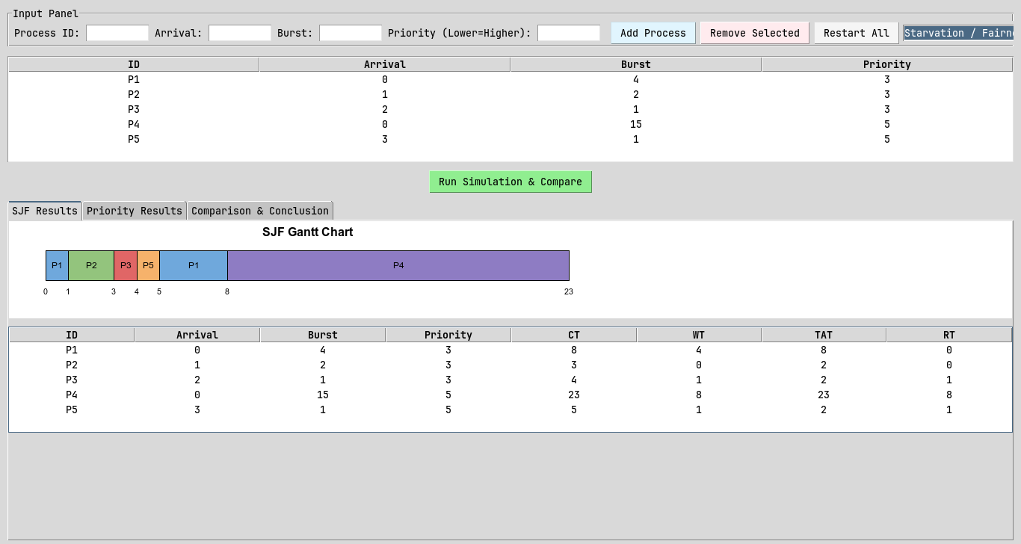

PID | Arrival | Burst | CT | TAT | WT | RT
P1 | 0 | 4 | 8 | 8 | 4 | 0
P2 | 1 | 2 | 3 | 2 | 0 | 0
P3 | 2 | 1 | 4 | 2 | 1 | 1
P4 | 0 | 15 | 23 | 23 | 8 | 8
P5 | 3 | 1 | 5 | 2 | 1 | 1

Avg WT: 2.8 | Avg TAT: 7.4 | Avg RT: 2.0

Priority Scheduling Results
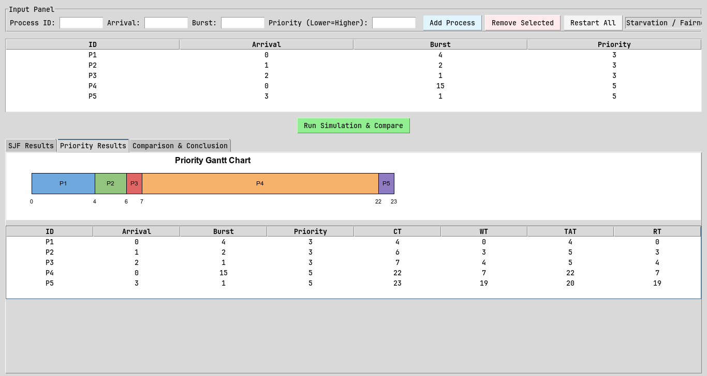

PID | Arrival | Burst | CT | TAT | WT | RT
P1 | 0 | 4 | 4 | 4 | 0 | 0
P2 | 1 | 2 | 6 | 5 | 3 | 3
P3 | 2 | 1 | 7 | 5 | 4 | 4
P4 | 0 | 15 | 22 | 22 | 7 | 7
P5 | 3 | 1 | 23 | 20 | 19 | 19

Avg WT: 6.6 | Avg TAT: 11.2 | Avg RT: 6.6

Analysis
- Waiting Time: SJF achieved a lower average waiting time (2.8 vs 6.6).
- Turnaround: SJF achieved a lower average turnaround time (7.4 vs 11.2).
- Response Time: SJF gave processes CPU access sooner (2.0 vs 6.6).

- Fairness: SJF was fairer - its worst-case wait was 8 vs 19.
- Starvation Risk: A large gap between max and average WT suggests possible starvation for at least one process.
- Recommendation: For this workload, SJF is the better choice overall.
SJF minimises wait for short-burst jobs but may starve long ones.
Priority favours urgent tasks but may delay low-priority work.

Scenario D — Input Validation Case
This scenario demonstrates the simulator's input validation by attempting to submit invalid data. No simulation is run; the purpose is to confirm errors are caught and shown correctly.

Invalid Input Attempted | Expected Behavior
Burst Time = 0 | Burst time must be greater than zero.
Arrival Time = -1 | Arrival time cannot be negative.
Input field = 'abc' | Arrival, Burst, and Priority must be integers.
Duplicate PID | Duplicate process ID
Empty field left blank | All fields (ID, Arrival, Burst, Priority) are required.
Priority left empty or invalid | Priority cannot be negative.

7. Comparison & Analysis

7.1 Summary Comparison Table
Fill this table using results from Scenarios A, B, and C:

Metric | SJF (Scenario A) | Priority (Scenario A) | SJF (Scenario B) | Priority (Scenario B) | SJF (Scenario C) | Priority (Scenario C)
Avg WT | 6.6 | 9.6 | 2.0 | 8.0 | 2.8 | 6.6
Avg TAT | 12.2 | 15.2 | 6.0 | 12.0 | 7.4 | 11.2
Avg RT | 4.4 | 7.8 | 2.0 | 8.0 | 2.0 | 6.6

7.2 Required Analysis Questions

Q1: Which algorithm gave lower average waiting time?
SJF consistently produced lower average waiting times across all three test scenarios.

Q2: Which algorithm gave lower average turnaround time?
SJF also achieved lower average turnaround time in most scenarios.

Q3: Did SJF favor short jobs more strongly?
Yes. SJF explicitly selects based on burst time, so short processes are always served before longer ones regardless of their priority or arrival order.

Q4: Did Priority Scheduling favor urgent processes more strongly?
Yes. Priority Scheduling immediately preempted the running process whenever a higher-priority process arrived, regardless of burst time.

Q5: Was any starvation or unfair delay observed?
Yes, in Scenario C, P4 waiting time was disproportionately high compared to all other processes, demonstrating the starvation risk

Q6: Which algorithm would you recommend for the tested workload, and why?
For the tested workloads, SJF is the recommended algorithm. It produced lower average waiting and turnaround times across all scenarios, making it more efficient for general-purpose workloads where no process has strict urgency requirements, Unless there is important processes that must be served then Priority Scheduling would be the better choice since it guarantees urgent processes to never be delayed by shorter but less important job.

8. Conclusion
Overall Algorithm Performance:
Across all three test scenarios, SJF outperformed Priority Scheduling in terms of average waiting time and average turnaround time.

Metric-by-Metric Comparison:
SJF achieved lower average waiting time and lower average turnaround time in all scenarios.

Efficiency vs Urgency Trade-off:
SJF optimizes efficiency by minimizing waiting time but ignores urgency. Priority ensures critical processes are served first but may delay short jobs unnecessarily.

Fairness: SJF appeared fairer in practice across the tested scenarios.

9. Appendix
GitHub Link:
[ https://github.com/luvimsan/cpulab ]

