Test Case Scenarios

Scenario A: Basic Mixed Workload
A normal workload with different arrival times and burst times to verify basic correctness of both algorithms.

Input Data
PID | Arrival Time | Burst Time | Priority
P1 | 0 | 8 | 3
P2 | 1 | 4 | 1
P3 | 2 | 9 | 4
P4 | 3 | 5 | 2
P5 | 4 | 2 | 5

SJF Results
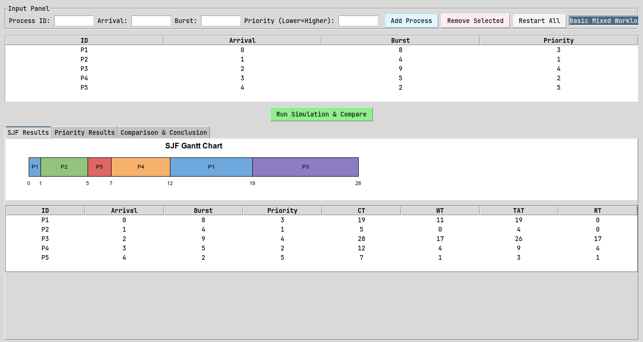

PID | Arrival | Burst | CT | WT | TAT | RT
P1 | 0 | 8 | 19 | 11 | 19 | 0
P2 | 1 | 4 | 5 | 0 | 4 | 0
P3 | 2 | 9 | 28 | 17 | 26 | 17
P4 | 3 | 5 | 12 | 4 | 9 | 4
P5 | 4 | 2 | 7 | 1 | 3 | 1

Avg WT: 6.6 | Avg TAT: 12.2 | Avg RT: 4.4

Priority Scheduling Results
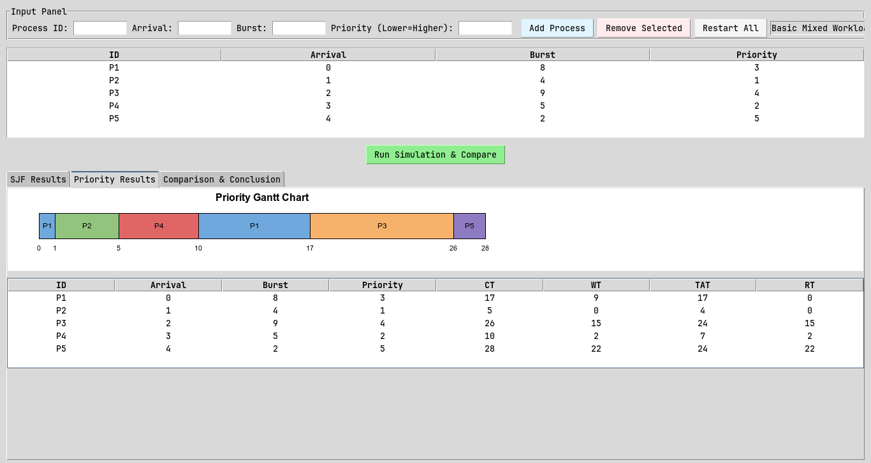

PID | Arrival | Burst | CT | WT | TAT | RT
P1 | 0 | 8 | 17 | 9 | 17 | 0
P2 | 1 | 4 | 5 | 0 | 4 | 0
P3 | 2 | 9 | 26 | 15 | 24 | 15
P4 | 3 | 5 | 10 | 2 | 7 | 2
P5 | 4 | 2 | 28 | 22 | 24 | 22

Avg WT: 9.6 | Avg TAT: 15.2 | Avg RT: 7.8

Analysis
- Waiting Time: SJF achieved a lower average waiting time (6.6 vs 9.6).
- Turnaround: SJF achieved a lower average turnaround time (12.2 vs 15.2).
- Response Time: SJF gave processes CPU access sooner (4.4 vs 7.8).

- Fairness: SJF was fairer - its worst-case wait was 17 vs 22.
- Starvation Risk: A large gap between max and average WT suggests possible starvation for at least one process.

- Recommendation: For this workload, SJF is the better choice overall.
SJF minimizes wait for short-burst jobs but may starve long ones.
Priority favors urgent tasks but may delay low-priority work.

Scenario B: Conflict Between Burst Time and Priority
A workload designed to reveal a meaningful difference: a short-burst process has low priority, while a long-burst process has high priority.

Input Data
PID | Arrival Time | Burst Time | Priority
P1 | 0 | 2 | 5
P2 | 0 | 10 | 1
P3 | 1 | 3 | 4
P4 | 2 | 1 | 3

SJF Results
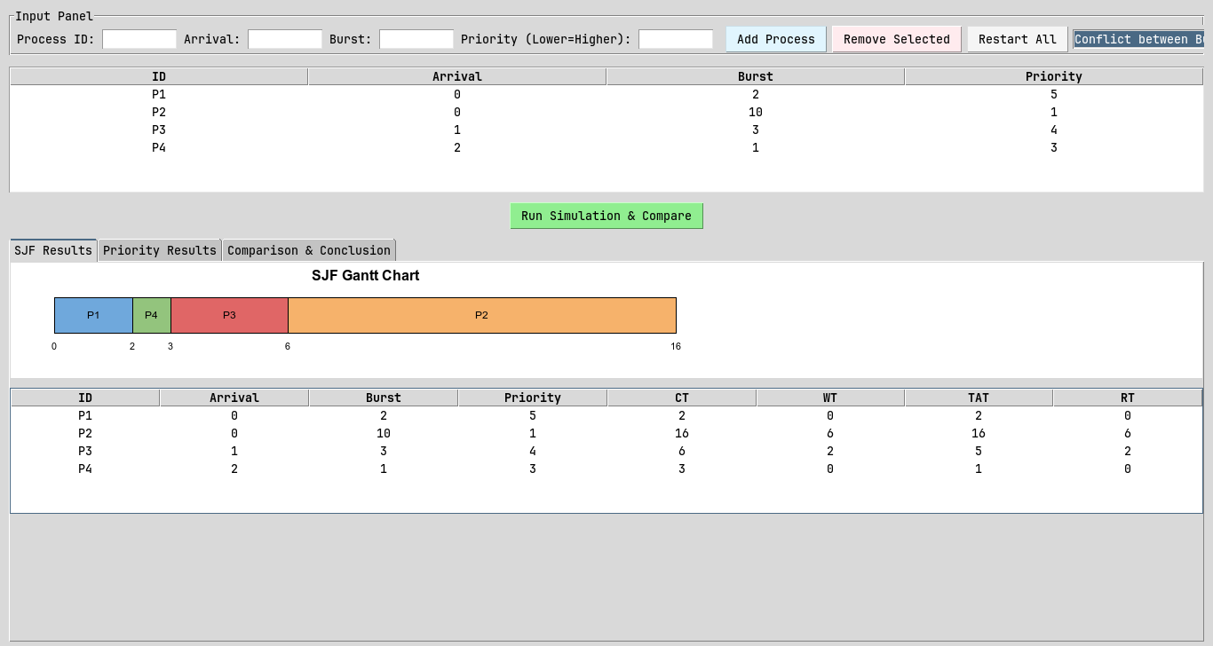

PID | Arrival | Burst | CT | TAT | WT | RT
P1 | 0 | 2 | 2 | 2 | 0 | 0
P2 | 0 | 10 | 16 | 16 | 6 | 6
P3 | 1 | 3 | 6 | 5 | 2 | 2
P4 | 2 | 1 | 3 | 1 | 0 | 0

Avg WT: 2.0 | Avg TAT: 6.0 | Avg RT: 2.0

Priority Scheduling Results
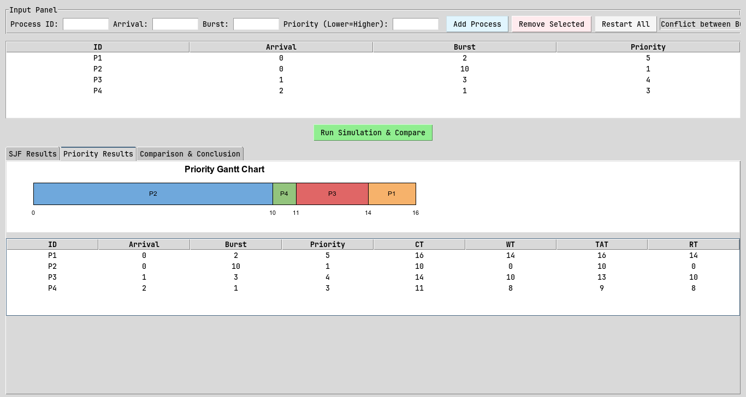

PID | Arrival | Burst | CT | TAT | WT | RT
P1 | 0 | 2 | 16 | 16 | 14 | 14
P2 | 0 | 10 | 10 | 10 | 0 | 0
P3 | 1 | 3 | 14 | 13 | 10 | 10
P4 | 2 | 1 | 11 | 9 | 8 | 8

Avg WT: 8.0 | Avg TAT: 12.0 | Avg RT: 8.0

Analysis
- Waiting Time: SJF achieved a lower average waiting time (2.0 vs 8.0).
- Turnaround: SJF achieved a lower average turnaround time (6.0 vs 12.0).
- Response Time: SJF gave processes CPU access sooner (2.0 vs 8.0).

- Fairness: SJF was fairer - its worst-case wait was 6 vs 14.
- Starvation Risk: A large gap between max and average WT suggests possible starvation for at least one process.

- Recommendation: For this workload, SJF is the better choice overall.
SJF minimises wait for short-burst jobs but may starve long ones.
Priority favours urgent tasks but may delay low-priority work.

Scenario C: Starvation / Fairness Case
A workload where one process may wait much longer under one of the algorithms, demonstrating unfair delay or starvation.

Input Data
PID | Arrival Time | Burst Time | Priority
P1 | 0 | 4 | 3
P2 | 1 | 2 | 3
P3 | 2 | 1 | 3
P4 | 0 | 15 | 5
P5 | 3 | 1 | 3

SJF Results
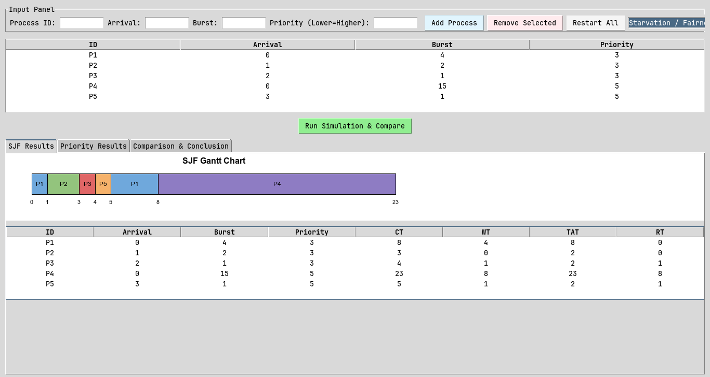

PID | Arrival | Burst | CT | TAT | WT | RT
P1 | 0 | 4 | 8 | 8 | 4 | 0
P2 | 1 | 2 | 3 | 2 | 0 | 0
P3 | 2 | 1 | 4 | 2 | 1 | 1
P4 | 0 | 15 | 23 | 23 | 8 | 8
P5 | 3 | 1 | 5 | 2 | 1 | 1

Avg WT: 2.8 | Avg TAT: 7.4 | Avg RT: 2.0

Priority Scheduling Results
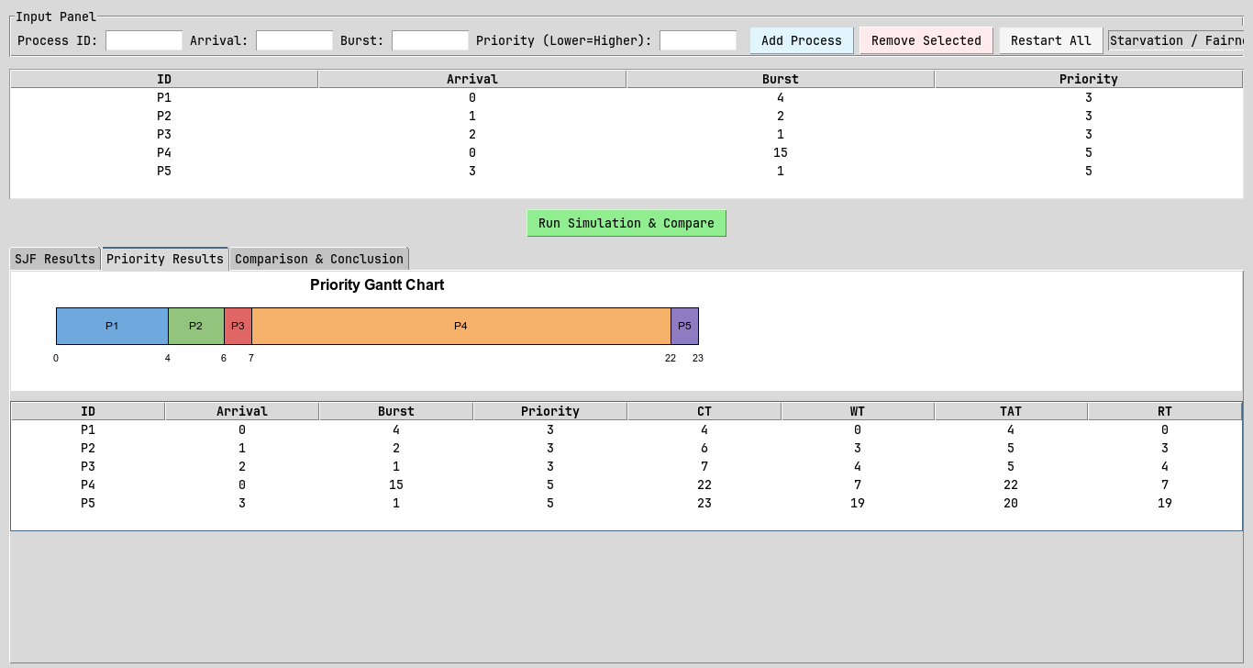

PID | Arrival | Burst | CT | TAT | WT | RT
P1 | 0 | 4 | 4 | 4 | 0 | 0
P2 | 1 | 2 | 6 | 5 | 3 | 3
P3 | 2 | 1 | 7 | 5 | 4 | 4
P4 | 0 | 15 | 22 | 22 | 7 | 7
P5 | 3 | 1 | 23 | 20 | 19 | 19

Avg WT: 6.6 | Avg TAT: 11.2 | Avg RT: 6.6

Analysis
- Waiting Time: SJF achieved a lower average waiting time (2.8 vs 6.6).
- Turnaround: SJF achieved a lower average turnaround time (7.4 vs 11.2).
- Response Time: SJF gave processes CPU access sooner (2.0 vs 6.6).

- Fairness: SJF was fairer - its worst-case wait was 8 vs 19.
- Starvation Risk: A large gap between max and average WT suggests possible starvation for at least one process.
- Recommendation: For this workload, SJF is the better choice overall.
SJF minimises wait for short-burst jobs but may starve long ones.
Priority favours urgent tasks but may delay low-priority work.

Scenario D: Input Validation Case
This scenario demonstrates the simulator's input validation by attempting to submit invalid data. No simulation is run; the purpose is to confirm errors are caught and shown correctly.

Invalid Input Attempted | Expected Behavior
Burst Time = 0 | Burst time must be greater than zero.
Arrival Time = -1 | Arrival time cannot be negative.
Input field = 'abc' | Arrival, Burst, and Priority must be integers.
Duplicate PID | Duplicate process ID
Empty field left blank | All fields (ID, Arrival, Burst, Priority) are required.
Priority left empty or invalid | Priority cannot be negative.

