# Text Analysis on “Hawaiian Pizza”

Serina Brenner

## Word Clouds

Below we see unigram, bigram, and trigram word clouds for the 2,000 most recent tweets about “Hawaiian Pizza” respectively.

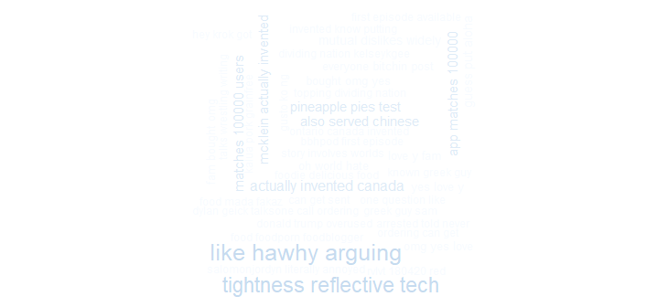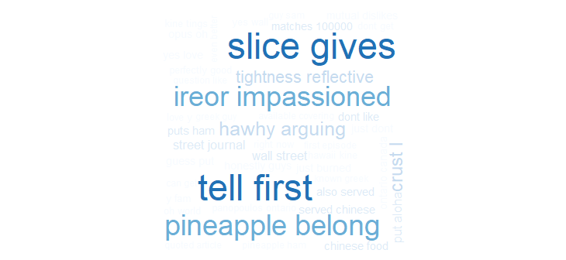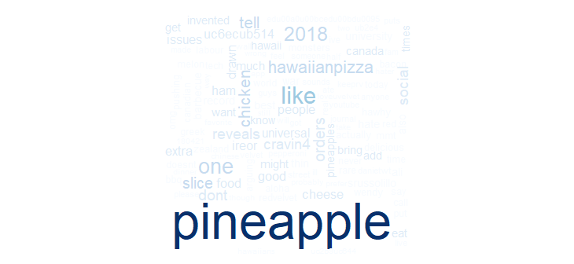

Below we see unigram, bigram, and trigram word clouds created using inverse document frequencies.

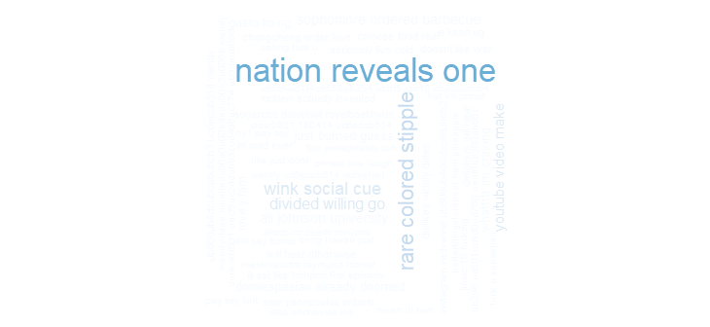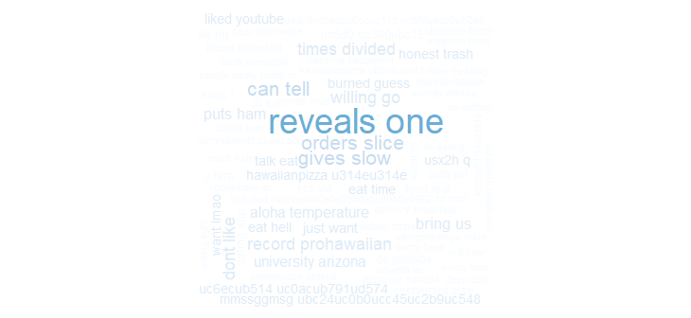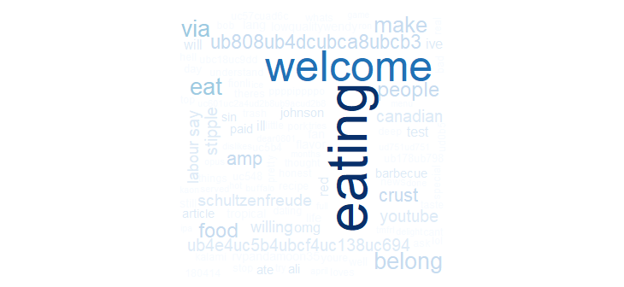

## Sentiment Analysis

Below is a graph displaying the sentiment analysis of the tweets scraped.

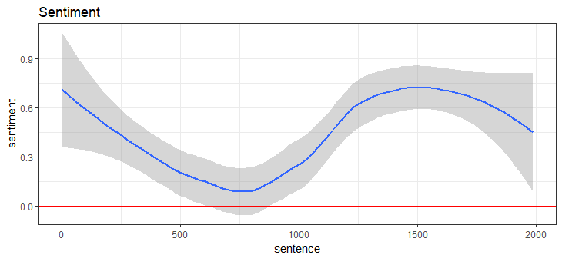

## Comparison and Commonality Clouds

Below are the comparison and commonality clouds respectively. The comparison shows the differences between negative and positive words found in these tweets. The commonality cloud shows the similarities the negative and positive tweets share. Labels were added to the comparison cloud to show the ratios between the positive and negative sentiments.

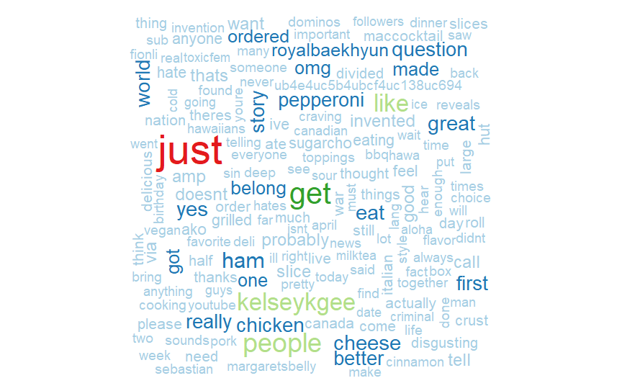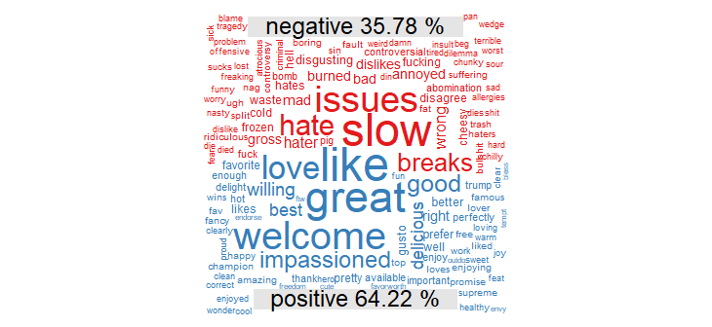

## Radar Chart

Below is a radar chart of the 2,000 tweets. This shows the emotions displayed in the tweets scraped. As you can see the most common emotion for Hawaiian pizza is love.

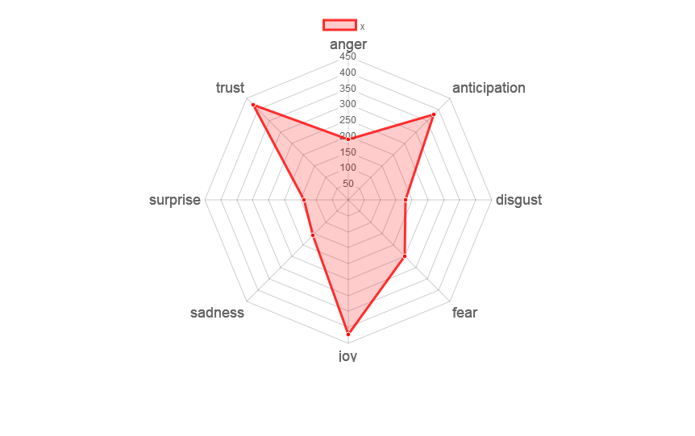

## Extra

I decided the radar chart did not show me enough and wanted to explore the emotions more in depth and see what makes up these segments of the radar chart. In order to do this, I used the code for the comparison cloud and created one representing every segment of the radar chart. I used labels to show the breakup of each emotion more clearly than the radar chart, and the colors help separate the different emotions.

