Minimum Spanning Trees HW

**Instructions:** A graph is given. Identify if a Minimum Spanning Tree exists, and then highlight the graph, starting at node 0. If a minimum spanning tree does not exist, explain why.

Answer Key is attached on back.

**Graph 1:**

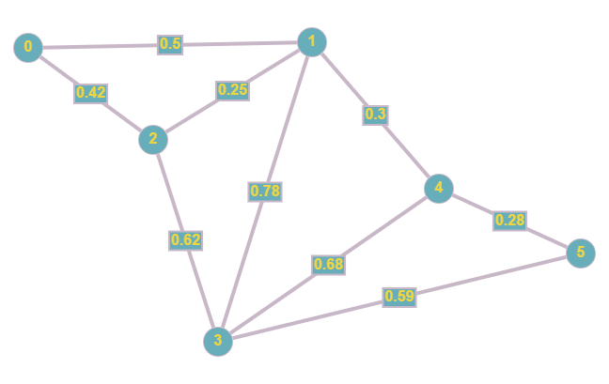

**Graph 2:**

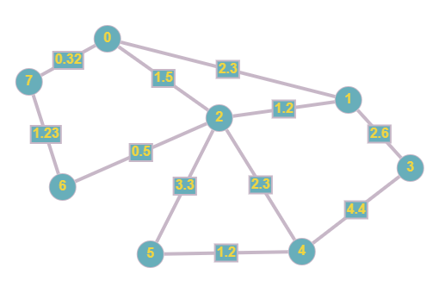

**Graph 3:**

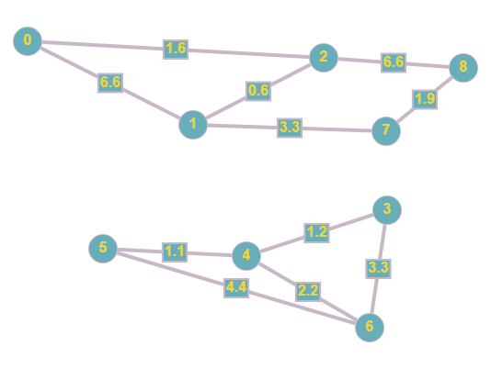

**Graph 4:**

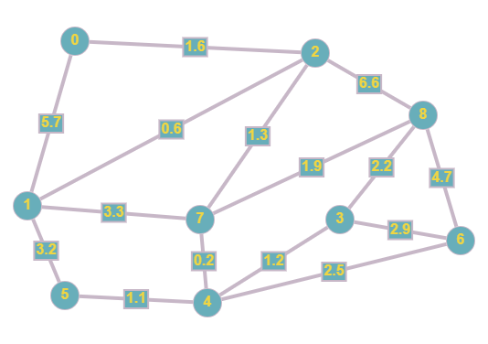

**Graph 5:**

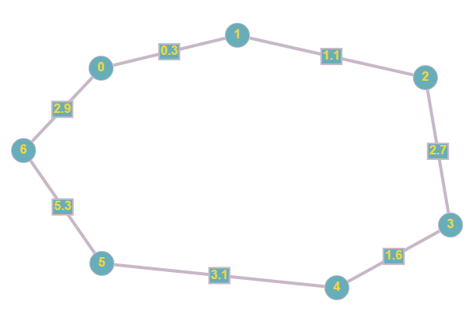

**Answer Key:**

MST Graph of Graph 1:

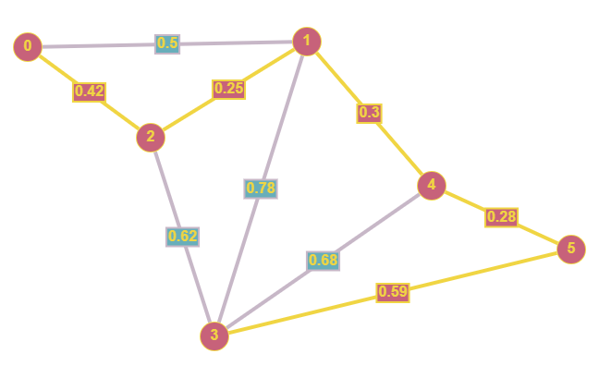

MST Graph of Graph 2:

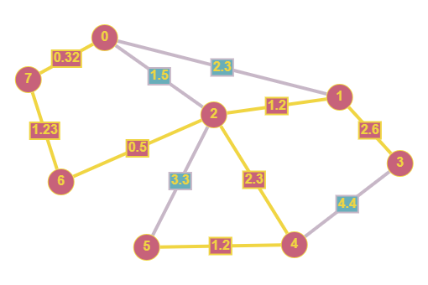

MST Graph of Graph 3:  
Graph 3 does not have a MST. It is a forest. The minimum spanning tree must be across a single connected component.

MST Graph of Graph 4:

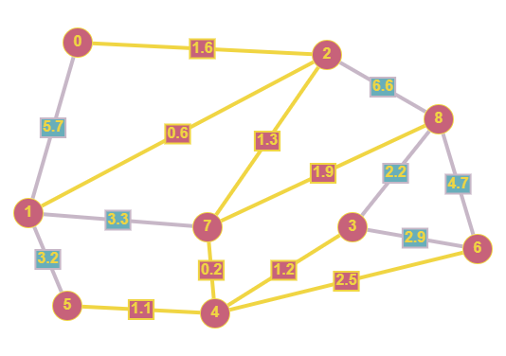

MST Graph of Graph 5:

Graph 5 is a single cycle. A minimum spanning tree cannot exist in a single cycle.