**Team members:**

Efrem Tekle (109623)

Daniel Abraha (109548 )

Luwam Tesfamariam (109410)

Suresh Prajapati (109524)

Sunena Gwachha (109578)

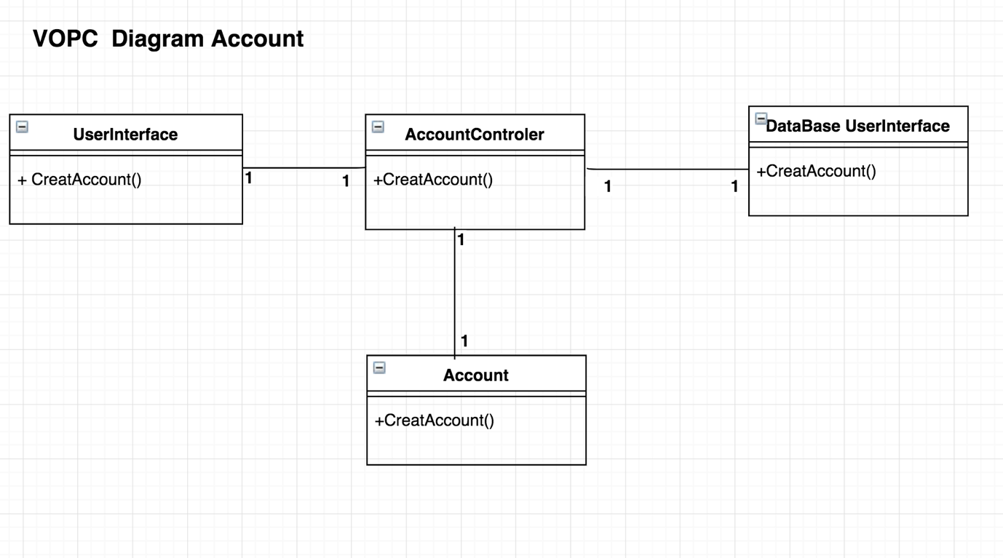

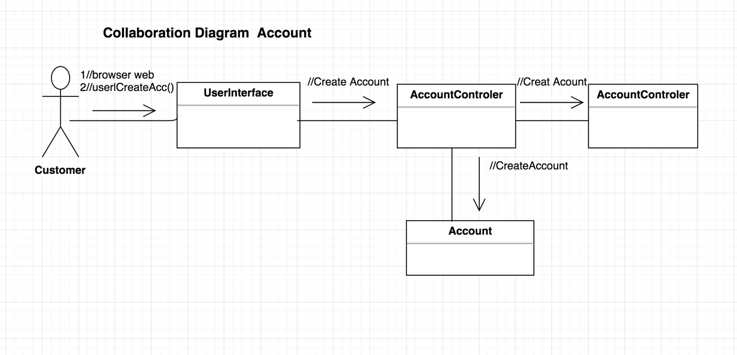

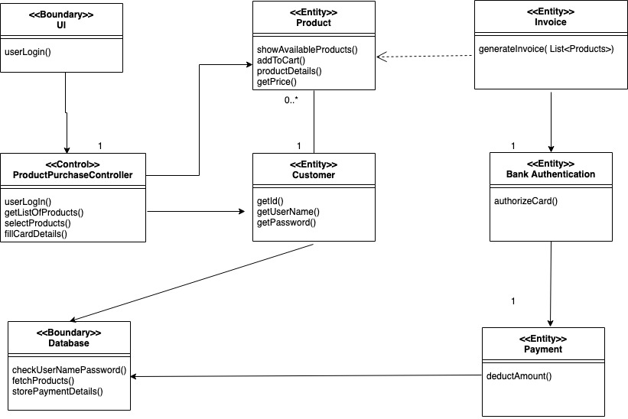

Fig. VOPC diagram for product purchase

