Documentation for Docker

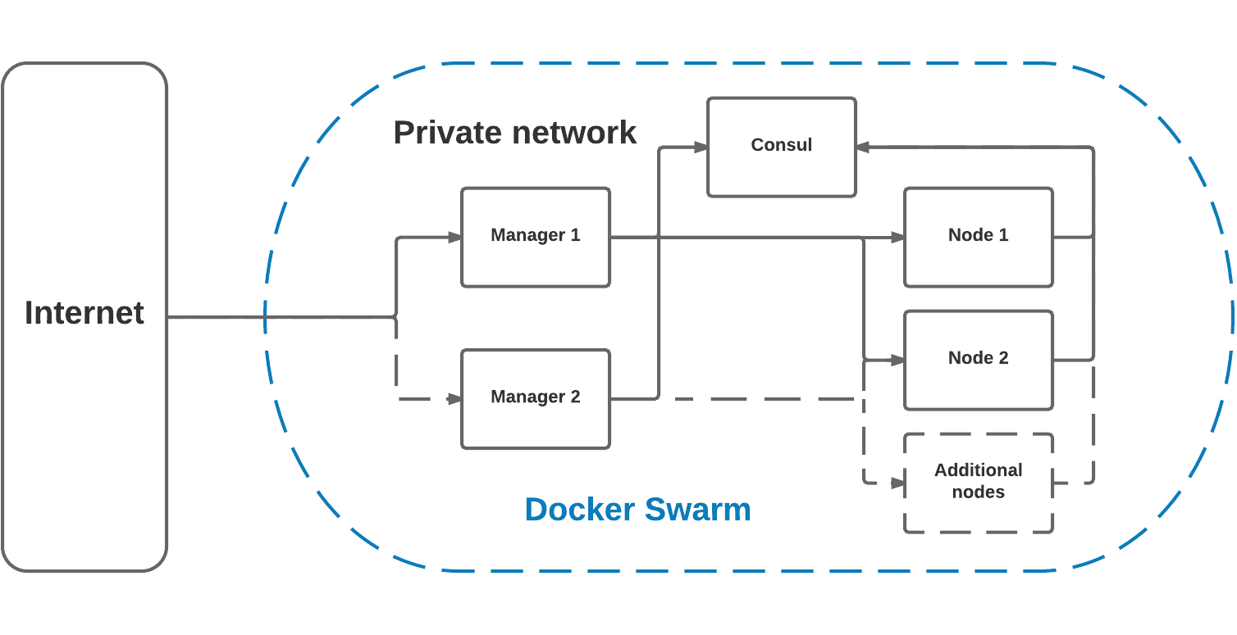

## **EpigenomeBrowser**

<https://epigenomegateway.readthedocs.io/en/latest/installation.html#use-docker>

|  |  |
| --- | --- |
| Command | Explanation |
|  | docker run -it -p 3000:3000 epgg/eg-react |
| cd eg-react/frontend  npm star  docker exec -it <container id> /bin/bash | docker container ls  docker container stop 1fa4ab2cf395 |
| save container as new image  $ docker commit <container_id> new_image_name:tag_name(optional) | docker tag friendlyhello gordon/get-started:part2  docker push username/repository:tag |
|  |  |
|  |  |
|  |  |
|  |  |
|  |  |

## **Sample**

|  |  |
| --- | --- |
| Command | Explanation |
|  | head $(find -name metrics_summary.csv) | sed -e 's/,,/, ,/g' | column -s, -t > summary.log |
|  |  |
|  |  |
|  |  |
|  |  |
|  |  |
|  |  |
|  |  |