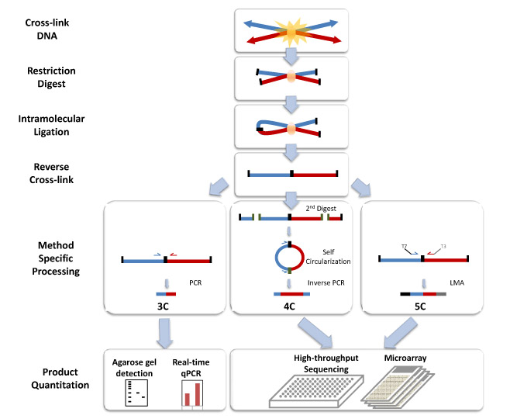

**Six steps:**

1. Crosslinking cells with formaldehyde
2. Digesting the DNA with a restriction enzyme that leaves sticky ends
3. Filling in the sticky ends and marking them with biotin
4. Ligating the crosslinked fragments
5. Shearing the resulting DNA and pulling down the fragments with biotin
6. Sequencing the pulled down fragments using paired-end reads.

