Documentation for Mysql

Setting in linux: <https://blog.csdn.net/skh2015java/article/details/80156278>

## **Sample**

|  |  |
| --- | --- |
| Command | Explanation |
|  | head $(find -name metrics_summary.csv) | sed -e 's,,/, ,/g' | column -s, -t > summary.log |
| sudo netstat -lntp | *# look for listening on the port* |
| sudo ps -aux | grep 'rserver' | *look for the rserver process* |
| sudo cat /var/log/syslog | Tar -xvz a.tar.gz |
|  |  |
|  |  |
|  |  |
|  |  |
|  |  |

## **Command**

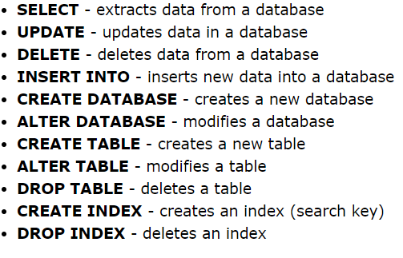

**SELECT:**

|  |  |
| --- | --- |
| SELECT DISTINCT column1, column2, ... | SELECT COUNT(DISTINCT Country) |
| IS NULL / IS NOT NULL |  |

SELECT column1, column2, ... FROM table_name  
WHERE condition1 AND (condition2 OR condition3) **NOT** condition4 ...; ORDER BY column1 ASC, column2 DESC;

**Command:**

|  |  |
| --- | --- |
| UPDATE table_name SET column1 = value1, ... WHERE condition; | |
| DELETE FROM table_name WHERE condition; |  |
| SELECT TOP number column_name(s) FROM table_name WHERE condition; | |
| MIN(), MAX() ## SELECT MIN(Price) AS SmallestPrice FROM Products; | |
| COUNT(), AVG(), SUM() ||  LIKE : MS (*) == (%), and (?) ==(_) for RegEx | |

**# Insert into:**

|  |
| --- |
| INSERT INTO table_name (column1, ...) VALUES (value1, ...); |
|  |

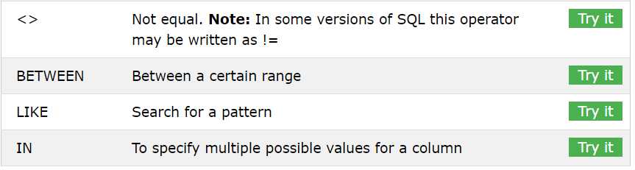

|  |  |
| --- | --- |
|  |  |
|  |  |
|  |  |

## **Single cell**

|  |  |
| --- | --- |
| Check summary | head $(find -name metrics_summary.csv) | sed -e 's/,,/, ,/g' | column -s, -t > summary.log |
|  |  |
|  |  |
|  |  |
|  |  |
|  |  |
|  |  |
|  |  |