

**Real estate project sales system through agency channel**

**Software Requirement Document**

– HoChiMinh, March 2024 –

**Table of Contents**

Record of Changes 4

Definition and Acronyms 5

I. Introduction 6

1. Product Background 6

2. Existing Systems 6

3. Business Opportunity 7

4. Software Product Vision 7

5. Major Features 8

6. Limitations and Exclusions 8

II. Overall Description 8

1. Product Overview 8

2. Business Process 10

III. User Requirements 13

1. Actors 13

2. Use Cases 13

2.1 Diagram 14

2.2 Descriptions 15

3. Business Rules 63

IV. Functional Requirements 64

1. System Functional Overview 64

1.1 Screen Flow 64

1.2 Screen Descriptions 67

1.3 Screen Authorization 68

1.4 Non-Screen Functions 69

2. Data Requirements 70

2.1 Logical Data Model 70

2.2 Data Dictionary 70

2.3 Reports 73

2.4 State transition diagram 77

3. Information page introducing real estate projects of investors 78

3.1 Investor_Add new Project 78

3.2 Investor_View Project 79

3.3 Project 80

4. The function allows investors to distribute real estate to sales agent channels 82

4.1 Real Estate Distribution Dashboard 82

4.2 Agent Channel Distribution 83

5. Dashboard & revenue statistics report, project, ... 84

5.1 Investor Dashboard 84

5.2 Revenue Statistics Report 85

6. When implementing a sales opening, it allows the establishment of a method where customers are given priority to purchase based on reservation information (by time, random number draw, etc.) 86

6.1 Priority Reservation Processing 86

6.2 Customer Priority Lottery System 87

7. The feature allows agents to manage the entire sales process of real estate products from the time customers reserve, open sales, to the successful purchase. 88

7.1 Purchase Progress Tracking 88

V. Non-Functional Requirements 89

1. External Interface Requirements 89

1.1 User Interfaces 89

1.2 Software Interfaces 89

1.3 Hardware Interfaces 90

1.4 Communications Interfaces 91

2. Quality Attributes 92

2.1 Usability 92

2.2 Performance 93

2.3 Security 94

2.4 Safety 94

2.5 Availability 95

2.6 Reliability 95

2.7 Design Constraints 95

2.8 [Others as relevant] 95

# Record of Changes

| **Date** | **A* M, D** | **In charge** | **Change Description** |
| --- | --- | --- | --- |
|  |  |  |  |
|  |  |  |  |
|  |  |  |  |
|  |  |  |  |
|  |  |  |  |
|  |  |  |  |
|  |  |  |  |
|  |  |  |  |
|  |  |  |  |
|  |  |  |  |
|  |  |  |  |
|  |  |  |  |
|  |  |  |  |

*A - Added M - Modified D - Deleted

# Definition and Acronyms

*[Fill all the definitions, acronyms,… used within the document] in the table format as below]*

| **Acronym** | **Definition** |
| --- | --- |
| BA | Business Analysis |
| BR | Business Rule |
| ERD | Entity Relationship Diagram |
| GUI | Graphical User Interface |
| PM | Project Manager |
| SDD | Software Design Description |
| SPMP | Software Project Management Plan |
| SRS | Software Requirement Specification |
| UAT | User Acceptance Test |
| UC | Use Case |
| API | Application Program Interface |

# I. Introduction

## 1. Product Background

In today's real estate market context, product distribution through the agency model has become an important strategy. Real estate investors realize that focusing on promotion, project development and optimizing product quality is important. Therefore, the distribution model through agents to maximize market access and strengthen customer relationships is reasonable in the current context.

## 2. Existing Systems

<https://vinhomes.vn/vi>

System Actors:

Invester

Admin: List

Real Estate Agents: List

Clients/Buyers: Search and view property listings, communicate with agents, and participate in transactions.

Features:

Compare Real Estate: Compare different properties using many criteria through a table to make it easy to choose

Listing Management: Allows agents to upload, edit, and manage property listings with detailed descriptions and images.

Transaction Tracking: Facilitates the monitoring of real estate transactions from listing to closing, providing transparency for both agents and clients.

Communication Tools: Enables seamless communication between agents and clients within the platform, reducing the need for external communication channels.

Document Storage: Securely stores and organizes essential documents related to transactions, ensuring easy accessibility for authorized users.

Pros:

Comprehensive Functionality: Covers various aspects of real estate management, providing a holistic solution.

User-Friendly Interface: Offers an intuitive interface for both agents and clients, enhancing user experience.

Enhanced Communication: Centralizes communication, improving efficiency and reducing the likelihood of information gaps.

Cons:

Learning Curve: New users may require some time to familiarize themselves with the platform's extensive features.

## 3. Business Opportunity

While there are existing property management platforms, the proposed system distinguishes itself by focusing on a tiered agent-based distribution model. This approach allows for a more targeted and localized marketing strategy, enhancing the efficiency of property transactions. Unlike some generic systems, the proposed solution prioritizes collaboration with tier 1 agents and embraces the expertise of tier 2 agents to provide a more personalized and effective service. The increasing reliance on technology in the real estate sector aligns with the proposed system's emphasis on a digitalized, agent-centric approach. The demand for more efficient, transparent, and collaborative real estate solutions is a trend that the system capitalizes on, positioning itself as an innovative and adaptive platform in the market

## 4. Software Product Vision

Envisioning a future where property distribution is seamless and efficient, our software product is a cutting-edge platform designed for property developers, agents, and clients. The vision is to create a collaborative ecosystem, empowering tiered agents to optimize regional market strategies and enhancing the overall real estate experience.

This innovative software, leveraging an agent-based model, aims to revolutionize how properties are marketed and transacted. By centralizing communication, transaction tracking, and regional market insights, the product ensures a streamlined process for developers and a personalized experience for clients. It aspires to be the go-to solution that not only addresses existing market challenges but also adapts to the ever-evolving trends in the real estate industry

## 5. Major Features

FE-01: Investors can distribute assets to agents to sell to customers

FE-02: Investors can accept a company/individual as a level 1 agent to directly distribute real estate

FE-03: Admin manages general accounts such as adding, deleting, editing, blocking, unblocking

FE-04: Admins can view information using the dashboard to manage users and reports of the entire system

FE-05: An agency can receive its lower agents to distribute real estate received from the superior agency

FE-06: The agency can post real estate sales and set up customer asset management methods

FE-07: Users can view information of Invester as well as agencies in the system

FE-08: Users can book real estate that is in the process of allowing booking and directly buy real estate that is in the process of being opened for sale.

## 6. Limitations and Exclusions

LI-1: Does not process online transactions but is just a website so agents can post some real estate from investors for sale..

LI-2: The platform does not guarantee future market conditions or property value fluctuations.

LI-3:   The platform will not conduct physical property inspections or assessments, the actual value of the real estate will be agreed upon by the parties themselves

# II. Overall Description

## 1. Product Overview

While there are existing property management platforms, the proposed system distinguishes itself by focusing on a tiered agent-based distribution model. This approach allows for a more targeted and localized marketing strategy, enhancing the efficiency of property transactions.

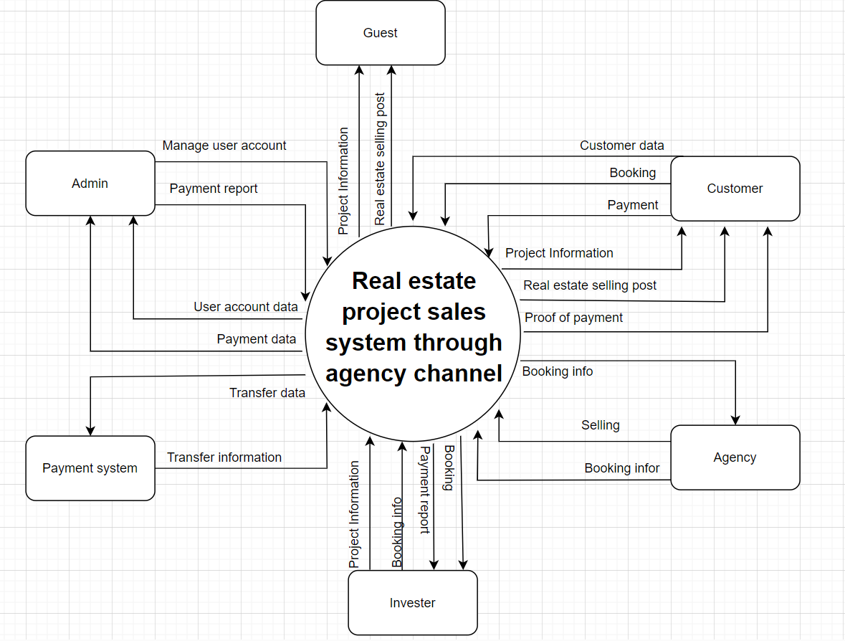

## 2. Business Process

Shows part of the real estate selling process, the investor's real estate selling model through an agent. The lanes in this example are the roles of each actor, indicating each group performing each step in the process to deliver real estate.

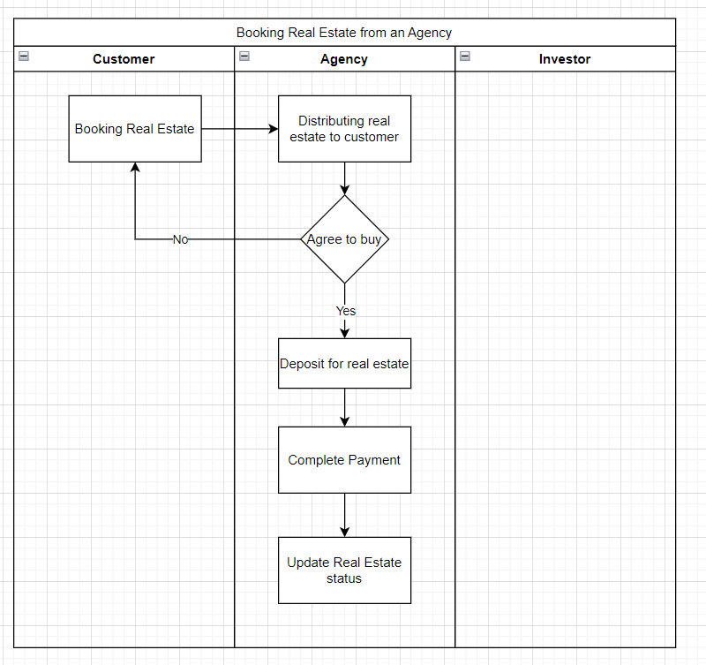

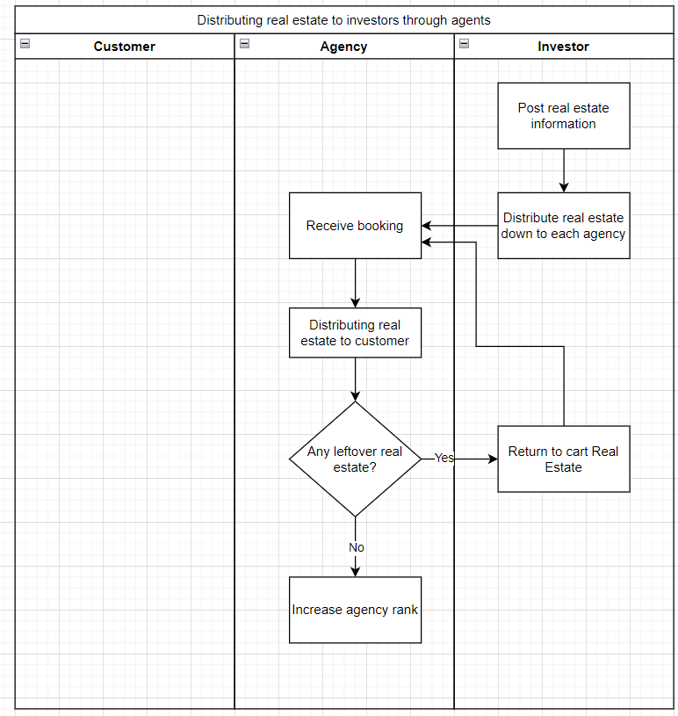

| **#** | **Process Step** | **Description** |
| --- | --- | --- |
| 1 | Booking Real Estate | Customers reserve real estate to view and buy |
| 2 | Distributing real estate to customer | Distributing real estate to customer |
| 3 | Deposit for real estate | Deposit a sum of money to hold the property |
| 4 | Complete Payment | Complete payments and paperwork of the real estate purchasing process |
| 5 | Update Real Estate status | Change the status of the real estate to sold if the transaction is completed, to open for sale if the transaction is canceled |

| **#** | **Process Step** | **Description** |
| --- | --- | --- |
| 1 | Post real estate information | Post detailed information about real estate on the homepage |
| 2 | Distribute real estate down to each agency | Each agency will distribute a number of real estate according to that agency's ranking |
| 3 | Receive booking | Receive viewing and purchasing information on real estate properties held by the agency |
| 4 | Return to cart Real Estate | The property will return to the shopping cart if not sold out to be sold in the next sales opening |
| 5 | Deposit for real estate | Deposit a sum of money to hold the property |
| 6 | Increase agency rank | Increase your rank if you sell all assigned properties in one sale to receive more properties in the next sale. |

# III. User Requirements

## 1. Actors

| **#** | **Actor** | **Description** |
| --- | --- | --- |
| 1 | Investor | The investor is the main manager of the system. Including creating projects, posting sales and receiving applications. Finally, they distribute orders to agents |
| 2 | Admin | The admin is the system operator, someone from the property development company or a designated representative managing the platform. They handle user management, property listings, content updates, and the overall maintenance of the platform to ensure smooth operations |
| 3 | Agency | The agency represents the real estate agents or brokers who are authorized to sell or lease properties on behalf of the investor. They use the system to manage their profiles, listings, client interactions, and sales processes. The system facilitates their daily operations, from property promotion to closing deals |
| 4 | Customer | Customers are potential buyers or tenants looking for properties. They utilise the system to browse listings, filter searches based on their preferences, communicate with agencies, schedule viewings, and eventually proceed with transactions |

## 2. Use Cases

### 2.1 Diagram

### 

### 2.2 Descriptions

| **ID** | **Use Case** | **Actors** | **Use Case Description** |
| --- | --- | --- | --- |
| UC-01 | Sign-up | Guest | This feature allows the actor to create a new customer account as public |
| UC-02 | Login | Investor, Admin, Agency, Customer | This feature allows the actor to login to the system to use features related to each role |
| UC-03 | Logout | Investor, Admin, Agency, Customer | This feature allows the actor to logout this account |
| UC-04 | Get real estate detail | Investor, Admin, Guest, Agency, Customer | This use case describes the process by which a project manager or team member obtains detailed information about a project from the project management system. |
| UC-05 | View realestate detail | Agency | The agency can view detail of real estate. |
| UC-06 | Change status reservation | Agency | The Agency can change status of reservation after finished. |
| UC-07 | Check contract | Agency | Agency can check contract and then update image of contract on web for admin. |
| UC-08 | View reservation history | Agency | The agency can view reservation history to verify and ensure accuracy. They can review details such as booking information, transaction history and other related information to navigate and manage their booking information effectively. |
| UC-09 | View customer reservation | Agency | The agency can view details such as customer profile information. |
| UC-10 | Confirm booking | Agency | Confirm and manage the booking process |
| UC-11 | View real estate | Customer | Customer view real estate suitable for purpose |
| UC-12 | Create reservation view real estate | Customer | Customer after find out real estate suitable for purpose they will click create reservation for view villa in reality with agency |
| UC-13 | Create Account | Customer | Customer create account for login into web and using service |
| UC-14 | View history reservation | Customer | Customers can check the history of reservation |
| UC-15 | Cancel Reservation | Customer | Customers use the "Cancel reservation" function to terminate an existing reservation slot for a real estate property. This involves selecting the reservation to be cancelled and confirming the cancellation. |
| UC-16 | Edit profile | Customer | Customer can edit their profile about password, address. |
| UC-17 | View profile | Investor | An Investor wants to view their personal information to verify and ensure accuracy. They can review details such as account information, transaction history, and other relevant information to navigate and manage their personal information effectively. |
| UC-18 | View wallet | Investor | An Investor can view the wallet after banking for create real estate post on web |
| UC-19 | Find real estate  after create | Investor | An Investor can search real estate after create . |
| UC-20 | Create real estate post | Investor | An investor create real estate information |
| UC-21 | Banking for create real estate post | Investor | An investor have to deposit money for create real estate post |
| UC-22 | View real estate post history | Investor | An Investor wants to view detailed information about real estate posted and detail information and status . |
| UC-23 | Create agency account | Admin | Admin creates accounts for users based on the want to join agency |
| UC-24 | View account listing | Admin | Admin views the list of accounts so that they can manage and access account details |
| UC-25 | Manage agency account | Admin | Admins can grant or remove permissions to agency accounts so they can have agency channel permissions |
| UC-26 | Manage customer account | Admin | Admins can manage user accounts, to secure transactions, as well as avoid clone accounts created for fraudulent purposes through recorded activities |
| UC-27 | View dashboard | Admin | Admin can view reports on the number of users and guests to the site, as well as view reports on transactions by customer and agent channels and send them to the investor. |
| UC-28 | Lock/unlock account | Admin | Admin can lock an account when receiving bad feedback about that account or temporarily lock it to review for violations of terms on the site. |
| UC-29 | Create investor account | Admin | Admin can create an account for agence to provide an account for the agency to work and manage the agency account |
| UC-30 | Check information reservation | Admin | Admin check existed information before change success status |
| UC-31 | Change status reservation | Admin |  |
| UC-32 | Assign agency | Admin |  |

| ID and Name: | **UC-01 Sign-up** | | |
| --- | --- | --- | --- |
| Created By: | PhongNG | Date Created: | 01/28/2024 |
| Primary Actor: | Guest | Secondary Actors: | None |
| Description: | This feature allows the actor to create a new customer account as public | | |
| Trigger: | The actor wants to create a new customer account for login | | |
| Preconditions: | PRE-01. Actor has to be on login page  PRE-02. On login page, the actor clicks “Đăng ký” to create a new account | | |
| Postconditions: | POST-01. System creates a new customer account and stores it in the database. | | |
| Normal Flow: | 1. Sign-in in sign-in page 2. In sign-in page, actors clicks on “Đăng ký” button 3. System redirects to sign-up page with a form:  * Username: A string can’t be identical * Password: A String contains at least 8 characters * Confirm password: A string must be identical to password * Phone number: A string of number having 9-11 characters  1. Actor fills all attributes in the form 2. The customer accepts the terms and conditions. 3. Actor clicks “Đăng ký” [Exception] 4. System checks input information:  * Valid: System create new accounXt and redirects to login page * Invalid: System shows error message according to wrong filled attribute. | | |
| Alternative Flows: | None | | |
| Exceptions: | 1.0.E1. This account is Invalid   1. System requests the actor to enter the another Username 2. System requests the actor to enter password in the right format 3. System informs that the confirm password must match the password 4. System informs that the phone number has been used and requires another phone number | | |
| Priority: | High | | |
| Frequency of Use: | Very often, every time there is a new customer. | | |
| Business Rules: | * Username does not exist before * Password must not be empty and contains at least 8 characters * Password and confirm password must match to each other * Phone number has not been assigned to any account before. | | |
| Other Information: | None | | |
| Assumptions: |  | | |

| ID and Name: | **UC-02 Login** | | |
| --- | --- | --- | --- |
| Created By: | PhongNG | Date Created: | 01/28/2024 |
| Primary Actor: | Investor, Admin, Agency, Investor | Secondary Actors: | N/A |
| Description: | This feature allows the actor to login to the system to use features related to each role | | |
| Trigger: | The actor wants to login to the website so that Actor can use the specific features | | |
| Preconditions: | PRE-01. The actor has a signed-up account  PRE-02. The actor clicks on “Đăng nhập” on the navigation bar | | |
| Postconditions: | POST-01. System logs the actor into the account and redirects to the homepage | | |
| Normal Flow: | **2.0 Login by username and password**  1.      Actor clicks on “Đăng nhập” on navigation bar.  2.    System redirects the actor to login page and shows the login form which has:  -      Username: A string can’t be identical  -      Password: A string contains at least 8 characters  Login button  3.      Actor enters the username and password.  [Exception]  4.      Actor clicks “Đăng nhập” button  5.  System checks input information:  -      Valid: System logs the actor into account and redirects to homepage  Invalid: System shows error message “Incorrect username or password” | | |
| Alternative Flows: | 2.1 Login by gmail   1. Actor chooses login via Google 2. System shows the list of Google accounts of User 3. Actor chooses the account to login 4. System logs the user into account and redirects to homepage | | |
| Exceptions: | 2.0.E1 Actor enters wrong username or password -> System responses with a message “Incorrect username or password”  2.0.E2 If the user enters incorrect login information more than the allowed number of times -> the system will temporarily lock the account and require the user to contact customer support | | |
| Priority: | High | | |
| Frequency of Use: | Very often, every time a user wants to access areas that require authentication. | | |
| Business Rules: | -     Username must not be empty  -     Password must not be empty and contain at least 8 characters  -    The actor has to wait for 5 minutes when fail to login 5 times | | |
| Other Information: | None | | |

| ID and Name: | **UC-03 Logout** | | |
| --- | --- | --- | --- |
| Created By: | PhongNG | Date Created: | 01/28/2024 |
| Primary Actor: | Investor, Admin, Agency, Investor | Secondary Actors: | N/A |
| Description: | Allows users to securely log out of the system, preventing unauthorised access to their session. | | |
| Trigger: | The actor wants to log out of the account | | |
| Preconditions: | PRE-01.  The actor already logged in to the account | | |
| Postconditions: | POST-01. The user has logged out of the system and can no longer access areas that require authentication | | |
| Normal Flow: | **3.0 Logout authentication**  1.  The user selects "Log out" in the system's interface .  2.  The system confirms the logout request and asks if the user is sure he wants to logout  3.   The user confirms wants to log out.  4.  The system deletes or disables the user's authentication and session information  5.  The system redirects the user to the home page or login page  6.  The system displays a successful logout message. | | |
| Alternative Flows: | 3.1 No logout confirmation  If the user does not confirm that he wants to log out, the system will continue the session | | |
| Exceptions: | 3.0.E1 If an error occurs during the logout process, the system notifies the error and asks the user to try again | | |
| Priority: | Medium | | |
| Frequency of Use: | Frequently, every time the user wants to end his session. | | |
| Business Rules: | BR-01,BR-02 | | |
| Other Information: | Logging out may require notification to federated systems so they can also handle session termination | | |
| Assumptions: | Users can easily find the option to log out from any page of the system | | |

| ID and Name: | **UC-04 Get Investor Information** | | |
| --- | --- | --- | --- |
| Created By: | PhongNG | Date Created: | 01/28/2024 |
| Primary Actor: | Investor, Admin, Guest, Agency, Investor | Secondary Actors: | Database |
| Description: | This use case describes the process by which a financial analyst or investment manager retrieves information about an investor from the system. | | |
| Trigger: | The use case is initiated when an analyst needs to review or update an investor's profile or investment portfolio | | |
| Preconditions: | PRE-01 The user is authenticated and authorized to access investor information.  PRE-02 The investor's information is already present in the system. | | |
| Postconditions: | POST-01 The user has accessed the desired list investor information | | |
| Normal Flow: | 4.0 Get Investor information   1. The analyst navigates to the investor information section of the system. 2. The system retrieves and displays detailed information about the investor | | |
| Alternative Flows: | None | | |
| Exceptions: | None | | |
| Priority: | High | | |
| Frequency of Use: | Very often, every time there is a need to retrieve investor information. | | |
| Business Rules: | BR-02 | | |
| Other Information: | This feature is crucial for users (Investors, Admins, Guests, and Agencies) to obtain accurate and up-to-date information about a specific investor, facilitating various interactions within the system. | | |
| Assumptions: | none | | |

| ID and Name: | **UC-05 Filter Project** | | |
| --- | --- | --- | --- |
| Created By: | PhongNG | Date Created: | 01/28/2024 |
| Primary Actor: | Investor, Admin, Guest, Agency, Investor | Secondary Actors: | Database/Filter Engine |
| Description: | This use case outlines the process by which a user filters search results to find properties that match their specific criteria. | | |
| Trigger: | This use case is triggered when a user wishes to narrow down a list of properties to those that fit certain parameters | | |
| Preconditions: | PRE-01 The user is on the property search page.  PRE-02 A list of properties is already displayed. | | |
| Postconditions: | POST-01 The user is presented with a list of properties that match the filter criteria | | |
| Normal Flow: | **5.0 Filter Project**     1. The user clicks on the filter button or link in the property search section. 2. The system presents various filter criteria (e.g., location, price range, property type, square footage). 3. The user selects or inputs desired criteria for the property search. 4. The user submits the filter request. 5. The system processes the request and updates the list of properties to only include those that meet the criteria. 6. The user reviews the filtered property results. | | |
| Alternative Flows: | **5.1** Filter Project   1. If no properties match the criteria, the system notifies the user and suggests broadening the search criteria 2. The user can modify filter criteria and re-submit the search as many times as needed | | |
| Exceptions: | 5.0.E1 If the system fails to process the filter request, an error message is displayed, and the user is prompted to try again (5.1) | | |
| Priority: | High | | |
| Frequency of Use: | Frequently used by users looking for specific real estate properties based on custom criteria. | | |
| Business Rules: | BR-02 | | |
| Other Information: | This feature enhances the user experience by allowing them to find real estate properties that match their specific preferences and requirements. | | |
| Assumptions: | none | | |

| ID and Name: | **UC-06 Get Project Detail** | | |
| --- | --- | --- | --- |
| Created By: | PhongNG | Date Created: | 01/28/2024 |
| Primary Actor: | Investor, Admin, Guest, Agency, Investor | Secondary Actors: | Database |
| Description: | This use case describes the process by which a project manager or team member obtains detailed information about a project from the project management system. | | |
| Trigger: | The use case is initiated when a user needs to view the specifics of a project, such as scope, status, timelines, resources, and other pertinent details | | |
| Preconditions: | PRE-01 The user has been authenticated and authorised to access the project information.  PRE-02 The project exists within the project management system  PRE-03 The user has filtered and found the project in the project list  PRE-04 The user has filtered and found the project in the project list | | |
| Postconditions: | POST-01 The user has accessed the detailed information of the specified project | | |
| Normal Flow: | **6.0 Get Project Detail**   1. The user logs into the project management system. 2. The user navigates to the list of available projects. 3. The user selects a project from the list. 4. The system displays a summary of the project. 5. The user requests to view detailed information by clicking on the project summary. 6. The system retrieves and presents detailed information about the project. | | |
| Alternative Flows: | 6.1 **Get Project Detail**   1. If the project is not found, the system notifies the user and prompts to search again. 2. If the user does not have permission to view the project details, the system displays an authorization error. | | |
| Exceptions: | 6.0.E1. If there is an error in retrieving the project details due to a system issue, an error message is displayed. (6.1) | | |
| Priority: | High | | |
| Frequency of Use: | Very often, every time there is a need to retrieve detailed information about a real estate project. | | |
| Business Rules: | BR-02 | | |
| Other Information: | This feature is essential for users (Investors, Admins, Guests, and Agencies) to obtain in-depth information about a specific real estate project, aiding decision-making and interactions within the system. | | |
| Assumptions: | none | | |

| ID and Name: | UC-07 Search Filter Agency | | |
| --- | --- | --- | --- |
| Created By: | PhongNG | Date Created: | 01/28/2024 |
| Primary Actor: | Investor, Admin, Guest, Agency, Investor | Secondary Actors: | Database/Search Engine |
| Description: | This use case details the functionality that allows a user to apply search filters to an agency listing to refine the results based on specific attributes such as location, services offered, agency size, or ratings. | | |
| Trigger: | The use case is initiated when a user needs to search for agencies that meet specific operational, geographical, or service-related requirements | | |
| Preconditions: | PRE-01 The user has access to the system and is authenticated if necessary.  PRE-02 A list of agencies is available for searching and filtering. | | |
| Postconditions: | POST-01 The user is presented with a list of agencies that correspond to the applied search filters | | |
| Normal Flow: | 7.0 Search Filter Agency     1. The user accesses the agency search interface. 2. The system displays options for various search filters. 3. The user selects the desired filters, such as location, service type, size, or rating and search by name. 4. The user applies the filters and initiates the search. 5. The system processes the search criteria and displays a list of agencies that match the filters. | | |
| Alternative Flows: | 7.1 Search Filter Agency   1. If no agencies meet the criteria, the system notifies the user to adjust the filters. 2. The user can clear all filters to restart the search process. | | |
| Exceptions: | 7.0 E1 If there is a system error or inability to access the agency database, an error message is displayed. (7.1) | | |
| Priority: | High | | |
| Frequency of Use: | Frequently used by users looking for real estate agencies based on specific criteria. | | |
| Business Rules: | BR-02 | | |
| Other Information: | This feature enhances the user experience by allowing them to find real estate agencies that match their specific preferences and requirements. | | |
| Assumptions: | none | | |

| ID and Name: | **UC-08 Get Agency Information** | | |
| --- | --- | --- | --- |
| Created By: | PhongNG | Date Created: | 01/28/2024 |
| Primary Actor: | Investor, Admin, Guest, Agency, Investor | Secondary Actors: | Database |
| Description: | This use case describes the process that a user follows to obtain detailed information about an agency, including its services, contact details, performance ratings, regulatory compliance status, and any other relevant data. | | |
| Trigger: | The use case is activated when a user needs to view or verify detailed information about an agency. | | |
| Preconditions: | PRE-01 The user is logged into the system and has the necessary permissions to access detailed agency information.  PRE-02 The agency's data is already present and up-to-date within the system. | | |
| Postconditions: | POST-01 The user has accessed the detailed information for the specified agency. | | |
| Normal Flow: | 8.0 Get Agency Information     1. The user navigates to the agency information section within the system. 2. The user inputs the name or identifier of the agency into the search field. 3. The system presents a list of agencies that match the search criteria. 4. The user selects the desired agency from the list. 5. The system retrieves and displays comprehensive information about the selected agency. | | |
| Alternative Flows: | 8.1  Get Agency Information  If the agency is not found, the system notifies the user, and they may modify the search criteria.  If multiple agencies match the search criteria, the user may need to select from a list of potential matches. | | |
| Exceptions: | 8.0.E1 If there is a technical error that prevents the retrieval of agency information, the system displays an error message. (8.1) | | |
| Priority: | High | | |
| Frequency of Use: | Very often, every time there is a need to retrieve agency information. | | |
| Business Rules: | BR-02 | | |
| Other Information: | This feature is crucial for users (Investors, Admins, Guests, and Agencies) to obtain accurate and up-to-date information about a specific agency, facilitating various interactions within the system. | | |
| Assumptions: | none | | |

| ID and Name: | **UC-009 View profile** | | |
| --- | --- | --- | --- |
| Created By: | HungNM | Date Created: | 1/30/24 |
| Primary Actor: | Agency | Secondary Actors: | None |
| Description: | This feature allows the agency to view their personal information within the system. | | |
| Trigger: | The agency wants to view their personal information. | | |
| Preconditions: | PRE-01: The agency has logged into the system. | | |
| Postconditions: | None | | |
| Normal Flow: | **9.1 Get information of agency**   1. The agency accesses the personal information management page. 2. The system displays the agency's personal information, including name, email address, phone number, and other details if available. | | |
| Alternative Flows: | None | | |
| Exceptions: | None | | |
| Priority: | Medium | | |
| Frequency of Use: | Frequently, whenever the agency wants to view or update personal information. | | |
| Business Rules: | None | | |
| Other Information: | None | | |
| Assumptions: | None | | |

| ID and Name: | **UC-010 Edit profile** | | |
| --- | --- | --- | --- |
| Created By: | HungNM | Date Created: | 1/30/24 |
| Primary Actor: | Agency | Secondary Actors: | None |
| Description: | This feature allows the agency to edit their personal information within the system. | | |
| Trigger: | The agency wants to edit their personal information. | | |
| Preconditions: | PRE-01: The agency has logged into the system. | | |
| Postconditions: | POST-01. The agency's personal information is updated within the system. | | |
| Normal Flow: | **10.1 Edit profile of agency**   1. The agency accesses the personal information management page. 2. The agency edits their personal information as desired. 3. The agency saves the changes. | | |
| Alternative Flows: | None | | |
| Exceptions: | None | | |
| Priority: | High | | |
| Frequency of Use: | Frequently, whenever the agency wants to update personal information. | | |
| Business Rules: | None | | |
| Other Information: | None | | |
| Assumptions: | None | | |

| ID and Name: | **UC-011 Delete booking history** | | |
| --- | --- | --- | --- |
| Created By: | HungNM | Date Created: | 1/30/24 |
| Primary Actor: | Agency | Secondary Actors: | None |
| Description: | This feature allows the agency to delete their booking history within the system.. | | |
| Trigger: | The agency wants to delete their booking history. | | |
| Preconditions: | PRE-01: The agency has logged into the system. | | |
| Postconditions: | POST-01. The agency's booking history is deleted from the system. | | |
| Normal Flow: | **11.1 Delete booking history**   1. The agency accesses the booking history management page. 2. The agency selects the bookings they want to delete. 3. The agency confirms the deletion of the bookings. | | |
| Alternative Flows: | None | | |
| Exceptions: | None | | |
| Priority: | Medium | | |
| Frequency of Use: | Occasionally, whenever the agency wants to delete old booking records. | | |
| Business Rules: | BR-04: The deletion of booking history is irreversible. | | |
| Other Information: | None | | |
| Assumptions: | None | | |

| ID and Name: | **UC-012 View booking history** | | |
| --- | --- | --- | --- |
| Created By: | HungNM | Date Created: | 1/30/24 |
| Primary Actor: | Agency | Secondary Actors: | None |
| Description: | This feature allows the agency to view their booking history within the system. | | |
| Trigger: | The agency wants to view their booking history. | | |
| Preconditions: | PRE-01: The agency has logged into the system. | | |
| Postconditions: | None | | |
| Normal Flow: | **12.1 View booking history**   1. The agency accesses the booking history management page. 2. The system displays a list of the agency's past bookings. | | |
| Alternative Flows: | None | | |
| Exceptions: | None | | |
| Priority: | Medium | | |
| Frequency of Use: | Frequently, whenever the agency wants to view booking history. | | |
| Business Rules: | BR-05: The booking history must be accessible only to authorized agency users. | | |
| Other Information: | None | | |
| Assumptions: | None | | |

| ID and Name: | **UC-013 View customer profile** | | |
| --- | --- | --- | --- |
| Created By: | HungNM | Date Created: | 1/30/24 |
| Primary Actor: | Agency | Secondary Actors: | None |
| Description: | This feature allows the agency to view the personal information of customers within the system. | | |
| Trigger: | The agency wants to view the personal information of a customer. | | |
| Preconditions: | PRE-01: The agency has logged into the system. | | |
| Postconditions: | None | | |
| Normal Flow: | **13.1 View customer profile**   1. The agency accesses the customer profile management page. 2. The agency searches for and selects the customer whose profile they want to view. 3. The system displays the personal information of the selected customer, including name, contact details, and any other relevant information. | | |
| Alternative Flows: | None | | |
| Exceptions: | None | | |
| Priority: | Medium | | |
| Frequency of Use: | Frequently, whenever the agency needs to access customer information for business purposes. | | |
| Business Rules: | BR-06: The agency can only view customer profiles of registered customers. | | |
| Other Information: | None | | |
| Assumptions: | None | | |

| ID and Name: | **UC-014 Confirm booking** | | |
| --- | --- | --- | --- |
| Created By: | HungNM | Date Created: | 1/30/24 |
| Primary Actor: | Agency | Secondary Actors: | None |
| Description: | This feature enables the agency to confirm bookings made by customers within the system. | | |
| Trigger: | The agency wants to confirm a booking made by a customer. | | |
| Preconditions: | PRE-01: The agency has logged into the system. | | |
| Postconditions: | None | | |
| Normal Flow: | **14.1 Confirm booking**   1. The agency accesses the booking management page. 2. The agency selects the booking they wish to confirm. 3. The agency confirms the selected booking. | | |
| Alternative Flows: | None | | |
| Exceptions: | None | | |
| Priority: | High | | |
| Frequency of Use: | Frequently, whenever the agency needs to confirm bookings made by customers. | | |
| Business Rules: | BR-07: The agency can only confirm bookings made by registered customers. | | |
| Other Information: | None | | |
| Assumptions: | None | | |

| ID and Name: | **UC-015 Edit Profile** | | |
| --- | --- | --- | --- |
| Created By: | AnhNLH | Date Created: | 27/1/2024 |
| Primary Actor: | Customer | Secondary Actors: | None |
| Description: | Customers use the "Edit Profile" function to update their personal information within the system. This may include changing the address, phone number, password, or other details. | | |
| Trigger: | Customers decide to update their personal information in their profile. | | |
| Preconditions: | PRE-01.The customer is logged into the system. | | |
| Postconditions: | POST-01.The customer's personal information is successfully updated and saved in the system. | | |
| Normal Flow: | **15.0 Edit Profile**   1. The customer logs into the system. 2. The customer selects the "Edit Profile" option. 3. The system displays the customer's current personal information. 4. The customer edits the necessary information to update, such as address, phone number, password, etc. 5. The customer confirms the intention to update the information and requests to save the changes. 6. The system saves the updated information and notifies the customer of the successful update. | | |
| Alternative Flows: | 15.1 Cancel the editing process   1. The customer selects the "Edit profile" option. 2. If the customer wants to cancel the editing process, they can choose the cancel option. | | |
| Exceptions: | 15.0.E1 If an error occurs during the information update process, the system notifies and returns to step 3. | | |
| Priority: | Medium | | |
| Business Rules: | * Customers can only edit their personal information when logged into the system. * The system must record detailed information about the profile editing process. | | |
| Other Information: | This feature helps customers maintain updated personal information and is in line with changing needs during system usage. | | |

| ID and Name: | **UC-016 View Profile** | | |
| --- | --- | --- | --- |
| Created By: | AnhNLH | Date Created: | 27/1/2024 |
| Primary Actor: | Customer | Secondary Actors: | None |
| Description: | Customers use the "View Profile" function to access and review their personal information within the system. This allows customers to see details such as their address, contact information, and other relevant profile details. | | |
| Trigger: | Customers decide to view their profile information. | | |
| Preconditions: | PRE-01. The customer is logged into the system. | | |
| Postconditions: | POST-01. The customer successfully views their profile information. | | |
| Normal Flow: | **16.0 View Profile**   1. The customer logs into the system. 2. The customer selects the "View Profile" option. 3. The system displays the customer's profile information, including address, contact details, and other relevant details. 4. The customer reviews the displayed information. | | |
| Alternative Flows: | 16.1 additional information for View Profile   1. choose appropriate options from the profile view. 2. customer do perform additional action | | |
| Exceptions: | 16.0.E1. If there is an error in displaying the profile information, the system notifies the customer. | | |
| Priority: | Low | | |
| Business Rules: | * The system must ensure the security and privacy of the customer's profile information. | | |
| Other Information: | This feature provides customers with easy access to their personal information and enhances their understanding of the details stored in their profiles. | | |

| ID and Name: | **UC-017 Create booking** | | |
| --- | --- | --- | --- |
| Created By: | AnhNLH | Date Created: | 27/1/2024 |
| Primary Actor: | Customer | Secondary Actors: | Agency |
| Description: | Customers use the "Create booking" function to initiate a new booking for a real estate property. This involves selecting a property, specifying details, and confirming the intention to purchase. | | |
| Trigger: | The customer decides to create a new booking for a real estate property. | | |
| Preconditions: | PRE-01. The customer is logged into the system.  PRE-02. The customer has selected a property they wish to purchase. | | |
| Postconditions: | POST-01. A new booking for the selected property is successfully created and stored in the system. | | |
| Normal Flow: | **17.0 Create booking**   1. The customer logs into the system. 2. The customer selects the desired real estate property. 3. The system displays details about the selected property, including price and other relevant information. 4. The customer specifies booking details, such as the desired payment plan, financing options, and any additional requirements. 5. The customer confirms the intention to purchase by selecting the "Create booking" option. 6. The system validates the booking details and confirms the successful creation of the new booking. 7. The booking is now stored in the system with a unique booking ID. | | |
| Alternative Flows: | 17.1 cancel the booking creation process   1. choose the cancel option. 2. customer can cancel the booking creation process | | |
| Exceptions: | 17.0.E1 If there is an error during the booking creation process, the system notifies the customer and returns to step 3. | | |
| Priority: | High | | |
| Business Rules: | * Customers can only create bookings when logged into the system. * The system must validate and store booking details accurately. | | |
| Other Information: | This feature enables customers to initiate the process of purchasing a real estate property through the system. | | |

| ID and Name: | **UC-018 Update booking** | | |
| --- | --- | --- | --- |
| Created By: | AnhNLH | Date Created: | 27/1/2024 |
| Primary Actor: | Customer | Secondary Actors: | Agency |
| Description: | Customers use the "Update booking" function to modify details of an existing booking for a real estate property. This involves changing booking specifications, payment plans, or other relevant information. | | |
| Trigger: | The customer decides to update details of an existing booking. | | |
| Preconditions: | PRE-01. The customer is logged into the system.  PRE-02. The customer has an existing booking that they wish to update. | | |
| Postconditions: | POST-01. The selected booking is successfully updated with the modified details. | | |
| Normal Flow: | **18.0 Update booking**   1. The customer logs into the system. 2. The customer selects the "Update booking" option. 3. The system displays a list of the customer's existing bookings. 4. The customer chooses the booking they want to update. 5. The system shows the details of the selected booking, allowing the customer to modify specifications, payment plans, or any other relevant information. 6. The customer confirms the changes and selects the "Update booking" option. 7. The system validates the modified details and confirms the successful update of the booking. | | |
| Alternative Flows: | 18.1 cancel option update   1. customers choose the cancel option. 2. customer decides not to proceed with the update | | |
| Exceptions: | 18.0.E1 If there is an error during the booking update process, the system notifies the customer and returns to step 3. | | |
| Priority: | Medium | | |
| Business Rules: | * Customers can only update bookings when logged into the system. * The system must validate and store updated booking details accurately. | | |
| Other Information: | This feature provides customers with the flexibility to adjust details of their existing bookings according to changing preferences or circumstances. | | |

| ID and Name: | **UC-019 Cancel booking** | | |
| --- | --- | --- | --- |
| Created By: | AnhNLH | Date Created: | 27/1/2024 |
| Primary Actor: | Customer | Secondary Actors: | Agency |
| Description: | Customers use the "Cancel booking" function to terminate an existing booking for a real estate property. This involves selecting the booking to be canceled and confirming the cancellation. | | |
| Trigger: | The customer decides to cancel an existing booking. | | |
| Preconditions: | PRE-01.The customer is logged into the system.  PRE-02.The customer has an existing booking that they wish to cancel. | | |
| Postconditions: | POST-01.The selected booking is successfully canceled, and relevant information is updated in the system. | | |
| Normal Flow: | **19.0 Cancel booking**   1. The customer logs into the system. 2. The customer selects the "Cancel booking" option. 3. The system displays a list of the customer's existing bookings. 4. The customer chooses the booking they want to cancel. 5. The system shows the details of the selected booking and confirms the customer's intention to cancel. 6. The customer confirms the cancellation by selecting the "Cancel booking" option. 7. The system updates its records, marks the booking as cancelled, and notifies the customer of the successful cancellation. | | |
| Alternative Flows: | 19.1 cancel option cancel booking   1. customer decides not to proceed with the cancellation 2. customers can choose the cancel option. | | |
| Exceptions: | 19.0.E1 If there is an error during the booking cancellation process, the system notifies the customer and returns to step 3. | | |
| Priority: | High | | |
| Business Rules: | * Customers can only cancel bookings when logged into the system. * The system must update relevant records accurately upon booking cancellation. | | |
| Other Information: | This feature allows customers to terminate a booking in case of changed preferences or unforeseen circumstances. | | |

| ID and Name: | **UC-020 Booking** | | |
| --- | --- | --- | --- |
| Created By: | AnhNLH | Date Created: | 27/1/2024 |
| Primary Actor: | Customer | Secondary Actors: | Agency |
| Description: | Customers use the "Customer Booking via Agency" function to reserve a real estate property through the agency channel. This involves selecting a property represented by the agency, specifying booking details, and confirming the reservation. | | |
| Trigger: | The customer decides to book a real estate property through the agency. | | |
| Preconditions: | PRE-01. The customer is logged into the system.  PRE-02. The customer has selected a property represented by the agency that they wish to book. | | |
| Postconditions: | POST-01. The selected property is successfully booked through the agency, and relevant information is updated in the system. | | |
| Normal Flow: | **20.0 Customer Booking via Agency**   1. The customer logs into the system. 2. The customer selects the desired real estate property represented by the agency. 3. The system displays details about the selected property, including availability, booking options, and other relevant information provided by the agency. 4. The customer specifies booking details, payment method, and any additional requirements. 5. The customer confirms the intention to book by selecting the "Book Property" option. 6. The system validates the booking details and confirms the successful reservation. 7. The property is now marked as booked in the system, and relevant records are updated, including the agency's information. | | |
| Alternative Flows: | 20.1 cancel option Customer Booking   1. customer decides not to proceed with the booking 2. they can choose the cancel option. | | |
| Exceptions: | 20.0.E1 If there is an error during the booking process, the system notifies the customer and returns to step 3. | | |
| Priority: | High | | |
| Business Rules: | * Customers can only book properties when logged into the system. * The system must validate and store booking details accurately. * Booking through the agency involves updating records related to both the property and the agency. | | |
| Other Information: | This feature allows customers to reserve a property through an agency, leveraging the services provided by the agency in the booking process. | | |

| ID and Name: | **UC-021 View booking** | | |
| --- | --- | --- | --- |
| Created By: | AnhNLH | Date Created: | 27/1/2024 |
| Primary Actor: | Customer | Secondary Actors: | Agency |
| Description: | Customers use the "View booking" function to check the details of an existing booking for a real estate property. This involves selecting the booking to be viewed and accessing information related to the booking. | | |
| Trigger: | The customer decides to view details of an existing booking. | | |
| Preconditions: | PRE-01. The customer is logged into the system.  PRE-02. The customer has at least one existing booking. | | |
| Postconditions: | The customer successfully views the details of the selected booking. | | |
| Normal Flow: | **21.0 View booking**   1. The customer logs into the system. 2. The customer selects the "View booking" option. 3. The system displays a list of the customer's existing bookings. 4. The customer chooses the booking they want to view. 5. The system shows the details of the selected booking, including booking information, payment details, and any additional notes. 6. The customer can navigate through the booking details and gather the required information. | | |
| Alternative Flows: | 21.1 cancel option View booking  customer decides not to view any booking  customers can choose the cancel option. | | |
| Exceptions: | 3.0.E1 If there is an error during the booking viewing process, the system notifies the customer and returns to step 3. | | |
| Priority: | Medium | | |
| Business Rules: | * Customers can only view booking details when logged into the system. * The system must accurately display booking details, including booking information and payment details. | | |
| Other Information: | This feature allows customers to review and gather information about their existing bookings. | | |

| ID and Name: | **UC-022 View profile** | | |
| --- | --- | --- | --- |
| Created By: | DucHM | Date Created: | 27/1/2024 |
| Primary Actor: | Investor | Secondary Actors: | Agency |
| Description: | The investor wants to see your personal information to verify and ensure accuracy. They can review details such as account information, transaction history, and other relevant information to navigate and manage their personal information effectively. | | |
| Trigger: | The Investor initiates the action to view their profile. | | |
| Preconditions: | PRE-1. Patron is logged into COS. | | |
| Postconditions: | POST-2. Patron is registered for payroll deduction. | | |
| Normal Flow: | 1. Users navigate to their profile page from the main dashboard or user menu. 2. The system retrieves and displays the user's profile information, including basic details such as name, contact information, and any other relevant data. 3. Users can review their profile information and navigate to other sections or features as needed. 4. Upon completion, users can return to the main dashboard or continue using other features of the platform. | | |
| Alternative Flows: | If the user accesses another user's profile (only applicable for admin users):  1.The system retrieves and displays the requested user's profile information.  2.Admin users may have additional privileges to view more detailed or restricted information.. | | |
| Exceptions: | 1. If the user's profile information cannot be retrieved:  * The system displays an error message indicating that there was an issue fetching the profile data. * Users may be prompted to refresh the page or try again later. | | |
| Priority: | High | | |
| Business Rules: | 1. Users can only view their own profiles by default. 2. Admin users may have permissions to view other users' profiles. | | |
| Other Information: | This use case is frequently executed by Investors to review their profile details for accuracy and management purposes. | | |

| ID and Name: | **UC-023 Edit profile** | | |
| --- | --- | --- | --- |
| Created By: | DucHM | Date Created: | 27/1/2024 |
| Primary Actor: | Investor | Secondary Actors: | Agency |
| Description: | An Investor wants to update their personal information to maintain accuracy. They can make changes to fields like address, contact information, and profile picture to reflect their current status. | | |
| Trigger: | The Investor initiates the action to edit their profile. | | |
| Preconditions: | PRE-1: The Investor is logged into the system. | | |
| Postconditions: | POST-2: The Investor successfully updates their profile information. | | |
| Normal Flow: | 1. Users access the profile editing page from their personal account. 2. They fill in the information they need to edit in the corresponding fields (name, address, contact information,...). 3. Users press the "Save" button to save the changes. 4. The system updates the information and displays a confirmation message. | | |
| Alternative Flows: | If users forget their password:   1. They click on the "Forgot Password" link on the login page. 2. They enter the registered email address and click the "Send Request" button. 3. The system sends an email with instructions for password recovery.   Users follow the instructions to reset their password and regain access to their account. | | |
| Exceptions: | If there is an error while saving the edited information:  The system displays a specific error message and asks the user to try again later. | | |
| Priority: | High | | |
| Business Rules: | 1. All user-inputted data must undergo validation to ensure accuracy and completeness. 2. Mandatory fields such as email address, username, and password must be provided. 3. Data format validation (e.g., email format, phone number format) should be enforced. | | |
| Other Information: | Investors frequently execute this use case to keep their profile information accurate. | | |

| ID and Name: | **UC-024 create new property** | | |
| --- | --- | --- | --- |
| Created By: | DucHM | Date Created: | 27/1/2024 |
| Primary Actor: | Investor | Secondary Actors: | Agency |
| Description: | An Investor wishes to add a new Property to their management list. They input details such as name, address, price, and description to create an efficient management portfolio. | | |
| Trigger: | The Investor initiates the action to create their profile. | | |
| Preconditions: | PRE-1: The Investor is logged into the system. | | |
| Postconditions: | POST-2: The Investor successfully adds a new Property to their portfolio. | | |
| Normal Flow: | 1. Users navigate to the "Create New Property" page from the main dashboard or property management section. 2. Users fill in the details of the new property, including property type, address, price, description, images, and any other relevant information. 3. Users may have the option to save the property as a draft or publish it immediately. 4. Upon submission, the system validates the entered data and saves the new property to the database. 5. Users receive a confirmation message indicating that the property has been successfully created. | | |
| Alternative Flows: | If users want to add additional details or features to the property:   1. The system provides options to include additional information such as amenities, floor plans, virtual tours, etc. 2. Users can upload documents such as property deeds or inspection reports. | | |
| Exceptions: | If there are missing mandatory fields or invalid data entered:   1. The system displays error messages indicating the specific issues that need to be addressed. 2. Users are prompted to correct the errors before the property can be saved or published. | | |
| Priority: | High | | |
| Business Rules: | 1. Mandatory fields such as property type, address, and price must be provided. 2. Data format validation (e.g., price format, address format) should be enforced. | | |
| Other Information: | Investors frequently execute this use case to expand their property portfolio. | | |

| ID and Name: | **UC-025 update property information** | | |
| --- | --- | --- | --- |
| Created By: | DucHM | Date Created: | 27/1/2024 |
| Primary Actor: | Investor | Secondary Actors: | Agency |
| Description: | An Investor wants to update information for a pre-existing Property to ensure accurate representation. They may modify details like price, description, and other relevant fields to reflect the current status of the Property. | | |
| Trigger: | The Investor initiates the action to update property information. | | |
| Preconditions: | PRE-1: The Investor is logged into the system. | | |
| Postconditions: | POST-2: The Investor successfully updates the information for the selected Property. | | |
| Normal Flow: | 1. Users navigate to the "Manage Properties" section or the specific property listing they want to update. 2. Users select the property they wish to update and access the "Edit" or "Update" option. 3. The system displays the current property information in editable fields. 4. Users make the desired changes to the property details, such as address, price, description, images, etc. 5. After making the updates, users confirm the changes and save the modifications. 6. The system validates the entered data, updates the property information in the database, and confirms successful update to the user. | | |
| Alternative Flows: | If users want to add or remove images for the property:   1. The system allows users to upload additional images or delete existing ones. | | |
| Exceptions: | If there are missing mandatory fields or invalid data entered:   1. The system displays error messages indicating the specific issues that need to be addressed. 2. Users are prompted to correct the errors before the property can be updated. | | |
| Priority: | High | | |
| Business Rules: | Mandatory fields must be validated to ensure completeness and accuracy of the updated information. | | |
| Other Information: | Investors frequently execute this use case to keep Property details up-to-date. | | |

| ID and Name: | **UC-026 view property list** | | |
| --- | --- | --- | --- |
| Created By: | DucHM | Date Created: | 27/1/2024 |
| Primary Actor: | Investor | Secondary Actors: | Agency |
| Description: | An Investor wants to see all the Properties they are managing to monitor and manage them effectively. They can view summary information for each Property and select to view detailed information if needed. | | |
| Trigger: | The Investor initiates the action to view their Property list. | | |
| Preconditions: | PRE-1: The Investor is logged into the system. | | |
| Postconditions: | POST-2: The Investor successfully views their Property list. | | |
| Normal Flow: | 1. Users navigate to the "Property Listings" or "Properties" section from the main dashboard or navigation menu. 2. The system retrieves and displays a list of available properties, including basic details such as property type, address, price, and status. 3. Users can browse through the list of properties, view summary information, and click on individual properties for more details. 4. The system provides sorting and filtering options to help users refine their search based on criteria such as location, price range, property type, etc. 5. Users can select specific properties to view detailed information, including images, descriptions, amenities, and contact information for the agent or owner. 6. After reviewing the property list, users can return to the main dashboard or continue browsing other sections of the website. | | |
| Alternative Flows: | If users want to narrow down their search results:   1. The system offers advanced filtering options, such as filtering by property size, number of bedrooms/bathrooms, or specific amenities. | | |
| Exceptions: | 1. If there are no properties matching the search criteria: 2. The system displays a message indicating that no properties were found based on the specified filters. | | |
| Priority: | High | | |
| Business Rules: | Users should only have access to view properties that are publicly listed or properties associated with their account (e.g., properties they have listed or favorited). | | |
| Other Information: | Investors frequently execute this use case to find specific Properties based on their criteria. | | |

| ID and Name: | **UC-027 search property** | | |
| --- | --- | --- | --- |
| Created By: | DucHM | Date Created: | 27/1/2024 |
| Primary Actor: | Investor | Secondary Actors: | Agency |
| Description: | An Investor wants to search for a Property based on specific criteria such as address, price, or area. They input search criteria and view results to choose the most suitable Properties for their needs. | | |
| Trigger: | The Investor initiates the action to view their Property list. | | |
| Preconditions: | PRE-1: The Investor is logged into the system. | | |
| Postconditions: | POST-2: The Investor successfully completes the Property search. | | |
| Normal Flow: | 1. Users navigate to the "Search Properties" section or use the search bar located on the website's homepage or property listing page. 2. Users enter search criteria such as location, property type, price range, number of bedrooms/bathrooms, etc. 3. The system retrieves properties that match the entered search criteria from the database. 4. Users are presented with a list of matching properties along with summarized information such as property type, address, price, and thumbnail images. 5. Users can click on a specific property to view detailed information or continue refining their search criteria. 6. Upon finding a suitable property, users can contact the agent or request more information directly from the property listing page. | | |
| Alternative Flows: | If users want to filter search results further:   1. The system provides filter options such as property features (e.g., pool, garage), property status (e.g., for sale, for rent), and listing date. 2. Users can apply filters to refine search results based on their preferences. | | |
| Exceptions: | If there are no properties matching the entered search criteria:   1. The system displays a message indicating that no properties were found based on the provided criteria. 2. Users may be prompted to adjust their search criteria and try again. | | |
| Priority: | High | | |
| Business Rules: | BR-03 | | |
| Other Information: | Investors frequently execute this use case to find specific Properties based on their criteria. | | |

| ID and Name: | **UC-028 delete for property** | | |
| --- | --- | --- | --- |
| Created By: | DucHM | Date Created: | 27/1/2024 |
| Primary Actor: | Investor | Secondary Actors: | Agency |
| Description: | An Investor wishes to remove an unnecessary or no longer managed Property from their portfolio. Before deletion, they need to confirm the decision, and the system should check if the Property is shared with any Agency. | | |
| Trigger: | The Investor initiates the delete to search property information. | | |
| Preconditions: | PRE-1: The Investor is logged into the system. | | |
| Postconditions: | POST-2: The Investor successfully delete the information for the selected Property. | | |
| Normal Flow: | 1. Users navigate to the "Manage Properties" section or the specific property listing they want to delete. 2. Users select the property they wish to delete and access the "Delete" or "Remove" option. 3. The system prompts users to confirm the deletion to prevent accidental removal. 4. Upon confirmation, the system deletes the property from the database. 5. Users receive a confirmation message indicating that the property has been successfully deleted. | | |
| Alternative Flows: | If users want to delete multiple properties at once:   1. The system provides bulk deletion options, allowing users to select multiple properties for removal. | | |
| Exceptions: | If the property being deleted is associated with ongoing transactions or contracts:   1. The system displays a warning message informing users of the potential implications and advises them to resolve any pending matters before proceeding with the deletion. | | |
| Priority: | High | | |
| Business Rules: | Only authorized users (e.g., agents, administrators) can delete properties. | | |
| Other Information: | Investors frequently execute this use case to manage their property portfolio efficiently. | | |

| ID and Name: | **UC-029 share property with agency** | | |
| --- | --- | --- | --- |
| Created By: | DucHM | Date Created: | 27/1/2024 |
| Primary Actor: | Investor | Secondary Actors: | Agency |
| Description: | An Investor wishes to add a new Property to their management list. They input details such as name, address, price, and description to create an efficient management portfolio. | | |
| Trigger: | The Investor initiates the action to share a Property with an Agency. | | |
| Preconditions: | PRE-1: The Investor is logged into the system. | | |
| Postconditions: | POST-2: The Investor successfully shares the selected Property with the chosen Agency. | | |
| Normal Flow: | 1. Users navigate to the property they wish to share with an agency. 2. Users select the option to share the property and specify the agency they want to share it with. 3. The system validates the agency's information and permissions to ensure authorized access. 4. Upon confirmation, the system sends a notification or email to the designated agency, informing them of the shared property. 5. The agency receives the notification and gains access to view the shared property within their account on the website. | | |
| Alternative Flows: | If users want to share multiple properties with the same agency:   1. The system provides bulk sharing options, allowing users to select multiple properties to share with the agency at once. | | |
| Exceptions: | If the designated agency does not exist or cannot be verified:   1. The system notifies the user and prompts them to verify or update the agency's information before proceeding with the sharing process. | | |
| Priority: | High | | |
| Business Rules: | Users must have appropriate permissions to share properties with agencies.  B | | |
| Other Information: | Investors frequently execute this use case to track their collaboration with different Agencies. | | |

| ID and Name: | **UC-30 view agents list** | | |
| --- | --- | --- | --- |
| Created By: | DucHM | Date Created: | 27/1/2024 |
| Primary Actor: | Investor | Secondary Actors: | Agency |
| Description: | An Investor wants to see a list of all Agencies with which they have shared Properties. They can view an overview of each Agency and select to view detailed information if needed. | | |
| Trigger: | The Investor initiates the action to view detailed information about a specific Agency. | | |
| Preconditions: | PRE-1: The Investor is logged into the system. | | |
| Postconditions: | POST-2: The Investor successfully views their list of Agencies. | | |
| Normal Flow: | 1. Users navigate to the "Agents" or "Agency Directory" section on the website. 2. The system retrieves and displays a list of registered agents along with their contact information, agency affiliation, and any other relevant details. 3. Users can scroll through the list or use search filters to find specific agents based on criteria such as location, agency name, or specialization. 4. Upon finding the desired agent, users can view their profile for more detailed information. | | |
| Alternative Flows: | If users want to sort the list of agencies based on certain attributes:   1. The system offers sorting options such as alphabetical order, rating, or proximity to the user's location to organize the list according to user preferences. | | |
| Exceptions: | If there are technical issues or system errors while retrieving the agency details:   1. The system notifies users of the issue and advises them to try again later. 2. Error logging mechanisms capture details of the issue for troubleshooting purposes. | | |
| Priority: | High | | |
| Business Rules: | Access to the agents list may be restricted based on user roles or permissions, such as admin-only access to view all agents. | | |
| Other Information: | Investors frequently execute this use case to track their collaboration with different Agencies. | | |

| ID and Name: | **UC-031 view agency detail** | | |
| --- | --- | --- | --- |
| Created By: | DucHM | Date Created: | 27/1/2024 |
| Primary Actor: | Investor | Secondary Actors: | Agency |
| Description: | An Investor wants to view detailed information about a specific Agency they have shared Properties with. They choose the Agency from the list and view information such as address, phone number, and other relevant details.. | | |
| Trigger: | The Investor initiates the action to view detailed information about a specific Agency. | | |
| Preconditions: | PRE-1: The Investor is logged into the system. | | |
| Postconditions: | POST-2: The Investor successfully views detailed information about the selected Agency. | | |
| Normal Flow: | 1. Users navigate to the "Agencies" or "Agency Directory" section on the website. 2. Users can either browse through the list of agencies or use search filters to find a specific agency. 3. Upon selecting a particular agency, the system retrieves and displays detailed information about the agency, including its name, address, contact information, services offered, and possibly client reviews or ratings. 4. Users can view additional details such as the agency's portfolio, team members, specialties, and any certifications or awards. 5. Users may have the option to contact the agency directly through provided contact information or inquiry forms. | | |
| Alternative Flows: | If users want to filter the list of agencies based on specific criteria:   1. The system provides filter options such as location, services offered, ratings, or specialties to narrow down the list of agencies. | | |
| Exceptions: | If the requested agency does not exist or cannot be found:   1. The system notifies users that the agency is not available and may suggest alternative actions such as searching for similar agencies or contacting customer support for assistance. | | |
| Priority: | High | | |
| Business Rules: | Access to view agency details may be restricted based on user roles or permissions, such as admin-only access to view all agency details. | | |
| Other Information: | Investors frequently execute this use case to manage their property portfolio efficiently. | | |

| ID and Name: | **UC-32 Create agency account** | | |
| --- | --- | --- | --- |
| Created By: | TuTNB | Date Created | 28/1/2024 |
| Primary Actor: | Admin | Secondary Actors | Investor |
| Description: | Admin creates accounts for users based on the want to join agency | | |
| Trigger: | Admin selects to create a new agency account. | | |
| Preconditions: | -        An account must fill out a registration form and wait for actor approval to become an agent channel.-  -        Actor has the right to create and authorize an account to become an agency account | | |
| Postconditions: | New agency account is created and stored in the system | | |
| Normal Flow: | -  Admin enters details for new agency account  - Details include agency name, contact info, owners, services, etc.  - System validates entered details  - New agency account is created and stored in system | | |
| Alternative Flows: | Create temporary agency account | | |
| Exceptions: | Required details missing for agency account creation  Duplicate agency name  Error while saving new agency account | | |
| Priority: | High | | |

| ID and Name: | **UC-33 View account listing** | | |
| --- | --- | --- | --- |
| Created By: | TuTNB | Date Created | 28/1/2024 |
| Primary Actor: | Admin | Secondary Actors | Investor |
| Description: | Actor views the list of accounts so that they can manage and access account details | | |
| Trigger: | The actor wants to check information of customer accounts and agency accounts | | |
| Preconditions: | -        The accounts must be in the system  -        Have access rights to the site's account management system | | |
| Postconditions: | List of accounts are displayed | | |
| Normal Flow: | -      Admin chooses to view account listing  - System displays paginated list of accounts with sorting/filtering options  - Account listings show fields like name, email, status, etc. | | |
| Alternative Flows: | Apply filters to account listings  Sort account listings  Export account listings | | |
| Exceptions: | Invalid details during agency account creation  Agency account does not exist  Error updating agency account | | |
| Priority: | Low | | |

| ID and Name: | **UC-34 Manage agency account** | | |
| --- | --- | --- | --- |
| Created By: | TuTNB | Date Created | 28/1/2024 |
| Primary Actor: | Admin | Secondary Actors | Investor |
| Description: | Actors can manage agency accounts and make adjustments as desired,  create a new agency account for a site that wants to join as an agency or delete an agency account no longer working for invester | | |
| Trigger: | Admin selects to manage agency accounts. | | |
| Preconditions: | Admin is logged in to system  Has permissions to manage agency accounts | | |
| Postconditions: | Agency account is created, updated or deactivated  Changes are updated in system | | |
| Normal Flow: | -        Update contact details of agency account  View and manage services offered by agency  Setup agency commissions and pricing  Deactivate agency account | | |
| Alternative Flows: | Put agency account on hold  Reactivate deactivated account | | |
| Exceptions: | -        Missing required details  -        Duplicate login name  -        Database connection error  -        System failure | | |
| Priority: | High | | |

| ID and Name: | **UC-35 Manage customers account** | | |
| --- | --- | --- | --- |
| Created By: | TuTNB | Date Created | 28/1/2024 |
| Primary Actor: | Admin | Secondary Actors | Investor |
| Description: | Admins can manage user accounts, to secure transactions, as well as avoid clone accounts created for fraudulent purposes through recorded activities | | |
| Trigger: | Admin selects to manage customer accounts options | | |
| Preconditions: | -        Admin is logged into the system  -        Admin has permission to manage customer accounts | | |
| Postconditions: | -        Customer account is created, updated, retrieved, locked or deleted successfully  -        Changes are reflected in the system | | |
| Normal Flow: | 1. -        Create new customer account 2. -        Update details of existing customer account 3. -        View details of customer account 4. -        Lock/Unlock customer account 5. -        Delete existing customer account | | |
| Alternative Flows: | -        Reset password of customer account | | |
| Exceptions: | 1. -        Mandatory details missing while creating account 2. -        Duplicate account creation attempted 3. -        Database error 4. -        System failure | | |
| Priority: | High | | |

| ID and Name: | **UC-36 View Dashboard** | | |
| --- | --- | --- | --- |
| Created By: | TuTNB | Date Created | 28/1/2024 |
| Primary Actor: | Admin | Secondary Actors | Investor |
| Description: | Admin can view reports on the number of users and guests to the site, as well as view reports on transactions by customer and agent channels and send them to the investor. | | |
| Trigger: | Admin selects to view dashboard from the main menu | | |
| Preconditions: | -        Admin is logged into the system  -        Admin has access permissions to view the dashboard | | |
| Postconditions: | -        Dashboard is displayed with updated information | | |
| Normal Flow: | -        System retrieves latest data from database  -        System renders graphical charts and metrics on dashboard interface  -        Admin views graphical and tabular representations of key metrics | | |
| Alternative Flows: | -        Admin filters dashboard data by date ranges  -        Admin exports dashboard data to file | | |
| Exceptions: | -        System unable to retrieve latest data  -        Error generating dashboard charts and metrics  -        Dashboard page fails to load | | |
| Priority: | High | | |

| ID and Name: | **UC-37 Lock/Unlock account** | | |
| --- | --- | --- | --- |
| Created By: | TuTNB | Date Created | 28/1/2024 |
| Primary Actor: | Admin | Secondary Actors | Investor |
| Description: | Admin can lock an account when receiving bad feedback about that account or temporarily lock it to review for violations of terms on the site. | | |
| Trigger: | Admin selects to lock/unlock an account | | |
| Preconditions: | -        Admin is logged into the system  -        Admin has permissions to lock/unlock accounts | | |
| Postconditions: | -        Account is locked or unlocked successfully  -        Account status is updated in system | | |
| Normal Flow: | -        Admin searches for user accounts  -        Admin selects lock or unlock options for that account  -        System updates account status accordingly | | |
| Alternative Flows: | -        Lock account after multiple failed login attempts  -        Auto-unlock account after certain lockout duration | | |
| Exceptions: | -        Account does not exist  -        Unable to update account status  -        System error | | |
| Priority: | High | | |

| ID and Name: | **UC-038 Choose priority of customer** | | |
| --- | --- | --- | --- |
| Created By: | AnhNLH | Date Created: | 30/1/2024 |
| Primary Actor: | Agency | Secondary Actors: | Agency System |
| Description: | The agency uses the "Choose priority of customer" function to choose the customer's priority when buying apartments at the time of sale. This is related to the order of purchase and sale as well as the ability to choose apartments according to the customer's wishes. | | |
| Trigger: | The agency decides on the customer's priority in the "Choose priority of customer" option. | | |
| Preconditions: | PRE-01.The agency is logged into the system.  PRE-02.There are customers who have registered to make reservations in the menu | | |
| Postconditions: | POST-01.Customer priorities are selected and saved in the system | | |
| Normal Flow: | **38.0 Choose priority of customer**   1. The customer logs into the system. 2. The customer selects the "Choose priority of customer " option. 3. The system displays a list of customers who have registered for reservations 4. The agency chooses the client's priority level for the project 5. The agency confirms the selected priority intent 6. The system saves the updated information and notifies the agency of the successful update. | | |
| Alternative Flows: | 38.1 Cancel the Choose priority of customer   1. The customer selects the "Choose priority of customer " option. 2. If the customer wants to cancel the Choose priority of the customer , they can choose the cancel option. | | |
| Exceptions: | 38.0.E1 If an error occurs during the Choose priority of customer process. The system will notify you and return to the home page | | |
| Priority: | Medium | | |
| Business Rules: | BR-08 | | |
| Other Information: | This feature helps agencies control customer priorities when projects are launched for sale. | | |

| ID and Name: | **UC-039 Confirm customer** | | |
| --- | --- | --- | --- |
| Created By: | AnhNLH | Date Created: | 30/1/2024 |
| Primary Actor: | Agency | Secondary Actors: | Agency System |
| Description: | The agency uses the "Confirm customer" function to confirm when customers register during the apartment buying and selling process. This helps the agency control reputable customers and select customers. | | |
| Trigger: | The agency decides to review purchased customers through the "Confirm customer" option. | | |
| Preconditions: | PRE-01.The agency is logged into the system.  PRE-02.There are customers who have registered to make reservations in the menu | | |
| Postconditions: | POST-01.The customer's request is confirmed or not saved in the system | | |
| Normal Flow: | **39.0 Confirm customer**   1. The customer logs into the system. 2. The customer selects the "Confirm customer" option. 3. The system displays a list of customers who have submitted booking applications 4. The agency chooses the option to approve or delete the client's review request 5. agency confirms saving of clients selected by option 6. The system saves the agency's approval confirmation and notification of successful saving to the system | | |
| Alternative Flows: | 39.1 Cancel the Choose priority of customer   1. before saving the agency's preferences for customer confirmation into the system 2. account can press the option to cancel the result | | |
| Exceptions: | 39.0.E1 If an error occurs during the Confirm customer process. The system will notify you and return to the home page | | |
| Priority: | Medium | | |
| Business Rules: | BR-09 | | |
| Other Information: | This feature helps agencies manage customers who sign up during the project purchasing process through information provided from the registration application. | | |

## 3. Business Rules

| ID | Rule Definition |
| --- | --- |
| BR-01 | User sessions should be automatically logged out after a period of inactivity to ensure security |
| BR-02 | The system must validate the provided identification details before retrieving information. |
| BR-03 | Property information displayed in search results must be accurate and up-to-date. |
| BR-04 | The deletion of booking history is irreversible. |
| BR-05 | The booking history must be accessible only to authorized agency users. |
| BR-06 | The agency can only view customer profiles of registered customers |
| BR-07 | The agency can only confirm bookings made by registered customers. |
| BR-08 | The system can only prioritize when the number of customers who have registered to buy seats is more than two people |
| BR-09 | The system can only confirm the customer only when there is a confirmation request from the customer sent to the agency in the system |
| BR-88 |  |

# IV. Functional Requirements

## 1. System Functional Overview

### 1.1 Screen Flow

Customer

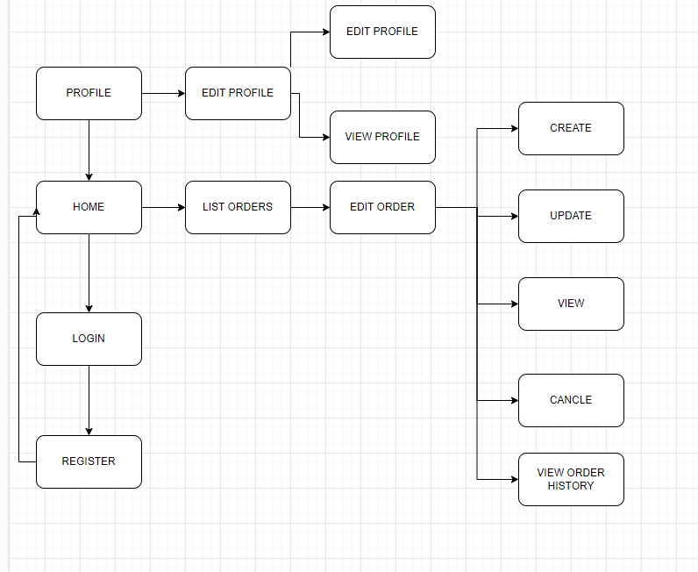

Agency

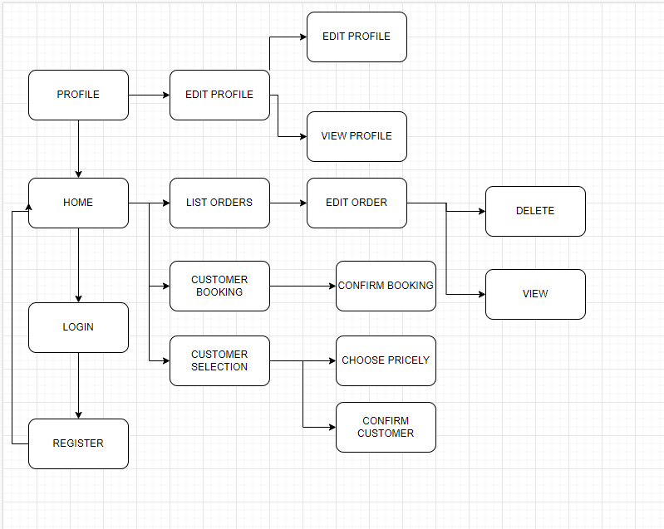

INVESTOR

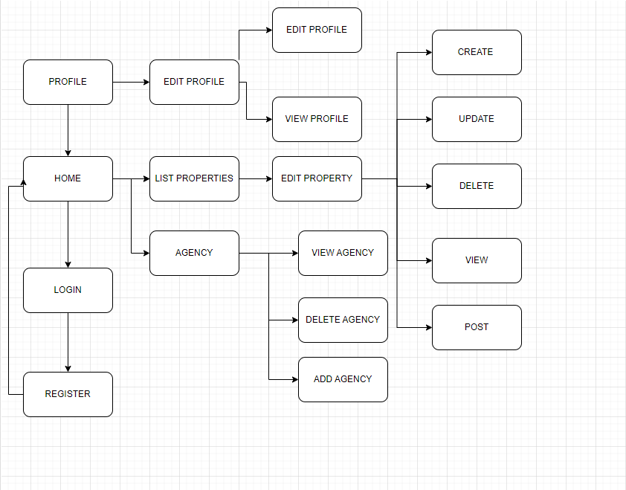

ADMIN

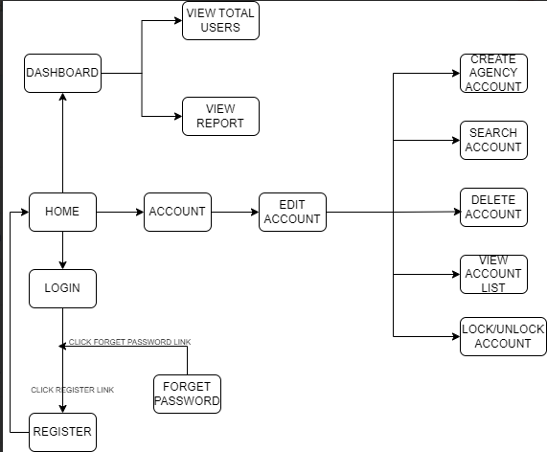

### 1.2 Screen Descriptions

| **#** | **Screen** | **Feature** | **Description** |
| --- | --- | --- | --- |
| FR-01 | LOGIN | authentication | Allows users to log in to the system by providing their credentials |
| FR-02 | REGISTER | User Registration | Allows new users to create an account in the system. |
| FR-03 | EDIT PROFILE | Profile Management | Allows users to edit their profile information. |
| FR-04 | MANAGE ORDER | Order Management | Allows users to view, add, edit, and delete orders. |
| FR-05 | MANAGE PROFILE | Profile Management | Allows users to view and manage user profiles. |
| FR-06 | MANAGE PROPERTY | Property Management | Allows users to view, add, edit, and delete properties. |
| FR-07 | MANAGE AGENCY | Agency Management | Allows users to manage real estate agencies. |
| FR-08 | MANAGE ACCOUNT | Account Management | Allows users to manage system accounts. |
| FR-09 | REPORT | Report Generation | Enables users to generate various reports. |
| FR-10 | PROPERTY DETAIL | Property Information | Displays detailed information about a specific property. |
| FR-11 | DISTRIBUTE DETAI | Distributor Information | Displays detailed information about a specific distributor. |
| FR-12 | LOGOUT | Session Termination | Allows users to end their current session and log out of the system. |

### 1.3 Screen Authorization

| **Screen** | **Admin** | **Customer** | **Agency** | **investor** |
| --- | --- | --- | --- | --- |
| LOGIN | x | x | x | x |
| REGISTER | x | x | x | X |
| EDIT PROFILE | x | x | x | x |
| MANAGE ORDER | x | x |  | x |
| MANAGE PROFILE | x | x |  |  |
| MANAGE PROPERTY | x |  |  | x |
| MANAGE AGENCY | x |  |  | x |
| MANAGE ACCOUNT | x |  |  |  |
| REPORT | x |  |  |  |
| PROPERTY DETAIL | x |  | x | x |
| DISTRIBUTE DETAI | x |  | x | x |
| LOGOUT | x | x | x | x |

### 1.4 Non-Screen Functions

| **#** | **System Function** | **Feature** | **Description** |
| --- | --- | --- | --- |
| FR-1 | Automatically delete bookings | Automated Backup | The database will automatically delete the booking if after 1 day the user does not confirm |
| FR-2 | Data Backup Service | Automated Backup | This service automatically backs up database records daily to prevent data loss in case of system failure. |
| FR-3 | Report Generation Job | Monthly Reports | Sends automated email notifications to users about updates, such as changes in booking status or new posts. |
| FR-4 | Data Synchronisation Service | API Sync | Synchronises data across different platforms or services in real-time through API calls, ensuring data consistency. |
| FR-5 | Auto logout | Automated | Auto logout after 15 minutes of inactivity |

## 2. Data Requirements

### 2.1 Logical Data Model

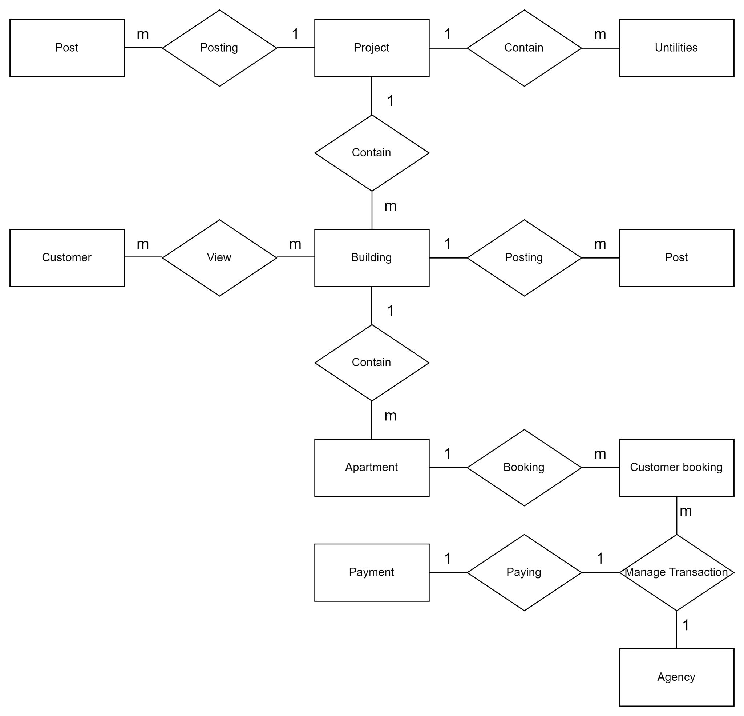

### 2.2 Data Dictionary

| **Data Element** | **Description** | **Composition or Data Type** | **Length** | **Values** |
| --- | --- | --- | --- | --- |
| UserID | Unique identifier for a user | INT |  | Auto-incremented integer |
| Username | Name chosen by the user for login | NVARCHAR | 255 |  |
| Password | Encrypted password for the user account | NVARCHAR | 255 |  |
| RoleID | Identifier for the user's role | INT |  | Integer |
| Status | Current status of the user (Active, Inactive, etc.) | NVARCHAR | 50 |  |
| CreateDate | The date and time the user was created | DATETIME |  | YYYY-MM-DD HH:MM:SS |
| ProjectID | Unique identifier for a project | INT |  | Auto-incremented integer |
| Year | Year the project was launched or completed | INT |  | YYYY |
| UtilitiesID | ID of associated utilities from Utilities table | INT |  | Integer |
| ProjectName | Name of the project | NVARCHAR | 255 |  |
| UtilitiesName | Name of the utility | NVARCHAR | 255 |  |
| BuildingID | Unique identifier for a building | INT |  | Auto-incremented integer |
| BuildingName | Name of the building | NVARCHAR | 255 |  |
| Address | Physical address of the building | NVARCHAR | 255 |  |
| TypeOfRealEstate | Type of the real estate (e.g., residential, commercial) | NVARCHAR | 255 |  |
| NumberOfFloors | Number of floors in the building | INT |  | Integer |
| NumberOfApartments | Number of apartments in the building | INT |  | Integer |
| Status | Current status of the building (e.g., under construction, completed) | NVARCHAR | 50 |  |
| YearOfConstruction | Year the building was constructed | DATE |  | YYYY-MM-DD |
| Images | Path or URL to the building's images | NVARCHAR | MAX | URL or file path |
| Describe | Description of the building | NVARCHAR | MAX |  |
| Investor | Name of the investor or investing company | NVARCHAR | 255 |  |
| Area | Total area of the building | FLOAT |  | Decimal |
| Amenities | Amenities available in the building | NVARCHAR | MAX |  |
| ApartmentID | Unique identifier for an apartment | INT |  | Auto-incremented integer |
| NumberOfBedrooms | Number of bedrooms in the apartment | INT |  | Integer |
| NumberOfBathrooms | Number of bathrooms in the apartment | INT |  | Integer |
| Furniture | Information about the furniture in the apartment | NVARCHAR | 255 |  |
| Area | The total area of the apartment | FLOAT |  | Decimal |
| Price | Price of the apartment | DECIMAL(18,2) |  | Decimal |
| AgencyID | Identifier for the agency listing the apartment | INT |  | Integer |
| ApartmentDescription | Description of the apartment | NVARCHAR | MAX |  |
| ApartmentStatus | Current status of the apartment (e.g., available, sold) | NVARCHAR | 50 |  |
| ApartmentType | Type of the apartment (e.g., studio, flat, penthouse) | NVARCHAR | 50 |  |
| FloorNumber | The floor number where the apartment is located | INT |  | Integer |
| BookingID | Unique identifier for a booking | INT |  | Auto-incremented integer |
| BookingDate | Date and time when the booking was made | DATETIME |  | YYYY-MM-DD HH:MM:SS |
| BookingStatus | Current status of the booking (e.g., confirmed, cancelled) | NVARCHAR | 50 |  |
| PostID | Unique identifier for a post | INT |  | Auto-incremented integer |
| SalesOpeningDate | Date and time when the sales open | DATETIME |  | YYYY-MM-DD HH:MM:SS |
| SalesClosingDate | Date and time when the sales close | DATETIME |  | YYYY-MM-DD HH:MM:SS |
| PostDate | Date and time when the post was made | DATETIME |  | YYYY-MM-DD HH:MM:SS |
| PostImages | Path or URL to images related to the post | NVARCHAR | MAX | URL or file path |
| PostDescription | Description of the post | NVARCHAR | MAX |  |

### 2.3 Reports

| **#** | **Report Name** | **Description** |
| --- | --- | --- |
| RPT-01 | Website Traffic Report | Show statistics on the number of users accessing the website over a specified time period. |
| RPT-02 | Monthly Sales Report | Provide sales statistics and insights for the past month. |
| RPT-03 | Customer Feedback Report | Provide analysis of customer satisfaction ratings and feedback comments. |
| RPT-04 | Agencies Sales and Commissions Report | Provide monthly sales and commission statistics for agencies. |
| RPT-05 | Agency Projects Sales Report | Provide statistics on real estate projects currently being sold and sold by agencies. |

| Report ID: | RPT-01 |
| --- | --- |
| Report Title: | Website Traffic Report |
| Report Purpose: | Show statistics on the number of users accessing the website over a specified time period. |
| Priority: | High |
| Report Users: | Admins, Investor |
| Data Sources: | Web server logs, Google Analytics |
| Frequency and Disposition; | • Generated daily, weekly, monthly  • Email report to admins and managers  • Upload to internal dashboard Latency: Report generated within 1 hour after period ends Visual Layout: Dashboard with charts Header and Footer: Header shows report name, date/time generated, date range Report Body:  • Total site visits  • Unique visitors  • Page views  • Pages per visit  • Visit duration  • Top pages  • Traffic sources  • Geographic location Selection Criteria: Date range Sort Criteria: Page views descending End-of-Report Indicator: None Interactivity: Click to drill down metrics for different pages, locations Security Access Restrictions: Login required, access controls on viewing reports |
| Latency: | • Daily reports compiled and sent within 24h  • Weekly/monthly reports compiled within 48h after the reporting period end |
| Visual Layout: | • Access timeline chart  • Vertical column chart comparing weeks/months  • Dashboard with key access metrics |
| Header and Footer: | • Header: Report name, reporting period, author  • Footer: Print/export date, page number |
| Report Body: | • Key metrics: Number of visits, visit duration, page views etc.  • Compare with previous period  • Top 5-10 pages, locations, sources details |
| End-of-Report Indicator: | • Concluding line: "End of report" |
| Interactivity: | • Click metrics to view underlying or drill-down data at day/week/month level |
| Security Access Restrictions: | • Login required for Admins to view full report  • Viewer users can only access partial report dashboards |

| Report ID: | RPT-02 |
| --- | --- |
| Report Title: | Monthly Sales Report |
| Report Purpose: | Provide sales statistics and insights for the past month. |
| Priority: | High |
| Report Users: | Admins, Investor,Agency |
| Data Sources: | Sales database, CRM system |
| Frequency and Disposition; | • Generated monthly, ready by 3rd business day of the month  •Visual Layouts:  •Bar charts for monthly/YoY comparison  •Grid view showing detailed numbers  •Dashboard with key metrics |
| Latency: | Generated monthly, ready by 3rd business day of the month |
| Visual Layout: | • Bar charts for monthly/YoY comparison  • Grid view showing detailed numbers  • Dashboard with key metrics |
| Header and Footer: | Header shows the report name, month, year. |
| Report Body: | • Total revenue, units sold, average order value  • Sales by product, region, salesperson  • Sales revenue across channels  • Monthly performance metrics vs goals  • YoY growth percentage |
| End-of-Report Indicator: | No additional indicators. Charts by default show full-period aggregates. |
| Interactivity: | •Click filters to slice report data.  •Drill-down to order/customer level details |
| Security Access Restrictions: | Login required. Access controls to limit visible data fields. |

| Report ID: | RPT-03 |
| --- | --- |
| Report Title: | Customer Feedback Report |
| Report Purpose: | Provide analysis of customer satisfaction ratings and feedback comments. |
| Priority: | Medium |
| Report Users: | Admins, Investor |
| Data Sources: | Customer surveys, NPS responses |
| Frequency and Disposition; | The report is compiled and produced weekly on Mondays  Email reports to the Marketing and Customer Service departments  Reports are stored on the system for 6 months  Report data is compiled from customer feedback survey database |
| Latency: | Generated weekly, available by Monday 5 PM |
| Visual Layout: | Summary dashboard with charts. Breakdown tables per question. Wordcloud. |
| Header and Footer: | Report name, date range. Page numbers in footer. |
| Report Body: | Overall satisfaction score  Net Promoter Score (NPS)  Star rating breakdown  Number of feedback responses  Summary of positive and negative themes  Word cloud of most common words  Feedback examples and quotes |
| End-of-Report Indicator: | none |
| Interactivity: | Filter feedback by product, demographic, attributes |
| Security Access Restrictions: | Login required. Customer data anonymized. |

| Report ID: | RPT-04 |
| --- | --- |
| Report Title: | Agencies Sales and Commissions Report |
| Report Purpose: | Provide monthly sales and commission statistics for agencies. |
| Priority: | High |
| Report Users: | Admins, Investor |
| Data Sources: | CRM system, Sales database |
| Frequency and Disposition; | Revenue and agent commission reports are generated monthly on the 5th working day of the month  Reports will be emailed to sales leadership and account managers  Reports are also stored on an internal database system  Reporting data is extracted and aggregated from the CRM system and sales database on a monthly basis |
| Latency: | Monthly report, finalised by 5th business day of the month |
| Visual Layout: | Bar charts for sales. Sortable table view. |
| Header and Footer: | Company name and logo, report name, month and year, page numbers |
| Report Body: | Sales volume by agency  Sales growth % compared to target and past periods  Commission rates and amounts per agency  Top 5 highest performing agencies |
| End-of-Report Indicator: | none |
| Interactivity: | Click agencies to drill down into sales representatives' performance. |
| Security Access Restrictions: | Login required, managers access their own team agencies data. |

| Report ID: | RPT-05 |
| --- | --- |
| Report Title: | Agency Projects Sales Report |
| Report Purpose: | Provide statistics on real estate projects currently being sold and sold by agencies. |
| Priority: | High |
| Report Users: | Admins, Investor |
| Data Sources: | CRM system, Agents sales database |
| Frequency and Disposition; | Revenue and agent commission reports are generated monthly on the 5th working day of the month  Reports will be emailed to sales leadership and account managers  Reports are also stored on an internal database system  Reporting data is extracted and aggregated from the CRM system and sales database on a monthly basis |
| Latency: | Weekly reports. |
| Visual Layout: | Interactive map with project status indicators. Summary dashboard. |
| Header and Footer: | Company logo, report name, date range, page numbers |
| Report Body: | Number of ongoing and completed projects per agency  Total units sold per project  % project units sold per agency  Top 5 best selling projects |
| End-of-Report Indicator: | none |
| Interactivity: | Click projects to drill down for units details |
| Security Access Restrictions: | Login required, access controls to limit data |

### 2.4 State transition diagram

1. State of real estate

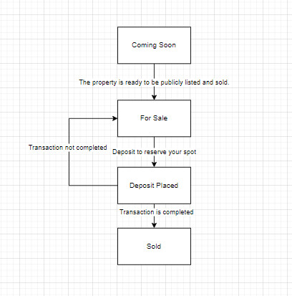

1. State of booking

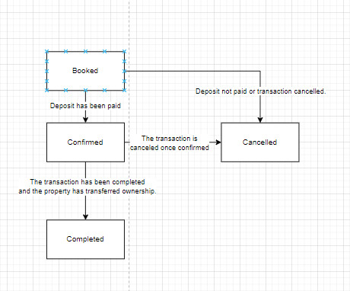

## 3. Information page introducing real estate projects of investors

### 3.1 Investor_Add new Project

Activate function: Users access the project management page and select the function to add a new project via the corresponding link on the interface.

Function description: This function allows investors or project managers to add a new project to the system. The interface includes a form or data entry page for users to fill in information about the new project. This information includes project name, apartment floor number, status, area, year of construction, address, location description, and other details related to the project.

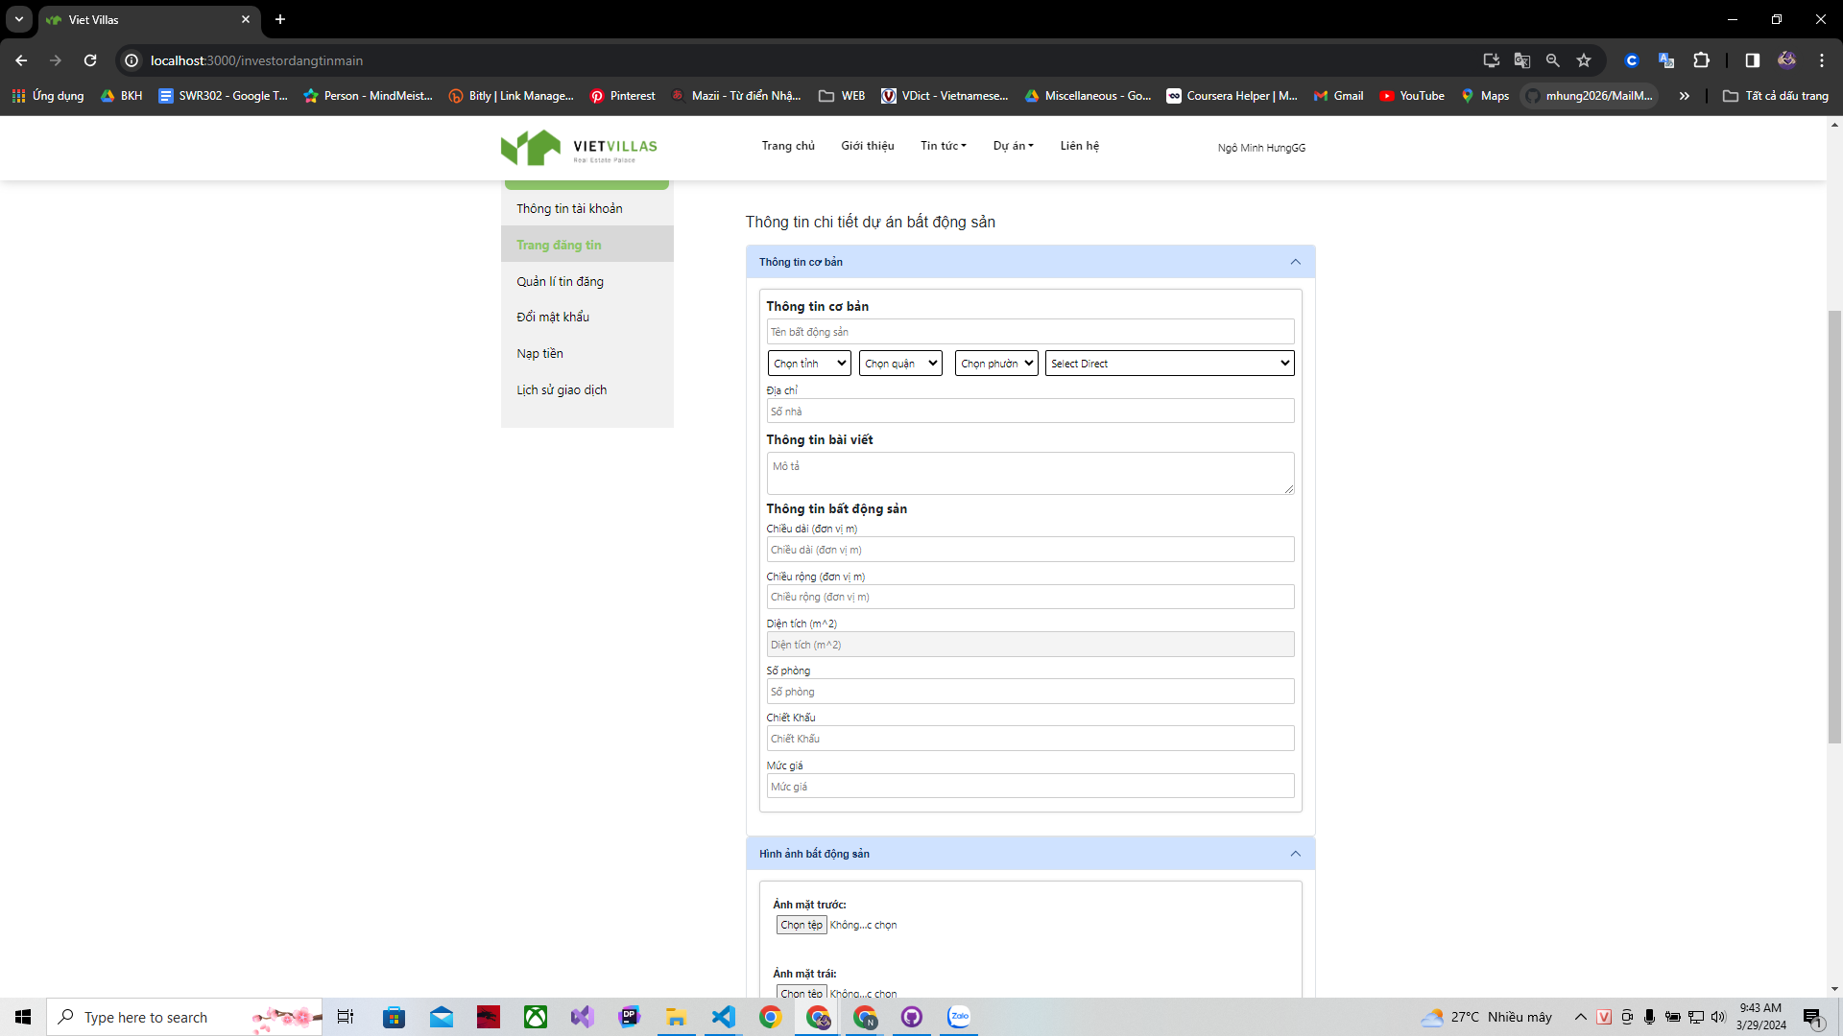

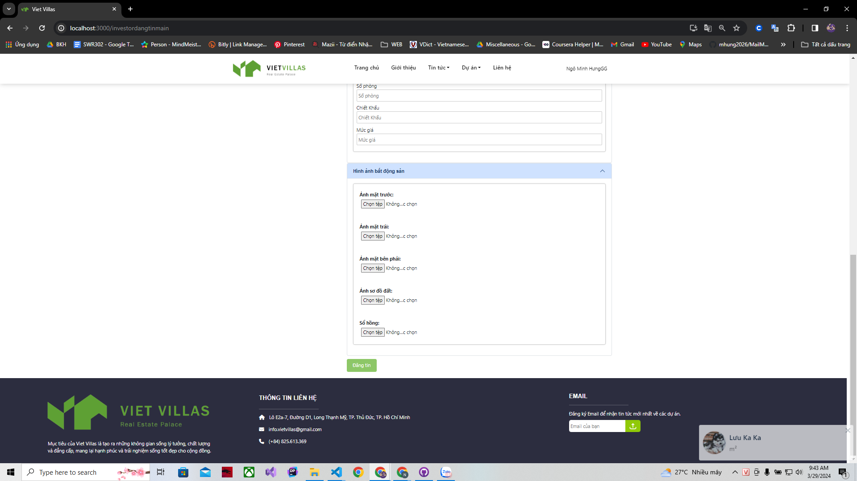

Function details:

Enter project information: Users fill in details about the new project in the fields provided on the interface. These information fields may include project name, apartment floor number, status, area, year built, address, location description, and other details tailored to your specific needs. project.

Check data validity: The system checks the validity of data entered from users, including checking date format, project value, and other information fields according to regulations. specific regulations and constraints.

Exception handling: If there is an input error or invalid information, the system provides detailed error messages and instructions for users to fix. Exceptions are also logged for later analysis.

Add new project: After the project information has been completely and validly filled in, users can press the "Add" button or similar to save the new project into the system.

This function provides the ability to add new projects to the system easily and effectively, helping to manage projects and investments strictly and accurately.

### 3.2 Investor_View Project

Activated:

Users, who can be investors or stakeholders, access the "Projects" section via a navigation bar or a direct link on the platform interface.

Function Description:

This function allows investors to view a list of projects. The interface displays a list of projects with a title like "A Doodle" followed by a brief description and status tag (for example, "For Sale"). Investors can search for specific projects using the search bar, filter projects by newest or other criteria, and add new projects if this function is allowed.

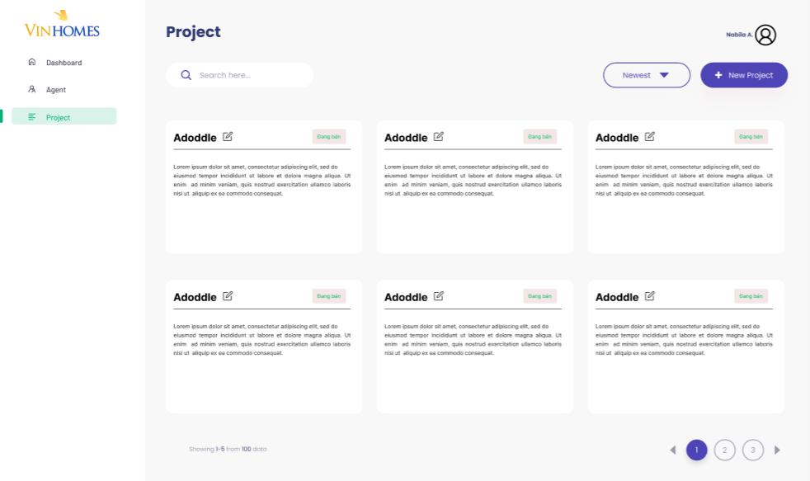

Detailed Features:

Project Cards: Each card represents a project. It contains the project name, a brief description, and a status indicating if the project is for sale.

Search Function: Allows users to search for projects by name or other details.

Filtering and Sorting Options: Users can sort projects based on various criteria such as newest, price, or relevance.

Add New Project Button: If available, users can add new projects to the list.

Pagination: Users can navigate through different pages to further explore the project.

This function is designed to provide investors with a comprehensive view of available or ongoing projects, helping them make smart decisions. It makes the process of tracking investments and understanding the status of each project in the portfolio leaner.

### 

### 

### 3.3 Project

Function Description:

The "Projects" function on the website or application allows users to view information about real estate projects that Vinhomes is developing or promoting. Specifically, from the image, it seems that users can search and view details about real estate projects.

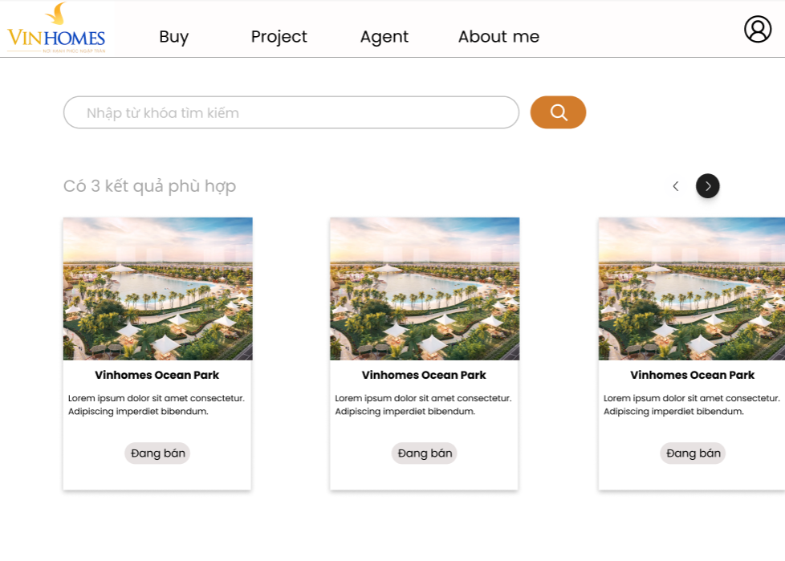

Detailed Features:

Search Bar: Allows users to enter keywords to search for specific projects in the system.

Search Results: Displays the number of results matching the search keyword. In this case, 3 results were found.

Project Card: Each project is displayed as a card with an illustration, project name ("Vinhomes Ocean Park"), and a brief description. It appears that each card also has a "For Sale" button, indicating that the project is in the process of going on sale.

Page Switching: Navigation buttons (< and >) allow users to switch between pages of search results, revealing more projects to view.

This "Project" function helps provide detailed and intuitive information about Vinhomes' real estate projects, helping users easily learn and decide to invest or buy real estate.

## 

## 

## 4. The function allows investors to distribute real estate to sales agent channels

## 4.1 Real Estate Distribution Dashboard

Activate Function:

Users can access the Real Estate Distribution Dashboard through the main menu link or through the corresponding links on the user interface.

Function Description:

The Real Estate Distribution Dashboard provides investors and managers with a comprehensive view of the distribution of real estate assets through sales and agent channels. This interface displays up-to-date information on the number of properties distributed, remaining inventory, and sales performance of each agent or channel.

Function Details:

Distribution Management:

Allows determining and updating the number of properties distributed to each agent or channel.

Data Analysis:

Integrate analytics tools to evaluate sales performance, inventory, and market trends.

Inventory management:

Track real estate inventory and alert when it reaches a specific threshold.

Distribution Optimization:

Use analytics to recommend effective distribution strategies, such as adjusting delivery quantities based on dealer sales performance.

Reporting and Exporting Data:

Provides the ability to create consolidated reports and export data for further analysis or management reporting purposes.

In brief:

Real Estate Distribution Dashboard provides a comprehensive solution for managing and analysing real estate distribution, helping investors and managers optimise distribution through providing accurate information and updates, sales performance analysis, and data-driven decision support.

## 

## 4.2 Agent Channel Distribution

Activate Function:

Users activate the Agent Channel Distribution function through the link on the main menu or through the corresponding links on the user interface.

Function Description:

The Dealer Channel Distribution function provides managers with a tool to distribute their products or services across different dealers and sales channels. This helps optimise market access and enhance sales performance across distribution channels.

Function Details:

Product/Service Allocation:

Allows users to allocate products or services to specific dealer channels.

Channel Performance Rating:

Integrate analytical tools to evaluate the sales performance of each agent channel, helping to identify effective distribution channels.

Agent Information Management:

Update and manage basic dealer information, including contact information, contracts, and distribution history.

Optimise Distribution Strategy:

Use data and analytics to recommend distribution strategies, such as adjusting product quantities or changing distribution channels based on performance.

Distribution Report:

Provides the ability to generate consolidated reports on product or service delivery across dealer channels, including performance and delivery trends.

In brief:

The Dealer Channel Distribution function provides a solution to manage and optimise the distribution of products or services through dealer and sales channels. This enhances market reach and improves sales performance through the use of analytical data and effective dealer information management.

## 5. Dashboard & revenue statistics report, project, ...

## 5.1 Investor Dashboard

General Description:

This dashboard provides insights and analytics:

Number of establishments: Includes the number of customers, agents, projects and finances.

Project statistics (Project statistics): Shows the percentage of projects that are on sale and sold out.

User Growth (User Growth): The chart can perform user growth month by month, with a comparison between this week and last week.

Financial Growth (Financial Growth): The chart shows key financial growth over the months, as well as a comparison between this week and last week.

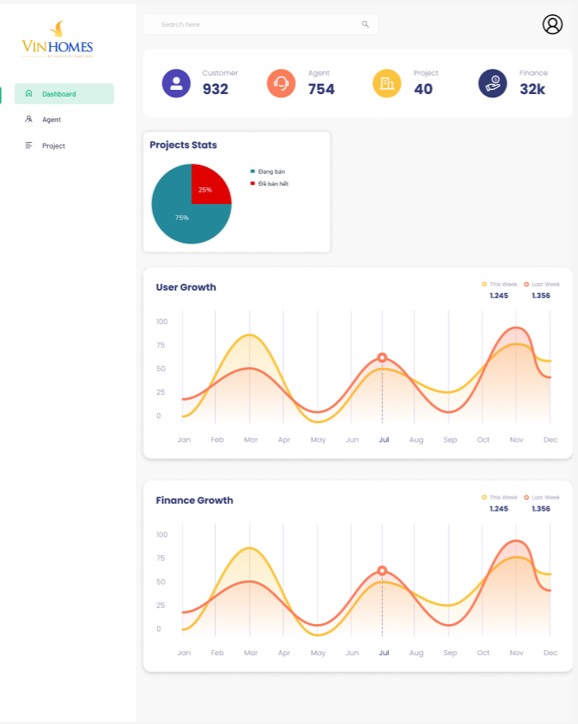

Detailed Features:

Digital database:

Customers: Number of current customers.

Agents: Number of active agents.

Projects: Total number of projects being developed or managed.

Financial: Estimated key financial numbers (could be revenue or profit).

Statistics project:

The pie chart shows the ratio between currently selling projects (For Sale) and sold out projects (Sold Out).

Increase key users and key finances:

Line charts can show increasing or decreasing trends over time, with the task of highlighting important data and making comparisons between two different time periods.

This investor dashboard provides a comprehensive and in-depth view of the business, helping investors track performance and make smart investment decisions.

## 5.2 Revenue Statistics Report

General Description:

The "Revenue Statistics Report" function on this dashboard is designed to provide detailed information and analysis on company revenue or specific projects. This includes tracking sales, evaluating growth over periods, and comparing sales between different time periods.

Detailed Features:

Track revenue: Dashboard charts and metrics help keep a close eye on real-time and historical revenue.

Growth analysis: Line chart shows revenue growth trends, with key events or data points highlighted.

Compare revenue: Allows you to compare revenue between time periods, for example this week versus last week.

This "Revenue Statistics Report" function helps investors and business managers capture necessary information to evaluate business performance and shape future development strategies.

## 

## 

## 

## 6. When implementing a sales opening, it allows the establishment of a method where customers are given priority to purchase based on reservation information (by time, random number draw, etc.)

## 6.1 Priority Reservation Processing

Activate Function:

Users enable Priority Reservation Processing through the system's admin interface, where they can set and manage priority rules for customers based on reservation information.

Function Description:

The Priority Reservation Processing function allows organising and managing the reservation process based on certain priority criteria. This includes classifying customers based on booking times, random lottery numbers, or other factors to ensure fairness and transparency in providing priority purchasing.

Function Details:

Setting Priority Criteria:

Allows definition of priority criteria such as booking time, customer reliability, number of previous purchases, etc.

Customer Classification:

Automatically classify customers into priority groups based on established criteria.

Booking Management:

Track and manage customer booking information, including booking times and assigned priorities.

Customer Interface:

Provide an easy-to-use interface for customers to book and track their preference status.

Reporting and Analysis:

Integrate reporting and analytics tools to evaluate the effectiveness of priority programs and adjust strategies accordingly.

In brief:

Priority Reservation Processing provides a solution to manage and organise the booking process in a fair and transparent manner, while optimising the customer experience by ensuring that customers meet our criteria. Prioritise the best purchasing opportunities.

## 6.2 Customer Priority Lottery System

Activate Function:

Users activate the Customer Priority Lottery System function through the system's management interface or settings page, where rules and criteria for the lottery process can be set.

Function Description:

This function allows organising priority draws for customers based on reservation or pre-registration information. This process helps ensure fairness and transparency in granting purchase rights or access to priority services to customers.

Function Details:

Set up a Drawing Session:

Create and configure lottery sessions, including setting time, registration criteria, and number of selected customers.

Registration:

Allow customers to register to participate in the lottery through an online interface or application.

Handling of Lotteries:

Automatically perform the lottery process based on established criteria and create a priority customer list.

Result Notice:

Send notifications to all participating customers about the results of the draw, including those selected and those not selected.

History Management and Reporting:

Store and analyse data from draws to evaluate efficiency and fairness, as well as provide detailed reporting.

In brief:

The Customer Priority Lottery System provides a fair and transparent method for determining which customers have priority in purchasing or accessing services. This process enhances customer satisfaction and equity, while providing an accurate database of customer needs and priorities.

## 7. The feature allows agents to manage the entire sales process of real estate products from the time customers reserve, open sales, to the successful purchase.

## 7.1 Purchase Progress Tracking

Activate the function: Users access the purchase progress tracking page through the menu link or corresponding links on the interface.

Function description: This function provides agents with the ability to track each step of the progress of the customer's purchasing process. Starting from when customers make a deposit, through the stages of document processing, financial approval, and finally contract signing and full payment. Agents can view the current status, next steps to take, and detailed transaction history.

Function details:

Tracking Status: Shows the current status of the purchase process, including completed and next stages.

Transaction Details: Provides detailed information about each step in the purchasing process, including time, amount, and documents involved.

Customer Communication Records: Stores and displays communication history between agents and customers related to purchases.

Document Management: Allows agents to upload, download and manage all documents related to customer purchases.

Payment Tracking: Track customer payments, including deposits, instalment payments, and final payments.

Exception Handling: Provides a mechanism to handle unusual situations or delays in the purchasing process.

This function provides a comprehensive solution for agents to track and manage customer purchase progress, helping to ensure the process runs smoothly and efficiently.

# V. Non-Functional Requirements

## 1. External Interface Requirements

### 1.1 User Interfaces

UI-1: The layout and design of the webpages shall follow modern web design principles to ensure a visually appealing and intuitive user experience.

UI-2: The website shall include a search bar prominently displayed on every page to facilitate easy property search by users.

UI-3: Each property listing shall display comprehensive information including property details, images, videos, location map, and contact information for the agent or distributor.

### 1.2 Software Interfaces

SI-1: Property Management System (PMS)

SI-1.1: The website shall retrieve property listing data from the Property Management System through a programmatic API. This includes property details, images, videos, pricing, and availability.

SI-1.2: The website shall push updates on property availability, pricing changes, and new listings to the Property Management System in real-time.

SI-2: User Authentication System

SI-2.1: The website shall integrate with a User Authentication System to manage user accounts, authentication, and authorization.

SI-2.2: User registration, login, and password reset functionalities shall be handled through this interface.

### 1.3 Hardware Interfaces

Hardware Interface Specifications:

HI-1: Server Configuration

Application Server

CPU: Intel Xeon 8 Core 2.40 GHz

Memory Space: 128 GB RAM 1333 MHz

Storage Space: 2 TB

Operating System: MS Windows Server 2012 R2

Software: Microsoft IIS 8.x, .NET Framework 4.5

Database Server

CPU: Intel Xeon 12 Core 2.40 GHz

Memory Space: 256 GB RAM 1333 MHz

Storage Space: 3 TB

Operating System: MS Windows Server 2012 R2

Software: Microsoft SQL Server 2000

HI-2: Client Configuration

PC Device

CPU: Intel Core 2 Dual 2.00 GHz

Memory Space: 4 GB RAM 1333MHz

Storage Space: HDD: 500GB, 2.5" SATA x 2, RAID 1

Operating System: Windows Win7/Win8/Win10

Operator Display: 18.5-inch widescreen, 16:9 format, 1280 x 720 pixel, 1024 x 768 pixel

POS Device

CPU: Intel® Celeron® Processor G1820TE (2.2GHz, Dual Core)

Memory Space: 2GB (Max. 4GB), DDR3 SO-DIMM slot x 2 (1 open)

Storage Space: HDD: 500GB, 2.5" SATA x 2, RAID 1

Operating System: Windows Embedded POS Ready 7

Operator Display: 15" XGA TFT color LCD with resistive touch screen, Integrated, 1024 x 768 pixel

Proximity Sensor

Option: Integrated Camera/Mic

Mobility Device

CPU: Quad-Core 1.2 GHz

Memory Space: 1.5 GB

Storage Space: 8 GB

Operating System: Android 8.0

Wifi Standard: 5GHz Wi-fi

Operator Display: 7.0 inches, 1280 x 800 Pixels

HI-3: Network

WAN Network: Speed ≥ 2Mbps/10 Users operate together

### 1.4 Communications Interfaces

CI-1: The real estate distribution website shall utilise email notifications to communicate important updates and notifications to users, including but not limited to:

Confirmation of property inquiry submissions.

Notification of property booking or reservation confirmation.

Updates on property availability, pricing changes, or new listings.

Password reset instructions and account verification emails.

CI-2: The website shall support communication via web browser for users to interact with the platform and access its features seamlessly. This includes browsing property listings, submitting inquiries, viewing property details, and managing user accounts.

## 2. Quality Attributes

### 2.1 Usability

Usability Requirements:

USE-1: The real estate distribution website shall prioritise ease of use and intuitive navigation to ensure users can easily find and access the information they need. Specific requirements include:

* The website shall feature a user-friendly interface with clear and intuitive navigation menus, search functionality, and interactive elements.
* Property listings shall be presented in a structured and organised manner, with detailed information readily accessible to users.
* The website shall provide consistent design and layout across all pages to enhance user familiarity and ease of navigation.
* Users shall be able to filter and refine property search results efficiently, allowing them to quickly find properties that match their criteria.

USE-2: The website shall facilitate efficient learning and memorability for users, enabling them to become proficient in using the platform with minimal effort. Specific requirements include:

* The website shall provide clear instructions and guidance to users on how to use its features and functionalities effectively.
* Users shall be able to easily learn and remember how to perform common tasks such as searching for properties, viewing property details, and contacting agents.
* The website shall include tooltips, help links, and contextual assistance to provide users with on-demand support and guidance as needed.

### 2.2 Performance

PER-1: The real estate distribution website shall be able to accommodate a total of 5000 users and a maximum of 1000 concurrent users during peak usage times without experiencing performance degradation. This peak usage period is defined as weekdays from 9:00 AM to 6:00 PM local time.

PER-2: 95% of webpages generated by the website shall download completely within 3 seconds from the time the user requests the page, over a range of internet connections with speeds ranging from 5 Mbps to 100 Mbps.

PER-3: The average response time for property search queries shall be less than 1 second, with a maximum response time of 3 seconds, when the website database contains up to 1 million property listings.

PER-4: The average time taken to load property listing pages shall be less than 2 seconds, with a maximum load time of 5 seconds, regardless of the number of images and multimedia content included in the listing.

### 2.3 Security

SEC-1: The system shall maintain comprehensive audit logs of all user activities, including login attempts, data access, and administrative actions. Audit logs shall include details such as timestamps, user identities, and the nature of the activity performed, to facilitate monitoring, forensic analysis, and compliance auditing.

SEC-2: Regular security assessments, vulnerability scans, and penetration testing shall be conducted to identify and address potential security vulnerabilities and weaknesses in the system. Any identified security issues shall be promptly addressed and remediated to maintain the integrity and security of the system.

### 2.4 Safety

SAF-1: The real estate distribution website shall display relevant safety information for properties, including any known hazards or risks associated with the property or its surroundings. This information may include details about potential safety hazards such as nearby hazardous materials, environmental risks, or safety concerns related to the property's construction or location.

### 2.5 Availability

AVL-5: The website shall implement load balancing and failover mechanisms to distribute traffic across multiple servers and mitigate the impact of hardware failures or performance degradation on overall system availability. This includes automatic failover to backup servers in the event of server failures or resource exhaustion.

AVL-6: The website shall maintain comprehensive logs and records of system uptime and downtime, including details of any scheduled maintenance events, unplanned outages, and incidents affecting service availability. These records shall be used for performance monitoring, analysis, and reporting to stakeholders.

### 2.6 Reliability

REL-1: The real estate distribution website shall demonstrate a high level of reliability by ensuring that no more than 1% of user sessions result in software failures or errors. This equates to no more than 10 failed sessions out of every 1,000 user sessions. Software failures include errors, crashes, or unexpected behaviour that disrupts the user experience.

### 2.7 Design Constraints

SDES-1: Programming languages: ASP.NET API , Javascript

DES-2: Web server: IIS 5.0

DES-3: Web browser: IE 6.0

### 2.8 [Others as relevant]

SCA-1: The system shall be able to accommodate a 50% increase in user load compared to typical usage levels without significant impact on performance, ensuring smooth operation during promotional events or marketing campaigns.

SCA-2: The system architecture shall be designed to scale horizontally, allowing for easy addition of additional hardware resources to support increased user demand without requiring significant modifications to the system architecture or software components.