Tagline: Prediction of Your Thyroid Tumor – A Step toward Action

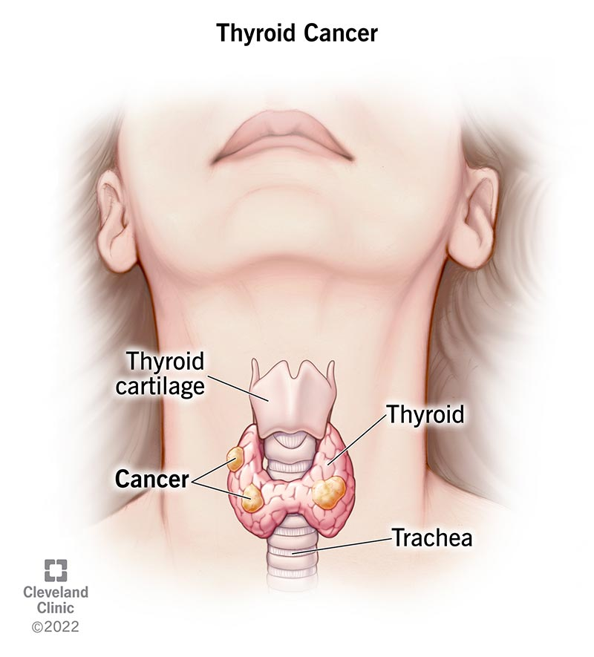

Essence of our endeavor

Thyroid tumors can often be a source of worry, but knowing whether it’s malignant or benign can bring clarity and guide your next steps. Our advanced prediction model, built using cutting-edge machine learning algorithms, assesses your thyroid tumor's risk based on key health factors, helping you determine whether your tumor is malignant or benign. With early and accurate predictions, you can make informed decisions about your health with confidence.

How It Works

Our thyroid tumor prediction tool uses XGBoost technique to analyze your medical data. By inputting key health indicators, the model evaluates the likelihood that your thyroid tumor is benign or malignant. The system provides an easy-to-understand risk assessment, giving you valuable insights into the nature of your thyroid condition and helping you take informed action.

Benign or Malignant-Insight

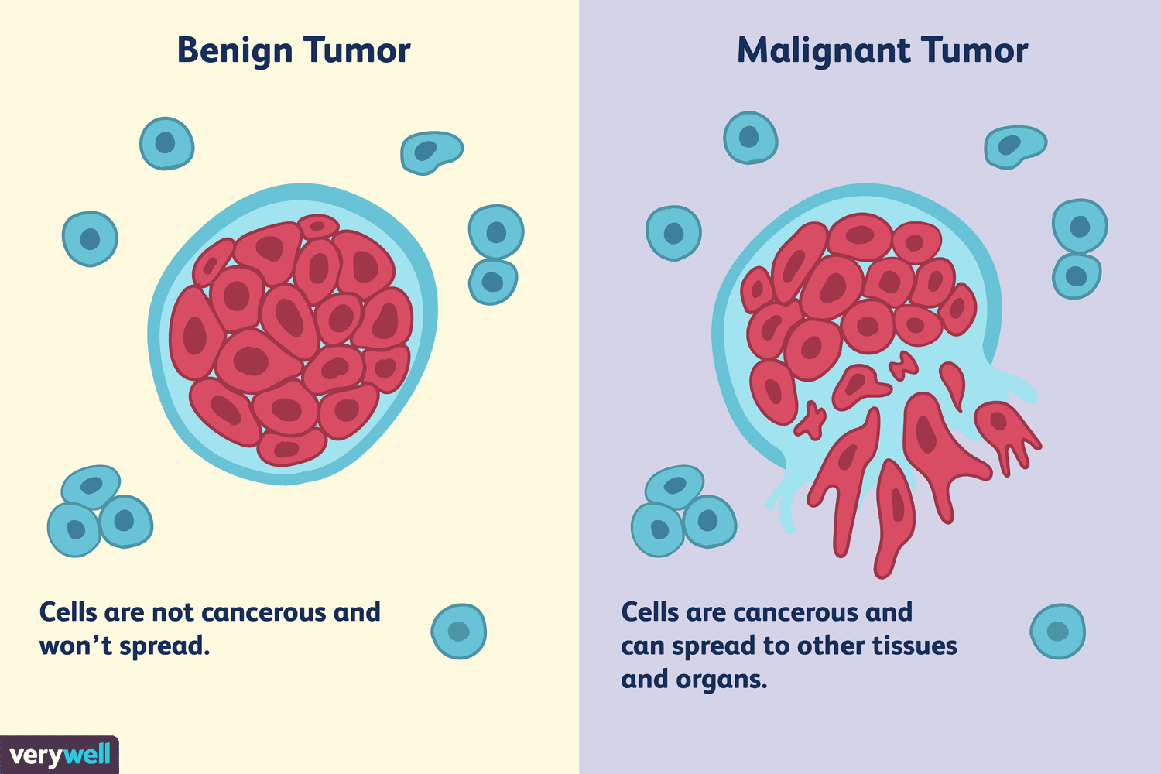

Benign thyroid tumors are non-cancerous growths that typically do not spread to other parts of the body. These tumors are usually slow-growing and may cause little to no harm, though they can still lead to complications depending on their size or location within the thyroid. Malignant thyroid tumors, however, are cancerous and have the potential to invade nearby tissues or spread to other organs. Malignant thyroid cancer tends to grow more rapidly and requires immediate medical attention to prevent further progression. Determining whether a thyroid tumor is benign or malignant is crucial for deciding the most appropriate treatment plan.

Common Symptoms of Thyroid Tumors

Symptoms vary depending on whether the tumor is benign or malignant, but here are some general signs that may indicate a thyroid tumor:

* A lump in the neck
* Difficulty swallowing or breathing
* Hoarseness or voice changes
* Swollen lymph nodes in your neck
* Pain in your neck and throat
* Fatigue or unexplained weight changes

Significant Factors for Tumor Prediction

Our model identifies key factors that influence whether a thyroid tumor is benign or malignant:

* Country and Ethnicity - Geographic and cultural variations affect cancer risk.
* Family History - Genetic predisposition plays a crucial role in thyroid cancer.
* Iodine Deficiency - Insufficient iodine impacts thyroid function.
* Diabetes and Obesity - Metabolic conditions increase cancer risk.
* Smoking - Tobacco use accelerates cancer development.
* Gender - Older adults, particularly women, have a higher likelihood of developing thyroid tumors.
* Radiation Exposure - Previous radiation treatments increase likelihood of cancer.

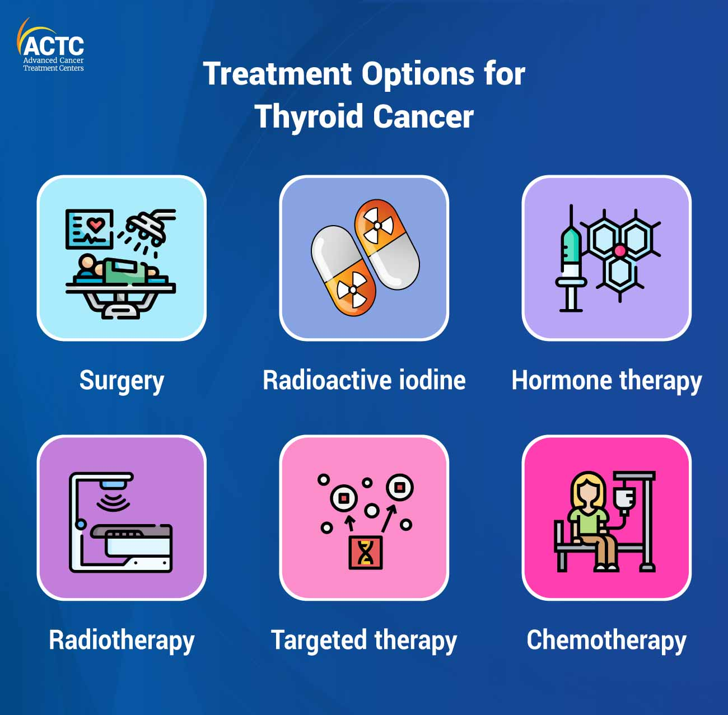If your thyroid tumor is malignant what should you do?

While the exact causes of thyroid cancer remain unclear, there is no guaranteed way to prevent it in individuals with average risk. For those at high risk, such as those with an inherited gene linked to medullary thyroid cancer (MTC), preventive measures like **prophylactic thyroidectomy** (surgical removal of the thyroid) may be considered. It's crucial to consult with a genetic counselor to understand your risk and available options.

To reduce risk, it's important to **limit radiation exposure**, particularly in childhood. Radiation to the head and neck is a known risk factor, so doctors avoid it unless absolutely necessary. Although imaging tests like x-rays and CT scans involve some radiation, the risk from these tests, especially at low doses, is considered minimal. For those with a family history of MTC or genetic conditions like **multiple endocrine neoplasia type 2 (MEN2)**, early genetic testing and regular check-ups can help detect and treat the condition early, preventing cancer development.