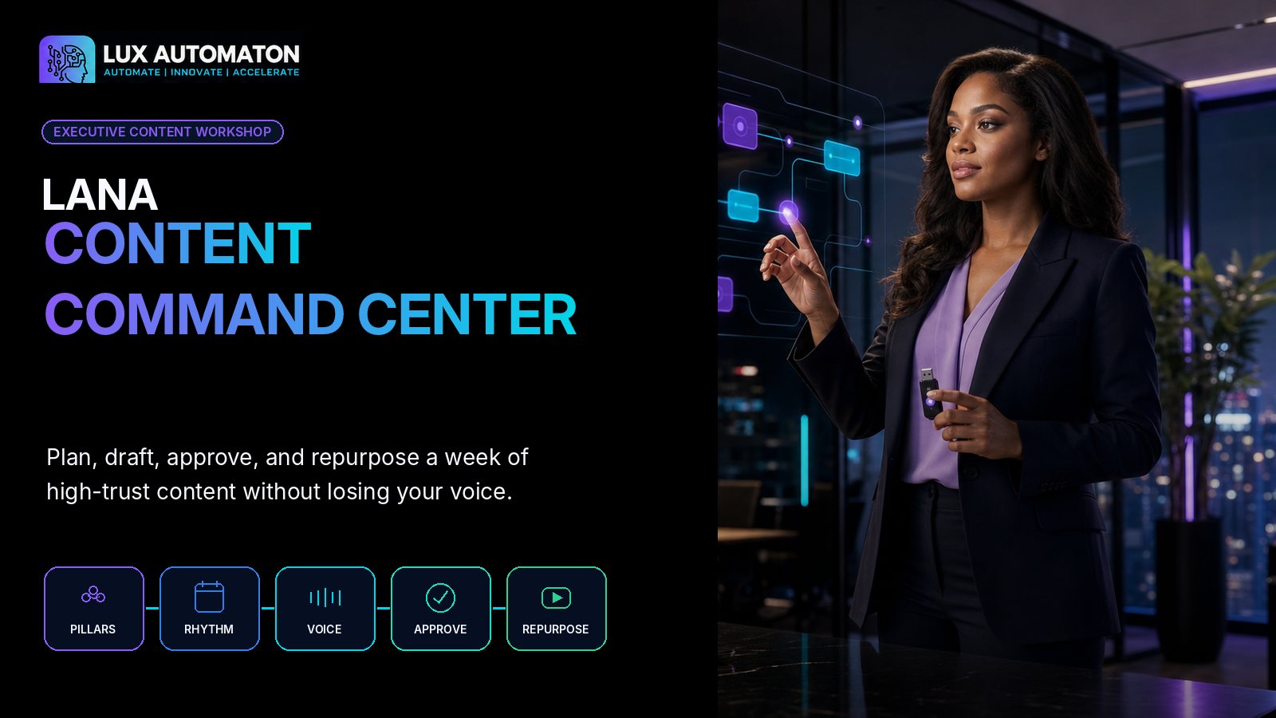
LANA Content Command Center
Plan, draft, approve, and repurpose a week of high-trust content without losing your voice.
AUDIENCE  Founders + small teams | LEVEL  Beginner to intermediate | CORE TIME  90 minutes | FINAL PROJECT  One-week command center
Lux Automaton Editorial | Publication-ready curriculum package

NAVIGATION

Workshop Contents
1 | Workshop overview
2 | Source analysis
3 | Learning framework
4 | Complete modules and lessons
5 | Final project and rubric
6 | Visual-production package
7 | Publishing package
8 | Quality-assurance report
9 | Structured JSON delivery

WORKSHOP PROMISE
A complete one-week Content Command Center containing a three-pillar strategy, a 15-idea bank, a weekly publishing board, one approved anchor post, a short-form video script, an email draft, and a documented review and approval workflow.

1. WORKSHOP OVERVIEW

LANA Content Command Center
URL SLUG | lana-content-command-center
AUDIENCE | Founders, consultants, coaches, creators, subject-matter experts, and small business teams
LEVEL | Beginner to intermediate
AGE / RANGE | Adults and emerging professionals, 16+
DURATION | 90 minutes + optional 30-minute Command Center Lab
DELIVERY | Live workshop; Virtual workshop; Team training; Self-paced intensive

Catalog description
Build a practical content operating system that turns your expertise into clear weekly publishing, preserves your voice, adds human review, and translates one strong idea into social posts, short-form video, and email.

Detailed overview
LANA Content Command Center helps founders and small teams replace irregular, generic, last-minute content production with a repeatable editorial system. Learners define three content pillars, establish a realistic weekly publishing rhythm, capture the voice and evidence that make their writing specific, apply a responsible review and approval process, and repurpose one approved idea into video and email. Every exercise contributes to a working one-week content command center that can be used immediately after the workshop.
FINAL LEARNER OUTCOME
A complete one-week Content Command Center containing a three-pillar strategy, a 15-idea bank, a weekly publishing board, one approved anchor post, a short-form video script, an email draft, and a documented review and approval workflow.

MATERIALS  - Participant workbook, printed or digital  - Laptop or tablet with a writing tool  - Three recent customer questions, calls, or project notes  - Two examples of content that sound like the learner at their best  - One current offer, service, product, or topic to promote  - Calendar or scheduling view  - Optional AI writing assistant approved for the learner's data policy  - Authentic Lux Automaton logo and supplied visual assets for the facilitator | PREREQUISITES  - No prior AI or content-strategy experience is required.  - Bring a description of your audience, offer, or area of expertise.  - Bring one topic you can teach from experience.  - Teams should identify who can approve customer-facing content.

Learning goals
- Define three durable content pillars tied to audience needs and business goals.
- Build a realistic weekly publishing rhythm with a clear job for each content touchpoint.
- Create specific, evidence-rich drafts that retain the founder's natural voice.
- Apply a repeatable human review and approval process before publication.
- Translate one approved idea into a short-form video and an email without simple copy-and-paste repetition.
- Leave with a ready-to-use one-week Content Command Center.

Safety and privacy notes
- Do not paste confidential customer information, private conversations, contracts, credentials, health information, financial details, or unpublished strategy into a public AI tool.
- Use summaries, redacted examples, or approved enterprise/private systems when sensitive context is required.
- Verify names, dates, numbers, quotations, claims, links, and source attributions before publication.
- Keep a human approval gate for every customer-facing post, video, newsletter, or automated message.
- Do not imitate another creator's distinctive voice or reproduce protected content without permission.
- Use only photographs, music, screenshots, testimonials, and brand assets you have the right to publish.
- Avoid presenting generated examples, composite stories, or hypothetical results as real customer evidence.
- Make captions, transcripts, readable contrast, descriptive links, and alt text part of the publishing workflow.

Extension activities
- Expand the one-week command center into a four-week editorial cycle.
- Record the short-form video and compare the spoken version with the written anchor post.
- Build a searchable proof library of approved stories, examples, statistics, quotations, and FAQs.
- Create a monthly content retrospective using audience questions, saves, replies, qualified conversations, and conversions.
- Map which drafting, review, scheduling, and archive steps can be automated without removing human judgment.
- Create a team-specific approval policy for claims, customer stories, regulated topics, and crisis communications.

2. SOURCE ANALYSIS

Source Analysis

Source summary
The supplied curriculum names five practical stages: define content pillars, create a weekly publishing rhythm, draft without sounding generic, review and approve, and repurpose into video and email. The supplied Lux Automaton logo and photographs establish the premium navy, cyan, and electric-violet visual direction and position LANA as the workshop's AI strategist and educator.
FACTS PRESERVED  - The workshop retains all five supplied curriculum stages in the original sequence.  - Each module fits the supplied 15-20 minute time range.  - The workshop ends with repurposing approved content into video and email.  - Human review and approval remain explicit steps rather than optional afterthoughts. | NEW CURRICULUM ELEMENTS  - Ten substantial lessons organized as two lessons per supplied module.  - The LANA Pillar Fit Map, Idea Bank, Weekly Rhythm Board, SIGNAL Draft Brief, CLEAR Review, Approval Lane, and Translation Map.  - A practical final project assembled from every lesson deliverable.  - Privacy, factual accuracy, rights, accessibility, and customer-data safeguards.  - A facilitator deck, participant workbook, branded visual package, publishing package, and structured JSON.

Design and factual approach
The curriculum is original and is built from the user's five-part brief, Lux Automaton's supplied brand references, and broadly accepted editorial practices. Teaching examples are fictional and are clearly presented as examples rather than source facts.
SOURCE NOTE
No external article, transcript, or platform-specific source was supplied. The workshop therefore avoids unstable algorithm claims and uses evergreen content-system principles.

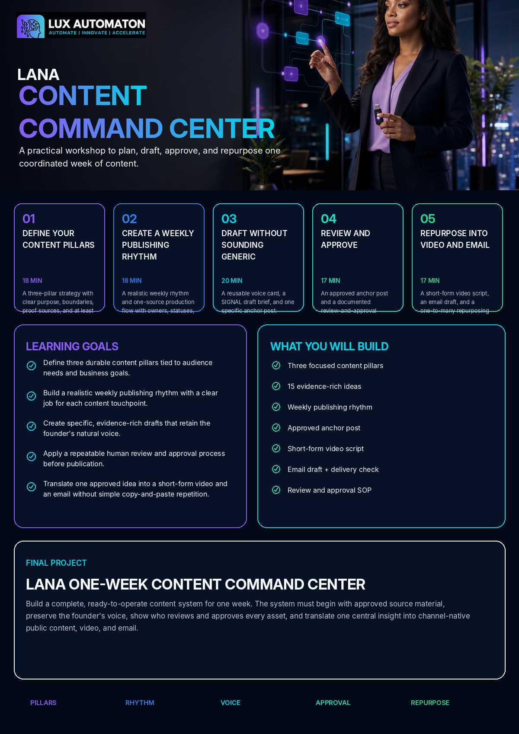

3. LEARNING FRAMEWORK

Five-Module Learning Framework
The workshop moves from strategic focus to weekly execution, then protects quality through voice, review, approval, and channel translation. Each lesson produces an artifact used in the final project.
01  DEFINE YOUR CONTENT PILLARS  18 min | 02  CREATE A WEEKLY PUBLISHING RHYTHM  18 min | 03  DRAFT WITHOUT SOUNDING GENERIC  20 min | 04  REVIEW AND APPROVE  17 min | 05  REPURPOSE INTO VIDEO AND EMAIL  17 min

Module 1: Define Your Content Pillars
Choose the recurring conversations your brand should lead, then create an evidence-rich bank of ideas inside each pillar.
MODULE OUTCOME
A three-pillar strategy with clear purpose, boundaries, proof sources, and at least fifteen usable ideas.

- Choose the Three Conversations Your Brand Should Own
- Build an Evidence-Rich Idea Bank

Module 2: Create a Weekly Publishing Rhythm
Give every publishing day a purpose and connect the work through one simple production board.
MODULE OUTCOME
A realistic weekly rhythm and one-source production flow with owners, statuses, and deadlines.

- Give Every Publishing Day a Job
- Build the One-Source Production Flow

Module 3: Draft Without Sounding Generic
Capture the founder's natural voice and use a structured drafting brief that gives AI real source material, boundaries, and intent.
MODULE OUTCOME
A reusable voice card, a SIGNAL draft brief, and one specific anchor post.

- Capture the Voice Before You Prompt
- Draft with the LANA SIGNAL Brief

Module 4: Review and Approve
Separate drafting from approval, use a five-pass editorial review, and define the lane every asset follows before publication.
MODULE OUTCOME
An approved anchor post and a documented review-and-approval operating procedure.

- Run the LANA CLEAR Editorial Review
- Create the Approval Lane

Module 5: Repurpose into Video and Email
Translate the approved idea into channel-native video and email while preserving the original insight and voice.
MODULE OUTCOME
A short-form video script, an email draft, and a one-to-many repurposing map.

- Translate the Anchor into Short-Form Video
- Deepen the Idea in Email

Facilitation timing
WELCOME AND SETUP | 5 min
FIVE MODULES | 90 min
FINAL PROJECT ASSEMBLY / NEXT STEPS | 5 min
OPTIONAL COMMAND CENTER LAB | 30 min

4. COMPLETE MODULES AND LESSONS

Complete Curriculum
Every lesson below is ready to teach. Teaching examples are fictional unless explicitly marked as learner-supplied evidence.


01 | DEFINE YOUR CONTENT PILLARS  Choose the recurring conversations your brand should lead, then create an evidence-rich bank of ideas inside each pillar.

MODULE OUTCOME
A three-pillar strategy with clear purpose, boundaries, proof sources, and at least fifteen usable ideas.

Lesson 1: Choose the Three Conversations Your Brand Should Own
MODULE | Define Your Content Pillars
DURATION | 9 minutes
LESSON OVERVIEW | Separate durable content pillars from random topics and formats, then choose three conversations that connect audience needs, founder credibility, and business relevance.
LEARNER DELIVERABLE | A three-pillar Content Strategy Card with purpose, audience need, business bridge, proof sources, and boundaries for each pillar.


Learning objectives
- Distinguish a content pillar from a topic, format, or campaign.
- Identify the intersection of audience need, credible expertise, and business relevance.
- Write a clear purpose and boundary for three content pillars.

Teaching lesson
A content pillar is a durable conversation your audience should associate with your brand. It is not a single topic, a platform, or a format. ‘LinkedIn tips’ is a platform-and-format idea. ‘How owner-led firms build a repeatable client experience’ is a pillar because it can support stories, tutorials, opinions, checklists, case examples, video, and email over time. Strong pillars reduce the blank-page problem by answering a strategic question before drafting begins: which conversation are we contributing to today?
Use three tests. First, audience pull: does the pillar address a recurring question, fear, goal, decision, or problem that matters to the people you want to serve? Second, credible depth: can you teach this from direct experience, approved evidence, customer patterns, or a point of view you can defend? Third, business bridge: does the conversation naturally connect to the work you provide without turning every post into a pitch? A pillar that fails audience pull becomes self-focused. A pillar that lacks credible depth becomes generic. A pillar with no business bridge may earn attention but never help the right person understand your value.
Keep the number small. Three pillars are enough for a first command center because each pillar can carry several angles. A useful mix is: one problem pillar that helps the audience diagnose what is wrong; one process pillar that shows how better work happens; and one perspective or proof pillar that demonstrates judgment, stories, outcomes, and beliefs. The names do not need to be clever. They need to be clear enough that another person could correctly sort an idea into the right pillar.
Every pillar also needs a boundary. Boundaries protect focus and trust. Write what the pillar includes, what it excludes, and what evidence qualifies. For example, a founder who helps service firms improve operations might use ‘Client Delivery Clarity’ as a pillar. It includes handoffs, expectations, approvals, and project communication. It excludes unrelated productivity hacks. It uses anonymized project patterns, approved examples, and the founder’s operating methods. This boundary keeps the pillar useful and prevents the brand from chasing every trending topic. Your goal is not to cover everything. Your goal is to become reliably useful in three connected conversations.
PRACTICAL EXAMPLE / CASE STUDY
Maya runs Northstar Operations, a fictional consultancy for small professional-service firms. She initially lists ‘AI, productivity, leadership, systems, marketing, and entrepreneurship.’ After applying the three tests, she narrows to: Diagnose Operational Drag, Build a Calm Client Delivery System, and Lead Change Without Losing the Human. The three pillars fit her clients, her experience, and her offer while giving her dozens of possible angles.

Step-by-step instructions
- Write the audience you want to help and the result they are trying to achieve.
- List ten recurring questions, frustrations, decisions, or misconceptions you hear from that audience.
- Group the items into three meaningful conversations rather than formats or platforms.
- Score each conversation for audience pull, credible depth, and business bridge on a 1-5 scale.
- Name the three strongest pillars and write one sentence describing what each includes and excludes.
HANDS-ON ACTIVITY  - Complete the LANA Pillar Fit Map. Place candidate pillars in a three-circle test: audience need, credible expertise, and business relevance. Select the three with the strongest overlap and write their boundaries. | CONCRETE LEARNER DELIVERABLE  - A three-pillar Content Strategy Card with purpose, audience need, business bridge, proof sources, and boundaries for each pillar.

Four useful tips
- Name pillars in customer language, not internal department language.
- Choose conversations you can sustain for at least three months.
- Make at least one pillar diagnostic and one pillar process-oriented.
- Use boundaries to say no to attractive but distracting topics.
COMMON MISTAKE TO AVOID
Choosing broad nouns such as ‘business,’ ‘AI,’ or ‘mindset’ without specifying the customer problem or decision inside the category.

CHECK-IN QUESTION
Could a teammate look at a new idea and place it in one pillar without asking you what you meant?

KNOWLEDGE CHECK  - Which option is the strongest content pillar: ‘Instagram Reels,’ ‘AI,’ or ‘How local service businesses respond to new leads without losing the human touch’ ? | ANSWER  - The third option. It names a durable customer conversation and can support many formats, examples, and teaching angles.

Facilitator guidance
Push learners away from platform names and toward recurring customer conversations. When a pillar is too broad, ask: ‘Which decision or problem inside that category do you want to be known for helping with?’ For teams, require agreement on the boundaries before moving on.

Recommended resources
- LANA Pillar Fit Map
- Recent customer questions
- Sales call notes
- Past high-performing content
- Current offer description

Lesson visual direction
IMAGE / DIAGRAM DESCRIPTION
LANA stands in a premium night studio beside three glowing glass panels labeled Audience Need, Credible Expertise, and Business Relevance. Their overlap forms three clear content pillars while a founder reviews the map.

Premium Lux Automaton executive technology studio at night, deep navy and black, cyan and electric-violet architectural light, warm Black woman AI strategist in black blazer and lavender blouse leading a founder through three transparent glass circles that represent audience need, credible expertise, and business relevance, three glowing pillar cards emerging from the overlap, sophisticated editorial composition, realistic photography, negative space for headline and authentic logo, no fake logo, no tiny interface text, 16:9.
Accessible alt text: LANA guides a founder through three overlapping criteria that produce three focused content pillars.

Lesson 2: Build an Evidence-Rich Idea Bank
MODULE | Define Your Content Pillars
DURATION | 9 minutes
LESSON OVERVIEW | Turn each pillar into a repeatable bank of questions, stories, proof, teaching points, and calls to action so weekly publishing does not begin from zero.
LEARNER DELIVERABLE | A 15-idea bank with source, reader shift, call to action, and publication status for every idea.


Learning objectives
- Generate multiple content angles from one pillar.
- Separate source material from finished content ideas.
- Create an organized bank of at least fifteen evidence-rich ideas.

Teaching lesson
Content becomes generic when it begins with an empty prompt instead of real source material. An idea bank solves that problem by storing the raw ingredients behind future posts: customer questions, moments from the work, myths, decisions, examples, frameworks, data you are allowed to use, and stories you can responsibly tell. The bank is not a list of vague titles. Each entry should contain enough context that a useful draft can be produced later.
Use five angle types inside every pillar. Questions capture what the audience asks. Friction captures what repeatedly goes wrong. Frameworks capture the way you explain or solve the problem. Proof captures approved examples, observations, before-and-after contrasts, or lessons from practice. Perspective captures what you believe, disagree with, or want the market to understand differently. Five angle types across three pillars create fifteen starting points without manufacturing novelty.
Add a source field to every idea. The source might be an anonymized call note, an approved testimonial, a personal experience, a public reference you will verify, a recurring objection, or your own process. Then add the reader shift: what should the audience understand, feel, decide, or do after engaging with the piece? Finally, add a possible next step. The next step can be reflective rather than promotional: answer a question, save a checklist, review a workflow, or reply with a challenge. This makes the idea strategically useful while preserving reader value.
A well-kept idea bank is also a risk-control tool. It helps the team distinguish facts from examples, approved stories from private stories, and original insight from borrowed inspiration. Label entries as approved, needs verification, or private-do-not-publish. When AI is used, feed it the approved source summary rather than an entire private conversation. The quality of the draft will depend more on the quality of the source than on clever wording in the prompt.
Do not try to fill a giant backlog in this lesson. Build a small, high-confidence bank that reflects what your audience actually cares about. Fifteen ideas are enough to support the first month while you observe what earns questions, saves, replies, and qualified conversations. The command center should grow from real feedback, not endless brainstorming.
PRACTICAL EXAMPLE / CASE STUDY
For the fictional pillar ‘Build a Calm Client Delivery System,’ Maya records five angles: a question about kickoff expectations, a friction story about missing approvals, a handoff framework, an anonymized before-and-after project example, and a perspective piece titled ‘Speed without clarity creates rework.’ Each idea includes its source and the reader shift.

Step-by-step instructions
- Create one column or section for each of your three pillars.
- Under each pillar, add one question, one friction pattern, one framework, one proof item, and one perspective.
- Attach the approved source or a short source summary to every idea.
- Write the reader shift and a possible next action for every entry.
- Label each idea approved, needs verification, or private-do-not-publish.
HANDS-ON ACTIVITY  - Build the 3 x 5 LANA Idea Bank: three pillars by five angle types. Select the strongest idea as the anchor for the rest of the workshop. | CONCRETE LEARNER DELIVERABLE  - A 15-idea bank with source, reader shift, call to action, and publication status for every idea.

Four useful tips
- Capture the exact customer question before translating it into polished language.
- Save proof and context with the idea so future drafting is easier.
- Mark sensitive material before it reaches a writing tool.
- Prefer ten strong ideas with evidence over fifty empty headlines.
COMMON MISTAKE TO AVOID
Saving only catchy titles while discarding the story, example, question, or evidence that would make the draft specific.

CHECK-IN QUESTION
Does your selected anchor idea include a real source and a clear reader shift, or is it only a topic?

KNOWLEDGE CHECK  - Why should every idea include a source field? | ANSWER  - The source gives the draft specific, verifiable material and helps separate approved evidence from private or unverified information.

Facilitator guidance
Keep the pace fast by giving learners the five angle types. If they are stuck, ask for the last customer question they answered, the last mistake they corrected, or the last decision they explained. Remind them that invented customer stories must be labeled as examples.

Recommended resources
- LANA 3 x 5 Idea Bank
- Customer FAQ list
- Approved testimonials
- Founder notebook
- Project retrospective notes

Lesson visual direction
IMAGE / DIAGRAM DESCRIPTION
A transparent three-column idea bank fills with question, friction, framework, proof, and perspective cards while LANA organizes approved and private sources.

Lux Automaton premium night studio, LANA in black blazer and lavender blouse organizing a transparent glass content idea bank with three columns and five color-coded card types, clear visual labels represented by icons for question, friction, framework, proof, perspective, small founder team watching, deep navy, cyan and violet glow, realistic editorial photography, negative space, authentic logo area left blank, no fake logo, no illegible text, 16:9.
Accessible alt text: LANA organizes fifteen content ideas across three pillars and five evidence-based angle types.


02 | CREATE A WEEKLY PUBLISHING RHYTHM  Give every publishing day a purpose and connect the work through one simple production board.

MODULE OUTCOME
A realistic weekly rhythm and one-source production flow with owners, statuses, and deadlines.

Lesson 3: Give Every Publishing Day a Job
MODULE | Create a Weekly Publishing Rhythm
DURATION | 9 minutes
LESSON OVERVIEW | Design a sustainable weekly rhythm in which each touchpoint performs a distinct role: teach, prove, converse, invite, or deepen the relationship.
LEARNER DELIVERABLE | A weekly publishing rhythm with distinct roles, realistic timing, and a documented minimum viable week.


Learning objectives
- Choose a realistic publishing frequency based on capacity.
- Assign a strategic job to each weekly touchpoint.
- Balance teaching, proof, conversation, and invitation.

Teaching lesson
Consistency becomes easier when the week has a rhythm, not when the team promises to ‘post more.’ A publishing rhythm is a repeatable pattern that gives each content touchpoint a job. The rhythm should fit the team’s capacity, the audience’s decision process, and the amount of approved source material available. It does not need to fill every day or every platform. A small rhythm that is reliably completed is more useful than an ambitious calendar that collapses after two weeks.
Start with one anchor idea. The anchor is the most complete expression of the week’s insight: a thoughtful post, article, audio note, video, or newsletter. Around it, assign supporting roles. A teaching touchpoint explains a concept or method. A proof touchpoint shows an example, observation, demonstration, or lesson from the work. A conversation touchpoint asks a meaningful question or responds to an objection. An invitation touchpoint helps the right person take a next step. A deepening touchpoint, often email, gives more context to people who have chosen a closer relationship with the brand.
The roles matter more than fixed weekdays. A founder may use a three-touch rhythm: teach on Tuesday, converse on Thursday, and send an email on Friday. A team with more capacity may use five touches. The command center should show the purpose of each item so the week does not become five versions of the same sales message. It should also show the primary audience, pillar, format, owner, and approval deadline.
Build in breathing room. Drafting, review, revisions, scheduling, and production all require time. If the anchor post publishes Wednesday, the approval deadline should not also be Wednesday. Work backward from the publishing moment and protect a review window. Content that requires customer approval, legal review, data verification, or video editing needs an earlier start.
Finally, define the minimum viable week. This is the version you can still complete during a busy period without sacrificing accuracy or trust. For many founders it is one strong anchor, one conversation post, and one email. Additional formats are a bonus. The weekly rhythm is not a punishment schedule. It is a decision system that protects focus and helps the team know what good completion looks like.
PRACTICAL EXAMPLE / CASE STUDY
Maya chooses a four-touch rhythm: Monday diagnostic post, Wednesday process lesson, Thursday conversation question, and Friday email. She adds one invitation every other week rather than pitching daily. Her minimum viable week is the Wednesday process lesson plus Friday email.

Step-by-step instructions
- Estimate the number of quality content touches you can create and approve each week.
- Choose the weekly anchor and the pillar it will serve.
- Assign a job to each additional touchpoint: teach, prove, converse, invite, or deepen.
- Set draft, review, approval, and publish dates by working backward.
- Define the minimum viable week for high-demand periods.
HANDS-ON ACTIVITY  - Complete the LANA Weekly Rhythm Map. Build a three-, four-, or five-touch week and label the job, pillar, audience, owner, and approval deadline for each item. | CONCRETE LEARNER DELIVERABLE  - A weekly publishing rhythm with distinct roles, realistic timing, and a documented minimum viable week.

Four useful tips
- Design around your actual approval capacity, not your idealized ambition.
- Use one anchor idea to reduce context switching.
- Separate invitations from value so every post does not feel like a pitch.
- Leave at least one buffer window for revision or delayed approvals.
COMMON MISTAKE TO AVOID
Scheduling several posts without assigning different jobs, which produces repetitive content and constant urgency.

CHECK-IN QUESTION
Can you explain the purpose of every item in your week in one verb?

KNOWLEDGE CHECK  - What is the best reason to define a minimum viable week? | ANSWER  - It preserves consistency and quality during busy periods without forcing an unrealistic publishing volume.

Facilitator guidance
Do not let learners assume daily publishing is required. Ask what they can draft, review, and approve well. Encourage teams to include review deadlines, not only publish dates. A useful rhythm should still work when the founder has client work.

Recommended resources
- LANA Weekly Rhythm Map
- Current calendar
- Team capacity estimate
- Audience decision journey
- Idea bank

Lesson visual direction
IMAGE / DIAGRAM DESCRIPTION
LANA arranges five glowing weekly cards around one anchor idea, each card carrying a different job: teach, prove, converse, invite, or deepen.

Premium Lux Automaton editorial command center at night, LANA directing a transparent weekly calendar with one central anchor content card and five surrounding roles represented by clear icons: teach, proof, conversation, invitation, email/deepen, diverse small team, deep navy black, cyan and violet lights, realistic photography, elegant negative space, no fake logo, no tiny text, 16:9.
Accessible alt text: A weekly content rhythm assigns a distinct strategic job to every publishing touchpoint.

Lesson 4: Build the One-Source Production Flow
MODULE | Create a Weekly Publishing Rhythm
DURATION | 9 minutes
LESSON OVERVIEW | Connect source notes, drafting, review, scheduling, publication, and repurposing through one visible board so the team knows what is next.
LEARNER DELIVERABLE | A one-source weekly production board with status, owner, reviewer, deadlines, current file, next action, and learning field.


Learning objectives
- Map the content production stages from source to archive.
- Assign clear status labels and ownership.
- Build a single visible command board for the week.

Teaching lesson
A calendar shows when content should publish. A command center shows how the work reaches that point. Without a visible production flow, content lives in messages, personal notes, shared documents, scheduling tools, and memory. The team can see the due date but not the next action. The one-source production flow solves this by giving every asset one record and one current status.
Use a simple lane: Captured, Selected, Drafting, Review, Revision, Approved, Scheduled, Published, Repurpose, and Archived. Not every team needs all ten statuses, but the difference between ‘drafted,’ ‘approved,’ and ‘scheduled’ must remain visible. A draft is not approved merely because it exists. An approved piece is not scheduled merely because the publish date is near. Clear status language reduces duplicate work and prevents unreviewed content from moving forward.
The asset record should contain the pillar, audience, source, owner, reviewer, approval deadline, publish date, channel, call to action, link to the current file, and any rights or privacy notes. Keep the record lightweight enough to maintain. The content itself can live in a document or approved workspace, but the command board should always link to the current version. Avoid sending multiple attachments with names such as ‘final,’ ‘final2,’ and ‘really final.’ Use one document with version history or a clear version number.
The board should also display the next action. ‘In review’ is only useful when someone knows who is reviewing it and by when. Write the next action as a verb: verify the number, approve the example, record the video, add captions, schedule the email, or request customer permission. This transforms the board from an archive into an operating system.
End the flow with published evidence and learning. Save the final link, publication date, and a brief observation after the piece has had time to work. Capture meaningful signals such as questions, replies, saves, qualified visits, conversations, or conversions. The goal is not to chase a single public metric. It is to learn which pillars, examples, and formats help the right people move closer to a useful decision. The command center becomes stronger when the learning feeds the next idea bank.
PRACTICAL EXAMPLE / CASE STUDY
Northstar Operations once managed content through text messages and separate documents. Maya creates one board with an owner, reviewer, due date, file link, and next action. The Thursday post is not labeled ‘almost done’; it is labeled ‘Revision - Maya to replace private customer detail by 2 p.m.’ The ambiguity disappears.

Step-by-step instructions
- Draw the stages an asset follows from captured source to published archive.
- Choose a short set of unambiguous status labels.
- Define the required fields for every content record.
- Assign an owner, reviewer, approval deadline, and next action to the selected anchor idea.
- Add a post-publication learning field that feeds the idea bank.
HANDS-ON ACTIVITY  - Build the LANA Weekly Command Board for the current week. Move the selected anchor idea through the first three statuses and assign the next action. | CONCRETE LEARNER DELIVERABLE  - A one-source weekly production board with status, owner, reviewer, deadlines, current file, next action, and learning field.

Four useful tips
- Use one current file link per asset.
- Write next actions as verbs with one owner and one due time.
- Keep approval separate from scheduling.
- Archive the published link and learning, not just the draft.
COMMON MISTAKE TO AVOID
Treating the publishing calendar as the production system even though it does not show source, reviewer, status, or next action.

CHECK-IN QUESTION
At a glance, can every person tell what is blocked, who owns the next move, and when approval is due?

KNOWLEDGE CHECK  - Why is ‘in progress’ a weak status? | ANSWER  - It does not show the current stage, owner, blocker, or next action. A more specific status makes the work executable.

Facilitator guidance
Ask learners to reduce unnecessary statuses, but do not let them merge drafting, approval, and scheduling. For solo founders, separate the roles by time: creator mode, reviewer mode, and publisher mode. The system still benefits from explicit gates.

Recommended resources
- LANA Weekly Command Board
- Existing content calendar
- Shared document system
- Approval policy
- Publishing links

Lesson visual direction
IMAGE / DIAGRAM DESCRIPTION
A glass command board shows a content asset moving through Captured, Drafting, Review, Approved, Scheduled, Published, and Repurpose stages, with LANA pointing to the next action.

Lux Automaton futuristic content operations room, LANA at transparent glass kanban board with glowing stages from captured source to drafting, review, approved, scheduled, published, repurpose, visible owner and next action icons, small founder team, deep navy, cyan and violet, realistic high-end photography, clean large visual hierarchy, blank logo area, no fake brand text, 16:9.
Accessible alt text: A single content asset moves through a visible production board with clear ownership and next actions.


03 | DRAFT WITHOUT SOUNDING GENERIC  Capture the founder's natural voice and use a structured drafting brief that gives AI real source material, boundaries, and intent.

MODULE OUTCOME
A reusable voice card, a SIGNAL draft brief, and one specific anchor post.

Lesson 5: Capture the Voice Before You Prompt
MODULE | Draft Without Sounding Generic
DURATION | 10 minutes
LESSON OVERVIEW | Identify the language, perspective, rhythm, evidence, and boundaries that make the founder recognizable before asking AI to draft.
LEARNER DELIVERABLE | A reusable Voice Card containing perspective, language, rhythm, evidence, reader relationship, signature patterns, banned language, and truth boundaries.


Learning objectives
- Recognize the signals that make a brand voice specific.
- Create a reusable LANA Voice Card from real examples.
- Define language and behaviors the draft should avoid.

Teaching lesson
A generic draft is often the predictable result of generic instructions. ‘Write an engaging post about leadership’ provides no experience, audience tension, evidence, point of view, or language pattern. The model fills the gap with safe, familiar phrases. Preserving voice starts before prompting by documenting what the founder actually sounds like when explaining something they know well.
Voice is more than adjectives such as professional, warm, or bold. Capture observable signals. Perspective is the recurring way the founder interprets a problem. Language includes phrases they naturally use and words they avoid. Rhythm includes sentence length, pacing, questions, contrast, humor, and the amount of explanation. Evidence includes the kinds of stories, examples, frameworks, or details the founder relies on. Relationship describes how the founder addresses the reader: peer to peer, teacher to learner, trusted adviser, challenger, or guide. Boundaries identify what the brand will not claim, reveal, imitate, or exaggerate.
Build the Voice Card from evidence, not imagination. Review two pieces of writing, one transcript, or a few minutes of the founder explaining the topic aloud. Highlight sentences that feel unmistakably natural. Record specific patterns: ‘opens with a direct observation,’ ‘uses short contrast lines,’ ‘names the tradeoff,’ ‘avoids hype,’ ‘gives one concrete example,’ or ‘ends with a thoughtful question rather than a hard pitch.’ Add three signature phrases and three banned phrases. A banned phrase may be a cliché the founder dislikes, a claim the business cannot support, or jargon the audience does not use.
Voice preservation also requires source fidelity. The writing tool should not invent a childhood story, customer result, credential, or opinion merely to make the piece more interesting. Tell it to mark missing information rather than fill gaps. When a story is composite or hypothetical, label it clearly. When the founder’s real perspective is not yet known, ask questions before drafting.
The Voice Card does not need to freeze the brand into one tone. A founder can be more concise in a short video and more reflective in email while keeping the same perspective and boundaries. The card provides continuity. It makes editing faster because the reviewer can point to an agreed pattern instead of saying, ‘This just does not sound like us.’
PRACTICAL EXAMPLE / CASE STUDY
Maya's first AI drafts use phrases such as ‘game-changing,’ ‘unlock your potential,’ and ‘in today's fast-paced world.’ None match her measured style. Her Voice Card says: start with an operational observation, name the tradeoff, use plain language, include one real work pattern, never promise effortless transformation, and close with a practical question. The next draft is immediately more recognizable.

Step-by-step instructions
- Collect two examples of writing or speaking that sound natural and credible.
- Highlight perspective, language, rhythm, evidence, relationship, and boundaries.
- Write five observable voice rules rather than vague adjectives.
- Add three signature phrases or sentence patterns and three phrases to avoid.
- State what the drafting tool must do when source information is missing.
HANDS-ON ACTIVITY  - Complete the LANA Voice Card and test it by rewriting one generic sentence in the founder's natural voice. | CONCRETE LEARNER DELIVERABLE  - A reusable Voice Card containing perspective, language, rhythm, evidence, reader relationship, signature patterns, banned language, and truth boundaries.

Four useful tips
- Use transcripts because spoken explanations often reveal natural rhythm.
- Describe voice with actions the writer can follow.
- Include what must never be invented.
- Keep examples short enough to reuse in future briefs.
COMMON MISTAKE TO AVOID
Describing the voice only as ‘professional, authentic, and engaging,’ which gives the drafting tool almost no usable direction.

CHECK-IN QUESTION
Could another writer use your Voice Card and make a draft recognizably closer to you?

KNOWLEDGE CHECK  - Which voice instruction is more useful: ‘sound authentic’ or ‘open with a direct observation, use plain language, name one tradeoff, and avoid hype’ ? | ANSWER  - The second instruction because it describes observable writing behavior.

Facilitator guidance
Invite learners to read a short past post aloud. Voice often becomes obvious through cadence and word choice. Correct any tendency to copy another creator. The goal is to articulate the learner's own patterns, not manufacture a persona.

Recommended resources
- LANA Voice Card
- Past posts
- Call or podcast transcript
- Founder notes
- Approved brand language

Lesson visual direction
IMAGE / DIAGRAM DESCRIPTION
LANA listens to a founder's spoken explanation while a transparent voice fingerprint captures perspective, language, rhythm, evidence, and boundaries.

High-end Lux Automaton studio at night, LANA listening warmly as a founder speaks, transparent glass voice fingerprint interface with five large icon zones for perspective, language, rhythm, evidence, and boundaries, lavender blouse, black blazer, cyan and violet lighting, realistic photography, editorial negative space, no fake logo, no illegible text, 16:9.
Accessible alt text: LANA captures a founder's natural voice patterns before any AI drafting begins.

Lesson 6: Draft with the LANA SIGNAL Brief
MODULE | Draft Without Sounding Generic
DURATION | 10 minutes
LESSON OVERVIEW | Use a six-part brief that gives a writing assistant approved source material, audience intent, grounding, natural voice, action, and limits.
LEARNER DELIVERABLE | A saved SIGNAL Brief, three candidate openings, and one revised anchor post linked to its approved source.
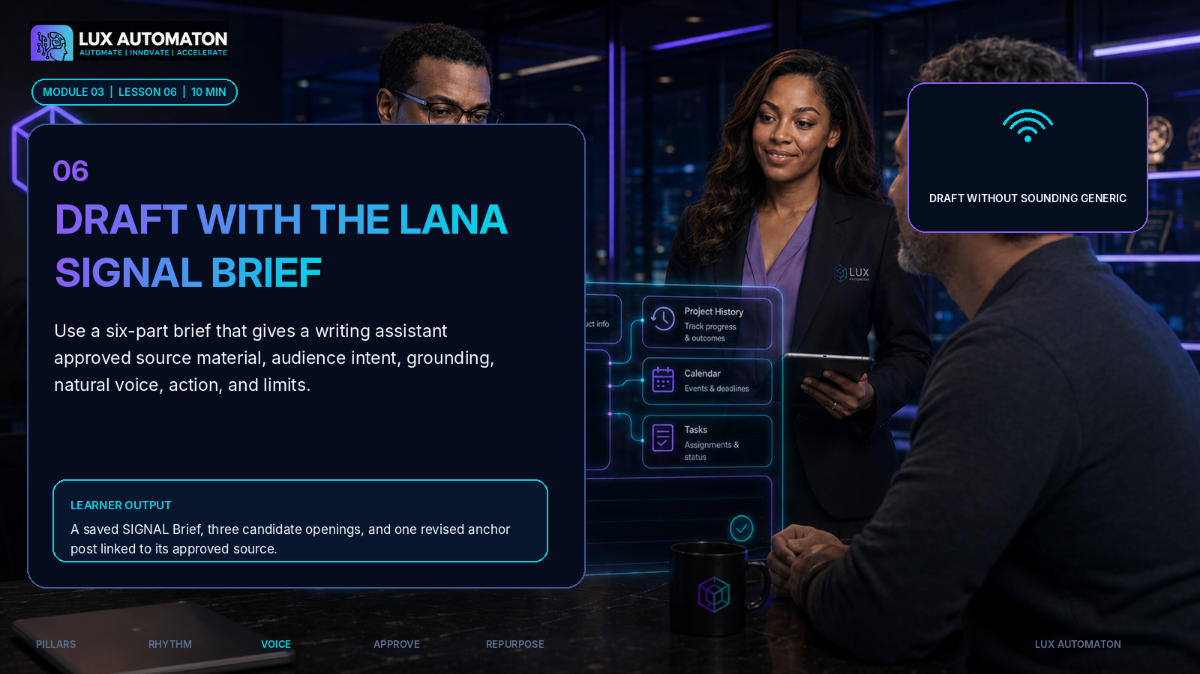

Learning objectives
- Build a complete SIGNAL drafting brief.
- Generate a draft from approved source rather than empty instructions.
- Revise the draft for specificity, usefulness, and natural voice.

Teaching lesson
The best prompt in this workshop is not a magic sentence. It is a compact editorial brief. LANA SIGNAL organizes the information a writer or AI assistant needs: Source, Intended reader, Grounding, Natural voice, Action, and Limits. The framework reduces guessing and gives the reviewer something concrete to evaluate.
Source is the approved material the draft may use: notes, a transcript excerpt, a framework, verified facts, or an anonymized example. Intended reader names the specific person, their current situation, and the shift the content should create. Grounding identifies the evidence or practical detail that must appear. Natural voice points to the Voice Card and any example language. Action defines the job of the piece: teach, prove, converse, invite, or deepen, plus the next step for the reader. Limits set length, format, claims, privacy, banned language, and what to do when information is missing.
Before generating a full draft, ask for structure. Request three possible openings, a short outline, or two contrasting approaches. Choose the direction that best fits the idea, then draft. This keeps the founder in control of the argument. When the first version arrives, do not merely ask to ‘make it better.’ Diagnose the weakness. Ask for one stronger example, a clearer contrast, a shorter opening, less jargon, or a more useful final question. Specific revision requests preserve the underlying insight.
Use AI as a drafting partner, not a source of authority. If the draft introduces a statistic, quotation, event, customer detail, or claim that was not in the approved source, remove it or verify it independently. If the tool smooths the writing until every sentence sounds alike, reintroduce the founder's natural rhythm. A deliberate fragment, a direct question, or a sharp contrast may be part of the voice.
The anchor post should make one useful move. It does not need to summarize the entire pillar. A strong piece often includes a recognizable tension, a clear point of view, one grounded example, a practical takeaway, and a next step. Keep the source attached to the asset record so the reviewer can compare what was written with what was actually known. The final draft should feel more specific than a blank-page draft because the system carries context into the writing process.
PRACTICAL EXAMPLE / CASE STUDY
Maya uses a call-note summary about a project that stalled because no one owned approvals. Her SIGNAL brief names agency owners as the reader, requires an anonymized handoff example, uses her no-hype Voice Card, and asks for a teaching post ending with a diagnostic question. The draft opens with ‘A delayed project is often an approval problem wearing a deadline problem's clothes.’ The line sounds like Maya because the brief supplied her perspective and rhythm.

Step-by-step instructions
- Paste or link only the approved source summary for the selected anchor idea.
- Complete Source, Intended reader, Grounding, Natural voice, Action, and Limits.
- Request three openings and a short outline before requesting the full draft.
- Choose one direction and generate the anchor post.
- Revise with precise instructions, then mark any new claims that require verification.
HANDS-ON ACTIVITY  - Complete a SIGNAL Brief and produce one 250-450 word anchor post or equivalent long-form social draft. | CONCRETE LEARNER DELIVERABLE  - A saved SIGNAL Brief, three candidate openings, and one revised anchor post linked to its approved source.

Four useful tips
- Ask for structure before prose when the idea is complex.
- State the reader shift and content job explicitly.
- Tell the tool to flag gaps instead of inventing details.
- Revise the cause of generic writing, not just the adjective used to describe it.
COMMON MISTAKE TO AVOID
Using a clever prompt with no source, evidence, audience tension, or voice rules and then blaming the tool for producing familiar language.

CHECK-IN QUESTION
Can you trace every story, fact, claim, or example in the draft back to an approved source or a clearly labeled teaching example?

KNOWLEDGE CHECK  - What does the G in SIGNAL represent? | ANSWER  - Grounding: the evidence, example, detail, or practical proof the draft must include.

Facilitator guidance
Keep learners from spending the full lesson polishing. The goal is a strong working draft and a reusable brief. Ask them to highlight any sentence that could have been written for any business; those are the places that need more source, perspective, or evidence.

Recommended resources
- LANA SIGNAL Brief
- Voice Card
- Approved source note
- Idea bank
- Anchor post template

Lesson visual direction
IMAGE / DIAGRAM DESCRIPTION
A six-part glass SIGNAL panel connects source material to an approved anchor post while LANA and a founder compare multiple openings.

Lux Automaton executive content studio, transparent six-part SIGNAL drafting interface with large icon sections for source, intended reader, grounding, natural voice, action, limits, LANA and founder selecting among three opening cards, deep navy black, cyan violet and teal glow, realistic premium photography, clean negative space for title and authentic logo, no fake logo, no tiny text, 16:9.
Accessible alt text: The SIGNAL framework turns approved source material and voice guidance into a specific anchor draft.


04 | REVIEW AND APPROVE  Separate drafting from approval, use a five-pass editorial review, and define the lane every asset follows before publication.

MODULE OUTCOME
An approved anchor post and a documented review-and-approval operating procedure.

Lesson 7: Run the LANA CLEAR Editorial Review
MODULE | Review and Approve
DURATION | 8 minutes
LESSON OVERVIEW | Review the anchor draft through five separate passes: Correct, Legible, Evidence-backed, Aligned, and Responsible.
LEARNER DELIVERABLE | An approval-ready anchor post with a completed CLEAR checklist and documented reviewer decision.


Learning objectives
- Apply a structured review instead of vague taste-based editing.
- Identify factual, voice, usefulness, and risk issues.
- Produce a documented approval-ready version.

Teaching lesson
Drafting and reviewing are different modes of work. Drafting asks, ‘What could this become?’ Reviewing asks, ‘Is this accurate, useful, on-brand, and safe to publish?’ When the modes are mixed, the writer may spend too long perfecting sentences before the idea is sound, or a reviewer may change the voice without noticing a factual risk. LANA CLEAR separates the review into five focused passes.
Correct checks names, numbers, dates, quotations, links, grammar, and the relationship between the claim and the source. Legible checks whether the reader can follow the opening, structure, transitions, format, and next step. Evidence-backed checks whether the piece includes enough specific support and whether examples are real, approved, composite, or hypothetical. Aligned checks the pillar, audience, content job, Voice Card, offer, and current business priority. Responsible checks privacy, rights, accessibility, fairness, regulated claims, customer permission, and the human approval requirement.
Review one pass at a time. Trying to fix every issue in one read increases the chance of missing something important. Use comments that name the problem and the requested action. ‘This does not work’ is weak. ‘Replace this unsupported outcome claim with the approved process result’ is executable. Separate required changes from optional style preferences. Otherwise the review process expands indefinitely and the writer cannot tell what blocks approval.
The reviewer should compare the draft with the source and the SIGNAL Brief. A polished sentence can still be wrong. A vivid customer story can still be private. A high-energy claim can still violate the Voice Card. When information is uncertain, pause publication. The deadline does not convert an unverified claim into a verified one.
Approval means the required checks are complete and the approver is willing to stand behind the content. Record who approved the asset and when. This does not create bureaucracy for its own sake. It protects the customer, the founder, and the team while making future work faster. Repeated review comments should become updated Voice Card rules, templates, or source requirements so the same issue is not corrected every week.
PRACTICAL EXAMPLE / CASE STUDY
Maya's draft says a clearer approval system ‘cuts project delays in half.’ The source does not support that number. During the Correct and Evidence-backed passes, she replaces it with an approved observation: ‘The team stopped waiting in three different inboxes for the same decision.’ During the Responsible pass, she removes a client name and labels the example as anonymized.

Step-by-step instructions
- Read the draft once without editing to identify its main idea and job.
- Run the Correct, Legible, Evidence-backed, Aligned, and Responsible passes separately.
- Mark each comment as required or optional.
- Resolve required changes and recheck the source and Voice Card.
- Record the reviewer, approval status, and date.
HANDS-ON ACTIVITY  - Use the CLEAR checklist to review the anchor post. Make at least one evidence improvement, one voice improvement, and one reader-usefulness improvement before approval. | CONCRETE LEARNER DELIVERABLE  - An approval-ready anchor post with a completed CLEAR checklist and documented reviewer decision.

Four useful tips
- Review against the brief, not only personal taste.
- Separate accuracy corrections from style preferences.
- Pause when the source cannot support the claim.
- Turn repeated review notes into reusable rules.
COMMON MISTAKE TO AVOID
Treating approval as a quick proofread even though the content may contain unsupported claims, private details, or a voice mismatch.

CHECK-IN QUESTION
Would you be comfortable explaining the source and approval decision behind every claim in the draft?

KNOWLEDGE CHECK  - Which CLEAR pass asks whether a customer story is approved, anonymized, composite, or hypothetical? | ANSWER  - Evidence-backed and Responsible. The evidence pass checks what the story proves; the responsible pass checks permission, privacy, and truthful labeling.

Facilitator guidance
Use a short sample sentence to demonstrate the difference between required and optional comments. For regulated or high-risk industries, tell learners to insert their existing compliance review rather than treating CLEAR as a replacement for legal or professional review.

Recommended resources
- LANA CLEAR Checklist
- SIGNAL Brief
- Voice Card
- Source note
- Rights and privacy notes

Lesson visual direction
IMAGE / DIAGRAM DESCRIPTION
Five glowing review lenses labeled with icons inspect one anchor post while LANA and a business owner approve only after all checks are complete.

Premium Lux Automaton night studio, LANA and diverse founder reviewing a transparent content document through five large glowing editorial lenses representing correct, legible, evidence, aligned, responsible, human approval control visible, navy black, cyan violet, realistic photography, sophisticated clean composition, blank authentic logo area, no fake text, 16:9.
Accessible alt text: A content draft passes through five editorial checks before a human approves publication.

Lesson 8: Create the Approval Lane
MODULE | Review and Approve
DURATION | 9 minutes
LESSON OVERVIEW | Define who writes, reviews, approves, schedules, and responds, then document a lightweight operating procedure for every customer-facing asset.
LEARNER DELIVERABLE | A one-page approval SOP containing roles, risk levels, deadlines, reapproval triggers, and post-publication checks.


Learning objectives
- Assign clear roles for creation and publication.
- Define approval gates for different risk levels.
- Create a practical content approval SOP.

Teaching lesson
A review checklist improves the asset. An approval lane improves the system. The lane defines who can move an asset from one status to the next, what evidence is required, and what happens when the deadline or reviewer is unavailable. This matters for a team, but it also matters for a solo founder. One person can hold several roles, yet the roles should still occur at different moments. Writing and approving in the same rushed minute removes the benefit of independent review.
Start with five roles: source owner, writer, reviewer, approver, and publisher. The source owner confirms that the underlying story, data, quote, or example is permitted and accurate. The writer produces the draft. The reviewer applies CLEAR and requests changes. The approver accepts the final customer-facing version. The publisher schedules, checks the live asset, and archives the link. Add a response owner when the content invites questions or customer conversations.
Not every asset needs the same approval depth. Create three risk levels. Standard content uses approved teaching material and can follow the normal review lane. Sensitive content includes customer stories, unpublished numbers, employees, complaints, legal or financial claims, health topics, crisis messages, or strong comparative statements. It requires an additional named reviewer or source owner. Urgent content may move quickly, but it still needs a designated approver and a written record of what was checked. ‘Urgent’ should not mean ‘unowned.’
Define service levels for the lane. How long does a reviewer normally have? What is the cutoff for the publish date? Who makes the final call when comments conflict? What happens when the approver is absent? What changes require a new approval after an asset was already approved? A changed claim, customer detail, price, link, or call to action may require another review. Minor formatting changes may not. Write the rules plainly.
Finally, close the loop after publication. Confirm the asset displayed correctly, captions and links work, the correct version is live, and the response owner knows what to do. If a mistake is discovered, pause scheduled derivatives, correct the source record, and document the decision. A dependable approval lane increases creative speed because the team no longer negotiates the process from scratch every time.
PRACTICAL EXAMPLE / CASE STUDY
Northstar Operations uses a solo-founder lane for standard posts: Maya writes in the morning, reviews after a break, and approves the next day. Customer-story content adds the account lead as source owner. A price or service claim requires Maya's final approval after every material change. The process is small but explicit.

Step-by-step instructions
- Name the source owner, writer, reviewer, approver, publisher, and response owner for your current team.
- Define standard, sensitive, and urgent content categories.
- Set the normal review window and publication cutoff.
- List material changes that require reapproval.
- Write the post-publication check and correction process.
HANDS-ON ACTIVITY  - Complete the LANA Approval Lane SOP for the selected anchor post and one sensitive-content scenario. | CONCRETE LEARNER DELIVERABLE  - A one-page approval SOP containing roles, risk levels, deadlines, reapproval triggers, and post-publication checks.

Four useful tips
- Use role names even when one person fills every role.
- Create a backup approver before an urgent situation occurs.
- Define what counts as a material change.
- Assign a response owner for content that invites conversation.
COMMON MISTAKE TO AVOID
Assuming a shared document automatically creates accountability even though no reviewer, deadline, or final approver is named.

CHECK-IN QUESTION
If the normal approver is unavailable tomorrow, does the system show exactly what can proceed and who can decide?

KNOWLEDGE CHECK  - Why should a solo founder separate writer and approver roles by time? | ANSWER  - The pause creates a fresh review perspective and reduces the chance that drafting momentum substitutes for approval.

Facilitator guidance
Keep the SOP proportional. A two-person business does not need a six-department workflow. It still needs clear roles and sensitive-content rules. Ask teams to name one real scenario that should receive a higher review level.

Recommended resources
- LANA Approval Lane SOP
- CLEAR Checklist
- Team role list
- Content risk examples
- Escalation contact list

Lesson visual direction
IMAGE / DIAGRAM DESCRIPTION
A transparent approval lane moves an asset through source owner, writer, reviewer, approver, publisher, and response owner, with a separate sensitive-content gate.

Lux Automaton premium executive command center, transparent approval workflow lane with six large role stations represented by clear icons, LANA guiding a small team, separate shield gate for sensitive content, visible human approval, deep navy black with cyan violet lighting, realistic editorial photography, clear hierarchy, negative space, no fake logo or tiny text, 16:9.
Accessible alt text: A clear approval lane assigns ownership from source verification through publication and audience response.

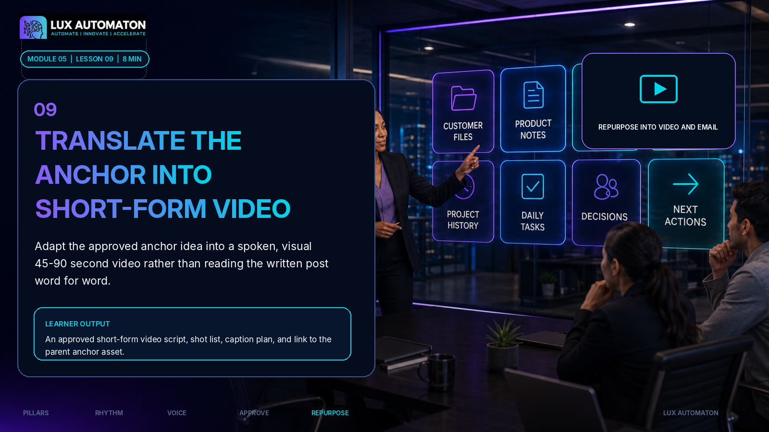
05 | REPURPOSE INTO VIDEO AND EMAIL  Translate the approved idea into channel-native video and email while preserving the original insight and voice.

MODULE OUTCOME
A short-form video script, an email draft, and a one-to-many repurposing map.

Lesson 9: Translate the Anchor into Short-Form Video
MODULE | Repurpose into Video and Email
DURATION | 8 minutes
LESSON OVERVIEW | Adapt the approved anchor idea into a spoken, visual 45-90 second video rather than reading the written post word for word.
LEARNER DELIVERABLE | An approved short-form video script, shot list, caption plan, and link to the parent anchor asset.


Learning objectives
- Identify the single spoken idea for the video.
- Write a concise hook-to-next-step script.
- Create a simple shot, caption, and approval plan.

Teaching lesson
Repurposing is translation, not duplication. A written post can hold several paragraphs, transitions, and supporting details. Short-form video must earn attention through voice, expression, pacing, and visual change. The approved insight remains the same, but the delivery should be rebuilt for listening and watching. Reading the post word for word usually sounds stiff because written sentences are longer and more compressed than natural speech.
Choose one spoken promise. Ask: what is the single idea the viewer should remember after sixty seconds? Build a simple sequence: Hook, Tension, Insight, Proof, and Next Step. The hook names a recognizable situation, contrast, or question. The tension explains why the issue matters. The insight gives the founder's point of view or method. The proof adds one permitted example, demonstration, or practical detail. The next step tells the viewer what to notice, try, save, ask, or do.
Write for the mouth. Use contractions, shorter sentences, concrete words, and intentional pauses. Read the script aloud and remove any sentence you cannot say naturally in one breath. Keep the founder's Voice Card visible. Spoken delivery may be warmer and more conversational, but the perspective and boundaries remain the same. Do not add an exciting statistic merely because the visual format feels more promotional. The video is still governed by the approved source and CLEAR review.
Plan visuals that clarify rather than distract. A video can use direct-to-camera delivery, one screen demonstration, a whiteboard, product detail, or simple text emphasis added during editing. The shot list should identify the opening frame, one or two supporting visuals, caption needs, and the closing frame. Captions and an accurate transcript improve access and also make review easier.
Before recording, confirm whether a logo, customer screen, workplace, document, or background item can appear. After recording, review the spoken claims, on-screen text, captions, music rights, and final call to action. Save the approved script and final file in the same asset record as the anchor post. The command center should show that the video is a derivative of the approved idea, not a separate ungoverned message.
PRACTICAL EXAMPLE / CASE STUDY
Maya's anchor post explains that project delays often hide an approval problem. Her video hook becomes: ‘If your project is late, do not ask only who missed the deadline. Ask who was waiting for a decision.’ She uses a three-card approval diagram as the visual proof and closes by asking viewers to identify the next unowned approval in their workflow.

Step-by-step instructions
- Write the one idea the viewer should remember.
- Draft Hook, Tension, Insight, Proof, and Next Step in spoken language.
- Read the script aloud and cut anything that sounds written rather than spoken.
- Create a three-to-five-shot plan and caption requirement.
- Apply the relevant CLEAR checks before recording or publishing.
HANDS-ON ACTIVITY  - Create a 45-90 second script and simple shot list from the approved anchor post. Perform one read-through with a timer. | CONCRETE LEARNER DELIVERABLE  - An approved short-form video script, shot list, caption plan, and link to the parent anchor asset.

Four useful tips
- Translate the insight; do not narrate the full post.
- Use one idea and one next step.
- Read aloud before recording.
- Review on-screen text and background details as carefully as the spoken script.
COMMON MISTAKE TO AVOID
Copying the full written post into a teleprompter, which produces dense, unnatural delivery and weak visual pacing.

CHECK-IN QUESTION
Does the video have one memorable spoken idea, or is it trying to compress the entire pillar into sixty seconds?

KNOWLEDGE CHECK  - What is the difference between repurposing and duplication? | ANSWER  - Repurposing preserves the core insight while rebuilding the message for the strengths, limits, and audience behavior of a new channel.

Facilitator guidance
Ask learners to stand and read the script. Spoken friction becomes obvious immediately. Do not require polished recording during the core workshop; the deliverable is an approval-ready script and shot plan. Encourage captions and accessible framing from the start.

Recommended resources
- LANA Video Translation Map
- Approved anchor post
- Voice Card
- CLEAR Checklist
- Simple shot-list template

Lesson visual direction
IMAGE / DIAGRAM DESCRIPTION
LANA turns an approved anchor card into a five-part short-video sequence while a founder records a direct-to-camera segment with captions and a simple visual aid.

Lux Automaton content studio at night, LANA translating one approved content card into a five-step short-form video flow, founder recording direct to camera, simple captions and visual aid icons, deep navy black, cyan violet, realistic premium photography, elegant negative space, authentic logo area blank, no fake logo, no tiny text, 16:9.
Accessible alt text: An approved written insight is translated into a concise spoken video with a clear hook, proof, and next step.

Lesson 10: Deepen the Idea in Email
MODULE | Repurpose into Video and Email
DURATION | 9 minutes
LESSON OVERVIEW | Use email to add context, reflection, and a direct next step while keeping the message connected to the approved anchor idea.
LEARNER DELIVERABLE | An approved email draft, delivery checklist, and completed repurposing map connected to the parent anchor asset.
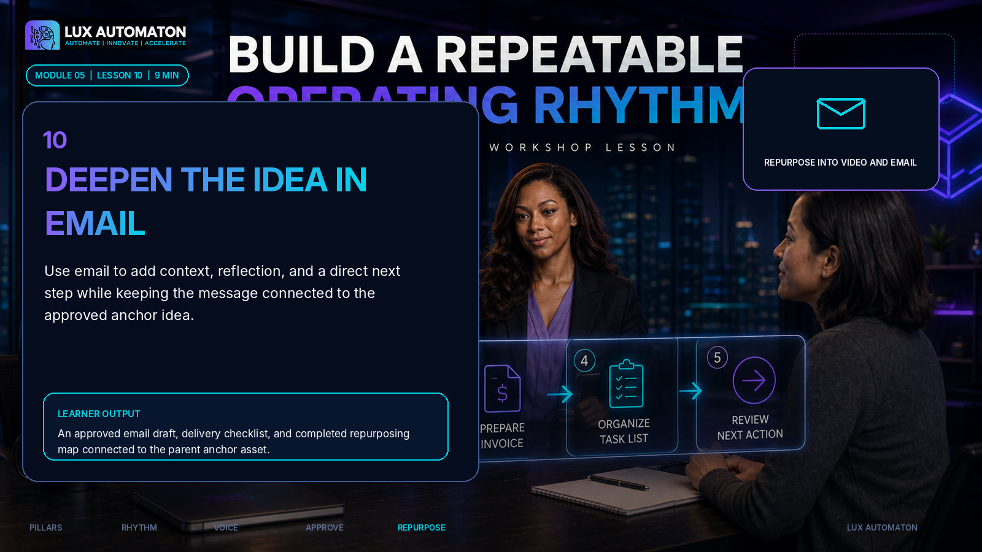

Learning objectives
- Translate the anchor insight into an email-native structure.
- Write a clear subject line, opening, body, and call to action.
- Complete the one-to-many repurposing map for the week.

Teaching lesson
Email is a relationship channel. The reader has chosen a closer connection than a casual feed impression, so the message can slow down, add context, and speak more directly. The email should not merely paste the anchor post beneath a subject line. It should deepen the idea in a way that respects the inbox and gives the reader a clear reason to open, continue, and respond.
Use a simple structure: Subject, Opening, One Idea, Story or Proof, Practical Move, Call to Action, and optional P.S. The subject should accurately frame the value or tension without exaggeration. The opening can connect the idea to a recent observation, question, or situation. The body should develop one idea, not collect every lesson from the week. The story or proof gives the message texture. The practical move helps the reader apply the insight. The call to action can invite a reply, a checklist review, a conversation, or a relevant offer.
Email voice can be more personal than a public post, but it still follows the Voice Card and source boundaries. Use first person when the founder has a real experience or opinion. Do not pretend a generated observation happened ‘this morning’ if it did not. Avoid false urgency, deceptive subject lines, or unsupported scarcity. When promoting an offer, make the relationship between the teaching and the offer clear. The reader should understand what happens after clicking or replying.
The email also completes the repurposing map. Link the anchor post, video script, email, and any smaller derivative to one parent idea in the command center. Record what changed for each channel: the public post may emphasize the argument, the video the memorable spoken contrast, and the email the reflection and practical application. This prevents accidental repetition and helps the team see how one idea can create coordinated reach without becoming content clutter.
Finish with an approval and delivery check. Confirm the subject, preview line, links, personalization fields, audience segment, sender name, reply destination, accessibility, and scheduled time. Send a test to a real inbox and review it on a small screen. After publication, capture replies and questions as source material for the next idea bank. The content command center is complete when publishing and listening become one continuous loop.
PRACTICAL EXAMPLE / CASE STUDY
Maya's email subject is ‘The deadline is not always the real problem.’ She opens with an anonymized moment from a project review, explains the hidden approval gap, gives a three-question decision check, and invites readers to reply with the approval that is currently blocking their team. The email adds reflection rather than repeating the social post.

Step-by-step instructions
- Choose the deeper angle the email will add to the approved anchor idea.
- Draft the subject, preview line, opening, one idea, proof, practical move, and call to action.
- Compare the email with the post and video to remove unnecessary repetition.
- Run CLEAR plus the email delivery check for links, audience, sender, reply path, and mobile view.
- Complete the repurposing map and capture future questions from replies.
HANDS-ON ACTIVITY  - Write a 300-500 word email from the approved anchor idea and complete the one-to-many Translation Map for post, video, email, and one optional derivative. | CONCRETE LEARNER DELIVERABLE  - An approved email draft, delivery checklist, and completed repurposing map connected to the parent anchor asset.

Four useful tips
- Use email to deepen, not duplicate.
- Make the subject accurate before making it clever.
- Test every link and personalization field.
- Turn replies into future source material with permission and privacy controls.
COMMON MISTAKE TO AVOID
Sending the social post unchanged as an email, which ignores the reader's closer relationship and the practical requirements of the inbox.

CHECK-IN QUESTION
What new value does the email add that the public post and video do not?

KNOWLEDGE CHECK  - Why should the post, video, and email remain linked to one parent idea in the command center? | ANSWER  - The link preserves source, approval, consistency, and learning while showing how each channel translates the same insight differently.

Facilitator guidance
Have learners read only the subject and first two lines. Ask whether the promise is accurate and whether the opening earns the next sentence. For teams with an email platform, remind them to use approved consent, audience, and delivery practices already required by their organization.

Recommended resources
- LANA Email Deepening Template
- Translation Map
- Approved anchor post
- Video script
- Email delivery checklist

Lesson visual direction
IMAGE / DIAGRAM DESCRIPTION
One approved anchor idea branches into a public post, short video, and email, then loops audience replies back into the idea bank while LANA monitors approval and delivery.

Premium Lux Automaton content command center, LANA beside a transparent one-to-many repurposing map: one approved anchor idea branching into social post, short video, and email, audience reply loop returning to idea bank, human approval icons, deep navy black, cyan violet teal light, realistic executive photography, clean negative space, no fake logo or tiny text, 16:9.
Accessible alt text: One approved idea becomes a coordinated post, video, and email, with audience responses returning to the idea bank.

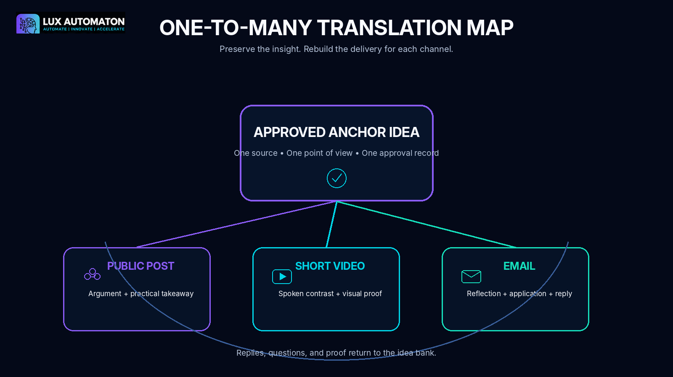
05 | FINAL PROJECT AND RUBRIC  LANA One-Week Content Command Center

LANA One-Week Content Command Center
Build a complete, ready-to-operate content system for one week. The system must begin with approved source material, preserve the founder's voice, show who reviews and approves every asset, and translate one central insight into channel-native public content, video, and email.

Required steps
- Define the audience, business objective, and content promise for the week.
- Complete three content pillars with purpose, boundaries, and proof sources.
- Build a 15-idea bank and select one anchor idea.
- Create a realistic weekly publishing rhythm and minimum viable week.
- Build the weekly command board with owners, statuses, deadlines, file links, and next actions.
- Complete the Voice Card and SIGNAL Brief.
- Draft, revise, and approve one anchor post using CLEAR.
- Document the Approval Lane SOP.
- Translate the anchor into a 45-90 second video script and shot list.
- Deepen the idea in a 300-500 word email and complete the Translation Map.
- Add a post-publication learning and response plan.

Expected deliverables
- Three-pillar Content Strategy Card
- 15-idea evidence bank
- Weekly publishing rhythm
- One-source command board
- LANA Voice Card
- SIGNAL Brief and approved anchor post
- Completed CLEAR review
- Approval Lane SOP
- Short-form video script and shot list
- Email draft and delivery check
- One-to-many Translation Map
- One-week learning and response plan

Completion checklist
☐ Every content idea belongs to one pillar and names its source.
☐ The weekly rhythm fits actual drafting and approval capacity.
☐ The anchor post contains a specific perspective, example, and reader next step.
☐ Claims, examples, customer information, links, and rights are reviewed.
☐ A named human approves each customer-facing asset.
☐ The video sounds natural when read aloud and includes a caption plan.
☐ The email adds value beyond the public post and has tested delivery details.
☐ All derivatives link to the approved parent idea.
☐ The command board shows the current status and next action for every asset.
☐ Audience replies and learning have a documented return path to the idea bank.

Evaluation rubric
Criterion | Pts | Excellent evidence | Developing evidence
Pillar strategy and idea quality | 4 | Three focused pillars with useful boundaries, approved proof sources, and a strong 15-idea bank. | Pillars or ideas are broad, weakly sourced, or disconnected from audience need.
Weekly operating system | 4 | Realistic rhythm, visible statuses, owners, deadlines, next actions, and learning loop. | Calendar exists but production ownership and approval are unclear.
Voice and drafting quality | 4 | Voice Card and SIGNAL produce a specific, evidence-rich anchor draft that sounds natural. | Draft relies on generic language, vague prompts, or unsupported detail.
Review, approval, and responsibility | 4 | CLEAR review, risk levels, permissions, approval, rights, privacy, and accuracy are documented. | Approval is informal or important claims, permissions, and risks are unresolved.
Channel translation and readiness | 4 | Video and email are channel-native, linked to the parent idea, approved, and ready for production or scheduling. | Derivatives repeat the post or lack delivery, caption, link, or approval readiness.
SCORING
Ready to launch: 17-20 points. Revise then launch: 13-16. Rebuild key elements: 0-12.

Reflection questions
- Which pillar gives you the clearest combination of audience need, evidence, and business relevance?
- Which part of your current process creates the most avoidable delay or generic writing?
- What source material do you need to capture more consistently?
- Which approval risk deserves a stronger rule before you publish more frequently?
- What did the video or email reveal that was not obvious in the original post?
- What audience signal will you use to improve next week's command center?
OPTIONAL ADVANCED CHALLENGE
Expand the one-week command center into a four-week editorial cycle. Assign one anchor per week, create a proof library, define standard and sensitive approval lanes, and map responsible automations for source capture, reminders, scheduling, transcription, and archive while keeping human approval before publication.

6. VISUAL-PRODUCTION PACKAGE

Visual Production Package
The package contains an authentic-logo-ready workshop hero, thumbnail, ten lesson visuals, five educational diagrams, a printable overview, and a 4:5 social image. Exact text was added during layout rather than generated inside photographic artwork.


Included assets
- 00_workshop_hero.png
- 01_workshop_thumbnail.png
- 02_lesson_01_choose_three_conversations.png
- 03_lesson_02_evidence_rich_idea_bank.png
- 04_lesson_03_every_day_has_a_job.png
- 05_lesson_04_one_source_production_flow.png
- 06_lesson_05_capture_the_voice.png
- 07_lesson_06_signal_brief.png
- 08_lesson_07_clear_review.png
- 09_lesson_08_approval_lane.png
- 10_lesson_09_translate_to_video.png
- 11_lesson_10_deepen_in_email.png
- 12_diagram_pillar_fit_map.png
- 13_diagram_weekly_rhythm.png
- 14_diagram_signal_brief.png
- 15_diagram_clear_review.png
- 16_diagram_translation_map.png
- 17_printable_workshop_overview.png
- 18_social_promo_4x5.png

LANA Pillar Fit Map
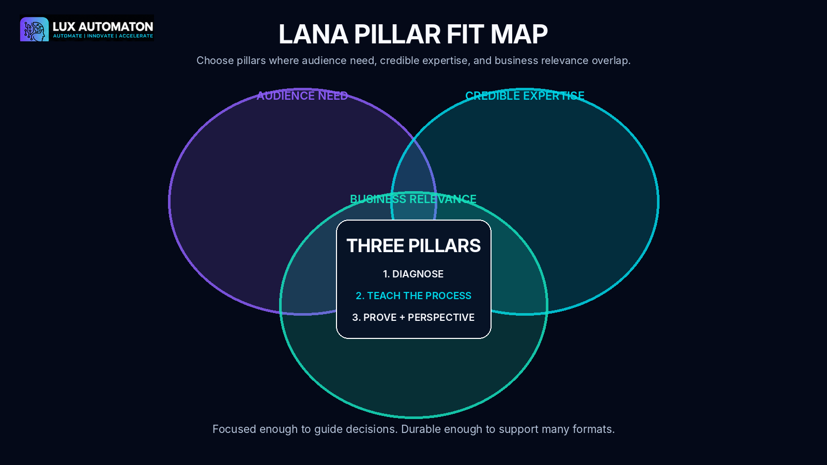

Weekly Publishing Rhythm
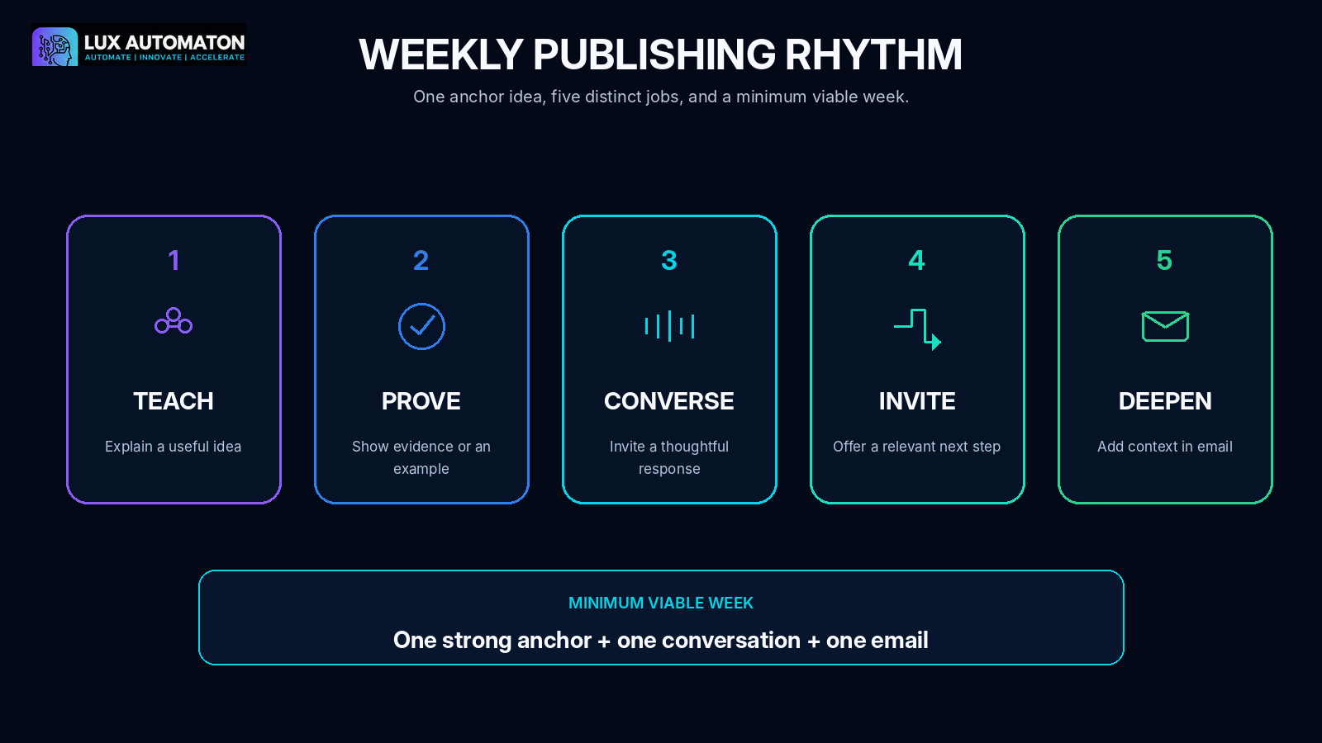

LANA SIGNAL Draft Brief
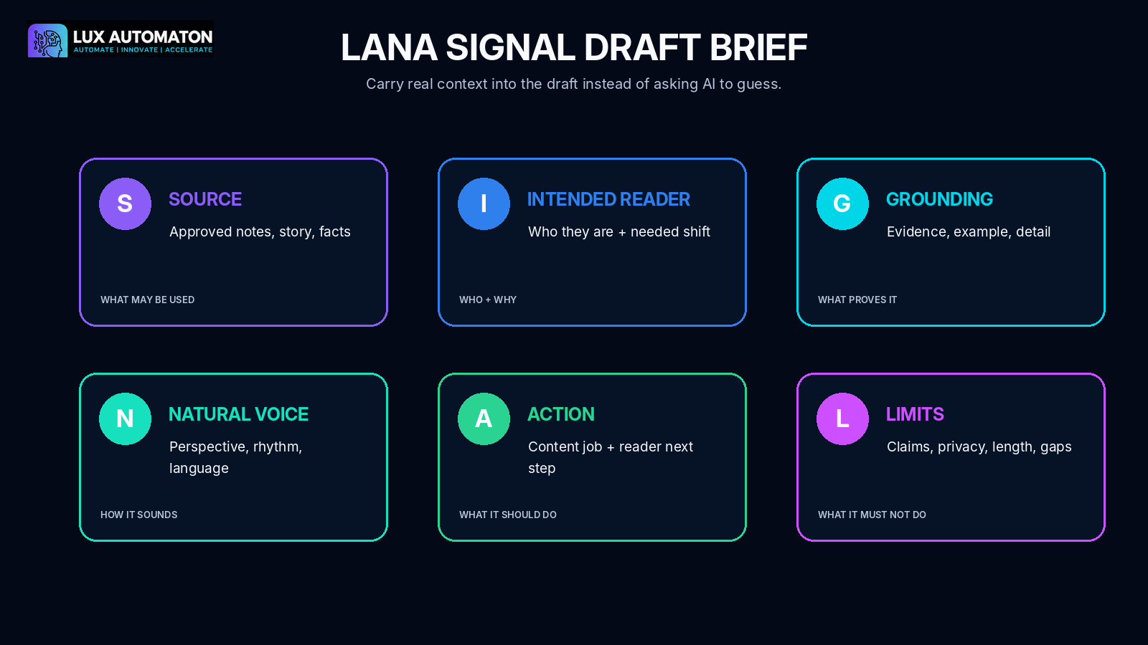

LANA CLEAR Review
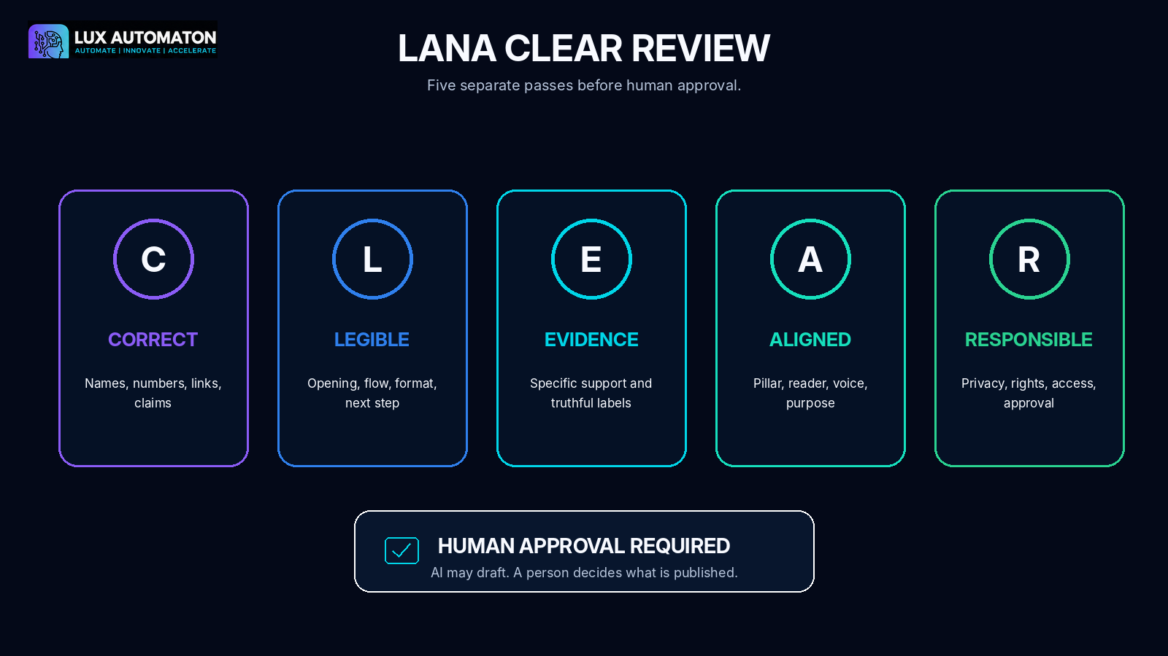

One-to-Many Translation Map


Generation and accessibility rules
- Use the supplied authentic Lux Automaton logo; do not ask an image model to recreate it.
- Keep large, intentional negative space for headlines and branded overlays.
- Avoid small interface text, fake analytics, and unsupported performance claims.
- Use LANA as a warm Black woman AI strategist in a black blazer and lavender blouse.
- Preserve high contrast, readable hierarchy, and descriptive alt text.
- Keep owner control and human approval visible in workflow visuals.

7. PUBLISHING PACKAGE

Publishing Package
SEO TITLE | LANA Content Command Center Workshop | Lux Automaton
META DESCRIPTION | Build a weekly content system that defines your pillars, preserves your voice, adds human approval, and repurposes one idea into posts, video, and email.
WORKSHOP EXCERPT | Stop beginning every week with a blank page. LANA Content Command Center gives founders and small teams a clear system for choosing what to say, drafting in a recognizable voice, approving responsibly, and turning one strong idea into a coordinated week of content.
SUGGESTED CTA | Build your Content Command Center and publish your first coordinated week with clarity, voice, and human control.

Promotional headlines
- Turn One Strong Idea into a Full Week of Content
- Build a Content System That Still Sounds Like You
- From Content Pillars to Approved Posts, Video, and Email
- Stop Posting Randomly. Start Operating a Content Command Center.
- Plan, Draft, Approve, and Repurpose with LANA

Social captions
SOCIAL CAPTION 1
Your content does not need more noise. It needs a system. In LANA Content Command Center, you will define your pillars, build a weekly rhythm, draft in your real voice, add human approval, and repurpose one idea into video and email.

SOCIAL CAPTION 2
One idea. One approved source. One coordinated week. Build your LANA Content Command Center and leave with the actual posts, video script, email, workflow, and approval system.

SOCIAL CAPTION 3
Generic content usually starts with generic context. This workshop teaches you to carry real source material, voice, evidence, and human judgment through the entire publishing process.

SOCIAL CAPTION 4
Founders: stop managing content through memory, messages, and last-minute drafts. Build a visible weekly command board that shows the source, owner, reviewer, deadline, status, and next action.

SOCIAL CAPTION 5
Your best post can become a short video and a useful email without copy-and-paste repetition. Learn how to translate the idea for each channel while preserving the insight.

Newsletter announcement
LANA Content Command Center is a practical 90-minute Lux Automaton workshop for founders, experts, and small teams who want a dependable weekly content system. You will define three pillars, create a realistic publishing rhythm, capture your natural voice, draft with the SIGNAL framework, review with CLEAR, document human approval, and translate one approved insight into video and email. You will leave with a complete one-week Content Command Center ready to use.

YouTube description
Build a content operating system that turns your expertise into a coordinated week of trusted content. LANA Content Command Center guides you through five stages: define your content pillars, create a weekly publishing rhythm, draft without sounding generic, review and approve, and repurpose the approved idea into short-form video and email. The workshop includes practical templates, a participant workbook, facilitator guidance, branded visuals, and a final one-week Content Command Center project.

Suggested tags
content strategy, AI content workshop, founder marketing, content pillars, editorial workflow, brand voice, prompt writing, content approval, video repurposing, email marketing, Lux Automaton, LANA

Team leader announcement
Bring one current offer, three customer questions, and two examples of writing that sound like your team at its best. By the end of the session, every participant will have a shared content strategy, a visible weekly workflow, an approved anchor draft, and channel-ready video and email derivatives.

8. QUALITY-ASSURANCE REPORT

Quality-Assurance Report
LESSON COMPLETENESS
Verified: all ten lessons contain duration, overview, three objectives, a 300-600 word teaching section, case study, steps, activity, deliverable, four tips, common mistake, check-in, knowledge check with answer, facilitator guidance, resources, image description, image prompt, and alt text.

ACTIVITY DELIVERABLES
Verified: every lesson activity produces an artifact used in the final project.

FINAL PROJECT ALIGNMENT
Verified: the final project assembles the pillar strategy, idea bank, rhythm, command board, voice card, SIGNAL draft, CLEAR review, approval SOP, video script, and email taught earlier.

LESSON UNIQUENESS
Verified: lessons progress from strategy to production, voice, review, governance, and channel translation without repeating the same outcome.

SAFETY PRIVACY
Verified: the workshop addresses confidential data, permission, rights, verification, truthful examples, accessibility, human approval, and responsible correction.

VISUAL ALIGNMENT
Verified: all visual directions use Lux Automaton's premium navy, cyan, and electric-violet studio, LANA's supplied visual identity, human control, and an intentional area for the authentic logo.

FACTUAL ACCURACY
Verified: no unstable platform algorithm claims are used. Supplied curriculum facts are preserved, and fictional teaching examples are labeled as examples.

TEACHABILITY
Verified: facilitator guidance, timing, instructions, answer keys, templates, and learner deliverables make the workshop teachable without unwritten content.

Final instructional verification
- Every activity produces a concrete learner artifact.
- Every final project component is taught and practiced earlier.
- No lesson repeats the same instructional outcome.
- Examples are fictional or learner-supplied and are labeled appropriately.
- Safety guidance covers data, claims, rights, privacy, accessibility, and human approval.
- All visual assets use supplied brand references and the authentic logo.
- The facilitator can teach the workshop without additional unwritten content.

9. STRUCTURED JSON DELIVERY

Structured JSON Delivery
The complete machine-readable workshop is supplied as the companion file LANA_Content_Command_Center_Workshop.json. It contains the full curriculum, lesson objects, activities, deliverables, final project, rubric, visual specifications, publishing copy, quality checks, and references without compressing the data into unreadably small print.
COMPANION FILE
LANA_Content_Command_Center_Workshop.json

Top-level schema
IDENTITY | Workshop title, audience, level, duration, descriptions, and learner outcome.
SOURCE_ANALYSIS | Source notes, distinctions between supplied facts and original teaching examples.
MATERIALS / GOALS / PREREQUISITES | Operational requirements and learning framework.
SAFETY_PRIVACY | Privacy, accuracy, rights, accessibility, and human-approval guidance.
MODULES | Five module summaries with durations, outcomes, and lesson references.
LESSONS | Ten complete lesson objects with teaching, activities, checks, visuals, and alt text.
FINAL_PROJECT | Brief, steps, deliverables, checklist, rubric, reflection, and advanced challenge.
VISUAL_PACKAGE | Hero, thumbnail, lesson visuals, diagrams, overview, social asset, and prompts.
PUBLISHING | SEO, promotional, newsletter, video-description, tags, CTA, and team copy.
QA / REFERENCES | Instructional verification and supporting reference list.

Recommended publishing workflow
- Store the JSON as the source of truth for website, LMS, CMS, or database ingestion.
- Use lesson_number and module_number as stable ordering keys.
- Use visual_asset to connect each lesson to its production-ready image file.
- Preserve alt_text in every image component for accessibility.
- Keep safety_privacy and facilitator_guidance visible in instructor-facing views.
- Validate imported text against the companion PDF or DOCX before publishing.

Compact example object
{
"lesson_number": 1,
"module_title": "Define Your Content Pillars",
"title": "Choose the Three Conversations Your Brand Should Own",
"duration_minutes": 9,
"deliverable": "A three-pillar Content Strategy Card with purpose, audience need, business bridge, proof sources, and boundaries for each pillar.",
"visual_asset": "02_lesson_01_choose_three_conversations.png"
}

