
Participant Workbook
LANA Content Command Center
CORE TIME  90 minutes | MODULES  5 | WORKSHEETS  12+ | FINAL BUILD  One-week command center
Lux Automaton Editorial | Publication-ready curriculum package

HOW TO USE THIS WORKBOOK

Build as You Learn
Complete the pages in order. Every worksheet becomes part of your final one-week Content Command Center. Use real, approved source material whenever possible. Mark anything private or unverified before using a writing assistant.
BRING WITH YOU  - Laptop or tablet with a writing tool  - Three recent customer questions, calls, or project notes  - Two examples of content that sound like the learner at their best  - One current offer, service, product, or topic to promote  - Calendar or scheduling view | KEEP VISIBLE  - Your audience and offer  - Your best writing samples  - Privacy and approval rules  - The current source note  - The next action for every asset

FINAL BUILD
A complete one-week Content Command Center containing a three-pillar strategy, a 15-idea bank, a weekly publishing board, one approved anchor post, a short-form video script, an email draft, and a documented review and approval workflow.

Workshop map
01 Define Your Content Pillars 18 min
A three-pillar strategy with clear purpose, boundaries, proof sources, and at least fifteen usable ideas.
02 Create a Weekly Publishing Rhythm 18 min
A realistic weekly rhythm and one-source production flow with owners, statuses, and deadlines.
03 Draft Without Sounding Generic 20 min
A reusable voice card, a SIGNAL draft brief, and one specific anchor post.
04 Review and Approve 17 min
An approved anchor post and a documented review-and-approval operating procedure.
05 Repurpose into Video and Email 17 min
A short-form video script, an email draft, and a one-to-many repurposing map.

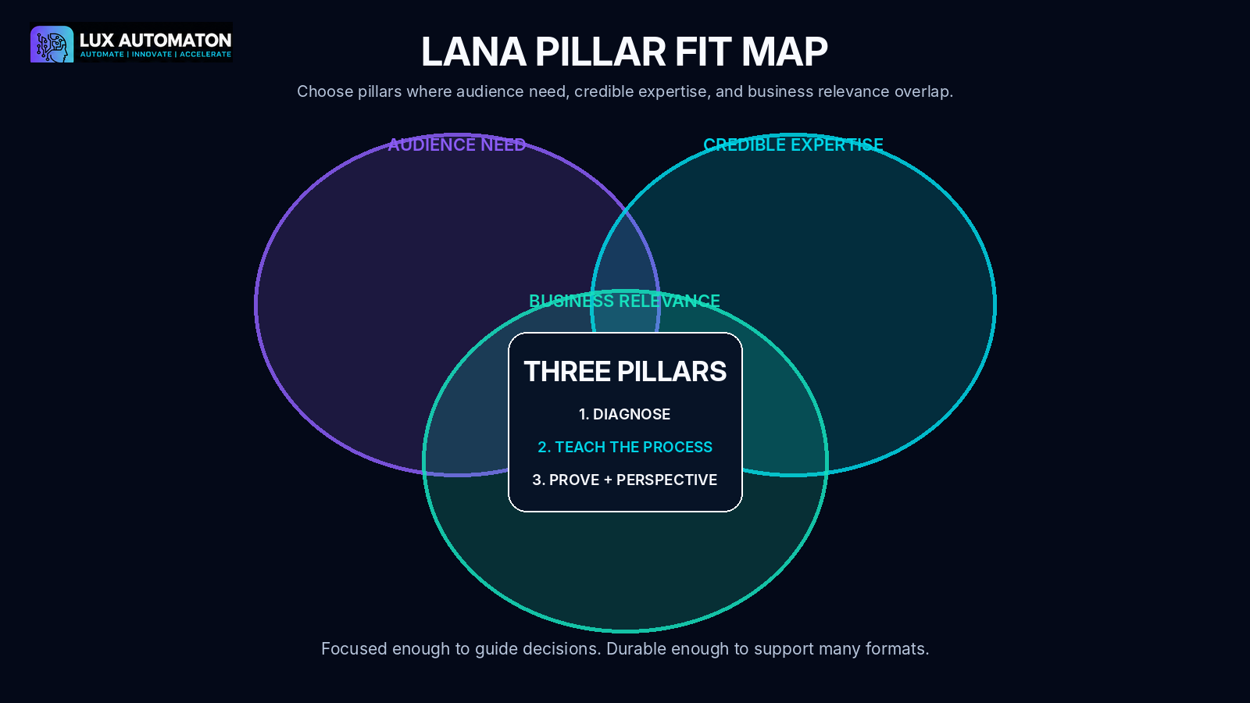
01 | DEFINE YOUR CONTENT PILLARS  Choose three durable conversations and build a 15-idea bank.

Worksheet 1: Audience and Business Bridge
Write the strategic context your pillars must serve.
Audience I want to help:
________________________________________________________________________________
________________________________________________________________________________
The result or change they want:
________________________________________________________________________________
________________________________________________________________________________
My offer, service, or expertise:
________________________________________________________________________________
________________________________________________________________________________
Why I have credible experience in this area:
________________________________________________________________________________
________________________________________________________________________________
What I do not want the brand to be known for:
________________________________________________________________________________
________________________________________________________________________________

Worksheet 2: LANA Pillar Fit Map
CANDIDATE CONVERSATION | AUDIENCE PULL 1-5 | CREDIBLE DEPTH 1-5 | BUSINESS BRIDGE 1-5 | KEEP?

Selected pillars
PILLAR | PURPOSE | INCLUDES | EXCLUDES | PROOF SOURCES

Worksheet 3: 3 x 5 Evidence-Rich Idea Bank
Add one question, friction, framework, proof item, and perspective to each pillar.
PILLAR / ANGLE | IDEA OR QUESTION | SOURCE | READER SHIFT | STATUS
Selected anchor idea:
________________________________________________________________________________
________________________________________________________________________________
________________________________________________________________________________

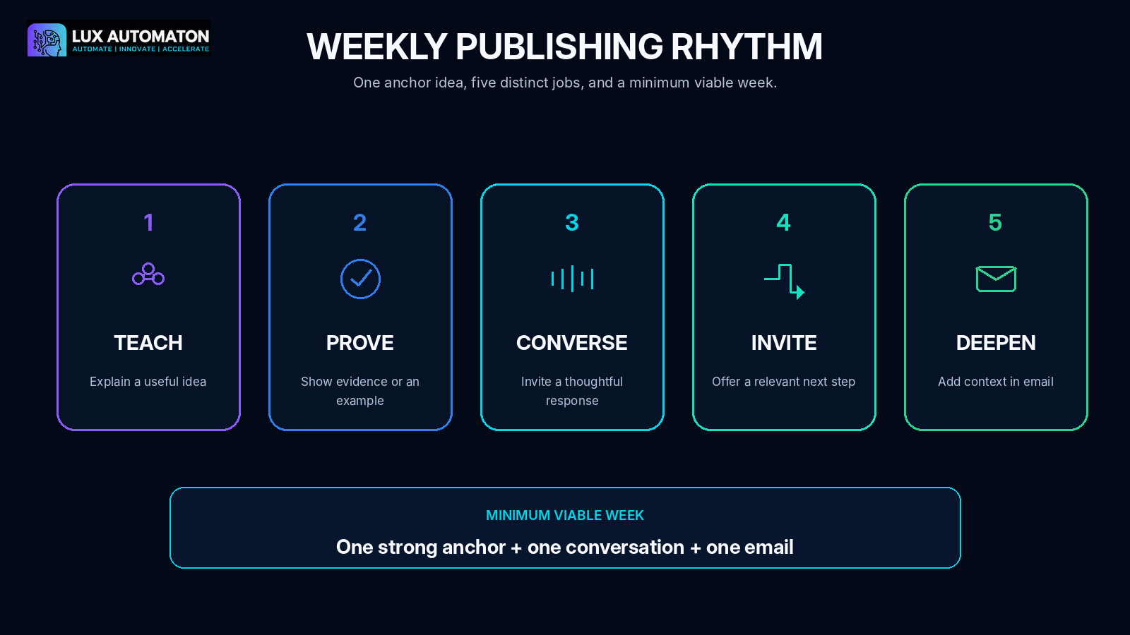
02 | CREATE A WEEKLY PUBLISHING RHYTHM  Give every content touchpoint a job and make production visible.

Worksheet 4: Weekly Rhythm Map
DAY / SLOT | CONTENT JOB | PILLAR | FORMAT | OWNER | APPROVAL DUE | PUBLISH
My minimum viable week:
________________________________________________________________________________
________________________________________________________________________________
________________________________________________________________________________

Worksheet 5: One-Source Command Board
ASSET | SOURCE | STATUS | OWNER | REVIEWER | NEXT ACTION | DUE
Status language we will use:
________________________________________________________________________________
________________________________________________________________________________
Post-publication learning fields:
________________________________________________________________________________
________________________________________________________________________________

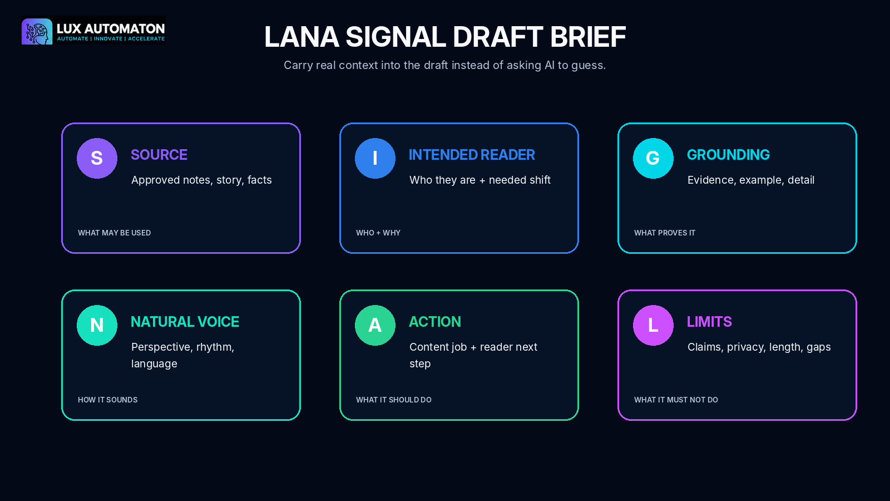
03 | DRAFT WITHOUT SOUNDING GENERIC  Capture voice and create the SIGNAL brief before drafting.

Worksheet 6: LANA Voice Card
Perspective: How do I interpret this problem?
________________________________________________________________________________
________________________________________________________________________________
Language: What words and phrases feel natural?
________________________________________________________________________________
________________________________________________________________________________
Rhythm: How do my sentences and explanations move?
________________________________________________________________________________
________________________________________________________________________________
Evidence: What examples or proof do I rely on?
________________________________________________________________________________
________________________________________________________________________________
Relationship: How do I address the reader?
________________________________________________________________________________
________________________________________________________________________________
Boundaries: What must never be invented, exposed, or exaggerated?
________________________________________________________________________________
________________________________________________________________________________
________________________________________________________________________________
Three signature patterns:
________________________________________________________________________________
________________________________________________________________________________
Three phrases or behaviors to avoid:
________________________________________________________________________________
________________________________________________________________________________

Worksheet 7: LANA SIGNAL Draft Brief
S - SOURCE
Approved notes, story, facts, transcript, or framework

________________________________________________________________________________
________________________________________________________________________________
________________________________________________________________________________
I - INTENDED READER
Specific reader, current situation, and needed shift

________________________________________________________________________________
________________________________________________________________________________
________________________________________________________________________________
G - GROUNDING
Example, evidence, practical detail, or proof

________________________________________________________________________________
________________________________________________________________________________
________________________________________________________________________________
N - NATURAL VOICE
Voice Card rules and sample language

________________________________________________________________________________
________________________________________________________________________________
________________________________________________________________________________
A - ACTION
Content job and reader next step

________________________________________________________________________________
________________________________________________________________________________
________________________________________________________________________________
L - LIMITS
Length, format, privacy, claims, banned language, missing information rule

________________________________________________________________________________
________________________________________________________________________________
________________________________________________________________________________
Three possible openings:
OPENING 1 | OPENING 2 | OPENING 3
Anchor draft workspace:
________________________________________________________________________________
________________________________________________________________________________
________________________________________________________________________________
________________________________________________________________________________
________________________________________________________________________________
________________________________________________________________________________
________________________________________________________________________________
________________________________________________________________________________
________________________________________________________________________________
________________________________________________________________________________
________________________________________________________________________________
________________________________________________________________________________

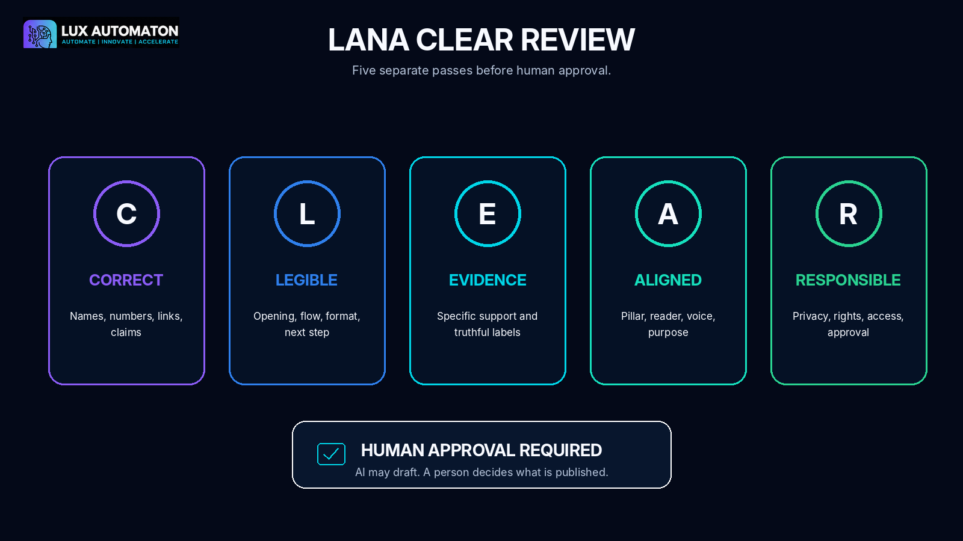
04 | REVIEW AND APPROVE  Use CLEAR and document the approval lane.

Worksheet 8: LANA CLEAR Review
Pass | What I checked | Required change | Complete
Correct | Names, dates, numbers, quotes, links, grammar, source match |  | ☐
Legible | Opening, flow, structure, format, next step |  | ☐
Evidence-backed | Specific support and truthful example labels |  | ☐
Aligned | Pillar, audience, job, Voice Card, offer |  | ☐
Responsible | Privacy, rights, access, claims, customer permission, approval |  | ☐
Reviewer:
________________________________________________________________________________
Approval decision and date:
________________________________________________________________________________
________________________________________________________________________________

Worksheet 9: Approval Lane SOP
ROLE | NAMED OWNER | WHAT THEY VERIFY | NORMAL DEADLINE | BACKUP / ESCALATION
RISK LEVEL | EXAMPLES | REQUIRED REVIEWERS | CAN PUBLISH WHEN...
Material changes that require reapproval:
________________________________________________________________________________
________________________________________________________________________________
Post-publication check:
________________________________________________________________________________
________________________________________________________________________________
Correction and pause process:
________________________________________________________________________________
________________________________________________________________________________
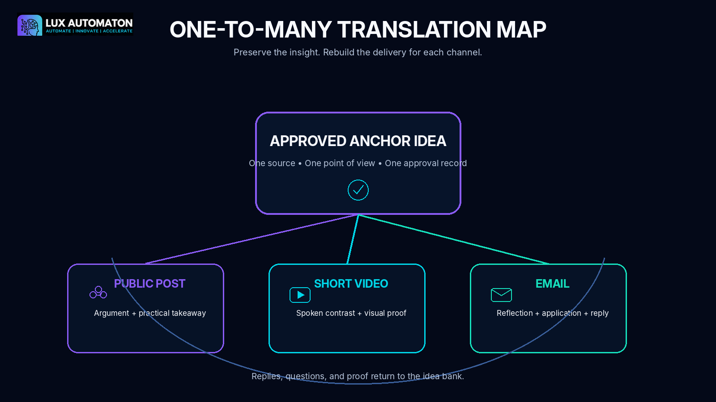
05 | REPURPOSE INTO VIDEO AND EMAIL  Translate the approved insight for each channel.

Worksheet 10: Short-Form Video Translation
One idea the viewer should remember:
________________________________________________________________________________
________________________________________________________________________________
Hook:
________________________________________________________________________________
________________________________________________________________________________
Tension:
________________________________________________________________________________
________________________________________________________________________________
Insight:
________________________________________________________________________________
________________________________________________________________________________
Proof or demonstration:
________________________________________________________________________________
________________________________________________________________________________
Next step:
________________________________________________________________________________
________________________________________________________________________________
SHOT | VISUAL / ACTION | SPOKEN LINE | CAPTION / ON-SCREEN TEXT | RIGHTS / APPROVAL CHECK

Worksheet 11: Email Deepening Draft
Subject line:
________________________________________________________________________________
________________________________________________________________________________
Preview line:
________________________________________________________________________________
________________________________________________________________________________
Opening:
________________________________________________________________________________
________________________________________________________________________________
One idea:
________________________________________________________________________________
________________________________________________________________________________
Story or proof:
________________________________________________________________________________
________________________________________________________________________________
Practical move:
________________________________________________________________________________
________________________________________________________________________________
Call to action:
________________________________________________________________________________
________________________________________________________________________________
Optional P.S.:
________________________________________________________________________________
________________________________________________________________________________

Worksheet 12: One-to-Many Translation Map
CHANNEL | WHAT REMAINS THE SAME | WHAT CHANGES FOR THE CHANNEL | APPROVAL / DELIVERY CHECK | LIVE LINK / FILE

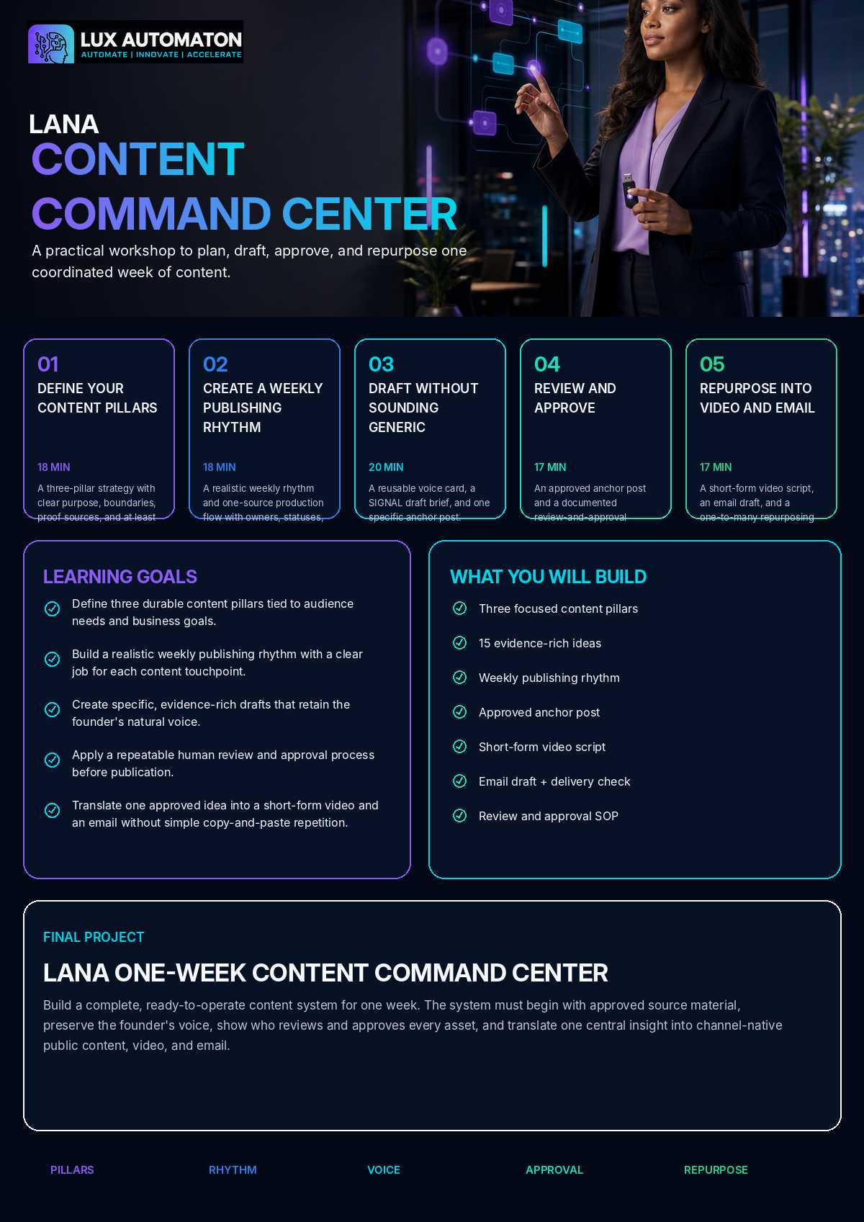
06 | FINAL PROJECT  Assemble the LANA One-Week Content Command Center.

LANA One-Week Content Command Center
Build a complete, ready-to-operate content system for one week. The system must begin with approved source material, preserve the founder's voice, show who reviews and approves every asset, and translate one central insight into channel-native public content, video, and email.

Assembly checklist
☐ Three-pillar Content Strategy Card
☐ 15-idea evidence bank
☐ Weekly publishing rhythm
☐ One-source command board
☐ LANA Voice Card
☐ SIGNAL Brief and approved anchor post
☐ Completed CLEAR review
☐ Approval Lane SOP
☐ Short-form video script and shot list
☐ Email draft and delivery check
☐ One-to-many Translation Map
☐ One-week learning and response plan

Launch readiness checklist
☐ Every content idea belongs to one pillar and names its source.
☐ The weekly rhythm fits actual drafting and approval capacity.
☐ The anchor post contains a specific perspective, example, and reader next step.
☐ Claims, examples, customer information, links, and rights are reviewed.
☐ A named human approves each customer-facing asset.
☐ The video sounds natural when read aloud and includes a caption plan.
☐ The email adds value beyond the public post and has tested delivery details.
☐ All derivatives link to the approved parent idea.
☐ The command board shows the current status and next action for every asset.
☐ Audience replies and learning have a documented return path to the idea bank.

20-point self-evaluation
Criterion | Points available | My score
Pillar strategy and idea quality | 4 | ____
Weekly operating system | 4 | ____
Voice and drafting quality | 4 | ____
Review, approval, and responsibility | 4 | ____
Channel translation and readiness | 4 | ____

Reflection
Which pillar gives you the clearest combination of audience need, evidence, and business relevance?
________________________________________________________________________________
________________________________________________________________________________
________________________________________________________________________________
Which part of your current process creates the most avoidable delay or generic writing?
________________________________________________________________________________
________________________________________________________________________________
________________________________________________________________________________
What source material do you need to capture more consistently?
________________________________________________________________________________
________________________________________________________________________________
________________________________________________________________________________
Which approval risk deserves a stronger rule before you publish more frequently?
________________________________________________________________________________
________________________________________________________________________________
________________________________________________________________________________
What did the video or email reveal that was not obvious in the original post?
________________________________________________________________________________
________________________________________________________________________________
________________________________________________________________________________
What audience signal will you use to improve next week's command center?
________________________________________________________________________________
________________________________________________________________________________
________________________________________________________________________________
ADVANCED CHALLENGE
Expand the one-week command center into a four-week editorial cycle. Assign one anchor per week, create a proof library, define standard and sensitive approval lanes, and map responsible automations for source capture, reminders, scheduling, transcription, and archive while keeping human approval before publication.

My next seven actions
ACTION | OWNER | DUE | STATUS

