LUX APP REVIEW
Five GitHub Apps Worth Watching
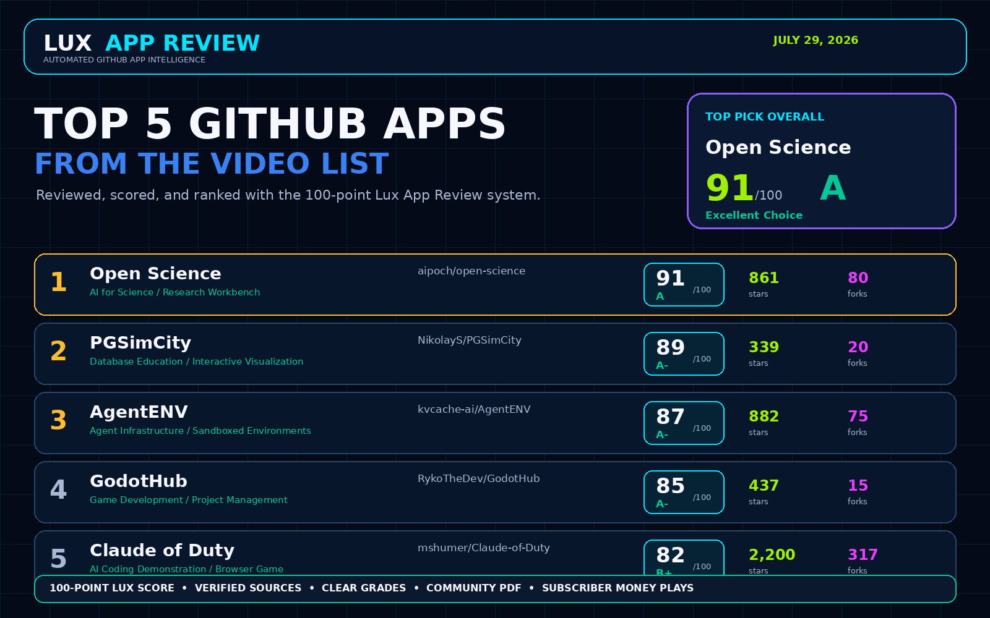
Research snapshot: July 29, 2026. Scores are editorial judgments, not security certifications.

Ranking at a glance
# | App | Category | Score | Grade | Stars | Forks
1 | Open Science | AI for Science / Research Workbench | 91 | A | 861 | 80
2 | PGSimCity | Database Education / Interactive Visualization | 89 | A- | 339 | 20
3 | AgentENV | Agent Infrastructure / Sandboxed Environments | 87 | A- | 882 | 75
4 | GodotHub | Game Development / Project Management | 85 | A- | 437 | 15
5 | Claude of Duty | AI Coding Demonstration / Browser Game | 82 | B+ | 2200 | 317

1. Open Science - 91/100 (A)
A local-first, model-agnostic desktop workbench that lets researchers plan, execute, inspect, and preserve AI-assisted scientific work in one workspace.

What it solves
Research workflows are fragmented across chat tools, notebooks, files, databases, code, and reporting. Open Science keeps projects, sessions, artifacts, permissions, notebooks, connectors, and model access in one inspectable desktop environment.

Why it stands out
- Released desktop installers for macOS, Windows, and Linux
- Local project state with explicit approval controls and inspectable tool activity
- Multiple model-provider paths, including custom gateways and subscription-based backends
- Scientific connectors, notebooks, reusable skills, artifacts, and persistent sessions
- Apache-2.0 licensing and active July 2026 release activity

Best for
Researchers, analysts, labs, medical-research teams, and technical organizations that want an inspectable AI research workspace.

Score breakdown
Area | Points | Maximum
Usefulness | 19 | 20
Project Health | 14 | 15
Community Momentum | 14 | 15
Ease of Use | 13 | 15
Trust & Safety | 14 | 15
Product Quality | 9 | 10
Innovation | 8 | 10

Risks
- The project is still early and its roadmap says major reproducibility and multi-model capabilities remain under development.
- Researchers remain responsible for methods, interpretation, privacy, and scientific validity.
- Provider credentials, unpublished data, patient identifiers, and sensitive files require careful handling.
- The app has a large and fast-changing capability surface, so version-specific testing matters.
Lux verdict: Excellent Choice

2. PGSimCity - 89/100 (A-)
An explorable 3D city that turns PostgreSQL internals into a visual system you can walk through, inspect, and deliberately stress.

What it solves
PostgreSQL behavior is difficult to understand from diagrams and documentation alone. PGSimCity makes backends, buffers, WAL, checkpoints, autovacuum, replication, locks, storage, and query flow visible and interactive.

Why it stands out
- No-install live web experience with a 14-chapter guided tour
- 234-test suite with explicit correctness claims and specialist review rounds
- Interactive scenarios for cache thrash, checkpoint storms, long transactions, replication lag, and commit behavior
- Clear separation between modeled behavior and optional real PGlite-backed query flow
- Static deployment, minimal external services, and Apache-2.0 licensing

Best for
Developers, DBAs-in-training, educators, onboarding programs, and engineering teams learning PostgreSQL operations.

Score breakdown
Area | Points | Maximum
Usefulness | 18 | 20
Project Health | 15 | 15
Community Momentum | 11 | 15
Ease of Use | 15 | 15
Trust & Safety | 14 | 15
Product Quality | 8 | 10
Innovation | 8 | 10

Risks
- It is a 0.x educational model, not a PostgreSQL emulator.
- Numbers are scaled for human observation and should not be treated as production measurements.
- Touch controls were only verified in Chrome mobile emulation at the research snapshot.
- The SimCity-inspired name requires careful trademark disclaimers in marketing.
Lux verdict: Worth Trying

3. AgentENV - 87/100 (A-)
A distributed platform for running large numbers of isolated, snapshot-capable AI-agent environments using Firecracker microVMs.

What it solves
Agent training and evaluation need fast, reproducible, isolated environments that can pause, resume, snapshot, fork, and scale without wasting resources.

Why it stands out
- Sub-100 ms snapshot, pause, resume, and fork goals described by the maintainers
- Firecracker isolation with OCI-compatible images and E2B-compatible API
- Distributed control-plane work, S3-compatible snapshots, warm pools, and storage optimizations
- Strong technical depth across Rust, Go, Firecracker, ublk, OverlayBD, and OpenAPI tooling
- MIT license and active pull-request activity in late July 2026

Best for
AI infrastructure teams, agent-evaluation platforms, RL researchers, and organizations operating isolated agent sandboxes at scale.

Score breakdown
Area | Points | Maximum
Usefulness | 19 | 20
Project Health | 14 | 15
Community Momentum | 13 | 15
Ease of Use | 8 | 15
Trust & Safety | 10 | 15
Product Quality | 11 | 10
Innovation | 12 | 10

Risks
- The README explicitly says authorization is not currently supported; the API must not be exposed publicly.
- Requires Linux kernel 6.8+, KVM access, privileged infrastructure, and experienced operators.
- The distributed control plane is described as a prototype.
- No SECURITY.md was detected at the research snapshot.
Lux verdict: Worth Trying

4. GodotHub - 85/100 (A-)
A desktop project manager that combines Godot version management, project organization, templates, Git workflows, workspaces, and community news.

What it solves
Godot creators often manage engine versions, projects, templates, repositories, terminals, and launch settings through separate tools. GodotHub brings those jobs into one desktop interface.

Why it stands out
- Project creation, import, clone, search, sorting, categories, pinning, and batch operations
- Godot version browsing, downloading, installing, importing, and cleanup
- Built-in Git staging, commits, branches, stashes, diffs, push, pull, fetch, and undo
- Reusable templates, workspaces, theme customization, news, and quick actions
- Tauri desktop architecture with React/TypeScript frontend and Rust backend

Best for
Godot developers, game-jam teams, students, indie studios, and creators managing multiple projects and engine versions.

Score breakdown
Area | Points | Maximum
Usefulness | 18 | 20
Project Health | 13 | 15
Community Momentum | 11 | 15
Ease of Use | 14 | 15
Trust & Safety | 13 | 15
Product Quality | 8 | 10
Innovation | 8 | 10

Risks
- The maintainer says the app has only been tested on Windows.
- The repository is still relatively small and has limited contributor breadth.
- Git operations inside a project manager create meaningful file-loss risk if edge cases are not thoroughly tested.
- Cross-platform behavior needs community validation before broad deployment.
Lux verdict: Worth Trying

5. Claude of Duty - 82/100 (B+)
A large browser-based first-person shooter generated through an orchestrated fleet of AI coding agents, with procedural graphics, audio, physics, AI, and performance tooling.

What it solves
The repository demonstrates how a complex interactive product can be decomposed into subsystems, built by coordinated agents, evaluated visually, profiled, and improved through reproducible tests.

Why it stands out
- Roughly 55,000 lines across 11 subsystems, according to the maintainer
- No external art or audio assets; content is generated procedurally from code
- Reproducible screenshot capture, image-diff gates, gameplay profiling, and scripted playtests
- Detailed performance investigation and transparent before/after measurements
- Unusually honest assessment of visual limits and multi-agent orchestration failures

Best for
AI builders, game developers, agent-orchestration researchers, and teams studying visual regression and performance testing.

Score breakdown
Area | Points | Maximum
Usefulness | 15 | 20
Project Health | 8 | 15
Community Momentum | 15 | 15
Ease of Use | 12 | 15
Trust & Safety | 14 | 15
Product Quality | 8 | 10
Innovation | 10 | 10

Risks
- The project has only two commits and no formal release history.
- The maintainer explicitly says it does not achieve modern Call of Duty quality.
- Performance remains around 28-30 fps in the cited Apple-silicon test.
- It is more valuable as an AI-engineering case study than as a production-ready game framework.
Lux verdict: Promising

Sources
AIPOCH Open Science repository - https://github.com/aipoch/open-science
AIPOCH Open Science roadmap - https://github.com/aipoch/open-science/blob/main/ROADMAP.md
AIPOCH Open Science release article - https://www.aipoch.com/blog/open-science-first-three-steps
Claude of Duty repository - https://github.com/mshumer/Claude-of-Duty
AgentENV repository - https://github.com/kvcache-ai/AgentENV
AgentENV license - https://github.com/kvcache-ai/AgentENV/blob/main/LICENSE
AgentENV security page - https://github.com/kvcache-ai/AgentENV/security
GodotHub repository - https://github.com/RykoTheDev/GodotHub
PGSimCity repository - https://github.com/NikolayS/PGSimCity
PGSimCity live demo - https://nikolays.github.io/PGSimCity/

