LUX AI KIDS
Your First Video Game
Imagine It. Draw It. Play It!
Facilitator Guide • Ages 6-8 • Beginner • 120 minutes
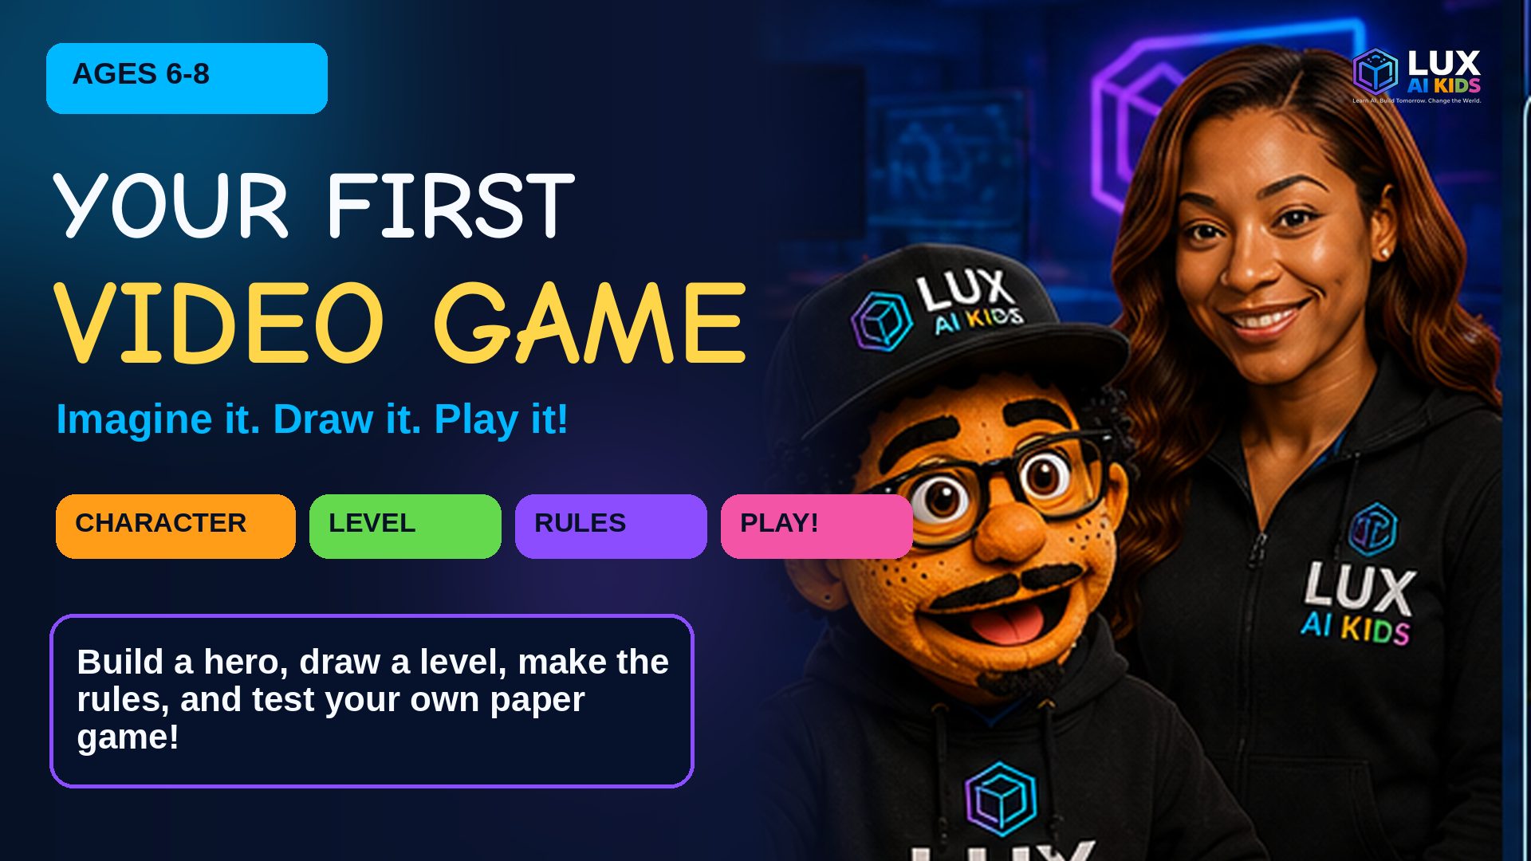
AI helps. People decide. Ask a grown-up first.

1. Workshop Overview
WORKSHOP PROMISE
Ace helps young game designers invent a hero, draw a level, make simple rules, and playtest a paper game. LANA introduces safe, grown-up-guided AI prompts for game art ideas.

Audience | Lux AI Kids, ages 6-8
Level | Beginner; no coding required
Time | 120 minutes, or two 60-minute sessions
Final build | A playable paper game prototype
Group size | 1-24 children; pairs for playtesting
Adult role | Guide, read aloud, support cutting/writing, and handle any AI tool

Final Learner Outcome
Each child leaves with a character card, a paper level map, a four-rule game concept, two safe AI art prompts, and a playtested paper prototype.

Learning Goals
- Name the four basic parts of a game: character, goal, challenge, and rules.
- Choose a theme and tell a one-sentence game story.
- Design a character with one clear power.
- Draw a level with a start, path, challenge, and goal.
- Write four simple rules that another child can follow.
- Playtest, listen, and improve one part of the game.
- Use AI only with a grown-up and without sharing private information.

Materials
- Paper or cardboard
- Crayons and markers
- Child-safe scissors
- Index cards
- Stickers for tokens
- A ruler
- Pencil
- Optional: tape or glue

2. Set Up, Safety, and Teaching Rhythm

Room Setup
- Place materials in small bins at each table.
- Put the Game Recipe cards where everyone can see them.
- Give each child a workbook, one index card, and one sticker token.
- Set up a “Game Garage” table for extra paper, tape, and fixes.
- Pair children for playtesting before the workshop begins.

Safety and Privacy
- A grown-up handles any AI tool. Children may help write the prompt on paper.
- Never type a child's full name, school, address, phone number, face photo, or private story into an AI tool.
- Use child-safe scissors and provide help when cutting small pieces.
- AI ideas are suggestions. The child stays the game designer and makes the final choices.
- Keep competition friendly. The goal of playtesting is learning, not winning.

Best Rhythm for Ages 6-8
- Teach for 2-4 minutes, then let children do something with their hands.
- Read every direction aloud.
- Use picture choices and sentence starters.
- Allow invented spelling, drawing, pointing, or dictation.
- Use a 60-second movement break after Mission 3.
- Signal transitions with: “Pencils down, designer eyes up.”
IMPORTANT
This workshop creates a paper prototype. It does not require children to open an AI tool or share personal information online.

3. Workshop Schedule
Time | Mission | Main Activity | Kid Deliverable
20 min | 1. What Makes a Game a Game? | Game Recipe Sort: match picture cards to CHARACTER, GOAL, CHALLENGE, and RULES. | A completed four-part Game Recipe strip.
15 min | 2. Pick Your Theme | Theme Dash: choose a world card, then add one place and one mission. | A theme card and one-sentence game story.
20 min | 3. Design Your Character | Create a two-sided Character Card on an index card: picture on the front, name/power/story on the back. | A finished character card with one power and a short story.
20 min | 4. Draw the Board | Build Level 1 on paper or cardboard using a ruler, crayons, and sticker tokens. | A paper game level with start, path, challenge, special spaces, and goal.
20 min | 5. Make the Rules | Create a Rules Card and test the rules with a pretend turn. | A four-rule card, three move cards, and two paper AI prompts.
25 min | 6. Playtest Time! | Play, Watch, Ask, Fix, Play Again. | A completed playtest sheet and one “Make It Better” change ticket.

Two-Session Option
- Session 1 (60 minutes): Missions 1-3, ending with completed character cards.
- Session 2 (60 minutes): Missions 4-6, ending with a short game showcase.

Mission 1: What Makes a Game a Game? (20 minutes)
BIG IDEA  Every game needs a character, a goal, a challenge, and rules. | DELIVERABLE  A completed four-part Game Recipe strip.

Learning Objectives
- Point to the four parts of a game.
- Explain what a goal tells the player.
- Build a four-part Game Recipe strip.

Read-Aloud Teaching Script
Say: A game is a tiny world with something to do. A character tries to reach a goal. A challenge makes the trip interesting. Rules tell everyone how to play.

Simple Example
In a treasure game, the explorer is the character, the treasure chest is the goal, the river is the challenge, and “move one card each turn” is a rule.

Step-by-Step
- Show the four Game Recipe cards.
- Say and act out each part together.
- Use a familiar game such as tag to find the four parts.
- Kids place or draw the four parts on their worksheet.
- Invite two children to share their recipe.

Hands-On Activity
Game Recipe Sort: match picture cards to CHARACTER, GOAL, CHALLENGE, and RULES.

Four Useful Tips
- Use movement: pose as a hero, point to a goal, step over a pretend obstacle, then freeze for a rule.
- Use familiar games; children do not need video-game experience.
- Keep examples short and concrete.
- Praise every answer that shows thinking, then gently name the correct game part.
COMMON MISTAKE TO AVOID
Starting with lots of decorations before the goal is clear.

Check-In
Ask: What tells the player how to win?
Answer: The goal.

Facilitator Guidance
For emerging readers, say the words aloud and let children use the picture icons. For advanced learners, ask them to find the four parts in two different games.

Recommended Resources
Workbook pages 5-6; printable Game Recipe cards; Diagram 1.

Alt text: Ace points to a game controller while four bright cards show a character, a goal, a challenge, and rules.

Mission 2: Pick Your Theme (15 minutes)
BIG IDEA  A theme tells where the game happens and what kind of adventure it feels like. | DELIVERABLE  A theme card and one-sentence game story.

Learning Objectives
- Choose one game world.
- Name a simple mission for that world.
- Finish a one-sentence game story.

Read-Aloud Teaching Script
Say: A theme is the world of your game. It can be space, a jungle, the ocean, a magic castle, Dinosaur Land, Robot City, or a world you invent.

Simple Example
Theme: Underwater City. Mission: Help a tiny submarine collect three pearls and reach the coral gate.

Step-by-Step
- Spread out the theme cards.
- Let each child point to or draw a favorite world.
- Ask: Who lives there? What could they need?
- Complete the sentence: “In my game, the player will ___ in ___.”
- Give the game a fun name.

Hands-On Activity
Theme Dash: choose a world card, then add one place and one mission.

Four Useful Tips
- Offer six choices, not twenty.
- Children may mix two themes, such as Space Jungle.
- Accept invented spelling on kid pages.
- Ask sensory questions: What colors, sounds, or shapes belong in this world?
COMMON MISTAKE TO AVOID
Choosing so many themes that the game has no clear world.

Check-In
Ask: What does a theme tell us?
Answer: Where the game happens and what it feels like.

Facilitator Guidance
Read the theme names aloud. A child may circle a picture instead of writing. Keep this mission moving so there is time to build.

Recommended Resources
Workbook pages 7-8; printable Theme Cards.
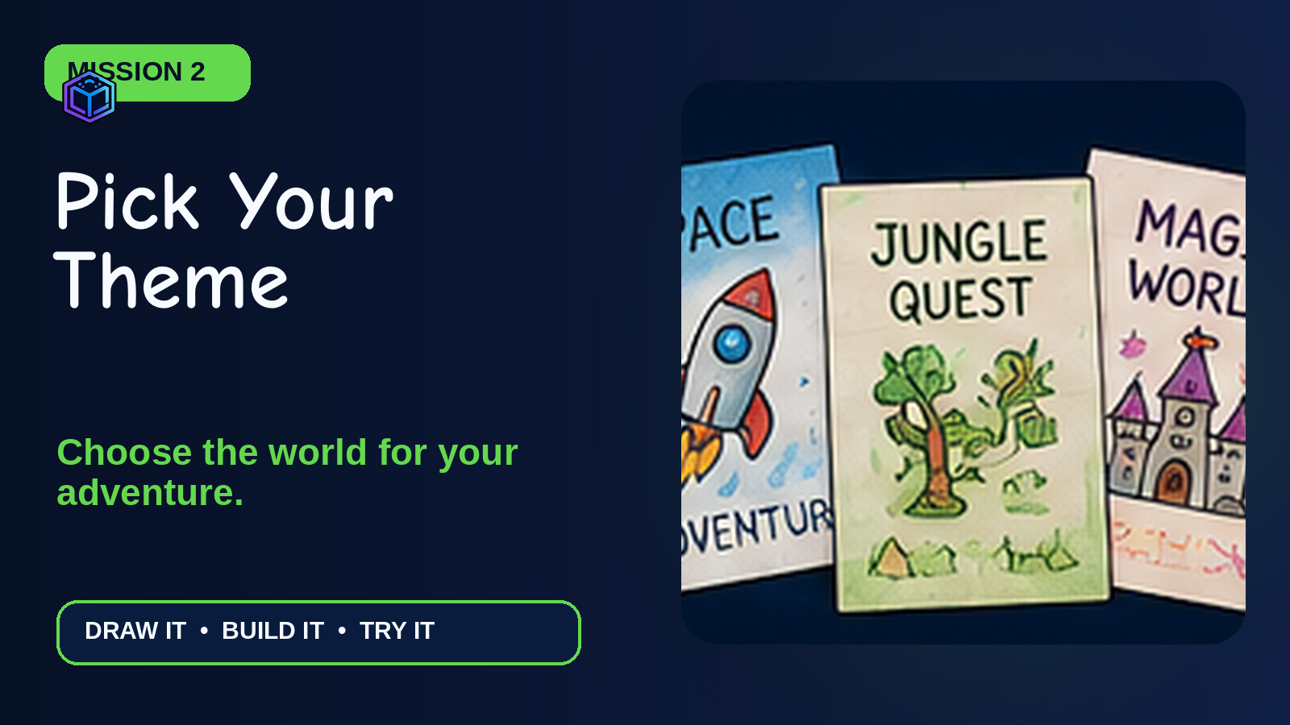
Alt text: Three hand-drawn cards show a space adventure, jungle quest, and magic world.

Mission 3: Design Your Character (20 minutes)
BIG IDEA  A strong game hero has a name, a clear look, one useful power, and a reason to act. | DELIVERABLE  A finished character card with one power and a short story.

Learning Objectives
- Draw a simple game hero.
- Choose one power that helps with the goal.
- Tell a one- or two-sentence character story.

Read-Aloud Teaching Script
Say: Your character is the one the player helps. Give the hero one special power. One strong power is easier to understand than ten powers.

Simple Example
Milo Mooncat glows in dark caves. He wants to return a lost star to the sky before sunrise.

Step-by-Step
- Pick a shape, animal, person, robot, or creature.
- Draw the face and body with big simple shapes.
- Add one color clue or special item.
- Choose one power that helps with the game goal.
- Finish: “My hero is ___. They can ___. They need to ___.”

Hands-On Activity
Create a two-sided Character Card on an index card: picture on the front, name/power/story on the back.

Four Useful Tips
- Start with circles, squares, and triangles.
- Make the power useful for the level.
- Use one power first; helpers can be an extension.
- Let children dictate the story to an adult if writing slows them down.
COMMON MISTAKE TO AVOID
Giving the hero so many powers that no challenge can be difficult.

Check-In
Ask: Why should the hero have one clear power?
Answer: It is easier to understand and makes the challenge more fun.

Facilitator Guidance
Model a “good enough” drawing. This is design, not an art contest. Ask children to explain their choices instead of judging the drawing.

Recommended Resources
Workbook pages 9-10; printable Character Cards; AI Prompt Recipe diagram.
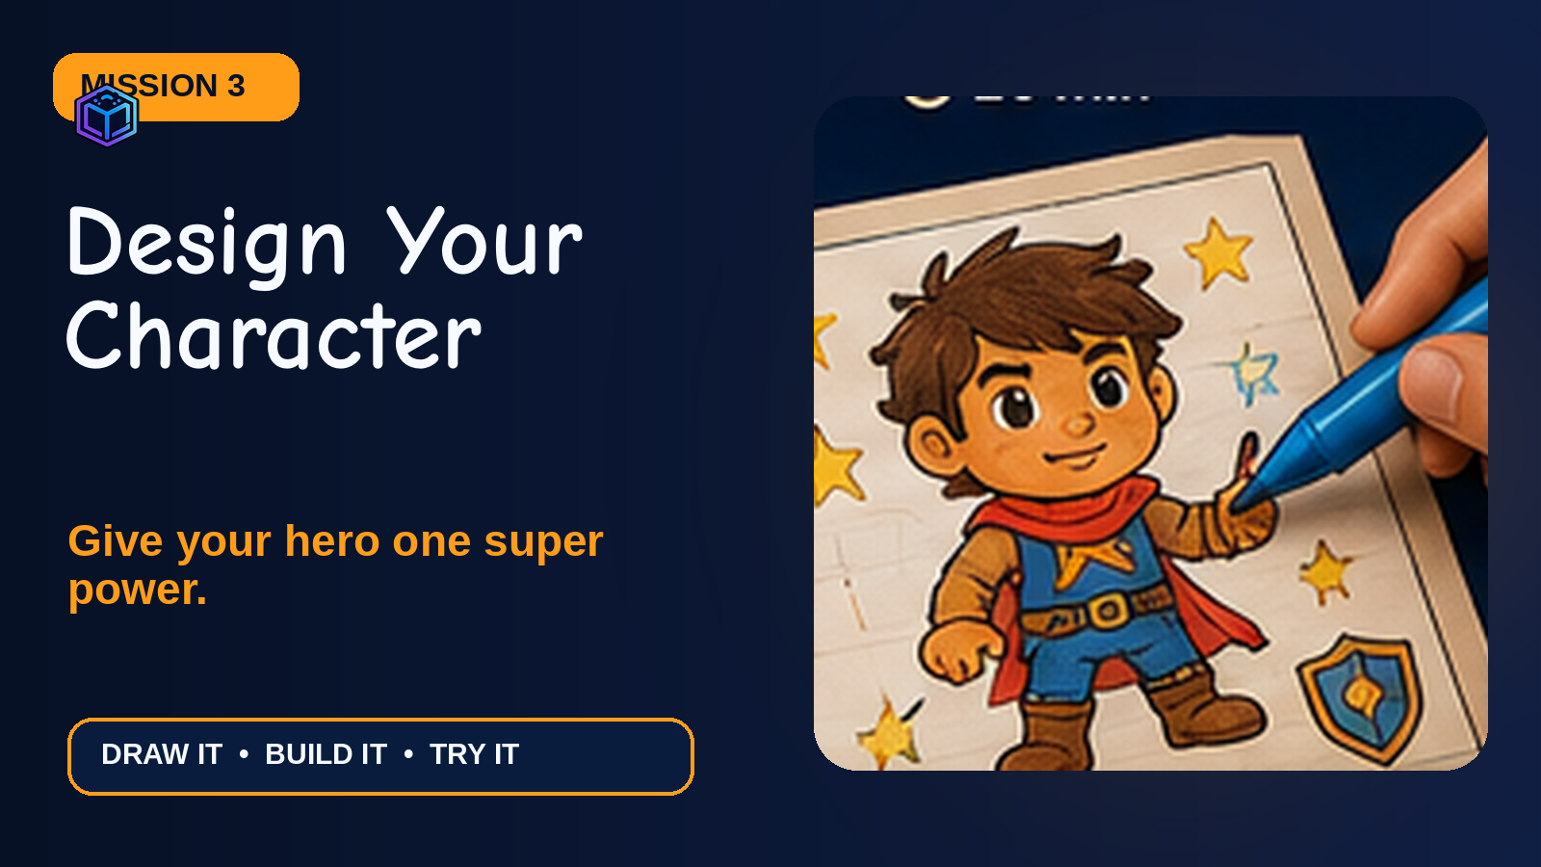
Alt text: A hand draws a friendly caped hero on a character card with stars around the figure.

Mission 4: Draw the Board (20 minutes)
BIG IDEA  A level is a path from START to GOAL with fun choices and challenges along the way. | DELIVERABLE  A paper game level with start, path, challenge, special spaces, and goal.

Learning Objectives
- Place a start and a goal.
- Draw a clear path with 12-20 spaces.
- Add at least one challenge and three special spaces.

Read-Aloud Teaching Script
Say: Your paper board is a map of the first game level. The player needs a way to start, move, meet a challenge, and reach the goal.

Simple Example
Start at the treehouse. Follow the river path. A broken bridge sends you back one space. Star spaces give another turn. The goal is the treasure cave.

Step-by-Step
- Draw a large START shape.
- Draw a winding path of 12-20 spaces.
- Add one challenge space.
- Add three star or bonus spaces.
- Draw the GOAL and decorate the world after the path works.

Hands-On Activity
Build Level 1 on paper or cardboard using a ruler, crayons, and sticker tokens.

Four Useful Tips
- Draw the path lightly in pencil first.
- Keep spaces large enough for a sticker token.
- Make the challenge slow the player, not stop the game forever.
- Test the path with a finger before coloring.
COMMON MISTAKE TO AVOID
Making the board beautiful but forgetting a clear path to the goal.

Check-In
Ask: What four things belong in every level path?
Answer: Start, path, challenge, and goal.

Facilitator Guidance
Offer a pre-drawn path template to children who need motor support. Advanced learners may add a shortcut or secret path.

Recommended Resources
Workbook pages 11-12; blank board template; Diagram 2.
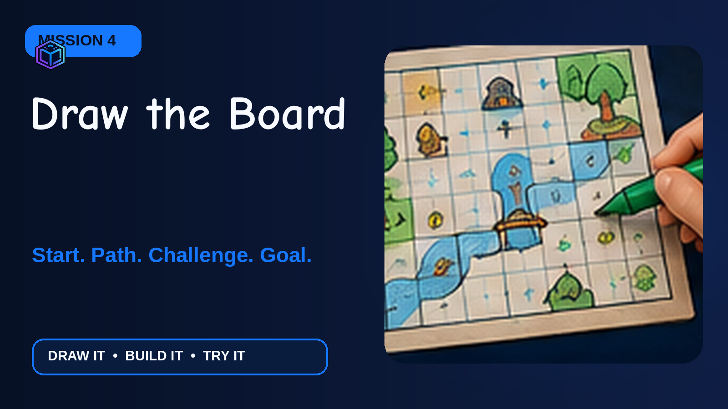
Alt text: A hand draws a colorful square-grid level with a river, trees, a bridge, and a treasure goal.

Mission 5: Make the Rules (20 minutes)
BIG IDEA  Rules make the game clear, fair, and possible to play without the designer explaining every move. | DELIVERABLE  A four-rule card, three move cards, and two paper AI prompts.

Learning Objectives
- Write or dictate four easy rules.
- Make three move cards numbered 1, 2, and 3.
- Create two safe AI art prompts with a grown-up.

Read-Aloud Teaching Script
Say: Rules answer four questions: How do we start? What happens on a turn? What do special spaces do? How do we win?

Simple Example
1. Put your token on START. 2. Draw a move card and move that many spaces. 3. A star gives one extra turn; a cloud sends you back one space. 4. The first player to reach the treasure wins.

Step-by-Step
- Write or dictate the start rule.
- Make move cards 1, 2, and 3.
- Choose what bonus and challenge spaces do.
- Write the winning rule.
- Read the rules aloud and remove extra words.
- With a grown-up, build one character-art prompt and one level-art prompt.

Hands-On Activity
Create a Rules Card and test the rules with a pretend turn.

Four Useful Tips
- Use short sentences and one action at a time.
- Use pictures beside rules for early readers.
- Make every player follow the same rules.
- Ask a child who did not write the rules to explain them back.
COMMON MISTAKE TO AVOID
Changing rules during the game only to help one player win.

Check-In
Ask: How do you know a rule is clear?
Answer: Another player can follow it without extra help.

Facilitator Guidance
The adult handles any AI tool. Children write prompts on paper. Do not enter names, schools, faces, addresses, or private stories.

Recommended Resources
Workbook pages 13-15; move cards; Diagram 4.
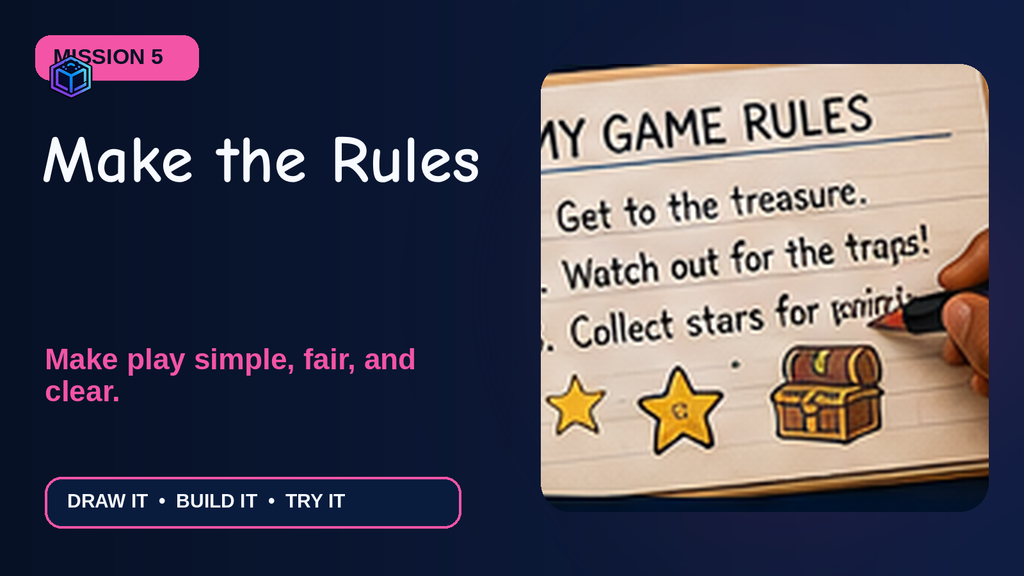
Alt text: A hand writes four simple game rules in a notebook beside stars and a treasure chest.

Mission 6: Playtest Time! (25 minutes)
BIG IDEA  Game designers learn by watching real players and changing one thing at a time. | DELIVERABLE  A completed playtest sheet and one “Make It Better” change ticket.

Learning Objectives
- Teach the game in 30 seconds.
- Use the Fun-Fair-Clear check.
- Make one helpful change after playtesting.

Read-Aloud Teaching Script
Say: A playtest is not a test of you. It is a test of the game. If someone gets confused, that is useful information for the designer.

Simple Example
A player keeps missing the bridge rule. The designer adds a bright orange arrow and changes the rule to “Bridge: go back 1.”

Step-by-Step
- Pair up or make groups of three.
- Designer gives a 30-second explanation, then watches quietly.
- Players take a few turns or finish the game.
- Ask: Was it fun? Was it fair? Was it clear?
- Choose one change to make.
- Play one more quick round.

Hands-On Activity
Play, Watch, Ask, Fix, Play Again.

Four Useful Tips
- Watch where players pause or ask questions.
- Change only one thing before trying again.
- Thank the tester, even when feedback is hard to hear.
- Celebrate improvements, not perfect games.
COMMON MISTAKE TO AVOID
Explaining every move instead of seeing whether the game and rules are clear.

Check-In
Ask: What are the three playtest questions?
Answer: Was it fun, fair, and clear?

Facilitator Guidance
Keep competition gentle. Stop play if frustration grows. Invite children to trade games and give one kind compliment before one suggestion.

Recommended Resources
Workbook pages 16-19; Playtest Loop diagram; Change Tickets.
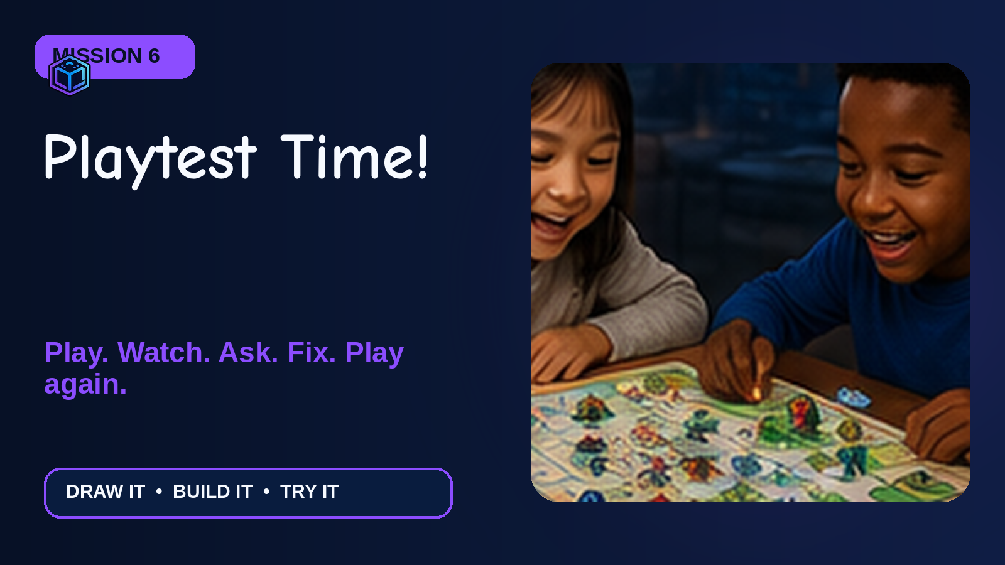
Alt text: Two smiling children play a colorful handmade board game together at a table.

4. Final Project: My First Game Pack
Build a small paper game that another child can understand and play. The finished pack shows the game world, hero, level, rules, art ideas, and one improvement from playtesting.

Required Deliverables
- Theme and game name
- Character card with one power and story
- Level 1 board with start, path, challenge, and goal
- Four-rule card and move cards 1-3
- Two safe AI art prompts written on paper
- Playtest sheet with one improvement
- 30-second game pitch

Completion Checklist
☐ My game has a clear goal.
☐ My hero has one useful power.
☐ My board has a start and goal.
☐ My rules are short and fair.
☐ I used no private information in my AI prompts.
☐ Someone played my game.
☐ I changed one thing to make it better.

Kid-Friendly Evaluation Rubric
Part | Ready to Play | Almost Ready | Keep Building
Game Idea | Theme, goal, and story are easy to understand. | Most parts are clear; one needs help. | The goal or story is still missing.
Playable Level | Start, path, challenge, and goal all work. | The path works with a little help. | The player cannot yet reach the goal.
Rules | Another child can play using the rules. | One or two rules need explaining. | Rules are missing or change during play.
Playtest & Improve | The designer listened and made one useful change. | The game was tested but not changed yet. | The game still needs a playtest.
Safe AI Use | Prompts are creative and contain no private information. | A grown-up needs to help revise a prompt. | Private information must be removed before use.

Reflection Questions
- What part of your game makes you smile?
- What was tricky to build?
- What did your playtester teach you?
- What did you change?
- What would happen in Level 2?

Optional Level-Up Challenge
Create Level 2, add a helper or villain, make a game-box cover, or rebuild the idea in ScratchJr with a grown-up.

5. Differentiation and Family Extension

For Age 6 or Emerging Readers
- Use picture cards and let the child point or dictate.
- Offer the blank board template instead of starting from an empty page.
- Write rules for the child while they explain.
- Use only two move cards: 1 and 2.

For Age 8 or Fast Finishers
- Add a shortcut and a secret space.
- Create a helper or villain card.
- Add a second challenge with a different rule.
- Make Level 2 or a game-box cover.

Support for Attention and Sensory Needs
- Show a visual timer and announce 5-minute warnings.
- Offer a quiet drawing spot.
- Let children stand while drawing or use a clipboard.
- Reduce choices to two themes or two colors.
- Use larger tokens and thicker markers.

Family Take-Home Challenge
Play the game at home with one family member. Ask the three playtest questions: Was it fun? Was it fair? Was it clear? Change one thing and bring the improved version back.
PARENT / CAREGIVER MESSAGE
Your child designed a paper game today. Ask them to teach it to you. Please handle any AI tool yourself and keep names, schools, addresses, photos, and private stories out of prompts.

6. Visual Production Notes
The package includes an original visual for the cover and every lesson, four educational diagrams, a printable overview, and a social promotional image. Authentic Lux AI Kids logo artwork is placed during layout rather than requested from an image model.

Workshop thumbnail
Generation prompt: 16:9 kid-friendly Lux AI Kids workshop scene. Ace and LANA help diverse children ages 6-8 build a colorful handmade paper video game with character cards, a winding level map, goal flag, obstacles, stars, and sticker tokens. Bright creative classroom, deep navy with cyan and violet glow, playful orange, green, blue, and pink accents. Large simple shapes, joyful expressions, negative space for title, no words, no logos.
Accessible alt text: Ace and LANA help young children draw a hero and a colorful game level on paper.

Workshop hero
Generation prompt: Wide cinematic photo-style classroom scene with Ace, LANA, and three children ages 6-8 making a paper game prototype from cardboard, crayons, index cards, stickers, scissors, and a ruler. Friendly, bright, simple, and playful. Group on right, clean dark space on left, no typography or logos.
Accessible alt text: Children create a paper game with Ace and LANA at a classroom table.

Lesson 1 - What Makes a Game a Game?
Generation prompt: Original 16:9 Lux AI Kids lesson visual for ages 6-8. Ace points to a game controller while four bright cards show a character, a goal, a challenge, and rules. Deep navy creative classroom, cheerful cyan, violet, orange, green, blue, and pink accents, large simple visual hierarchy, no readable interface text, no generated logos, clear area for authentic branding.
Accessible alt text: Ace points to a game controller while four bright cards show a character, a goal, a challenge, and rules.

Lesson 2 - Pick Your Theme
Generation prompt: Original 16:9 Lux AI Kids lesson visual for ages 6-8. Three hand-drawn cards show a space adventure, jungle quest, and magic world. Deep navy creative classroom, cheerful cyan, violet, orange, green, blue, and pink accents, large simple visual hierarchy, no readable interface text, no generated logos, clear area for authentic branding.
Accessible alt text: Three hand-drawn cards show a space adventure, jungle quest, and magic world.

Lesson 3 - Design Your Character
Generation prompt: Original 16:9 Lux AI Kids lesson visual for ages 6-8. A hand draws a friendly caped hero on a character card with stars around the figure. Deep navy creative classroom, cheerful cyan, violet, orange, green, blue, and pink accents, large simple visual hierarchy, no readable interface text, no generated logos, clear area for authentic branding.
Accessible alt text: A hand draws a friendly caped hero on a character card with stars around the figure.

Lesson 4 - Draw the Board
Generation prompt: Original 16:9 Lux AI Kids lesson visual for ages 6-8. A hand draws a colorful square-grid level with a river, trees, a bridge, and a treasure goal. Deep navy creative classroom, cheerful cyan, violet, orange, green, blue, and pink accents, large simple visual hierarchy, no readable interface text, no generated logos, clear area for authentic branding.
Accessible alt text: A hand draws a colorful square-grid level with a river, trees, a bridge, and a treasure goal.

Lesson 5 - Make the Rules
Generation prompt: Original 16:9 Lux AI Kids lesson visual for ages 6-8. A hand writes four simple game rules in a notebook beside stars and a treasure chest. Deep navy creative classroom, cheerful cyan, violet, orange, green, blue, and pink accents, large simple visual hierarchy, no readable interface text, no generated logos, clear area for authentic branding.
Accessible alt text: A hand writes four simple game rules in a notebook beside stars and a treasure chest.

Lesson 6 - Playtest Time!
Generation prompt: Original 16:9 Lux AI Kids lesson visual for ages 6-8. Two smiling children play a colorful handmade board game together at a table. Deep navy creative classroom, cheerful cyan, violet, orange, green, blue, and pink accents, large simple visual hierarchy, no readable interface text, no generated logos, clear area for authentic branding.
Accessible alt text: Two smiling children play a colorful handmade board game together at a table.

7. Publishing Copy
SEO title: Your First Video Game Workshop for Kids Ages 6-8 | Lux AI Kids
Meta description: A playful, beginner-friendly workshop where kids ages 6-8 design a hero, draw a level, write simple rules, and playtest a paper video game with Ace and LANA.
Excerpt: Young creators become game designers in six hands-on missions. No coding is required - just paper, crayons, imagination, and a willingness to test an idea.
CTA: Grab your crayons. Your first game begins with one big idea!
Tags: kids game design, ages 6-8, paper prototype, AI for kids, creative learning, STEM workshop, Lux AI Kids

Parent / Teacher Announcement
New Lux AI Kids workshop: Your First Video Game! Children ages 6-8 will invent a game world, design a hero, draw a playable level, make simple rules, and learn how game designers improve ideas through playtesting. The workshop is screen-light and beginner-friendly. Any AI art activity is optional, paper-based, and guided by an adult.

