Trevor Hickey
February 3, 2014
CSCI 410 - Programming Languages
Problem 6b, 12, 23(a&c) pg. 163 - 165

6. Use the grammar in Example 3.2, show a parse tree and a leftmost derivation for each of the following statements:

The grammar:
<assign> → <id> = <expr>
<id> → A|B|C
<expr> → <id> + <expr>
| <id> * <expr>
| ( <expr> )
| <id>

b. B = C * (A * C + B)

<assign> → <id> = <expr>
→ B = <expr>
→ B = <id> * <expr>
→ B = C * <expr>
→ B = C * ( <expr> )
→ B = C * ( <id> * <expr> )
→ B = C * ( A * <expr> )
→ B = C * ( A * <id> + <expr> )
→ B = C * ( A * C + <expr> )
→ B = C * ( A * C + <id> )
→ B = C * ( A * C + B)

as a parse tree:
[<assign> [[<id> [B]] [=] [<expr> [<id> [C]] [*] [<expr> [[(] [<expr> [[<id> [A]] [*] [<expr> [[<id> [C]] [+] [<expr> [<id> [B]]]] ]]] [)] ]]]]]
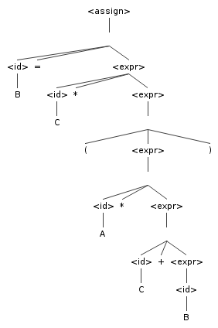

12. Consider the following grammar:
<S> → a <S> c <B>
| <A>
| b
<A> → c <A>
| c
<B> → d
| <A>
Which of the following sentences are in the language generated by this grammar?
a. abcd | True  <S> → a <S> c <B>  → a b c <B>  → a b c d
b. acccbd | False  <S> → a <S> c <B>  → a <A> c <B>  → a c <A> c <B>  → a c c c <B>  → a c c c <A>  → a c c c <A> *can't evaluate out a 'b'
c. acccbcc | False  <S> → a <S> c <B>  → a <A> c <B>  → a c <A> c <B>  → a c c c <B>  → a c c c <A> *can't evaluate out a 'b'
d. acd | False  <S> → a <S> c <B>  → a <S> c <B> *<S> can't evaluate to null
e. accc | True  <S> → a <S> c <B>  → a <A> c <B>  → a c <A> c <B>  → a c c c <B>  → a c c c <A> *<A> can't evaluate to null

23. Compute the weakest precondition for each of the following assignment statements and postconditions:

a. a = 2 * (b - 1) - 1 {a > 0}
{2 * (b - 1) - 1 > 0}
{2 * b - 3 > 0}
{b > 3/2 }

c. a = a + 2 * b - 1 {a > 1}
{a + 2 * b - 1 > 1}
{a + 2b > 2}
{2b > 2 - a}
{b > (2 - a)/2}

