LUXECRAFT CONSULTING
Phase 1
Implementation Framework

The complete operational reference for
delivering Phase 1 to a custom home builder or remodeler
Internal Use Only · Master Reference Document
Let's build something that lasts.
LuxeCraftConsulting.com

CONTENTS
Table of Contents
Section 1 · Overview & Philosophy
The LuxeCraft approach to JobTread implementation. Three principles that drive every Phase 1 engagement.
Section 2 · The 13-Week Structure
Week 0 through Week 12. The dependency-driven sequence and why it works.
Section 3 · The Three Tracks
Light, Moderate, Heavy. When each track applies and what changes between them.
Section 4 · The Build Complexity Scorecard
How we triage clients in Phase 0. The 20 weighted criteria, scoring bands, and interpretation.
Section 5 · Build-Out vs. Rollout
Why these run in parallel. How prerequisites gate team rollouts.
Section 6 · The Rollout Playbook
The four-step pattern that runs every team rollout week. Pre-approval, kickoff, practice, adoption check.
Section 7 · The Success Champion Role
Who they are, what they do, how we train them. The weekly Champion call.
Section 8 · Scope Management & Change Requests
How we protect the engagement from scope creep. The change request process.
Section 9 · The Deliverable System
What the client sees at each phase. What stays internal.
Section 10 · Using the Toolkit
Pointers to every tool we have built. When to use each one.
Section 11 · Phase 2 Transition
What happens after Week 12. Support Lab handoff.

SECTION 1
Overview & Philosophy
LuxeCraft Phase 1 is a 13-week JobTread implementation engagement for custom home builders and remodelers. The goal of Phase 1 is to take a client from a signed engagement to full team adoption of JobTread, with a trained Success Champion who can carry the work forward after we step back.
This document is the operational reference for delivering Phase 1. It captures how we run engagements, why we run them this way, and what every artifact in the LuxeCraft toolkit is for.
This is an internal operational manual. It is meant for the consultant delivering the engagement, not the client.
The Three Principles
Every choice in the LuxeCraft Phase 1 framework comes back to one of three principles. When in doubt, return to these.
1. Lowest friction first, then dependency order
We start the team rollout with the tools that have no dependencies and the lowest cognitive load. Messaging, to-dos, daily logs. These build the habit of opening JobTread every day. Once the habit is there, we layer on the heavier tools in the order their data dependencies require: budgets, then schedules, then time tracking, then everything that builds on those.
2. Champion-led, not consultant-led
The consultant is temporary. The Success Champion is permanent. Every team-facing rollout is co-led by the Champion. Every weekly leadership conversation is with the Champion. By Week 12, the Champion runs the system. We have built a leader, not just configured a tool.
3. Repeatable playbook, every time
Every team rollout follows the same four-step Rollout Playbook. Every weekly Champion call follows the same seven-element structure. Every client engagement starts with the same Build Complexity Scorecard. The repetition is the point. Predictability is what makes adoption stick and what makes the consulting work scalable.
The team does not have to feel the change for the change to be real. Consistency is the lever.

What Phase 1 Is, and What It Is Not
LuxeCraft offers four engagement tiers: Phase 0 (Discovery & Review), Phase 1 (12-week implementation), Phase 2 (Legacy Builder Program), and the JobTread Support Lab membership. This document covers Phase 1 only. Understanding what Phase 1 is and is not is the first protection against scope creep.
PHASE 1 IS | PHASE 1 IS NOT
A 13-week implementation engagement | An open-ended consulting relationship
Focused on a single primary entity | A multi-company or multi-entity buildout
Standard JobTread native capabilities | Custom API or integration development
A trained Success Champion at the end | A permanent consulting presence
A repeatable framework with three tracks | A bespoke project per client
Owned by LuxeCraft from kickoff to handoff | Client-managed with LuxeCraft on call

SECTION 2
The 13-Week Structure
Phase 1 runs for 13 weeks. Week 0 is discovery and kickoff. Weeks 1 through 12 are the build-out and rollout. Week 12 is handoff.
Within those 13 weeks, the work is divided between two parallel tracks: the build-out (consultant-led, configuring the account) and the team rollout (consultant plus Champion, introducing tools to the team). The relative length of each varies by track assignment, which is covered in Section 3.
The Dependency-Driven Sequence
The team rollout sequence is not arbitrary. Tools are introduced in the order their data dependencies allow. You cannot roll out time tracking before budgets and schedules exist, because time codes against budget assemblies and logs against scheduled work. You cannot roll out selections before the budget structure is in place, because selections reference budget items.
This is why the framework rejects the older friction-only sequence ("start with the easy stuff and work toward the hard stuff"). In practice, friction is one input, but operational dependencies are the deciding factor. The full sequence is:
Foundation (must come first)
- Customers and jobs basics, including the customer pipeline
- Messaging and to-dos (habit-building, no dependencies)
Core build sequence (each enables the next)
- Budgets, the heartbeat. Cost catalog and budget templates ready.
- Plans and parameters, built around the budget
- Schedules, referencing the budget structure
- Selections and allowances, which require budget plus schedule
- Time tracking, which requires both budgets and schedules
Flexible / parallel modules
- Daily logs, which can slot in once habits are built
- Documents and files, which can come earlier or later
Sales side
- Proposals and contracts, which use selections
Financial closure
- Change orders, which modify budgets that now exist
- Purchase orders, invoicing, and cost tracking
Leadership layer
- Dashboards and reports, which need data flowing first
The sequence reflects how the system actually works, not how the team feels about each tool.

Week-by-Week (Moderate Track Default)
Below is the default Moderate Track week-by-week structure. Light Track shifts the build phase shorter and rollout longer. Heavy Track does the opposite. See Section 3 for the full track-by-track breakdown.
WEEK | FOCUS | WHO IS INVOLVED
Week 0 | Discovery, scope confirmation, kickoff | Consultant, owner, Champion
Week 1 | Build: cost catalog, customer pipeline, user roles, document templates | Consultant heads-down + Champion training
Week 2 | Build: budget templates, plans and parameters | Consultant heads-down + Champion training
Week 3 | Build: schedule templates, selections catalog, allowances | Consultant heads-down + Champion training
Week 4 | Build wraps: customer/job data loaded, integrations verified, Champion ready | Consultant heads-down + Champion training
Week 5 | Rollout: messaging, to-dos, daily logs (Tier 1 habits) | Full team kickoff
Week 6 | Rollout: budgets go live | Estimators, PMs
Week 7 | Rollout: plans and schedules | PMs, estimators, field
Week 8 | Rollout: time tracking | Field team primarily
Week 9 | Rollout: selections and allowances | Selections coordinator, designer, back office
Week 10 | Rollout: documents, files, proposals, contracts | Sales, owner, back office
Week 11 | Rollout: change orders, POs, invoicing, cost tracking | Back office, bookkeeping, PMs
Week 12 | Optimization: dashboards, KPIs, Support Lab handoff | Owner, leadership, Champion

Why Week 0 Matters
Week 0 is not a buffer. It is the foundation that protects the entire engagement. The work that happens in Week 0 is what makes the next 12 weeks succeed or fail.
Track confirmation from the Build Complexity Scorecard
Run the scorecard against the Phase 0 audit findings. Score the account, see the recommended track, confirm the track with the client. Document the score. This is now the basis for what is in scope and what triggers a rebid.
Scope confirmation document signed
Send the track-specific Scope Confirmation document via JobTread custom document. Get it signed before Week 1 begins. This is the contract for the engagement.
Implementation Roadmap delivered
Generate the client-facing Implementation Roadmap from the Roadmap Generator tool. Send it to the client. This is what they reference when they wonder what is coming next.
JobTread schedule imported
Generate the consultant-facing JobTread CSV from the CSV Generator tool. Import it into JobTread under the new client job. This is your week-by-week internal tracker for the engagement.
Success Champion identified and committed
Confirm who the Champion is. Get their commitment. Send them the Success Champion Playbook. Schedule the recurring 30-minute weekly Champion call back-to-back with the team call.
Weekly cadence scheduled
Recurring 1-hour team call plus 30-minute Champion call, same day, weeks 1 through 11. Plus a final session in Week 12.

SECTION 3
The Three Tracks
Every Phase 1 engagement is assigned to one of three tracks based on the Build Complexity Scorecard. The track determines the relative length of the build-out phase versus the team rollout phase. Total length is always 13 weeks.
Light track engagements have a short build because the account is mostly clean already. Moderate track engagements need real build-out alongside cleanup. Heavy track engagements are near build-from-scratch and need the most consultant time on the build side.
Track Comparison
 | BUILD PHASE | ROLLOUT PHASE
Light (score 38-88) | 2 weeks (W1-W2) | 9 weeks (W3-W11)
Moderate (score 89-139) | 4 weeks (W1-W4) | 7 weeks (W5-W11)
Heavy (score 140-190) | 6 weeks (W1-W6) | 5 weeks (W7-W11)
Note: every track ends with Week 12 as handoff/optimization. The build and rollout numbers above do not include Week 0 (discovery) or Week 12 (handoff).
When to Assign Each Track
Light Track
Use when the JobTread account is largely in working order. Cost catalog exists and is mostly correct. Budget templates exist and work. Schedule templates exist. Selections catalog has structure. The work is refinement, gap-fill, and team rollout, not new construction.
Common scenarios: client has been on JobTread for 6+ months and is asking for help to get the team using it. Client started a self-implementation and got most of the build done. Client previously worked with another consultant and the build was completed.
Moderate Track
Use when the account needs meaningful build-out alongside cleanup. Some templates exist but need significant restructuring. Selections catalog is partial. Cost catalog has gaps. Document templates need work. The work is real new build plus rollout.
Common scenarios: client has been on JobTread but only used it lightly. Client has good operational data in spreadsheets that needs to migrate to JobTread structures. Client started but stalled on the build.
Heavy Track
Use when the account is near-empty or requires substantial reconstruction. Cost catalog must be built from scratch or rebuilt. Budget templates must be constructed. Selections catalog must be built. Often a migration from BuilderTrend, CoConstruct, or spreadsheets is involved.
Common scenarios: client just signed up for JobTread. Client is migrating from another platform with active jobs. Client has no current digital structure for their estimating, scheduling, or selections workflow.

How Tracks Adjust Within the Same 13 Weeks
Heavy Track does not extend the timeline. It extends the build phase and condenses the rollout phase. This means the consultant has more heads-down time in Heavy track engagements but the Champion has to absorb more in fewer rollout weeks.
If a Heavy Track client truly cannot fit into 13 weeks, it is quoted as a separate 16-week engagement, not adjusted within the standard framework. This protects the predictability of the standard engagement.
Light Track Rollout Schedule
Weeks 3-4 are catch-up time built into the rollout. Light track has more rollout weeks than tools to roll out, which means there is room for buffer weeks and adoption deepening. This is intentional. Light track clients often have less internal momentum because their account already mostly worked, so the longer rollout helps drive habit change.
Moderate Track Rollout Schedule
The standard 7-week rollout pacing. One major theme per week. This is the most common track and the one all defaults are designed around.
Heavy Track Rollout Schedule
Tools are combined into the same rollout week. Week 8 of Heavy track rolls out budgets, plans, and schedules together because the team has already absorbed enough during the build phase to handle multiple tool launches in the same week. This requires more Champion engagement and more leadership air cover.
Heavy track engagements are the highest-stakes Phase 1 work. They require the most disciplined Rollout Playbook execution and the most engaged Success Champion.

SECTION 4
The Build Complexity Scorecard
The Build Complexity Scorecard is the diagnostic tool used in Phase 0 (Discovery & Review) to assign a Phase 1 engagement to a track. It is a 20-criterion rubric with weighted scoring.
The scorecard is delivered as an interactive HTML tool. It auto-saves locally, supports JSON export and import, generates a client-ready report, and prints to PDF for inclusion in the Discovery & Review deliverable.
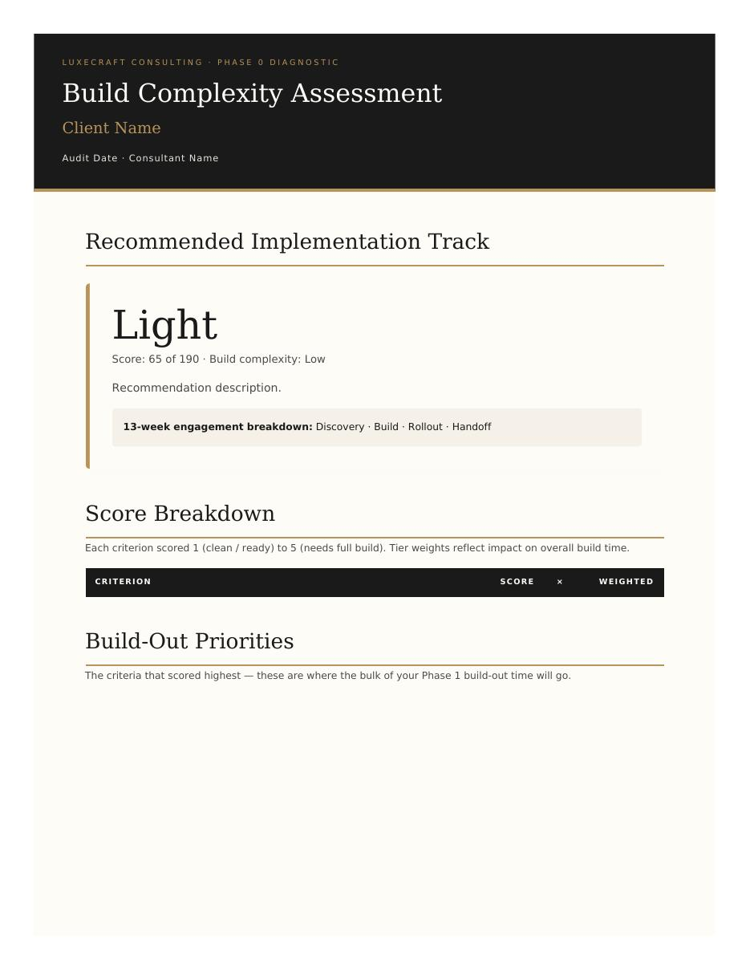
The Build Complexity Scorecard interactive HTML tool

How the Scoring Works
Each of the 20 criteria is scored on a 1 to 5 scale. 1 means the area is clean and ready. 5 means it needs to be built from scratch. The score is multiplied by the weight tier, then summed.
Tier 1 — Highest Impact (×3 weight)
These six criteria have the largest impact on overall build time. They are the items that, if scored high, will drive the bulk of Phase 1 build work.
- User roles and permissions
- Budget template
- Schedule template
- Selections catalog
- Cost catalog
- Team data readiness (customer/vendor lists, historical jobs)
Tier 2 — Significant Impact (×2 weight)
These six criteria add meaningful build time but are not the deciders. Often a mix of cleanup and net-new build.
- Document templates (contracts, proposals, change orders)
- Cost inboxing setup
- Reporting and dashboards
- Specifications
- Prior platform migration
- Vendors
Tier 3 — Lighter Impact (×1 weight)
These eight criteria are quicker to set up or already in place for most clients. Still scored, but lower weight.
- Customer pipeline
- Time tracking configuration
- Daily logs setup
- Plans
- File storage
- Messaging and communication
- Account hygiene (duplicates, naming, abandoned data)
- Integrations (QBO, accounting)

Score Bands and Track Assignment
Total weighted score determines the track. The minimum possible score is 38 (all 1s). The maximum is 190 (all 5s).
SCORE BAND | RECOMMENDED TRACK | BUILD INVESTMENT
38 to 88 | Light Track | 2 weeks build, 9 weeks rollout
89 to 139 | Moderate Track | 4 weeks build, 7 weeks rollout
140 to 190 | Heavy Track | 6 weeks build, 5 weeks rollout
The Notes Field
Each criterion has a notes field. Notes are documentation only. They do not affect the score. They are used to capture context for the build-out priorities section of the report and to remember the why behind any judgment calls when scoring.
Notes are shown on the generated report for any criterion scoring 3 or higher (a build-out priority). They give the client visibility into what is driving the recommendation.
How to Run the Scorecard
1. Complete Phase 0 Discovery & Review
Review the JobTread account end-to-end. Run the JobTread Account Audit, the Owner Discovery Form, and the Team Usage Assessment. These are the inputs to the scorecard.
2. Score each of the 20 criteria
Open the scorecard tool. Enter client information. Score each criterion 1 to 5 based on what you found in the audit. Add notes for any criterion scoring 3 or higher.
3. Review the recommended track
The tool calculates the weighted score and shows the recommended track. The track is a recommendation, not a verdict. Override if you have a justified reason, but document the reason.
4. Generate the client report
The tool generates a client-ready report showing the verdict track, score breakdown, build-out priorities, and next steps. Export to PDF and include in the Phase 0 deliverable.
5. Save the JSON
Save progress as JSON to your client folder. This becomes the audit trail for the track assignment if it is ever questioned later.
The scorecard is a diagnostic, not a verdict. Use judgment, but always document why.

SECTION 5
Build-Out vs. Rollout
The single most important structural insight in the LuxeCraft framework is that build-out and rollout are not sequential. They run in parallel. The build-out track is consultant-led, heads-down work configuring the account. The rollout track is the introduction of tools to the team, starting once the build is far enough along to support each rollout.
This was a hard-won lesson. The original framework treated build-out and rollout as sequential phases ("finish the build, then start the rollout"). In practice, that does not work. Some build-out tasks are not needed until later in the rollout. Some rollout tools require build-out work that has not yet started. Forcing a strict sequence either delays the rollout unnecessarily or rushes the build.
Build-out and rollout are entangled. The framework treats them as parallel tracks with explicit prerequisites.
Prerequisites Gate Each Rollout
Every rollout week has a build-out prerequisite. The team rollout cannot begin for a tool until that tool's build-out prerequisite is met. This protects the team from being asked to use tools that are not ready.
ROLLOUT WEEK | TOOL BEING ROLLED OUT | BUILD-OUT PREREQUISITE
Tier 1 (early) | Messaging, to-dos, daily logs | User roles configured, account hygiene baseline
Foundation | Budgets | Cost catalog complete, budget templates tested
Foundation | Plans + schedules | Plans tab structure, parameters tied to budget, schedule template
Foundation | Time tracking | Cost codes mapped, time tracking permissions configured
Sales | Selections + allowances | Selections catalog complete, customer-facing experience tested
Sales | Proposals + contracts | Proposal/contract templates branded and ready, e-sign tested
Financial | Change orders, POs, invoicing, cost tracking | Change order workflow tested, QBO sync working
Handoff | Dashboards, KPIs, reports | All prior data flowing, leadership KPIs defined

How the Two Tracks Coordinate
During the Build Phase (Weeks 1 through W2/W4/W6 depending on track)
The consultant is heads-down on the build. The Success Champion is in weekly training, learning the tools one week ahead of when they will be rolled out. The team is not yet involved with new tools. This is also when customer and job data is loaded so that when the team starts using JobTread in the rollout, they are working with real jobs, not test data.
During the Rollout Phase (remaining weeks through W11)
The consultant is split between final build-out polish and running the Rollout Playbook for each week's tool launch. The Success Champion is co-leading the team rollouts. The team is actively using JobTread.
During the Handoff Phase (Week 12)
The dashboards and reports get configured (the leadership layer). The final adoption review happens. The client transitions to Support Lab membership. The consultant steps back.
PREP Subtasks: The Communication Bridge
In the JobTread CSV that lives in the consultant's tracking system, every week has two clusters of subtasks: active work for that week, and PREP subtasks at the end. The PREP subtasks are what the consultant needs to gather, coordinate, or confirm during this week to be ready for next week's active work.
This is the communication bridge to the client. At the end of each weekly meeting, the recap to the client includes the PREP items: "Here is what I need from you this week to be ready for next week." This gives the client clear visibility and gives the consultant the inputs needed to keep the build-out moving.
PREP subtasks are how the framework keeps the build-out and rollout in sync. They are the operational glue.

SECTION 6
The Rollout Playbook
Every team rollout, regardless of which week it falls in or which tool is being rolled out, follows the same four-step playbook. The team should know this sequence so well that they anticipate what is coming next. Predictability drives adoption.
The Rollout Playbook is the most important structural element of the rollout phase. Without it, every team rollout becomes a custom event, draining consultant energy and confusing the team. With it, the work is repeatable and the team learns to engage with the pattern.

Step 1 — Pre-Approval (1 week before rollout)
The consultant builds the slide deck and any Loom walkthroughs for the tool being rolled out. The content is sent to leadership and the Success Champion for approval on two dimensions:
Readiness
Is the team ready for this tool? Do they have the account access, training prerequisites, and time to adopt it? Is leadership prepared to support adoption with their own visible use of the tool?
Accuracy
Does the content reflect how we actually use this tool in our business? Does it match the language, process, and edge cases of the client team?
Approval is required before the team kickoff. No exceptions. This protects the team from being launched into something the back office is not prepared to support.
Step 2 — Team Kickoff Session (Day 1 of rollout week)
Live team meeting over Zoom. The Success Champion co-leads. The consultant walks through the slide deck, demonstrates the tool live in JobTread, and facilitates Q&A. The session is recorded and distributed afterward for anyone who could not attend live or wants to reference it later.
The Champion's role in this session is critical. They are not a passive observer. They speak. They demonstrate. They take a question. The team needs to see the Champion as a co-owner of the rollout, not just a meeting attendee.

Step 3 — Practice Week (Days 2 through 5 of rollout week)
The team uses the tool in real work. The Success Champion is the first point of contact for questions. The consultant monitors JobTread activity remotely and flags users with low or no adoption.
This is where adoption either takes root or starts to drift. The consultant's job during the practice week is not to swoop in and answer every question. The consultant's job is to support the Champion as they handle the questions, and to identify patterns that suggest a training gap or a process problem.
Step 4 — Adoption Check (End of rollout week)
Quick review between consultant and Success Champion at the end of the week. Three questions:
- Who is using it?
- Who is not?
- What is breaking?
Any holdouts get a targeted follow-up. Sometimes a 1:1 training session. Sometimes a written reference document. Sometimes just a personal nudge from the Champion. Refinements are made before the next tool rolls out so the next rollout starts from a stronger foundation.
Why the Playbook Works
The Rollout Playbook works because it answers the team's two most common implicit questions: What is going to happen? And how should I respond?
When the team knows that every rollout is preceded by leadership signoff, they trust that what is being rolled out has been considered carefully. When they know there will be a live kickoff session, they know they will get the chance to ask questions. When they know there is a practice week, they know they have permission to make mistakes. When they know there is an adoption check, they know that not using the tool will be noticed.
The Rollout Playbook is not just a process. It is a contract with the team about how change happens here.

SECTION 7
The Success Champion Role
The Success Champion is the most important role in any LuxeCraft engagement. They are the person on the client team who carries the new way of working forward after the consultant is gone. Without a strong Champion, every Phase 1 engagement degrades within months of completion. With a strong Champion, the system runs and improves indefinitely.
The Champion is not a backup consultant. They are the leader of adoption.
Who the Champion Is
The Champion is identified by the client owner during Phase 0 or Week 0. They are typically not the owner. They are someone on the team who has:
- Visible influence with peers, even without formal authority
- Genuine investment in how the company operates
- Detail orientation and follow-through
- Comfort in the system enough to be a learner alongside teammates
- Available bandwidth (this is not a 5-hour-a-week role, but it requires real time)
The Champion is given the LuxeCraft Success Champion Playbook on Day 1 of the engagement. The playbook is theirs to keep. It contains their weekly reading material, the toolkit they will use throughout the engagement, and the certification framework they are working toward.

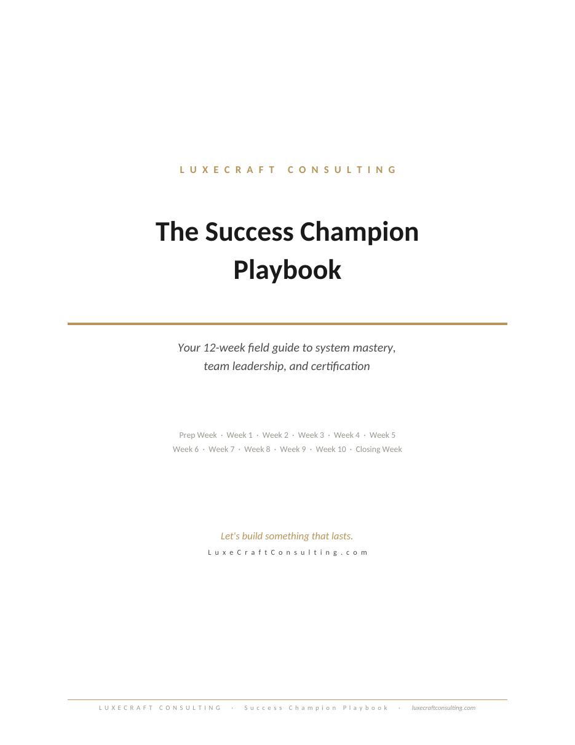
The Success Champion Playbook delivered to every Champion

How the Champion Is Trained
Champion training is delivered through three coordinated channels:
1. Weekly reading
The Champion reads one chapter of the Success Champion Playbook each week, starting with the Prep Week chapter before kickoff. Each chapter takes 15 to 20 minutes to read and is paced to match the moment they will be living in that week. Resistance in Week 1. Mindset in Week 2. System mastery in Week 3. And so on.
2. Weekly Champion call
A dedicated 30-minute weekly meeting between the consultant and the Champion, scheduled back-to-back with the team call (1 hour team call plus 30 minutes Champion call, same day). This call is private. It is a space for honest conversation, leadership coaching, and practical problem-solving.
3. Co-leadership of every team rollout
The Champion is in every team rollout session. They are introduced as the co-lead. They speak. They demonstrate. They take questions. The team sees them as a partner in the implementation, not a passenger.
The Weekly Champion Call Structure
Every Champion call follows the same seven-element structure. This is documented in the consultant-facing CSV as subtasks for each weekly Champion task (named SC: [Theme]).
1. Accountability check
Did they complete what they committed to last week? If yes, celebrate it. If no, surface the obstacle without judgment.
2. Review the Playbook chapter
What landed? What did not? What questions came up? The chapter is the framework. The conversation makes it real.
3. Reflection questions
Each chapter has reflection questions. Ask them out loud. Listen. The answers tell you what is happening on the ground.
4. Talking points
The leadership coaching content for this week. Frame it as conversation, not lecture.
5. Watch-fors
Things to notice in the team this coming week. Specific, behavioral, observable.
6. Self-sufficiency drill
A scenario or question they have to work through themselves before next session. Builds the muscle of figuring things out without the consultant.
7. Capture the commitment
What will they commit to this week? Write it down. Bring it to next week.

The Certification Framework
By the end of Phase 1, the Champion earns the designation of LuxeCraft Certified Success Champion. Certification is not a final exam. It is a recognition of demonstrated competency across five domains, evidenced by the signed benchmarks at the end of each weekly chapter.
- Workflow and System Mastery: end-to-end understanding of the JobTread build
- Dashboard Literacy: ability to read, interpret, and act on performance data
- Accountability Leadership: demonstrated habit of holding the team to process standards
- Troubleshooting Competency: ability to identify and resolve common system breakdowns
- Process Improvement: at least one documented workflow improvement completed
Certified Champions become the reason LuxeCraft implementations last beyond the engagement. They also become referral and case-study sources for future LuxeCraft work.
Certification is not the finish line. It is the starting line for the next phase of the Champion's leadership.

SECTION 8
Scope Management & Change Requests
Scope management in Phase 1 is built on three layers of protection: discovery-side protections (preventing scope creep), engagement-side protections (handling it when it happens), and structural protections (the framework itself defines what is in and out of scope).
Layer 1: Discovery-Side Protections
The Build Complexity Scorecard is the deciding artifact for what work is in scope. After Phase 0, the score and assigned track are documented and shared with the client. The track-specific Scope Confirmation document defines what is included in the engagement at that track level, what is universally out of scope, and what would trigger a track upgrade.
The client signs the Scope Confirmation document before Week 1 begins. This is the contract for the engagement. From that point forward, scope is no longer ambiguous.
Layer 2: Engagement-Side Protections
The Change Request Process is the formal protocol for handling any request that might fall outside scope. Three steps:
1. Submit
The client submits a written change request describing what is needed and why.
2. Review
LuxeCraft reviews the request within 3 business days and provides one of three responses: accommodate within current scope, defer to Support Lab, or quote a scope addendum.
3. Approve
No additional work begins until the client approves the change in writing.
This process is documented in the Scope Confirmation document. The client knows it exists before scope creep ever surfaces. Having a written process makes the conversation easier when it happens, because both sides have already agreed to the rules.

Layer 3: Structural Protections
The framework itself defines what is in and out of scope at the universal level. These boundaries apply to every Phase 1 engagement regardless of track.
Universal Out of Scope (every engagement)
- Bookkeeping or ongoing financial management
- Hiring decisions or HR consulting
- Custom code, API development, or non-JobTread tool implementation
- Implementation of non-JobTread software platforms
- Ongoing subscription costs (JobTread, integrations) remain the client's
- Day-to-day operational management of the client's team
- On-site visits or in-person training
- Legal, tax, or compliance advice
Track-Specific Out of Scope
Each of the three Scope Confirmation documents lists what would trigger a track upgrade. For example, in a Light Track engagement, building a cost catalog from scratch is out of scope and would trigger an upgrade to Moderate or Heavy. These boundaries are listed specifically in each track's Scope Confirmation document.
Track Upgrade Path
If during the engagement it becomes clear that the scope is bigger than the assigned track, the track upgrade path is the formal protocol for adjusting:
1. Identify the trigger
What specifically is making this engagement larger than the current track? Document it.
2. Re-score the scorecard
Re-run the Build Complexity Scorecard with the new information. Confirm the new track recommendation.
3. Quote the upgrade
Quote the additional work and timeline impact. Send a scope addendum.
4. Get the upgrade signed
No additional work begins until the upgrade is signed. If the client declines the upgrade, document the items being deferred to a future engagement or the Support Lab.
Scope creep is not a failure. It is what happens when a client's needs become clearer during the work. The framework's job is to handle it predictably, not pretend it will not happen.

SECTION 9
The Deliverable System
Phase 1 has a defined set of deliverables, some of which are client-facing and some of which are internal. Knowing what gets sent to the client and when is what creates the polished, predictable experience that distinguishes a LuxeCraft engagement.
Client-Facing Deliverables
DELIVERABLE | WHEN | FORMAT
Build Complexity Scorecard report | End of Phase 0 | Branded PDF (printed from scorecard tool)
Scope Confirmation document | Week 0 | JobTread custom document, signed
Implementation Roadmap | Week 0 | Branded PDF (from Roadmap Generator) or HTML link
Success Champion Playbook | Week 0 | Printed booklet in onboarding box, or PDF
Weekly meeting recap | Every week | Branded PDF (from Meeting Recap skill)
Tier-specific training slide decks | Each rollout week | Branded PDF, sent for leadership pre-approval
Loom walkthroughs | As needed | Loom links shared in JobTread or by email
Phase 0 Discovery & Review report | End of Phase 0 | Interactive HTML or branded docx
Final 60/90-day plan | Week 12 | Branded PDF
Support Lab onboarding | Week 12 | Skool community invitation

Internal Deliverables (Consultant Only)
DELIVERABLE | WHEN | PURPOSE
JobTread schedule CSV | Week 0 | Imported into JobTread for week-by-week tracking
Champion call notes | Every week | Captured in JobTread or consultant's tracker
Adoption monitoring data | Every week | JobTread activity reports for spotting holdouts
Build-out task tracking | Throughout build phase | Internal tracker for build prerequisites
Scorecard JSON file | Phase 0 | Audit trail for the track assignment
Brand Standards Across All Deliverables
Every client-facing deliverable follows the same brand standards. This is non-negotiable. The consistency is what creates the impression of a polished, premium boutique consulting firm rather than a one-person operation.
Color palette
- Black (1A1A1A) for primary text and headers
- Gold (B8935A) for accents, section labels, pull quotes
- Cream (F5F1E8) for background fills and table shading
- Cream-darker (E8E4DC) for alternating row shading
- Text gray (4A4A4A) for body copy
Typography
- Cormorant Garamond for primary headings (or Calibri serif fallback)
- Montserrat or Calibri for body text
- Letter-spaced gold all-caps for section labels
- Italic gold for pull quotes
Voice
- Warm but professional
- "We" language for the company, except on the About page
- No emojis
- No em dashes
- Direct, confident, never over-explanatory
Every client-facing document should look like it came from a premium boutique consultancy. Warm but not casual. Immediately recognizable as LuxeCraft.

SECTION 10
Using the Toolkit
This section is the directory of every operational tool we have built. Each tool is designed for a specific moment in the Phase 1 engagement. Use them in the order presented below.
1. The Build Complexity Scorecard
Used at the end of Phase 0. Score the audit findings, get a track recommendation, generate the client-ready report.
File: LuxeCraft_Build_Complexity_Scorecard.html
When: End of Phase 0, before Week 0 kickoff
Output: Branded PDF report + saved JSON for audit trail

2. The Scope Confirmation Templates
Three markdown templates, one per track. After scorecard runs and track is assigned, customize the relevant template, paste into JobTread custom document builder, send for client signature.
Files: LuxeCraft_Scope_Confirmation_Light_Track.md, _Moderate_Track.md, _Heavy_Track.md
When: Week 0, after track assignment
Output: Signed JobTread custom document
3. The Implementation Roadmap Generator
Interactive HTML tool. Enter client name, kickoff date, track. Generates branded vertical roadmap showing all 13 weeks with dates, themes, and color-coded categories. Print to PDF for the client.
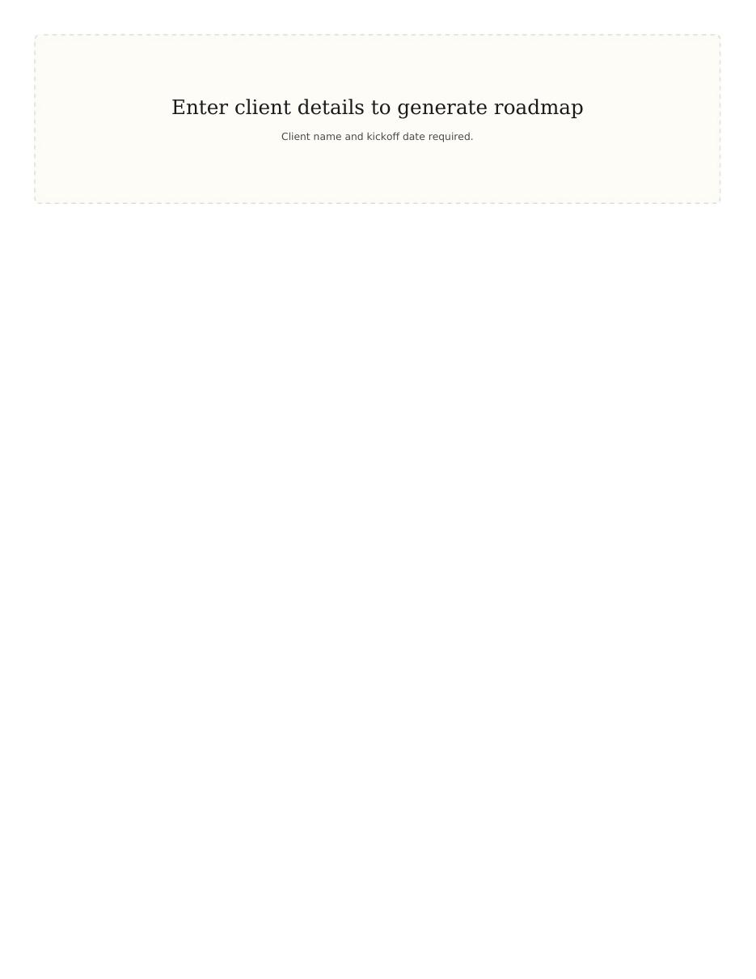
The Implementation Roadmap Generator
File: LuxeCraft_Implementation_Roadmap_Generator.html
When: Week 0, before kickoff meeting
Output: Branded PDF roadmap for the client

4. The JobTread Schedule CSV Generator
Interactive HTML tool. Generates a JobTread-importable CSV containing the parent job, all 13 weekly tasks, all 12 Champion session tasks, and the 3 milestone invoices. Each weekly task includes active subtasks and PREP subtasks.
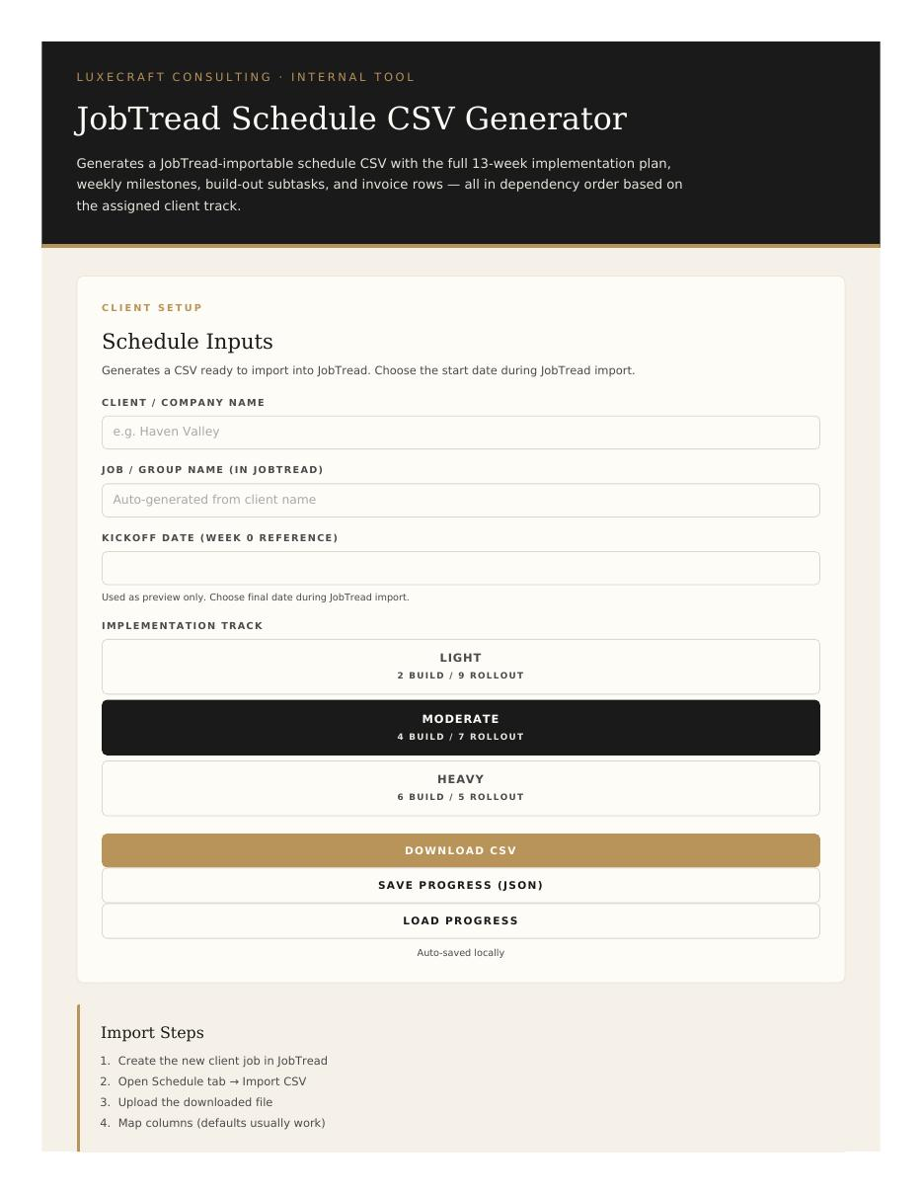
The JobTread Schedule CSV Generator
File: LuxeCraft_JobTread_Schedule_CSV_Generator.html
When: Week 0, before kickoff meeting
Output: JobTread-importable CSV for the consultant's internal tracking

5. The Success Champion Playbook
64-page brand-formatted Word doc. Twelve chapters: Prep Week, Weeks 1-10, Closing Week. Plus the 10-tool toolkit appendix. Upload to Google Drive to convert to Google Doc, edit per client if needed, print to PDF, mail in onboarding box.
File: LuxeCraft_Success_Champion_Playbook.docx
When: Week 0, given to the Champion at kickoff
Output: Printed booklet for the Champion's permanent reference
6. The Meeting Recap Skill
Skill-based document generator (training-calendar style) that takes Zoom meeting notes and produces a branded session recap PDF. Used after every weekly meeting to send recap and PREP-for-next-week to the client.
Skill: meeting-recap
When: After every weekly meeting
Output: Branded PDF session recap
Tool Coordination
The tools are designed to work together. The scorecard's track assignment determines which Scope Confirmation template to use, which configuration the Implementation Roadmap and CSV generators will produce, and which version of the playbook chapters apply. JSON saves from each tool can be kept in the client folder as the audit trail.
The toolkit is the framework operationalized. Use it as a system, not as individual files.

SECTION 11
Phase 2 Transition
Phase 1 ends in Week 12. The handoff to Phase 2 is what determines whether the work we built in those 12 weeks lasts or degrades. A poor handoff means the client falls back into old habits within 60 days. A good handoff means the system runs and improves indefinitely.
What Phase 2 Is
Phase 2 is the Legacy Builder Program. It is a longer-term advisory relationship for clients who completed Phase 1 and want continued strategic support beyond the implementation. Phase 2 is not implementation work. It is operational and strategic consulting on top of a working system.
Most Phase 1 clients do not move directly to Phase 2. They transition to the Support Lab membership instead, which is the lighter-touch option. Phase 2 is for clients who specifically want the deeper relationship.
What the Support Lab Is
The Support Lab is a Skool-based community membership for clients who have completed Phase 1. It includes:
- Access to a library of training videos and reference material
- Monthly office hours with Megan
- Community of other LuxeCraft clients sharing wins and challenges
- Continued access to consultant for short questions through the community
- First look at new tools and frameworks LuxeCraft develops
Every Phase 1 client transitions into the Support Lab at the end of Week 12. This is not optional. It is part of the engagement and is included in the Phase 1 fee.

How the Handoff Works
Week 11 (Phase 1)
Begin the dashboards and KPIs conversation with leadership. Identify what they will want to see weekly and monthly going forward. Configure role-based dashboards. This sets up the visibility layer they will use after handoff.
Week 12 Day 1 (Phase 1)
Final adoption review with the owner and Champion. Document any open items. Build the 60/90-day plan: what the client will work on without consultant support, what they will bring to Support Lab office hours, what would trigger a deeper Phase 2 conversation.
Week 12 Day 2 to Day 4 (Phase 1)
Onboard the Champion and any other relevant client team members to the Support Lab. Confirm logins. Walk them through how to engage with the community. Schedule the first 60-day check-in.
Week 12 Day 5 (Phase 1 close)
Final Phase 1 invoice. Final certification celebration with the Champion. Champion Commitment signed. The consultant formally steps back.
Days 1-30 post-handoff (Support Lab)
The Champion is in light touch with the consultant through the community. The team is using JobTread without consultant assistance. The 60-day check-in is on the calendar.
60-day check-in
Brief call between consultant and Champion. What is sticking? What is drifting? Any course-corrections needed? This is the most important post-handoff data point.
90-day check-in
Second brief call. By this point, drift patterns are visible if they exist. This is where Phase 2 conversations sometimes start, if the client needs deeper support.
The handoff is not the end of the relationship. It is the start of a different kind of relationship.

CLOSING
Using This Document
This framework document is the master operational reference for delivering Phase 1. It is not a one-time read. It is a working document. Reference it when you are unsure about a decision. Update it when the framework evolves. Hand it to a new consultant or contractor before they ever touch a client engagement.
The framework will continue to evolve. Every client engagement reveals something. Every Champion teaches something. The principles are stable. The execution gets sharper with every iteration.
The framework is the floor, not the ceiling. It is what makes the work repeatable. Judgment is what makes the work great.
If you are reading this as a future consultant or contractor: welcome. The work is real. The clients are good people. The Champions become exceptional leaders if you do this well. Take it seriously. Bring care to it. The framework will hold up the work as long as you hold up your end.
Let's build something that lasts.
LuxeCraft Consulting
LuxeCraftConsulting.com

