PROJECT REPORT
GO CLEAN IT
PROJECT MANAGEMENT PLAN FOR THE LIVE DEPLOYMENT OF A QR-BASED CAMPUS CLEANING REPORT AND DISPATCH SYSTEM
Submitted to fulfil the assignment of the
Manajemen Proyek course (EBI 4E3)
[Insert university logo here]
Prepared by:
Muhammad Farid Hasyim | [NIM]
Rasyha Naufal | [NIM]
Abdillah Ridho | [NIM]
Rasyid | [NIM]
Lecturer: [Lecturer name]
[STUDY PROGRAM]
[FACULTY]
[UNIVERSITY]
[CITY]
2026

APPROVAL SHEET
GO CLEAN IT: PROJECT MANAGEMENT PLAN FOR THE LIVE DEPLOYMENT OF A QR-BASED CAMPUS CLEANING REPORT AND DISPATCH SYSTEM
Prepared by:
Muhammad Farid Hasyim | [NIM]
Rasyha Naufal | [NIM]
Abdillah Ridho | [NIM]
Rasyid | [NIM]
This report has been reviewed and approved as the baseline project management plan for the Go Clean It pilot in one campus building.
[City], ____________ 2026
Approved by,  Lecturer, Manajemen Proyek  [Lecturer name]  NIDN: ____________ | Acknowledged by,  Facility unit coordinator  [Coordinator name]  NIP: ____________
Project manager
Muhammad Farid Hasyim
NIM: [NIM]

PREFACE
Praise and gratitude to God Almighty for the blessings that allowed the team to complete this project report, “Go Clean It: Project Management Plan for the Live Deployment of a QR-Based Campus Cleaning Report and Dispatch System”. The report is submitted to fulfil the assignment of the Manajemen Proyek course (EBI 4E3).
The report applies the project management processes taught in the course to a real problem on campus: dirty rooms and toilets that nobody knows how to report, and cleaners who do not know where they are needed. It starts from a working prototype that the team built and tested, and plans every step needed to run the system live in one building.
The team thanks [Lecturer name], the lecturer of the Manajemen Proyek course, for the guidance and for the question “why not WhatsApp?” that reshaped the design; the facility unit of the pilot building for its time and data; and the friends who tested the prototype on their own phones. The prototype code and parts of the planning model were prepared with the help of an AI coding assistant (Claude Code), directed and checked by the team.
The team realises that this report is not perfect. Suggestions and criticism are welcome so that the plan and the system can be improved.
[City], October 2026
The authors

ABSTRACT
Cleaning problems in campus buildings are reported informally: students and lecturers do not know whom to tell, cleaners receive requests without a clear location, and nobody can see how fast problems are fixed. Go Clean It addresses this with a QR plate on every room and floor that opens a web page where anyone can report a problem without logging in; cleaners on shift are notified by WhatsApp, one of them accepts, the job is closed with a photo, and the reporter rates it. A working prototype was built and tested first. This report presents the project management plan for deploying the system live in one building with a team of four.
The plan follows the five process groups and ten knowledge areas of the PMBOK Guide as taught in the course. The scope covers 21 requirements and a work breakdown structure of 76.36 work-days in eight categories and 26 activities. The critical path method with three-point estimates gives 36.91 working days with two tied critical paths. After resource leveling the planned finish is Tue 1 Dec 2026; the committed date of Wednesday 2 December has a probability of about 68%, and the 95% date is 7 Dec. Cash to the end of the pilot is Rp 14.24 million, the cost baseline including in-kind labor is Rp 40.77 million and the authorized budget is Rp 44.46 million. Running the system costs about Rp 2.10 million per month. Eight high risks have named owners and responses. Success is measured by a median time from report to accept under 15 minutes and at least 80% of reports accepted, compared with a Week 0 baseline.
Keywords: project management, PMBOK, critical path method, earned value management, QR code, facility management
TABLE OF CONTENTS
APPROVAL SHEET ii
PREFACE iii
ABSTRACT iv
LIST OF TABLES viii
LIST OF FIGURES x
LIST OF ABBREVIATIONS xi
CHAPTER I INTRODUCTION 1
1.1 Background 1
1.2 Problem Statement 2
1.3 Objectives 2
1.4 Benefits 3
1.5 Scope and Limitations 3
1.6 Report Structure 4
CHAPTER II LITERATURE REVIEW 5
2.1 Projects and Project Management 5
2.2 PMBOK Process Groups and Knowledge Areas 5
2.3 Initiation: Charter, Business Case and Stakeholders 6
2.4 Scope Management and the Work Breakdown Structure 6
2.5 Schedule Management: CPM, PERT and Schedule Compression 7
2.6 Resource Management: Loading, Leveling and Responsibility 7
2.7 Cost Management and Earned Value 8
2.8 Quality, Risk, Communication, Procurement and Change Control 9
2.9 Supporting Technology and Regulation 9
CHAPTER III METHODOLOGY 11
3.1 Type of Study 11
3.2 Object and Setting 11
3.3 Data and Sources 11
3.4 Planning Framework and Stages 12
3.5 Analysis Techniques 13
3.6 Tools 13
3.7 Review of the Previous Plan Version 14
CHAPTER IV RESULTS AND DISCUSSION: PROTOTYPE AND PROJECT PLAN 17
4.1 Prototype Results 17
4.1.1 Reporter Flow 17
4.1.2 Room and Floor QR Codes 18
4.1.3 Cleaner, Supervisor and Admin 19
4.1.4 Test Results and Gaps 20
4.2 Project Initiation 21
4.2.1 Project Charter 21
4.2.2 Stakeholder Register 24
4.3 Project Management Plan Overview 26
4.4 Scope Management Plan 27
4.5 Requirements Traceability Matrix 27
4.6 Scope Statement 29
4.7 Work Breakdown Structure 32
4.8 Schedule Management 36
4.9 Cost Management 45
4.9.1 Cost Management Plan 46
4.9.2 The Seven Steps of Estimating 46
4.9.3 Cost Classification 47
4.9.4 Cash Estimates to the End of the Pilot 47
4.9.5 In-Kind Labor 49
4.9.6 Budget Summary 50
4.9.7 Reserve Analysis 51
4.9.8 Cost Baseline 52
4.9.9 Running Cost After the Pilot 54
4.9.10 Cost Levers 56
4.10 Quality Management 57
4.11 Resource Management 57
4.11.1 Resource List 58
4.11.2 Resource Breakdown Structure 59
4.11.3 Resource Estimates per Activity 59
4.11.4 Resource Loading and Leveling 61
4.11.5 Responsibility Assignment Matrix 65
4.12 Communication Management 67
4.13 Risk Management 68
4.14 Procurement Management 73
4.15 Stakeholder Engagement Plan 75
4.16 Integration Management and Change Control 75
4.17 QR Deployment Plan 77
4.17.1 Principles 77
4.17.2 Plate Types and Quantities 78
4.17.3 Plate Options and Recommendation 79
4.17.4 Plate Specification 79
4.17.5 Plate Register 81
4.17.6 Procedure 82
4.17.7 Maintenance and Misuse 83
CHAPTER V EXECUTION, MONITORING, CONTROLLING AND CLOSING 84
5.1 Executing Plan 84
5.2 Measures and Thresholds 86
5.3 Earned Value Management 87
5.4 Validating Scope and Controlling the Project 90
5.5 Evaluation of the Pilot 91
5.6 Evaluation of Project Management 92
5.7 Closing Plan 92
CHAPTER VI CONCLUSIONS AND RECOMMENDATIONS 94
6.1 Conclusions 94
6.2 Recommendations 95
REFERENCES 96
APPENDICES 98
Appendix A. Process Groups × Knowledge Areas 98
Appendix B. Inputs, Tools and Techniques, and Outputs 98
Appendix C. Price Sources and Assumptions 99
Appendix D. Terms Used 101

LIST OF TABLES
Table 3.1 Data used in the plan and their sources 11
Table 3.2 Analysis techniques and where they are applied 13
Table 3.3 Review findings on version 1.0 and the fixes in this plan 14
Table 3.4 Coverage of the course materials in this report 16
Table 4.1 Prototype features and test status 20
Table 4.2 Project charter 21
Table 4.3 Project team 23
Table 4.4 Constraint priority (six constraints) 24
Table 4.5 Stakeholder register 24
Table 4.6 Project management plan overview 26
Table 4.7 Scope management plan 27
Table 4.8 Requirements traceability matrix (RTM) 27
Table 4.9 Scope statement: from the first state to the next state 29
Table 4.10 Project scope: WHAT, HOW and WHAT 30
Table 4.11 100% rule check of the WBS 35
Table 4.12 WBS dictionary (examples) 35
Table 4.13 Activity list with three-point estimates, dependencies and effort 36
Table 4.14 Critical path method: forward and backward pass with leveled dates 39
Table 4.15 Crashing options and cost slopes 43
Table 4.16 Crashing steps, cheapest slope first 43
Table 4.17 Crashing both critical paths together 44
Table 4.18 Cost management plan 46
Table 4.19 Seven steps of cost estimating applied 46
Table 4.20 Cost classification 47
Table 4.21 Cash estimates with estimate type, range and basis 47
Table 4.22 In-kind labor at placeholder rates 50
Table 4.23 Budget summary 50
Table 4.24 Expected monetary value of cost risks 52
Table 4.25 Time-phased cost baseline by week 53
Table 4.26 Monthly running cost scenarios 54
Table 4.27 First-year cost of ownership 55
Table 4.28 Cost levers and trade-offs 56
Table 4.29 Quality management plan 57
Table 4.30 Resource list 58
Table 4.31 Resource estimates per activity (work-days) 59
Table 4.32 Total work-days per person and role 61
Table 4.33 Resource loading by week, before and after leveling 62
Table 4.34 Daily peak loads against capacity 62
Table 4.35 Activities moved by leveling 64
Table 4.36 What-if leveling scenarios 64
Table 4.37 Responsibility assignment matrix (RACI) 65
Table 4.38 Communication management plan 67
Table 4.39 Risk register 68
Table 4.40 Decisions with dates and defaults 72
Table 4.41 Procurement plan and vendor selection criteria 73
Table 4.42 Change control procedure 75
Table 4.43 Change log 76
Table 4.44 Plate types and quantities 78
Table 4.45 Plates per floor (assumed until the site survey) 78
Table 4.46 Plate options and recommendation 79
Table 4.47 Plate specification 79
Table 4.48 Plate register fields 81
Table 4.49 Plate installation procedure 82
Table 4.50 Plate maintenance and misuse rules 83
Table 5.1 Week-by-week execution plan with proof of completion 85
Table 5.2 Measures, frequency and health thresholds 86
Table 5.3 Earned value formulas 87
Table 5.4 Weekly earned value tracking table 89
Table 5.5 Deliverables and formal acceptance (validate scope) 90
Table 5.6 Pilot evaluation design 91
Table 5.7 Closing steps 92
Table 5.8 Lessons learned template 93
Table A.1 Process groups and knowledge areas mapped to this report 98
Table B.1 Inputs, tools and techniques, and outputs of the main processes 99
Table C.1 Price sources and assumptions (checked 15 October 2026) 100

LIST OF FIGURES
Figure 3.1 Planning framework: the five process groups and the course terms 12
Figure 4.1 Reporter flow in the prototype: room page, report form and live status 18
Figure 4.2 Floor plate page and the admin QR sheet 18
Figure 4.3 Cleaner queue and task page with a single accept button 19
Figure 4.4 Supervisor summary and admin user list 20
Figure 4.5 Milestones on the way to the pilot 24
Figure 4.6 Stakeholder map: power and interest 26
Figure 4.7 How the project is organized 27
Figure 4.8 Scope in context: first state to next state 29
Figure 4.9 How a report travels 31
Figure 4.10 WBS in the class style: level bands 0 to 3 33
Figure 4.11 Network diagram 38
Figure 4.12 How likely is each finish date 41
Figure 4.13 Baseline schedule 42
Figure 4.14 Time-cost trade-off: crashing and fast tracking 45
Figure 4.15 Cash estimates with their accuracy range 49
Figure 4.16 From cash to authorized budget 51
Figure 4.17 Cost baseline S-curve 53
Figure 4.18 Running cost per month after the pilot 55
Figure 4.19 Resource loading 63
Figure 4.20 Risk matrix: probability and impact 71
Figure 4.21 Change control: how a change gets approved 76
Figure 4.22 QR plates in the pilot building 79
Figure 4.23 Example room and floor plates 80
Figure 4.24 Where the plate goes 81
Figure 5.1 Earned value at the end of week 5 88

LIST OF ABBREVIATIONS
Abbreviation | Meaning
AC | Actual cost
BAC | Budget at completion (cost baseline)
BSP | Business solution provider (WhatsApp reseller)
CCB | Change control board
CPI | Cost performance index
CPM | Critical path method
CV | Cost variance
EAC | Estimate at completion
EMV | Expected monetary value
ETC | Estimate to complete
EV | Earned value
EVM | Earned value management
MOV | Measurable organizational value
PERT | Program evaluation and review technique
PM | Project manager
PMBOK | Project Management Body of Knowledge
PV | Planned value
QR | Quick Response (two-dimensional bar code)
RACI | Responsible, accountable, consulted, informed
RBS | Resource breakdown structure
RLS | Row-level security (database)
ROM | Rough order of magnitude (estimate)
RTM | Requirements traceability matrix
SPI | Schedule performance index
SV | Schedule variance
TCPI | To-complete performance index
TE | Estimated total time
UU PDP | Undang-Undang Pelindungan Data Pribadi (Indonesian personal data protection law)
VAC | Variance at completion
WBS | Work breakdown structure

CHAPTER I
INTRODUCTION

1.1 Background
Clean classrooms, laboratories and toilets are part of a good learning environment. In many campus buildings, however, a dirty room is reported informally. Students and lecturers do not have a cleaner’s phone number, so problems travel by word of mouth or are not reported at all. Cleaners receive requests by phone or chat without a clear room, and no single person owns a request. Nobody records when a problem was reported, taken or fixed, so the faculty cannot see how fast problems are solved and there is no proof of work.
The team proposed Go Clean It, a report and dispatch system built around QR codes. A QR plate on the wall of every room and every floor opens a web page for that place. Anyone can report a problem in a few taps without logging in or installing an app. The cleaners who are on shift receive a WhatsApp message with a one-time link, only one of them can accept the job, the job is closed with an “after” photo, and the reporter rates it. If nobody accepts within 10 minutes the report escalates to a supervisor, and a dashboard shows the median time to accept and the share of reports accepted.
The design changed after the lecturer, acting as the project sponsor, asked “why not WhatsApp?”. Reporting moved from an app account to a guest web page opened by the QR code, every room page received a button to contact the cleaner on duty by WhatsApp, cleaners are notified by WhatsApp instead of an app, and QR codes were planned for floors as well as rooms. The team then built a clickable prototype, deployed it at gocleanit.vercel.app, and connected it to a shared database so that several phones see the same reports. The prototype proves the flow, but it is not a production system: its demo table is open, there are no real logins or security rules, and WhatsApp sending is simulated.
Taking the system live is a project in its own right. It needs a .com domain, a production database with backups, WhatsApp business verification, a privacy notice under the Indonesian personal data protection law, a security review, 61 physical QR plates, training for cleaners and supervisors, a pilot and a handover. These activities have dependencies, costs, risks and a fixed deadline at the end of the term, and they are carried out by a team of four students. This report therefore applies the project management processes of the course to plan the live deployment of Go Clean It in one building.

1.2 Problem Statement
Based on the background, this report answers the following questions:
- How should the scope of the live deployment be defined and broken down so that every requirement is traced to a deliverable?
- How long will the live deployment take, which activities are critical, and how likely is the committed finish date?
- How much will the project cost to the end of the pilot, and how much will the system cost to run afterwards?
- How should the work be divided within a team of four, and how sensitive is the schedule to the availability of each member?
- How will the project be monitored, controlled and evaluated so that the pilot shows whether the system works?

1.3 Objectives
The objectives of this report are:
- To define the scope, requirements and work breakdown structure of the live deployment.
- To build a schedule baseline with the critical path, the probability of the committed date and options to shorten it.
- To estimate the cost to the end of the pilot, the authorized budget and the running cost after the pilot.
- To assign the work to the four team members, level the resources and test the effect of availability on the finish date.
- To set up the monitoring, control, evaluation and closing processes, including the measures that decide whether the pilot succeeded.

1.4 Benefits
- For the facility unit and the faculty: faster response to cleaning problems, one owner per request, photo evidence of work and numbers on response time.
- For reporters (students, lecturers and staff): a way to report a problem in seconds without an app or an account.
- For cleaners and supervisors: clear tasks with the exact room, no duplicate requests and fair escalation.
- For the team: practice in applying the full project management cycle to a real system, from charter to closing.
- For the course: a worked example that connects every topic of the course slides to one project.

1.5 Scope and Limitations
- The pilot covers one building of about 40 rooms on 4 floors, up to 50 reports a day, 9 cleaners and 2 supervisors. The exact building is decision D7 (Section 4.13).
- The baseline starts on Monday 12 October 2026. The pilot runs for 10 working days from 16 Nov to 27 Nov 2026. Indonesian public holidays are not modelled.
- Prices were checked on 15 October 2026. Dollar prices are converted at Rp 17,900 per US$. Labor rates are placeholders until the institution’s rates are known.
- The floor layout and plate counts are assumptions until the site survey (work package 3.5) replaces them with the real list.
- Out of scope: payments by users, GPS or indoor positioning, in-app chat, a native Android or iOS app, AI features, SMS, integration with other university systems, and more than one building in the pilot.
- This report is a plan made before execution. Actual results of the pilot will be reported in the closing report (Section 5.7).

1.6 Report Structure
- Chapter I, Introduction, explains the background, problem statement, objectives, benefits, scope and limitations.
- Chapter II, Literature Review, summarises the project management theory and the supporting technology used in the plan.
- Chapter III, Methodology, describes the type of study, data sources, planning framework, analysis techniques and tools, and the review of the previous plan version.
- Chapter IV, Results and Discussion, presents the prototype results and the initiating and planning outputs: charter, stakeholders, scope, WBS, schedule, cost, quality, resources, communication, risk, procurement, stakeholder engagement, change control and the QR deployment plan.
- Chapter V, Execution, Monitoring, Controlling and Closing, describes how the plan will be executed, measured, controlled and closed.
- Chapter VI, Conclusions and Recommendations, answers the problem statement and lists the next steps.

CHAPTER II
LITERATURE REVIEW

2.1 Projects and Project Management
A project is a temporary endeavour undertaken to create a unique product, service or result, and project management is the application of knowledge, skills, tools and techniques to project activities to meet the project requirements (Project Management Institute [PMI], 2017). A project has a defined start and end, which separates it from ongoing operations such as daily cleaning.
Every project balances competing constraints. The classic triple constraint links scope, time and cost (Schwalbe, 2019); the course extends it to six constraints by adding quality, resources and risk, so that changing one constraint moves at least one other. A useful practice is to rank the constraints at the start: which are fixed, which may flex and which are capped (Kerzner, 2017).

2.2 PMBOK Process Groups and Knowledge Areas
The PMBOK Guide organises project management into five process groups (initiating, planning, executing, monitoring and controlling, and closing) and ten knowledge areas (integration, scope, schedule, cost, quality, resource, communications, risk, procurement and stakeholder management), with 49 processes in total (PMI, 2017). The process groups are not phases: monitoring and controlling runs through the whole project, and planning is repeated as more is known.
In the course these process groups are described in practical terms: the “mapping plan” is the planning process group, the “execute plan” is executing, and the “evaluation plan” is monitoring and controlling. Each knowledge area contributes a subsidiary plan, and together they form the project management plan.

2.3 Initiation: Charter, Business Case and Stakeholders
The project charter formally authorises the project and gives the project manager authority to use resources. Its inputs include the business case, the statement of work, agreements, enterprise environmental factors and organizational process assets (PMI, 2017). Projects can be categorised as solving a problem, seizing an opportunity or following a directive (Schwalbe, 2019).
Marchewka (2015) argues that every project should define its measurable organizational value (MOV): the measurable benefit the organization receives, stated so that it can be verified after the project. For Go Clean It the MOV is the time from report to accept and the share of reports accepted.
Stakeholders are analysed by their power over the project and their interest in it. The power–interest grid (Mendelow, 1981) gives four strategies: manage closely (high power, high interest), keep satisfied (high power, low interest), keep informed (low power, high interest) and monitor (low power, low interest).

2.4 Scope Management and the Work Breakdown Structure
Scope management ensures that the project includes all the work required, and only the work required. The scope baseline consists of the scope statement, the work breakdown structure (WBS) and the WBS dictionary (PMI, 2017). The requirements traceability matrix (RTM) links each requirement to the deliverable and work package that satisfies it and to its acceptance criterion.
The WBS is a deliverable-oriented hierarchical decomposition of the total scope. Level 0 is the project, level 1 the categories, and the lowest level the work packages, which can be estimated, scheduled, assigned and controlled. The 100% rule requires that each parent equals the sum of its children, so that no work is missing and no work is counted twice (Schwalbe, 2019). The course illustrates scope as the move from a first state to a next state: business goals, constraints and processes are the inputs, and the prioritised improvements are the result.
Two processes check the scope during the project: control quality asks whether a deliverable meets its specification, and validate scope asks whether the customer formally accepts it (PMI, 2017).

2.5 Schedule Management: CPM, PERT and Schedule Compression
The critical path method (Kelley & Walker, 1959) computes, through a forward and a backward pass over the activity network, the early start (ES), early finish (EF), late start (LS) and late finish (LF) of every activity. Slack is LS − ES; activities with zero slack form the critical path, the longest path and therefore the shortest possible project duration.
The program evaluation and review technique (Malcolm et al., 1959) uses three estimates per activity, optimistic (o), most likely (m) and pessimistic (p), to compute the expected duration te = (o + 4m + p) ÷ 6 and the standard deviation σ = (p − o) ÷ 6. Assuming the path duration is approximately normal, the probability of finishing by a date follows from z = (date − expected duration) ÷ σ of the path; a one-sided 95% level uses 1.645σ.
A schedule can be compressed in two ways (PMI, 2017; Schwalbe, 2019). Crashing adds resources to activities on the critical path, choosing the lowest cost slope first, where slope = (crash cost − normal cost) ÷ (normal time − crash time). Fast tracking performs activities in parallel that were planned in sequence; it costs no extra effort but adds risk. After each change the critical path must be recomputed, because another path may become critical.

2.6 Resource Management: Loading, Leveling and Responsibility
Resource management covers planning, estimating activity resources, acquiring, developing and managing the team, and controlling resources (PMI, 2017). The course groups resources as the 4Ms (men, machines, money and material) plus services, space and time. Effort, measured in work-days, is not the same as duration: two people working one day on an activity give two work-days in one day.
Resource loading shows the amount of each resource a schedule needs per period. Resource leveling resolves over-allocation by shifting activities, first within their slack and then, if necessary, by delaying the project; a common heuristic schedules the activity with the smallest late start first (Schwalbe, 2019). A responsibility assignment matrix in RACI form shows who is responsible, accountable, consulted and informed for each work package, with exactly one accountable person per package (PMI, 2017).
Adding people adds communication paths. Brooks (1975) showed that a team of n people has n(n − 1) ÷ 2 communication channels, so a team of four has six channels and a group of six has fifteen.

2.7 Cost Management and Earned Value
Cost estimates are classified by their accuracy (Schwalbe, 2019): a rough order of magnitude (ROM) estimate is accurate to −50% to +100%, a budgetary estimate to −10% to +25%, and a definitive estimate to −5% to +10%. Estimating techniques include expert judgement, analogous, parametric, bottom-up and three-point estimating, reserve analysis, cost of quality and vendor bid analysis (PMI, 2017).
Reserve analysis separates contingency reserves, which cover identified risks and are part of the cost baseline authority of the project manager, from management reserves, which cover unknown risks and are released by the sponsor (PMI, 2017). Expected monetary value (EMV) is the probability of a risk multiplied by its impact. The cost baseline is the time-phased budget against which performance is measured.
Earned value management (Fleming & Koppelman, 2010; PMI, 2017) compares planned value (PV), earned value (EV) and actual cost (AC). Schedule variance is SV = EV − PV and cost variance is CV = EV − AC; the schedule performance index is SPI = EV ÷ PV and the cost performance index is CPI = EV ÷ AC. Following the course, the estimate to complete is ETC = (BAC − EV) ÷ CPI, the estimate at completion is EAC = AC + ETC, the variance at completion is VAC = BAC − EAC, and the estimated total time is TE = ATE + (OD − ATE × SPI) ÷ SPI, where ATE is the actual time elapsed and OD the original duration.

2.8 Quality, Risk, Communication, Procurement and Change Control
Quality management distinguishes quality assurance, which improves the process, from quality control, which inspects the product; the cost of quality includes prevention, appraisal and failure costs (PMI, 2017). Risk management identifies risks, analyses them qualitatively by probability and impact (score = P × I) and quantitatively, plans responses and monitors them. Responses to threats are avoid, transfer, mitigate, accept and escalate; responses to opportunities are exploit, share, enhance and accept (PMI, 2017).
Procurement management decides what to make or buy, selects vendors by evaluation criteria and chooses a contract type. Integrated change control evaluates every change request against scope, schedule, cost, quality and risk; a change control board approves or rejects changes, and the 48-hour policy lets the project manager decide a time-sensitive change and then obtain approval within 48 hours or reverse it (Schwalbe, 2019).

2.9 Supporting Technology and Regulation
A QR code is a two-dimensional bar code standardised in ISO/IEC 18004 (International Organization for Standardization [ISO], 2015). It offers four error-correction levels (L, M, Q and H, which recover about 7%, 15%, 25% and 30% of the code) and needs a quiet zone of at least four modules around the symbol. Level Q is a good choice for a plate on a wall that may be scratched or dirty.
The WhatsApp Business Platform lets an organization send template messages to users from a verified business account through the Cloud API, either directly or through a business solution provider. Messages are charged per message by category (marketing, utility, authentication and service), with rates that differ by country and change over time (Meta Platforms, 2026).
The live system uses managed services: Vercel hosts the web application (Vercel, 2026) and Supabase provides a managed PostgreSQL database with authentication, storage and row-level security, which enforces data access rules inside the database (Supabase, 2026). Because the system stores phone numbers and photos, it falls under Law Number 27 of 2022 on Personal Data Protection (Republik Indonesia, 2022), which requires a lawful basis, a privacy notice, security measures and limits on retention.

CHAPTER III
METHODOLOGY

3.1 Type of Study
This is an applied project planning study. It develops the baseline project management plan for a real system before execution, using quantitative models for the schedule, the resources and the cost. The study is based on one case: the live deployment of Go Clean It in one campus building.

3.2 Object and Setting
The object is the live deployment of Go Clean It for the facility unit of one faculty building (assumed to be Gedung A with 4 floors and about 40 places until decision D7). The stakeholders are the lecturer as sponsor, the facility unit with its cleaners and supervisors, the faculty as budget holder, university legal, IT and finance, the reporters, and the project team of four. The planning horizon runs from 12 October to 2 December 2026.

3.3 Data and Sources
Table 3.1 Data used in the plan and their sources
Data | Source | Type
Problem, requirements and feedback (“why not WhatsApp?”) | Discussion with the lecturer, the technical blueprint and the facility unit | Primary
Prototype behaviour and test results | The team’s prototype at gocleanit.vercel.app and tests on the shared database | Primary
Rooms, floors, plate positions and Week 0 response times | Site survey and baseline observation planned with the facility unit (work packages 3.5 and 3.6) | Primary (planned)
Process groups, formulas, estimate types and templates | Manajemen Proyek lecture slides (Weeks 1 to 7) and the literature in Chapter II | Secondary
Data model and security tests | Go Clean It technical blueprint, version 3 (11 tables, 22 security tests) | Secondary
Prices of the domain, hosting, database, messages and plates | Vendor price pages and marketplace listings checked on 15 October 2026 (Appendix C) | Secondary
Exchange rate | Bank Indonesia JISDOR, 6 October 2026 | Secondary

3.4 Planning Framework and Stages
The study follows the PMBOK process groups as taught in the course (Figure 3.1). It was carried out in five stages:
- Prototype and feedback. Build a clickable prototype, deploy it, test it with several phones and revise the design after the lecturer’s feedback.
- Initiating. Write the project charter with the business case, MOV, objectives, milestones and go/no-go criteria, and analyse the stakeholders.
- Planning (mapping plan). Produce the subsidiary plan of each knowledge area: scope and WBS, schedule, cost, quality, resources, communication, risk, procurement, stakeholder engagement, change control and the QR deployment plan.
- Execution, monitoring and closing design. Define how the work will be executed week by week, which measures will be tracked and how the project and the pilot will be evaluated and closed.
- Review. Check the plan against the course materials and the needs of a live deployment, and correct the gaps (Section 3.7).
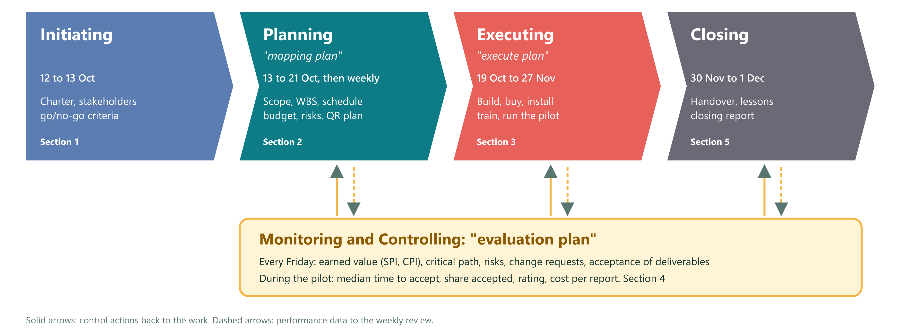
Figure 3.1 Planning framework: the five process groups and the course terms

3.5 Analysis Techniques
Table 3.2 Analysis techniques and where they are applied
Technique | Purpose | Applied in
Three-point estimate (PERT) | Expected duration and uncertainty of each activity | Section 4.8
Critical path method | Early and late dates, slack and the critical paths | Section 4.8
Normal approximation | Probability of finishing by a date; 95% date | Section 4.8
Crashing and fast tracking | Options and costs to shorten the schedule | Section 4.8
Resource loading and leveling (smallest late start first) | Remove over-allocation within capacity; what-if scenarios | Section 4.11
Seven steps of estimating and estimate types | Cash and labor estimates with accuracy ranges | Section 4.9
Reserve analysis and expected monetary value | Contingency and management reserve | Sections 4.9 and 4.13
Time-phased cost baseline and earned value | Planned value per week; performance indices | Sections 4.9 and 5.3
Probability × impact matrix | Risk scores and priorities | Section 4.13
Power–interest grid | Stakeholder engagement strategies | Section 4.2.2
RACI matrix | One accountable owner per work package | Section 4.11

3.6 Tools
To keep every number consistent, the schedule and cost model was written as a small Node.js program. It holds the activity list with three-point estimates, dependencies and effort per person, runs the critical path method and the resource leveling, computes the crashing and fast-tracking options and the time-phased cost baseline, and writes one data file. The plan text, the tables and all charts in this report are generated from that file, so a change in an estimate updates every table and figure at once.
The prototype was built with HTML and JavaScript, hosted on Vercel, connected to a Supabase database and kept in a GitHub repository. Claude Code, an AI coding assistant, was used to write the code under the direction of the team. This report was prepared in Microsoft Word.

3.7 Review of the Previous Plan Version
The first version of the plan (version 1.0, 12 October 2026) was written for the prototype stage: free services, no labor cost and QR stickers as a single printing task. It was reviewed against the course slides for Weeks 1 to 3 and 5 to 7, the class briefs and the needs of a live deployment. Table 3.3 lists the findings and where each fix is found in this report, and Table 3.4 shows where each topic of the course materials is applied. The slides on quality, risk, communications, procurement and stakeholders were not yet available, so those areas follow standard PMBOK practice.
Table 3.3 Review findings on version 1.0 and the fixes in this plan
ID | Finding in v1.0 | Reference | Fix in this plan | Section
A1 | Labor was valued at zero and the cash budget was close to Rp 0 | Week 5: most project cost is often labor; direct and indirect costs | Full cost: cash plus in-kind labor of the team of four and partners at stated rates | 4.9
A2 | Estimate type and accuracy not stated | Week 5: ROM −50% to +100%, budgetary −10% to +25%, definitive −5% to +10% | Every cost line has a type and a low, base and high value | 4.9
A3 | Estimating did not follow the 7 steps or use the full technique list | Week 5: 7 steps; expert judgment, analogous, parametric, bottom-up, three-point, reserve analysis, cost of quality, vendor bid analysis | Steps applied in order. Vendor quotes, parametric (price per message, per plate) and analogous (marketplace prices) added. Basis of estimate on each line | 4.9
A4 | No cost management plan content | Week 5: accuracy and units, procedure links, control thresholds, performance rules, report format, process description | Added as a table | 4.9
A5 | EAC and ETC written in a different form. No time forecast | Week 5: ETC = (BAC − EV) ÷ CPI, EAC = AC + ETC, TE formula | Slide formulas used, with a time forecast | 5.3
A6 | Reserve was a schedule number only. No contingency or expected monetary value | Week 5: reserve analysis. Week 3 mapping: quantitative risk analysis | Contingency 15% checked against expected monetary value (EMV) of cost risks. Management reserve from the schedule uncertainty | 4.9, 4.13
A7 | Schedule assumed unlimited people and treated effort as equal to duration | Week 6: resource-limited scheduling, loading, leveling. Week 7: effort is not duration | Effort and duration separated. Resource breakdown, loading histogram, leveling and capacity scenarios | 4.8, 4.11
A8 | Schedule confidence used 2σ and called it 95% | Statistics | One-sided 95% uses 1.645σ. Probability of the committed date is stated | 4.8
A9 | Charter lacked statement of work, agreements, environmental factors, process assets, go/no-go criteria and project category | Week 3: charter inputs and the three criteria for a project | Added | 4.2.1
A10 | Six constraints (scope, time, cost, quality, resources, risk) not applied | Week 1: triple constraint extended to six | Constraint priority table: what is fixed and what may flex | 4.2.1
A11 | Change control had no board and no rule for urgent changes | Week 3: change control board, 48-hour policy | Change control board and 48-hour rule | 4.16
A12 | Project management plan overview missing | Week 3: overview, organization, management and technical processes, work, schedule, budget | Added | 4.3
A13 | Closing had no retrospective or transition to operations | Week 3: closing outputs, retrospective questions | Added, with ownership transfer for domain, accounts and QR register | 5.7
A14 | Risk register had probability and impact scores only | Week 3 mapping: qualitative and quantitative analysis | EMV added for cost risks. Live-system risks added | 4.13
A15 | Prototype services assumed: free tiers, Vercel Hobby plan, Web3Forms email, an open database table | Reality of a live system | Production stack, plans and prices (Supabase Pro, Vercel Pro, own .com, WhatsApp Cloud API) | 4.9, 4.14
A16 | No domain, production database plan, backup and restore test, monitoring, privacy notice, security review or support plan | Reality of a live system | New work packages 4.1, 6.1, 7.1, 7.3, 7.4, 8.2 and new risks | 4.7, 4.13
A17 | QR stickers treated as one printing task | Reality and request: QR for each floor and each room, on the wall | QR deployment plan: plate types, quantities per floor, specification, placement, register, installation, scan test, maintenance | 4.17
A18 | QR codes would point to the prototype web address | Reality: a printed QR cannot be changed | Own .com bought and live before any plate is printed. Plate production waits for the domain and the production database | 4.8, 4.17
A19 | Risk shown in Initiating and Executing in the process map | Week 3 slide: risk maps to Planning and Controlling | Map aligned. PMBOK 6 adds "implement risk responses" in Executing, noted in Appendix A | A
A20 | WBS mixed phases with deliverables | Week 3 scope: WBS is deliverable-oriented | Kept two phase-type packages (3.0 and 8.0), with a note on how they would split | 4.7

Table 3.4 Coverage of the course materials in this report
Class material | Topic | Where it is in this report
Week 1 | Project concept, triple constraint extended to six, PMBOK framework | 4.2.1 (constraint priority), Appendix A
Week 2 | Five process groups, ten knowledge areas, ITTO scheme | Appendix A (map), Appendix B (ITTO of the main processes)
Week 3 (charter) | Integration: charter, project management plan, direct and manage, monitor and control, change control, close | 4.2.1, 4.3, 4.16, 5.1, 4, 5.7
Week 3 (scope) | Scope management, requirements, scope statement, WBS and 100% rule, validate and control scope | 4.4 to 4.7, 5.4
Week 5 | Cost: estimating techniques and 7 steps, estimate types, budget, cost control, EVM | 4.9, 5.3
Week 6 | Resources: resource types, loading, leveling, resource-limited scheduling | 4.11, 4.8
Week 7 | Schedule: network, CPM, PERT, crashing, fast tracking | 4.8
Not yet available | Quality, risk, communications, procurement, stakeholders | 4.10, 4.12, 4.13, 4.14, 4.15 (standard PMBOK practice)

CHAPTER IV
RESULTS AND DISCUSSION: PROTOTYPE AND PROJECT PLAN
This chapter presents the results of the study. Section 4.1 reports what the prototype already proves. Sections 4.2 to 4.17 present the initiating and planning outputs, which together form the baseline project management plan for the live deployment.

4.1 Prototype Results
The prototype is a single web page deployed on Vercel at gocleanit.vercel.app and connected to a shared table in Supabase, so that every phone sees the same reports within about three seconds. Its interface is in Bahasa Indonesia, with loading states for slow campus Wi-Fi and a test drawer that switches between the roles of reporter, cleaner, supervisor and admin for demonstrations.

4.1.1 Reporter Flow
A reporter scans a room plate and lands on the page of that room, with the room and building already filled in. The reporter taps “Laporkan masalah kebersihan”, picks one of six problem categories (toilet, floor, trash, window, furniture or other), optionally adds a note or a photo, and sends. A live status page then shows the steps sent, accepted, in progress and done, and the reporter can rate the job when it is done. A button on every room page opens WhatsApp to contact the cleaner on duty.
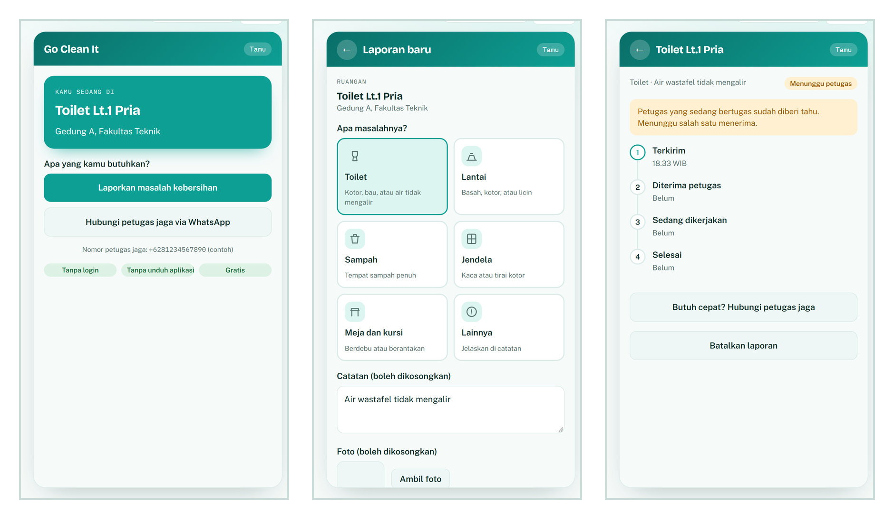
Figure 4.1 Reporter flow in the prototype: room page, report form and live status

4.1.2 Room and Floor QR Codes
A room plate opens the page of that room directly. A floor plate, placed at the lift and the stairs, asks “which room?” and lists the rooms on that floor, including a common area for corridors. Every QR code holds a random token instead of the room number, so codes cannot be guessed and a damaged plate can be replaced without losing history. The admin prints all plates from the QR tab.
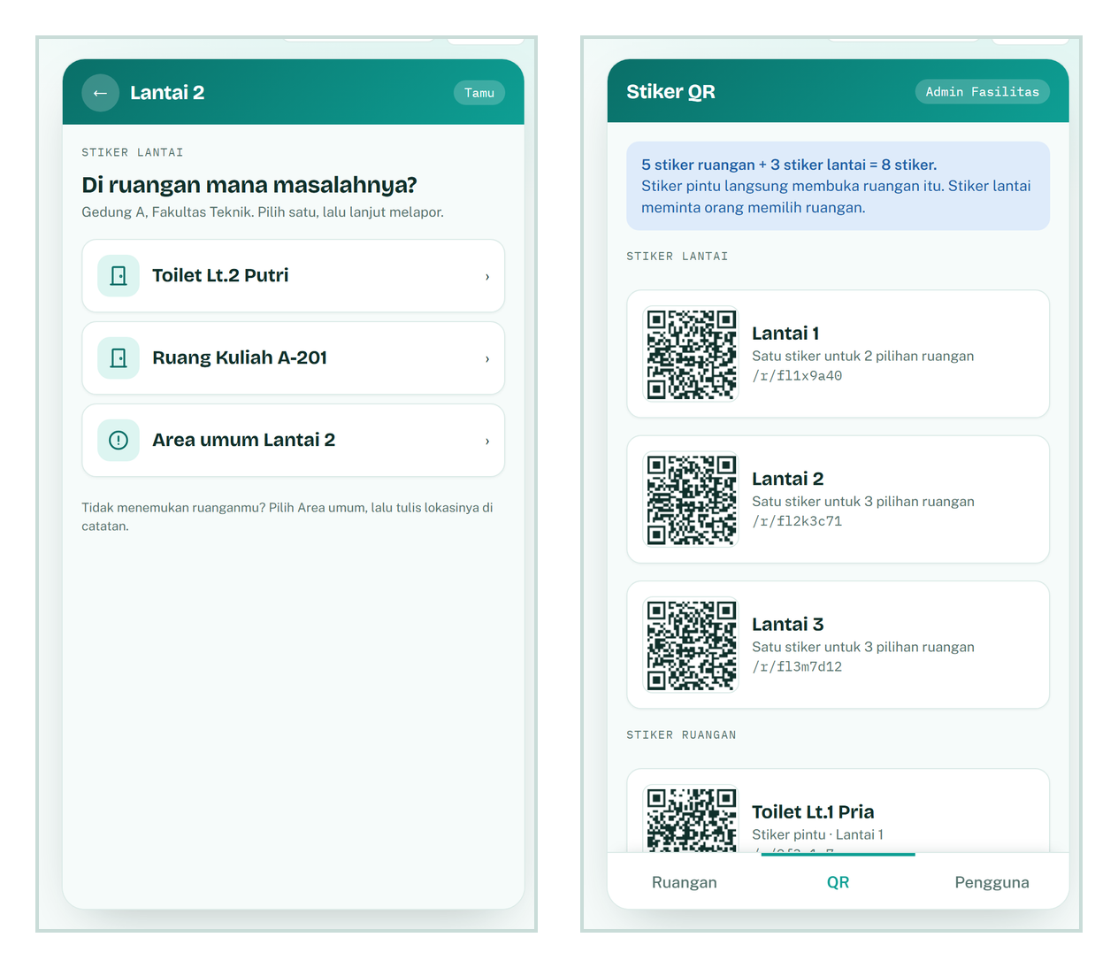
Figure 4.2 Floor plate page and the admin QR sheet

4.1.3 Cleaner, Supervisor and Admin
Only cleaners on shift see the queue of their building. When two cleaners press Accept at the same moment, only one receives the task, because the database update succeeds only while the report is still unassigned. A job can be finished only with an “after” photo. If nobody accepts within 10 minutes, the report escalates to the supervisor, who can reassign it. The supervisor summary shows the median time to accept and the share of reports accepted, and the admin can deactivate a user so that access closes at once while the history remains.
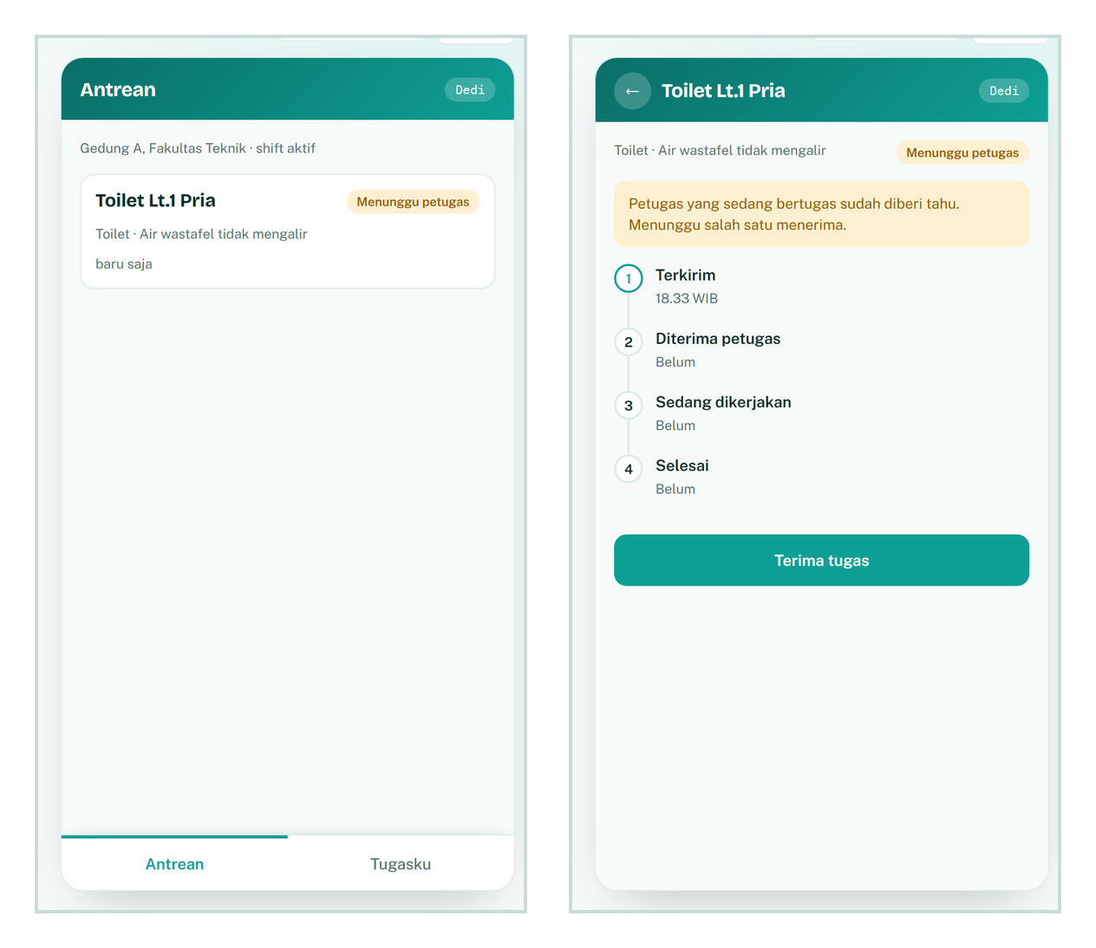
Figure 4.3 Cleaner queue and task page with a single accept button
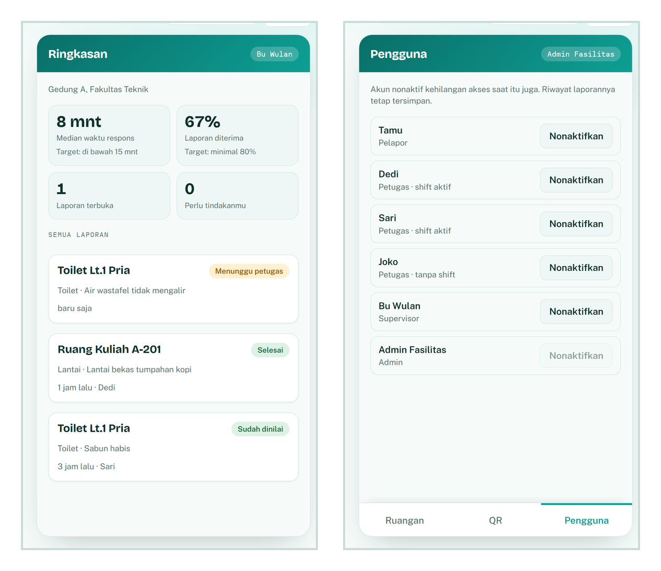
Figure 4.4 Supervisor summary and admin user list

4.1.4 Test Results and Gaps
Table 4.1 Prototype features and test status
Feature | Status | Evidence
Guest report from a room QR, without login | Works | Room page, form and status (Figure 4.1)
Floor QR with a room picker | Works | Floor page (Figure 4.2)
WhatsApp button to the cleaner on duty | Works with a sample number | Room page
Reports shared across phones | Works | Shared Supabase table, refreshed every 3 seconds
Only one cleaner can accept a report | Works | Test on the shared database: the second accept returns nothing
Finish requires an “after” photo | Works | Task page
Escalation after 10 minutes | Simulated | Test tool that moves time forward by 10 minutes
Supervisor dashboard (median time, share accepted) | Works with sample data | Figure 4.4
Admin: users and QR sheet | Works | Figures 4.2 and 4.4
Email alert to the coordinator | Blocked | Waiting for the Web3Forms access key
WhatsApp messages to cleaners | Not in the prototype | Planned in work packages 6.2 and 6.3

The prototype therefore proves the main flow and the atomic accept on a shared database, but three gaps remain before it can serve real users: the demo table is open, with no real logins or row-level security; WhatsApp sending is simulated; and there is no production environment, domain, backup or monitoring. The rest of this chapter plans how these gaps are closed. Testers were told not to enter real personal data, because the demo table is public.

4.2 Project Initiation
Initiating defines the project and obtains the authority to start it. Its outputs are the project charter and the stakeholder register.

4.2.1 Project Charter
Table 4.2 Project charter
Item | Content
Project name | Go Clean It: live deployment of the campus room cleaning report and dispatch system
Project manager | Muhammad Farid Hasyim, with authority over scope and schedule inside this charter
Project team | Muhammad Farid Hasyim (project manager), Rasyha Naufal (lead developer, front end), Abdillah Ridho (developer, back end and security), Rasyid (field, QR and testing lead). The two developers build with Claude Code
Sponsor | The lecturer (master user)
Customer | The facility unit of the pilot building
Project category | Problem and opportunity (Week 3 categories). Priority: high for the faculty pilot. Needed: by the end of the term
Business case | When a room is dirty nobody knows who to tell, cleaners do not know where to go, and nobody can see how fast problems are fixed. A QR plate on every room and floor lets anyone report with no login. The right on-shift cleaner is notified, accepts, finishes with a photo, and the reporter rates it
Statement of work (summary) | Deliver a secured web system on its own .com domain, notifications by WhatsApp, QR plates installed in one building (about 40 rooms, 4 floors), training for cleaners and supervisors, a 10-working-day pilot, and an evaluation report
MOV (measurable organizational value) | Median time from report to accept under 15 minutes and at least 80% of reports accepted, compared with the Week 0 baseline. Cost per report is tracked (planned about Rp 2,300 in the recommended scenario, Section 4.9)
Objectives (SMART) | 1) By 10 Nov 2026 the secured system is live on the project's own .com and passes all 22 security tests. 2) By 12 Nov every QR plate is installed and scan-tested. 3) A 10-working-day pilot runs from 16 Nov to 27 Nov. 4) By 2 Dec the evaluation report compares pilot and Week 0 numbers
Summary milestones | Charter approved 13 Oct · Friends test done 16 Oct · Decisions done 21 Oct · Domain live 23 Oct · Security core green 28 Oct · Production environment 30 Oct · WhatsApp verified 2 Nov · Deployed 10 Nov · Security review done 12 Nov · Plates installed 12 Nov · Dry run done 13 Nov · Pilot 16 Nov to 27 Nov · Evaluation report 1 Dec
Summary budget | Cash to the end of the pilot Rp 14.24 million (range Rp 9.51 million to Rp 23.89 million). In-kind labor Rp 26.53 million. Baseline (BAC) Rp 40.77 million. Contingency Rp 2.14 million and management reserve Rp 1.56 million bring the authorized budget to Rp 44.46 million. Running cost after the pilot: Rp 1.39 million to Rp 3.38 million per month, recommended Rp 2.10 million (Section 4.9)
Go/no-go criteria (Week 3: need, funding, commitment) | Need: reported problem and sponsor request. Funding: the faculty approves the year-1 running cost (Rp 25.22 million recommended scenario) before the pilot (decision D14). Commitment: the facility unit names a coordinator, installs the plates and answers the contact number
Agreements | Letter or message from the facility unit confirming staff time, building access and the contact number. Vendor terms of service (Vercel, Supabase, Meta, registrar). A data processing note with the university (decision D5)
Enterprise environmental factors | Personal data law (UU PDP). Campus Wi-Fi coverage. WhatsApp business policies and rate cards that change quarterly. Vendor terms (Vercel Hobby plan is for personal, non-commercial use). Exchange rate
Organizational process assets | Blueprint with 11 tables and 22 security tests. Clickable prototype and its lessons. Version 1.0 plan. University procurement and legal rules (to be obtained)
Assumptions | One building of about 40 rooms on 4 floors. Up to 50 reports a day. 9 cleaners and 2 supervisors. Cleaners own a phone with WhatsApp. A team of four works on the project, each member full time on weekdays (capacity 1.0, to be confirmed in decision D18). The two developers build with Claude Code
High-level risks | Cleaners do not use the app. WhatsApp verification is slow. Nobody answers the contact number. Domain or database lost. QR plates damaged or misplaced. The system has no owner after the pilot
Approval | Sponsor signature or written yes (date: ____). Facility unit (date: ____). Project manager (date: ____). Team members Rasyha Naufal, Abdillah Ridho and Rasyid (date: ____)

Project team (four people). Planned work-days include the weekly team meeting.
Table 4.3 Project team
Name | Role | Leads (WBS packages) | Accountable for | Planned work-days
Muhammad Farid Hasyim | Project manager and product owner | 1.1 Charter and plan, 1.2 Evaluation report, 1.3 Team coordination, 4.1 Domain, 6.1 Production accounts and backups, 6.2 WhatsApp verification, 7.1 Privacy notice, 8.2 Handover | Scope, schedule, budget, stakeholders, change control (chair), weekly status | 10.76
Rasyha Naufal | Lead developer (front end) | 3.1 and 3.3 Test fixes, 4.2 Scaffold, 5.1 Reporter flow, 5.3 Supervisor and admin, 7.3 Hardening and deploy | Screens, deployments, DNS records, review of back-end code | 13.66
Abdillah Ridho | Developer (back end and security) | 4.3 Schema, 4.4 Security core and tests, 5.2 Cleaner flow, 6.3 Notifications, 7.4 Security review | Database, security tests S1 to S22, notifications, review of front-end code, on call in the pilot | 15.29
Rasyid | Field, QR and testing lead | 3.2 Friends test, 3.5 Site survey, 3.6 Week 0 baseline, 7.2 QR plate production, 7.5 Installation and scan test, 7.6 Training and dry run, 8.1 Pilot field support | Plates and the plate register, user tests, training, pilot data, contact for cleaners and supervisors | 13.80

Roles are a proposal. Swapping people between roles changes only the names. Moving work between people can change the leveled schedule (what-if table in Section 4.11.4).
Constraint priority (Week 1: six constraints). Changing one constraint moves at least one other.
Table 4.4 Constraint priority (six constraints)
Constraint | Priority | Rule
Quality and security | Fixed | No go-live unless all 22 security tests pass and the security review is done
Scope | Flexible | Cut optional features first: browser push, second language, extra dashboard charts. The plate print file generator is not optional
Time | Flexible up to the reserve | The committed finish may slip inside the management reserve. Beyond it, the sponsor decides
Cost | Capped | The authorized budget is the cap. Contingency needs the project manager. Management reserve needs the sponsor
Resources | Fixed | Four team members (project manager, two developers, field lead) and facility staff as agreed. Over-allocation is resolved by leveling, not overtime
Risk | Accepted within appetite | Risks with score 12 or more need a named owner and a response

Milestones at a glance.
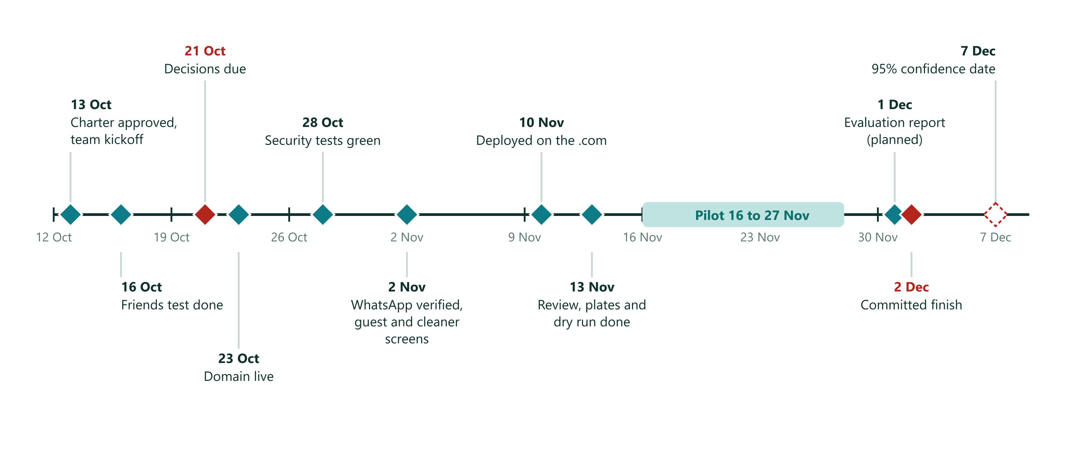
Figure 4.5 Milestones on the way to the pilot

4.2.2 Stakeholder Register
Table 4.5 Stakeholder register
Stakeholder | Interest in project | Power | Interest | Engagement strategy
Muhammad Farid Hasyim (project manager) | Delivery and learning | High | High | Manage closely
Project team: Rasyha Naufal, Abdillah Ridho, Rasyid | Clear tasks, fair workload, learning, grade | High | High | Manage closely. Weekly team meeting, one owner per package (Section 4.11.5)
Lecturer (sponsor) | Idea proven and defensible | High | High | Manage closely. Demo in week 2, evaluation report on 2 Dec
Facility unit | Faster, visible cleaning | High | High | Manage closely. Owns decisions D1, D4, D6, D9, D10 and the plate installation
Faculty (budget holder) | Year-1 running cost | High | Medium | Keep satisfied. One-page cost summary before the pilot
University finance and procurement | Payment method for dollar services, vendor rules | Medium | Low | Monitor. Inform early about the payment request (D15)
University IT and legal | Data protection, retention, security review | High | Low | Keep satisfied. Send data classification and privacy notice draft
Supervisors | Escalations and dashboard | Medium | High | Keep informed. Involve in the dry run
Cleaners | Easy tasks, no blame | Low | High | Keep informed. Test with 2 to 3 real cleaners before launch
Reporters (students, lecturers, staff) | Report in seconds | Low | Medium | Keep informed through the plate text and the status page
Friends (early testers) | Help a friend | Low | Medium | Monitor. One test round, one thank-you
Suppliers: registrar, Vercel, Supabase, Meta WhatsApp, plate printer | Paid services | Medium | Low | Monitor limits and price changes (Section 4.14)

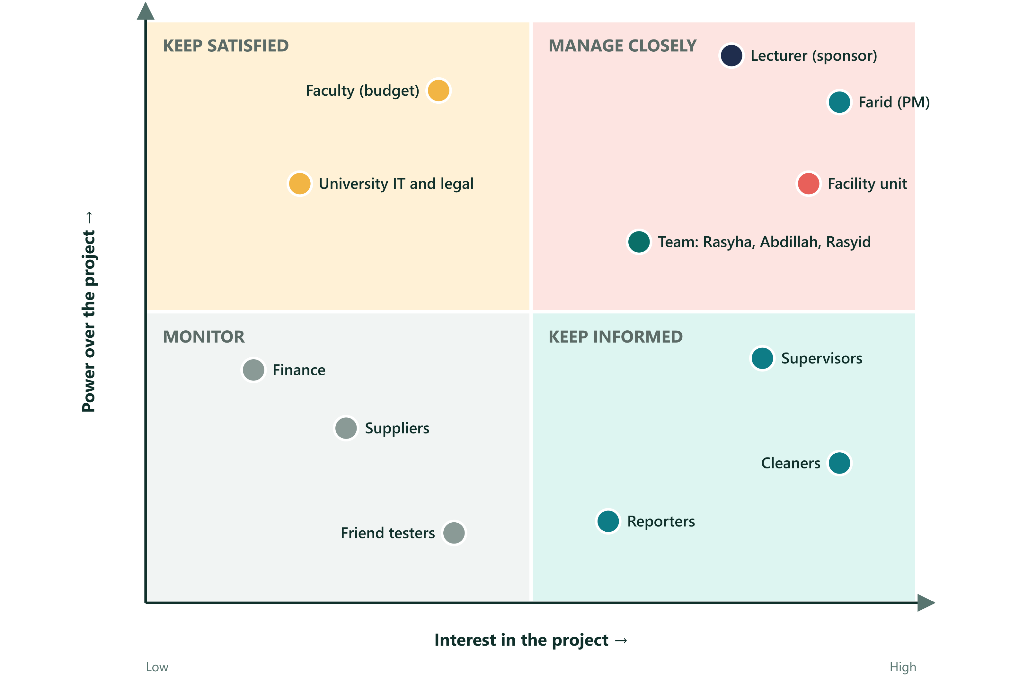
Figure 4.6 Stakeholder map: power and interest

4.3 Project Management Plan Overview
Table 4.6 Project management plan overview
Element (Week 3) | Content
Introduction | Live deployment of Go Clean It in one building, with a 10-working-day pilot and a handover to operations
How the project is organized | Sponsor (lecturer) approves scope and budget. Project manager (Muhammad Farid Hasyim) runs the plan and accepts work. Rasyha Naufal and Abdillah Ridho build and test the system with Claude Code. Rasyid leads the site survey, QR plates, user tests and training. The facility unit supplies staff, data and installs the plates. University IT and legal review security and privacy. Change control board in Section 4.16
Management processes | This plan: scope, schedule, cost, quality, resource, communication, risk, procurement, stakeholder and change management, with a weekly review every Friday
Technical processes | Phased build. Security before screens. Migrations are append-only. One commit per phase. Bilingual summary at the end of each phase. Separate development and production environments
Work to be done | WBS in Section 4.7 (76.36 work-days of effort)
Schedule | Baseline in Section 4.8. Planned finish Tue 1 Dec 2026. Committed finish Wed 2 Dec 2026
Budget | Cost baseline in Section 4.9
Subsidiary plans | 4.4 scope, 4.8 schedule, 4.9 cost, 4.10 quality, 4.11 resource, 4.12 communication, 4.13 risk, 4.14 procurement, 4.15 stakeholder, 4.16 change, 4.17 QR deployment

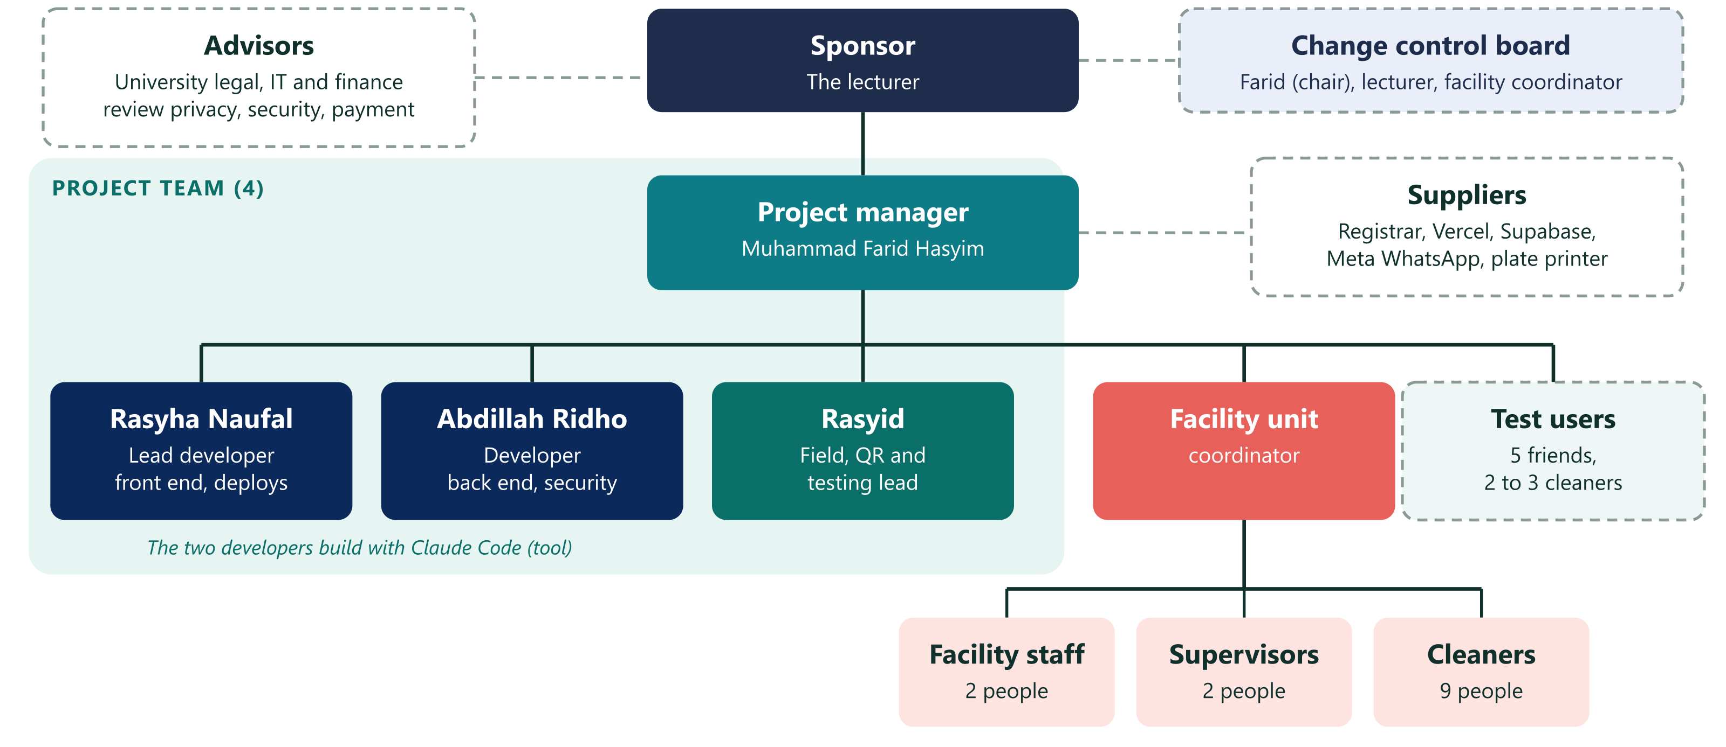
Figure 4.7 How the project is organized

4.4 Scope Management Plan
Table 4.7 Scope management plan
Question | Answer
How is scope defined? | Scope statement (Section 4.6) plus WBS (Section 4.7) plus WBS dictionary. Together they form the scope baseline
How is the WBS created and kept? | Deliverable-oriented. Built by the people who do the work. Checked against the 100% rule at every change
How are requirements collected and traced? | Interviews with the lecturer and facility unit, the blueprint, the prototype test. Each requirement is traced to a work package and an acceptance criterion (Section 4.5)
How is scope formally accepted? | Each deliverable has acceptance criteria and a named accepter (Section 5.4). Control Quality comes first, then Validate Scope
How are changes handled? | Change request, board review and the 48-hour rule (Section 4.16). Verbal requests are logged, not built
How is creep measured? | Scope variance % = (current requirements − baseline requirements) ÷ baseline requirements × 100%

4.5 Requirements Traceability Matrix
Table 4.8 Requirements traceability matrix (RTM)
ID | Requirement | Source | WBS package | Acceptance criterion | Status
REQ-01 | A guest reports with no login and no app | Lecturer | 5.1 | Filed in 3 taps or fewer from a QR scan, by 5 testers | Prototype done
REQ-02 | Room QR and floor QR both work | Farid | 5.1, 5.3, 7.2 | Floor QR cannot reach another floor (S19). Retired QR rejected (S22) | Prototype done
REQ-03 | A cleaner sees only reports in buildings where they are on shift | Blueprint | 4.4, 5.2 | S6 and S7 pass | Todo
REQ-04 | Only one cleaner can accept a report | Blueprint | 4.4, 5.2 | S8 passes: two simultaneous accepts, one winner | Prototype done (open table)
REQ-05 | Proof photo is required to finish | Facility unit | 5.2 | Finish is refused without an "after" photo | Prototype done
REQ-06 | Reporter can rate and cancel own report | Blueprint | 5.1 | S15 passes | Prototype done
REQ-07 | Cleaners get a WhatsApp message with a one-time link | Lecturer | 6.2, 6.3 | Real message received and link opens the task (S17) | Todo
REQ-08 | Report escalates to the supervisor after 10 minutes | Blueprint | 6.3 | Test with a 5-second interval, supervisor notified | Prototype done (simulated)
REQ-09 | Supervisor sees median response time and percent accepted | Facility unit | 5.3 | Dashboard equals a hand calculation | Prototype done (sample data)
REQ-10 | Admin generates QR plates and deactivates users | Facility unit | 5.3 | Deactivated user loses access at once (S11). Plate PDF opens with the right room | Prototype done (no PDF)
REQ-11 | Database enforces security: RLS, no direct writes, append-only audit | Blueprint | 4.4 | S1 to S5 pass | Todo
REQ-12 | Reporter's phone number never reaches a cleaner | Blueprint | 4.4, 5.2 | S16 and S21 pass | Todo
REQ-13 | Bahasa Indonesia, mobile first, clear loading states | Farid | 5.1, 5.2, 5.3 | Friends test: no tester needs help for the main flow | Prototype done
REQ-14 | Week 0 baseline is measured and compared | Lecturer | 3.6, 8.1 | Baseline file holds real numbers | Todo
REQ-15 | Reporter can reach a person on WhatsApp from the QR page | Lecturer | 5.1 | Button opens WhatsApp with the room name typed | Prototype done
REQ-16 | The system runs on the project's own .com with HTTPS, and every QR points to it | Farid | 4.1, 7.2 | Domain resolves with a valid certificate. 100% of plates open the production site | Todo
REQ-17 | Daily database backups and a tested restore | Farid | 6.1 | A restore drill recovers a test copy within 1 hour | Todo
REQ-18 | Uptime and error alerts reach a named person | Farid | 7.3 | A test outage sends an alert within 10 minutes | Todo
REQ-19 | Privacy notice in Bahasa Indonesia and a retention job (photos 90 days, reports 1 year) | University | 7.1 | Notice reviewed by university legal. Retention job deletes a test photo after 90 days | Todo
REQ-20 | Every room and floor has a durable wall plate, registered and scan-tested | Lecturer | 3.5, 7.2, 7.5 | 100% of plates registered with photo. Scan test passes on 3 phone models | Todo
REQ-21 | A named person supports the system after the pilot, with a runbook | Facility unit | 8.2 | Runbook reviewed in a dry run. Support rota signed | Todo

Check in both directions: every requirement has a work package, and every package serves a requirement. Packages 1.0 and 8.1 serve the charter objectives.

4.6 Scope Statement
Scope in context: from the first state to the next state. Scope answers WHAT is needed, HOW it is done through processes and organization, and WHAT the business gets in the end.
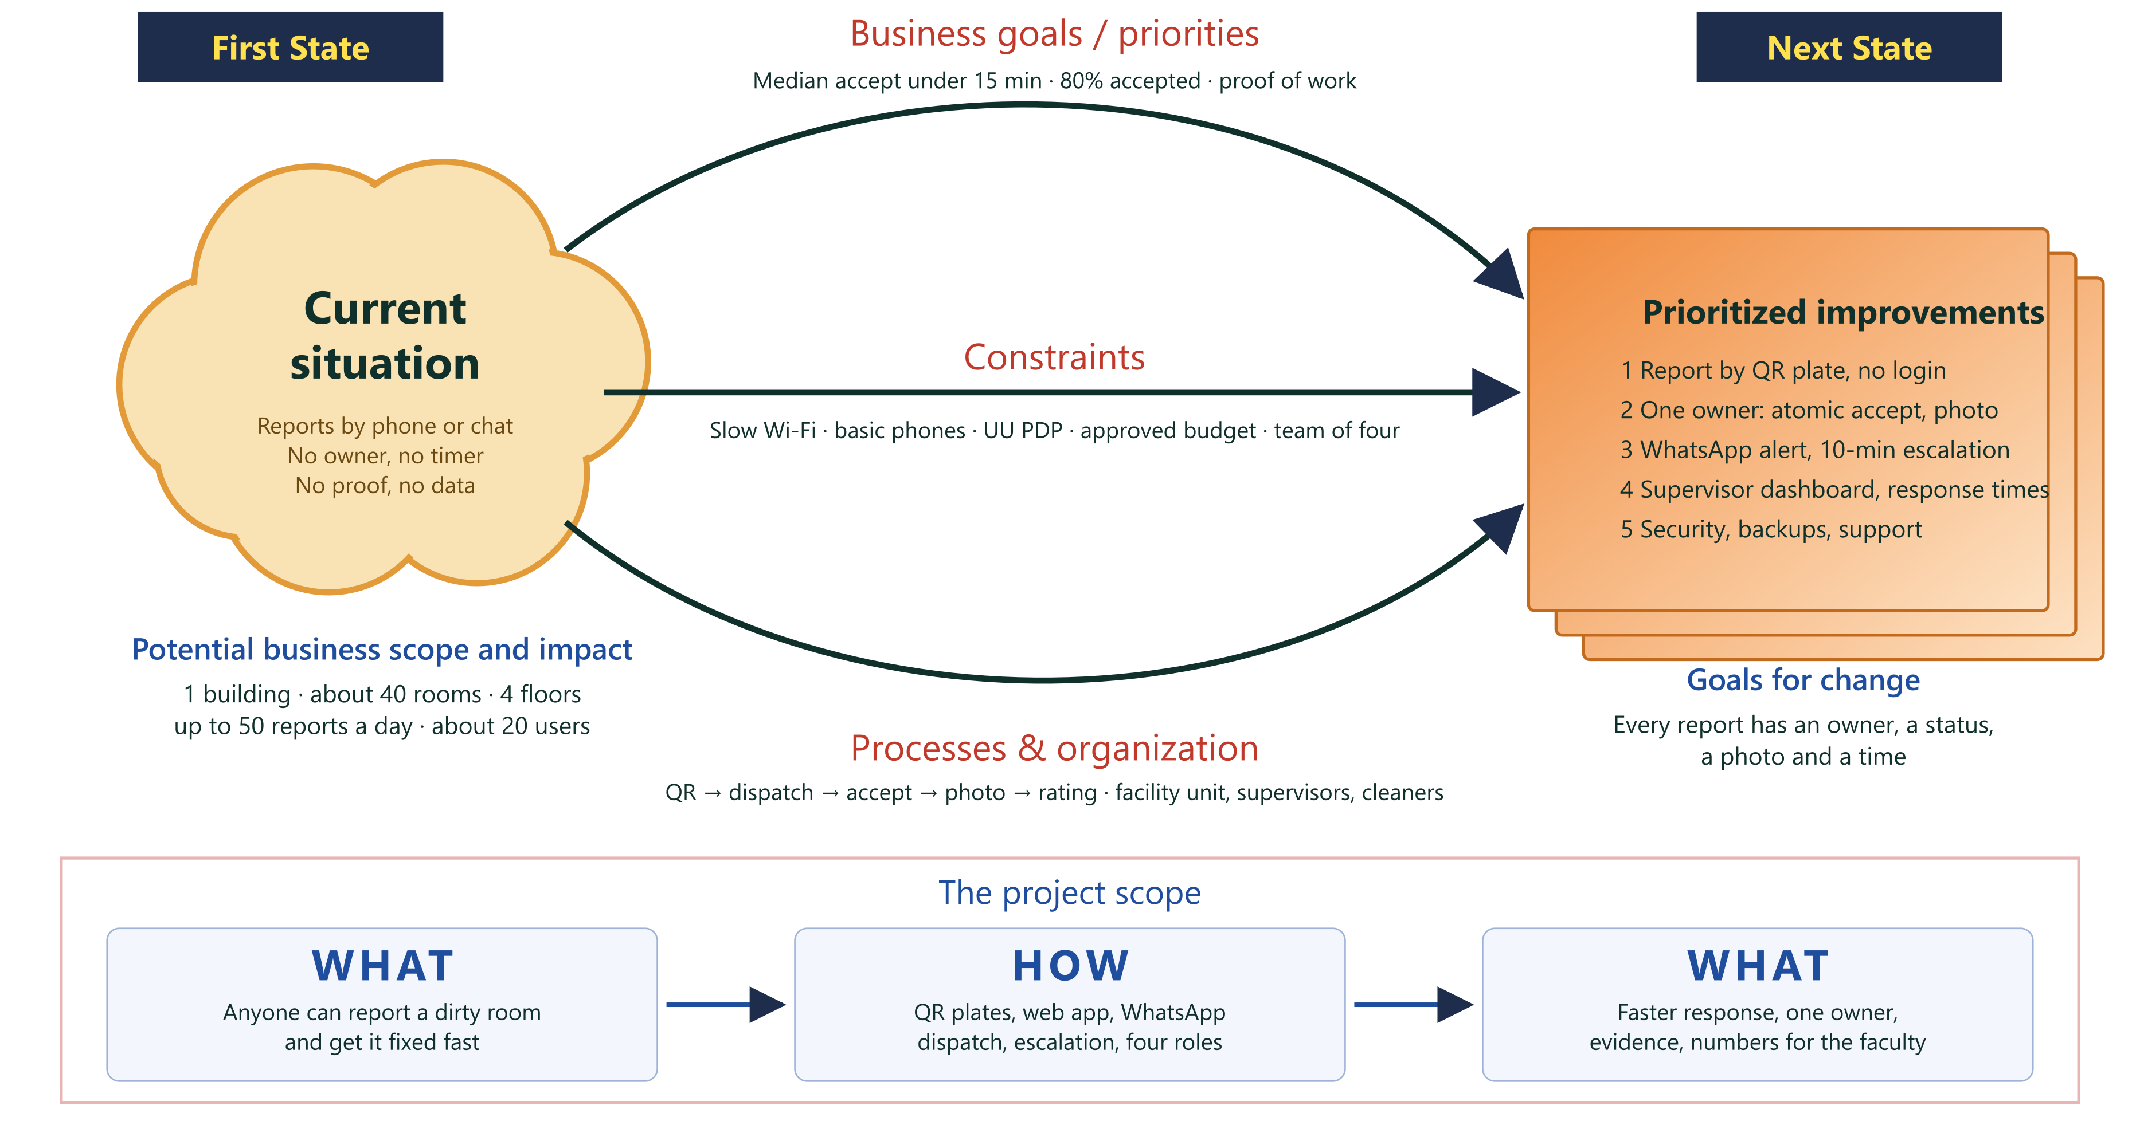
Figure 4.8 Scope in context: first state to next state
Table 4.9 Scope statement: from the first state to the next state
Element | Go Clean It
First state (current situation) | Cleaning problems are reported by phone, chat or word of mouth. Nobody owns a request, cleaners guess the room, nobody measures response time, and there is no record or proof of work
Business goals and priorities (input) | Median report-to-accept time under 15 minutes. At least 80% accepted. Visible response times for the faculty. Proof of work
Constraints (input) | Slow campus Wi-Fi and basic Android phones. UI in Bahasa Indonesia. Personal data law (UU PDP). Approved budget. Team of four. Security before screens
Processes and organization (input) | Facility unit, supervisors, on-shift cleaners and reporters. QR scan, dispatch to on-shift cleaners, accept, work, photo proof, rating, escalation after 10 minutes
Next state (goals for change) | Every report reaches an on-shift cleaner within minutes, has one owner and a status, is backed by a photo, and is measured. Every room and floor has a working QR plate
Prioritized improvements | 1) Report by QR with no login (REQ-01, 02, 15, 20). 2) One owner per report: atomic accept and proof photo (REQ-04, 05). 3) Notification and escalation (REQ-07, 08). 4) Visibility: supervisor dashboard (REQ-09). 5) Control and keep it running: security, backups, support (REQ-11, 17, 18, 21)
Potential business scope and impact | One building, about 40 rooms, up to 50 reports a day, about 20 users. Impact is measured against the Week 0 baseline and by cost per report

Table 4.10 Project scope: WHAT, HOW and WHAT
WHAT (what is needed) | HOW (processes and organization) | WHAT (what the business gets)
Anyone can report a dirty room, and it gets fixed fast | QR scan → dispatch to on-shift cleaners → accept → work → photo proof → rating. Escalation to the supervisor after 10 minutes. Roles: reporter, cleaner, supervisor, admin | Faster response, one owner per request, evidence of work, and numbers for the faculty

Product scope: a secured web system (guest report page, cleaner queue, supervisor dashboard, admin) on its own .com domain, with WhatsApp notification and daily backups, running in one pilot building with QR plates on every room and floor.
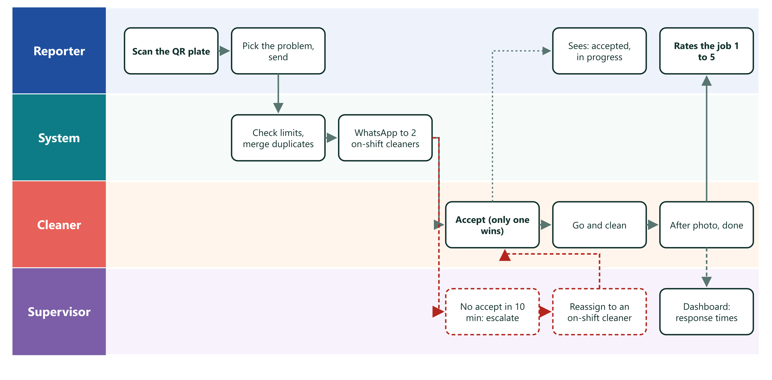
Figure 4.9 How a report travels
Deliverables: secured database with tests · reporter, cleaner, supervisor and admin screens · notification and escalation service · production environment with backups and monitoring · domain and DNS · QR plates (room, toilet, floor, lobby), register and scan-test record · privacy notice and retention job · security review report · training notes and guide cards · runbook and support plan · pilot data · evaluation report · project documents (this plan, weekly logs, change log, closing report).
Acceptance criteria: see Section 4.5 and the accepter column in Section 5.4.
Boundaries (exclusions): no payment by users · no GPS or indoor positioning · no in-app chat · no native Android or iOS app · no AI features · only one building in the pilot · no servers run by the project (managed services only) · no SMS · no integration with the university's other systems · WhatsApp sending needs a verified Meta business account. If verification is late, the pilot runs with email and the in-app queue.

4.7 Work Breakdown Structure
Levels follow the class scheme: 0 Project, 1 Category, 2 Sub-category, 3 Work package. Effort is in work-days (it can be larger than the duration of an activity when several people work in parallel). Package 2.0 (clickable prototype) is finished before the baseline date and is a sunk cost. It is not counted in the budget. Package 1.3 (weekly team meeting) is level-of-effort work: it has effort and cost but is not an activity in the network.
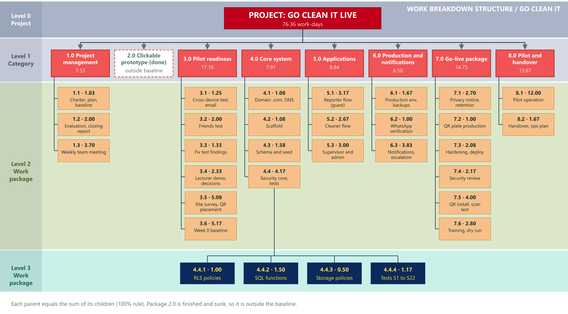
Figure 4.10 WBS in the class style: level bands 0 to 3
Text version of the same WBS:
0 Go Clean It live deployment 76.36
├─ 1.0 Project management 7.53
│ ├─ 1.1 Charter, plan, baseline approved 1.83
│ ├─ 1.2 Evaluation and closing report 2.00
│ └─ 1.3 Team coordination (weekly meeting) 3.70
├─ 2.0 Clickable prototype (complete, outside baseline) 0.00
├─ 3.0 Pilot readiness 17.16
│ ├─ 3.1 Cross-device test and email fix 1.25
│ ├─ 3.2 Friends test, 5 testers 2.00
│ ├─ 3.3 Fix test findings 1.33
│ ├─ 3.4 Lecturer demo and decisions 2.33
│ ├─ 3.5 Site survey, room and floor list, QR placement plan 5.08
│ └─ 3.6 Week 0 baseline measurement 5.17
├─ 4.0 Core system 7.91
│ ├─ 4.1 Domain .com, DNS and email records 1.08
│ ├─ 4.2 Scaffold 1.08
│ ├─ 4.3 Schema and seed 1.58
│ └─ 4.4 Security core and tests 4.17
│ ├─ 4.4.1 RLS policies and helper functions 1.00
│ ├─ 4.4.2 SQL functions and triggers 1.50
│ ├─ 4.4.3 Storage policies 0.50
│ └─ 4.4.4 Security tests S1 to S22 1.17
├─ 5.0 Applications 8.84
│ ├─ 5.1 Reporter flow (guest) 3.17
│ ├─ 5.2 Cleaner flow 2.67
│ └─ 5.3 Supervisor, admin, QR sheet and plate check 3.00
├─ 6.0 Production and notifications 6.50
│ ├─ 6.1 Production environment and backups 1.67
│ ├─ 6.2 WhatsApp verification and templates 1.00
│ └─ 6.3 Notifications and escalation 3.83
├─ 7.0 Go-live package 14.75
│ ├─ 7.1 Privacy notice, retention and legal review 2.70
│ ├─ 7.2 QR plate production 1.00
│ ├─ 7.3 Hardening, monitoring and deploy to production 2.08
│ ├─ 7.4 Security review 2.17
│ ├─ 7.5 QR plate installation and scan test 4.00
│ └─ 7.6 Training and dry run 2.80
└─ 8.0 Pilot and handover 13.67
├─ 8.1 Pilot operation, 10 working days 12.00
└─ 8.2 Handover and operations plan 1.67
100% rule check (parent = sum of children):
Table 4.11 100% rule check of the WBS
Parent | Children | Sum | Parent value | Result
1.0 | 1.83 + 2.00 + 3.70 | 7.53 | 7.53 | OK
3.0 | 1.25 + 2.00 + 1.33 + 2.33 + 5.08 + 5.17 | 17.16 | 17.16 | OK
4.0 | 1.08 + 1.08 + 1.58 + 4.17 | 7.91 | 7.91 | OK
4.4 | 1.00 + 1.50 + 0.50 + 1.17 | 4.17 | 4.17 | OK
5.0 | 3.17 + 2.67 + 3.00 | 8.84 | 8.84 | OK
6.0 | 1.67 + 1.00 + 3.83 | 6.50 | 6.50 | OK
7.0 | 2.70 + 1.00 + 2.08 + 2.17 + 4.00 + 2.80 | 14.75 | 14.75 | OK
8.0 | 12.00 + 1.67 | 13.67 | 13.67 | OK
Project | sum of all categories | 76.36 | 76.36 | OK

Note on deliverable orientation. The class slides ask for a WBS built around deliverables, not around activities or departments. Most level 1 categories are deliverables (core system, applications, production and notifications, go-live package). Two are phases (3.0 Pilot readiness and 8.0 Pilot and handover). They are kept because the facility unit and the lecturer manage them as separate stages. If a pure deliverable view is required, 3.0 splits into test report, decision list, site survey and baseline dataset, and 8.0 into pilot dataset, runbook and evaluation report.
WBS dictionary (examples):
Table 4.12 WBS dictionary (examples)
Field | 4.1 Domain .com, DNS | 6.1 Production environment | 7.2 QR plate production
Responsible | Farid buys the domain (account owner decision D13). Rasyha sets the DNS records | Farid sets up accounts, billing and backups. Rasyid runs the restore drill. Accepted by Abdillah | Rasyid, accepted by facility unit
Description | Buy the .com, set DNS to Vercel, email records (SPF, DKIM, DMARC), HTTPS, registrar 2-factor login, auto-renew | Supabase Pro project for production, separate from development. Secrets, migrations, daily backups, weekly export, restore drill | Design plates, generate tokens in the production database, get 3 quotes, print samples, order, inspect delivery
Deliverable | Live domain with valid certificate. Registrar account with two admins | Production database and web app. Restore drill report | Plates delivered and counted. Print files archived
Acceptance | REQ-16 met. Domain renews automatically for at least 1 year | REQ-17 met. Service role key only on the server | Sample plates pass the scan test on 3 phone models. 100% of plates counted and checked against the register
Depends on | 3.4 (domain name decision) | 4.4 and 4.1 | 6.1, 4.1, 3.5
Effort | 1.08 | 1.67 | 1.00
Risk | Name taken, payment method, registrar account owner | Wrong key exposed, backup not tested | Misprint, wrong token, long delivery

4.8 Schedule Management
Estimating durations (Week 7). Duration is calendar working time and is not the same as effort. Example: the site survey takes about 3 days but uses 2 facility staff, so it costs about 5 work-days of effort. Three-point estimate: te = (o + 4m + p) ÷ 6 and σ = (p − o) ÷ 6. Dependency type: M mandatory, D discretionary, E external.
Table 4.13 Activity list with three-point estimates, dependencies and effort
ID | Activity | WBS | Predecessors (type) | o | m | p | te | σ | Effort | Effort by role
A | Charter, plan and baseline approved (with team kickoff) | 1.1 | none | 0.5 | 1 | 2 | 1.08 | 0.25 | 1.83 | FH 1.08, RN 0.25, AR 0.25, RS 0.25
B | Cross-device test and email fix | 3.1 | A (M) | 0.5 | 1 | 3 | 1.25 | 0.42 | 1.25 | RS 0.60, RN 0.65
C | Friends test (5 testers) | 3.2 | B (M) | 1 | 2 | 3 | 2.00 | 0.33 | 2.00 | RS 1.00, FH 0.50, TST 0.50
D | Fix test findings | 3.3 | C (M) | 1 | 1 | 3 | 1.33 | 0.33 | 1.33 | RN 0.60, AR 0.40, RS 0.33
E | Lecturer demo and decisions (provider, domain, building, funding) | 3.4 | D (D), people available (E) | 1 | 2 | 5 | 2.33 | 0.67 | 2.33 | FH 0.75, RN 0.25, LEC 0.50, FAC 0.83
F | Site survey: room and floor list, QR placement plan | 3.5 | A (M), facility staff (E) | 1.5 | 3 | 5 | 3.08 | 0.58 | 5.08 | FAC 4.00, RS 1.08
G | Week 0 baseline measurement. Observation by the facility unit | 3.6 | A (M), facility staff (E) | 5 | 5 | 6 | 5.17 | 0.17 | 5.17 | FAC 4.00, RS 1.17
H | Domain .com bought, DNS and email records set | 4.1 | E (M) | 0.5 | 1 | 2 | 1.08 | 0.25 | 1.08 | FH 0.50, RN 0.58
I | Scaffold | 4.2 | D (D) | 0.5 | 1 | 2 | 1.08 | 0.25 | 1.08 | RN 0.80, AR 0.28
J | Schema and seed | 4.3 | I (M) | 1 | 1.5 | 2.5 | 1.58 | 0.25 | 1.58 | AR 1.20, RN 0.38
K | Security core and tests | 4.4 | J (M) | 3 | 4 | 6 | 4.17 | 0.50 | 4.17 | AR 3.20, RN 0.97
L | Reporter flow (guest) | 5.1 | K (M) | 2 | 3 | 5 | 3.17 | 0.50 | 3.17 | RN 2.40, RS 0.77
M | Cleaner flow | 5.2 | K (M) | 2 | 2.5 | 4 | 2.67 | 0.33 | 2.67 | AR 2.00, RS 0.67
N | Supervisor and admin (with QR sheet generator) | 5.3 | L, M (M) | 2 | 3 | 4 | 3.00 | 0.33 | 3.00 | RN 2.30, FH 0.70
O | Production environment and backups | 6.1 | K, H (M) | 1 | 1.5 | 3 | 1.67 | 0.33 | 1.67 | FH 1.20, RS 0.47
P | WhatsApp account verification and templates (external wait) | 6.2 | E (M), Meta review (E) | 3 | 7 | 15 | 7.67 | 2.00 | 1.00 | FH 0.50, LEG 0.50
Q | Notifications and escalation | 6.3 | L, M (M), P (E) | 3 | 3.5 | 6 | 3.83 | 0.50 | 3.83 | AR 2.90, RS 0.93
R | Privacy notice, retention and legal review | 7.1 | E (M), university legal (E) | 2 | 3 | 6 | 3.33 | 0.67 | 2.70 | FH 1.20, LEG 1.00, AR 0.50
S | QR plate production (design, quotes, print, delivery) | 7.2 | O, F, H (M), printer (E) | 4 | 6 | 10 | 6.33 | 1.00 | 1.00 | RS 0.80, FAC 0.20
T | Hardening and deploy to production | 7.3 | Q, N, O (M) | 1.5 | 2 | 3 | 2.08 | 0.25 | 2.08 | RN 1.50, AR 0.58
U | Security review before go-live | 7.4 | T (M) | 1 | 2 | 4 | 2.17 | 0.50 | 2.17 | AR 0.90, RN 0.40, FH 0.30, LEG 0.57
V | QR plate installation and scan test | 7.5 | S, T (M) | 1 | 1.5 | 3 | 1.67 | 0.33 | 4.00 | FAC 3.00, RS 1.00
W | Training and dry run | 7.6 | U, V, R, G (M) | 1 | 1 | 2 | 1.17 | 0.17 | 2.80 | RS 0.50, FAC 0.50, CLN 1.50, SUP 0.30
X | Handover and operations plan | 8.2 | W (M) | 1 | 1.5 | 3 | 1.67 | 0.33 | 1.67 | FH 0.60, RS 0.40, AR 0.50, FAC 0.17
Y | Pilot operation (10 working days) | 8.1 | W (M) | 10 | 10 | 10 | 10.00 | 0.00 | 12.00 | FH 1.50, RS 2.50, RN 1.50, AR 1.50, FAC 3.00, SUP 2.00
Z | Evaluation and closing report | 1.2 | Y, X (M) | 1 | 2 | 3 | 2.00 | 0.33 | 2.00 | FH 1.00, RS 0.40, RN 0.15, AR 0.15, LEC 0.30

Role codes: FH Muhammad Farid Hasyim, RN Rasyha Naufal, AR Abdillah Ridho, RS Rasyid, FAC facility unit staff, CLN cleaners, SUP supervisors, TST testers, LEC lecturer, LEG university legal or IT.
Network diagram (activity on node).
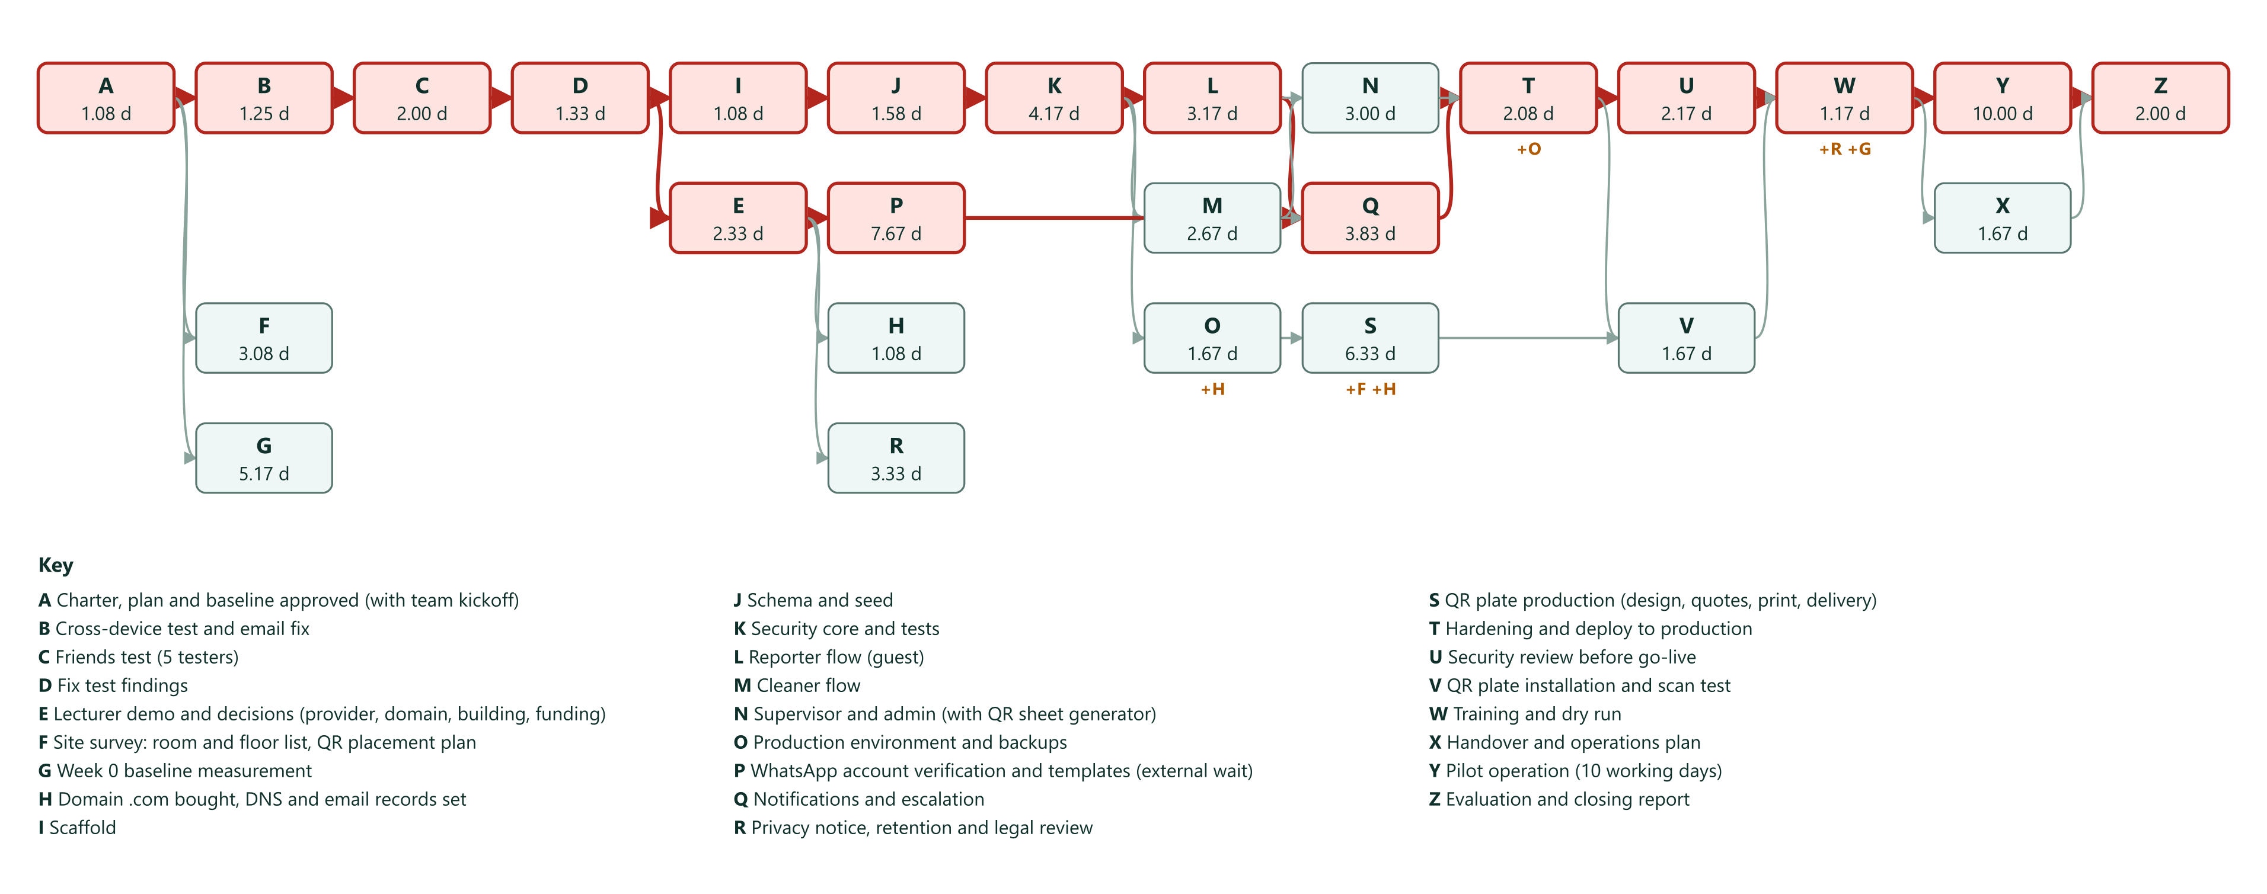
Figure 4.11 Network diagram
Critical path method. Forward pass: ES = largest EF of predecessors, EF = ES + te. Backward pass: LF = smallest LS of successors, LS = LF − te. Slack = LS − ES. The last two columns show the baseline after resource leveling (Section 4.11).
Table 4.14 Critical path method: forward and backward pass with leveled dates
ID | te | ES | EF | LS | LF | Slack | Critical | Early start to end | Leveled start to end
A | 1.08 | 0.00 | 1.08 | 0.00 | 1.08 | 0.00 | Yes | 12 Oct to 13 Oct | 12 Oct to 13 Oct
B | 1.25 | 1.08 | 2.33 | 1.08 | 2.33 | 0.00 | Yes | 13 Oct to 14 Oct | 13 Oct to 14 Oct
C | 2.00 | 2.33 | 4.33 | 2.33 | 4.33 | 0.00 | Yes | 14 Oct to 16 Oct | 14 Oct to 16 Oct
D | 1.33 | 4.33 | 5.66 | 4.33 | 5.66 | 0.00 | Yes | 16 Oct to 19 Oct | 16 Oct to 19 Oct
E | 2.33 | 5.66 | 7.99 | 5.66 | 7.99 | 0.00 | Yes | 19 Oct to 21 Oct | 19 Oct to 21 Oct
F | 3.08 | 1.08 | 4.16 | 12.66 | 15.74 | 11.58 | No | 13 Oct to 16 Oct | 13 Oct to 16 Oct
G | 5.17 | 1.08 | 6.25 | 18.57 | 23.74 | 17.49 | No | 13 Oct to 20 Oct | 16 Oct to 23 Oct
H | 1.08 | 7.99 | 9.07 | 12.99 | 14.07 | 5.00 | No | 21 Oct to 23 Oct | 21 Oct to 23 Oct
I | 1.08 | 5.66 | 6.74 | 5.66 | 6.74 | 0.00 | Yes | 19 Oct to 20 Oct | 19 Oct to 20 Oct
J | 1.58 | 6.74 | 8.32 | 6.74 | 8.32 | 0.00 | Yes | 20 Oct to 22 Oct | 20 Oct to 22 Oct
K | 4.17 | 8.32 | 12.49 | 8.32 | 12.49 | 0.00 | Yes | 22 Oct to 28 Oct | 22 Oct to 28 Oct
L | 3.17 | 12.49 | 15.66 | 12.49 | 15.66 | 0.00 | Yes | 28 Oct to 2 Nov | 28 Oct to 2 Nov
M | 2.67 | 12.49 | 15.16 | 12.99 | 15.66 | 0.50 | No | 28 Oct to 2 Nov | 28 Oct to 2 Nov
N | 3.00 | 15.66 | 18.66 | 16.49 | 19.49 | 0.83 | No | 2 Nov to 5 Nov | 2 Nov to 5 Nov
O | 1.67 | 12.49 | 14.16 | 14.07 | 15.74 | 1.58 | No | 28 Oct to 30 Oct | 28 Oct to 30 Oct
P | 7.67 | 7.99 | 15.66 | 7.99 | 15.66 | 0.00 | Yes | 21 Oct to 2 Nov | 21 Oct to 2 Nov
Q | 3.83 | 15.66 | 19.49 | 15.66 | 19.49 | 0.00 | Yes | 2 Nov to 6 Nov | 2 Nov to 6 Nov
R | 3.33 | 7.99 | 11.32 | 20.41 | 23.74 | 12.42 | No | 21 Oct to 27 Oct | 21 Oct to 27 Oct
S | 6.33 | 14.16 | 20.49 | 15.74 | 22.07 | 1.58 | No | 30 Oct to 9 Nov | 30 Oct to 9 Nov
T | 2.08 | 19.49 | 21.57 | 19.49 | 21.57 | 0.00 | Yes | 6 Nov to 10 Nov | 6 Nov to 10 Nov
U | 2.17 | 21.57 | 23.74 | 21.57 | 23.74 | 0.00 | Yes | 10 Nov to 12 Nov | 10 Nov to 12 Nov
V | 1.67 | 21.57 | 23.24 | 22.07 | 23.74 | 0.50 | No | 10 Nov to 12 Nov | 10 Nov to 12 Nov
W | 1.17 | 23.74 | 24.91 | 23.74 | 24.91 | 0.00 | Yes | 12 Nov to 13 Nov | 12 Nov to 13 Nov
X | 1.67 | 24.91 | 26.58 | 33.24 | 34.91 | 8.33 | No | 13 Nov to 17 Nov | 13 Nov to 17 Nov
Y | 10.00 | 24.91 | 34.91 | 24.91 | 34.91 | 0.00 | Yes | 13 Nov to 27 Nov | 16 Nov to 27 Nov
Z | 2.00 | 34.91 | 36.91 | 34.91 | 36.91 | 0.00 | Yes | 27 Nov to 1 Dec | 30 Nov to 1 Dec

Result
- Two critical paths tie. Build path: A → B → C → D → I → J → K → L → Q → T → U → W → Y → Z. WhatsApp path: A → B → C → D → E → P → Q → T → U → W → Y → Z. Both finish at day 15.66 and feed notifications (Q). Waiting for Meta verification is as critical as writing the code.
- Time-only project duration: 36.91 working days, finish 1 Dec.
- After resource leveling (Section 4.11): 37.00 working days, planned finish Tue 1 Dec. With four people nobody on the critical path is over capacity; only the Monday start of the pilot adds 0.09 days. Committed finish: Wed 2 Dec 2026, which keeps 1.00 working day of buffer.
- Schedule uncertainty: σ of the longer critical path is 2.37 days (the WhatsApp path, because verification can take 3 to 15 working days). One-sided 95% confidence uses 1.645σ, which gives 40.80 days, about 7 Dec. The chance of finishing by the committed date is about 68% (z = 0.46). Version 1.0 used 2σ and called it 95%.
- Decisions are due by 21 Oct. Activity E has no slack because the WhatsApp path is critical. A decision delayed by one day delays the pilot by one day.
- Domain before plates. A printed QR cannot be changed, so plate production (S) waits for the domain (H) and for the production database (O) that creates the tokens.
- Long poles outside our control: E (people's calendars), P (Meta review), S (printer lead time), G and F (facility unit time).
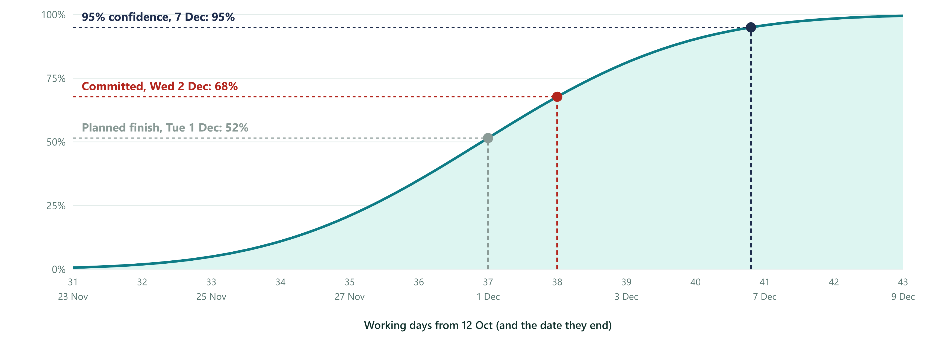
Figure 4.12 How likely is each finish date
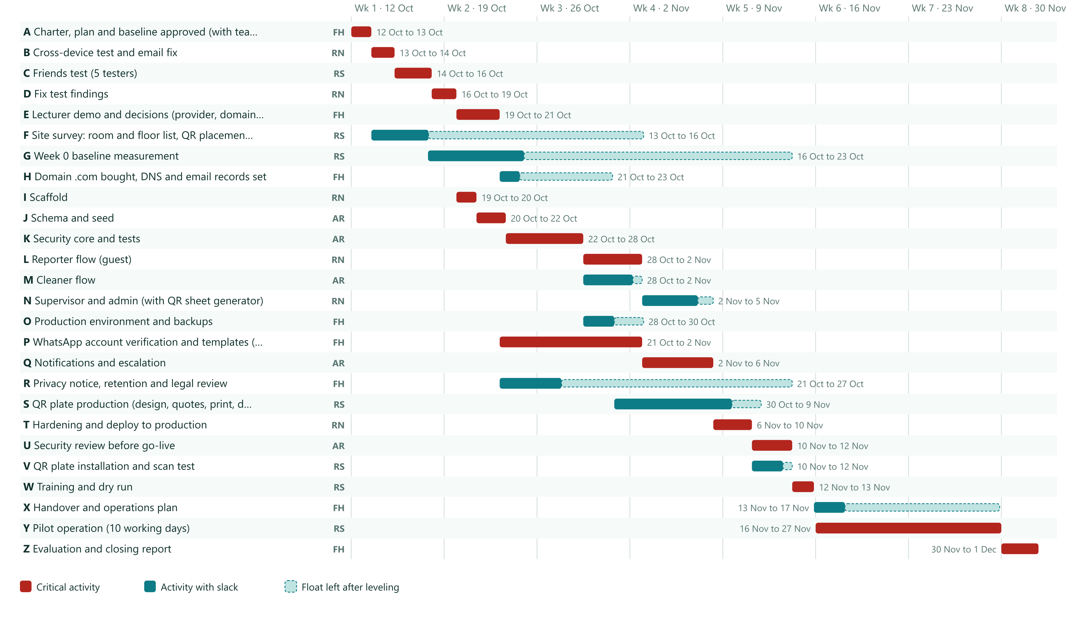
Figure 4.13 Baseline schedule
Schedule compression. Crashing adds effort to shorten an activity on the critical path. Slope = (crash effort cost − normal effort cost) ÷ (normal time − crash time). Pick the cheapest slope first, only on the critical path, and recompute after each cut. Costs use the placeholder labor rates in Section 4.9 and are planning assumptions.
Table 4.15 Crashing options and cost slopes
Activity | Cut (days) | Extra cost | Slope (Rp per day saved) | How it is bought
C Friends test (5 testers) | 1.00 | Rp 200,000 | Rp 200,000 | All 5 testers test on the same day
B Cross-device test and email fix | 0.50 | Rp 200,000 | Rp 400,000 | Test during the same session as the email fix
U Security review before go-live | 0.67 | Rp 250,000 | Rp 373,134 | Reviewer starts reading code while hardening is finishing
T Hardening and deploy to production | 0.58 | Rp 200,000 | Rp 344,828 | Second review pass in parallel with deployment checks
P WhatsApp account verification and templates (external wait) | 2.00 | Rp 700,000 | Rp 350,000 | Prepare Meta business documents before the decision meeting and pay for assisted onboarding (Rp 500,000)
K Security core and tests | 1.00 | Rp 600,000 | Rp 600,000 | Second review pass in parallel with writing tests
L Reporter flow (guest) | 0.50 | Rp 300,000 | Rp 600,000 | Reuse prototype screens
S QR plate production (design, quotes, print, delivery) | 2.00 | Rp 500,000 | Rp 250,000 | Express printing and courier (Rp 300,000) and a pre-approved design

Table 4.16 Crashing steps, cheapest slope first
Step | Cut | Project duration | Days saved | Extra cost | Cumulative extra cost
0 | Baseline | 36.91 |  | Rp 0 | Rp 0
1 | C by 1.00 d | 35.91 | 1.00 | Rp 200,000 | Rp 200,000
2 | S by 2.00 d (no gain: not on the critical path now) | 35.91 | 0.00 | Rp 0 | Rp 200,000
3 | T by 0.58 d | 35.33 | 0.58 | Rp 200,000 | Rp 400,000
4 | P by 2.00 d (no gain: not on the critical path now) | 35.33 | 0.00 | Rp 0 | Rp 400,000
5 | U by 0.67 d | 34.83 | 0.50 | Rp 250,000 | Rp 650,000
6 | B by 0.50 d | 34.33 | 0.50 | Rp 200,000 | Rp 850,000
7 | K by 1.00 d (no gain: not on the critical path now) | 34.33 | 0.00 | Rp 0 | Rp 850,000
8 | L by 0.50 d (no gain: not on the critical path now) | 34.33 | 0.00 | Rp 0 | Rp 850,000

Two paths are critical, so cutting only the build path (K or L) or only the WhatsApp path (P) saves nothing. Both must be cut together, which doubles the price of a saved day:
Table 4.17 Crashing both critical paths together
Combination | Project duration | Cumulative extra cost
C, U, B, T (steps above) | 34.33 | Rp 850,000
plus P and K together | 33.33 | Rp 2,150,000
plus P, K and L together | 32.83 | Rp 2,450,000

Fast tracking (parallel work, no extra effort, more risk). Starting the scaffold (I) right after the charter instead of after the friends test saves nothing alone, because the WhatsApp path is also critical. Starting WhatsApp verification (P) right after the charter, before the decision meeting, also saves nothing alone. Doing both saves 4.58 days (finish about 32.33 days). Risk: if the lecturer or facility unit chooses a different provider or building, the verification work is lost and the scaffold may need rework. Recommended: start the Meta business verification paperwork now (cost: Farid's time only), and keep the scaffold after the friends test.
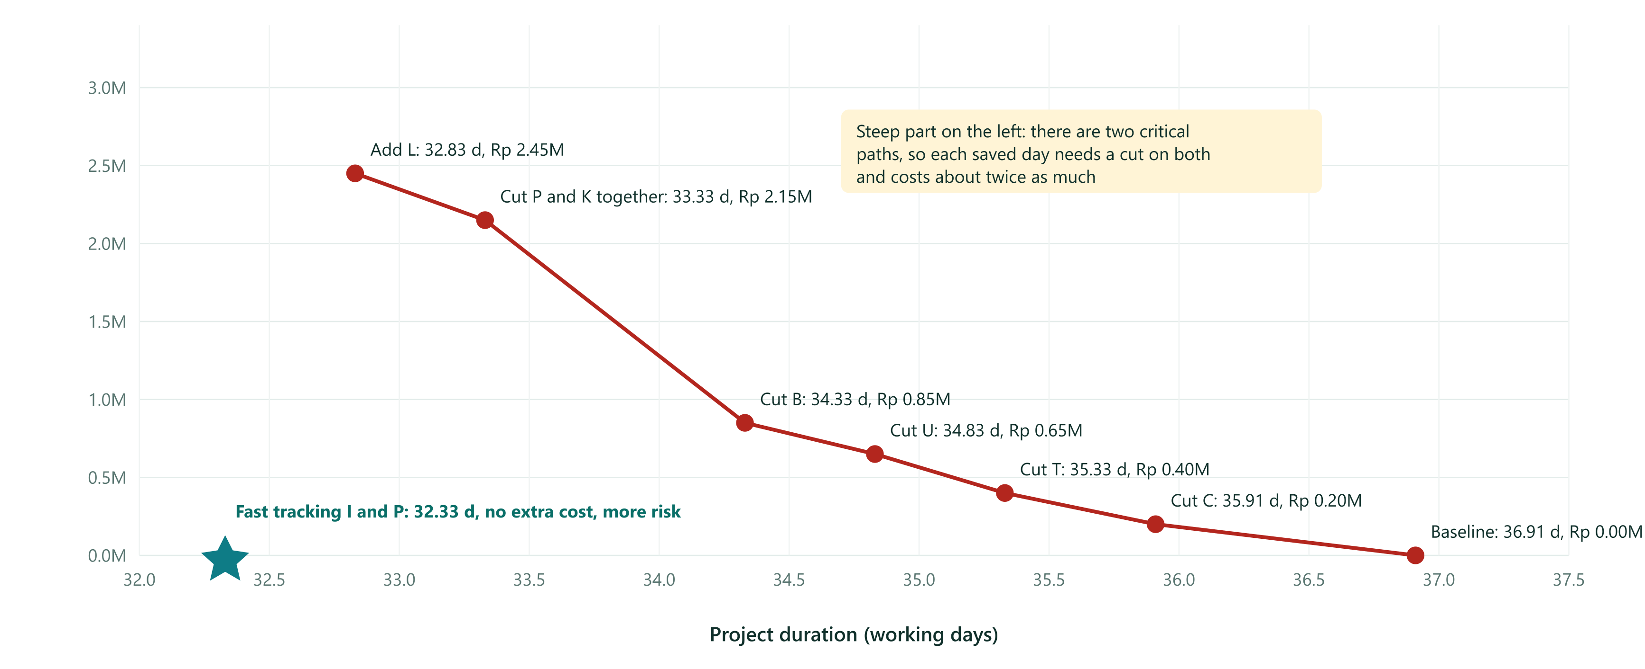
Figure 4.14 Time-cost trade-off: crashing and fast tracking
The committed baseline stays at Wed 2 Dec until the board approves the change as CR-06 (Section 4.16).

4.9 Cost Management
Cost management estimates, budgets and controls the cost of the project. This section follows the cost topics of Week 5 of the course.

4.9.1 Cost Management Plan
Table 4.18 Cost management plan
Element | Plan
Level of accuracy and unit of measure | Units: rupiah and work-days. Items priced from published rates or quotes are budgetary (−10% to +25%). Placeholder items without a quote are ROM (−50% to +100%) and are replaced by a quote or in-kind support before purchase. After quotes the estimate becomes definitive (−5% to +10%)
Organizational procedure links | University procurement rules and payment approval (to be obtained, decision D15). Vendor terms of service
Control thresholds | CPI and SPI bands in Section 5.2. Contingency is released by the project manager. Management reserve is released by the sponsor. Any item over +25% of its estimate goes to the change board
Rules of performance measurement | Earned value is credited only when a work package is accepted (0% or 100%). Actual cost is cash paid plus work-days spent valued at the stated rates
Reporting format | Weekly table in Section 5.3 every Friday. Monthly cash report to the faculty after go-live
Process description | Plan cost management, estimate costs, determine budget, control costs (Sections 4.9 to 5.4)

4.9.2 The Seven Steps of Estimating
Table 4.19 Seven steps of cost estimating applied
Step | What was done here
1. Define the work and environment | Live deployment, one building, about 40 rooms, up to 50 reports a day, rupiah budget, dollar services converted at Rp 17,900
2. Divide the work into elements | WBS levels 1 to 3 (Section 4.7). Estimates are made per work package
3. Select estimating techniques | Bottom-up for effort. Three-point (PERT) for durations. Parametric for messages (price per message × messages per report) and plates (price per plate × count). Analogous for marketplace prices. Vendor bid analysis: 3 quotes for plates and for a message provider if one is needed. Reserve analysis. Cost of quality (Section 4.10)
4. Calculate and check | Totals below are summed by line and checked against the S-curve baseline
5. Document the calculation | Basis of estimate on each line. Price sources and dates in Appendix C
6. Assess risk in the estimate | Low and high values per line. Expected monetary value of cost risks (Section 4.13). Contingency (Section 4.9.7)
7. Allow for support overhead | Support and maintenance people and indirect costs are listed in Section 4.9.9. Plates, domain and cloud renewals are in the running cost

4.9.3 Cost Classification
Table 4.20 Cost classification
Class | Items in this project
Direct costs (can be assigned to a work package) | Domain, cloud services, WhatsApp messages, plates and mounting kit, guide cards, SIM card, team and partner effort
Indirect costs (supervision, administration, overhead) | Project manager supervision, facility unit administration, university legal and IT review, finance approval. They grow with time: a shorter project costs less
Tangible benefits | Median response time, share of reports accepted, cost per report, cleaner time saved
Intangible benefits | Transparency, trust of reporters, a record of work, faculty visibility
Sunk cost (spent, not recoverable) | Clickable prototype and version 1.0 plan. They are not counted in the baseline

4.9.4 Cash Estimates to the End of the Pilot
Table 4.21 Cash estimates with estimate type, range and basis
WBS | Item | Type | Range | Low | Base | High | Basis of estimate
H | Domain .com, first year | Budgetary | -10% / +25% | Rp 180,000 | Rp 200,000 | Rp 250,000 | Cloudflare about US$10.46 (rising to about US$11.2 after 1 Nov 2026) or Indonesian registrar promo Rp 121,900 and renewal Rp 195,000. Budget at Rp 200,000
O | Supabase Pro, 2 months (production database, 7-day backups) | Definitive | -5% / +10% | Rp 850,250 | Rp 895,000 | Rp 984,500 | US$25 per month from supabase.com/pricing, 8 GB database, 250 GB egress, 100 GB storage, US$10 compute credit included
O | Vercel Pro, 2 months (1 seat, commercial use) | Definitive | -5% / +10% | Rp 680,200 | Rp 716,000 | Rp 787,600 | US$20 per month per seat from vercel.com/pricing. The Hobby plan is for personal, non-commercial use only
P | Dedicated phone number (SIM) for WhatsApp, 2 months | Budgetary | -10% / +25% | Rp 99,000 | Rp 110,000 | Rp 137,500 | Prepaid SIM Rp 50,000 plus Rp 30,000 per month to stay active. Number must not be registered in a normal WhatsApp app
R | Legal and privacy review (if not done in kind by the university) | ROM | -50% / +100% | Rp 1,500,000 | Rp 3,000,000 | Rp 6,000,000 | ROM placeholder. Replace with a quote or university legal office time
S | QR plates: 61 pieces at Rp 50,000 | Budgetary | -10% / +25% | Rp 2,745,000 | Rp 3,050,000 | Rp 3,812,500 | Marketplace listings: acrylic sign 15x20 cm Rp 30,000 to 40,000, UV-printed acrylic Rp 10,000 to 50,000. Budget 3 mm acrylic, UV print, mounting tape at Rp 50,000 each. Get 3 quotes
S | Plate delivery and mounting kit (tape, screws, wipes) | Budgetary | -10% / +25% | Rp 315,000 | Rp 350,000 | Rp 437,500 | Estimate. Needs vendor quote
U | Independent security review (if not done by university IT in kind) | ROM | -50% / +100% | Rp 2,500,000 | Rp 5,000,000 | Rp 10,000,000 | ROM placeholder. Replace with a quote or university IT time
W | Printed guide cards for cleaners and supervisors, 20 pieces | Budgetary | -10% / +25% | Rp 90,000 | Rp 100,000 | Rp 125,000 | Estimate at Rp 5,000 per laminated A5 card
Y | WhatsApp messages in the pilot (Meta utility rate), about 30 reports a day for 14 calendar days | Budgetary | -10% / +25% | Rp 330,294 | Rp 366,993 | Rp 458,741 | Rp 356.65 per utility message (Meta rate card for Indonesia, effective 1 Jan 2026) x 2.45 messages per report
Y | Data allowance for cleaners during the pilot (optional, 9 people) | ROM | -50% / +100% | Rp 225,000 | Rp 450,000 | Rp 900,000 | Assumption Rp 50,000 per person if campus Wi-Fi does not cover work areas

Total cash: low Rp 9,514,744, base Rp 14,237,993, high Rp 23,893,341. Cloud services are counted for 2 months (the pilot month plus one month of preparation). Items marked ROM are placeholders. If the university legal office and IT do the reviews in kind, cash falls by about Rp 8,000,000.
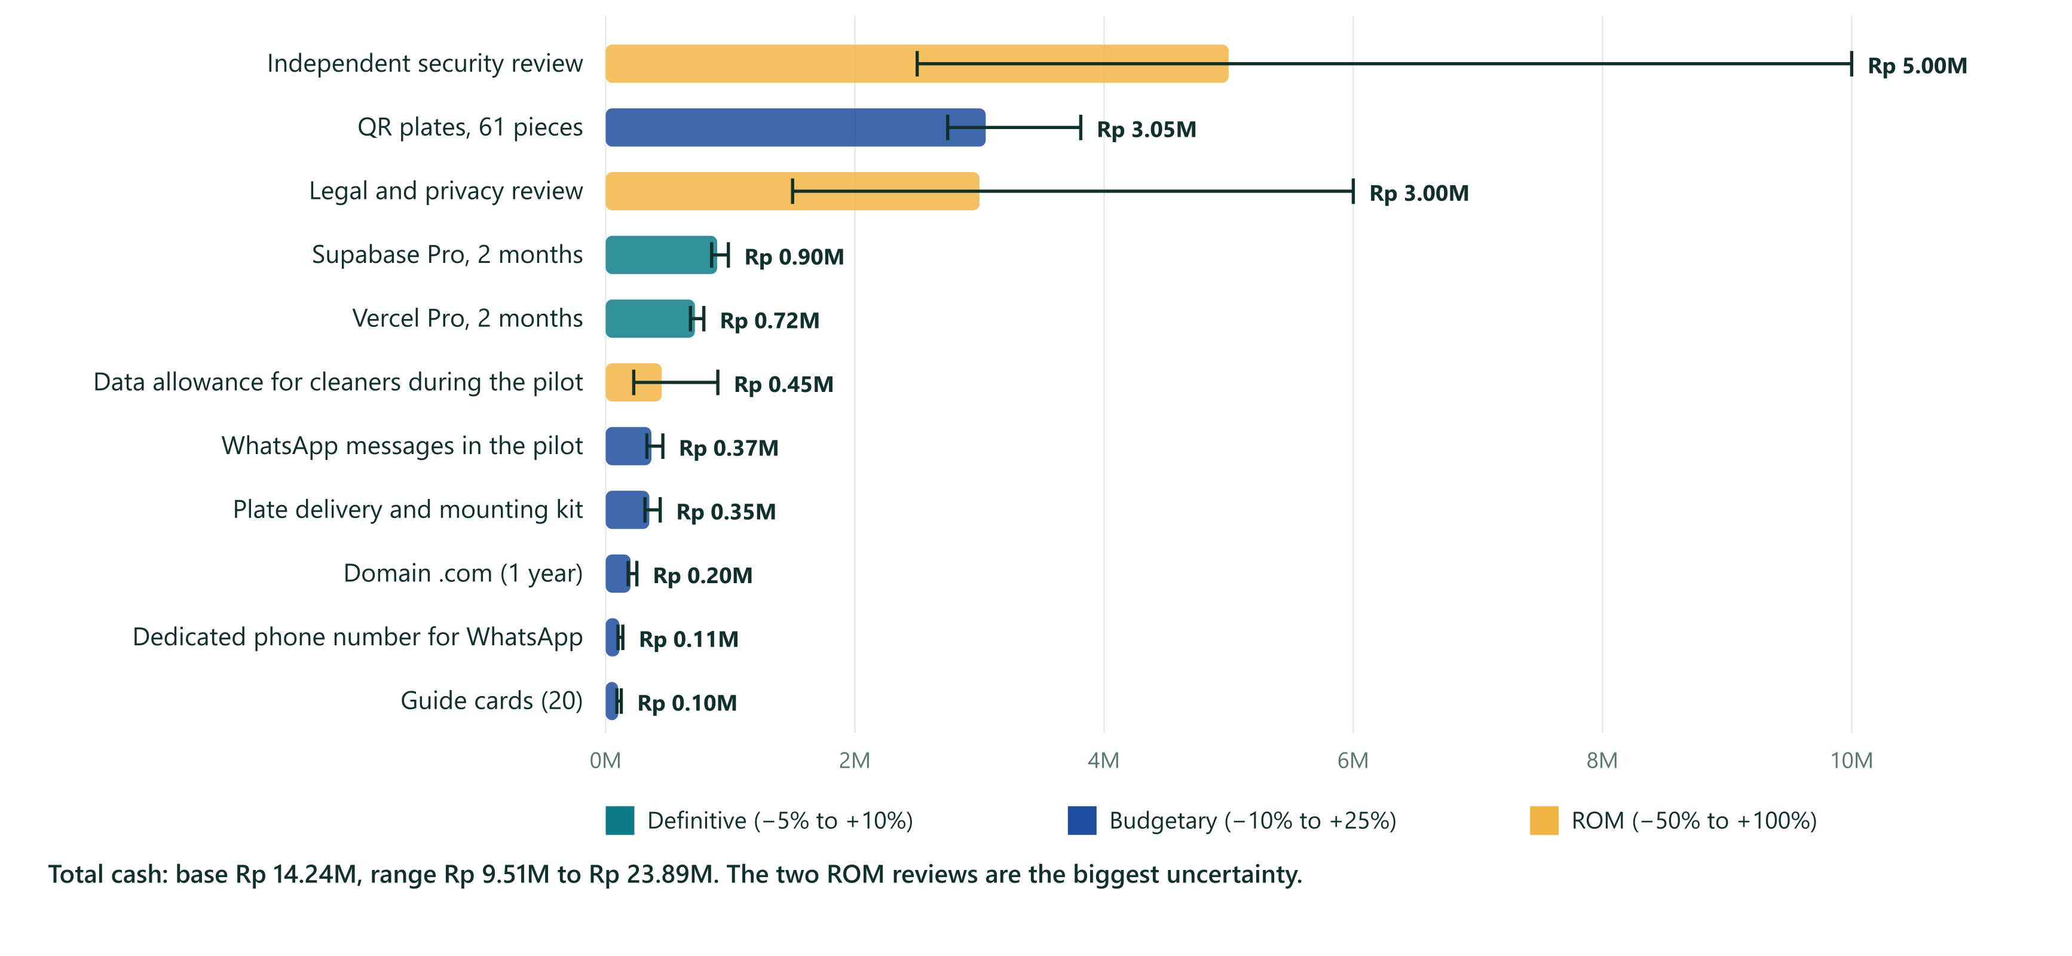
Figure 4.15 Cash estimates with their accuracy range

4.9.5 In-Kind Labor
Rates are placeholders to be replaced with the institution's rates. Labor is shown because most of a project's cost is often labor (Week 5). All four team members use one team rate of Rp 400,000 per work-day, including the weekly meeting (WBS 1.3). Claude Code is a tool the developers already have, so it adds no cash.
Table 4.22 In-kind labor at placeholder rates
Role | Work-days | Rate per day | Value
Muhammad Farid Hasyim (project manager) | 10.76 | Rp 400,000 | Rp 4,302,000
Rasyha Naufal (lead developer) | 13.66 | Rp 400,000 | Rp 5,462,000
Abdillah Ridho (developer) | 15.29 | Rp 400,000 | Rp 6,114,000
Rasyid (field, QR and testing lead) | 13.80 | Rp 400,000 | Rp 5,518,000
Facility staff | 15.70 | Rp 200,000 | Rp 3,140,000
Cleaners | 1.50 | Rp 180,000 | Rp 270,000
Supervisors | 2.30 | Rp 300,000 | Rp 690,000
Testers | 0.50 | Rp 0 | Rp 0
Lecturer | 0.80 | Rp 0 | Rp 0
Univ. legal/IT | 2.07 | Rp 500,000 | Rp 1,035,000
In-kind labor in the baseline (team and partners) |  |  | Rp 26,531,000

4.9.6 Budget Summary
Table 4.23 Budget summary
Line | Amount | Note
Cash to the end of the pilot (base) | Rp 14,237,993 | Range Rp 9,514,744 to Rp 23,893,341
In-kind labor: project team of four (53.49 work-days) | Rp 21,396,000 | Rp 400,000 per work-day (placeholder)
In-kind labor: facility staff, cleaners, supervisors, university legal | Rp 5,135,000 | Placeholder rates
Cost baseline (BAC) | Rp 40,768,992 | Used for earned value
Contingency (15% of cash, reserve analysis) | Rp 2,135,699 | Known risks. Released by the project manager
Management reserve (schedule uncertainty) | Rp 1,556,000 | 3.89 work-days × Rp 400,000. Released by the sponsor
Authorized budget | Rp 44,460,691 | Cap for the project phase

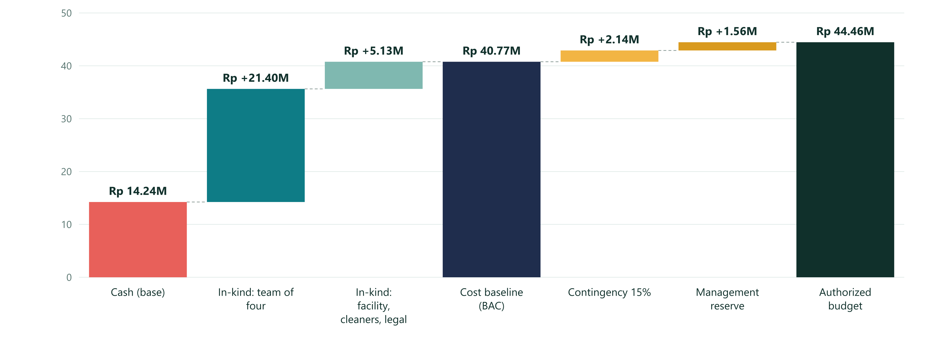
Figure 4.16 From cash to authorized budget

4.9.7 Reserve Analysis
Contingency is a percentage based on risk and complexity (Week 5). A 15% rate on cash gives Rp 2,135,699. A cross-check by expected monetary value of the main cost risks gives Rp 1,685,373 (below). The 15% contingency covers the EMV with a margin, so it is kept.
Table 4.24 Expected monetary value of cost risks
Cost risk | Probability | Impact | EMV (P × impact)
Plates need partial reprint (misprint, wrong token, damage) | 25% | Rp 1,220,000 | Rp 305,000
WhatsApp direct onboarding fails, a provider (BSP) is needed for 2 months | 30% | Rp 1,500,000 | Rp 450,000
Independent reviewer finds issues, 3 extra developer days | 40% | Rp 1,200,000 | Rp 480,000
Message volume 2.5 times higher than planned during the pilot | 20% | Rp 550,489 | Rp 110,098
Exchange rate +5% on dollar-priced items (2 months) | 50% | Rp 80,550 | Rp 40,275
Domain or DNS mistake delays plate order by 1 week (extra labor) | 15% | Rp 2,000,000 | Rp 300,000
Total EMV |  |  | Rp 1,685,373

The management reserve covers schedule uncertainty only: the difference between the one-sided 95% duration and the expected duration (40.80 − 36.91 = 3.89 work-days).

4.9.8 Cost Baseline
The WBS is the input and the output is the cost baseline: the time-phased budget used to measure cost performance. Cost is spread over each activity's leveled dates.
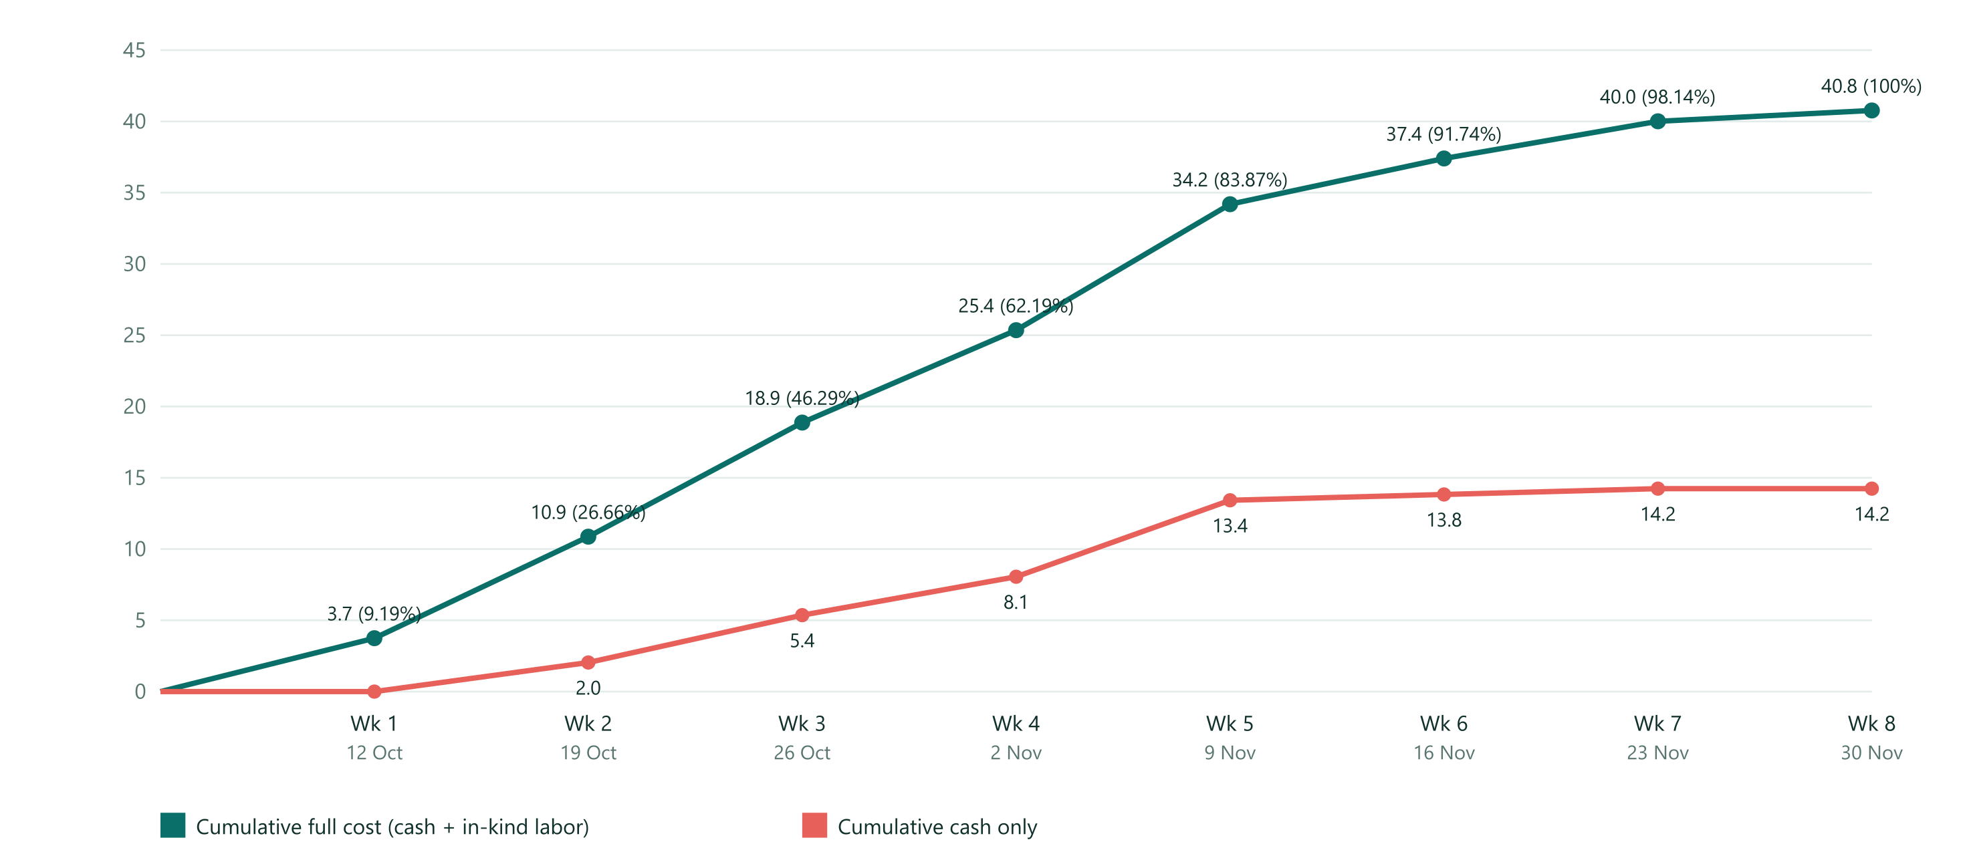
Figure 4.17 Cost baseline S-curve
Table 4.25 Time-phased cost baseline by week
Week | Starts | Cash in week | Labor in week | Total in week | Cumulative (PV) | % of BAC
1 | 12 Oct | Rp 0 | Rp 3,745,377 | Rp 3,745,377 | Rp 3,745,377 | 9.19%
2 | 19 Oct | Rp 2,039,637 | Rp 5,082,802 | Rp 7,122,439 | Rp 10,867,816 | 26.66%
3 | 26 Oct | Rp 3,323,082 | Rp 4,680,871 | Rp 8,003,953 | Rp 18,871,769 | 46.29%
4 | 2 Nov | Rp 2,695,089 | Rp 3,787,082 | Rp 6,482,171 | Rp 25,353,940 | 62.19%
5 | 9 Nov | Rp 5,363,191 | Rp 3,475,035 | Rp 8,838,226 | Rp 34,192,166 | 83.87%
6 | 16 Nov | Rp 408,497 | Rp 2,799,832 | Rp 3,208,329 | Rp 37,400,495 | 91.74%
7 | 23 Nov | Rp 408,497 | Rp 2,200,000 | Rp 2,608,497 | Rp 40,008,992 | 98.14%
8 | 30 Nov | Rp 0 | Rp 760,000 | Rp 760,000 | Rp 40,768,992 | 100%

4.9.9 Running Cost After the Pilot
The project budget ends after the pilot. A live system keeps costing money every month. The faculty must approve this before the pilot (decision D14). Messages per report: 2.45 (2 cleaners notified first, 15% escalated to a supervisor, 30% of reporters get one update). Meta utility rate Rp 356.65 per message.
Table 4.26 Monthly running cost scenarios
Scenario | Reports per month | Messages per month | Supabase Pro | Vercel Pro | Domain, SIM, plate upkeep | WhatsApp (Meta) | Provider fee | Cleaner data | Per month | Per year
Lean (direct Meta API, no data allowance) | 600 | 1,470 | Rp 447,500 | Rp 358,000 | Rp 59,375 | Rp 524,275 | Rp 0 | Rp 0 | Rp 1,389,150 | Rp 16,669,800
Recommended (direct Meta API, data allowance) | 900 | 2,205 | Rp 447,500 | Rp 358,000 | Rp 59,375 | Rp 786,413 | Rp 0 | Rp 450,000 | Rp 2,101,288 | Rp 25,215,456
High volume (provider fee, 50 reports a day) | 1,500 | 3,675 | Rp 447,500 | Rp 358,000 | Rp 59,375 | Rp 1,310,689 | Rp 750,000 | Rp 450,000 | Rp 3,375,564 | Rp 40,506,768

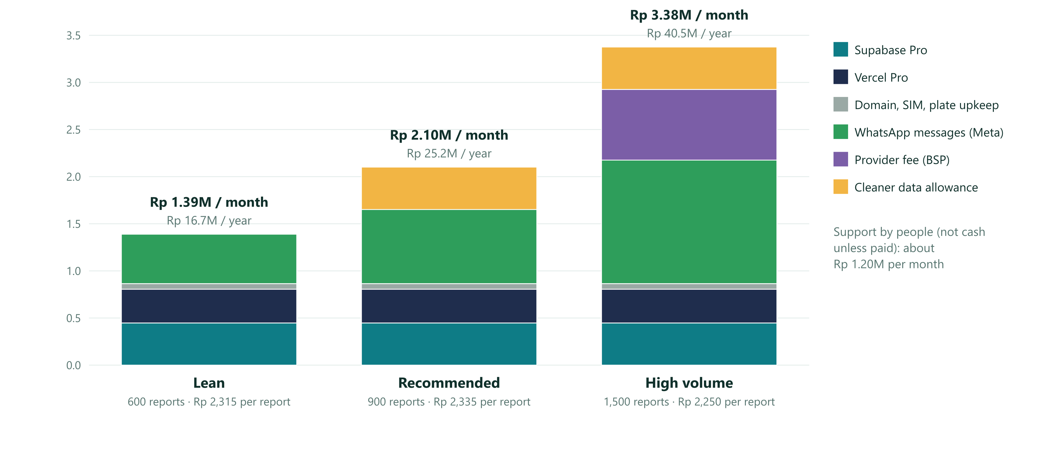
Figure 4.18 Running cost per month after the pilot
Support and maintenance by people (not cash unless paid): 2 maintainer days and 1 developer day each month at the team rate, about Rp 1,200,000 per month or Rp 14,400,000 per year at the placeholder rates.
Table 4.27 First-year cost of ownership
First-year total | Lean | Recommended | High volume
One-time cash (plates, kit, reviews, cards) | Rp 11,500,000 | Rp 11,500,000 | Rp 11,500,000
12 months of running cost (cash) | Rp 16,669,800 | Rp 25,215,456 | Rp 40,506,768
First-year cash needed | Rp 28,169,800 | Rp 36,715,456 | Rp 52,006,768
Plus support by people at placeholder rates | Rp 14,400,000 | Rp 14,400,000 | Rp 14,400,000

Unit costs in the recommended scenario: about Rp 52,532 per room per month and Rp 2,335 per report. Compare these with the Week 0 baseline of what a late or lost cleaning request costs today.

4.9.10 Cost Levers
Table 4.28 Cost levers and trade-offs
Choice | Effect on cost | Trade-off
WhatsApp through Meta Cloud API directly instead of a provider (BSP) | Saves about Rp 750,000 per month (provider platform fee, third-party figure, unverified) | We maintain the integration and the template approvals ourselves
Notify 2 cleaners first, then all after 3 minutes, instead of everyone at once | Each extra message per report costs about Rp 320,985 per month at 900 reports | Slightly slower pickup in busy moments
Vercel Hobby instead of Pro | Saves Rp 358,000 per month | Hobby is for personal, non-commercial use. Confirm with the vendor before using it for an institution
Point-in-time recovery for the database | Adds about Rp 1,790,000 per month | Not needed for the pilot. Daily backups and a weekly export are enough at this size
Vinyl stickers instead of acrylic plates | Saves about Rp 2,318,000 once (estimated unit price Rp 12,000 against Rp 50,000) | Peel off, tear and get picked at. More replacements and re-inspection
Exchange rate moves ±10% | Cloud cost moves about Rp 80,550 per month | Review quarterly. Meta also changes rates quarterly
Cleaners use campus Wi-Fi only | Saves Rp 450,000 per month | Needs Wi-Fi coverage in corridors and toilets. Check in the site survey

4.10 Quality Management
Table 4.29 Quality management plan
Item | Plan
Quality objectives | All 22 security tests pass. No tester needs help for the main flow. 100% of plates scan on 3 phone models. Uptime 99% or better. Health checks healthy
Quality assurance (process) | One phase at a time. Security before screens. Separate development and production environments. Migrations are append-only. A second person verifies each plate installation. The other developer reviews every pull request before merge
Quality control (product) | npm run test:db for the database. Friends test for usability. Plate samples scanned before bulk print. Security review before go-live. Weekly health check
Validate Scope vs Control Quality | Control Quality asks "does it meet the specification" (tests, internal). Validate Scope asks "will the customer sign it" (Section 5.4, external). Control Quality comes first
Plate acceptance test | Sample plates scan in under 2 seconds at 30 to 60 cm on 3 phone models (2 low-end Android, 1 iPhone) in corridor light. Adhesion holds for 48 hours. 50 wipe cycles with water and a common disinfectant leave the print intact
Metrics | Test pass rate, defects per phase, scan success rate, time to file a report, taps to file, uptime, error rate
Cost of quality | Prevention: tests first, sample plates, written procedures. Appraisal: friends test, scan tests, security review, restore drill. Failure: reprint, rework, outage. Budgeted lines: security review, plate samples, guide cards

4.11 Resource Management
Resource management has six processes: plan resource management, estimate activity resources, acquire resources, develop team, manage team and control resources. A resource is anything scarce that an activity needs. The class lists the 4Ms (men, machines, money, material) and other items such as services, space and time.

4.11.1 Resource List
Table 4.30 Resource list
Type | Resource | Quantity and availability | Cost treatment
Men (people) | Project team: Muhammad Farid Hasyim (project manager), Rasyha Naufal (lead developer), Abdillah Ridho (developer), Rasyid (field, QR and testing lead) | 4 people, full time on weekdays (capacity 1.0 each, confirm in D18) | In kind at Rp 400,000 per work-day (placeholder)
Men (people) | Facility unit staff (survey, baseline, installation) | 2 people, part time (capacity 2.0) | In kind
Men (people) | Cleaners (9) and supervisors (2) | Training sessions and the pilot | In kind
Men (people) | Lecturer, university legal and IT, 5 friend testers | Short sessions | Lecturer and testers free. Legal and IT in kind or ROM cash
Machines (tools) | Claude Code, the AI coding assistant used by the two developers | Already available to the team | No incremental cash
Machines (equipment) | Team laptops, 3 test phones, cleaners' own phones, stepladder and drill (facility unit) | Available | Owned. Data allowance optional
Materials (consumed) | 61 QR plates, mounting tape and screws, 20 guide cards, SIM card | Bought | Cash (Section 4.9.4)
Services | Domain registrar, Vercel, Supabase, Cloudflare DNS, WhatsApp Cloud API, email sending | Subscriptions | Cash (Sections 4.9.4 and 4.9.9)
Space | Facility unit room for training. A room for the weekly team meeting | Available | Free
Time | The most rigid resource | 32.33 (fast tracked) to 40.80 (95% confidence) working days | Reserve in Section 4.8
Money (secondary resource) | Authorized budget | Rp 44,460,691 | Controlled in Section 5.3

4.11.2 Resource Breakdown Structure
Go Clean It resources
├─ Project team (4)
│ ├─ Muhammad Farid Hasyim, project manager
│ ├─ Development
│ │ ├─ Rasyha Naufal, lead developer (front end)
│ │ ├─ Abdillah Ridho, developer (back end and security)
│ │ └─ Claude Code (tool)
│ └─ Rasyid, field, QR and testing lead
├─ Customer side
│ ├─ Facility unit (staff, supervisors, cleaners)
│ ├─ Lecturer (sponsor)
│ └─ University legal, IT, finance
├─ Test users (5 friends, 2 to 3 cleaners)
├─ Equipment (laptops, phones, tools)
├─ Materials (plates, tape, cards, SIM)
└─ Services
├─ Domain and DNS
├─ Hosting (Vercel) and database (Supabase)
└─ Messaging (WhatsApp Cloud API, email)

4.11.3 Resource Estimates per Activity
Work-days per person or role. FH Farid, RN Rasyha, AR Abdillah, RS Rasyid. The other codes are in Section 4.8.
Table 4.31 Resource estimates per activity (work-days)
ID | Activity | Lead | Duration te | Effort | FH | RN | AR | RS | FAC | CLN | SUP | TST | LEC | LEG
A | Charter, plan and baseline approved (with team kickoff) | Farid | 1.08 | 1.83 | 1.08 | 0.25 | 0.25 | 0.25
B | Cross-device test and email fix | Rasyha | 1.25 | 1.25 |  | 0.65 |  | 0.60
C | Friends test (5 testers) | Rasyid | 2.00 | 2.00 | 0.50 |  |  | 1.00 |  |  |  | 0.50
D | Fix test findings | Rasyha | 1.33 | 1.33 |  | 0.60 | 0.40 | 0.33
E | Lecturer demo and decisions (provider, domain, building, funding) | Farid | 2.33 | 2.33 | 0.75 | 0.25 |  |  | 0.83 |  |  |  | 0.50
F | Site survey: room and floor list, QR placement plan | Rasyid | 3.08 | 5.08 |  |  |  | 1.08 | 4.00
G | Week 0 baseline measurement | Rasyid | 5.17 | 5.17 |  |  |  | 1.17 | 4.00
H | Domain .com bought, DNS and email records set | Farid | 1.08 | 1.08 | 0.50 | 0.58
I | Scaffold | Rasyha | 1.08 | 1.08 |  | 0.80 | 0.28
J | Schema and seed | Abdillah | 1.58 | 1.58 |  | 0.38 | 1.20
K | Security core and tests | Abdillah | 4.17 | 4.17 |  | 0.97 | 3.20
L | Reporter flow (guest) | Rasyha | 3.17 | 3.17 |  | 2.40 |  | 0.77
M | Cleaner flow | Abdillah | 2.67 | 2.67 |  |  | 2.00 | 0.67
N | Supervisor and admin (with QR sheet generator) | Rasyha | 3.00 | 3.00 | 0.70 | 2.30
O | Production environment and backups | Farid | 1.67 | 1.67 | 1.20 |  |  | 0.47
P | WhatsApp account verification and templates (external wait) | Farid | 7.67 | 1.00 | 0.50 |  |  |  |  |  |  |  |  | 0.50
Q | Notifications and escalation | Abdillah | 3.83 | 3.83 |  |  | 2.90 | 0.93
R | Privacy notice, retention and legal review | Farid | 3.33 | 2.70 | 1.20 |  | 0.50 |  |  |  |  |  |  | 1.00
S | QR plate production (design, quotes, print, delivery) | Rasyid | 6.33 | 1.00 |  |  |  | 0.80 | 0.20
T | Hardening and deploy to production | Rasyha | 2.08 | 2.08 |  | 1.50 | 0.58
U | Security review before go-live | Abdillah | 2.17 | 2.17 | 0.30 | 0.40 | 0.90 |  |  |  |  |  |  | 0.57
V | QR plate installation and scan test | Rasyid | 1.67 | 4.00 |  |  |  | 1.00 | 3.00
W | Training and dry run | Rasyid | 1.17 | 2.80 |  |  |  | 0.50 | 0.50 | 1.50 | 0.30
X | Handover and operations plan | Farid | 1.67 | 1.67 | 0.60 |  | 0.50 | 0.40 | 0.17
Y | Pilot operation (10 working days) | Rasyid | 10.00 | 12.00 | 1.50 | 1.50 | 1.50 | 2.50 | 3.00 |  | 2.00
Z | Evaluation and closing report | Farid | 2.00 | 2.00 | 1.00 | 0.15 | 0.15 | 0.40 |  |  |  |  | 0.30

Plus 3.70 work-days for the weekly team meeting (WBS 1.3: 1 hour a week for 4 people), shared equally and not part of the network.
Table 4.32 Total work-days per person and role
Person or role | Total work-days | Share of team work
Muhammad Farid Hasyim (project manager) | 10.76 | 20%
Rasyha Naufal (lead developer) | 13.66 | 26%
Abdillah Ridho (developer) | 15.29 | 29%
Rasyid (field, QR and testing lead) | 13.80 | 26%
Facility staff | 15.70
Cleaners | 1.50
Supervisors | 2.30
Testers | 0.50
Lecturer | 0.80
Univ. legal/IT | 2.07
All | 76.36

4.11.4 Resource Loading and Leveling
Resource loading is the amount of each resource a schedule needs in each period. The table shows average units per working day by week, before and after leveling (before → after). Capacity: each team member 1.0, facility staff 2.0. Daily peaks matter more than weekly averages.
Table 4.33 Resource loading by week, before and after leveling
Week | Farid | Rasyha | Abdillah | Rasyid | Facility staff
Wk 1 (12 to 16 Oct) | 0.34 → 0.34 | 0.27 → 0.27 | 0.12 → 0.12 | 0.82 → 0.68 | 1.41 → 0.93
Wk 2 (19 to 23 Oct) | 0.45 → 0.45 | 0.56 → 0.56 | 0.68 → 0.68 | 0.11 → 0.25 | 0.36 → 0.83
Wk 3 (26 to 30 Oct) | 0.43 → 0.43 | 0.52 → 0.52 | 0.82 → 0.82 | 0.39 → 0.39 | 0.01 → 0.01
Wk 4 (2 to 6 Nov) | 0.17 → 0.17 | 0.66 → 0.66 | 0.66 → 0.66 | 0.38 → 0.38 | 0.03 → 0.03
Wk 5 (9 to 13 Nov) | 0.09 → 0.09 | 0.33 → 0.33 | 0.30 → 0.30 | 0.35 → 0.34 | 0.71 → 0.70
Wk 6 (16 to 20 Nov) | 0.29 → 0.29 | 0.18 → 0.18 | 0.27 → 0.27 | 0.35 → 0.35 | 0.33 → 0.33
Wk 7 (23 to 27 Nov) | 0.18 → 0.18 | 0.17 → 0.18 | 0.17 → 0.18 | 0.27 → 0.28 | 0.29 → 0.30
Wk 8 (30 Nov to 4 Dec) | 0.20 → 0.21 | 0.04 → 0.04 | 0.04 → 0.04 | 0.09 → 0.09 | 0.00 → 0.00

Table 4.34 Daily peak loads against capacity
Daily peak (units per day) | Capacity | Before leveling | After leveling
Farid | 1.0 | 1.00 | 1.00
Rasyha | 1.0 | 0.85 | 0.85
Abdillah | 1.0 | 0.92 | 0.92
Rasyid | 1.0 | 1.08 | 0.85
Facility staff | 2.0 | 2.07 | 1.80

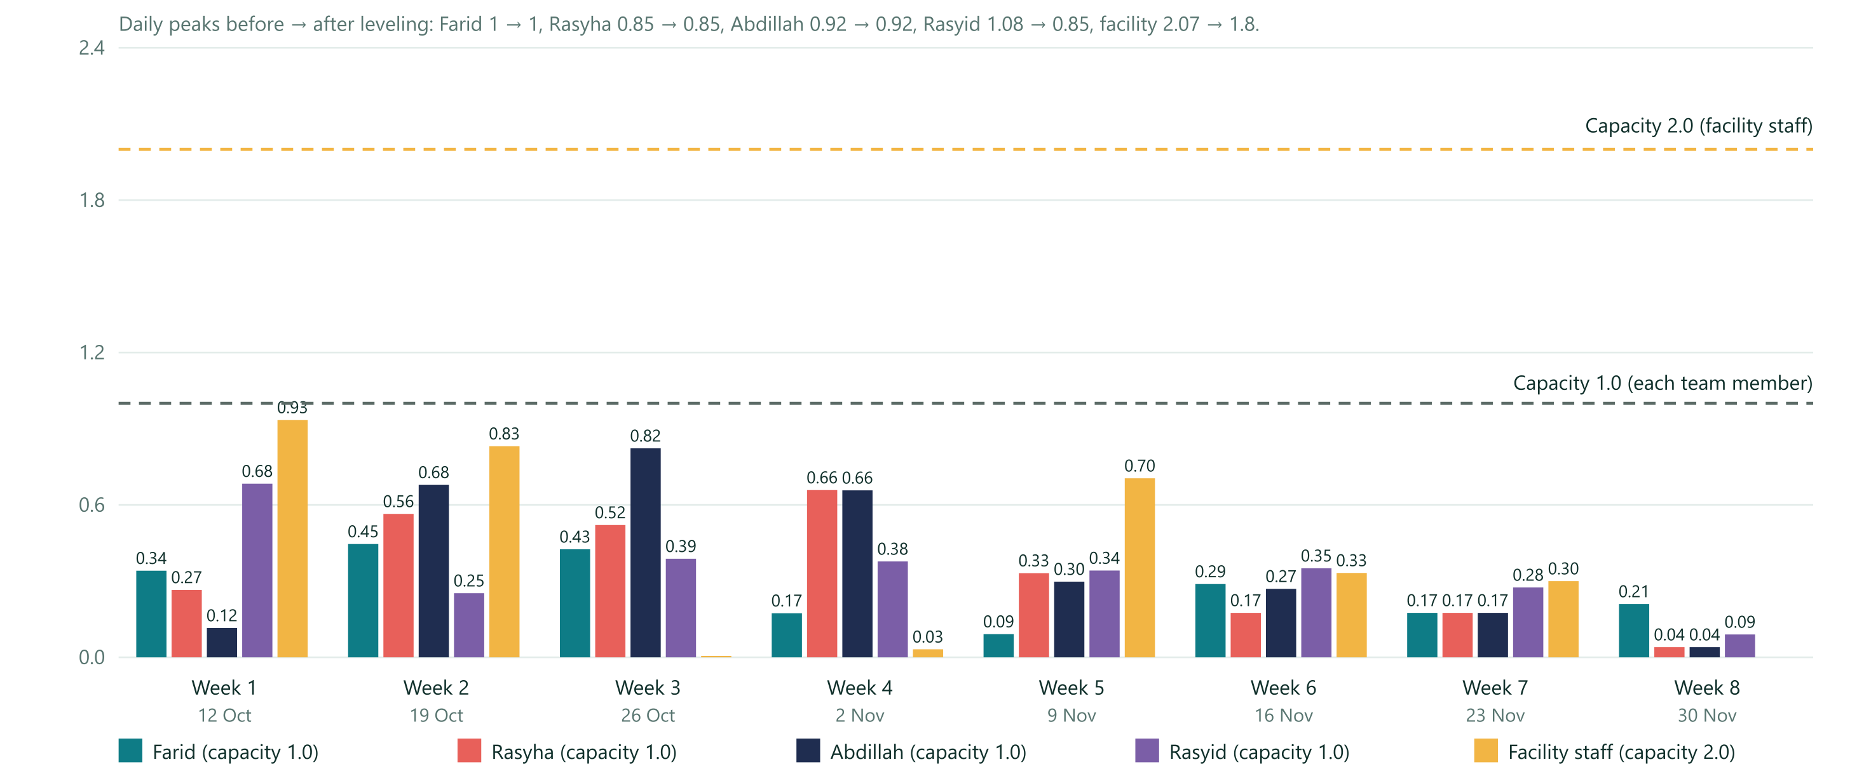
Figure 4.19 Resource loading
Leveling steps (Week 6): (1) network diagram and CPM, (2) table of resources per activity (Section 4.11.3), (3) time-phased loading table (above), (4) find conflicts: Rasyid peaks at 1.08 per day in week 1 because the friends test, the site survey and the baseline overlap, and facility staff peak at 2.07, (5) smooth by shifting activities inside their float. Farid is at exactly 1.0 during the charter and kickoff, which is allowed.
Table 4.35 Activities moved by leveling
Activity | Early start (day, date) | Leveled start (day, date) | Reason
G Week 0 baseline measurement | 1.08, 13 Oct | 4.13, 16 Oct | Rasyid runs the friends test and the site survey in week 1. The baseline has large slack
Y Pilot operation (10 working days) | 24.91, 13 Nov | 25.00, 16 Nov | Date constraint: the pilot starts on a Monday (start no earlier than 16 Nov)
Z Evaluation and closing report | 34.91, 27 Nov | 35.00, 30 Nov | Follows Y

Result: after leveling the project finishes in 37.00 working days (Tue 1 Dec). People do not delay the critical path; only the Monday start of the pilot adds 0.09 days. No daily load is above capacity. The committed finish of Wed 2 Dec keeps 1.00 working day of buffer.
Utilization. On average the team spends about 36% of its working time on this project, so the plan fits around other courses. But several activities need most of one person's day (charter and kickoff, security core, the three flows, notifications), so the peak days must be protected. If each member can give only half a day, the finish moves to 23 Dec (table below).
What-if: why the team of four matters (same leveling rules, same estimates):
Table 4.36 What-if leveling scenarios
Scenario | Leveled finish | Working days | Effect
Team of four (this plan) | Tue 1 Dec | 37.00 | Baseline
Version 2.1: Farid alone plus an AI builder with two streams | Wed 2 Dec | 37.98 | Farid was the bottleneck: 1.07 days of leveling delay and no buffer
Rasyid unavailable: Farid takes his work | 3 Dec | 38.81 | 1.81 days later than this plan
One developer leaves: the other takes all development | 14 Dec | 45.98 | 8.98 days later, beyond the 95% date (risk L10)
Everyone half time (capacity 0.5 each, for example because of classes) | 23 Dec | 52.85 | 15.85 days later. Confirm availability in D18 before the baseline is approved

4.11.5 Responsibility Assignment Matrix
R does the work, A is accountable, C is consulted, I is informed. Each WBS package has exactly one A. Farid is accountable for the project as a whole; each package is owned by the person who leads it.
Table 4.37 Responsibility assignment matrix (RACI)
WBS package | Farid | Rasyha | Abdillah | Rasyid | Lecturer | Facility unit | Univ. legal/IT
1.1 Charter and plan | R | C | C | C | A (approves) | I
1.2 Evaluation report | R | C | C | R (data) | A (approves) | C
1.3 Team coordination | A, R | R | R | R
3.1 and 3.3 Tests and fixes | I | A, R | R | R (tests)
3.2 Friends test | C | C | I | A, R
3.4 Demo and decisions | R | R (demo) | I | I | A | C
3.5 Site survey and QR plan | I | I | I | A, R |  | R
3.6 Week 0 baseline | I |  |  | A, R | I | R
4.1 Domain and DNS | A, R | R (DNS) | I |  | I
4.2 Scaffold | I | A, R | C
4.3 and 4.4 Schema, security core and tests | I | C (review) | A, R |  |  |  | C
5.1 Reporter flow | I | A, R | C (review) | R (user test) |  | C
5.2 Cleaner flow | I | C (review) | A, R | R (user test) |  | C
5.3 Supervisor and admin | R (requirements) | A, R | C (review) | C |  | C
6.1 Production environment and backups | A, R | C | C (accepts) | R (restore drill) |  |  | C
6.2 WhatsApp verification | A, R | I | C |  | C | C | C
6.3 Notifications and escalation | I | C | A, R | R (phone tests) | C | C
7.1 Privacy notice and legal review | A, R | I | R (retention job) |  | C |  | R
7.2 QR plate production | C | I | R (tokens) | A, R |  | C
7.3 Hardening and deploy | I | A, R | R |  | I
7.4 Security review | R (coordinates) | R (fixes) | A, R |  | I |  | R (review)
7.5 Plate installation and scan test | I |  |  | A, R |  | R
7.6 Training and dry run | C | C | C | A, R | I | R
8.1 Pilot operation | R (daily numbers) | R (on call) | R (on call) | A, R (field) | I | R
8.2 Handover and operations plan | A, R | C | R (runbook) | R (register) | C | C (accepts) | C

Acquire, develop and manage the team (Week 6): the team is pre-assigned (four classmates). Kickoff on day 1: agree roles, this RACI, working hours, exam dates and the tools (GitHub, the tracker, a team WhatsApp group). Weekly team meeting every Monday (1 hour). Two-person rule: every pull request is reviewed by the other developer, and Rasyid pairs with a developer for scan tests and pilot on-call. Disagreements are raised at the weekly meeting; Farid decides if the team cannot agree, and records it. Good work is named in the Friday status. Cleaners are onboarded with a one-time link, a 15-minute walk-through, a guide card and a named contact (Rasyid).
Control resources: every Friday each team member logs hours against Section 4.11.3. Re-level when anyone is above 1.0 per day for more than two days, or is unavailable. Use the what-if table to see the effect on the finish date.

4.12 Communication Management
Communication channels = n(n − 1) ÷ 2. The team alone has 4 × 3 ÷ 2 = 6 channels. Adding the lecturer and the facility coordinator gives 6 people and 15 channels. To keep this simple, Farid is the single contact for the lecturer, the faculty and the facility unit, and Rasyid is the contact for cleaners and supervisors.
Table 4.38 Communication management plan
What | Audience | Owner | How often | Channel
Team meeting: done last week, plan this week, blockers, risks, hours | Project team (4) | Farid | Every Monday, 1 hour | In person or video call. Notes in the tracker
Daily check-in: done, doing, blocked | Project team | Each member | Every working day | Team WhatsApp group
Code review | Developers | Rasyha and Abdillah | Every pull request | GitHub
Weekly status (tracker, S-curve in rupiah, risks, decisions needed) | Lecturer, facility unit | Farid | Every Friday | Message with a link to the tracker
Demo | Lecturer, facility unit | Farid and Rasyha | Week 2 and after go-live | Live on a phone
Decision request with a date | Decision owner | Farid | When due (Section 4.13) | Written
Change request outcome | Requester | Farid | Within 3 working days | Message
Monthly cost report | Faculty | Farid | Monthly after go-live | One-page summary
Go-live notice and how to report | All reporters | Facility unit and Rasyid | Before the pilot | Notice board and the plate text
Pilot instructions | Cleaners, supervisors | Rasyid with the facility unit | Before the pilot | Guide card, 15-minute walk-through, WhatsApp message
Pilot daily numbers (reports, time to accept, open items) | Team, facility unit | Rasyid | Every pilot day | Message with counts
Incident notice (system down, data problem) | Facility unit, lecturer, team | Abdillah (on call), Rasyha as backup | Within 30 minutes of detection | Phone call or message
Broken or missing plate report | Supervisor, Rasyid | Cleaners | Weekly round | Supervisor list
Evaluation report | Lecturer, facility unit, faculty, university IT | Farid | 2 Dec | Document

4.13 Risk Management
Process (Week 3 mapping): plan risk management, identify risks, qualitative analysis, quantitative analysis, plan responses, control risks. Scoring: probability P and impact I from 1 to 5. Score = P × I. Threat responses: avoid, transfer, mitigate, accept, escalate. Opportunity responses: exploit, share, enhance, accept. R1 to R10 carry over from version 1.0 (R3, R5 and R9 rewritten for a live system). R11 (prototype mistaken for the finished system) is closed. L1 to L9 are new risks of running a live system. L10 is the risk of working as a team of four.
Table 4.39 Risk register
ID | Risk | P | I | Score | Response | Plan | Trigger | Owner
R1 | Cleaners do not accept or update tasks on phones | 3 | 5 | 15 | Mitigate | Test with 2 to 3 real cleaners before launch. Make the WhatsApp link the only step they need. Guide card | A cleaner needs help in the dry run | Facility unit
R2 | Nobody answers the coordinator number | 3 | 4 | 12 | Mitigate | Name a person and hours. Escalation covers the gap | Contact button unanswered in test | Facility unit
R3 | WhatsApp verification is slow or rejected (3 to 15 working days, on the critical path) | 4 | 4 | 16 | Mitigate, then Accept | Start Meta paperwork now. Use the institution's documents. Fallback: email, in-app queue and browser push | No verification by 2 Nov | Farid
R4 | Personal data mishandled (names, numbers, photos) | 2 | 5 | 10 | Mitigate | Privacy notice, RLS, retention job, no cleaner access to reporter data, security review | Real data in the open prototype table | Farid
R5 | Open prototype table abused | 3 | 2 | 6 | Accept | Replaced by the secured system. Tell testers it is public | Odd rows appear | Farid
R6 | Decision-makers unavailable (decisions due 21 Oct) | 3 | 4 | 12 | Mitigate | Book dates now. Every decision has a default (Section 4.13 list) | No answer by 19 Oct | Farid
R7 | Security core takes longer (p = 6 days) | 3 | 3 | 9 | Mitigate | Start early, reserve, crash option in Section 4.8 | K not done by 28 Oct | Abdillah
R8 | Spam or prank reports once plates are public | 3 | 3 | 9 | Mitigate | Rate limits, bot check, retire a QR | Report spike | Farid
R9 | Running cost higher than planned (message volume, exchange rate) | 3 | 3 | 9 | Mitigate | Notify 2 cleaners first. Monthly cost report. Budget range in Section 4.9 | Month over 25% above plan | Farid
R10 | University wants campus-only reporting | 2 | 3 | 6 | Avoid | Ask in D11. Add a campus email check if required | Answer is yes | Lecturer
L1 | Domain expires or the registrar account is lost, so every plate stops working | 2 | 5 | 10 | Mitigate | Register under an institutional email with 2 admins, 2-factor login, auto-renew, calendar alerts 60 and 30 days before expiry, 3-year registration if allowed | Renewal notice not handled 30 days before | Facility unit and Farid
L2 | Database outage or data loss | 2 | 5 | 10 | Mitigate | Supabase Pro daily backups, weekly export, restore drill, monitoring | Alert or failed restore drill | Abdillah
L3 | Plates stolen, peeled, damaged or lost after renovation | 4 | 3 | 12 | Mitigate | Acrylic plates, 10% spares, weekly round, register with photos, replace within 3 working days, retire old tokens | Plate missing at a round | Facility unit
L4 | A plate is installed in the wrong place or carries the wrong token | 3 | 4 | 12 | Mitigate | Two-person install, scan test per plate, register photo, 10% inspection before install | Scan opens the wrong room | Rasyid
L5 | WhatsApp number restricted or banned | 2 | 4 | 8 | Mitigate | Official Cloud API, approved templates, consent, no bulk marketing, quality monitoring | Quality rating drops | Farid
L6 | Only one person can maintain the system after the pilot | 3 | 4 | 12 | Mitigate | Handover, runbook, second admin on every account, code in an institutional GitHub organization | A team member leaves the project | Lecturer and facility unit
L7 | Poor Wi-Fi or mobile signal at the plate location | 3 | 3 | 9 | Mitigate | Test signal during the site survey. Lightweight page. Data allowance if needed | Slow load at a plate | Rasyid and facility unit
L8 | Reporters photograph people | 3 | 3 | 9 | Mitigate | Hint on the form. EXIF stripped. 90-day photo retention | A photo with a face is found | Farid
L9 | Payment method for dollar services is not available (international card) | 3 | 3 | 9 | Mitigate | Institutional virtual card (decision D15). Prepay one quarter | Card declined | Faculty finance
L10 | A team member is unavailable (exams, illness) or the workload is uneven | 3 | 4 | 12 | Mitigate | Every package has a backup person who reviews it. Weekly hours check. Exam dates in the team calendar from day 1. If a developer drops out the other takes over (finish about 14 Dec, Section 4.11.4) | Someone logs under half the planned hours for a week | Farid
O1 | Opportunity: facility unit adopts the QR flow earlier than planned | 2 | 4 | 8 | Enhance | Give them the sticker sheets and a short guide early | Facility unit asks for plates | Rasyid

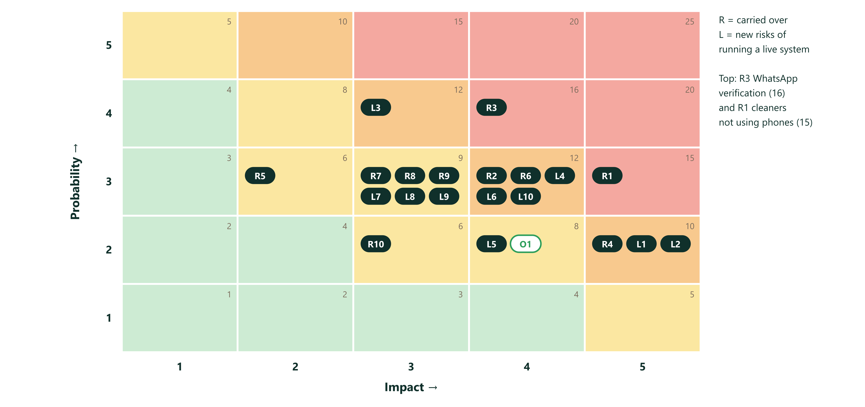
Figure 4.20 Risk matrix: probability and impact
8 threats score 12 or more, so the risk indicator in Section 5.2 starts at red. Review the register every Friday. The cost effect of the main risks is in the EMV table (Section 4.9.7).
Decisions with dates (these are risk responses). The default applies if nobody answers by the date.
Table 4.40 Decisions with dates and defaults
# | Question | Needed by | Decision owner | Default if no answer | Answer
D1 | How cleaners sign in | 21 Oct | Facility unit | One-time WhatsApp link, long session
D2 | Allowed email domains (optional reporter account only) | Before 28 Oct | Farid | No optional accounts in the pilot
D3 | WhatsApp route: Meta Cloud API directly or a provider (BSP), and who pays | 21 Oct | Lecturer and facility unit | Meta Cloud API directly, paid by the faculty
D4 | Do cleaners have WhatsApp and data on their own phones | 21 Oct | Facility unit | Yes, with a data allowance
D5 | Retention: photos 90 days, reports 1 year | 2 Nov | University | As written in the blueprint
D6 | One supervisor per faculty with a reachable number | 21 Oct | Facility unit | Facility unit coordinator
D7 | Pilot building, number of floors and rooms | 21 Oct | Lecturer | Gedung A, 4 floors, 40 places
D8 | Week 0 baseline measured manually | Starts 13 Oct | Facility unit | Start with notes on paper
D9 | QR layout: room, toilet (outside and inside), floor and lobby plates | 21 Oct | Facility unit and Rasyid | Table in Section 4.17
D10 | One coordinator number or one per building | 21 Oct | Facility unit | One number
D11 | Guests from outside campus allowed | 21 Oct | Lecturer | Yes, with limits
D12 | Email address for notifications | Now | Farid | Farid's address
D13 | Domain name (.com), registrar, and which email owns the registrar account | 21 Oct | Farid and lecturer | Institutional email, two admins
D14 | Who pays the year-1 running cost and from which budget line | Before 6 Nov | Faculty | Recommended scenario, Rp 25.22 million
D15 | Payment method for dollar services (institutional virtual card) | 27 Oct | Faculty finance | Prepay by the faculty
D16 | Who maintains the system after the pilot, and support hours | 12 Nov | Facility unit and lecturer | Facility coordinator plus Farid until handover
D17 | Dedicated SIM number for the WhatsApp business number: owner and top-up | 21 Oct | Facility unit | Facility unit buys and owns it
D18 | Each team member's weekly availability and exam dates (full time assumed) | 16 Oct | Each team member, collected by Farid | Full time on weekdays. At half time the finish moves to 23 Dec (Section 4.11.4)

4.14 Procurement Management
Processes (Week 3 mapping): plan procurement, conduct procurement, control procurement, close procurement. Method: vendor bid analysis. Collect written quotes, compare on the criteria below, record the choice and the reason.
Table 4.41 Procurement plan and vendor selection criteria
Item | Make or buy | Options | Selection criteria | Contract type | Lead time | Decide by | Owner
.com domain | Buy | Cloudflare Registrar (about US$10.46 a year, rising slightly after 1 Nov), Rumahweb (promo Rp 121,900, renewal Rp 195,000), DomaiNesia (about Rp 139,000), Namecheap (renewal about US$18.7) | Price including renewal, local payment option, privacy protection, 2-factor login, easy transfer, no lock-in | Annual subscription | Same day | 21 Oct | Farid
Hosting (web) | Buy | Vercel Pro (US$20 per seat per month) | Commercial use allowed, deploy from GitHub, uptime | Monthly subscription | Same day | 27 Oct | Farid
Database | Buy | Supabase Pro (US$25 per month, 7-day daily backups) | Daily backups, Singapore region, standard Postgres, no lock-in | Monthly subscription | Same day | 27 Oct | Farid
WhatsApp sending | Buy | Meta WhatsApp Cloud API directly (no platform fee, per-message charges) or a provider such as Qontak (about Rp 750,000 per month plus messages, unverified) | Total monthly cost, template approval support, ease of integration, support in Bahasa | Pay per message (plus provider fee if any) | 3 to 15 working days for verification | 21 Oct | Farid
Business phone number (SIM) | Buy | Any Indonesian prepaid operator | Not registered in a normal WhatsApp app, stays active | Prepaid | 1 day | 21 Oct | Facility unit
QR plates | Buy | Local acrylic and UV print shops (3 quotes). Marketplace sellers for samples | Unit price at 61 pieces, UV print durability, QR contrast, sample before order, delivery time, reprint policy, accepts vector files, tape included | Fixed price per order | 4 to 10 working days | 30 Oct | Rasyid
Security review | Buy or in kind | University IT, an independent reviewer | Experience with web apps and Postgres row-level security, written report, availability | Fixed fee or in kind | 1 to 4 working days | 6 Nov | Abdillah
Legal and privacy review | In kind or buy | University legal office, external lawyer | Knows UU PDP, Bahasa Indonesia notice | In kind or fixed fee | 2 to 6 working days | 2 Nov | Lecturer
Email sending | Buy | Resend free plan (3,000 emails a month, 100 a day) or Web3Forms free plan | Own domain authentication (SPF, DKIM, DMARC), volume | Free tier | Same day | 27 Oct | Abdillah
Build and test | Make | Rasyha Naufal and Abdillah Ridho with Claude Code | n/a | Internal (team) | n/a | n/a | Rasyha

Account ownership rule: every vendor account is created with an institutional email, has at least two admins, uses 2-factor login, and is documented in the runbook. Payments use the institutional card or a prepaid budget (D15). This protects the system if one person leaves.
Control and close: check each invoice against the quote. Keep quotes, invoices and sample photos with the plan. At close, cancel services that are not needed, record final costs, and confirm that renewals are on calendar.

4.15 Stakeholder Engagement Plan
See Section 4.2.2. Targets: lecturer and facility unit from supportive to leading by the pilot start. Faculty from neutral to supportive after the one-page cost summary. Cleaners from unaware to supportive: involve 2 to 3 of them in the dry run and ask what they would change. University IT and legal receive the privacy notice and the data classification before the pilot. Finance receives the payment request (D15) early. Inside the team: agree roles at the kickoff, keep the RACI current, and share credit in the Friday status.

4.16 Integration Management and Change Control
Baselines: scope baseline (Sections 4.6 and 4.7), schedule baseline (Section 4.8), cost baseline (Section 4.9). Work performed is the approved plan plus approved changes. Baselines change only through an approved change request.
Change control board (CCB): Farid (chair), the lecturer, and the facility unit coordinator. Two of three members must agree. Rasyha attends as technical advisor without a vote. Decisions are recorded in the change log.
Table 4.42 Change control procedure
Step | Who | What
1 | Anyone | Writes a change request: what, why, who asked, date
2 | Farid | Logs it and checks the effect on scope, schedule, cost, risk and quality
3 | Farid | Decides alone if the effect is under 0.5 work-day, under Rp 500,000, and no critical activity moves. Otherwise the board decides
4 | Board | Approves, rejects or asks for more information, normally within 3 working days
5 | Farid | Updates the affected baseline and the blueprint if the data model or security rules change
6 | Farid | Tells the requester and everyone affected

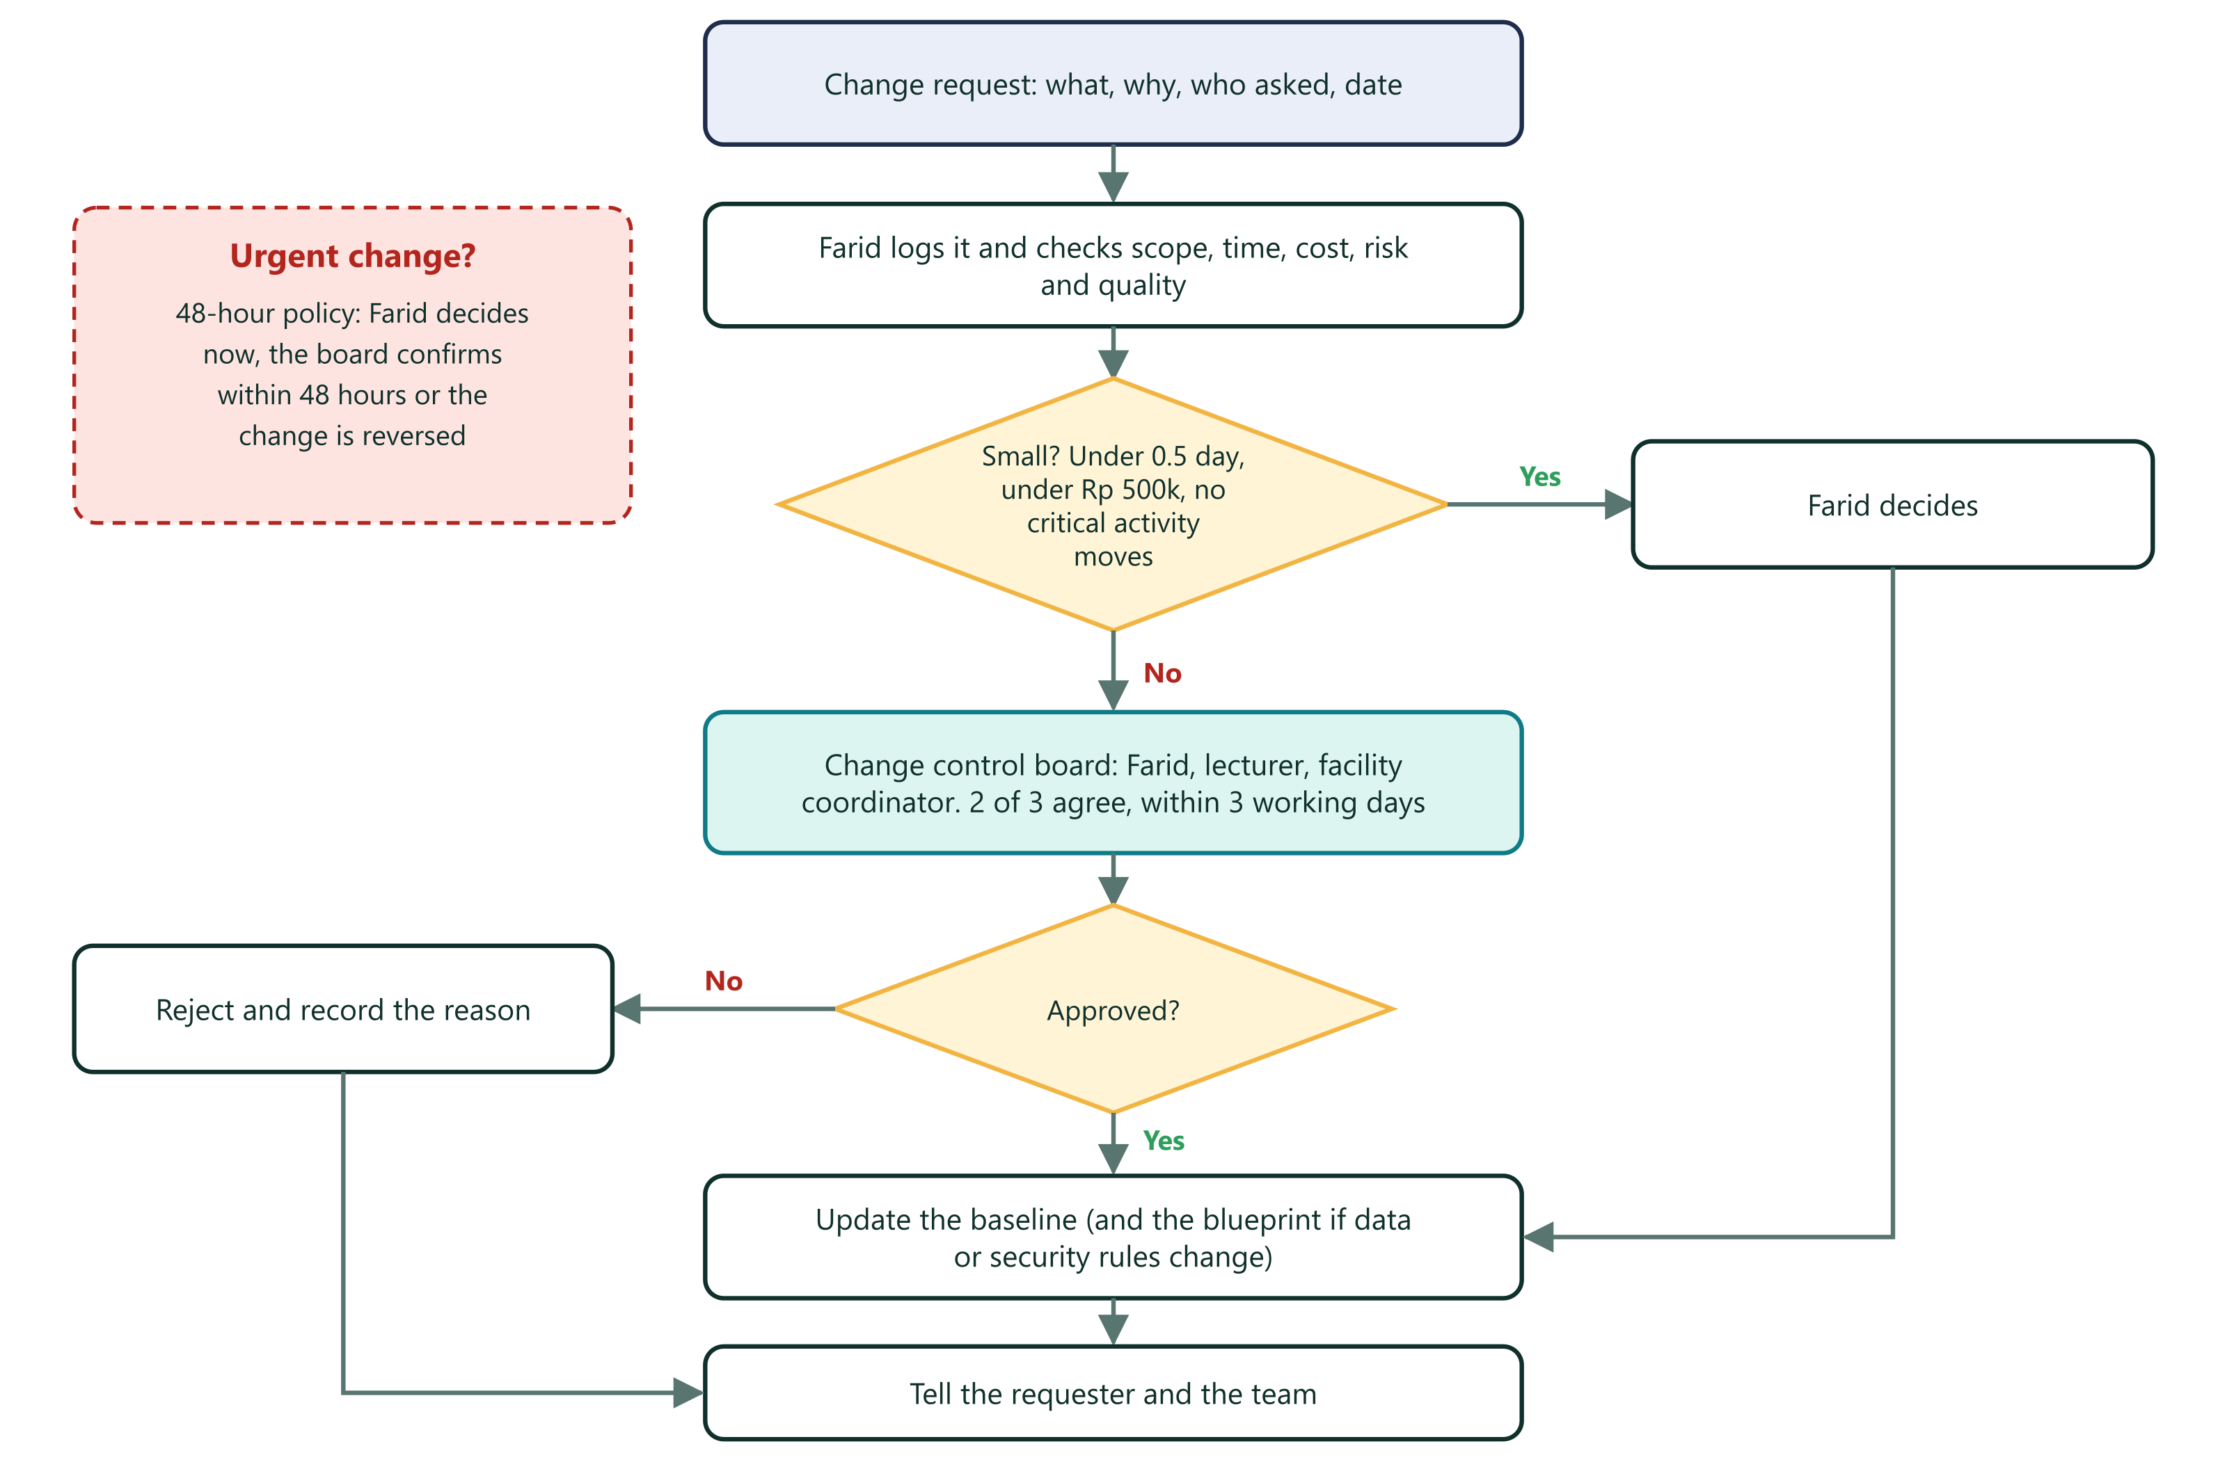
Figure 4.21 Change control: how a change gets approved
48-hour policy (Week 3): for time-sensitive changes the project manager may decide and then has 48 hours to get board approval or reverse the decision. Delegate small changes to the lowest level but tell everyone.
Table 4.43 Change log
ID | Date | Change | Requested by | Impact | Decision
CR-01 | 9 Oct | Guests report without login. QR for floors | Lecturer | Added REQ-01, 02, 15 and tests S19 to S22 | Approved, in prototype
CR-02 | 10 Oct | Shared data through an open table for the prototype | Farid | Added known gaps G1 to G3 | Approved for the prototype only
CR-03 | 15 Oct | Version 2.0: live deployment baseline replaces version 1.0 | Farid | Adds domain, production, QR plates, privacy, support. Budget now includes labor and running cost | Pending approval
CR-04 | 15 Oct | Notify 2 on-duty cleaners first, all after 3 minutes, to limit message cost | Farid | Small change to the notify function | Pending approval
CR-05 | 15 Oct | Admin "plate check" page that shows the room without creating a report | Farid | About 0.3 work-day inside package 5.3 | Pending approval
CR-06 | 15 Oct | Start WhatsApp verification before the decision meeting (fast tracking) | Farid | Saves up to 4.6 days with the scaffold. Risk if the provider choice changes | Pending approval
CR-07 | 15 Oct | Several plates may point to one room (inside and outside a toilet) in the plate table | Farid | No schema change. The table already allows it | Pending approval
CR-08 | 15 Oct | Team of four replaces "one project manager plus AI builder": work assigned to named people, team labor counted in the baseline | Farid | Planned finish Tue 1 Dec instead of Wed 2 Dec (committed date unchanged). Cost baseline Rp 40.77 million instead of Rp 29.02 million. Cash unchanged | Pending approval

4.17 QR Deployment Plan
This plan covers a QR code for every room, every toilet and every floor, mounted on the wall, with a register so each plate can be found, checked and replaced.

4.17.1 Principles
- One plate, one token. The QR holds a random token, not the room number. The database maps the token to a room or a floor. A plate can be replaced without touching report history.
- Our own .com on the plate. The QR holds https://<domain>/r/<32-character token>. The domain is bought and live before any plate is printed, because a printed QR cannot be changed.
- Human-readable fallback. Every plate also prints the room name, floor, domain and the urgent contact line, so a failed scan does not block a report.
- Registered and tested. Every plate is in the register with a photo and a scan-test result before it counts as installed.
- Spares and upkeep. 10% spare plates. A weekly visual check and a monthly register audit.

4.17.2 Plate Types and Quantities
Table 4.44 Plate types and quantities
Plate type | Where | Points to | Count
Room plate | Wall beside the door of each classroom, lab, office and toilet | That room | 40
Toilet inside plate | Inside the toilet near the washbasin or exit. Separate token, same room | The toilet room | 6
Floor plate | Lift lobby and stair landing on each floor (2 per floor) | The floor (room picker with "Area umum") | 8
Entrance lobby plate | Main entrance | Ground floor picker | 1
Spares (10%, rounded up) | Facility unit store | Unassigned tokens, activated when used | 6
Total |  |  | 61

Table 4.45 Plates per floor (assumed until the site survey)
Floor | Rooms | Toilets | Room plates (rooms + toilets) | Toilet inside | Floor plates | Lobby | Plates on floor
1 | 9 | 2 | 11 | 2 | 2 | 1 | 16
2 | 8 | 2 | 10 | 2 | 2 | 0 | 14
3 | 9 | 1 | 10 | 1 | 2 | 0 | 13
4 | 8 | 1 | 9 | 1 | 2 | 0 | 12
Total | 34 | 6 | 40 | 6 | 8 | 1 | 55

The floor split is an assumption. The site survey (package 3.5) replaces it with the real list.
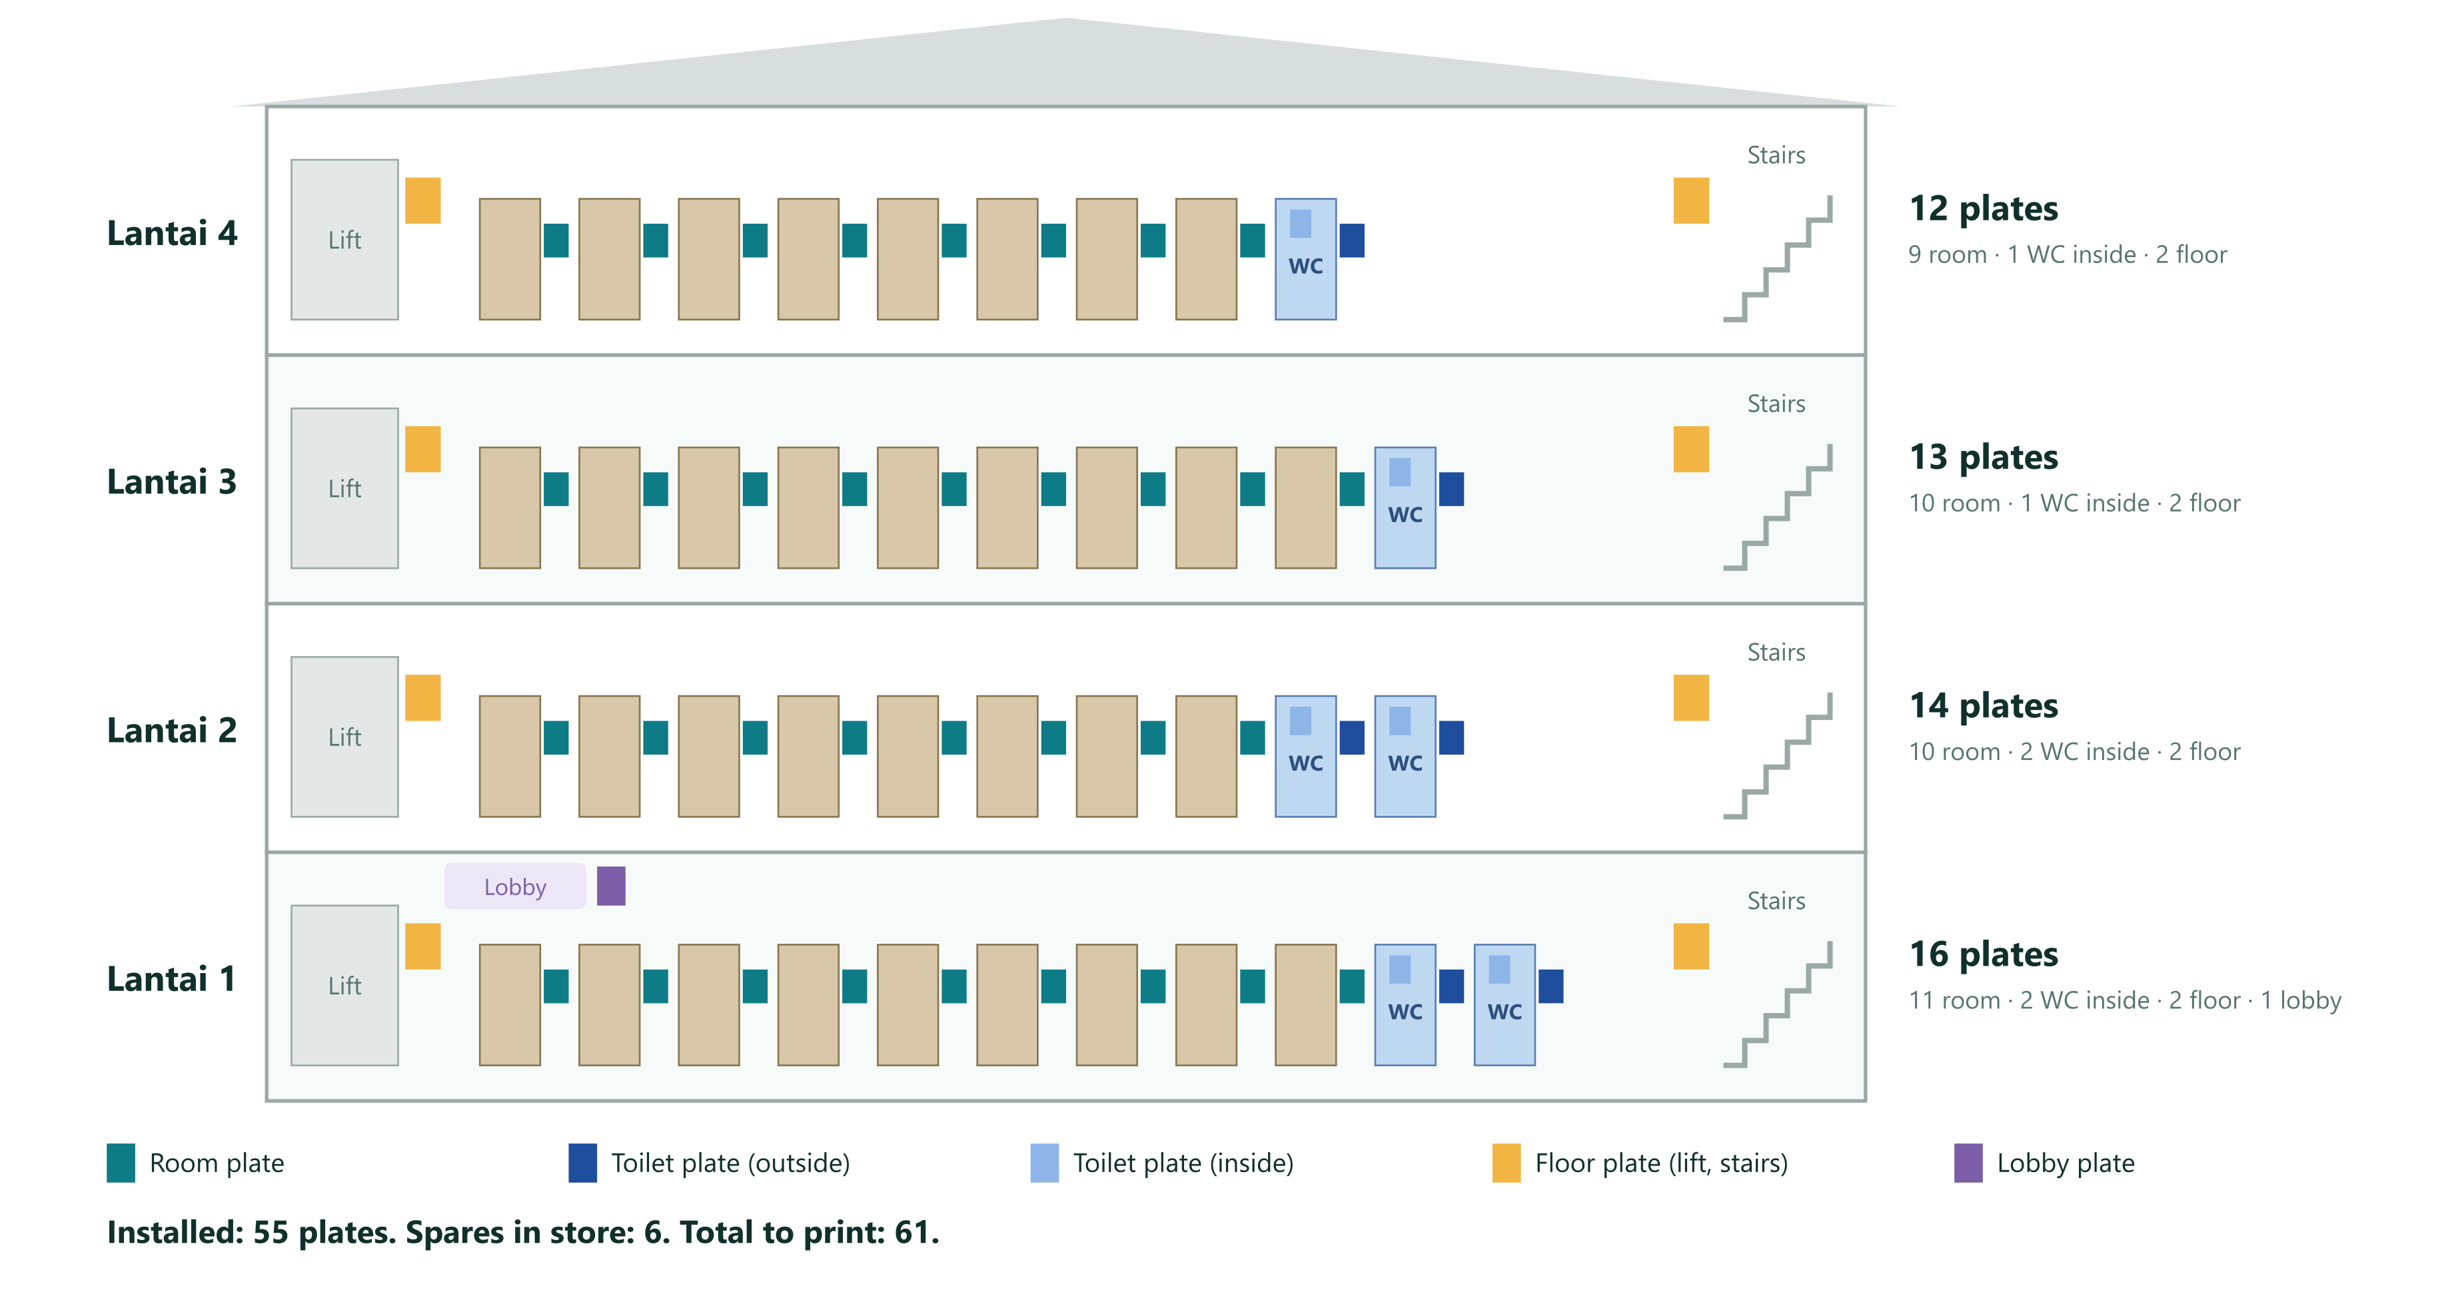
Figure 4.22 QR plates in the pilot building

4.17.3 Plate Options and Recommendation
Table 4.46 Plate options and recommendation
Option | Unit cost (estimate) | Good for | Weak points
Laminated vinyl sticker (A5) | Rp 8,000 to 15,000 (ROM, from Rp 99,000 per square meter print) | Cheap trial, flat clean walls | Peels, tears, picked at, hard to clean. More replacements
Acrylic plate 15 x 20 cm, 3 mm, UV print (recommended) | Rp 35,000 to 75,000, budget Rp 50,000 (marketplace listings Rp 10,000 to 50,000 for smaller or thinner items) | Walls, toilets, offices | Can crack if hit. Needs tape and screws in public corridors
Aluminum composite plate with UV print | Rp 75,000 to 150,000 (ROM) | Wet or vandal-prone places | Costs more. Heavier

4.17.4 Plate Specification
Table 4.47 Plate specification
Item | Specification | Reason
Size and material | 15 x 20 cm portrait, 3 mm acrylic, UV print, matte or anti-glare face | Big enough to read from a corridor. Durable and wipeable
QR size | 9 x 9 cm including a quiet zone of at least 4 modules (about 1 cm) | A 37 x 37 module code gives about 2.4 mm per module. Scans at 30 to 60 cm
QR content | https://<domain>/r/ plus a 32-character random token (about 58 characters, QR version 5) | Not guessable (122 bits). Short enough for a clean code
Error correction | Level Q (25%) | Survives scratches and dirt
Colors | Pure black QR on white. No gradients, no logo inside the code | Maximum contrast for low-end cameras
Text | Bahasa Indonesia first, short English line. Room name in large type. Building and floor. Plate ID. Domain. Urgent contact line | Readable fallback, no personal data
Mounting | 3M foam tape and 2 corner screws, or tamper-resistant adhesive. Edges sealed | Resist peeling and theft
Height and position | QR center 120 to 135 cm from the floor, 10 to 20 cm from the door frame, same side in the whole building | Reachable from a wheelchair. Easy to learn
Durability tests | 48-hour adhesion. 50 wipe cycles with water and a common disinfectant | Cleaning staff wipe walls

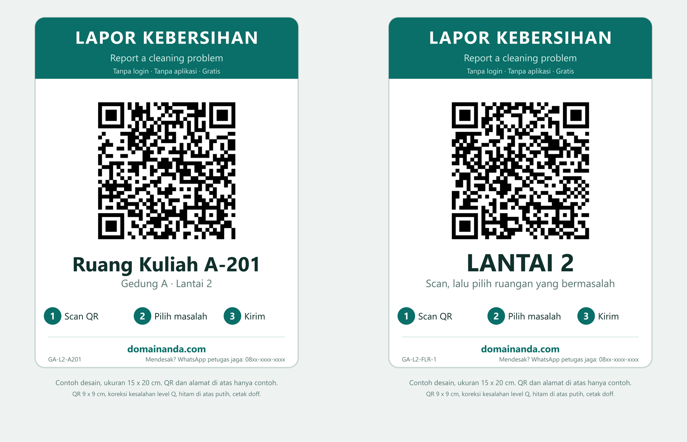
Figure 4.23 Example room and floor plates
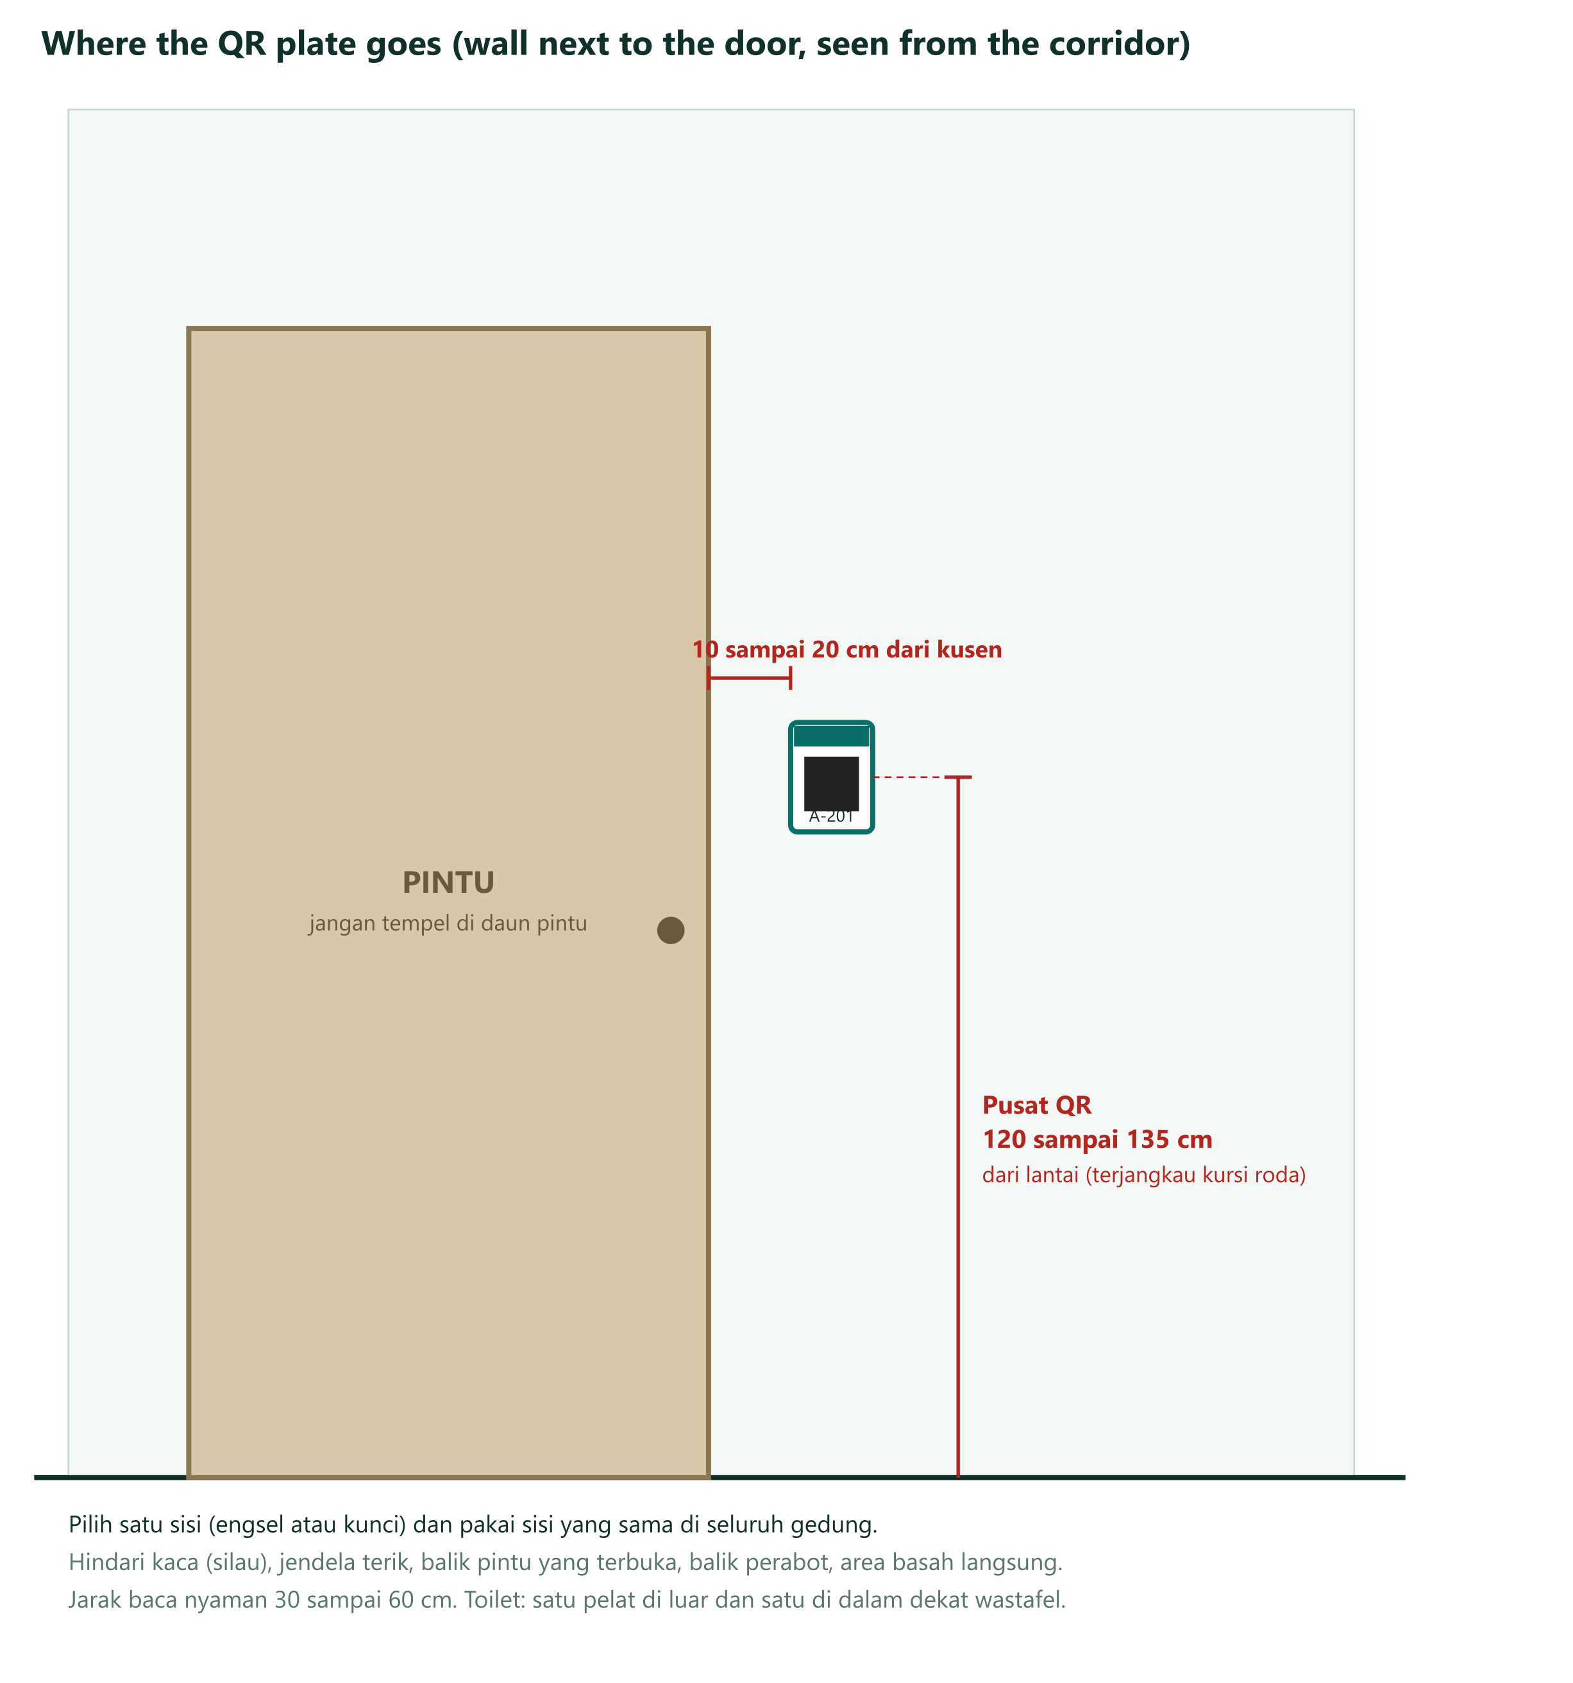
Figure 4.24 Where the plate goes

4.17.5 Plate Register
The register is the qr_code table in the production database plus an exported sheet for the facility unit. One row per physical plate (several plates may point to one room).
Table 4.48 Plate register fields
Field | Example | Purpose
Plate ID | GA-L2-A201 | Printed small on the plate. Matches the register
Token | (32 random characters) | In the QR. Treated as semi-secret
Type | Room, toilet inside, floor, lobby | Behavior of the page
Building, floor, room | Gedung A, 2, Ruang Kuliah A-201 | Where it points
Location note | Left of door, QR center 130 cm | To find and replace it
Installed date and by | 12 Nov, Rasyid and one facility staff | Accountability
Photo | Wall photo after install | Proof and later comparison
Scan test | Pass on 3 phone models, date | Acceptance
Status | Active, damaged, retired | Retired tokens stop working (S22)
Replaced by | New plate ID | History
Scan count (first week) | Number | A plate with zero scans in week 1 is checked

4.17.6 Procedure
Table 4.49 Plate installation procedure
Step | Who | When | Output
1. Site survey: walk each floor with the floor plan, list every place, mark the plate spot, photograph it, check phone signal | Facility unit, Rasyid | 13 Oct to 16 Oct | Room and floor list, placement plan, signal notes
2. Buy the domain, set DNS, deploy production | Farid, Rasyha | 21 Oct to 30 Oct | Live domain with HTTPS. Production database
3. Generate tokens in the production database and the print files named by plate ID | Abdillah, checked by Rasyid | from 30 Oct | Print files, register rows (status "planned")
4. Print 3 sample plates and test them on 5 phones in corridor light, plus adhesion and wipe tests | Rasyid, facility unit | first 2 days of plate production | Sample test record
5. Order with 3 quotes. Inspect delivery: count, spelling, QR contrast, 10% random token check against the register | Rasyid, facility unit | 30 Oct to 9 Nov | Inspection record
6. Install in pairs, one mounts and one scans and records. Start with one floor, then the rest | Facility staff with Rasyid | 10 Nov to 12 Nov | Register rows (status "active"), photos
7. Scan check with the admin plate check page. It shows the room name and does not create a report or alert cleaners | Facility staff | During install | Pass or fail per plate
8. Announce "QR live" with a notice at the entrance | Facility unit | 12 Nov | Notice posted
9. Watch scan counts in the first week and check plates with zero scans | Rasyid | First week of the pilot | Check list

4.17.7 Maintenance and Misuse
Table 4.50 Plate maintenance and misuse rules
Topic | Rule
Weekly round | Cleaners look at plates during their round and report missing or damaged ones to the supervisor
Monthly audit | Supervisor checks 20% of plates against the register. All plates once a year
Replacement | Within 3 working days from spares. The old token is retired and a new token is issued. The new plate is scan-tested
Renovation or renaming | Rename the room in the admin screen. Plates keep working. If rooms are split or merged, issue new plates and retire the old tokens
Stock | Keep 10% spares. Reorder when spares fall below 5%
Photographed or shared QR | Rate limits and the bot check apply. A misused token can be retired at once
Privacy | Plates carry no personal data. Scan logs hold no personal data

CHAPTER V
EXECUTION, MONITORING, CONTROLLING AND CLOSING
This chapter describes how the plan in Chapter IV will be carried out (the execute plan), how performance will be measured and controlled (the evaluation plan), how the pilot will be evaluated, and how the project will be closed.

5.1 Executing Plan
Rules while executing
- One phase at a time. Re-read the matching sections of the blueprint before starting.
- Security before screens: package 4.4 must be green before 5.1 to 5.3 begin.
- One commit per phase after typecheck, lint and tests pass. Development and production are separate environments.
- End every phase with a 5-line summary in English and Bahasa Indonesia: what was built, why, how the reviewer verifies it, what is next.
- Do not change the data model or security rules without updating the blueprint in the same commit.
- Keep the service role key out of client code, logs and git. Production secrets live only in the vendor dashboards.
- No QR plate is printed before the domain is live and the tokens exist in the production database.
- Direct and manage work with the PMIS: GitHub (code and docs), the tracker file, and this plan.
- Two-person rule: every pull request is reviewed by the other developer before merge, and every plate installation is checked by a second person.
Week-by-week execution plan (leveled dates)
Table 5.1 Week-by-week execution plan with proof of completion
Week | Dates | Activities in progress | Done when (proof)
1 | 12 to 16 Oct | A, B, C, D, F, G | Plan approved and team kickoff held. Email works. Friends test done. Site survey done. Baseline observation started
2 | 19 to 23 Oct | D, E, G, H, I, J, K, P, R | Findings fixed. Demo held. Decisions answered by 21 Oct. Scaffold and schema. Domain live. WhatsApp verification started. Baseline done
3 | 26 to 30 Oct | K, L, M, O, P, R, S | Security tests green (28 Oct). Privacy notice drafted. Production environment and restore drill. Plate design and quotes started
4 | 2 to 6 Nov | L, M, N, P, Q, S, T | Guest and cleaner screens. WhatsApp verified. Supervisor and admin screens. Notifications and escalation. Sample plates passed, plates ordered
5 | 9 to 13 Nov | S, T, U, V, W, X | Plates delivered. Deployed on the .com. Security review done. Plates installed and scan-tested. Training and dry run done
6 | 16 to 20 Nov | X, Y | Pilot running from Mon 16 Nov. Runbook and handover plan done
7 | 23 to 27 Nov | Y | Pilot running. Pilot ends Fri 27 Nov
8 | 30 Nov to 4 Dec | Z | Evaluation report on Tue 1 Dec, accepted by the committed date, Wed 2 Dec

Conduct procurement: book the domain on 21 Oct; order the plates after samples pass (30 Oct); start Meta verification on 21 Oct; confirm Vercel, Supabase and the payment method before 28 Oct.
Quality assurance in execution: friends test, sample plates, restore drill, security review, dry run, weekly health check (PROJECT-PLAN.md section 5.3).
Managing the team and stakeholders: weekly team meeting on Monday and a daily check-in in the team group (Section 4.12). The developers work one phase per Claude Code session with the blueprint and this plan as inputs; the other developer reviews before merge. Farid reviews each phase summary before the next phase starts. Rasyid keeps the plate register and the pilot numbers. Friday status message. Weekly 15-minute check with the facility unit.

5.2 Measures and Thresholds
Table 5.2 Measures, frequency and health thresholds
Area | Measure | Formula | Frequency | Green | Amber | Red
Schedule | Schedule performance index | SPI = EV ÷ PV | Weekly | 0.95 or more | 0.85 to 0.94 | Below 0.85
Cost | Cost performance index | CPI = EV ÷ AC | Weekly | 0.95 or more | 0.85 to 0.94 | Below 0.85
Critical path | Slack used | Re-run the CPM table | Weekly | Critical paths unchanged | A third path becomes critical | Finish beyond 7 Dec
Scope | Scope variance | (current requirements − 21) ÷ 21 × 100% | Weekly | 0 to 7% | 7 to 15% | Over 15%
Quality | Security tests passing | passing ÷ 22 | Each phase from 4.4 | 100% | n/a | Any failing
Quality | Plates scan-tested | passed ÷ installed | During install | 100% | 95 to 99% | Below 95%
Operations | Uptime | from the uptime monitor | Daily | 99% or more | 98 to 99% | Below 98%
Operations | Health checks H1 to H9 | healthy ÷ 9 | Weekly | All | 1 failing | 2 or more failing
Risk | Open threats scoring 12 or more | count | Weekly | 3 or fewer | 4 to 5 | 6 or more, or a trigger fired
Cost (running) | Monthly cost against plan | actual ÷ plan | Monthly | Within 10% | 10 to 25% over | Over 25%
Pilot (MOV) | Median time reported to accepted | median of accepted − reported | Daily in the pilot | Under 15 min | 15 to 20 min | Over 20 min
Pilot (MOV) | Reports accepted | accepted ÷ reports | Daily in the pilot | 80% or more | 70 to 79% | Below 70%
Pilot | Average rating | mean of ratings 1 to 5 | Daily | 4.0 or more | 3.5 to 3.9 | Below 3.5
Pilot | Cost per report | monthly cost ÷ reports | Monthly | At or below Rp 2,568 (plan + 10%) | Up to 25% above plan | More than 25% above plan

5.3 Earned Value Management
Planned value PV comes from the time-phased baseline in Section 4.9.8. Earned value EV is the budgeted cost of packages that are fully accepted. Actual cost AC is cash paid plus work-days spent valued at the stated rates. Formulas follow the Week 5 slides.
Table 5.3 Earned value formulas
Metric | Formula | Meaning
PV | Budget planned up to today | What should be done
EV | Budget of accepted work | What is done
AC | Money and work actually spent | What it cost
SV | EV − PV | Negative means behind
CV | EV − AC | Negative means over budget
SPI | EV ÷ PV | 1 on time, below 1 late
CPI | EV ÷ AC | 1 on budget, below 1 over budget
ETC | (BAC − EV) ÷ CPI (progress above 50%) | Estimate of cost to finish if the trend continues
EAC | AC + ETC | Estimate of total cost at completion
VAC | BAC − EAC | Expected over or under budget at the end
TE | ATE + (OD − ATE × SPI) ÷ SPI | Estimated total time. ATE actual time spent, OD original duration
TCPI | (BAC − EV) ÷ (BAC − AC) | Efficiency needed from now to stay in budget

Worked example (illustration only, not real data). End of week 5: PV = Rp 34,192,166, BAC = Rp 40,768,992. Suppose accepted work is worth EV = Rp 32,000,000 and Rp 35,000,000 has been spent.
- SV = Rp 32,000,000 − Rp 34,192,166 = −Rp 2,192,166. CV = Rp 32,000,000 − Rp 35,000,000 = −Rp 3,000,000.
- SPI = 0.94 (amber, behind). CPI = 0.91 (amber, over budget).
- Progress is 78% (above 50%), so ETC = (Rp 40,768,992 − Rp 32,000,000) ÷ 0.91 = Rp 9,636,255. EAC = AC + ETC = Rp 35,000,000 + Rp 9,636,255 = Rp 44,636,255. VAC = Rp 40,768,992 − Rp 44,636,255 = −Rp 3,867,263. TCPI = 1.52.
- Time: ATE = 25 working days, OD = 37.00. TE = 25 + (37.00 − 25 × 0.94) ÷ 0.94 = 39.36 working days, about 2.36 days late.
- Reading: the project is about 6% behind and 9% over budget. The forecast overrun of Rp 3,867,263 is larger than the contingency of Rp 2,135,699. The board would choose between crashing (Section 4.8), cutting a requirement, or accepting a later finish.
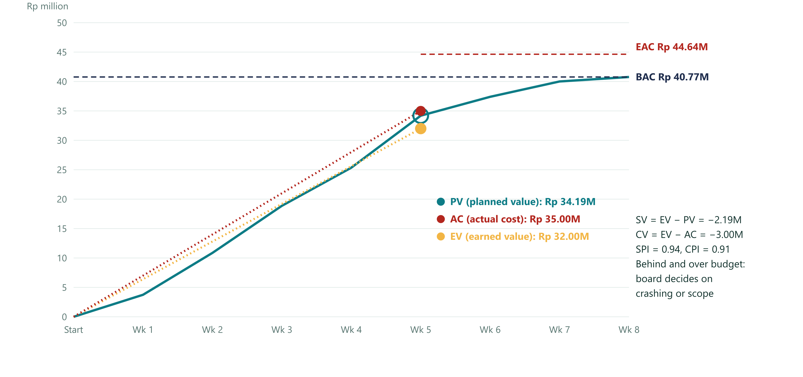
Figure 5.1 Earned value at the end of week 5
Weekly tracking table (fill every Friday):
Table 5.4 Weekly earned value tracking table
Week | PV (cumulative) | EV | AC | SV | CV | SPI | CPI | ETC | EAC | Status
1 | Rp 3,745,377
2 | Rp 10,867,816
3 | Rp 18,871,769
4 | Rp 25,353,940
5 | Rp 34,192,166
6 | Rp 37,400,495
7 | Rp 40,008,992
8 | Rp 40,768,992

5.4 Validating Scope and Controlling the Project
Validate scope (formal acceptance). After Control Quality passes, the accepter signs. A deliverable rejected here becomes a change request, not a defect.
Table 5.5 Deliverables and formal acceptance (validate scope)
Deliverable | Accepter | Date due | Signed (date)
Approved charter and plan (1.1) | Lecturer | 13 Oct
Friends test report (3.2, 3.3) | Farid | 19 Oct
Decisions list answered (3.4) | Lecturer and facility unit | 21 Oct
Site survey and QR placement plan (3.5) | Facility unit | 16 Oct
Domain live with HTTPS (4.1) | Farid | 23 Oct
Security core with 22 tests green (4.4) | Farid | 28 Oct
Reporter, cleaner, supervisor, admin screens (5.0) | Facility unit | 5 Nov
Production environment and restore drill (6.1) | Abdillah | 30 Oct
WhatsApp verified and templates approved (6.2) | Farid | 2 Nov
Notifications and escalation (6.3) | Facility unit | 6 Nov
Privacy notice and retention (7.1) | University legal | 27 Oct
QR plates delivered and checked (7.2) | Facility unit | 9 Nov
Deployed system with monitoring (7.3) | Farid | 10 Nov
Security review report (7.4) | University IT | 12 Nov
QR plates installed and scan-tested (7.5) | Facility unit and supervisors | 12 Nov
Training and dry run (7.6) | Facility unit and supervisors | 13 Nov
Runbook and support plan (8.2) | Facility unit and lecturer | 17 Nov
Pilot data and evaluation report (8.1, 1.2) | Lecturer | 1 Dec

Control scope. Look for sources of change before they arrive. Likely sources: the lecturer wants a new view, the facility unit wants a new category, cleaners ask for chat, someone asks for a second building. Each goes through Section 4.16. Example: if requirements grow from 21 to 24, scope variance = (24 − 21) ÷ 21 × 100% = 14.3% (amber).
Control schedule. Every Friday re-run the CPM table with actual dates. Note which slack was used. If a third path becomes critical, tell the sponsor. Use compression only after checking the new critical paths.
Control costs. Compare AC with EV. Release contingency only through a logged decision. Check each invoice against its quote. Report monthly after go-live.
Control resources. Every Friday each team member logs hours against Section 4.11.3. Re-level when anyone is above capacity for more than two days or is unavailable (what-if table in Section 4.11.4).
Control risks. Update the register every Friday. Close risks that cannot happen any more. Add new risks as they appear.
Control procurement and communications. Check the Friday message went out, open decisions have answers by their dates, and vendor accounts have two admins.

5.5 Evaluation of the Pilot
Table 5.6 Pilot evaluation design
Item | Plan
Question | Does the QR and WhatsApp flow make cleaning requests faster and more visible than the current way, and at what cost per report?
Baseline | Week 0 (3.6): for 5 working days note for each cleaning request the time asked, the time a cleaner started, and the time finished
Pilot data | The report_event table: reported, accepted and done timestamps, plus ratings and plate scan counts
Primary result | Median reported to accepted under 15 minutes and at least 80% accepted, compared with Week 0
Secondary results | Median accepted to done, escalations per day, average rating, reports per day, cleaner adoption, reports with an after-photo, QR scan success, uptime, cost per report
Qualitative | 15-minute talk with 3 cleaners, 2 supervisors, 5 reporters. What was confusing, what would they change
Decision rule | Both primary results met and cost per report within plan: recommend expanding to more buildings and fund year 1. One met: fix the cause and extend 2 weeks. Neither met: stop and review the assumption about cleaners and phones
Data hygiene | Remove personal data before sharing. Follow the retention decision

5.6 Evaluation of Project Management
At the end compare plan and actual: duration (37.00 planned working days), effort (76.36 work-days), cost (baseline Rp 40,768,992), scope (21 requirements), number of change requests, risks that happened, and decisions that were late. Record the lessons in the closing report.

5.7 Closing Plan
Closing finalizes all activities and transfers the completed or cancelled work to the right people. Main outputs (Week 3): final product transition and updates to organizational process assets.
Table 5.7 Closing steps
Step | Output | Owner | Due
Final acceptance of all deliverables | Signed table in Section 5.4 | Lecturer | 1 Dec
Transfer ownership of the domain, registrar account, Vercel, Supabase, Meta business account, SIM and GitHub organization to the institution | Accounts with two institutional admins. 2-factor login set. Passwords and keys rotated | Farid and facility unit | 17 Nov
Hand over the system and QR register | Admin access, runbook, how to add rooms and cleaners, how to print and replace plates, register export | Abdillah (system) and Rasyid (QR register) | 17 Nov
Confirm the support rota and the budget line for year 1 | Signed rota and approved budget (D14, D16) | Facility unit and faculty | 1 Dec
Close procurement | Final invoices matched to quotes. Unneeded services cancelled. Renewal dates on calendar | Farid | 1 Dec
Release resources | Thank testers and cleaners. Release the team members and the facility unit contact | Farid | 1 Dec
Archive | Plan, logs, change log, risk register, quotes, evaluation report kept in the repository | Farid | 1 Dec
Final cost reconciliation | Planned versus actual by line, and variance explanation | Farid | 1 Dec
Retrospective | Two questions: what went well that we should continue, and what could we do differently | All four team members | 1 Dec
Lessons learned and closing report | Planned vs actual (Section 5.6) and pilot result (Section 5.5) | Farid | 1 Dec
Next step decision | Expand, extend, or stop (rule in Section 5.5) | Lecturer, facility unit and faculty | After the report

Lessons learned template
Table 5.8 Lessons learned template
Area | What happened | What we would do next time
Scope
Schedule
Cost and effort
Quality
People and communication
Risks
Tools and suppliers
QR plates and installation

CHAPTER VI
CONCLUSIONS AND RECOMMENDATIONS

6.1 Conclusions
Based on the results and discussion, the problem statement is answered as follows:
- Scope. The live deployment is defined by 21 requirements, each traced to a work package and an acceptance criterion. The WBS has eight level-1 categories and 26 activities with 76.36 work-days of effort, and every parent equals the sum of its children. The prototype is outside the baseline as a sunk cost, and the exclusions are stated in the scope statement.
- Schedule. The critical path takes 36.91 working days, and two paths are critical at the same time: the build path through the security core and the WhatsApp verification path, which depends on Meta’s review. After resource leveling the planned finish is Tue 1 Dec 2026. The committed date of Wednesday 2 December keeps one working day of buffer and has a probability of about 68%; the 95% date is 7 Dec. Fast tracking the scaffold and the WhatsApp verification together could save up to 4.58 days at the price of more risk.
- Cost. Cash to the end of the pilot is Rp 14.24 million (range Rp 9.51 million to Rp 23.89 million). With in-kind labor the cost baseline is Rp 40.77 million, and with a 15% contingency and the management reserve the authorized budget is Rp 44.46 million. After the pilot the system costs about Rp 2.10 million per month in the recommended scenario, or about Rp 2,335 per report, which the faculty must approve before go-live.
- Team. The four members have clear roles and one accountable owner per work package. With the work shared, nobody on the critical path is over capacity. The schedule is sensitive to availability: if one developer leaves the finish moves to 14 Dec, and if everyone can work only half days it moves to 23 Dec.
- Control and evaluation. Performance is reviewed every Friday with earned value (SPI and CPI), the critical path, the risk register and change requests through the change control board. Eight threats score 12 or more and have named owners. The pilot succeeds if the median time from report to accept is under 15 minutes and at least 80% of reports are accepted, compared with the Week 0 baseline, at a cost per report within plan.

6.2 Recommendations
- Close the open decisions with their owners: each member’s availability and exam dates (D18), the WhatsApp route and who pays (D3), the pilot building (D7) and the domain and account owner (D13), and the year-1 running cost (D14) before deployment.
- Start the Meta business verification paperwork immediately, because WhatsApp verification is on the critical path, and decide on fast tracking through change request CR-06.
- Protect the peak days of each team member and keep a backup reviewer for every work package, so that the loss of one person does not stop the critical path.
- Replace the placeholders as soon as possible: the institution’s labor rates, quotes for the legal and security reviews, three quotes for the plates, and the real room list from the site survey; then re-baseline.
- Keep the prototype for demonstrations only and do not enter real personal data until the secured system with row-level security and the 22 security tests is live.
- After the pilot, apply the decision rule in Section 5.5: expand to more buildings if both primary results are met within the planned cost, extend the pilot by two weeks if one is met, and stop and review if neither is met.

REFERENCES
Bank Indonesia. (2026). Jakarta Interbank Spot Dollar Rate (JISDOR). Bank Indonesia.
Brooks, F. P. (1975). The mythical man-month: Essays on software engineering. Addison-Wesley.
Fleming, Q. W., & Koppelman, J. M. (2010). Earned value project management (4th ed.). Project Management Institute.
Go Clean It Team. (2026). Go Clean It technical blueprint, version 3 [Unpublished project document]. https://github.com/luxelineproject7-source/Go-Clean-It
International Organization for Standardization. (2015). Information technology — Automatic identification and data capture techniques — QR Code bar code symbology specification (ISO/IEC Standard No. 18004:2015). ISO.
Kelley, J. E., & Walker, M. R. (1959). Critical-path planning and scheduling. In Proceedings of the Eastern Joint Computer Conference (pp. 160–173). ACM.
Kerzner, H. (2017). Project management: A systems approach to planning, scheduling, and controlling (12th ed.). Wiley.
Malcolm, D. G., Roseboom, J. H., Clark, C. E., & Fazar, W. (1959). Application of a technique for research and development program evaluation. Operations Research, 7(5), 646–669.
Marchewka, J. T. (2015). Information technology project management: Providing measurable organizational value (5th ed.). Wiley.
Mendelow, A. L. (1981). Environmental scanning: The impact of the stakeholder concept. In Proceedings of the Second International Conference on Information Systems (ICIS 1981 Proceedings, 20).
Meta Platforms. (2026). Pricing on the WhatsApp Business Platform. https://developers.facebook.com/docs/whatsapp/pricing
Project Management Institute. (2017). A guide to the project management body of knowledge (PMBOK guide) (6th ed.). Project Management Institute.
Republik Indonesia. (2022). Undang-Undang Nomor 27 Tahun 2022 tentang Pelindungan Data Pribadi.
Schwalbe, K. (2019). Information technology project management (9th ed.). Cengage Learning.
Supabase. (2026). Pricing. https://supabase.com/pricing
Vercel. (2026). Pricing. https://vercel.com/pricing
[Lecturer name]. (2026). Manajemen Proyek (EBI 4E3) lecture slides, Weeks 1–7 [Lecture notes]. [University].

APPENDICES

Appendix A. Process Groups × Knowledge Areas
The mapping follows the Week 3 course slide. Risk is mapped to planning and controlling on the slide; the PMBOK Guide also has “implement risk responses” in executing, shown in brackets.
Table A.1 Process groups and knowledge areas mapped to this report
Knowledge area | Initiating | Planning | Executing | Monitoring and Controlling | Closing
Integration | 4.2.1 Charter | 4.3, 4.16 Plan and change process | 5.1 Direct and manage work | 5.4 Monitor and control, integrated change control | 5.7 Close project
Scope |  | 4.4 to 4.7 |  | 5.4 Validate and control scope | 5.7 Final acceptance
Schedule |  | 4.8 |  | 5.3, 5.4 Control schedule
Cost |  | 4.9 Estimate, budget |  | 5.3 EVM, 5.4 Control costs | 5.7 Cost reconciliation
Quality |  | 4.10 Plan quality | 5.1 Manage quality | 5.2 Control quality
Resources |  | 4.11 Plan, estimate resources | 5.1 Acquire, develop, manage team | 5.4 Control resources | 5.7 Release resources
Communications |  | 4.12 | 5.1 Manage communications | 5.4 Control communications
Risk |  | 4.13 Identify, analyze, plan responses | [5.1 Implement responses] | 5.4 Control risks | 5.7 Lessons
Procurement |  | 4.14 Plan procurement | 5.1 Conduct procurement | 5.4 Control procurement | 5.7 Close procurement
Stakeholders | 4.2.2 Identify | 4.15 Plan engagement | 5.1 Manage engagement | 5.4 Control engagement

Appendix B. Inputs, Tools and Techniques, and Outputs
Items from the class slides and briefs. Items marked (PMBOK 6) are standard practice that is not on the slides.
Table B.1 Inputs, tools and techniques, and outputs of the main processes
Process | Inputs | Tools and techniques | Outputs
Develop project charter | Statement of work, business case, agreements, environmental factors, process assets | Expert judgment, meetings | Signed project charter (PMBOK 6: assumption log)
Define scope | Charter, scope management plan, requirements documentation, assumption log, risk register | Expert judgment, analysis (PMBOK 6) | Project scope statement
Create WBS | Scope statement, requirements | Decomposition (PMBOK 6) | Scope baseline: scope statement, WBS, WBS dictionary
Develop schedule | Activity list, durations, dependencies, resources | CPM, PERT, leveling, crashing, fast tracking | Schedule baseline, network diagram, Gantt chart
Estimate costs | Scope baseline, project schedule, human resource plan, environmental factors (market, vendors), process assets (lessons, files) | Expert judgment, analogous, parametric, bottom-up, three-point, reserve analysis, cost of quality, estimating software, vendor bid analysis | Activity cost estimates, basis of estimate, project document updates
Determine budget | WBS, cost estimates | Aggregation, reserve analysis (PMBOK 6) | Cost baseline (time-phased budget)
Control costs | Cost baseline, work performance data | Earned value management | Revised estimates, budget updates, modified cost information
Validate scope | Scope baseline, requirements documentation, RTM, validated deliverables, work performance data | Inspection, group decision making | Accepted deliverables, change requests, work performance information
Perform integrated change control | Change requests, project plan, performance reports | Change control system, change control board, meetings | Approved or rejected changes, plan updates
Close project | Accepted deliverables, plan, records | Meetings, retrospective | Final product transition, process asset updates

Appendix C. Price Sources and Assumptions
Prices change. Re-quote before buying. Where sources disagree the conservative (higher) figure is used.
Table C.1 Price sources and assumptions (checked 15 October 2026)
Item | Value used | Source and note
Exchange rate | Rp 17,900 per US$ | Bank Indonesia JISDOR via Journal Arta: Rp 17,917 on 6 Oct 2026
.com domain | Rp 200,000 per year | Cloudflare at cost about US$10.46, registry fee rises from US$10.26 to US$10.97 on 1 Nov 2026. Namecheap renewal about US$18.48 plus US$0.20. Rumahweb promo Rp 121,900, renewal Rp 195,000 (listing without a date). DomaiNesia Rp 139,000
Database | US$25 per month (Supabase Pro) | supabase.com/pricing: 8 GB database, 250 GB egress, 100 GB storage, 7-day backups, US$10 compute credit (one Micro instance). Point-in-time recovery US$100 per month. Free projects pause after 1 week of inactivity
Hosting | US$20 per seat per month (Vercel Pro) | vercel.com/pricing: Hobby is for personal, non-commercial use. Pro includes 1 TB bandwidth
WhatsApp message rates (Indonesia) | Utility Rp 356.65. Marketing Rp 586.33. Authentication Rp 356.65 | Rate card in IDR effective 1 Jan 2026 (published by a Meta provider). Meta changes rates quarterly. Check Meta pricing before launch
WhatsApp free messages | Planned as billable (conservative) | Meta's page says utility templates inside an open 24-hour window are free. A provider article says they become billable from 1 Oct 2026. The conservative reading is used
WhatsApp provider fee | Rp 750,000 per month (only in the high scenario) | Third-party comparison for Qontak, unverified. Direct Meta Cloud API has no platform fee but needs our own integration
Email sending | Rp 0 | Resend free plan: 3,000 emails per month, 100 per day, 3 domains. Pro US$20 per month
QR plates | Rp 50,000 each (budgetary) | Marketplace listings: vinyl print Rp 99,000 per square meter, acrylic QR signs Rp 10,000 to 50,000, acrylic sign 15 x 20 cm with vinyl Rp 30,000 to 40,000. No 2026 quote for 15 x 20 cm UV-printed plates was found. Get 3 quotes
SIM card and top-up | Rp 50,000 plus Rp 30,000 per month | Estimate
Labor rates (placeholders) | Team members (Farid, Rasyha, Abdillah, Rasyid) Rp 400,000 each, facility staff Rp 200,000, cleaners Rp 180,000, supervisors Rp 300,000, university legal Rp 500,000 per day | Assumptions. Replace with the institution's rates
Legal and security review | Rp 3,000,000 and Rp 5,000,000 | ROM placeholders. Replace with quotes or university time
Messages per report | 2.45 | Assumption: 2 cleaners notified, 15% escalated, 30% of reporters get an update
Reports per month | 600 lean, 900 recommended, 1,500 high | Assumption. High equals 50 reports a day

Appendix D. Terms Used
Work package: lowest level of the WBS with owner, duration and cost. 100% rule: a parent equals the sum of its children. Scope baseline: scope statement plus WBS plus WBS dictionary. RTM: table tracing each requirement to the deliverable that meets it. Critical path: longest path, shortest possible project time. Slack: LS − ES. PERT: (o + 4m + p) ÷ 6. Crashing: add resources to shorten a critical activity, chosen by slope. Fast tracking: do tasks in parallel that were planned in sequence, which adds risk. Resource loading: amount of a resource needed per period. Resource leveling: shifting activities inside their float to smooth the load. ROM, budgetary, definitive: estimate types with accuracy bands of −50/+100, −10/+25 and −5/+10 percent. Contingency: reserve for known risks. Management reserve: reserve for unknown risks, released by the sponsor. EVM: earned value management using PV, EV and AC. Sunk cost: money already spent that cannot be recovered. CCB: change control board.

