TSG-RAN WG1 #45 R1-061369
Shanghai, China, May 8-12, 2006

Source: Ericsson
Title: LTE random-access capacity and collision probability
Agenda Item: 11.1.2
Document for: Discussion

Introduction
At the joint RAN1/RAN2 meeting in Athens in May 2006, RAN1 was tasked to estimate the collision probability of random access. This paper provides a first attempt on such an estimate, based on the random-access scheme outlined in [1]. Although we assume the structure of [1], the discussion below is valid for other random-access proposals as well.

Assumptions
This discussion makes the following assumptions, see also Figure 1.
- A time-domain random-access structure where a random-access slot occurs once every N:th sub-frame. More specifically, in Figure 1, we assume a random-access slot of length one sub-frame (0.5 ms) that occurs once every 10 ms (N = 20). Expressed differently, there are 100 random-access slots per second.
- Each random-access transmission covers a certain frequency range. By allocating larger overall bandwidth for random access, multiple random-access “opportunities can be provided in the frequency domain. More specifically, in Figure 1 we assume a 5 MHz overall transmission bandwidth and a
1.25 MHz random-access bandwidth, allowing for a maximum of four frequency-multiplexed random-access transmissions.
- There are 16 different preamble signatures that a UE select on random for each random-access attempt. It is assumed that, if multiple UEs make a random-access attempt in the same random-access slot and frequency band but with different preamble signatures, the network can resolve the different random-access attempts (a low preamble cross correlation). Thus, a collision is assumed to occur only if multiple UEs make a random access in the same random-access slot and frequency band using the same preamble signature.
We assume a large number of UEs in the cell. This implies that the collision probability can be expressed as 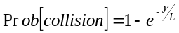where L is the total number of random-access opportunities per second and γ is the random-access intensity, i.e. there are, on average, γ random-access attempts per second and cell. The number of random-access opportunities per second is given by the number of random access slots per second multiplied by the number of random-access frequency bands in each random-access slot multiplied by the number of random-access preamble signatures. As an example, with 100 random-access slots per second (one random-access slot per 10 ms frame), 2 random-access frequency band, and 16 preamble signatures there are L = 100×4×16 = 3200 random-access opportunities per second.
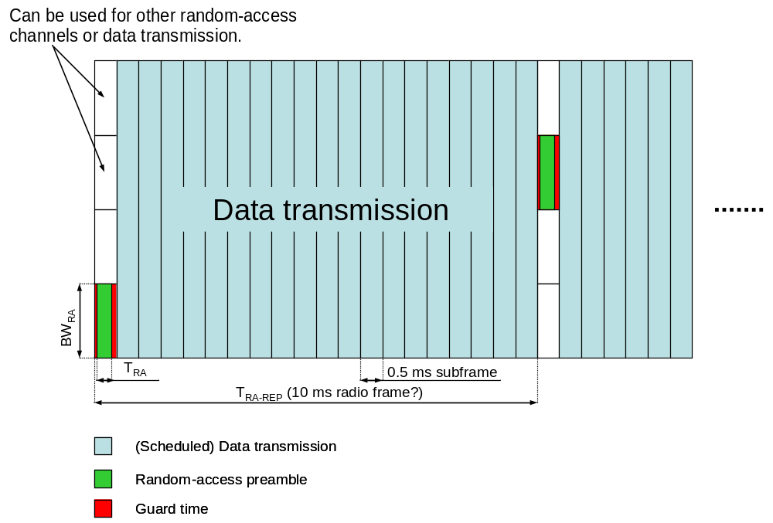’
Figure 1

Numerical results
Figure 2 shows the collision probability as a function of random-access intensity for different number of random-access opportunities per second L.
- L = 200 could e.g. correspond to a case with one random-access slot per 10 ms frame, one 1.25 MHz random-access frequency band, and 2 preamble signatures. This can be seen as a low-capacity random-access configuration.
- L = 1600 could e.g. correspond to the case with one random-access slot per 10 ms frame, one 1.25 MHz random-access frequency band, and 16 preamble signatures. This can be seen as a medium-capacity random-access configuration.
- L = 6400 could e.g. correspond to the case with one random-access slot per 10 ms frame, four 1.25 MHz random-access frequency band, and 16 preamble signatures. This can be seen as a high-capacity random-access configuration.

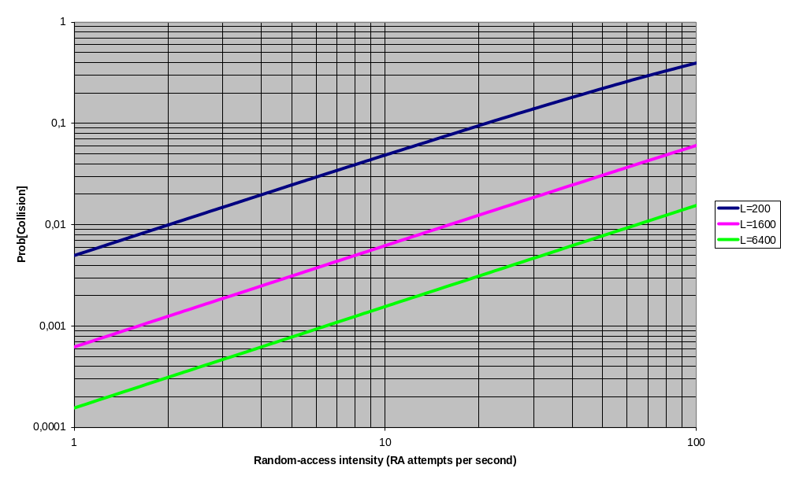
Figure 2 Collision probability as a function of the random-access intensity

Summary
This paper has provided a first attempt to estimate the E-UTRA random-access capacity and collision probability. Assuming a bandwidth of 5 MHz, one random-access slot every 10 ms, and 16 signatures, a high random-access intensity can be supported with a reasonable collision probability.

References
[1] R1-060584, “E-UTRA Random Access”

